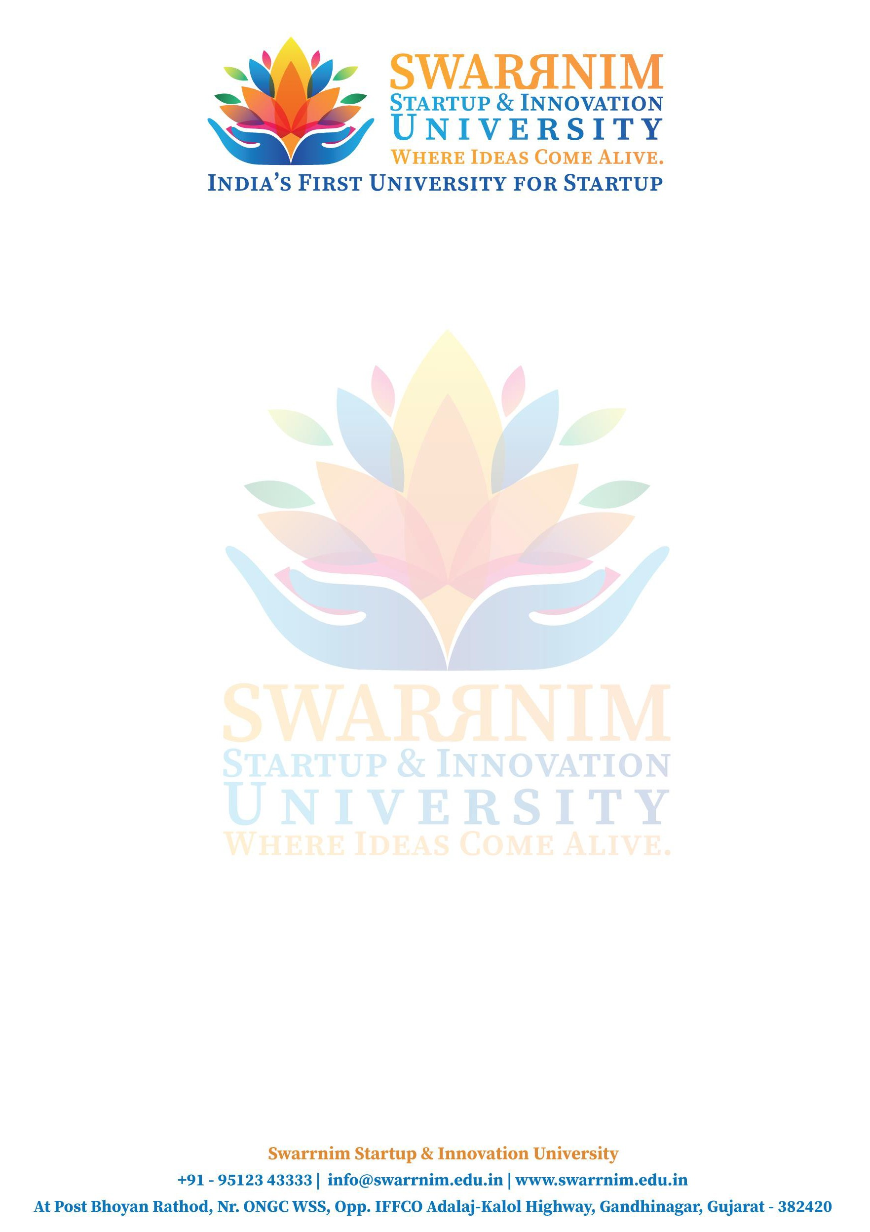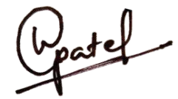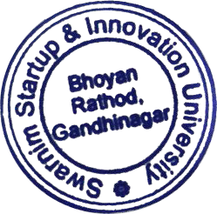

Date:-22/12/2023

To,

The Registrar,

Swarrnim Startup & Innovation University Gandhinagar.

Subject:-Financial Support to Attend Seminar/Workshop

As per our policy to support faculty to attend conferences & workshop, the following faculty member have sought approval to attend **“ WE B**

**DE VE L OP M E NT ”** being held 15/12/2023 TO 19/12/2023 at Dream IT Infotech Ltd-Anand. You are requested to kindly approve the financial support to following staff for the Purpose of Registration Fee/Travel & other Expenses.

|  |  |  |
| --- | --- | --- |
| **SR.NO** | **NAME** | **AMOUNT** |
| 1 | Pritee Manubhai Solanki | 5000 |
| 2 | Hardik Gautambhai Parmar | 5096 |
| 3 | Nirav Kirtikumar Dave | 7000 |
| 4 | Apeksha Lalitprasad Dave | 6290 |
| 5 | Vikas Chandra Sharma | 6000 |
| 6 | Chetan Pravinbhai Gondaliya | 7000 |
| 7 | Hirenkumar Anilbhai Kukadiya | 6000 |

Registrar

Swarrnim Startup & Innovation University