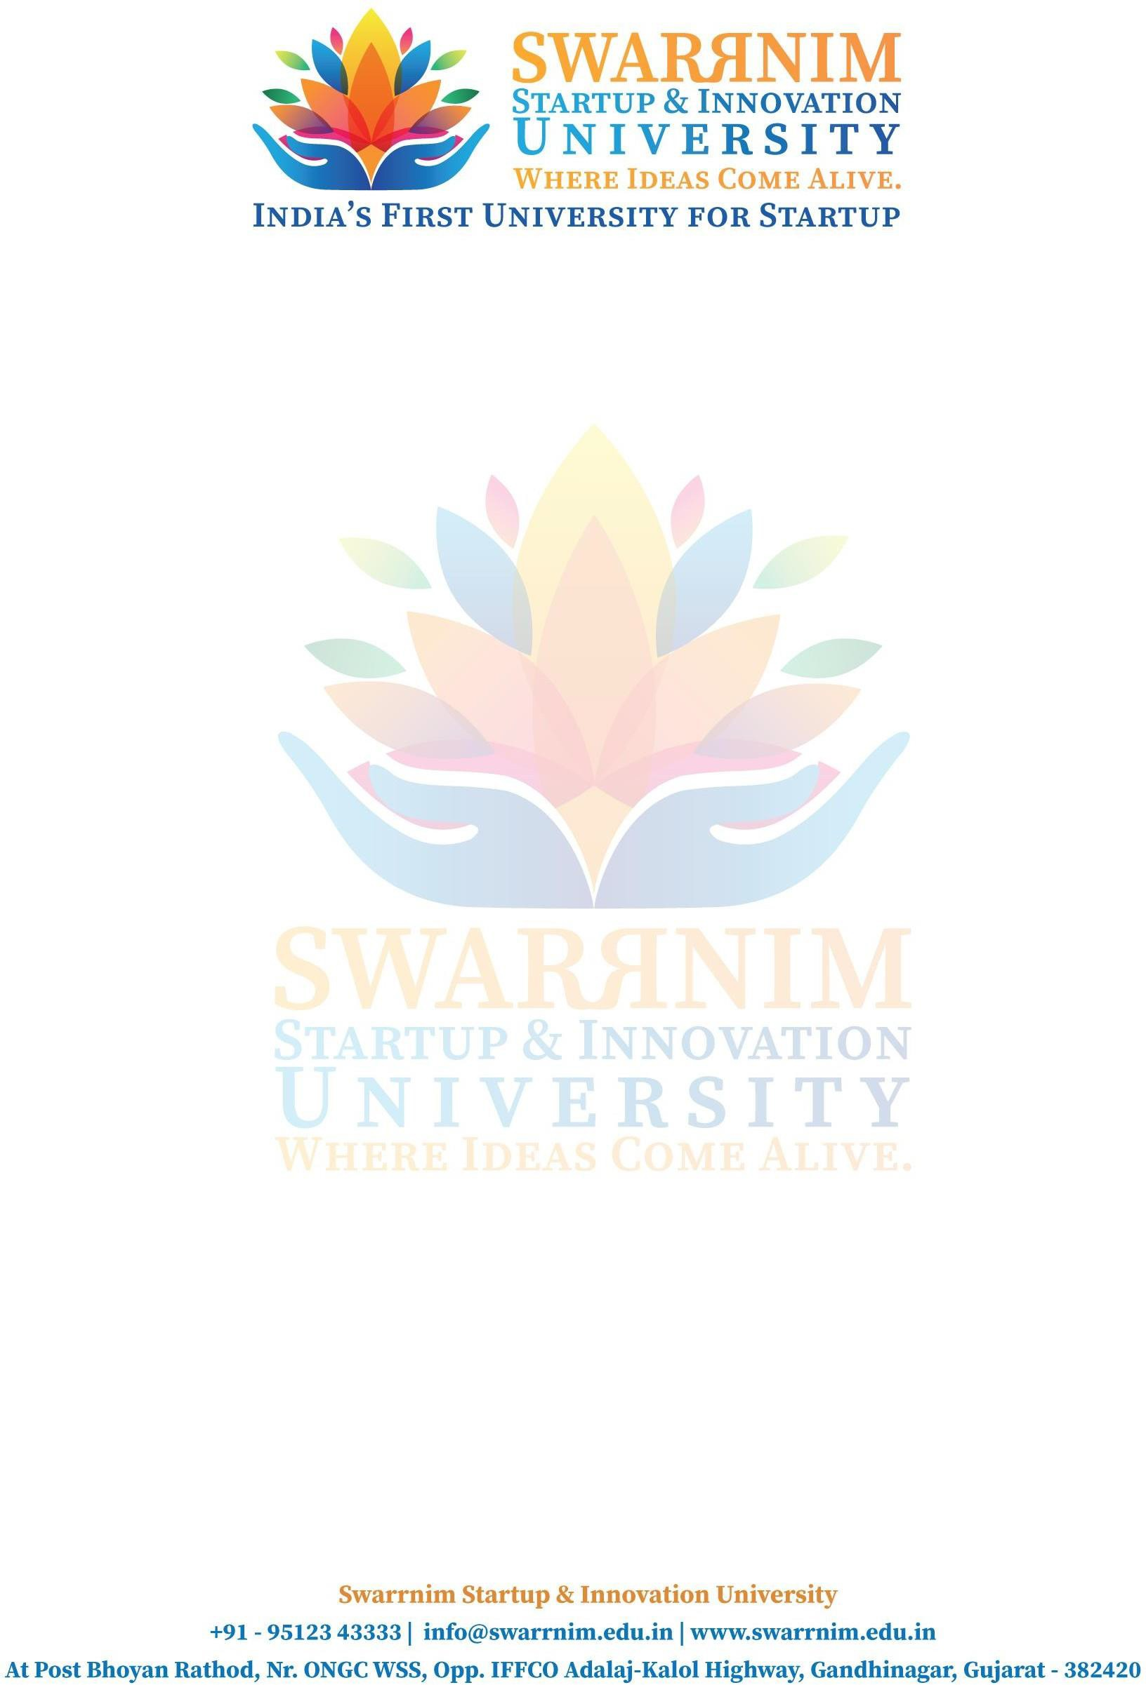

Date: 1/072022

To, Registrar,

Swarrnim Start Up & Innovation University, Gandhinagar

Subject: To provide financial support to faculties for Seminar

As per our policy to support faculty to attend conferences & Workshops, the following faculty member have sought approval to attend “Two day Seninar on Open Source for Web Development" on 11,12/07/2022 .You are requested to kindly approve the financial support.

**Requested expences :** Registration Fee/ Travel & Other Expense I hope you would find everything in order.

This are the list of faculties and their expenses :

|  |  |  |
| --- | --- | --- |
| 1 | Prof. AJANI SANJAYKUMAR LABHUBHAI | 5000 |
| 2 | Prof. ZALAK SANDIP BHOLE | 5000 |
| 3 | Prof. Rakesh Bhavsar | 5000 |
| 4 | Prof Yogesh khuswa | 5000 |
| 5 | Prof. Krutika Sharama | 5000 |
| 6 | Prof. Devshri Pandya | 5000 |
| 7 | Prof. Amrita Yadav | 5000 |
| 8 | Dr. Gaurav Kumar Ameta | 5000 |

Thank you for considering my request. I am happy to provide any additional information or documentation required to support my application. I look forward to your positive response.