**GOAL AND PURPOSE**

Curricular input processes must include all relevant stakeholders and follow a systematic and dynamic approach in accordance with local, regional, national and global health needs (in alignment with Regulatory requirements).

Curriculum implementation must include best practices for teaching-learning & continuous assessment.

Uniformity and standardised processes are key to enable successful curricular alignment and hence achievement of defined Programme and Course Outcomes.

Outcome analysis of student performance and attainment must be regularly carried out for all programmes and courses be used for curricular improvement. Curriculum revision must include content and process analysis that is need-based, relevant innovative and dynamic. **OBJECTIVES**

To define a standard procedure for curriculum design, development and to implementation for monitoring curriculum teaching-learning-assessment in a uniform manner while make improvements/revisions as necessary, including faculty development to ensure teacher quality Although all constituent units follow the directives of respective regulatory councils, this SOP will help to ensure that in all constituent units, curriculum processes are uniformly implemented and monitored in a student-centred manner, towards attainment of Programme Outcomes and Course Outcomes.

**CURRENT BEST PRACTICES**

The Outcome-Based Education Approach has been adopted, with outcomes defined as Programme Outcomes (POs), and Course Outcomes (COs) for all Programmes and Courses offered by the University which are implemented through a systematic and dynamic approach.

Course content, mapped to the POs and COs for all programs and courses along with the learning outcome competencies for cognitive, psychomotor as well as affective domains, written and aligned with teaching-learning and assessment methods

Curriculum implementation has a student-centred focus and is well informed by global practices in health professional education.

Faculty development in newer methods of teaching-learning, development of e-content and newer assessment methods is designed for successful curricular implementation which is planned and conducted regularly.

Both curricular implementation & monitoring are well documented and periodically analysed to derive inputs for continuous improvement of curriculum, its implementation and outcome attainment.

**1. CURRICULUM PLANNING**

**2. CURRICULAR IMPLEMENTATION**

**3. OUTCOME ATTAINMENT (OUTCOME ANALYSIS)**

4. **CURRICULAR REVISION**

**A. CURRICULUM PLANNING**

▪ Curriculum Planning shall be initiated at the Departmental Level

▪ For new programs as well as existing programs, the HOD with inputs from faculty, alumni, external subject experts shall prepare the curriculum focusing on and justifying relevance of curricular content to

▪ local, regional, national and global needs student aspirations and career goals ▪ Course content shall be mapped to the POs and COs for all programs and courses and the learning outcome competencies (LOCs) for cognitive, psychomotor as well as affective domains, written and aligned with teaching-learning and assessment methods:

o Curricular implementation strategies should include multiple methods, aligned to Learning Outcome Competencies (LOCs) and that are student centric, participatory, actively engaging the learners, promoting problem solving and critical thinking, enabling experiential learning and development of skills, values and ethics.

o Integrated(intra-andtrans-disciplinary)learning with special reference to cross-cutting issues, communication skills, environment and sustainability, health determinants using horizontal and vertical integration, problem-based learning, team-based learning, etc.



▪ The above shall be submitted to the concerned Board of Studies through the Curriculum Committee and Dean/Principal.

▪ The Board of Studies shall review the same and modify/accept the changes, after thorough discussion, deliberation. The Board shall recommend the same to the concerned Faculty and Academic Council.

▪ Modification if any of Program Outcomes (PO’s) and Course Outcomes (CO’s) for Programmes / Courses, shall include:

▪ Curricular enrichment Innovations

▪ Holistic student development and

▪ Continuous progression of learning ▪ Newer assessment methods

➢ ▪The concerned Faculties and Academic Council shall examine the curriculum proposals of the various Boards of Studies and Faculties and approve with suggested changes or refer back the curriculum to BOS with suggestions for modification

➢ ▪The Board of Management shall examine the curriculum proposed by the Academic Council and approve with suggested changes or refer back the curriculum to Academic Council for modification ➢ ▪The curricula / curricular changes approved by the University shall be communicated to the concerned Constituent Unit for implementation.

**CURRICULUM PLANNING - INPUT**

CURRICULUM PLANNING – OUTPUT 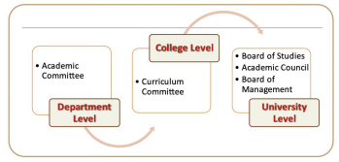 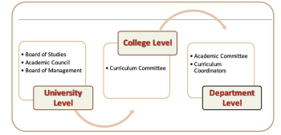B.



**CURRICULAR IMPLEMENTATION**

➢ The institutional curriculum committee shall develop the Curricular Implementation Plan and Schedule (Including content mapping, innovative T-L and Assessment Methods and new topics) for implementation by the Departments

**CURRICULAR IMPLEMENTATION AT THE DEPARTMENT LEVEL SHALL INCLUDE:** ▪ Course-wise Curriculum Content mapping to POs and COs

▪ Topic / Unit-wise - Specific Learning Objectives (SLO’s) by Department including all three domains – cognitive, psychomotor and affective

▪ Resources uploading by Faculty of respective colleges and departments to S.I.D-LMS-ERP system for students

▪ Development of lesson plans for all assigned teaching sessions.

▪ Student Feedback and a Continuous Assessment Plan followed by all Departments ▪ Support to students with special reference to advanced learners and slow performers ▪ Feedback collected periodically from all stakeholders to identify and drawing pertinent pointers to enhance the learning effectiveness

▪ Necessary infrastructure, resource materials and facilities shall be provided to all departments as per Regulatory norms and as per specific requirements of the course

▪ Teaching-Learning and Assessment following contemporary educational approaches ▪ Process manual for documentation of all teaching-learning, formative and continuous assessment processes shall be developed and followed by every department for every course and program

▪ Responsibility of the Department to conduct Outcome Analysis and prepare a report for each academic year.

▪ Regular training of all faculty so that they are updated to ensure quality of implementation **GUIDING FRAMEWORK FOR TEACHING-LEARNING-ASSESSMENT**

To ensure that every student at S.I.D receives best teaching-learning experiences and support, to reach their fullest potential and the desired proficiency benchmark for attainment of expected course and programme outcomes SPICES Model shall be used.

**SPICES MODEL** is well-known for implementation of teaching-learning in outcome- based education that has been globally accepted in health professional education. It can also be applied to other professional education programs.

It provides framework to shift the teaching-learning to a more active, analytical and participatory approach which is more student centred, as opposed to traditional method which is teacher-centric with lesser opportunity for active participation for students.



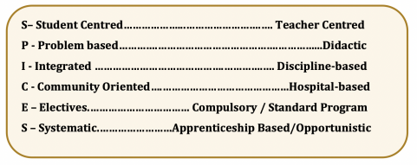

Harden RM, Sowden S, Dunn WR. Educational strategies in curriculum development: the SPICES model. Med Educ 1984; 18: 284-297.

Quirk M.E., Harden R. M. (2017). Curriculum planning and development. In Dent, J., Harden, R. M., & Hunt, D. (Eds.). A practical guide for medical teachers. (pp. 7) Elsevier Health Sciences. **RESPONSIBILITIES**

**The Head of Institution is responsible for ensuring effective implementation of the SOP at their respective constituent Unit.**

**IMPLEMENTATION OF STUDENT-CENTRED TEACHING - LEARNING**

The plan for implementation of T-L for all Programs will be finalised by the respective Constituent Units taking into consideration the respective Council norms and feedback analysis from various stakeholders well before commencement of the academic term. The same will be submitted to the BOS for inputs followed by Academic Council and Board of Management for approval The final plan as approved by Academic Council and Board of Management will be communicated to the Head of Institution for implementation

The academic calendar will be prepared by the respective colleges, taking inputs from the respective HODs and Education Units for scheduling the T-L activities and continuous assessment dates. The College Council/Dean will direct its implementation and assign responsibility to academic co ordinators.

Every HOD will ensure the implementation at the Departmental level

Feedback will be taken from students regarding the T-L Process as per Feedback SOP which will be informed to the HODs for making necessary changes/ addressing the concerns of the students. The HODs shall be responsible to ensure training of faculty in education technology and assign teaching responsibility according to the capability and content expertise of the teachers. The HODs will conduct regular meetings with departmental faculty to gather curricular inputs, obtain feedback and address their concerns.

The HODs will schedule and monitor the continuous internal assessment process

TheHODswillassignresponsibilitytotheteacherstosupportadvancedlearnersandslow performers The faculty members will be nominated / granted permission for attending training / workshops in newer methods of T-L and assessment both within the institution and outside including workshops, seminars and conferences Particular emphasis will be laid on innovative methods to enable the faculty to shift from teacher centred to student centred methodologies – interactive lectures, use of smart boards, effective group discussions, community and industrial visits, to enable students to critically analyse information and its practical application.

Experiential learning, patient-centric learning, evidence-based learning, integrated and interdisciplinary learning and participatory approach will be adopted during the faculty development workshops and implemented.Faculty will be encouraged to learn educational research methodology and undertake education innovation and research projects



The NAAC Core Values will be emphasised for being taught as part of all T-L processes i.e. Contributing to National Development

Fostering Global Competencies among Students

Inculcating a Value System among Students

Promoting the Use of Technology

Quest for Excellence

Student and faculty feedback will be taken to assess the effectiveness of implementation, including newer methods.

Teaching effectiveness will be reflected in students’ continuous internal assessment performance and class attendance.

The Head of Institutions will discuss progress and address difficulties faced during implementation through periodic meetings

DepartmentsandInstitutionaladministrationwillmaintainrecordsstrictly,whichmustbe up to date at all times

Every institution will give a yearly report of its teaching-learning methodologies and innovations to UCPE & FD.

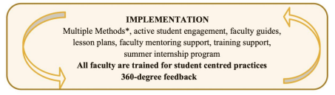**\*MULTIPLE METHODS**

Experiential Learning

Integrated / Interdisciplinary Learning

Participatory Learning

Problem Solving Methodologies

Self-Directed Learning

Patient Centric and Evidence Based Learning

The Humanities

Project Based Learning

Role Play

**C. OUTCOME ANALYSIS**

The Outcome Analysis reflects the extent to which the Program Outcomes (PO’s) and Course Outcomes (CO’s) are attained and whether the attainment levels are of the desired standards. Outcome Attainment for each batch of students is reflected in:

A. Programme Outcomes - Percentage of students passing the University Annual / Semester exam for each Program

B. Course Outcomes - For every Course in a Program - Course-wise Pass Percentage in University Exam C. Attainment Level (Level 1, Level 2 and Level 3) *which is determined for all Programmes and Courses 3. The Performance Levels provide valuable information to guide the Faculty, Department, Institution and University regarding areas in which students are demonstrating outstanding performance, optimum performance as well as areas for improvement and remediation

The following levels will be used to define the performance of the students

*Level 0 - <50%/40% Level 1 - 40/50 - <60 Level 2 - 60 - <70Level 3 - 70% and above

**\* As per regulatory norms**

Fail - Not meeting minimum level - Needs remediation Minimum Level of attainment – Needs improvement Above Minimum Level of attainment - Can do better Attained desired level of performance The findings of outcome analysis will be used to enhance curricular output and make improvements in attainment level of the students



**D. CURRICULUM ANALYSIS FOR REVIEW AND REVISION**

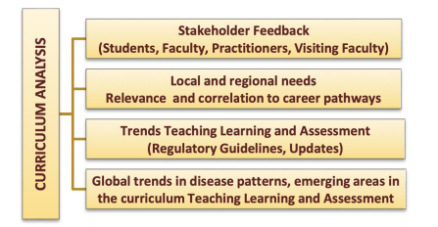**THE CURRICULUM ANALYSIS FOR EACH PROGRAM AND COURSE SHALL INCLUDE** Need-based identification of changes.

Review of national trends (regulatory guidelines, updates, guidelines) in disease patterns, Teaching Learning and Assessment / Evaluation Methods.

Review of global trends in disease patterns, emerging areas in the curriculum Teaching Learning and Assessment / Evaluation Methods.

Review of Local and regional needs and relevance and correlation to available and possible career pathways.

Review of stakeholder feedback (Students, Faculty, Practitioners and Visiting faculty experts).

Outcome Analysis Data for concerned Academic Year.

The cycle of curricular analysis, planning, implementation, and outcome analysis will be followed throughout the academic year.

