

Ref: SWARRNIM/RO/CIRCULAR/2019/15 04.06.2019
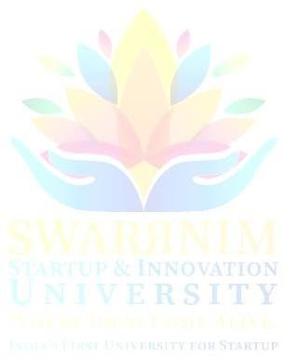


CIRCULAR

“World Environment Day”

Swarrnim Startup & Innovation University is organizing Tree plantation drive on date 5th June, 2019 in University campus. So all the faculties and students should be present on that day at 9:30 AM. Students are required to register their name to the Hod of Department one day before the event date.

Registrar

Copy to;
- The Vice President, Swarrnim Startup & Innovation University
- The Provost, Swarrnim Startup & Innovation University
- Chief Administrative Officer/Academic Director/Dean/ Principals/Functional Head/HODs, Swarrnim Startup & Innovation University

- Guard File



SWARRNIM STARTUP & INNOVATION UNIVERSITY ACTIVITY REPORT 2019

INSTITUTE & DEPARTMENT | Swarrnim Startup & Innovation University
ACTIVITY NAME/ EVENTNAME | 5thJune, World Environment Day  Environment Awareness Rally and Tree Plantation
MONTH | JUNE-2019
DATE OF THE EVENT | 05.06.2019
DUTRATION | 10:00 am
PLACE | SSIU Campus
Organizing committee head | Dr.Navin Banarase (Principal)

Objective of the event:
Every year, World Environment Day is observed globally on June 5. It is celebrated to mark the importance of nature and the environment and it also gives out a message to the global population that nature should not be undervalued and it should not be taken for granted at any cost.
The theme for World Environment Day 2019 is focus on solutions to plastic pollution under the campaign #Beat Air Pollution.

Flow of the event:
On the occasion of world environment day every member of SSIU university had taken oath for beat plastic pollution. Environment Awareness Rally was started at 10:00am from Aarihant General Hospital. After completion of rally tree plantation at herbal garden area was completed. Aaragvadha, Karvira, Aamalaki, Tulsi, Neem and other ornamentals plants were planted by students of SSIU, Teaching Staff, Non-Teaching staff, Admin staff.

Significance/Outcome:
More than 100 plants were planted in garden; more than 60 students had participated and around 50 members of SSIU were also actively participated.

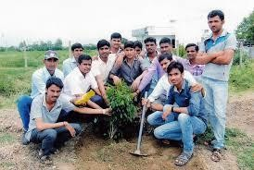
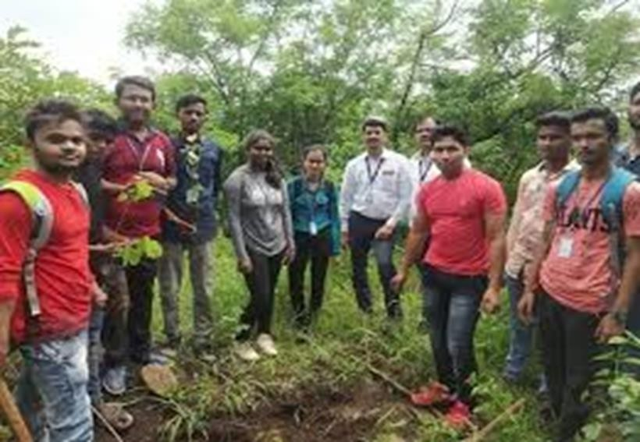

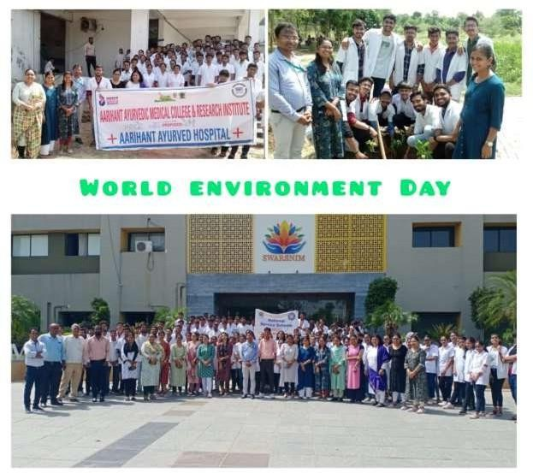

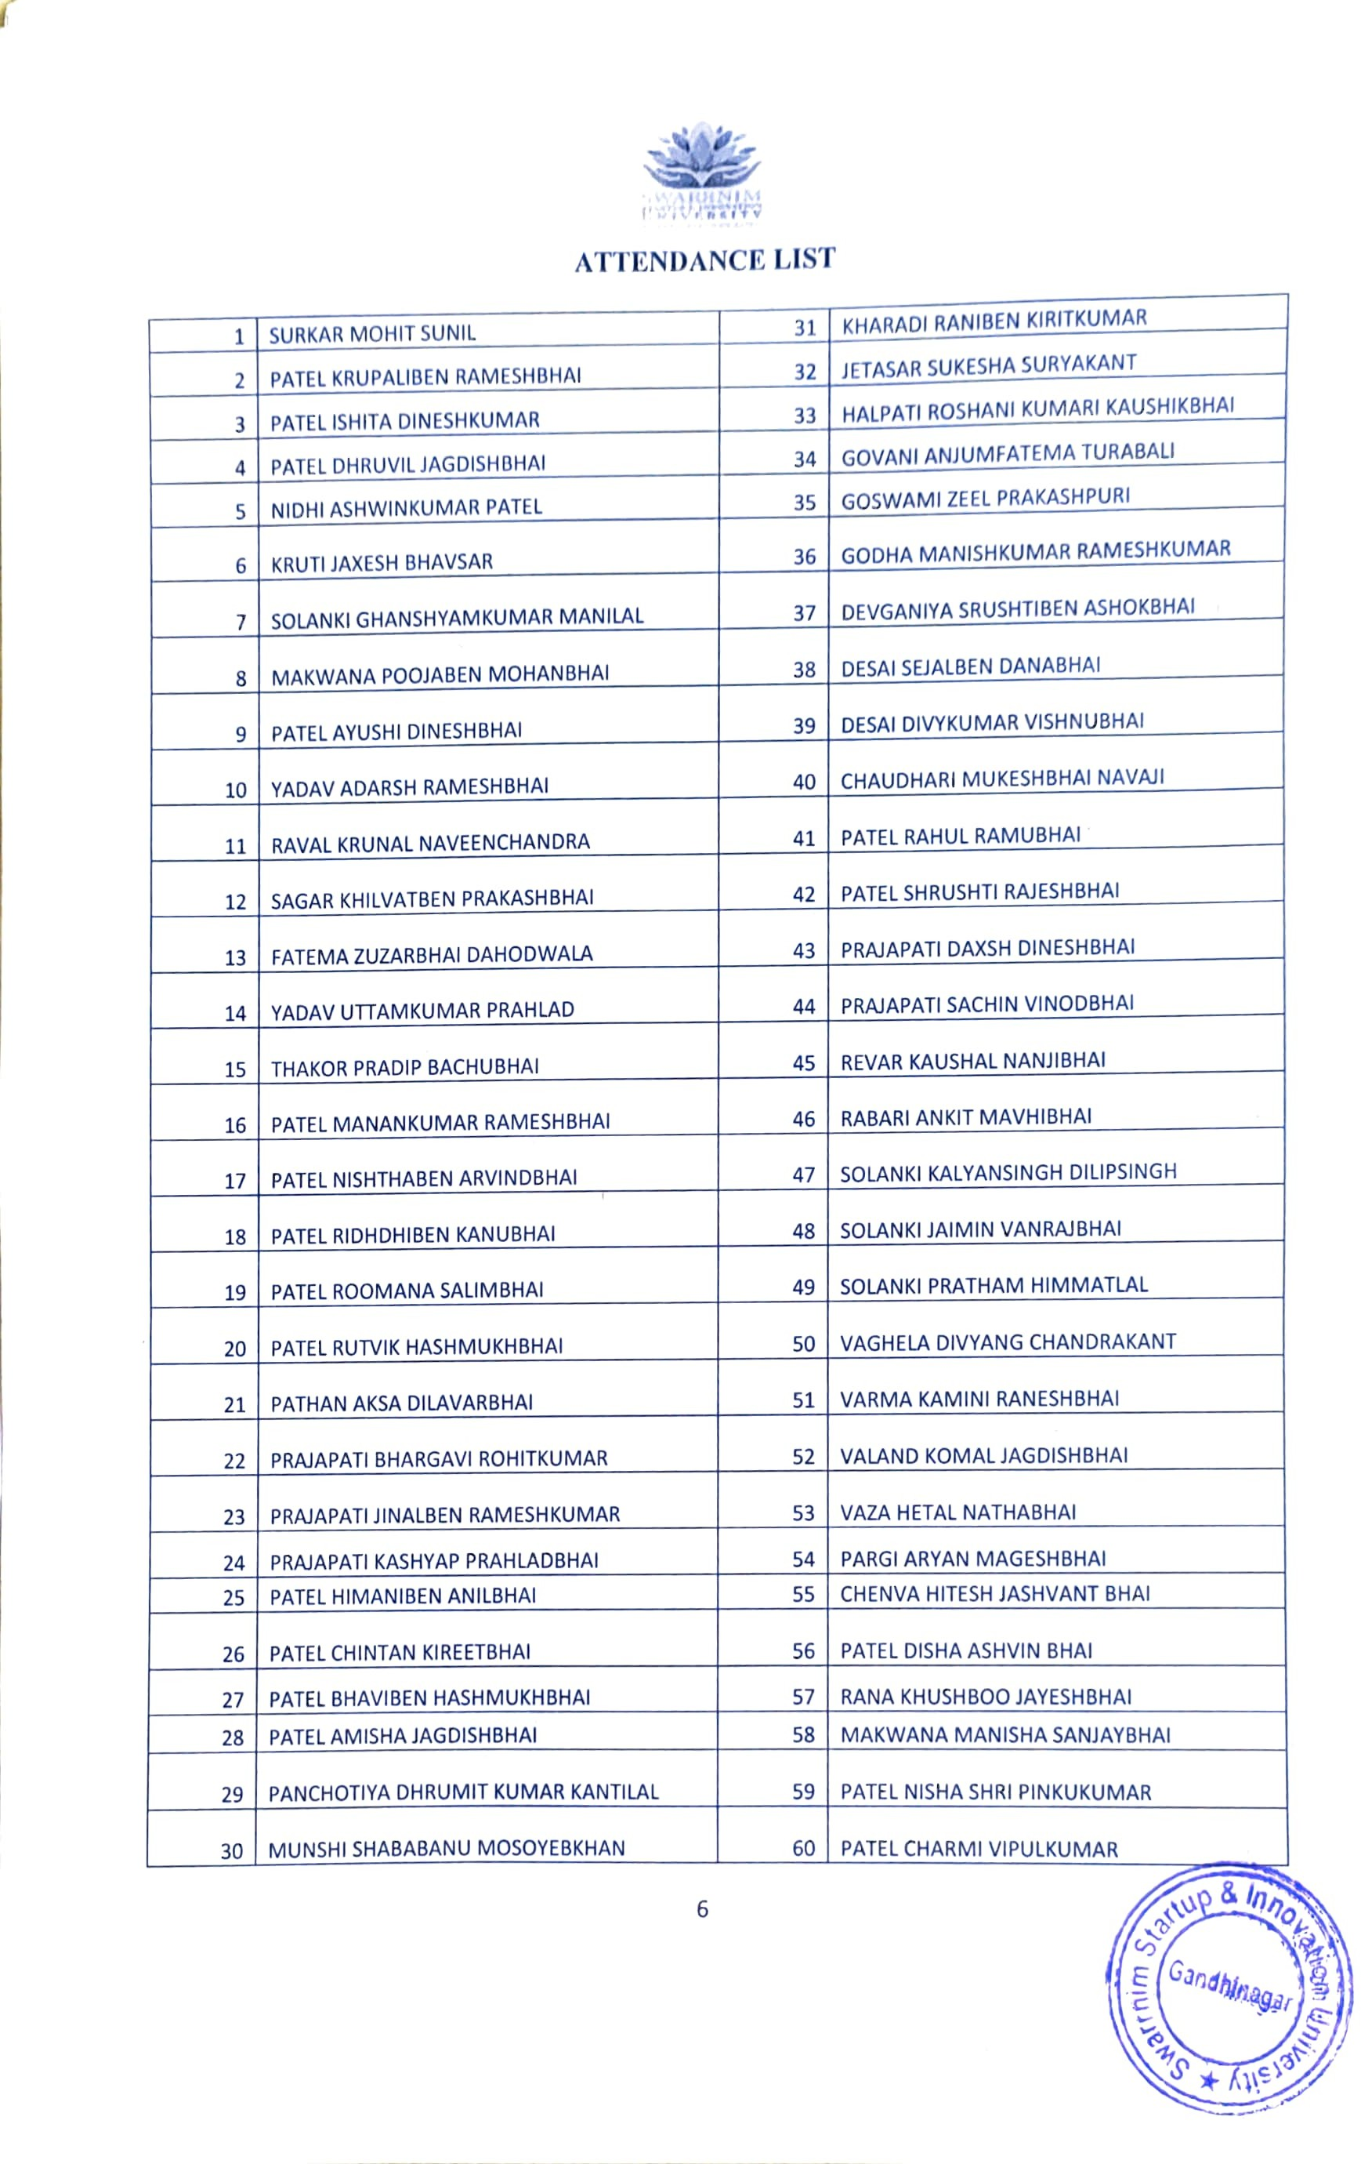

Ref: SWARRNIM/RO/CIRCULAR/2020/34 01.10.2020


CIRCULAR

“Environment Awareness Rally and Tree Plantation”

Swarrnim Startup & Innovation University is organizing Environment Awareness Rally and Tree Plantation on date 5th October, 2020 in University campus. So all the faculties and students should be present on that day at 10:00 AM. Students are required to register their name to the Hod of Department one day before the event date.

Registrar

Copy to;
- The Vice President, Swarrnim Startup & Innovation University
- The Provost, Swarrnim Startup & Innovation University
- Chief Administrative Officer/Academic Director/Dean/ Principals/Functional Head/HODs, Swarrnim Startup & Innovation University
- Guard File

SWARRNIM STARTUP & INNOVATION UNIVERSITY ACTIVITY REPORT 2020

INSTITUTE &DEPARTMENT | Swarrnim Startup & Innovation University
ACTIVITYNAME/EVENTNAME | Environment Awareness Rally and Tree Plantation
MONTH | October2020
DATEOFTHE EVENT | 05.10.2020
DUTRATION | 10:00 am
PLACE | SSIU Campus
Organizing committee member | - Dr. Navin Banarase (Principal)  - Dr. Megha Patel , Asst. Prof, Homoeopathy  - Ms. Pinal Ghoghara(Associate Professor, Nursing Department)

Objective of the event:
To Promote The theme for World Environment Day in 2020 was "Biodiversity" with the slogan "Time for Nature". The theme was a call to action to combat the loss of species and degradation of the natural world. As due to covid it couldn’t be promoted on world environment day.
To promote environmental sustainability by improving campus greenery, enhancing air quality, and contributing to climate change mitigation. This initiative helps create a healthier and more aesthetically pleasing campus environment while fostering a sense of responsibility towards ecological conservation among students.

Flow of the event:
Every member of SSIU university had participated and Environment Awareness Rally was started at 10:00am from Aarihant General Hospital. After completion of rally tree plantation at herbal garden area was completed. Arvada, Karvina, Amalaka, Tulsi, Neem and other ornamentals plants were planted by Teaching Staff, Non-Teaching staff, Admin staff.

Significance/Outcome:
20+ plants were planted in garden; and around 20 members of SSIU were also actively participated.

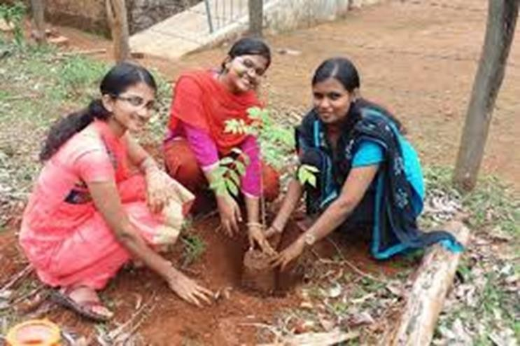

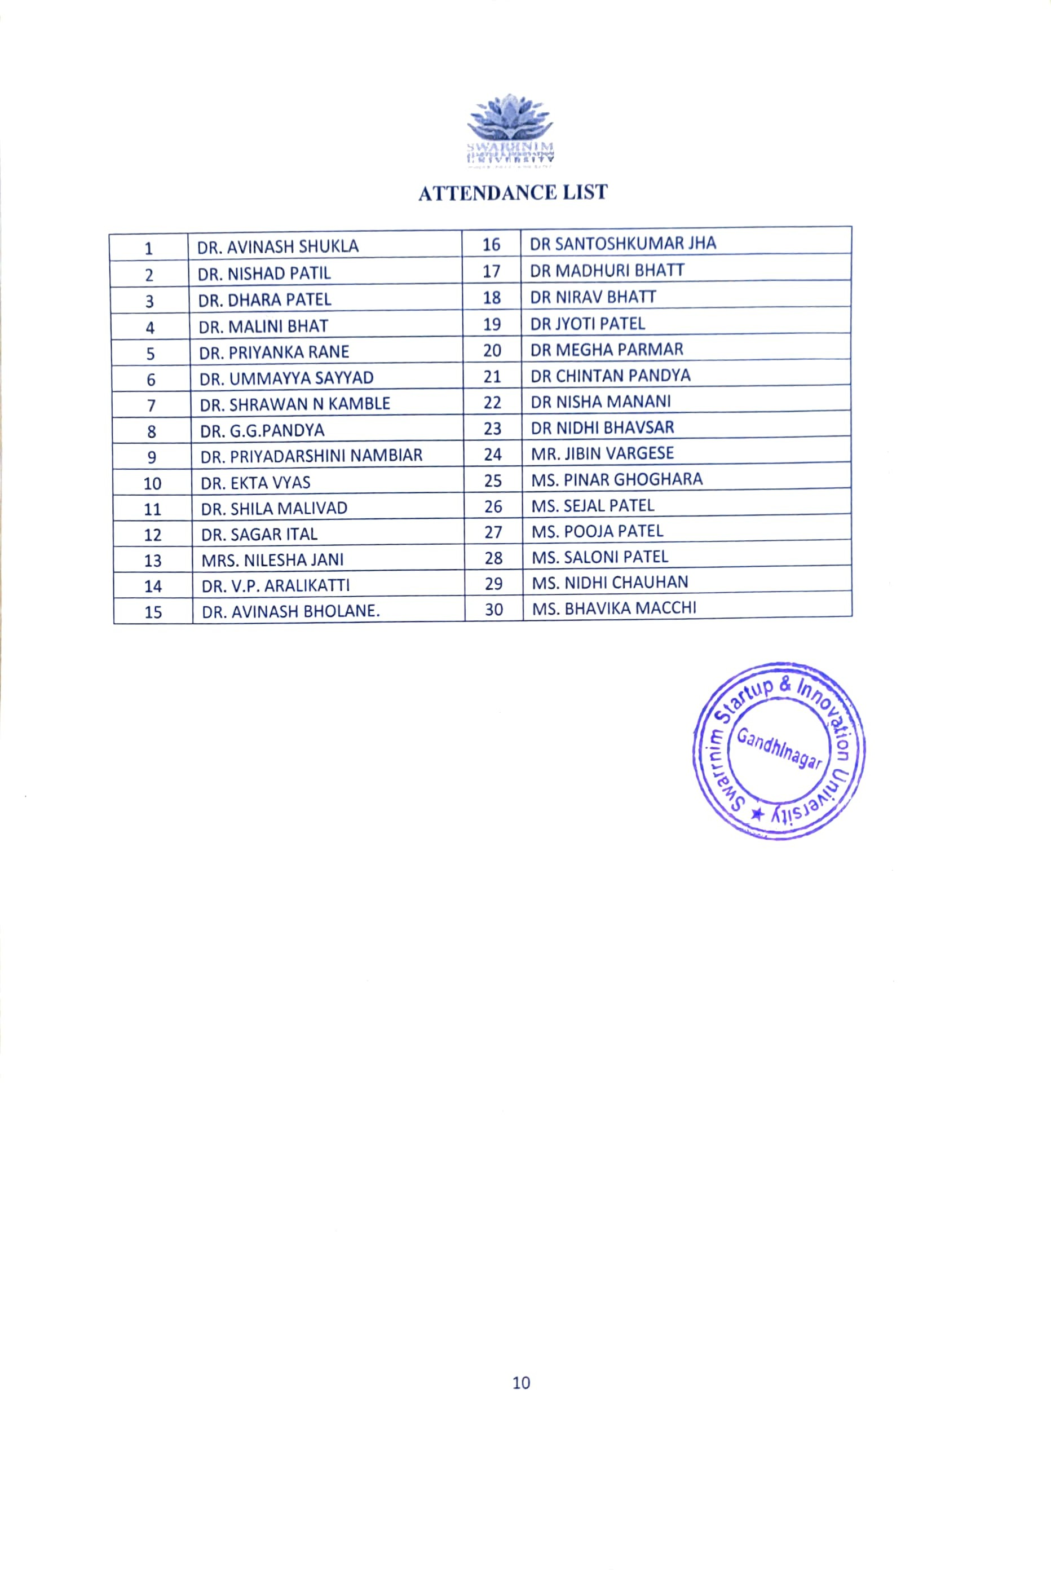

Ref: SWARRNIM/RO/CIRCULAR/2021/22 04.06.2021

CIRCULAR

“WORLD ENVIRONMENT DAY CELEBRATION -TREE PLANTATION DAY”

Swarrnim Startup & Innovation University is organizing Tree plantation drive on date 5th JUNE 2021 in University campus. So all the faculties and students should be present on that day at 10:00 AM. Students are required to register their name to the HOD of Department one day before the event date.

Registrar

Copy to;
- The Vice President, Swarrnim Startup & Innovation University
- The Provost, Swarrnim Startup & Innovation University
- Chief Administrative Officer/Academic Director/Dean/ Principals/Functional Head/HODs, Swarrnim Startup & Innovation University
- Guard File

SWARRNIM STARTUP & INNOVATION UNIVERSITY ACTIVITY REPORT 2021

Institute and Department | SWARRNIM STARTUP AND INNOVATION UNIVERSITY
Activity Name / Event Name | WORLD ENVIRONMENT DAY CELEBRATION -TREE PLANTATION DAY
Date of the event | 05/06/2021
Duration | 3 PM TO 4 PM
Semester | BY TEACHING FACULTY & HOSPITAL STAFF
Expert Details | DR. AMITA PETERS & DR VINEETA N KUMAR
Faculty Coordinator Details (Name, Designation,  Contact Details) | DR. VINEETA N KUMAR ASSITANT PROFESSOR SURGERY  MOB : 8306190804
Number of Participants | Doctors And Hospital Staff And Teaching Staff

Objective of the event:
  - For awareness about saving environment
  - To maintain the eco-system of universities garden

Flow of the event: mention the flow / schedule of the event in detail
Plants were arranged by higher authority and planted in universities garden.

Conclusion:

On 5/06/2020 Swarrnim Startup And Innovation University organised a tree plantation day celebration at university campus. On this day the teaching faculties and the hospital staff and students had enthusiastically participated to make our environment green. We had planted more than 30 plants in the campus.

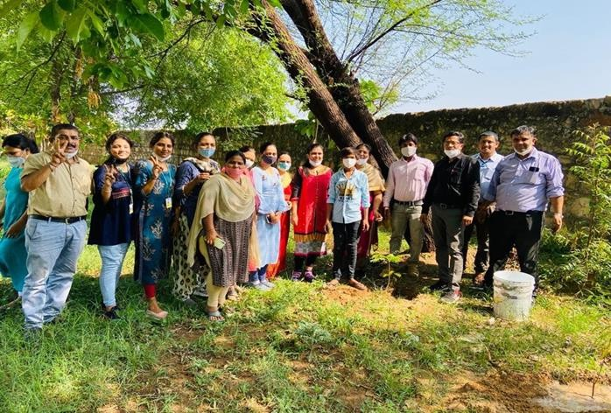

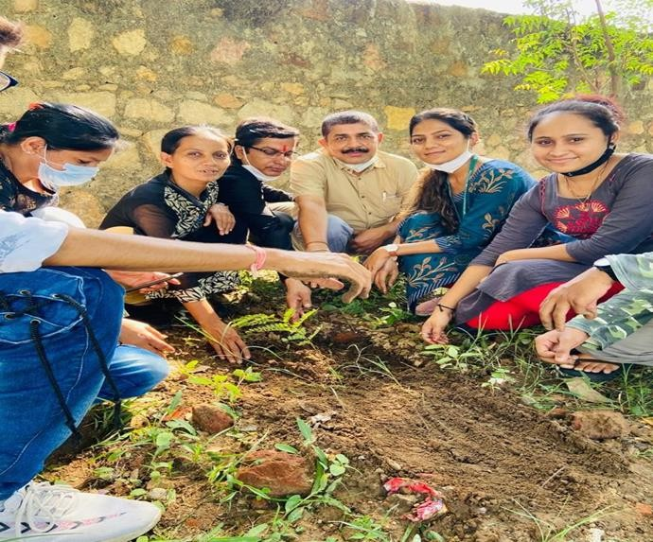

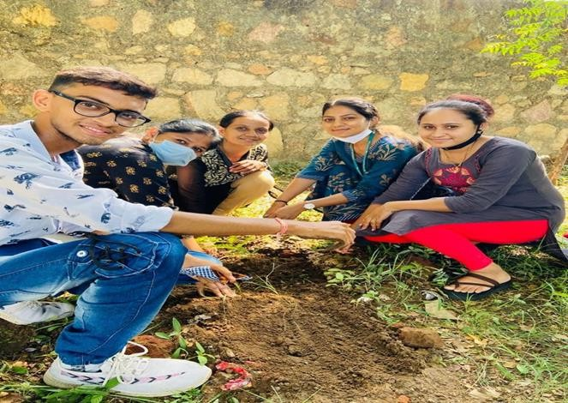

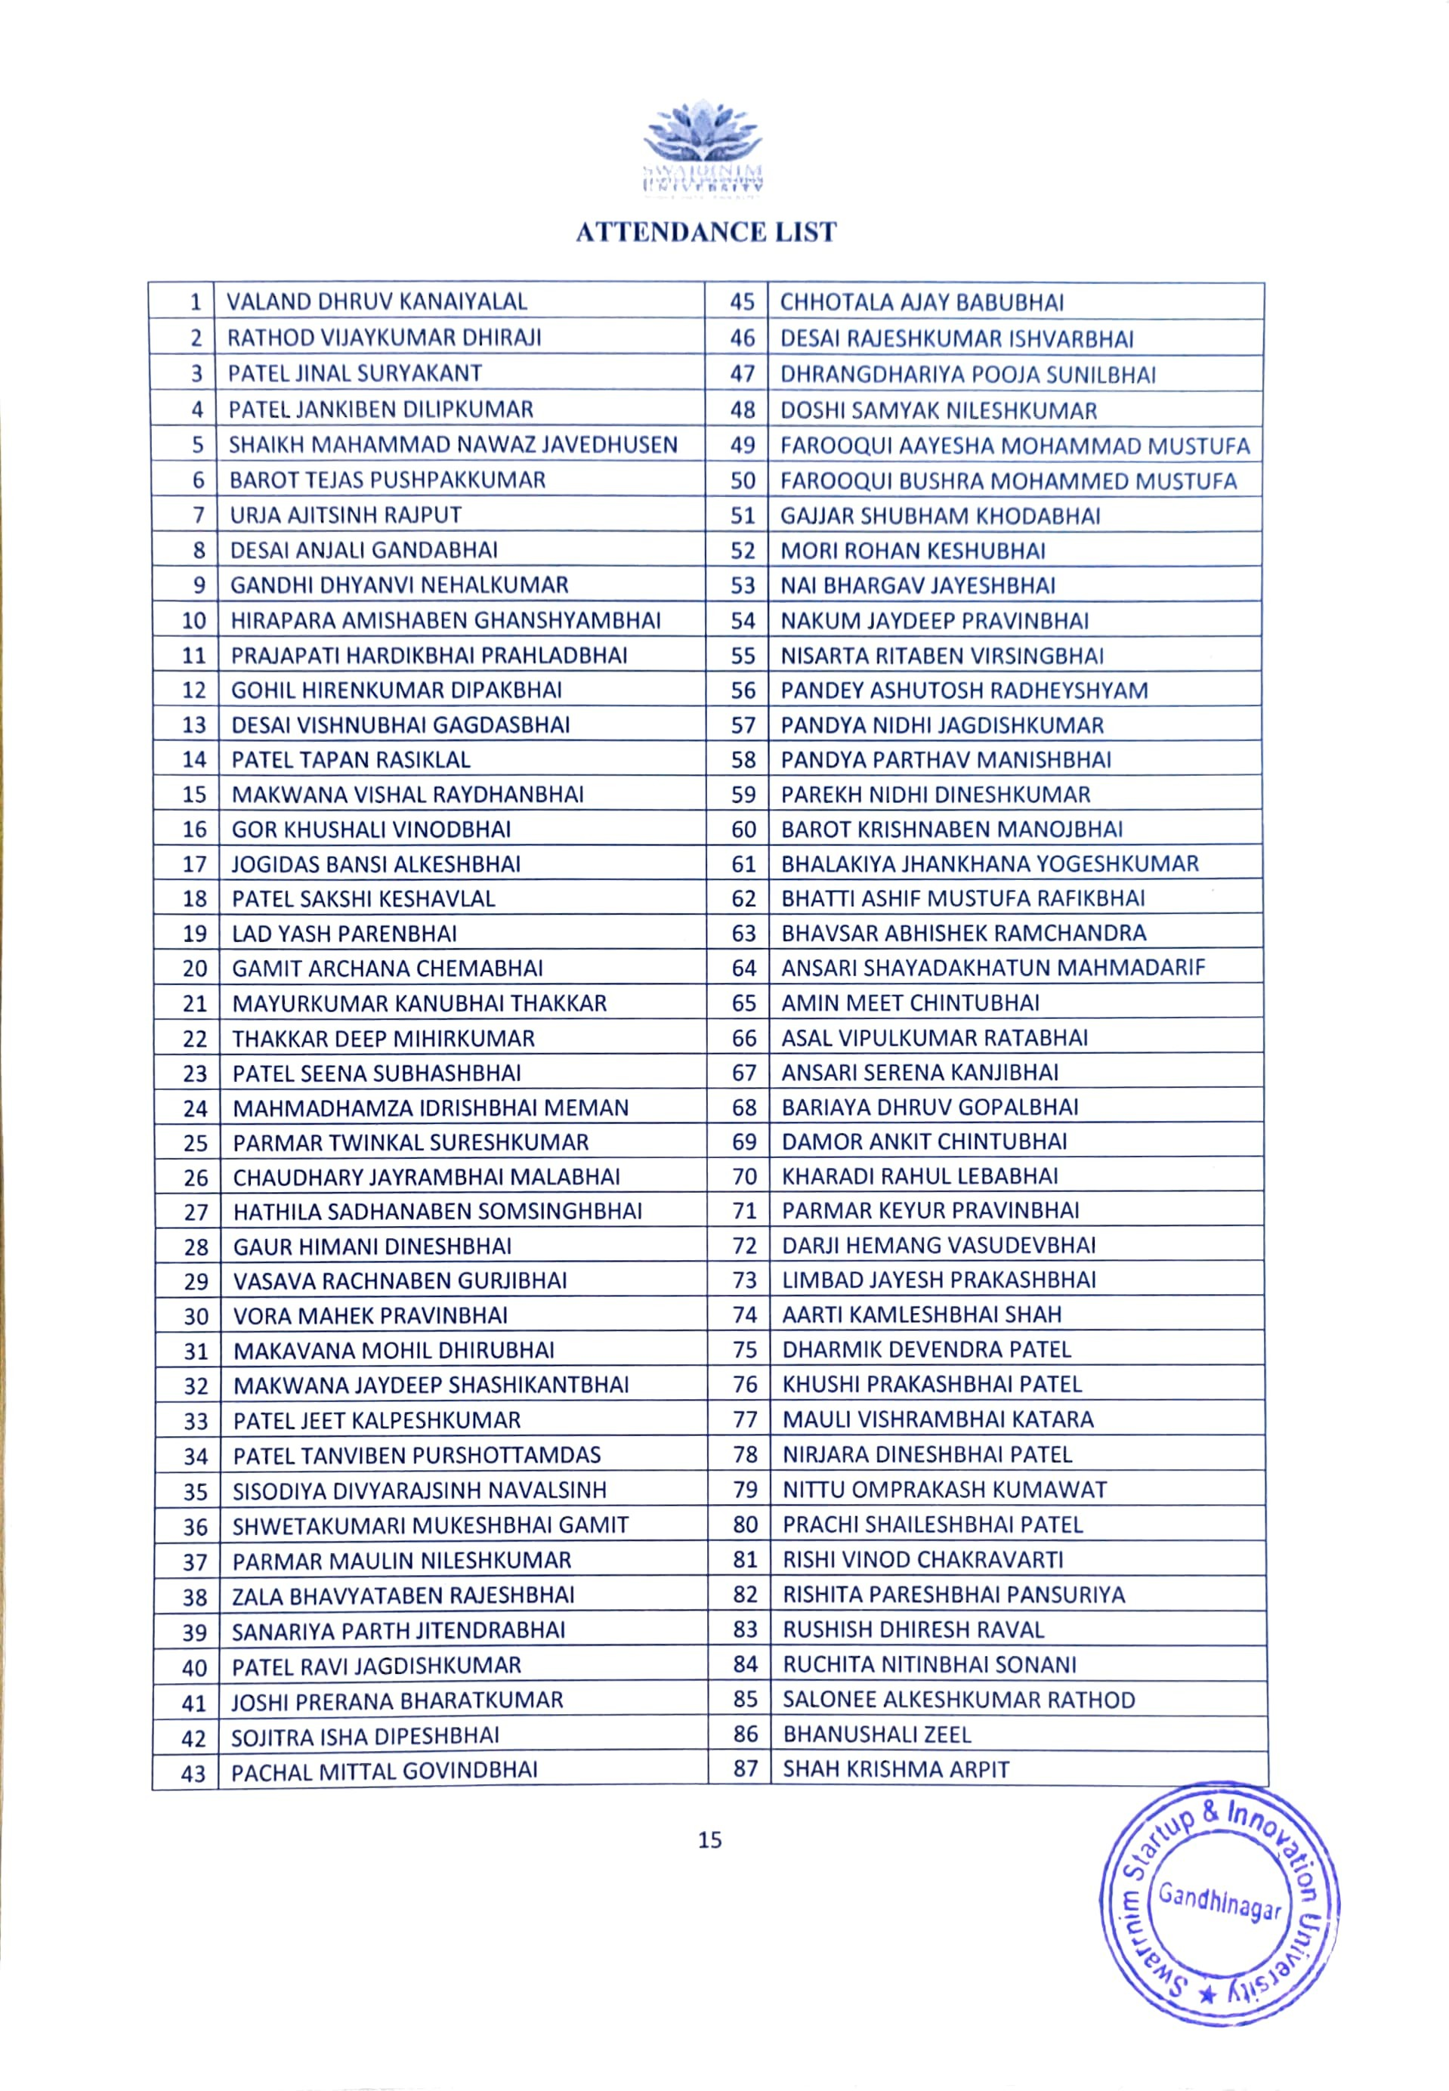



Ref: SWARRNIM/RO/CIRCULAR/2022/29 03.06.2022

CIRCULAR

“WORLD ENVIRONMENT DAY CELEBRATION -TREE PLANTATION DAY”

Swarrnim Startup & Innovation University is organizing Tree plantation drive on date 6th JUNE 2022 in University campus. So all the faculties and students should be present on that day at 10:00 AM. Students are required to register their name to the HOD of Department one day before the event date.

Registrar

Copy to;
    - The Vice President, Swarrnim Startup & Innovation University
    - The Provost, Swarrnim Startup & Innovation University
    - Chief Administrative Officer/Academic Director/Dean/ Principals/Functional Head/HODs, Swarrnim Startup & Innovation University
    - Guard File

SWARRNIM STARTUP & INNOVATION UNIVERSITY ACTIVITY REPORT 2022
INSTITUTE &DEPARTMENT | Swarrnim Startup & Innovation University, Bhoyan Rathod, Gujarat
ACTIVITYNAME/EVENTNAME | 5thJune, World Environment Day Tree Plantation Campaign
MONTH | JUNE-2022
DATEOFTHE EVENT | 06.06.2022
DUTRATION | 10:00am to 11:00am
PLACE | SSIU Campus
ORGANIZING COMMITTEE MEMBER | - Dr. Navin Banarase (Principal)  - Dr Amita V Peters

Objective of the event:
To promote this year theme-
The theme for World Environment Day 2022 was "Only One Earth". The campaign focused on:
- Living sustainably: The campaign encouraged people to live in harmony with nature and shift to a greener lifestyle.
- Transformative changes: The campaign called for transformative changes to policies and choices.
- Raising awareness: The campaign aimed to raise awareness and celebrate environmental action.

Flow of the event:
Event started at 10 AM with HOI’s addressing everyone regarding importance of the plantation and green earth.

Significance/Outcome:
200+ plants were planted in garden; more than 70 students had participated and around 60 members of SSIU were also actively participated.
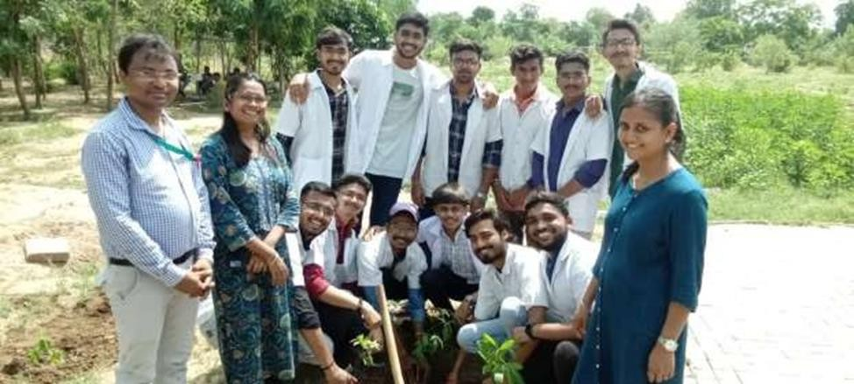
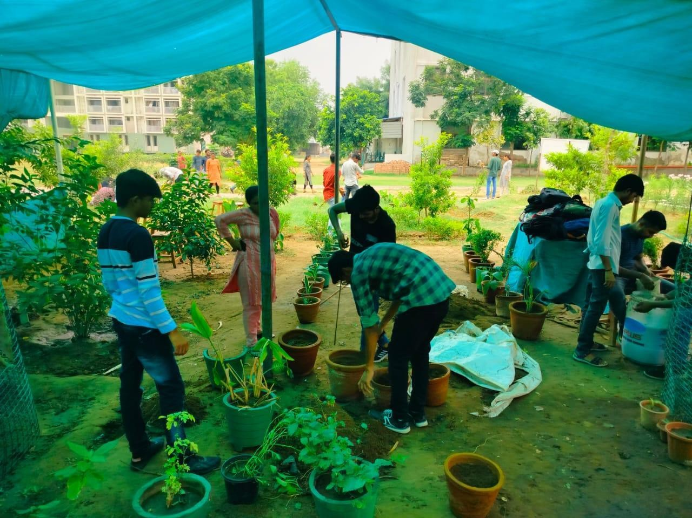

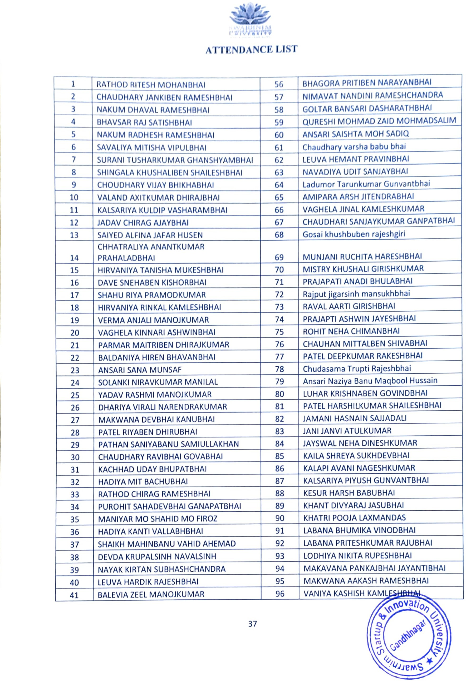



Ref: SWARRNIM/RO/CIRCULAR/2022/39 05.09.2022

CIRCULAR

“Tree Plantation”

Swarrnim Startup & Innovation University is organizing Tree plantation drive on date 6th September, 2022 in University campus. So all the faculties and students should be present on that day at 10:00 AM. Students are required to register their name to the Hod of Department one day before the event date.

Registrar

Copy to;
- The Vice President, Swarrnim Startup & Innovation University
- The Provost, Swarrnim Startup & Innovation University
- Chief Administrative Officer/Academic Director/Dean/ Principals/Functional Head/HODs, Swarrnim Startup & Innovation University
- Guard File

SWARRNIM STARTUP & INNOVATION UNIVERSITY ACTIVITY REPORT 2021

INSTITUTE | Swarrnim Startup & Innovation University
ACTIVITY NAME/ EVENT NAME | Tree Plantation Drive
MONTH | Dec -2021
DATE OF THE EVENT | 8.12.2021
DUTRATION | 9:00 am to 2:30pm
PLACE | SSIU Campus Gandhinagar
Coordinator | Dr. Amita V Peters Dr. Naveen Banarase Darshna Rathod Tanvi Vyas

Objectives of Event:-
To promote this year theme for World Environment Day that was "Ecosystem Restoration.
Tree plantation projects offer practical learning experiences for students, integrating environmental education with hands-on activities. Additionally, these initiatives encourage community involvement and awareness, reinforcing the college’s commitment to social responsibility and environmental advocacy.
Event Details:-
Event started at 10 AM
More than 100 Medicinal plantations were done by Students and teaching and non-teaching staff.
Significance–
Participating in tree plantation provides practical experience that supplements their academic studies. Tree plantation is significant because it enhances environmental health by improving air quality,

supporting biodiversity, and combating climate change, all while offering a range of ecological, economic, and social benefits that contribute to a more sustainable and resilient planet.

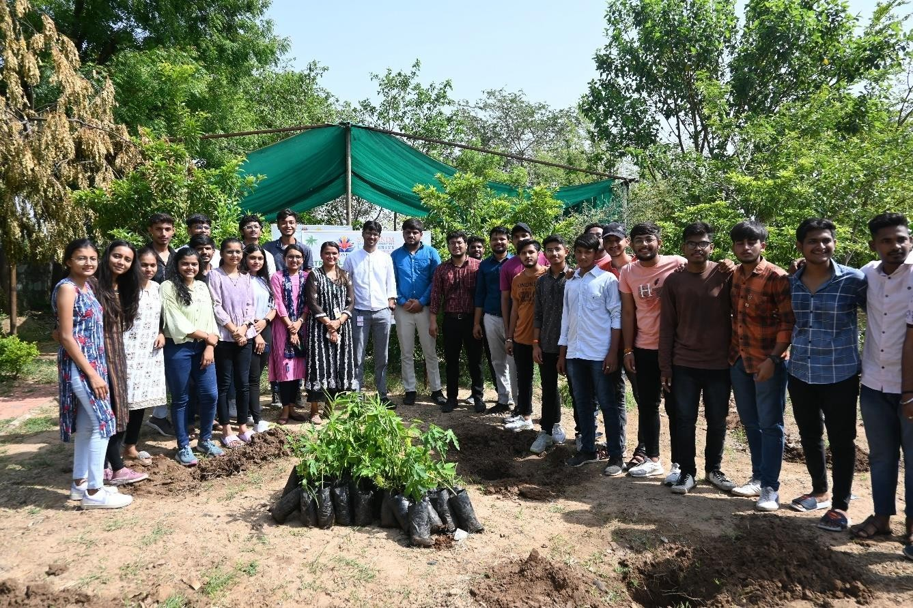
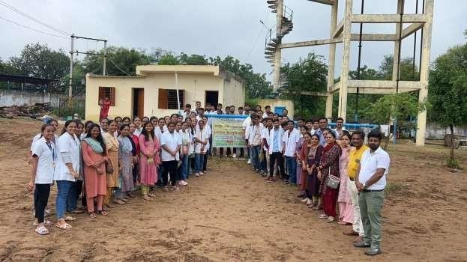

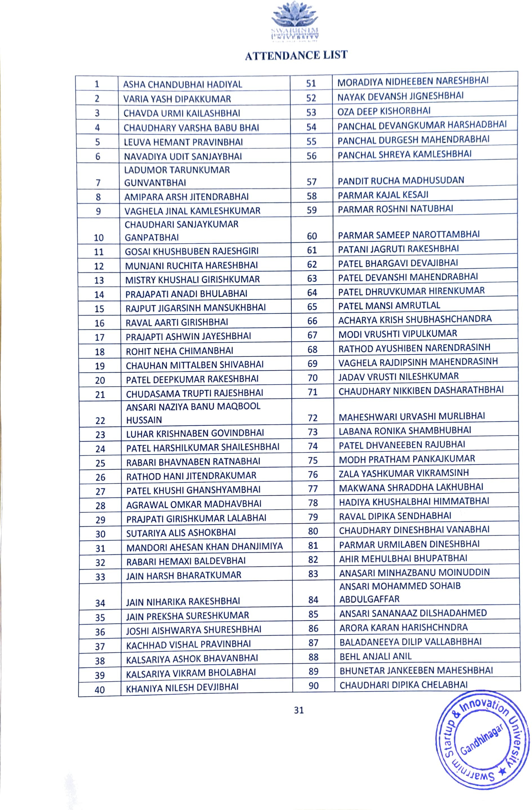



Ref: SWARRNIM/RO/CIRCULAR/2023/32 04.06.2023

CIRCULAR

“Tree Plantation”

Swarrnim startup & innovation university is organizing awareness rally and tree plantation programme on world environment day on date 5th June , 2023 in university campus. so all the faculties and students should be present on that day at 3:00 pm. students are required to register their name to the hod of department one day before the event date.

Registrar

Copy to;
- The Vice President, Swarrnim Startup & Innovation University
- The Provost, Swarrnim Startup & Innovation University
- Chief Administrative Officer/Academic Director/Dean/ Principals/Functional Head/HODs, Swarrnim Startup & Innovation University
- Guard File

SWARNIM STARTUP & INNOVATION UNIVERSITY ACTIVITY REPORT 2023
Institute and Department | SWARRNIM STARTUP AND INNOVATION UNIVERSITY
Activity Name / Event Name | AWARENESS RALLY AND TREE PLANTATION PROGRAMME ON WORLD ENVIRONMENT DAY
Date of the event | 8/09/2023
Duration | 10 AM TO 12:30 PM
Participants | Students & Faculties
Faculty Coordinator Details  (Name, Designation, Contact Details) | Dr Amita Peters  Dr Sourabhi ma’am Dr. Darshana Rathod

Objective of the event:
Every year, World Environment Day is observed globally on June 5. It is celebrated to mark the importance of nature and the environment and it also gives out a message to the global population that nature should not be undervalued and it should not be taken for granted at any cost.
The theme for World Environment Day 2023 is focus on solutions to plastic pollution under the campaign #BeatPlasticPollution.

Flow of Event-

Program started at 10 am and continued till 12:30 pm

Significance/Outcome:
Environmental and Aesthetic Benefits: Plantation on a university campus significantly improves air quality, reduces urban heat, and enhances the overall aesthetic appeal of the environment. By creating green spaces, it supports local biodiversity, helps in soil conservation, and offers cooling effects, contributing to a healthier and more pleasant campus atmosphere.

Educational and Well-being Impact: Plantations provide valuable hands-on learning experiences for students in fields like environmental science, horticulture, and sustainability. Additionally, these green areas offer tranquil spaces that promote relaxation and mental well- being, fostering a positive and engaging atmosphere for both academic and personal growth.

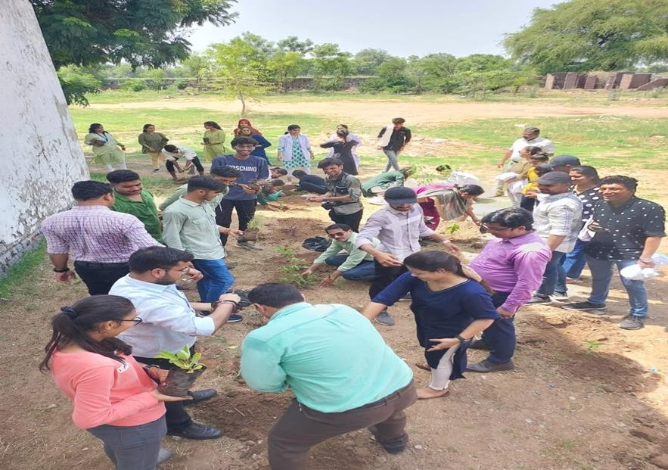
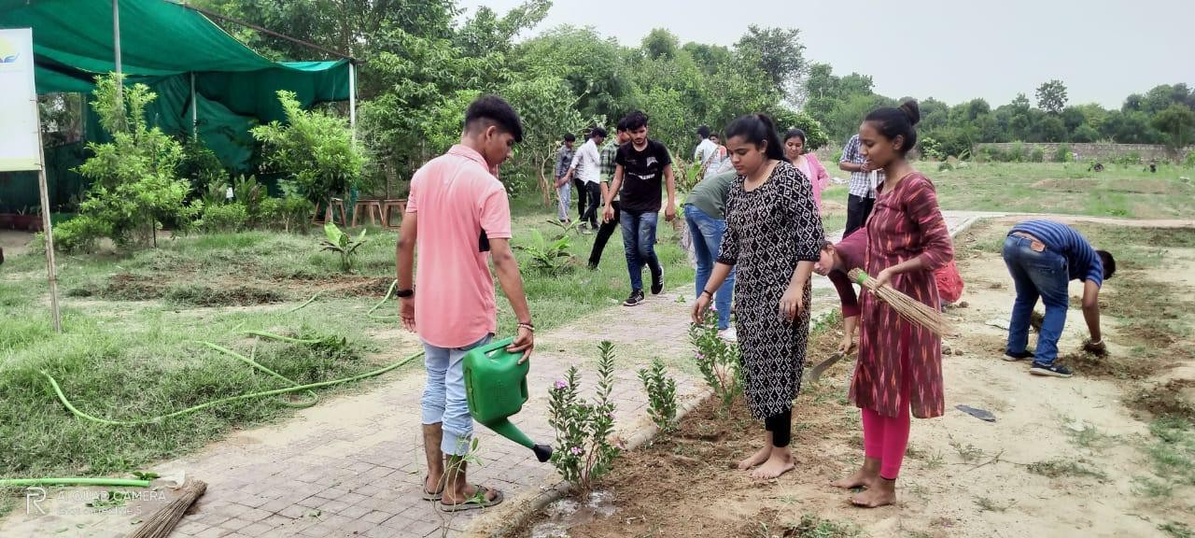

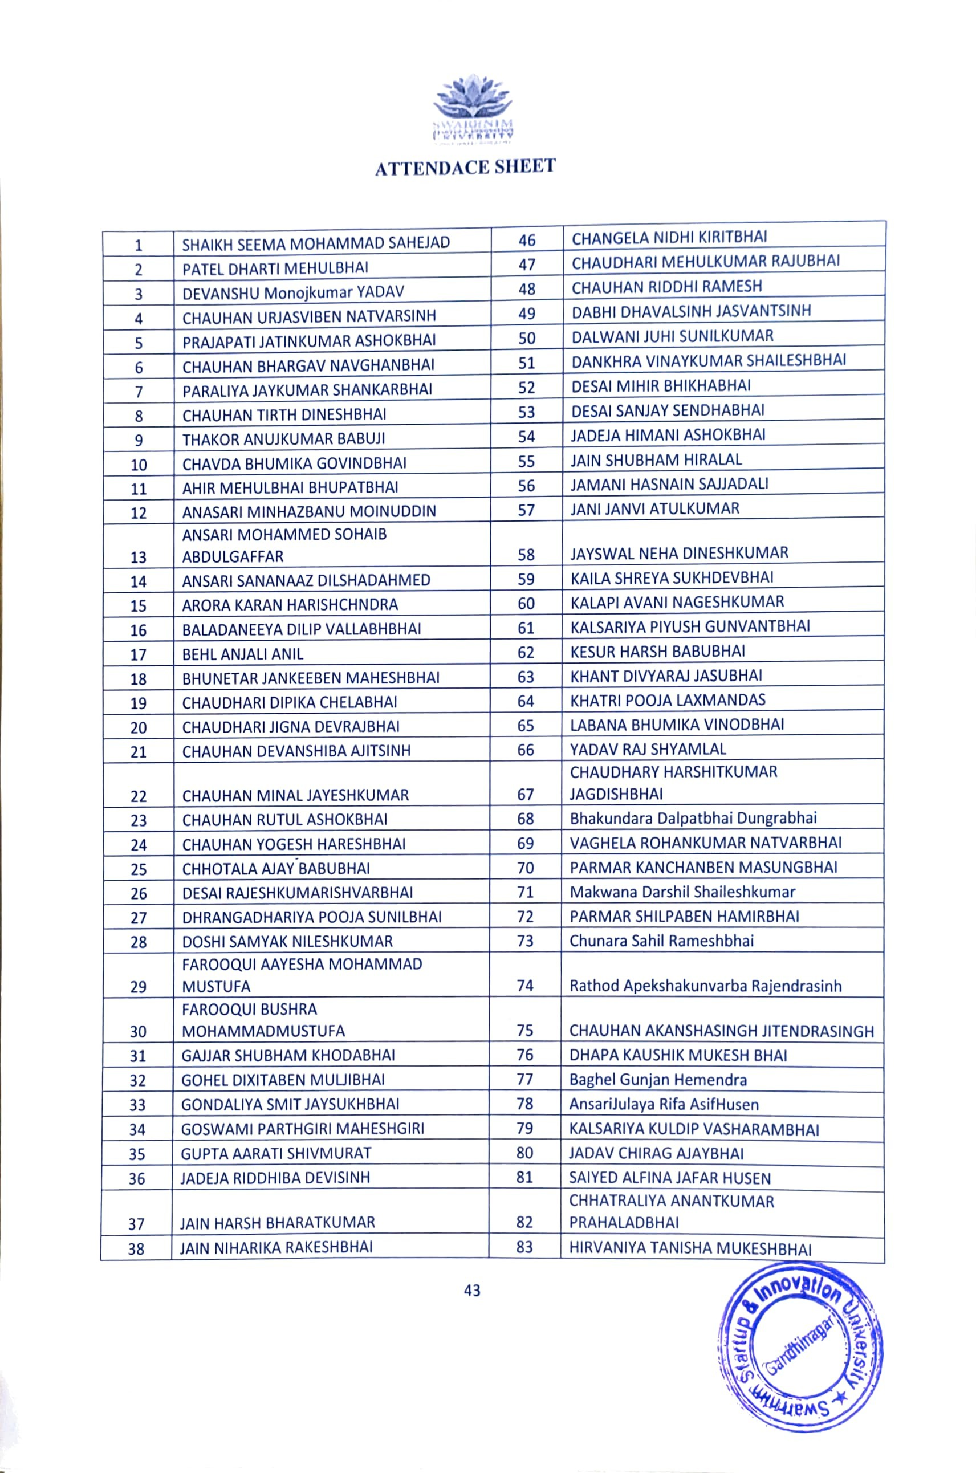



Ref: SWARRNIM/RO/CIRCULAR/2023 05.09.2023

CIRCULAR

“AWARENESS RALLY AND TREE PLANTATION PROGRAMME ON WORLD ENVIRONMENT DAY”

Swarrnim Startup & Innovation University is organizing awareness rally and tree plantation programme on world environment day on date 8th sep, 2023 in university campus so all the faculties and students should be present on that day at 10:00 AM. Students are required to register their name to the Hod of Department one day before the event date.

Registrar

Copy to;
- The Vice President, Swarrnim Startup & Innovation University
- The Provost, Swarrnim Startup & Innovation University
- Chief Administrative Officer/Academic Director/Dean/ Principals/Functional Head/HODs, Swarrnim Startup & Innovation University
- Guard File

SWARRNIM STARTUP & INNOVATION UNIVERSITY ACTIVITY REPORT 2022

INSTITUTE | SWARRNIM STARTUP & INNOVATION UNIVERSITY,  Bhoyan Rathod, Gandhinagar
ACTIVITY NAME/ EVENT NAME | Tree Plantation
MONTH | September -2022
DATE OF THE EVENT | 6.09.2022
DUTRATION | 10:00 am to 12:30pm
PLACE | UNIVERSITY CAMPUS
Coordinator | DR AMITA V PETERS DR NAVEEN BANARSEE DR AMIT VYAS

OBJECTIVES OF EVENT:-
The initiative aimed contribute to environmental sustainability through tree planting.The event also include da door-to-door survey, fostering community engagement and awareness.
The objective of establishing plantations on a university campus is to create a vibrant and sustainable environment that enhances the aesthetic appeal and ecological health of the campus. These plantations aim to improve air quality, provide shade, and support biodiversity, while also serving as living laboratories for students and researchers to study plant sciences, environmental management, and sustainable practices. Additionally, campus plantations foster a sense of community and well-

being among students, faculty, and staff, contributing to a more pleasant and engaging learning and working atmosphere.
EVENT DETAILS:-

Students were reached at Bileshvarpura around 10:15am, Medical officers welcomed students and faculties. After that Deep Pragtya ceremony

SIGNIFICANCE

Plantation on a university campus holds significant value by enriching the campus environment both environmentally and educationally. It enhances the aesthetic and ecological quality of the grounds, promoting cleaner air, reducing urban heat, and supporting local wildlife. Educationally, it provides practical learning opportunities for students in fields such as botany, environmental science, and landscape architecture. Furthermore, well-maintained green spaces foster a positive and tranquil atmosphere, contributing to the well-being and mental health of students and staff, and encouraging a culture of sustainability and environmental stewardship within the academic community.

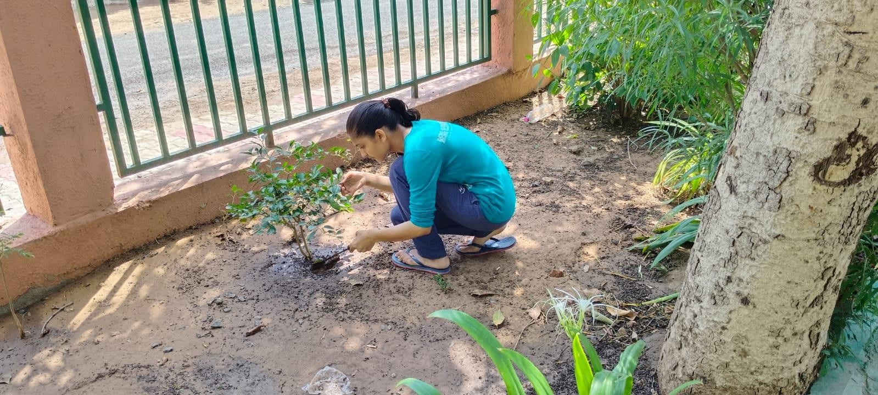

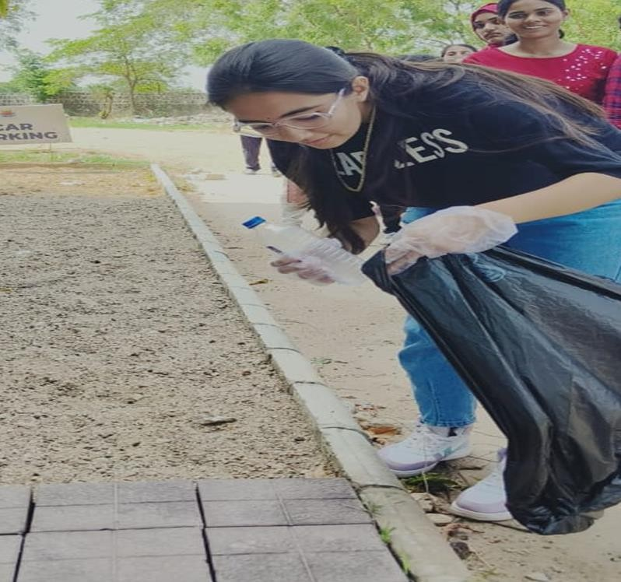

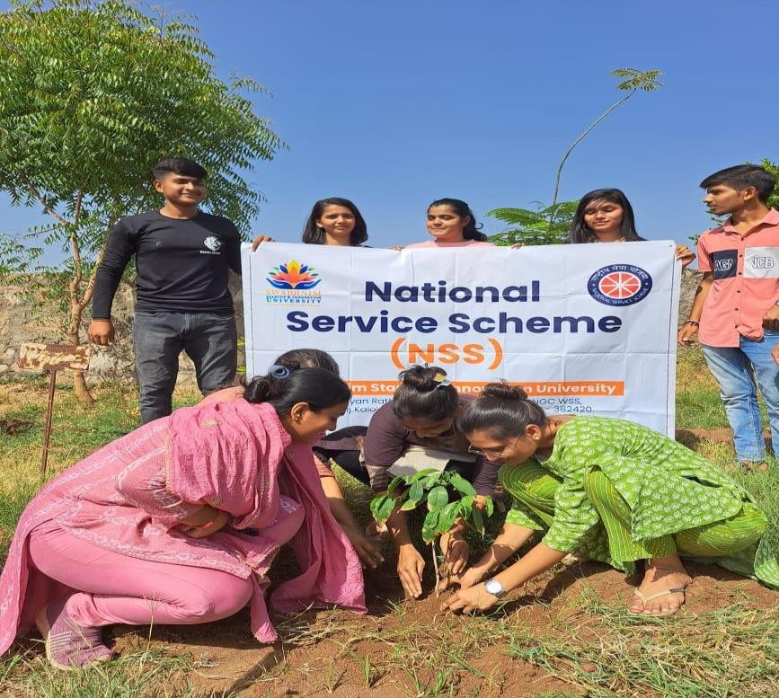

Ref: SWARRNIM/RO/CIRCULAR/2024/28 04.06.2024

CIRCULAR

“Tree Plantation ”

Swarrnim Startup & Innovation University is organizing Tree plantation drive on date 5th JUNE, 2024 in University campus. So all the faculties and students should be present on that day at 10:00 AM. Students are required to register their name to the Hod of Department one day before the event date.

Registrar

Copy to;
- The Vice President, Swarrnim Startup & Innovation University
- The Provost, Swarrnim Startup & Innovation University
- Chief Administrative Officer/Academic Director/Dean/ Principals/Functional Head/HODs, Swarrnim Startup & Innovation University
- Guard File

SWARRNIM STARTUP & INNOVATION UNIVERSITY ACTIVITY REPORT 2024
Institute / Department | SWARRNIM STARTUP AND INNOVATION UNIVERSITY
Activity / Event Name | Tree Plantation Drive
Date of the event | 05/06/2024
Hours | 3 hrs
Location | Saij Village & Swarrnim University campus of
Participant’s Branch/Institutes | SSIU MEMBERS
Participants | Internees & Faculty & 1Hospital staff
Full Name of Principal with designation | Prof. Dr. Amita V. Peter  Principal
Faculty Coordinator Details  (Name, Designation, Contact Details) | Dr. Jaya Srivastava Mrs Parvati Pillai Dr Vishal Shukla  Dr. Khushboo Prajapati

Objective of the event:
- To spread awareness about plantation & it’s benefits .
- To plant tree and make earth greener
- To promote this year theme- OUR LAND OUR FUTURE We are # generation restoration

Flow of Event:
- Gathered for event at 9:30 AM
- Took pledge at 10:20 AM

- Went to Saij Village at 11 AM
- Return at 12:30 PM

Significance/Outcome:
  - Students learnt & shared the importance of plantation.
  - To reinforce and sustain awareness around environmental action.
  - To make a difference by adopting sustainable habits, conserving resources, and promoting eco- friendly practices.
  - To make a better living in future
  - To generate sense of responsibility towards mother nature
Quote / Comment Conclusion
On 5 th June 2024, Students, faculties & hospital staff celebrated world environment Department of Environment & Chemical Engineering also joined in this Plantation drive.
We planted trees in University campus & distributed many medicinal plants more than 160 . Many students and others actively participated in this noble work.

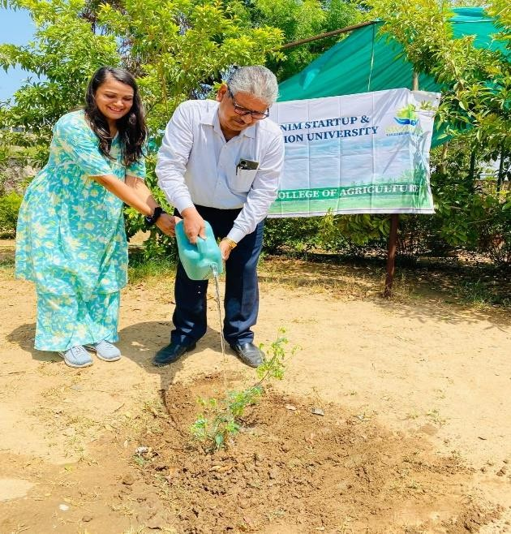
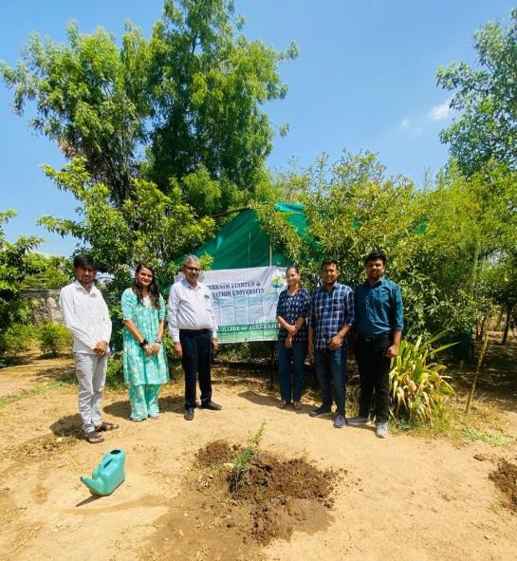

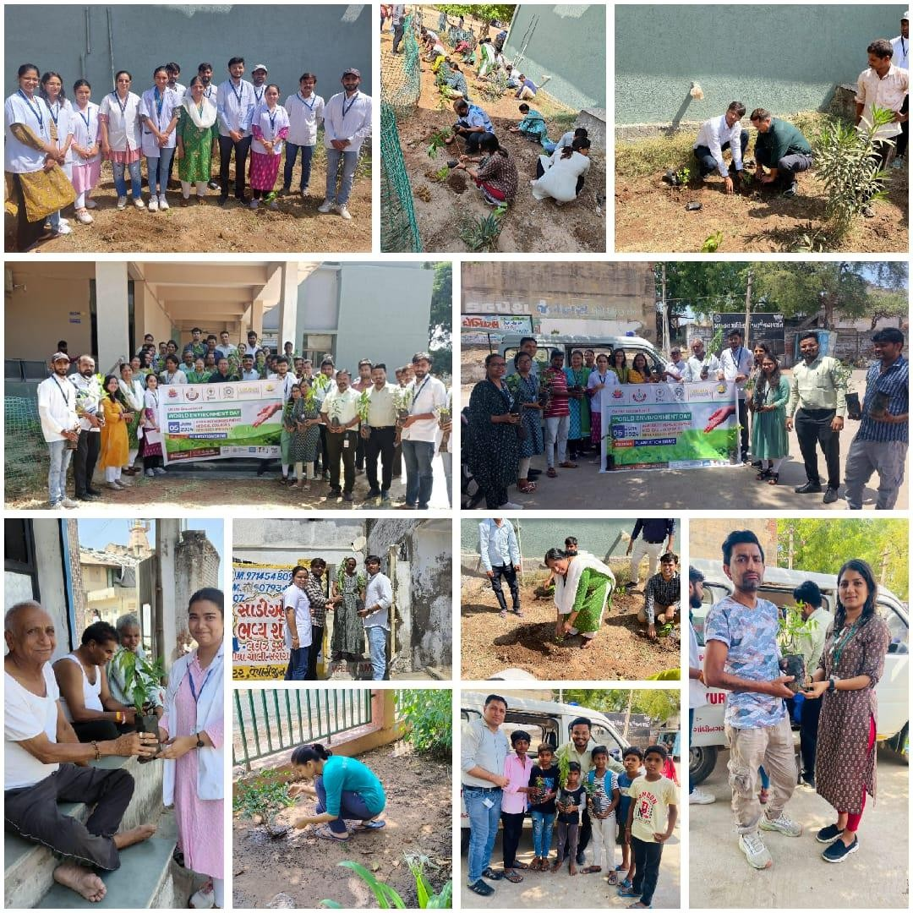

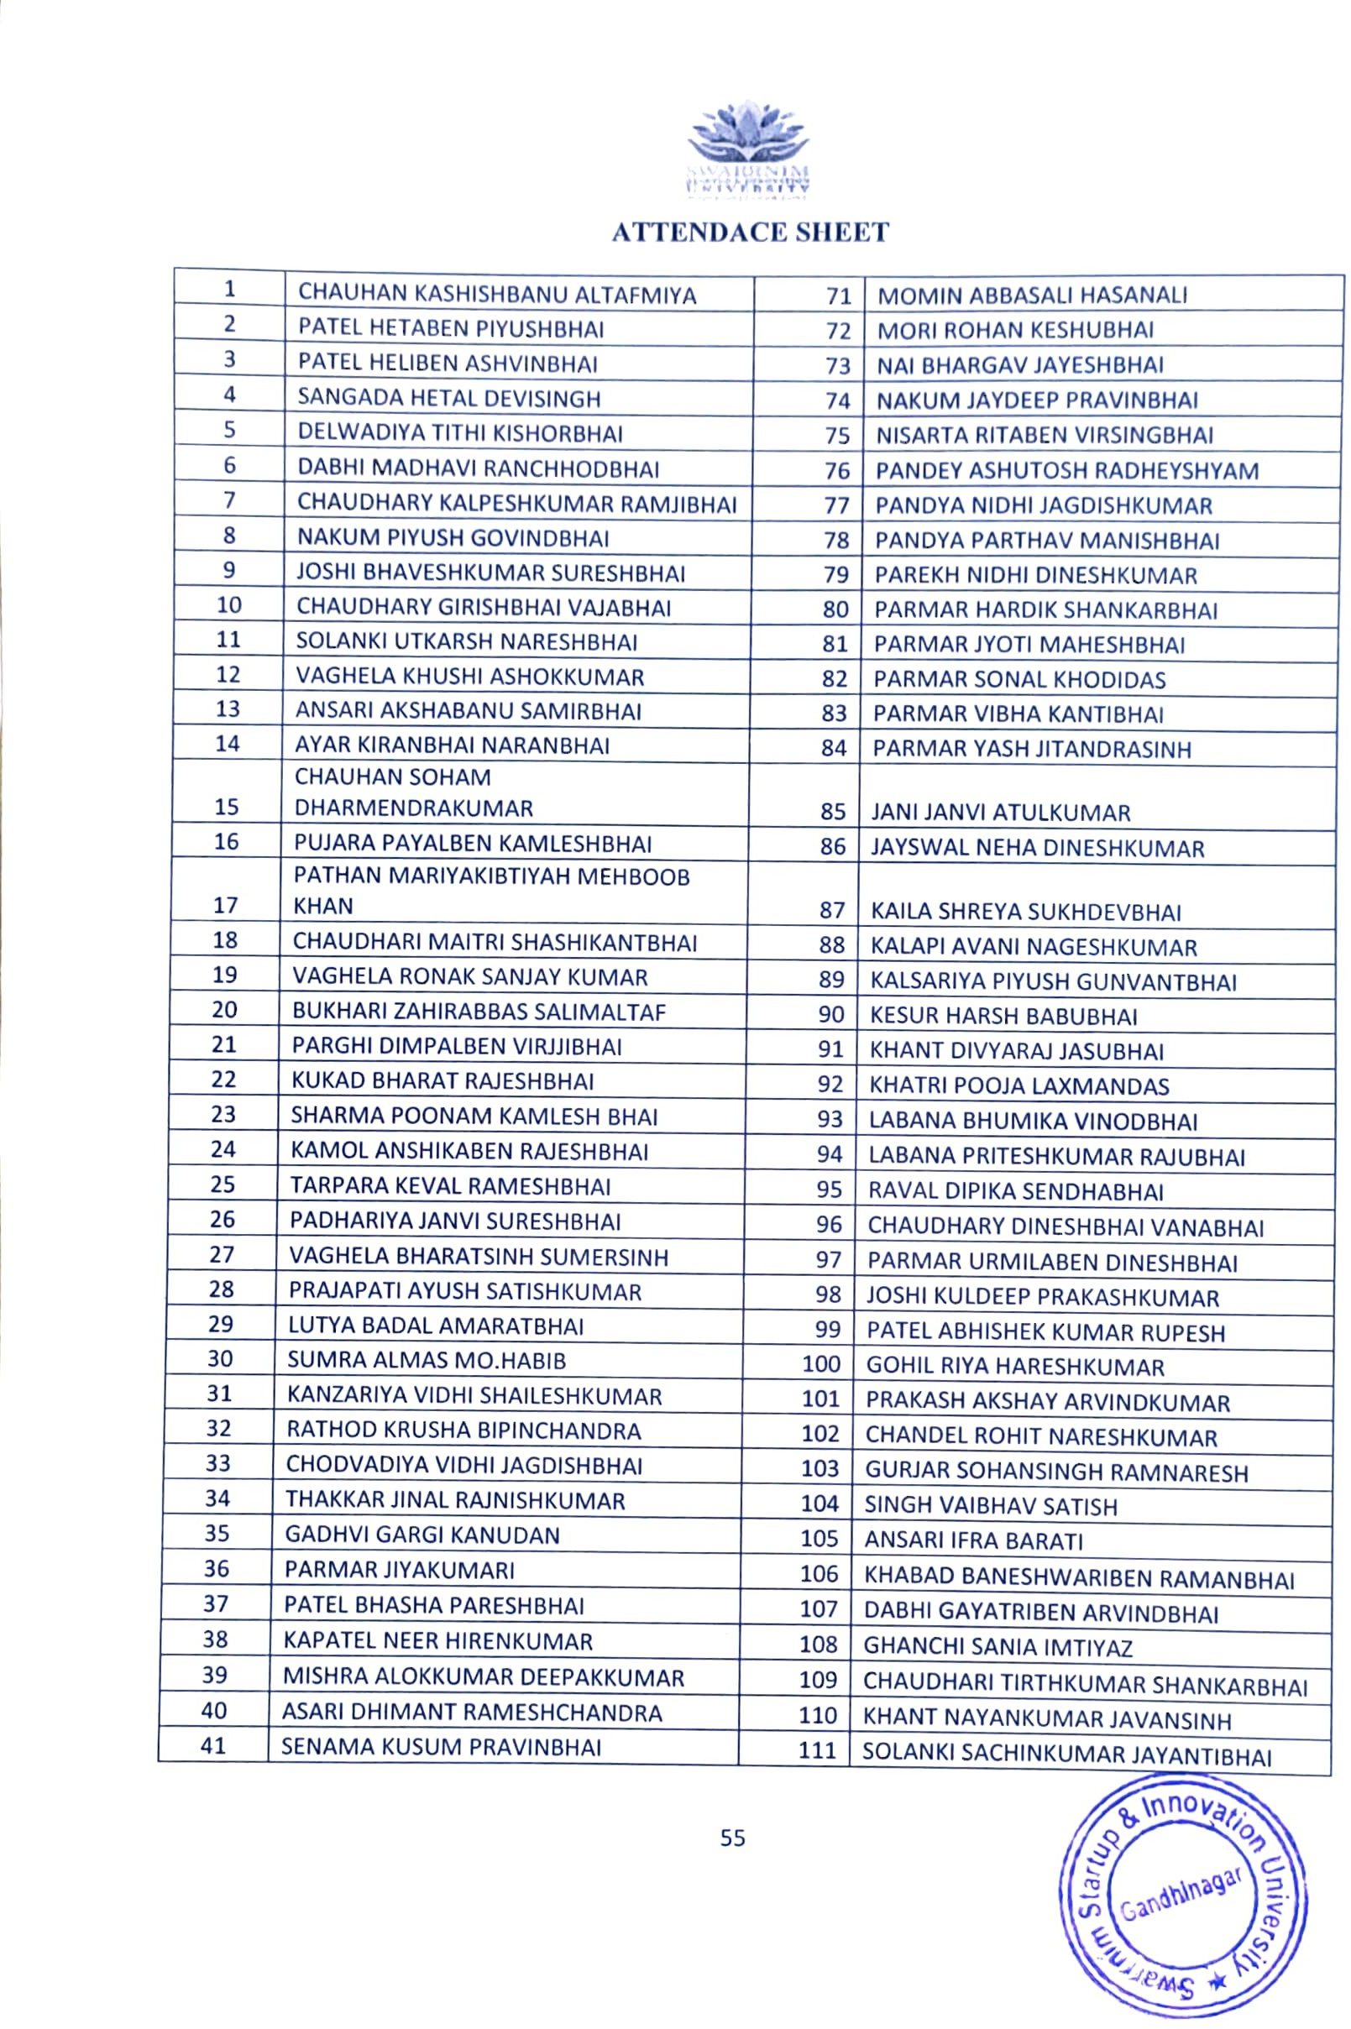

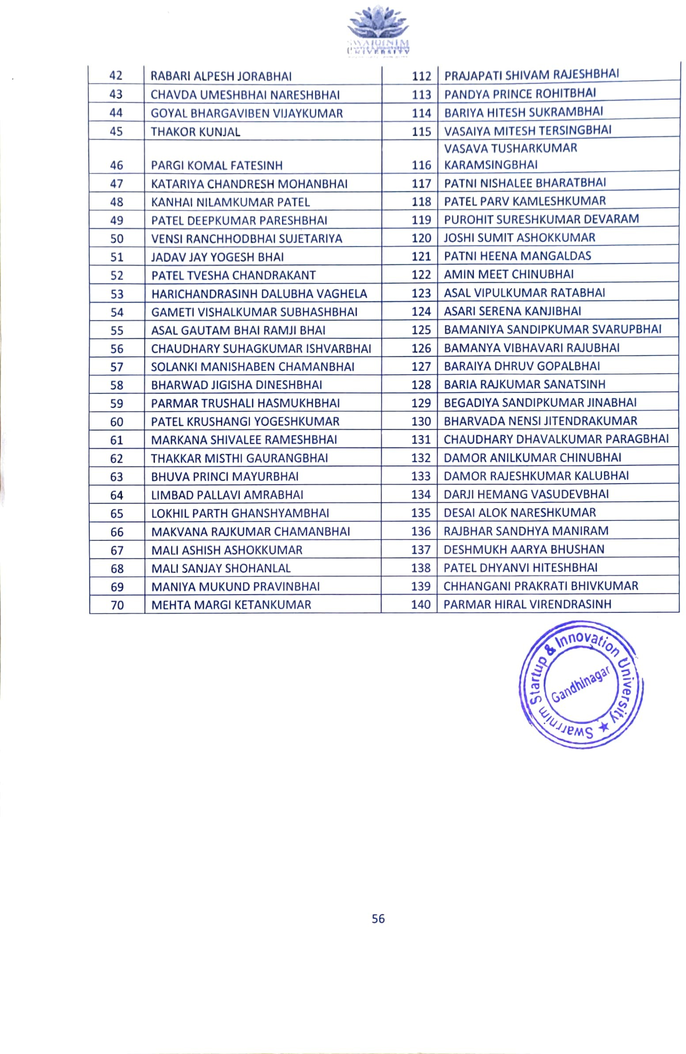

Ref: SWARRNIM/RO/CIRCULAR/2024/32 19.07.2024

CIRCULAR

“Tree Plantation”

Swarrnim Startup & Innovation University is organizing Tree plantation drive on date 22st JULY 2024 in University campus. So all the faculties and students should be present on that day at 2:00 PM. Students are required to register their name to the Hod of Department one day before the event date.

Registrar

Copy to;
- The Vice President, Swarrnim Startup & Innovation University
- The Provost, Swarrnim Startup & Innovation University
- Chief Administrative Officer/Academic Director/Dean/ Principals/Functional Head/HODs, Swarrnim Startup & Innovation University
- Guard File

SWARNIM STARTUP & INNOVATION UNIVERSITY ACTIVITY REPORT 2023
Institute and Department | SWARRNIM STARTUP AND INNOVATION UNIVERSITY
Activity Name / Event Name | AWARENESS RALLY AND TREE PLANTATION PROGRAMME ON WORLD ENVIRONMENT DAY
Date of the event | 8/09/2023
Duration | 10 AM TO 12:30 PM
Participants | Students & Faculties
Faculty Coordinator Details  (Name, Designation, Contact Details) | Dr Amita Peters  Dr Sourabhi ma’am Dr. Darshana Rathod

Objective of the event:
Every year, World Environment Day is observed globally on June 5. It is celebrated to mark the importance of nature and the environment and it also gives out a message to the global population that nature should not be undervalued and it should not be taken for granted at any cost.
The theme for World Environment Day 2023 is focus on solutions to plastic pollution under the campaign #BeatPlasticPollution.

Flow of Event-

Program started at 10 am and continued till 12:30 pm

Significance/Outcome:
Environmental and Aesthetic Benefits: Plantation on a university campus significantly improves air quality, reduces urban heat, and enhances the overall aesthetic appeal of the environment. By creating green spaces, it supports local biodiversity, helps in soil conservation, and offers cooling effects, contributing to a healthier and more pleasant campus
atmosphere.

Educational and Well-being Impact: Plantations provide valuable hands-on learning experiences for students in fields like environmental science, horticulture, and sustainability. Additionally, these green areas offer tranquil spaces that promote relaxation and mental well- being, fostering a positive and engaging atmosphere for both academic and personal growth.

