

**Academic Year**

**2021- 2022**

Date: 19/08/2021

To,

The Provost,

Swarrnim Startup and Innovation University,

Gandhinagar- 322420

Subject: Commencement of Soft Skills and Training Classes

As the Manager of the Training and Placement Department, I am writing to propose an initiative that will significantly enhance our students’ employability and overall professional development. In today’s competitive job market, technical skills alone are not sufficient. Employers increasingly seek candidates with strong skills—such as communication, teamwork, adaptability, and problem-solving abilities. To address this need, I recommend the introduction of Soft skills/ Quant/Verbal-training classes across all departments.

I kindly request your support in implementing this initiative. Let us work together to prepare our

Students’ for success beyond academia.

Thank you for your attention to this matter.

Sincerely,

Mr.Nimesh Dave

Manager,

Training and Placement Department

Swarrnim Startup and Innovation University

|  |  |  |  |  |
| --- | --- | --- | --- | --- |
| **INDEX** | | | |  |
| **SR. No.** |  | **Topic** | **Page No** |  |
| **1** | | **Training Need Analysis** | **1-6** |  | |
| **1.1** | | **Pre-Assessment Analysis** | 1-6 |  | |
| **2** | | **Training Need Initiative** | **7-59** |  | |
| **2.1** | | **Course Plan** | **8-20** |  | |
| 2.1.1 | | Odd Semester Course Plan | 8-14 |  | |
| 2.1.2 | | Even Semester Course Plan | 15-20 |  | |
| **2.2** | | **Time-Table** | **21-26** |  | |
| 2.2.1 | | Odd Semester Time-Table | 21-23 |  | |
| 2.2.2 | | Even Semester Time-Table | 24-26 |  | |
| **2.3** | | **Training Attendance** | **27-34** |  | |
| **2.4** | | **Workshop/Seminar** | **35-62** |  | |
|  | | Workshops Report 1 | 35-39 |  | |
|  | | Workshops Report 2 | 40-44 |  | |
|  | | Workshops Report 3 | 45-50 |  | |
|  | | Workshops Report 4 | 51-55 |  | |
|  | | Workshops Report 5 | 56-59 |  | |
| **3** | | **Post Assessment Analysis** | **60-78** |  | |
| **3.1** | | Slow Learner Chart | 79 |  | |
| **3.2** | | Average Learner Chart | 79 |  | |
| **3.3** | | Fast Learner Chart | 79 |  | |

**1 Training Need Analysis**

* 1. **Pre-Assessment Analysis**













**2 Training Need Initiative**

**5.1.3- Following Capacity development and skills enhancement initiatives**

**are taken by the institution:**

**1. Soft skills**

**2. Language and communication skills**

|  |  |  |  |
| --- | --- | --- | --- |
| **Name of Capacity building and skills enhancement** | **Date of Implementation (DD-MM-YYYY)** | **Number of Students Enrolled** | **Name of the agencies/consultants involved with contact details (If Any)** |
| English Language Class | 20-07-2021 | 228 | T&P (Internal Team) |

**2.1 Course Plan**

**2.1.1 Odd Semester Course Plan**

**ODD Semester -3**

|  |  |  |
| --- | --- | --- |
| **Course Title** | **Course Planner** | **Lectures Hours/Week** |
| VERBAL | Mr. Nimish Dave | 1 |

|  |  |  |  |
| --- | --- | --- | --- |
| **Reference Books (RB)** | | | |
| **Sr No** | **Title** | **Author** | **Publisher Name** |
| RB-1 | Cambridge English Empower A2 Elementary Workbook | Peter Anderson | Cambridge University Press |
| RB-2 | Cambridge English Empower B1+ Intermediate Student | Adrian Doff, Craig Thaine, | Cambridge University Press |
| RB-3 | High School English Grammar and Composition Book | Wren Martin | S.Chand |
| RB-4 | Commonly Mis-Pronounced Words | Lucy | English with Lucy |
| RB-5 | General English for Competitive Examinations | A.P. Bhardwaj | Dorling Kindersley |

|  |  |  |
| --- | --- | --- |
| **Relevant Websites ( RW )** | | |
| **Sr No** | **(Web address) (only if relevant to the course)** | **Salient Features** |
| RW-1 | <https://www.newtondesk.com/english-syllabus/> | English Grammar |
| RW-2 | <https://leverageedu.com/blog/50-difficult-words-with-meanings/> | Difficult Words- Vocabulary |
| RW-3 | <https://exams.recruitmentindia.in/questions/english/idioms-and-phrases/> | Worksheet -Idioms And Phrases |
| RW-4 | <https://exams.recruitmentindia.in/questions/english/spelling-test/> | Spelling Test |
| RW-5 | <https://www.grammarwiz.com/english-grammar-worksheets.html> | Grammar Worksheets |
| RW-6 | <https://owl.purdue.edu/owl_exercises/grammar_exercises/articles/articles_exercise_2.html> | Grammar Worksheets |
| RW-7 | <https://byjus.com/english/grammar-exercises/> | Grammar Worksheets |
| RW-8 | <https://www.englishgrammar.org/> | Grammar Worksheets |
| RW-9 | <https://www.hitbullseye.com/> | Punctuation, |
| RW-10 | <https://onlymyenglish.com/> | Tenses Exercise |

|  |  |  |
| --- | --- | --- |
| **AUDIO VISUALS (AV)** | | |
| **Sr No** | **(Web address) (only if relevant to the course)** | **Salient Features** |
| AV-1 | <https://www.youtube.com/watch?v=0Vr971stX4Y&list=PLsABmu-DQz-6WxP9pGjR9-SsiFJpwMRpE> | English Through Stories- **Red Roses** |
| AV-2 | <https://www.youtube.com/watch?v=X-BxJWWyO0E> | Parts Of Speech |
| AV-3 | <https://www.youtube.com/watch?v=YZ6Zz7SWr04> | Reading Comprehension |
| AV-4 | <https://www.youtube.com/watch?v=MrfwE2EClxs> | Para Jumbled, Sentence Arrangement |
| AV-5 | <https://www.youtube.com/watch?v=xFGUTzBlAP8> | Spot The Error |
| AV-6 | <https://www.youtube.com/watch?v=P3JYuFEIhuo> | Sentence Completion |
| AV-7 | <https://www.youtube.com/watch?v=kZHEcb_h7js> | Active Passive |
| AV-8 | <https://www.youtube.com/watch?v=AqX2dJ4IH5Q> | Degree Of Comparison |
| AV-9 | <https://www.youtube.com/watch?v=MwQdQI7valM> | Tenses |
| AV-10 | <https://www.youtube.com/watch?v=eplQBhE0-Hg> | Direct- Indirect |
| AV-11 | <https://www.youtube.com/watch?v=htYbnd9Pnos> | Tenses |
| AV-12 | <https://www.youtube.com/watch?v=Zjmgo7rh4pw> | Critical Reasoning |
| AV-13 | <https://www.youtube.com/watch?v=dI-6ppn_udc> | Subject Verb Agreement |
| AV-14 | <https://www.youtube.com/watch?v=4H3-2smRJJY> | Conditional Sentence |
| AV-15 | <https://www.youtube.com/watch?v=Fx43zz0XtUs> | Idioms And Phrases |
| AV-16 | <https://www.youtube.com/watch?v=3YPMi1RbSb> | One Word Substitute |

|  |  |  |  |  |  |  |
| --- | --- | --- | --- | --- | --- | --- |
| **Week Number** | **Lecture Number** | **Broad Topic (Sub Topic)** | **Other Readings, Relevant Websites, Audio Visual Aids** | **Lecture Description** | **Learning Outcomes** | **Pedagogical Tool Demonstration/ Case Study / Images / animation / ppt etc. Planned** |
| Week 1 | Lecture 1 | Parts of speech | RB-1,  RB-2  RB-3, RW-1, RW- 4,  AV-2 | Every word in English can be classified as one of eight parts of speech. The term part of speech refers to the role a word plays in a sentence that are nouns, pronouns, verb, adjective, adverb, preposition, conjunction and interjection | Students would be able to learn about the different parts of speech that the words we use every day fall into, and how we use them together to communicate ideas clearly. | Workbook,  practice sheets |
| Week 2 | Lecture 2 |
| Week 3 | Lecture 3 | Articles and punctuation | RB-1,  RB-2  RB-3  RW-4, RW-5 | Basic Concept and use of articles for formation of sentence. Basic concept and importance of use of punctuation. | Student would be able to understand concept and use of articles and punctuation in their sentence formation. | Workbook,  practice sheets |
| Week 4 | Lecture 4 | Tenses | RB-1,  RB-2  RB-3  RW-1,RW-5,  RW-6, AV- 9, AV-11 | They will learn all types of tenses and its’ formation. They will learn how to use them in their day to day life to make better professional communications. | Students will learn all type tenses and its’ sentence formation. Students will be able to express proper meaning | Workbook,  practice sheets |
| Week 5 | Lecture 5 |
| Week 6 | Lecture 6 |
| Week 7 | Lecture 7 | Active – Passive Voice | RB-1,  RB-2  RB-3  RW-5, RW-6  AV-7 | Students will learn basic concept of Active and Passive in verbal, how to use active and passive in their routine life to have effective communication. | Students would be able to use and identify active and passive in their sentences. | Workbook,  practice sheets |
| Week8 | Lecture 8 |
| Week 9 | Lecture 9 |
| Week 10 | Lecture 10 | Degree of Comparison | RB-1,  RB-2  RB-3  RW-1, RW-5, RW-9, AV- 8 | Students will learn degree of comparison as an important tool for finding the errors, sentence corrections and many other topics covered in different examination. | Students will be able to distinguish types of adjective and type of degrees. | Workbook,  practice sheets |

**ODD Semester- 5**

|  |  |  |
| --- | --- | --- |
| **Course Title** | **Course Planner** | **Lectures Hours/Week** |
| VERBAL | Mr. Nimish Dave | 1 |

|  |  |  |  |
| --- | --- | --- | --- |
| **Reference Books ( RB)** | | | |
| **Sr No** | **Title** | **Author** | **Publisher Name** |
| RB-1 | Cambridge English Empower A2 Elementary Workbook | Peter Anderson | Cambridge University press |
| RB-2 | Cambridge English Empower B1+ Intermediate | Craig Thaine, Herbert Puchta | Cambridge University press |
| RB-3 | High School English Grammar and Composition | Wren Martin | S.Chand |
| RB-4 | Commonly Mis-Pronounced Words | Lucy | English with Lucy |
| RB-5 | General English for Competitive Examinations | A.P. Bhardwaj | Dorling Kindersley (india)pvt.Ltd |

|  |  |  |
| --- | --- | --- |
| **Relevant Websites ( RW )** | | |
| **Sr No** | **(Web address) (only if relevant to the course)** | **Salient Features** |
| RW-1 | <https://www.newtondesk.com/english-syllabus/> | English Grammar |
| RW-2 | <https://leverageedu.com/blog/50-difficult-words-with-meanings/> | Difficult words- vocabulary |
| RW-3 | <https://exams.recruitmentindia.in/questions/english/idioms-and-phrases/> | Idioms and Phrases |
| RW-4 | <https://exams.recruitmentindia.in/questions/english/spelling-test/> | spelling test |
| RW-5 | <https://www.grammarwiz.com/english-grammar-worksheets.html> | grammar worksheets |
| RW-6 | <https://owl.purdue.edu/owl_exercises/grammar_exercises/articles/articles_exercise_2.html> | grammar worksheets |
| RW-7 | <https://byjus.com/english/grammar-exercises/> | grammar worksheets |
| RW-8 | <https://www.englishgrammar.org/> | grammar worksheets |
| RW-9 | <https://www.hitbullseye.com/> | EXAM tests |
| RW-10 | <https://onlymyenglish.com/> | tenses exercise |

|  |  |  |
| --- | --- | --- |
| **AUDIO VISUALS (AV)** | | |
| **Sr No** | **(Web address) (only if relevant to the course)** | **Salient Features** |
| AV-1 | <https://www.youtube.com/watch?v=0Vr971stX4Y&list=PLsABmu-DQz-6WxP9pGjR9-SsiFJpwMRpE> | english through stories- red roses |
| AV-2 | <https://www.youtube.com/watch?v=X-BxJWWyO0E> | parts of speech |
| AV-3 | <https://www.youtube.com/watch?v=YZ6Zz7SWr04> | reading comprehension |
| AV-4 | <https://www.youtube.com/watch?v=MrfwE2EClxs> | para jumbled, sentence arrangement |
| AV-5 | <https://www.youtube.com/watch?v=xFGUTzBlAP8> | spot the error |
| AV-6 | <https://www.youtube.com/watch?v=P3JYuFEIhuo> | sentence completion |
| AV-7 | <https://www.youtube.com/watch?v=kZHEcb_h7js> | active passive |
| AV-8 | <https://www.youtube.com/watch?v=AqX2dJ4IH5Q> | degree of comparision |
| AV-9 | <https://www.youtube.com/watch?v=MwQdQI7valM> | tenses |
| AV-10 | <https://www.youtube.com/watch?v=eplQBhE0-Hg> | direct- indirect |
| AV-11 | <https://www.youtube.com/watch?v=htYbnd9Pnos> | tenses |
| AV-12 | <https://www.youtube.com/watch?v=Zjmgo7rh4pw> | critical reasoning |
| AV-13 | <https://www.youtube.com/watch?v=dI-6ppn_udc> | Subject verb agreement |
| AV-14 | <https://www.youtube.com/watch?v=4H3-2smRJJY> | conditional sentence |
| AV-15 | <https://www.youtube.com/watch?v=Fx43zz0XtUs> | idioms and phrases |
| AV-16 | <https://www.youtube.com/watch?v=3YPMi1RbSb> | one word substitute |

|  |  |  |  |  |  |  |
| --- | --- | --- | --- | --- | --- | --- |
| **Week Number** | **Lecture Number** | **Broad Topic (Sub Topic)** | **Other Readings, Relevant Websites, Audio Visual Aids** | **Lecture Description** | **Learning Outcomes** | **Pedagogical Tool Demonstration/ Case Study / Images / animation / ppt etc. Planned** |
| Week 1 | Lecture 1 | Complete the Sentence | RB-3, RB-4, RB-5, RW- 1, RW-4, AV-6 | Students will learn that is a common test in most competitive exams. They will learn the strategy to solve it. | They will be able to solve complete the sentences segment in all competitive and placement related exams | Work book, Practice sheet |
| Week 2 | Lecture 2 | Sentence arrangement, sentence Correction | RB-3, RB-4, RB-5, RW- 1, RW-4, RW-9, AV-4 | Students will learn how to solve competitive and placement oriented questions based on sentence arrangement and Sentence correction. | Students will be able to identify and solve sentence arrangement and sentence correction segments in all examinations. | Work book, Practice sheet |
| Week 3 | Lecture 3 | Critical Reasoning | RB-3, RB-4, RB-5, RW- 1, RW-4, RW-9, AV-12 | It intends to assess skills in students -in identifying an argument, evaluating statements, reaching at a conclusion and formulating an appropriate course of action. | Students will be able to identify an argument, evaluating statements, reaching at a conclusion to resolve the problem. | Work book, Practice sheet |
| Week 4 | Lecture 4 |
| Week 5 | Lecture 5 | Written communication- e-mail, business letter, cover letter, CV | RB-3, RB-4, RB-5 | Students will learn good written communication that will improves teams, inspires high performance and enhances the workplace culture. | Communication is a two-way process, so they will be able to take notice of other people's verbal and nonverbal signals as well as their own along with written communication. | Work book, Practice sheet |
| Week 6 | Lecture 6 |
| Week 7 | Lecture 7 |
| Week 8 | Lecture 8 | Reading Comprehension | RB-3, RB-4, RB-5, RW- 1, RW-4, RW-9, | Reading Comprehension tests a student on a number of skills, including English comprehension and logical ability, language skills such as reading and vocabulary. They will learn its’ tricks to solve it promptly and quickly. | Speed reading, high concentration and material retention are all linked to Reading Comprehension. Students will be able to do them all simultaneously to solve reading comprehension. | Work book, Practice sheet |
| Week 9 | Lecture 9 |
| Week 10 | Lecture 10 | Mock Test | RB-1, RB-2, RB-3, RB-4, RB-5, RW- 1, RW-4,RW-9,  AV-4, AV-6, AV-12 | Mock tests will help students to be more focused about how to solve it in a better way. They will learn how to be ‘test –ready’. | Students will be able to overcome their fear of examination by practicing them again and again. |  |

**2.1.2 Even Semester Course Plan**

**Even Semester- 4**

|  |  |  |
| --- | --- | --- |
| **Course Title** | **Course Planner** | **Lectures Hours/Week** |
| VERBAL | Mr. Nimish Dave | 1 |

|  |  |  |  |
| --- | --- | --- | --- |
| **Reference Books ( RB)** | | | |
| **Sr No** | **Title** | **Author** | **Publisher Name** |
| RB-1 | Cambridge English Empower A2 Elementary | Peter Anderson | Cambridge University press |
| RB-2 | Cambridge English Empower B1+ Intermediate | Craig Thaine, Herbert Puchta | Cambridge University press |
| RB-3 | High School English Grammar and Composition | Wren Martin | S.Chand |
| RB-4 | Commonly Mispronounced Words | Lucy | English with Lucy |
| RB-5 | General English for Competitive Examinations | A.P. Bhardwaj | Dorling Kindersley pvt. Ltd |

|  |  |  |
| --- | --- | --- |
| **Relevant Websites ( RW )** | | |
| **Sr No** | **(Web address) (only if relevant to the course)** | **Salient Features** |
| RW-1 | <https://www.newtondesk.com/english-syllabus/> | English Grammar |
| RW-2 | <https://leverageedu.com/blog/50-difficult-words-with-meanings/> | Difficult Words- Vocabulary |
| RW-3 | <https://exams.recruitmentindia.in/questions/english/idioms-and-phrases/> | Idioms and Phrases |
| RW-4 | <https://exams.recruitmentindia.in/questions/english/spelling-test/> | Spelling Test |
| RW-5 | <https://www.grammarwiz.com/english-grammar-worksheets.html> | Grammar Worksheets |
| RW-6 | <https://owl.purdue.edu/owl_exercises/grammar_exercises/articles/articles_exercise_2.html> | Grammar Worksheets |
| RW-7 | <https://byjus.com/english/grammar-exercises/> | Grammar Worksheets |
| RW-8 | <https://www.englishgrammar.org/> | Grammar Worksheets |
| RW-9 | <https://www.hitbullseye.com/> | Punctuation |
| RW-10 | <https://onlymyenglish.com/> | Tenses Exercise |

|  |  |  |
| --- | --- | --- |
| **AUDIO VISUALS (AV)** | | |
| **Sr No** | **(Web address) (only if relevant to the course)** | **Salient Features** |
| AV-1 | <https://www.youtube.com/watch?v=0Vr971stX4Y&list=PLsABmu-DQz-6WxP9pGjR9-SsiFJpwMRpE> | English Through Stories- **Red Roses** |
| AV-2 | <https://www.youtube.com/watch?v=X-BxJWWyO0E> | Parts Of Speech |
| AV-3 | <https://www.youtube.com/watch?v=YZ6Zz7SWr04> | Reading Comprehension |
| AV-4 | <https://www.youtube.com/watch?v=MrfwE2EClxs> | Para Jumbled, Sentence Arrangement |
| AV-5 | <https://www.youtube.com/watch?v=xFGUTzBlAP8> | Spot The Error |
| AV-6 | <https://www.youtube.com/watch?v=P3JYuFEIhuo> | Sentence Completion |
| AV-7 | <https://www.youtube.com/watch?v=kZHEcb_h7js> | Active Passive |
| AV-8 | <https://www.youtube.com/watch?v=AqX2dJ4IH5Q> | Degree Of Comparision |
| AV-9 | <https://www.youtube.com/watch?v=MwQdQI7valM> | Tenses |
| AV-10 | <https://www.youtube.com/watch?v=eplQBhE0-Hg> | Direct- Indirect |
| AV-11 | <https://www.youtube.com/watch?v=htYbnd9Pnos> | Tenses |
| AV-12 | <https://www.youtube.com/watch?v=Zjmgo7rh4pw> | Critical Reasoning |
| AV-13 | <https://www.youtube.com/watch?v=dI-6ppn_udc> | Subject Verb Agreement |
| AV-14 | <https://www.youtube.com/watch?v=4H3-2smRJJY> | Conditional Sentence |
| AV-15 | <https://www.youtube.com/watch?v=Fx43zz0XtUs> | Idioms And Phrases |
| AV-16 | <https://www.youtube.com/watch?v=3YPMi1RbSb> | One Word Substitute |

|  |  |  |  |  |  |  |
| --- | --- | --- | --- | --- | --- | --- |
| **Week No.** | **Lecture Number** | **Broad Topic (Sub Topic)** | **Other Readings, Relevant Websites, Audio Visual Aids** | **Lecture Description** | **Learning Outcomes** | **Pedagogical Tool Demonstration/ Case Study / Images / animation / ppt etc. Planned** |
| Week 1 | Lecture 1 | Direct- Indirect Speech | RB-1,  RB-2,  RB-3,  RW-1,  RW-5, RW-6,  RW-8,  AV- 10 | Students will learn to understand the basic concept of direct and indirect speech. Student will know how to use direct - indirect speech. | Students will learn how to read conversations and hoe to interpret indirect speeches. | Practice sheet, workbook |
| Week 2 | Lecture 2 |
| Week 3 | Lecture 3 |
| Week 4 | Lecture 4 | Vocabulary- synonym- antonym, homophones, homonyms, words often confuse etc. | RB-1,  RB-2,  RB-4,  RW-2 | Students will learn how to improve vocabulary in English by getting acquainted to various different words. They will learn how to put them into sentences. | Students will be able to use different new words. They will also be able to solve vocabulary based questions more conveniently. | Practice sheet, workbook |
| Week 5 | Lecture 5 |
| Week 6 | Lecture 6 |
| Week 7 | Lecture 7 | Subject verb agreement  Conditional sentence | RB-1,  RB-2,  RB-3,  RW-1,  RW-5, RW-6,  RW-8,  AV- 13,  AV-14 | Student will understand how to use subject- verb in grammar. They will learn how it is useful in company placement rounds and for competitive exams.. | Students will be able to use conditional sentences in their vocabulary and they will also be able to identify error spotting with the help if it. | Practice sheet, workbook |
| Week 8 | Lecture 8 |
| Week 9 | Lecture 9 | Idioms and Phrases,  One Word Substitute | RB-1,  RB-5,  RW-3,  AV-15,  AV-16 | Students will learn different types of idioms that are used in professional life. They will also learn one word substitute to make their language richer. | The students will be able to use idioms and phrases in their routine and in all types of communications. They will also learn one word substitute as a part of vocabulary learning. | Practice sheet, workbook |
| Week 10 | Lecture 10 |

**EVEN Semester- 6**

|  |  |  |
| --- | --- | --- |
| **Course Title** | **Course Planner** | **Lectures Hours/Week** |
| VERBAL | Mr. Nimish Dave | 1 |

|  |  |  |  |
| --- | --- | --- | --- |
| **Reference Books ( RB)** | | | |
| **Sr No** | **Title** | **Author** | **Publisher Name** |
| RB-1 | Cambridge English Empower A2 Elementary Workbook | Peter Anderson | Cambridge University press |
| RB-2 | Cambridge English Empower B1+ Intermediate | Adrian Doff, Craig Thaine | Cambridge University press |
| RB-3 | High School English Grammar and Composition Book | Wren Martin | S.Chand |
| RB-4 | Commonly Mis-Pronounced Words | Lucy | English with Lucy |
| RB-5 | General English for Competitive Examinations | A.P. Bhardwaj | Dorling Kindersley (india)pvt.Ltd |

|  |  |  |
| --- | --- | --- |
| Relevant Websites ( RW ) | | |
| **Sr No** | **(Web address) (only if relevant to the course)** | **Salient Features** |
| RW-1 | <https://www.newtondesk.com/english-syllabus/> | English Grammar |
| RW-2 | <https://leverageedu.com/blog/50-difficult-words-with-meanings/> | vocabulary, Cloze Test,  Parajumble, sentence arrangement |
| RW-3 | <https://exams.recruitmentindia.in/questions/english/idioms-and-phrases/> | worksheet -idioms and phrases, one word substitute |
| RW-4 | <https://exams.recruitmentindia.in/questions/english/spelling-test/> | spelling test |
| RW-5 | <https://www.grammarwiz.com/english-grammar-worksheets.html> | grammar worksheets |
| RW-6 | <https://owl.purdue.edu/owl_exercises/grammar_exercises/articles/articles_exercise_2.html> | grammar worksheets |
| RW-7 | <https://byjus.com/english/grammar-exercises/> | grammar worksheets |
| RW-8 | <https://www.englishgrammar.org/> | grammar worksheets |
| RW-9 | <https://www.hitbullseye.com/> | Punctuation |
| RW-10 | <https://onlymyenglish.com/> | tenses exercise |

|  |  |  |
| --- | --- | --- |
| **AUDIO VISUALS (AV)** | | |
| **Sr No** | **(Web address) (only if relevant to the course)** | **Salient Features** |
| AV-1 | <https://www.youtube.com/watch?v=0Vr971stX4Y&list=PLsABmu-DQz-6WxP9pGjR9-SsiFJpwMRpE> | English through stories- red roses |
| AV-2 | <https://www.youtube.com/watch?v=X-BxJWWyO0E> | parts of speech |
| AV-3 | <https://www.youtube.com/watch?v=YZ6Zz7SWr04> | reading comprehension |
| AV-4 | <https://www.youtube.com/watch?v=MrfwE2EClxs> | para jumbled, sentence arrangement |
| AV-5 | <https://www.youtube.com/watch?v=xFGUTzBlAP8> | spot the error |
| AV-6 | <https://www.youtube.com/watch?v=P3JYuFEIhuo> | sentence completion |
| AV-7 | <https://www.youtube.com/watch?v=kZHEcb_h7js> | active passive |
| AV-8 | <https://www.youtube.com/watch?v=AqX2dJ4IH5Q> | degree of comparison |
| AV-9 | <https://www.youtube.com/watch?v=MwQdQI7valM> | tenses |
| AV-10 | <https://www.youtube.com/watch?v=eplQBhE0-Hg> | direct- indirect |
| AV-11 | <https://www.youtube.com/watch?v=htYbnd9Pnos> | tenses |
| AV-12 | <https://www.youtube.com/watch?v=Zjmgo7rh4pw> | critical reasoning |
| AV-13 | <https://www.youtube.com/watch?v=dI-6ppn_udc> | Subject verb agreement |
| AV-14 | <https://www.youtube.com/watch?v=4H3-2smRJJY> | conditional sentence |
| AV-15 | <https://www.youtube.com/watch?v=Fx43zz0XtUs> | idioms and phrases |
| AV-16 | <https://www.youtube.com/watch?v=3YPMi1RbSb> | one word substitute |

|  |  |  |  |  |  |  |
| --- | --- | --- | --- | --- | --- | --- |
| **Week Number** | **Lecture Number** | **Broad Topic (Sub Topic)** | **Other Readings, Relevant Websites, Audio Visual Aids** | **Lecture Description** | **Learning Outcomes** | **Pedagogical Tool Demonstration/ Case Study / Images / animation / ppt etc. Planned** |
| Week 1 | Lecture 1 | English Pronunciation- Transcription | RB-4 AV-1 | It will help students to understand actual way to read new words and it’s pronunciation. | They will learn how to pronounce correctly new words. | Exercise sheets, workbook |
| Week 2 | Lecture 2 | Para-Jumble | RB-5,AV-4, RW-2 | Students will learn different approaches to analyze paragraph and will learn how to identify transition words. | Students will be able to identify how to read and how to complete the para-jumbles correctly | Exercise sheets, workbook |
| Week 3 | Lecture 3 |
| Week 4 | Lecture 4 | Find The Error | RB-5  AV-5  RW-2 | Students will learn the importance of error spotting in exams and they will learn tricks to solve it easily. | Students will be able to apply tricks to spot the error/ find the error part for all types of competitive exams | Exercise sheets, workbook |
| Week5 | Lecture 5 |
| Week6 | Lecture 6 | Cloze Test | RB-5, RW-3 | Students will learn how to solve cloze test in no time. They will learn the tricks to solve two major formats of cloze test: fill in the blanks and replacing the word more swiftly and correctly. | They will be able to solve cloze tests more swiftly, they will be able identify both formats to perform the test. | Exercise sheets, workbook |
| Week7 | Lecture 7 |
| Week 8 | Lecture 8 | Mock Test ** | RB-5,  RB-4,AV-1  AV-4,AV-5, RW-2, RW-3 | Students will learn how to be placement ready with all the parameters keeping in mind. They will put all the verbal knowledge into practice by appearing for mock tests. | They will be more confident and prepared for the tests prior to actual company drives. | Exercise sheets, workbook |
| Week 9 | Lecture 9 |
| Week-10 | Lecture 10 |

**Practice Sheet- 1.** [**https://Odd Semester 3**](https://drive.google.com/file/d/1o3HWixXBsMk4Oo0xJOVAk2rew0NG3U5_/view?usp=drive_link)

**2.** [**https://Even Semester4**](https://drive.google.com/file/d/1WFgVB71Oq_CqE9Xwx_zjvM0D4S83MvQo/view?usp=drive_link)

**3. https://ODD Semester5**

**4.** [**https://Even Semester 6**](https://drive.google.com/file/d/1DUcekPphUI571QiKUMknJ3AWoQGc_XiV/view?usp=drive_link)

**2. Time- Table**

**2.2.1 Odd Semester Time-Table**

|  |  |  |  |  |  |  |
| --- | --- | --- | --- | --- | --- | --- |
| **Course: BBA/BCOM/BCA/BSC IT** | | | **Semester : 5** | | **Year : 2021-2022** | |
| **Day/Time** | **Monday** | **Tuesday** | **Wednesday** | **Thursday** | **Friday** | **Saturday** |
| **9:15 - 10:15** |  |  |  |  |  | **Verbal Ability** |
| **10:15 - 11:15** |  |  |  |  |  |  |
| **11:15 - 12:15** |  |  |  |  |  |  |
| **RECESS-12:15 - 1:00** | | | | | | |
| **13:00 - 14:00** |  |  |  |  |  |  |
| **14:00 - 15:00** |  |  |  |  |  |  |
| **15:00 - 16:00** |  |  |  |  |  |  |

|  |  |  |  |  |  |  |
| --- | --- | --- | --- | --- | --- | --- |
| **Course: BBA/BCOM/BCA/BSC IT** | | | **Semester : 3** | | **Year : 2021-2022** | |
| **Day/Time** | **Monday** | **Tuesday** | **Wednesday** | **Thursday** | **Friday** | **Saturday** |
| **9:15 - 10:15** |  |  |  |  |  |  |
| **10:15 - 11:15** |  |  |  |  |  |  |
| **11:15 - 12:15** |  |  |  |  |  | **Verbal Ability** |
| **RECESS-12:15 - 1:00** | | | | | | |
| **13:00 - 14:00** |  |  |  |  |  |  |
| **14:00 - 15:00** |  |  |  |  |  |  |
| **15:00 - 16:00** |  |  |  |  |  |  |

|  |  |  |  |  |  |  |
| --- | --- | --- | --- | --- | --- | --- |
| **Course: Diploma** | | | **Semester : 5** | | **Year : 2021-2022** | |
| **Day/Time** | **Monday** | **Tuesday** | **Wednesday** | **Thursday** | **Friday** | **Saturday** |
| **9:15 - 10:15** |  | **Verbal Ability** |  |  |  |  |
| **10:15 - 11:15** |  |  |  |  |  |  |
| **11:15 - 12:15** |  |  |  |  |  |  |
| **RECESS-12:15 - 1:00** | | | | | | |
| **13:00 - 14:00** |  |  |  |  |  |  |
| **14:00 - 15:00** |  |  |  |  |  |  |
| **15:00 - 16:00** |  |  |  |  |  |  |

|  |  |  |  |  |  |  |
| --- | --- | --- | --- | --- | --- | --- |
| **Course: Diploma** | | | **Semester : 3** | | **Year : 2021-2022** | |
| **Day/Time** | **Monday** | **Tuesday** | **Wednesday** | **Thursday** | **Friday** | **Saturday** |
| **9:15 - 10:15** |  |  |  |  |  |  |
| **10:15 - 11:15** |  |  |  |  |  |  |
| **11:15 - 12:15** |  |  |  |  |  |  |
| **RECESS-12:15 - 1:00** | | | | | | |
| **13:00 - 14:00** |  |  |  |  |  |  |
| **14:00 - 15:00** |  |  |  |  |  |  |
| **15:00 - 16:00** |  | **Verbal Ability** |  |  |  |  |

|  |  |  |  |  |  |  |  |
| --- | --- | --- | --- | --- | --- | --- | --- |
| **Course: MBA/MCA** | | | **Semester : 1** | | | **Year : 2021-2022** | |
| **Day/Time** | **Monday** | **Tuesday** | **Wednesday** | **Thursday** | **Friday** | | **Saturday** |
| **9:15 - 10:15** |  |  |  |  |  | |  |
| **10:15 - 11:15** |  |  |  |  |  | |  |
| **11:15 - 12:15** |  |  |  |  |  | |  |
| **RECESS-12:15 - 1:00** | | | | | | | |
| **13:00 - 14:00** |  |  |  |  |  | |  |
| **14:00 - 15:00** |  |  |  |  |  | | **Verbal Ability** |
| **15:00 - 16:00** |  |  |  |  |  | |  |

|  |  |  |  |  |  |  |  |
| --- | --- | --- | --- | --- | --- | --- | --- |
| **Course: MBA/MCA** | | | **Semester : 3** | | | **Year : 2021-2022** | |
| **Day/Time** | **Monday** | **Tuesday** | **Wednesday** | **Thursday** | **Friday** | | **Saturday** |
| **9:15 - 10:15** |  |  |  |  |  | |  |
| **10:15 - 11:15** |  |  |  |  |  | |  |
| **11:15 - 12:15** |  |  |  |  |  | |  |
| **RECESS-12:15 - 1:00** | | | | | | | |
| **13:00 - 14:00** |  |  |  |  |  | | **Verbal Ability** |
| **14:00 - 15:00** |  |  |  |  |  | |  |
| **15:00 - 16:00** |  |  |  |  |  | |  |

|  |  |  |  |  |  |  |  |
| --- | --- | --- | --- | --- | --- | --- | --- |
| **Course: SIT** | | | **Semester : 3** | | | **Year : 2021-2022** | |
| **Day/Time** | **Monday** | **Tuesday** | **Wednesday** | **Thursday** | **Friday** | | **Saturday** |
| **9:15 - 10:15** |  |  |  |  |  | |  |
| **10:15 - 11:15** |  |  |  |  |  | |  |
| **11:15 - 12:15** |  |  |  |  |  | |  |
| **RECESS-12:15 - 1:00** | | | | | | | |
| **13:00 - 14:00** |  |  |  |  |  | |  |
| **14:00 - 15:00** |  |  |  |  |  | |  |
| **15:00 - 16:00** |  |  |  |  |  | |  |
| **16:00 - 17:00** |  | **Verbal Ability** |  |  |  | |  |

|  |  |  |  |  |  |  |  |
| --- | --- | --- | --- | --- | --- | --- | --- |
| **Course: SIT** | | | **Semester : 5** | | | **Year : 2021-2022** | |
| **Day/Time** | **Monday** | **Tuesday** | **Wednesday** | **Thursday** | **Friday** | | **Saturday** |
| **9:15 - 10:15** |  |  |  |  |  | |  |
| **10:15 - 11:15** |  |  |  |  |  | |  |
| **11:15 - 12:15** |  |  |  |  |  | |  |
| **RECESS-12:15 - 1:00** | | | | | | | |
| **13:00 - 14:00** |  |  |  |  |  | |  |
| **14:00 - 15:00** |  |  |  |  |  | |  |
| **15:00 - 16:00** |  |  |  |  |  | |  |
| **16:00 - 17:00** | **Verbal Ability** |  |  |  |  | |  |

**2.2.2 Department wise Time Table -Even Semester**

|  |  |  |  |  |  |  |
| --- | --- | --- | --- | --- | --- | --- |
| **Course: BBA/BCOM/BCA/BSC IT** | | | **Semester : 4** | | **Year : 2021-2022** | |
| **Day/Time** | **Monday** | **Tuesday** | **Wednesday** | **Thursday** | **Friday** | **Saturday** |
| **9:15 - 10:15** |  |  |  |  |  |  |
| **10:15 - 11:15** |  |  |  |  |  | **Verbal Ability** |
| **11:15 - 12:15** |  |  |  |  |  |  |
| **RECESS-12:15 - 1:00** | | | | | | |
| **13:00 - 14:00** |  |  |  |  |  |  |
| **14:00 - 15:00** |  |  |  |  |  |  |
| **15:00 - 16:00** |  |  |  |  |  |  |

|  |  |  |  |  |  |  |
| --- | --- | --- | --- | --- | --- | --- |
| **Course: BBA/BCOM/BCA/BSC IT** | | | **Semester : 6** | | **Year : 2021-2022** | |
| **Day/Time** | **Monday** | **Tuesday** | **Wednesday** | **Thursday** | **Friday** | **Saturday** |
| **9:15 - 10:15** |  |  |  |  |  | **Verbal Ability** |
| **10:15 - 11:15** |  |  |  |  |  |  |
| **11:15 - 12:15** |  |  |  |  |  |  |
| **RECESS-12:15 - 1:00** | | | | | | |
| **13:00 - 14:00** |  |  |  |  |  |  |
| **14:00 - 15:00** |  |  |  |  |  |  |
| **15:00 - 16:00** |  |  |  |  |  |  |

|  |  |  |  |  |  |  |  |
| --- | --- | --- | --- | --- | --- | --- | --- |
| **Course: SIT** | | | **Semester : 4** | | | **Year : 2021-2022** | |
| **Day/Time** | **Monday** | **Tuesday** | **Wednesday** | **Thursday** | **Friday** | | **Saturday** |
| **9:15 - 10:15** |  |  |  |  |  | |  |
| **10:15 - 11:15** |  |  |  |  |  | |  |
| **11:15 - 12:15** |  |  |  |  |  | |  |
| **RECESS-12:15 - 1:00** | | | | | | | |
| **13:00 - 14:00** |  |  |  |  |  | |  |
| **14:00 - 15:00** |  |  |  |  |  | |  |
| **15:00 - 16:00** |  |  |  |  |  | |  |
| **16:00 - 17:00** |  | **Verbal Ability** |  |  |  | |  |

|  |  |  |  |  |  |  |  |
| --- | --- | --- | --- | --- | --- | --- | --- |
| **Course: SIT** | | | **Semester : 6** | | | **Year : 2021-2022** | |
| **Day/Time** | **Monday** | **Tuesday** | **Wednesday** | **Thursday** | **Friday** | | **Saturday** |
| **9:15 - 10:15** |  |  |  |  |  | |  |
| **10:15 - 11:15** |  |  |  |  |  | |  |
| **11:15 - 12:15** |  |  |  |  |  | |  |
| **RECESS-12:15 - 1:00** | | | | | | | |
| **13:00 - 14:00** |  |  |  |  |  | |  |
| **14:00 - 15:00** |  |  |  |  |  | |  |
| **15:00 - 16:00** |  |  |  |  |  | |  |
| **16:00 - 17:00** | **Verbal Ability** |  |  |  |  | |  |

|  |  |  |  |  |  |  |
| --- | --- | --- | --- | --- | --- | --- |
| **Course: Diploma** | | | **Semester : 4** | | **Year : 2021-2022** | |
| **Day/Time** | **Monday** | **Tuesday** | **Wednesday** | **Thursday** | **Friday** | **Saturday** |
| **9:15 - 10:15** |  |  |  |  |  |  |
| **10:15 - 11:15** |  |  |  |  |  |  |
| **11:15 - 12:15** |  |  |  |  |  |  |
| **RECESS-12:15 - 1:00** | | | | | | |
| **13:00 - 14:00** |  |  |  |  |  |  |
| **14:00 - 15:00** |  |  |  |  |  |  |
| **15:00 - 16:00** |  |  |  |  |  |  |
| **16:00 - 17:00** |  |  |  |  | **Verbal Ability** |  |

|  |  |  |  |  |  |  |
| --- | --- | --- | --- | --- | --- | --- |
| **Course: Diploma** | | | **Semester : 6** | | **Year : 2021-2022** | |
| **Day/Time** | **Monday** | **Tuesday** | **Wednesday** | **Thursday** | **Friday** | **Saturday** |
| **9:15 - 10:15** |  |  |  |  |  |  |
| **10:15 - 11:15** |  |  |  |  |  |  |
| **11:15 - 12:15** |  |  |  |  |  |  |
| **RECESS-12:15 - 1:00** | | | | | | |
| **13:00 - 14:00** |  |  |  |  |  |  |
| **14:00 - 15:00** |  |  |  |  |  |  |
| **15:00 - 16:00** |  |  |  |  |  |  |
| **16:00 - 17:00** |  |  |  | **Verbal Ability** |  |  |

|  |  |  |  |  |  |  |  |
| --- | --- | --- | --- | --- | --- | --- | --- |
| **Course: MBA/MCA** | | | **Semester :2** | | | **Year : 2021-2022** | |
| **Day/Time** | **Monday** | **Tuesday** | **Wednesday** | **Thursday** | **Friday** | | **Saturday** |
| **9:15 - 10:15** |  |  |  |  |  | |  |
| **10:15 - 11:15** |  |  |  |  |  | | **Verbal Ability** |
| **11:15 - 12:15** |  |  |  |  |  | |  |
| **RECESS-12:15 - 1:00** | | | | | | | |
| **13:00 - 14:00** |  |  |  |  |  | |  |
| **14:00 - 15:00** |  |  |  |  |  | |  |

|  |  |  |  |  |  |  |  |
| --- | --- | --- | --- | --- | --- | --- | --- |
| **Course: MBA/MCA** | | | **Semester :4** | | | **Year : 2021-2022** | |
| **Day/Time** | **Monday** | **Tuesday** | **Wednesday** | **Thursday** | **Friday** | | **Saturday** |
| **9:15 - 10:15** |  |  |  |  |  | | **Verbal Ability** |
| **10:15 - 11:15** |  |  |  |  |  | |  |
| **11:15 - 12:15** |  |  |  |  |  | |  |
| **RECESS-12:15 - 1:00** | | | | | | | |
| **13:00 - 14:00** |  |  |  |  |  | |  |
| **14:00 - 15:00** |  |  |  |  |  | |  |
| **15:00 - 16:00** |  |  |  |  |  | |  |

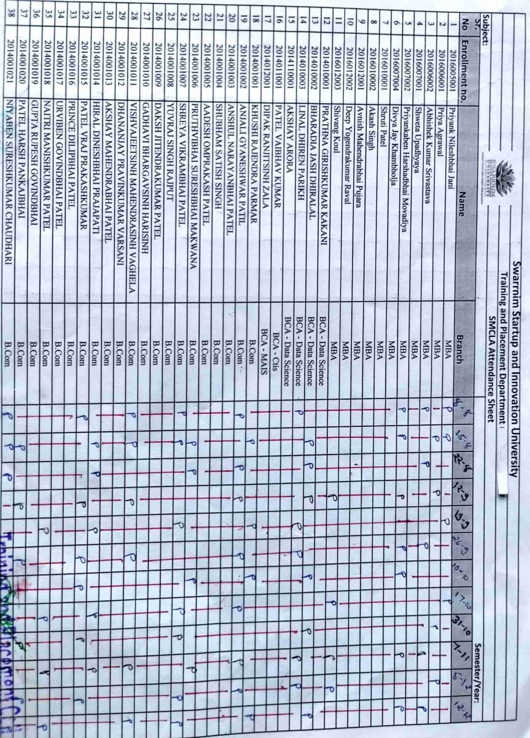**2.3 Training Attendance**

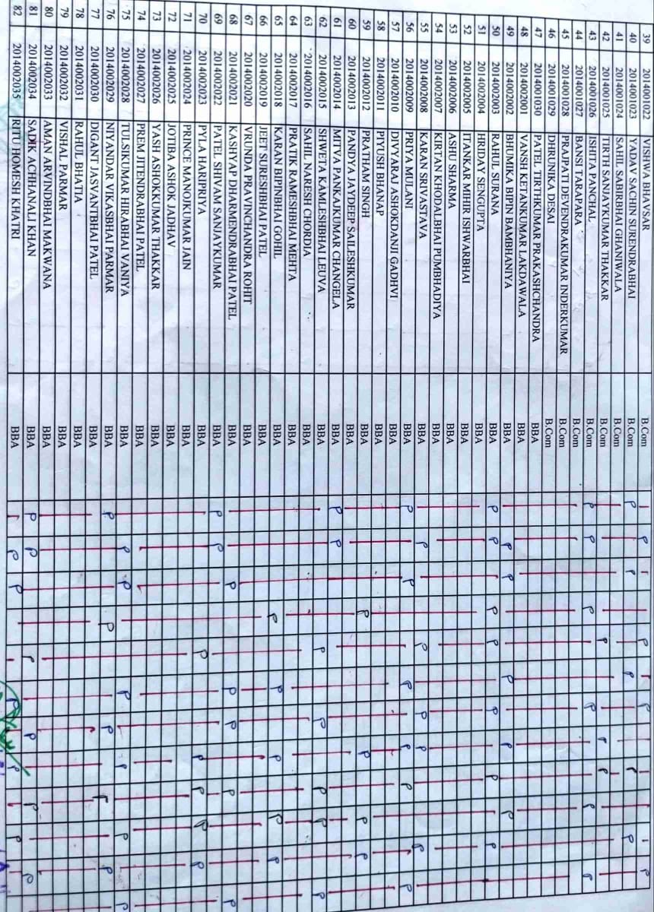

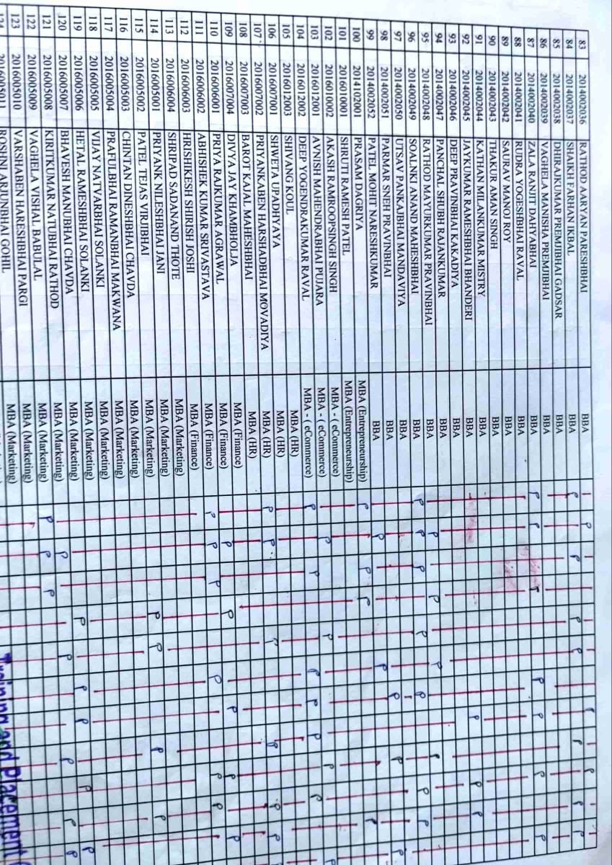

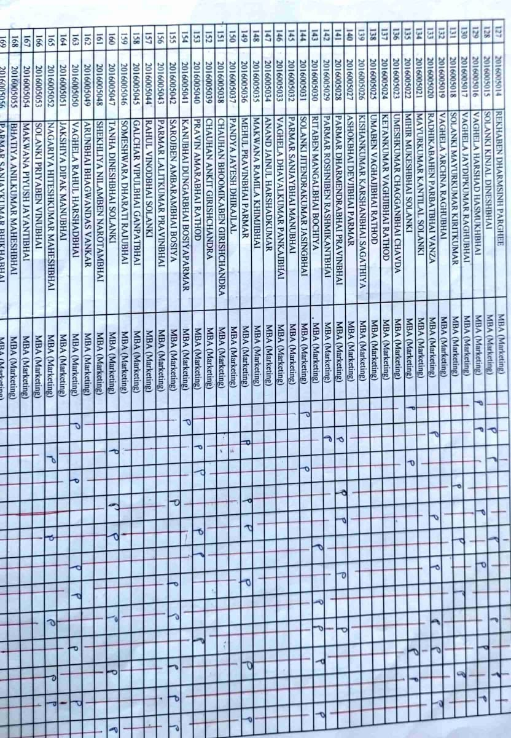

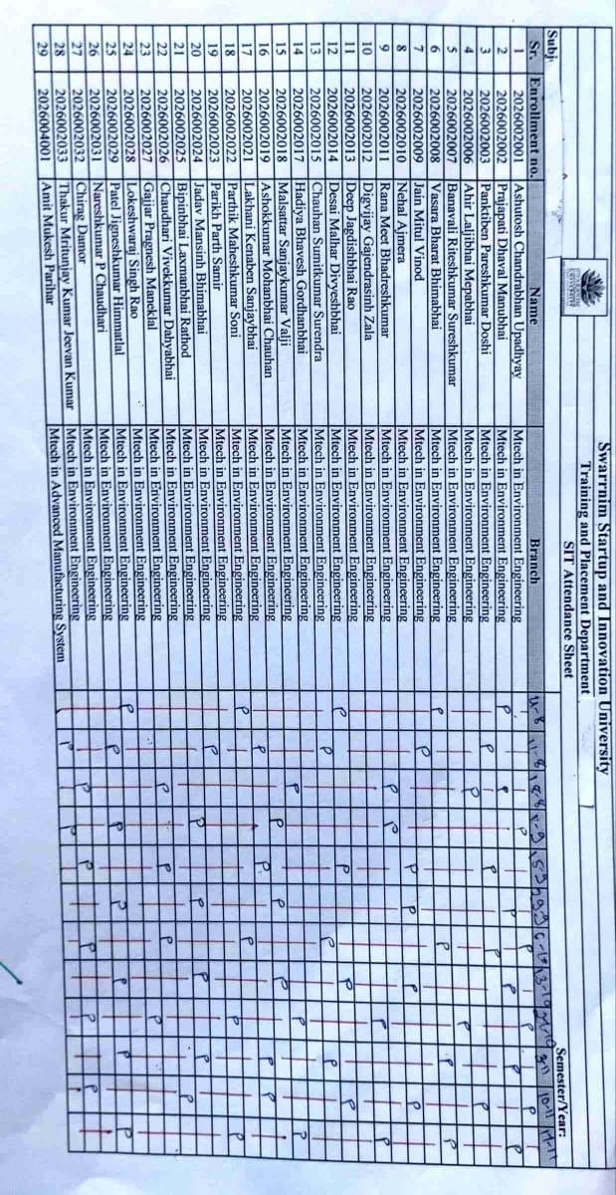

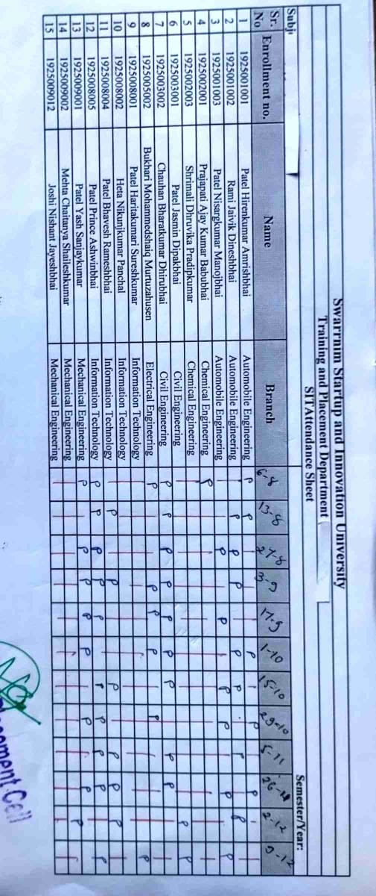

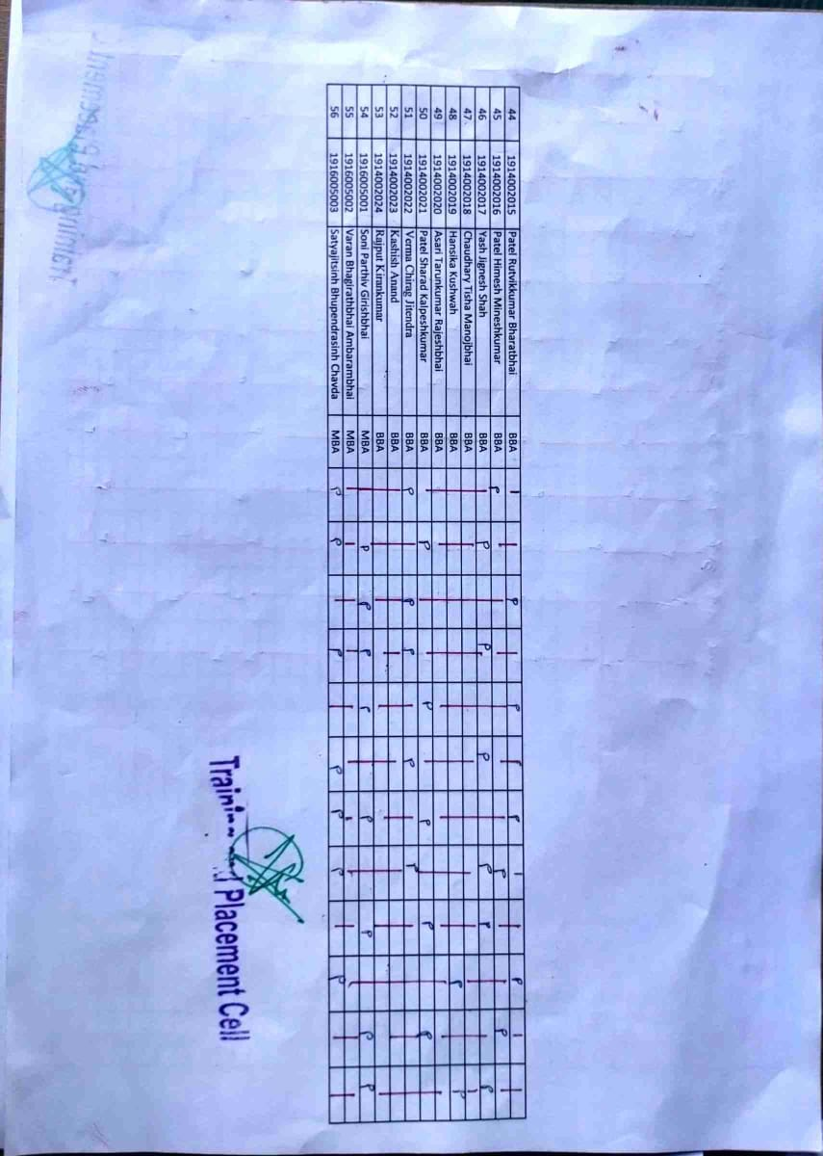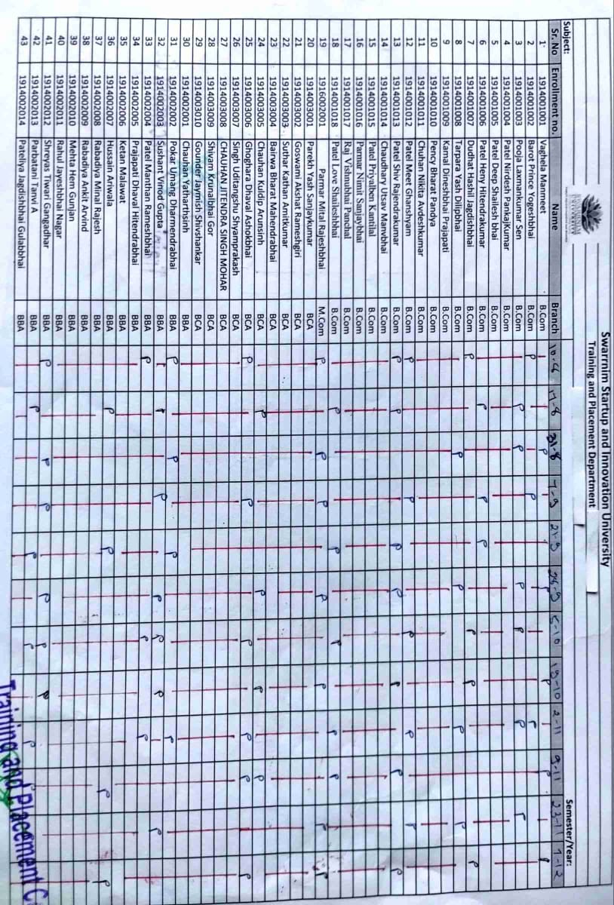

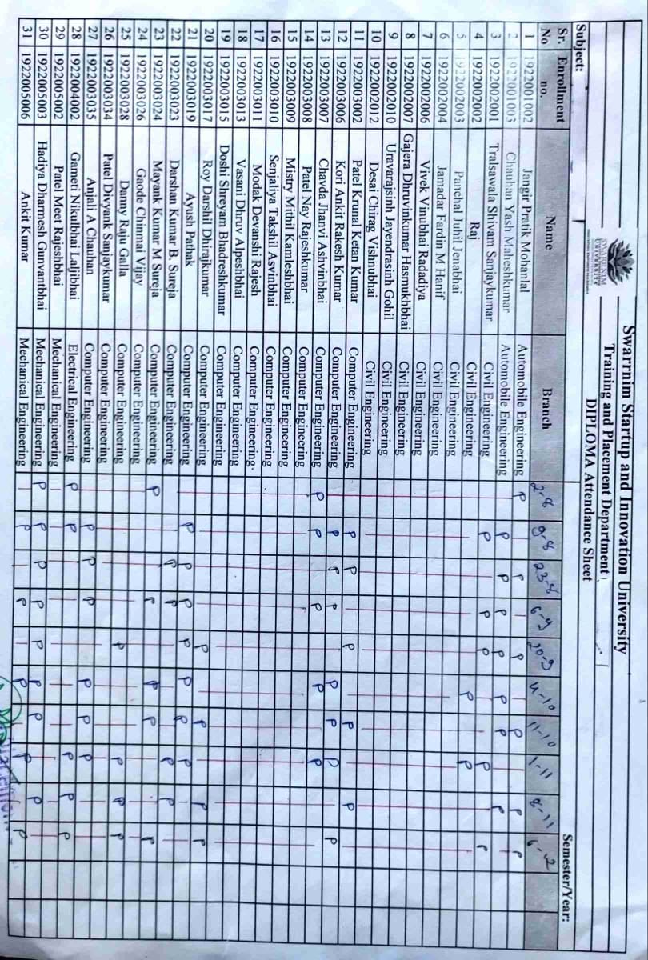

**2.4 Workshop/Seminar**

1. **Name of Event: Seminar on “Blank Canvas: Mastering Cloze Tests”.**

**Date of Event: 07/09/2021**

**Organized by: Training and Placement cell, Swarrnim Startup and Innovation University**

**Event Coordinator: Mr. Nimesh Dave**

**Objective:** to make students aware about [Improved Comprehension: Regular practice with Cloze Tests enhances reading comprehension by approximately 15%](https://readabilityformulas.com/how-to-use-the-cloze-test/)

**Report:**

The topic was introduced by the co-ordinator, also known as the cloze deletion test, is a valuable tool for assessing language comprehension. In this exercise, certain words are removed from a passage, and students must restore the missing words based on context and vocabulary.

How It Works

1. Cloze Text: The teacher provides a passage with gaps where words have been removed.
2. Student Task: Students fill in the blanks with appropriate words.
3. context Matters: Understanding context and analyzing the surrounding words are crucial for accurate completion.

**How to Administer and Score**

1. Administration:
   * Omit every 5th word, replacing it with a blank space.
   * Instruct students to write only one word in each blank.
   * Encourage guessing; misspellings are acceptable.
2. Scoring:
   * Students must restore the exact word in most cases.
   * Misspellings count as correct if the meaning is accurate.

**Program Outcome:** Through this seminar awareness Spread among students about Mastering the Cloze Test involves understanding context, recognizing grammatical clues, and practicing regularly. By honing these skills, students can excel in language comprehension

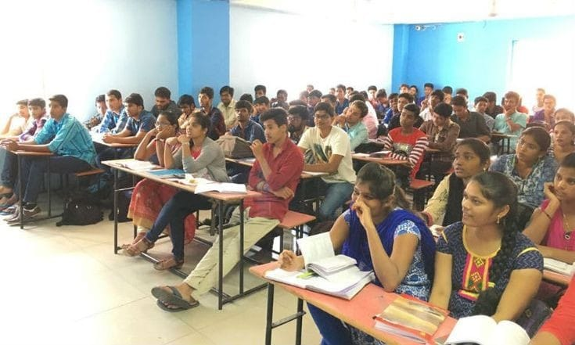

No. of Student attended: 68

Attendance:

|  |  |  |  |
| --- | --- | --- | --- |
| **Sr.no** | **Enrollment no.** | **Name of Student** | **Present / Absent** |
| 1 | 2124003003 | Prajapati Yash Bharatbhai | Present |
| 2 | 2124004001 | Patel Dhairya Nitulkumar | Present |
| 3 | 2124004002 | Dasadiya Shubham Rameshbhai | Present |
| 4 | 2124004003 | Khunt Om Shaileshbhai | Present |
| 5 | 2124004004 | Patel Ayush Dharmeshkumar | Present |
| 6 | 2124004005 | Ayush Deo | Present |
| 7 | 2124004006 | Ashish Katuwal | Present |
| 8 | 2124004007 | Prajapati Dineshkumar Rajaram | Present |
| 9 | 2124004008 | Goswami Ayush Diwan | Present |
| 10 | 2124004009 | Gajjar Aditya Rakeshbhai | Present |
| 11 | 2124004010 | Pala Ayush Rameshkumar | Present |
| 12 | 2124004011 | Dalsaniya Mihir Rameshbhai | Present |
| 13 | 2124004012 | Sagar Suhani Sureshbhai | Present |
| 14 | 2124004013 | Kharade Vishal Balasahab | Present |
| 15 | 2124004014 | Panchal Pratik Sevantibhai | Present |
| 16 | 2124004015 | Bhangale Bharat Manoharbhai | Present |
| 17 | 2124004016 | Nayak Saniya Manishkumar | Present |
| 18 | 2124004017 | Khandelwal Khushal Ashok | Present |
| 19 | 2124004018 | Sumit Chaudhary | Present |
| 20 | 2124004019 | Om Hirachand Solanki | Present |
| 21 | 2124004020 | Mukul Sureshkumar | Present |
| 22 | 2124004021 | Gajjar Aryan Miteshkumar | Present |
| 23 | 2124004022 | Gaurav Pandey | Present |
| 24 | 2124004023 | Panchal Hemraj Dharmendrakumar | Present |
| 25 | 2124004024 | Bharatkumar Shri Magnaram | Present |
| 26 | 2124004025 | Suman Kumar Mandal | Present |
| 27 | 2124004026 | Ankur Vishwakarma | Present |
| 28 | 2124004027 | Ruturajsinh Pratapsinh Parmar | Present |
| 29 | 2124004028 | Panjwani Vanshika Shankarlal | Present |
| 30 | 2124004029 | K Shravya | Present |
| 31 | 2124004030 | Tirgar Dhruvkumar Vasantbhai | Present |
| 32 | 2124004031 | Asari Narendrakumar | Present |
| 33 | 2124004032 | Madhav Nandan Singh | Present |
| 34 | 2124004033 | Parmar Jigar Jivanbhai | Present |
| 35 | 2124004034 | Sharma Nishit Kishan | Present |
| 36 | 2124004035 | Sharma Keshva Kishan | Present |
| 37 | 2124004036 | Rahul Kapar | Present |
| 38 | 2124004037 | Patel Parth Vishwajit | Present |
| 39 | 2124004038 | Joshi Pratik Narendra | Present |
| 40 | 2124004039 | Patel Deepkumar Rajeshbhai | Present |
| 41 | 2124004040 | Khan Mohammed Sunain Sadik Khan | Present |
| 42 | 2124003003 | Prajapati Yash Bharatbhai | Present |
| 43 | 2124004001 | Patel Dhairya Nitulkumar | Present |
| 44 | 2124004002 | Dasadiya Shubham Rameshbhai | Present |
| 45 | 2124004003 | Khunt Om Shaileshbhai | Present |
| 46 | 2124004004 | Patel Ayush Dharmeshkumar | Present |
| 47 | 2124004005 | Ayush Deo | Present |
| 48 | 2124004006 | Ashish Katuwal | Present |
| 49 | 2124004007 | Prajapati Dineshkumar Rajaram | Present |
| 50 | 2124004008 | Goswami Ayush Diwan | Present |
| 51 | 2124004009 | Gajjar Aditya Rakeshbhai | Present |
| 52 | 2124004010 | Pala Ayush Rameshkumar | Present |
| 53 | 2124004011 | Dalsaniya Mihir Rameshbhai | Present |
| 54 | 2124004012 | Sagar Suhani Sureshbhai | Present |
| 55 | 2124004013 | Kharade Vishal Balasahab | Present |
| 56 | 2124004014 | Panchal Pratik Sevantibhai | Present |
| 57 | 2124004015 | Bhangale Bharat Manoharbhai | Present |
| 58 | 2124004016 | Nayak Saniya Manishkumar | Present |
| 59 | 2124004017 | Khandelwal Khushal Ashok | Present |
| 60 | 2124004018 | Sumit Chaudhary | Present |
| 61 | 2124004019 | Om Hirachand Solanki | Present |
| 62 | 2124004020 | Mukul Sureshkumar | Present |
| 63 | 2124004021 | Gajjar Aryan Miteshkumar | Present |
| 64 | 2124004022 | Gaurav Pandey | Present |
| 65 | 2124004023 | Panchal Hemraj Dharmendrakumar | Present |
| 66 | 2124004024 | Bharatkumar Shri Magnaram | Present |
| 67 | 2124004025 | Suman Kumar Mandal | Present |
| 68 | 2124004026 | Ankur Vishwakarma | Present |



|  |  |  |  |
| --- | --- | --- | --- |
| **Seminar Assessment Report for The Academic Year 2021-2022** | | | |
| **2021-2022** | **Option** | **Total Answer** | **Average Evaluation (Out of 4)** |
| ***1. Was the Trainer well prepared with their content?*** | Strongly Agree | 52 | **3.68** |
| Agree | 10 |
| Not Agree | 6 |
| Strongly disagree | 0 |
| ***2. Was the trainer professional?*** | Strongly Agree | 54 | **3.74** |
| Agree | 10 |
| Not Agree | 4 |
| Strongly disagree | 0 |
| ***3. Did the training content matched your expectations?*** | Strongly Agree | 48 | **3.57** |
| Agree | 11 |
| Not Agree | 9 |
| Strongly disagree | 0 |
| ***4. Was the trainer punctual?*** | Strongly Agree | 59 | **3.84** |
| Agree | 7 |
| Not Agree | 2 |
| Strongly disagree | 0 |
| ***5. Was The Trainer communicating in English?*** | Strongly Agree | 55 | **3.69** |
| Agree | 5 |
| Not Agree | 8 |
| Strongly disagree | 0 |
| ***6. Was the class engaging?*** | Strongly Agree | 63 | **3.93** |
| Agree | 5 |
| Not Agree | 0 |
| Strongly disagree | 0 |
|  |  |  |  |
|  |  |  |  |
|  | **Average Score (Out of 4)** | **3.74** |  |
|  | **Total Effectiveness** | **93.50%** |  |

**2.Report on the Seminar on “Cloze Tests”**

**Event Name:** Seminar on “Cloze Tests”  
**Date:** 14/09/2021  
**Organized by:** Training and Placement Cell, Swarrnim Startup and Innovation University  
**Event Coordinator:** Mr. Nimesh Dave

**Objective:**  
The seminar aimed to enhance participants’ understanding and skills in tackling cloze tests, which are essential for competitive exams and language proficiency assessments. These tests evaluate comprehension, vocabulary, and grammatical accuracy, making them a critical component of language learning and assessment.

**Summary of the Event:**

The seminar on “Cloze Tests” was a well-attended event, drawing participants from various departments. Mr. Nimesh Dave, the event coordinator, began with an introduction to cloze tests, explaining their significance in evaluating language proficiency. He highlighted the different types of cloze tests, including fixed-ratio and rational deletion, and provided examples to illustrate each type.

The session included interactive activities where participants attempted cloze tests in real-time. This hands-on approach allowed attendees to apply the strategies discussed and receive immediate feedback. Mr. Dave emphasized the importance of context clues and grammatical knowledge in successfully completing cloze tests.

**Key Takeaways:**

* + 1. **Understanding Cloze Tests:** Participants gained a clear understanding of what cloze tests are and their importance in language assessments.
    2. **Strategies for Success:** The seminar provided practical strategies for tackling cloze tests, such as using context clues and understanding grammatical structures.
    3. **Interactive Learning:** The hands-on activities helped participants apply the strategies in real-time, enhancing their learning experience.
    4. **Feedback and Improvement:** Immediate feedback during the activities allowed participants to identify areas for improvement and refine their skills.

**Learning Outcome:**  
The seminar on “Cloze Tests” was a valuable learning experience for all attendees. It successfully met its objective of enhancing participants’ skills in tackling cloze tests, thereby contributing to their overall language proficiency. The interactive format and practical strategies shared during the seminar were particularly appreciated by the participants.

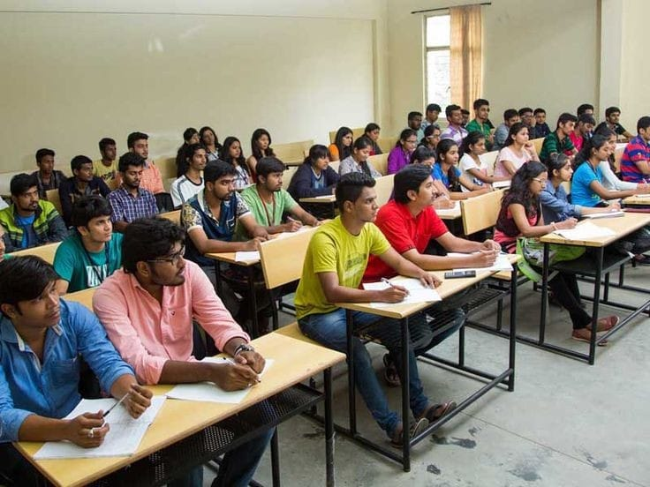

|  |  |  |  |  |
| --- | --- | --- | --- | --- |
| **Sr. No** | **Enrollment no.** | **Name** | **Branch** | **Present/ Absent** |
| 1 | 2116005001 | Trilokani Ashwin Hareshbhai | Mba- Marketing | Present |
| 2 | 2116005002 | Devda Vipul Prakash Sundar | Mba- Marketing | Present |
| 3 | 2116005003 | Kushwaha Rishabh Hemant | Mba- Marketing | Present |
| 4 | 2116005004 | Prajapati Pooja Nathuram | Mba- Marketing | Present |
| 5 | 2116005005 | Tripathi Krishna Shivprakash | Mba- Marketing | Present |
| 6 | 2116005006 | Bhatt Abhishek Yogeshchandra | Mba- Marketing | Present |
| 7 | 2116005007 | Bhanderi Abhaykumar Hiteshbhai | Mba- Marketing | Present |
| 8 | 2116005008 | Barot Shivamkumar Manojbhai | Mba- Marketing | Present |
| 9 | 2116005009 | Sheladiya Darshilkumar Himmatbhai | Mba- Marketing | Present |
| 10 | 2116005010 | Jani Yash Vipulbhai | Mba- Marketing | Present |
| 11 | 2116005011 | Patel Nishantkumar Narendrabhai | Mba- Marketing | Present |
| 12 | 2116005012 | Khambhaliya Darshan Jagdishbhai | Mba- Marketing | Present |
| 13 | 2116006001 | Gondalia Parth Kaushikbhai | Mba- Finance | Present |
| 14 | 2116006002 | Vipin Singh | Mba- Finance | Present |
| 15 | 2116006003 | Patel Keyurkumar Maheshbhai | Mba- Finance | Present |
| 16 | 2116006004 | Patel Dhruvkumar Dipakbhai | Mba- Finance | Present |
| 17 | 2116006005 | Soni Zeal Vijay | Mba- Finance | Present |
| 18 | 2116006006 | Palve Sagarbhai Amratbhai | Mba- Finance | Present |
| 19 | 2116006007 | Thakor Mahimaben Dipakkumar | Mba- Finance | Present |
| 20 | 2116006008 | Sahani Sahil Sohanlal | Mba- Finance | Present |
| 21 | 2116006009 | Chauhan Yash Nileshbhai | Mba- Finance | Present |
| 22 | 2116006010 | Amin Ekta Narayanbhai | Mba- Finance | Present |
| 23 | 2116006011 | Mali Arti Rakeshbhai | Mba- Finance | Present |
| 24 | 2116006012 | Solanki Hiral Pravinkumar | Mba- Finance | Present |
| 25 | 2116007001 | Purohit Diya Nareshkumar | Mba- Hr | Present |
| 26 | 2116007002 | Trivedi Siddharth Pravinchandra | Mba- Hr | Present |
| 27 | 2116007003 | Nikam Pranjali Pravin | Mba- Hr | Present |
| 28 | 2116007004 | Raval Kamya Ajaykumar | Mba- Hr | Present |
| 29 | 2116007005 | Chauhan Rakesh Gulabbhai | Mba- Hr | Present |
| 30 | 2116007006 | Agarwal Rupal Nankchand | Mba- Hr | Present |
| 31 | 2116007007 | Rajput Himadri Harivanshsingh | Mba- Hr | Present |
| 32 | 2116007008 | Hingu Hemali Dineshkumar | Mba- Hr | Present |
| 33 | 2116007009 | Pandya Maitri Sunilbhai | Mba- Hr | Present |
| 34 | 2116007010 | Parmar Aartiben Deepakbhai | Mba- Hr | Present |
| 35 | 2116007011 | Patel Brijesh Mukeshkumar | Mba- Hr | Present |
| 36 | 2116007012 | Dabbiwala Mohd Abrar Mohd Allarakha | Mba- Hr | Present |
| 37 | 2116007013 | Prajapati Jahnavi Kirit | Mba- Hr | Present |
| 38 | 2116007014 | Dave Harsh Jayeshkumar | Mba- Hr | Present |
| 39 | 2116007015 | Rajyaguru Satyam Bhadreshbhai | Mba- Hr | Present |
| 40 | 2116007016 | Patel Vishvaben Jayantibhai | Mba- Hr | Present |
| 41 | 2116007017 | Makwana Sonu Gautambhai | Mba- Hr | Present |
| 42 | 2116007018 | Sadhu Priteshkumar Girishbhai | Mba- Hr | Present |
| 43 | 2116007019 | Shrimali Vishakha Pravinkumar | Mba- Hr | Present |
| 44 | 2116010001 | Brahmbhatt Yash Bhalchandra | Mba - Entre | Present |
| 45 | 2116015001 | Raval Jaydi Itendrakumar | Mba- Finance | Present |
| 46 | 2116015002 | Patel Shivani Narendrabhai | Mba- Finance | Present |
| 47 | 2116015003 | Jha Khushbu Sanjivkumar | Mba- Finance | Present |
| 48 | 2116015004 | Delvadiya Jenil Ashvinbhai | Mba- Finance | Present |
| 49 | 2116015005 | Bhabhera Hardik Babubhai | Mba- Finance | Present |
| 50 | 2116015006 | Rathod Vikas Ramnikbhai | Mba- Finance | Present |
| 51 | 2114010001 | Topiya Hetkumar Maheshbhai | Bca (Ds) | Present |
| 52 | 2114010002 | Rajpara Dhruvika Dharmesh | Bca (Ds) | Present |
| 53 | 2114010003 | Bhagat Srustiben Rajeshbhai | Bca (Ds) | Present |
| 54 | 2114010004 | Bhumi Mansukhbhai Bhanushali | Bca (Ds) | Present |
| 55 | 2114011001 | Patel Arya Narendrabhai | Bca-Ctis | Present |
| 56 | 2114011002 | Sneh Gupta | Bca-Ctis | Present |
| 57 | 2114011003 | Dusara Jenis Bharatbhai | Bca-Ctis | Present |
| 58 | 2114011004 | Patel Yashvi Nalinbhai | Bca-Ctis | Present |
| 59 | 2114011005 | Senghal Ujas Jitendrbhai | Bca-Ctis | Present |
| 60 | 2114011006 | Goswami Tanvi Sureshgiri | Bca-Ctis | Present |
| 61 | 2114011007 | Ladumor Kaushik Ganpatbhai | Bca-Ctis | Present |
| 62 | 2116015001 | Raval Jaydi Itendrakumar | Mba- Finance | Present |
| 63 | 2116015002 | Patel Shivani Narendrabhai | Mba- Finance | Present |



|  |  |  |  |
| --- | --- | --- | --- |
| **Seminar Assessment Report for The Academic Year 2021-2022** | | | |
| **2021-2022** | **Option** | **Total Answer** | **Average Evaluation (Out of 4)** |
| ***1. Was the Trainer well prepared with their content?*** | Strongly Agree | 55 | **3.87** |
| Agree | 8 |
| Not Agree | 0 |
| Strongly disagree | 0 |
| ***2. Was the trainer professional?*** | Strongly Agree | 45 | **3.65** |
| Agree | 14 |
| Not Agree | 4 |
| Strongly disagree | 0 |
| ***3. Did the training content matched your expectations?*** | Strongly Agree | 47 | **3.70** |
| Agree | 13 |
| Not Agree | 3 |
| Strongly disagree | 0 |
| ***4. Was the trainer punctual?*** | Strongly Agree | 56 | **3.86** |
| Agree | 5 |
| Not Agree | 2 |
| Strongly disagree | 0 |
| ***5. Was The Trainer communicating in English?*** | Strongly Agree | 47 | **3.62** |
| Agree | 8 |
| Not Agree | 8 |
| Strongly disagree | 0 |
| ***6. Was the class engaging?*** | Strongly Agree | 59 | **3.94** |
| Agree | 4 |
| Not Agree | 0 |
| Strongly disagree | 0 |
|  |  |  |  |
|  |  |  |  |
|  | **Average Score (Out of 4)** | **3.77** |  |
|  | **Total Effectiveness** | **94.31%** |  |

1. **Brief Report on the Seminar on “Importance of General English in Competitive Exams”**

**Event Name:** Seminar on “Importance of General English in Competitive Exams”  
**Date:** 24/10/2021  
**Organized by:** Training and Placement Cell, Swarrnim Startup and Innovation University  
**Event Coordinator:** Mr. Nimesh Dave

**Objective:**  
The seminar aimed to highlight the crucial role of general English in competitive exams. It focused on enhancing participants’ understanding of how proficiency in English can significantly impact their performance in various competitive exams, thereby improving their overall employability.

**Summary of the Event:**

The seminar on “Importance of General English in Competitive Exams” was well-received, with a diverse group of participants from different academic backgrounds. Mr. Nimesh Dave, the event coordinator, began the session by discussing the various components of general English that are commonly tested in competitive exams, such as grammar, vocabulary, reading comprehension, and verbal reasoning.

Mr. Dave provided insights into the types of questions typically encountered in exams and shared effective strategies for tackling them. He emphasized the importance of regular practice and staying updated with current trends in exam patterns. The seminar also included interactive segments where participants engaged in mock tests and group discussions to apply the concepts learned.

**Key Takeaways:**

1. **Understanding Exam Patterns:** Participants gained a comprehensive understanding of the types of English questions commonly found in competitive exams.
2. **Effective Strategies:** The seminar provided practical strategies for improving performance in English sections of competitive exams.
3. **Interactive Learning:** Mock tests and group discussions helped participants apply the strategies in a simulated exam environment.
4. **Continuous Improvement:** Emphasis was placed on the importance of regular practice and staying informed about changes in exam patterns.

**Outcome:**  
The seminar on “Importance of General English in Competitive Exams” successfully achieved its objective of enhancing participants’ awareness and skills in general English. The practical strategies and interactive format were particularly appreciated, providing participants with valuable tools to improve their performance in competitive exams.

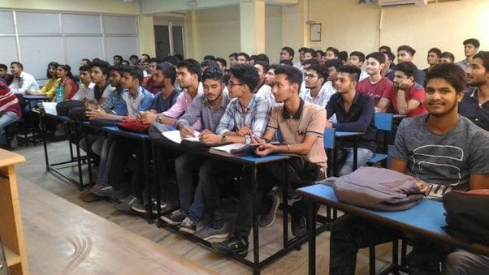

|  |  |  |  |  |
| --- | --- | --- | --- | --- |
| **Sr. No** | **Enrollment no.** | **Name** | **Branch** | **Present/ Absent** |
| 1 | 2156001001 | Makvana Jaydev Mukeshbhai | Chemistry | Present |
| 2 | 2156001002 | Modi Nandkumar Vikrambhai | Chemistry | Present |
| 3 | 2156001003 | Parmar Mahavirsinh Mavasang | Chemistry | Present |
| 4 | 2156001004 | Patel Datteshkumar Dilipkumar | Chemistry | Present |
| 5 | 2156001005 | Patel Devansh Bharatbhai | Chemistry | Present |
| 6 | 2156001006 | Prajapati Dilipkumar Amrutlal | Chemistry | Present |
| 7 | 2156001007 | Sadhu Nandan Girishbhai | Chemistry | Present |
| 8 | 2156001008 | Solanki Satishkumar Nagjibhai | Chemistry | Present |
| 9 | 2156001009 | Thakor Vinodkumar Pardhuji | Chemistry | Present |
| 10 | 2156001010 | Vyas Priyankkumar Rajendrakumar | Chemistry | Present |
| 11 | 2156001011 | Patel Kunj Mahendrabhai | Chemistry | Present |
| 12 | 2156001012 | Patel Alpaben Amrutbhai | Chemistry | Present |
| 13 | 2156001013 | Purnima Tiwari | Chemistry | Present |
| 14 | 2156001014 | Padariya Parita Ashokbhai | Chemistry | Present |
| 15 | 2156001015 | Patel Chirag Vishnubhai | Chemistry | Present |
| 16 | 2156001016 | Parmar Chirag Babubhai | Chemistry | Present |
| 17 | 2156001017 | Bhimani Milankumar Hasmukh | Chemistry | Present |
| 18 | 2156001018 | Chaudhari Suhagkumar Jayantilal | Chemistry | Present |
| 19 | 2156001019 | Patel Dhruvkumar Sanjaybhai | Chemistry | Present |
| 20 | 2156001020 | Patel Krupa Anilkumar | Chemistry | Present |
| 21 | 2156001021 | Patel Mihir Rajeshkumar | Chemistry | Present |
| 22 | 2156001022 | Patel Rahul Bhailalbhai | Chemistry | Present |
| 23 | 2156001023 | Thakor Jaydeepkumar Shaileshkumar | Chemistry | Present |
| 24 | 2156001024 | Prajapati Jay Arvindbhai | Chemistry | Present |
| 25 | 2156001025 | Zala Vanrajsinh Lakhubha | Chemistry | Present |
| 26 | 2156001026 | Patel Utsav Dashrathbhai | Chemistry | Present |
| 27 | 2156001027 | Padashala Amisha Dineshbhai | Chemistry | Present |
| 28 | 2156001028 | Chaudhari Dhaval Dahyabhai | Chemistry | Present |
| 29 | 2156001029 | Patel Sachin Kantilal | Chemistry | Present |
| 30 | 2156001030 | Patel Karan Rajubhai | Chemistry | Present |
| 31 | 2156001031 | Patel Deep Dineshbhai | Chemistry | Present |
| 32 | 2156001032 | Patel Vyomkumar Bharatbhai | Chemistry | Present |
| 33 | 2156001033 | Chavda Digvijaysinh Raghuji | Chemistry | Present |
| 34 | 2156001034 | Patel Kuldipkumar Bharatbhai | Chemistry | Present |
| 35 | 2156001035 | Patel Parthkumar Pravinbhai | Chemistry | Present |
| 36 | 2156001036 | Patel Mitesh Sendhabhai | Chemistry | Present |
| 37 | 2156001037 | Prajapati Krunal Shaileshkumar | Chemistry | Present |
| 38 | 2156001038 | Patel Harsh Jitendrakumar | Chemistry | Present |
| 39 | 2156001001 | Makvana Jaydev Mukeshbhai | Chemistry | Present |
| 40 | 2156001039 | Daraniya Hardikkumar Babulal | Chemistry | Present |
| 41 | 2156001040 | Chavada Harpalsinh Ishwarji | Chemistry | Present |
| 42 | 2156001041 | Patel Tejas Shaileshkumar | Chemistry | Present |
| 43 | 2156001042 | Prajapati Miteshkumar Karshanbhai | Chemistry | Present |
| 44 | 2156001043 | Parmar Akshaykumar Pravinbhai | Chemistry | Present |
| 45 | 2156001044 | Dave Jaiminkumar Babulal | Chemistry | Present |
| 46 | 2156001045 | Bhavsar Akshar Dilipkumar | Chemistry | Present |
| 47 | 2156001046 | Patel Jay Girishkumar | Chemistry | Present |
| 48 | 2156001047 | Prajapati Yashvantkumar Mahendrabhai | Chemistry | Present |
| 49 | 2156001048 | Upadhyay Devanshi Dhananjaykumar | Chemistry | Present |
| 50 | 2156001049 | Raval Ravikumar Kantibhai | Chemistry | Present |
| 51 | 2156001050 | Patel Harsh Sureshkumar | Chemistry | Present |
| 52 | 2156001051 | Rathod Krishnarajsinh Ranjitsinh | Chemistry | Present |
| 53 | 2156001052 | Bhatt Jalpa Maheshkumar | Chemistry | Present |
| 54 | 2156001053 | Patel Yashkumar Rajeshbhai | Chemistry | Present |
| 55 | 2156001054 | Modi Parthkumar Mukeshbhai | Chemistry | Present |
| 56 | 2156001055 | Limbadiya Arif Abdulraheman | Chemistry | Present |
| 57 | 2156001056 | Dodiya Akash Mahendrabhai | Chemistry | Present |
| 58 | 2156001057 | Patel Harshkumar Ganapatbhai | Chemistry | Present |
| 59 | 2156001058 | Fuletra Jay Vrajlal | Chemistry | Present |
| 60 | 2156001059 | Pandya Shubham Jitendrakumar | Chemistry | Present |
| 61 | 2156001060 | Patel Darshkumar Jitendrakumar | Chemistry | Present |
| 62 | 2156001061 | Patel Satyam Mukeshbhai | Chemistry | Present |
| 63 | 2156001062 | Valand Parth Baldevbhai | Chemistry | Present |
| 64 | 2156001063 | Sharma Janakkumar Rajendrakumar | Chemistry | Present |
| 65 | 2156001064 | Joshi Jinen Vrushilkumar | Chemistry | Present |
| 66 | 2156001065 | Pansara Poonam Girdharbhai | Chemistry | Present |
| 67 | 2156001066 | Patel Zankhanaben Hasmukhbhai | Chemistry | Present |
| 68 | 2156001067 | Prajapati Kamlesh Mohanbhai | Chemistry | Present |
| 69 | 2156001068 | Makwana Darshna Mahendrakumar | Chemistry | Present |
| 70 | 2156001069 | Patel Pinkeshkumar Hasmukhbhai | Chemistry | Present |
| 71 | 2156001070 | Patel Hasmukhkumar Ghanshyambhai | Chemistry | Present |
| 72 | 2156001071 | Gohel Krishnakumar Chikubhai | Chemistry | Present |
| 73 | 2156001072 | Patel Akashkumar Dineshbhai | Chemistry | Present |
| 74 | 2156001073 | Patel Maulik Hasmukhbhai | Chemistry | Present |
| 75 | 2156001074 | Gohil Chetansinh Gabhusinh | Chemistry | Present |
| 76 | 2156001075 | Sathavara Ankitkumar Maheshbhai | Chemistry | Present |
| 77 | 2156001076 | Jaiswal Mukesh Jagdishprasad | Chemistry | Present |
| 78 | 2156001077 | Patel Chandrakant Dharmendrakumar | Chemistry | Present |





|  |  |  |  |
| --- | --- | --- | --- |
| **Seminar Assessment Report for The Academic Year 2021-2022** | | | |
| **2021-2022** | **Option** | **Total Answer** | **Average Evaluation (Out of 4)** |
| ***1. Was the Trainer well prepared with their content?*** | Strongly Agree | 69 | **3.88** |
| Agree | 9 |
| Not Agree | 0 |
| Strongly disagree | 0 |
| ***2. Was the trainer professional?*** | Strongly Agree | 60 | **3.65** |
| Agree | 9 |
| Not Agree | 9 |
| Strongly disagree | 0 |
| ***3. Did the training content matched your expectations?*** | Strongly Agree | 51 | **3.54** |
| Agree | 18 |
| Not Agree | 9 |
| Strongly disagree | 0 |
| ***4. Was the trainer punctual?*** | Strongly Agree | 69 | **3.88** |
| Agree | 9 |
| Not Agree | 0 |
| Strongly disagree | 0 |
| ***5. Was The Trainer communicating in English?*** | Strongly Agree | 63 | **3.73** |
| Agree | 9 |
| Not Agree | 6 |
| Strongly disagree | 0 |
| ***6. Was the class engaging?*** | Strongly Agree | 69 | **3.88** |
| Agree | 9 |
| Not Agree | 0 |
| Strongly disagree | 0 |
|  |  |  |  |
|  |  |  |  |
|  | **Average Score (Out of 4)** | **3.76** |  |
|  | **Total Effectiveness** | **94.07%** |  |

**4.Seminar Report**

**Title:** English Vocabulary for Competitive Exams  
**Date:** 23/02/2021  
**Organized by:** Training and Placement Cell, Swarrnim Startup and Innovation University  
**Event Coordinator:** Mr. Nimish Dave

**Introduction:**

The Training and Placement Cell of Swarrnim Startup and Innovation University organized a seminar on “English Vocabulary for Competitive Exams” on 23rd February 2021. The seminar aimed to enhance the vocabulary skills of students preparing for various competitive exams, thereby improving their chances of success.

**Objective:**

The primary objective of the seminar was to provide students with effective strategies and techniques to expand their English vocabulary, which is a crucial component of competitive exams such as GRE, GMAT, CAT, and other entrance tests.

**Event Details:**

The seminar was coordinated by Mr. Nimish Dave, who ensured the smooth execution of the event. The session was conducted by experienced faculty members who specialize in English language teaching and competitive exam preparation.

**Key Highlights:**

1. **Vocabulary Building Techniques:** The seminar covered various methods to learn and retain new words, including the use of flashcards, mnemonic devices, and word association techniques.
2. **Contextual Learning:** Emphasis was placed on understanding words in context, which helps in better retention and application during exams.
3. **Practice Exercises:** Participants engaged in interactive exercises and quizzes to test their vocabulary knowledge and application skills.
4. **Resource Sharing:** Attendees were provided with a list of recommended books, websites, and apps for further vocabulary enhancement.

**Feedback:**

The seminar received positive feedback from the participants. They appreciated the practical tips and interactive nature of the session. Many students expressed that the seminar boosted their confidence in tackling the vocabulary section of competitive exams.

**Conclusion:**

The seminar on “English Vocabulary for Competitive Exams” was a successful event that provided valuable insights and tools to the students. The Training and Placement Cell plans to organize more such seminars in the future to support students in their academic and professional endeavors.

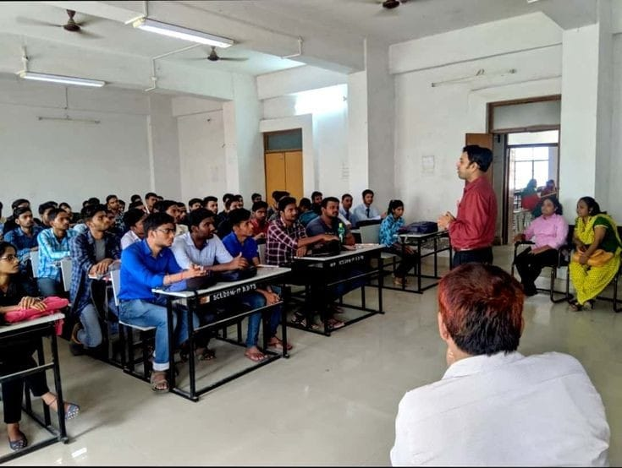

|  |  |  |  |  |
| --- | --- | --- | --- | --- |
| **Sr. No** | **Enrollment no.** | **Name** | **Branch** | **Present/Absent** |
| 1 | 2114003001 | Aditya Pratap Singh Bhagat Singh | BCA | Present |
| 2 | 2114003002 | Tanwani Piyush Dharmendra | BCA | Present |
| 3 | 2114003003 | Kamliya Navneet Bhukhubhai | BCA | Present |
| 4 | 2114003004 | Basantani Vinit Maheshkumar | BCA | Present |
| 5 | 2114003005 | Pirzada Amir Hamza Zakirhusain | BCA | Present |
| 6 | 2114003006 | Patel Neelkumar Rasikbhai | BCA | Present |
| 7 | 2114003007 | Rajput Premsingh Kanaiyalal | BCA | Present |
| 8 | 2114003008 | Prajapati Miten Vijaybhai | BCA | Present |
| 9 | 2114003009 | Jain Harsh Rajivkumar | BCA | Present |
| 10 | 2114003010 | Desai Jaydeep Mohanbhai | BCA | Present |
| 11 | 2114003011 | Harshkumar Manojkumar Barot | BCA | Present |
| 12 | 2114003012 | Rajpurohit Karina Gangeshkumar | BCA | Present |
| 13 | 2114003013 | Thakur Nikita Bhishampalsingh | BCA | Present |
| 14 | 2114003014 | Barot Rohitkumar Sanjaykumar | BCA | Present |
| 15 | 2114003015 | Brahmbhatt Dhruv Yogeshkumar | BCA | Present |
| 16 | 2114003016 | Viradiya Harsh Rajubhai | BCA | Present |
| 17 | 2114003017 | Shaikh Maaz Azaz Husain | BCA | Present |
| 18 | 2114003018 | Patel Keyur Kumar | BCA | Present |
| 19 | 2114003019 | Akash Chattar | BCA | Present |
| 20 | 2114003020 | Balai Priyansu Pawankumar | BCA | Present |
| 21 | 2114003021 | Navrang Lal Saini | BCA | Present |
| 22 | 2114003022 | Dev Rakeshbhai Nayee | BCA | Present |
| 23 | 2114003023 | Kalash Kumar Alwani | BCA | Present |
| 24 | 2114003024 | Soni Nishi Deepakbhai | BCA | Present |
| 25 | 2114003025 | Patel Nishabahen Mukeshbhai | BCA | Present |
| 26 | 2114003026 | Rajput Nikhilsingh Naredrasingh | BCA | Present |
| 27 | 2114003027 | Gayakwad Sachin Madanbhai | BCA | Present |
| 28 | 2114003028 | Nair Abhishek Jyotish | BCA | Present |
| 29 | 2114003029 | Tarun Goutam | BCA | Present |
| 30 | 2114003030 | Nagdev Prem Rajesh | BCA | Present |
| 31 | 2114003031 | Patil Swapnil Ravindrabhai | BCA | Present |
| 32 | 2114003032 | Vyas Dipen Govindbhai | BCA | Present |
| 33 | 2114003033 | Vivek Shrimal | BCA | Present |
| 34 | 2114003034 | Himir Sonpal | BCA | Present |
| 35 | 2114003035 | Barot Divyansh Uttamkumar | BCA | Present |
| 36 | 2114003036 | Ramchandani Deepak Nareshkumar | BCA | Present |
| 37 | 2114003037 | Joshi Het Tusharkumar | BCA | Present |
| 38 | 2114003038 | Saiyed Mohemmed Taha Aliazhar | BCA | Present |
| 39 | 2114003039 | Joshi Ansh Bharatbhai | BCA | Present |
| 40 | 2114003040 | Rajput Sahil Bholasingh | BCA | Present |
| 41 | 2114003041 | Shreshtha Ishwarkumar Toyaram | BCA | Present |
| 42 | 2114003042 | Vinaykumar Munnaprasad | BCA | Present |
| 43 | 2114003043 | Abhinav Kumar | BCA | Present |
| 44 | 2114003044 | Sevantibhai Bachubhai Panchal | BCA | Present |
| 45 | 2114003045 | Jangid Shubham Lalchand | BCA | Present |
| 46 | 2114003046 | Parmar Rahul Manubhai | BCA | Present |
| 47 | 2114003047 | Arun Rampravesh Nishad | BCA | Present |
| 48 | 2114003048 | Patel Yash Vasantbhai | BCA | Present |
| 49 | 2114003049 | Bhavik Ghanshyambhai Patel | BCA | Present |
| 50 | 2114003001 | Aditya Pratap Singh Bhagat Singh | BCA | Present |
| 51 | 2114003002 | Tanwani Piyush Dharmendra | BCA | Present |
| 52 | 2114003003 | Kamliya Navneet Bhukhubhai | BCA | Present |
| 53 | 2114003004 | Basantani Vinit Maheshkumar | BCA | Present |
| 54 | 2114003005 | Pirzada Amir Hamza Zakirhusain | BCA | Present |



|  |  |  |  |
| --- | --- | --- | --- |
| **Seminar Assessment Report for The Academic Year 2021-2022** | | | |
| **2021-2022** | **Option** | **Total Answer** | **Average Evaluation (Out of 4)** |
| ***1. Was the Trainer well prepared with their content?*** | Strongly Agree | 40 | **3.65** |
| Agree | 9 |
| Not Agree | 5 |
| Strongly disagree | 0 |
| ***2. Was the trainer professional?*** | Strongly Agree | 43 | **3.80** |
| Agree | 11 |
| Not Agree | 0 |
| Strongly disagree | 0 |
| ***3. Did the training content matched your expectations?*** | Strongly Agree | 50 | **3.93** |
| Agree | 4 |
| Not Agree | 0 |
| Strongly disagree | 0 |
| ***4. Was the trainer punctual?*** | Strongly Agree | 40 | **3.61** |
| Agree | 7 |
| Not Agree | 7 |
| Strongly disagree | 0 |
| ***5. Was The Trainer communicating in English?*** | Strongly Agree | 50 | **3.93** |
| Agree | 4 |
| Not Agree | 0 |
| Strongly disagree | 0 |
| ***6. Was the class engaging?*** | Strongly Agree | 54 | **4** |
| Agree | 0 |
| Not Agree | 0 |
| Strongly disagree | 0 |
|  |  |  |  |
|  |  |  |  |
|  | **Average Score (Out of 4)** | **3.82** |  |
|  | **Total Effectiveness** | **95.45%** |  |

**5.Seminar Report**

**Title:** **How to Write Business Letters**  
**Date:** 18/03/2021  
**Organized by:** Training and Placement Cell, Swarrnim Startup and Innovation University  
**Event Coordinator:** Mr. Nimish Dave

**Introduction:**  
The Training and Placement Cell at Swarrnim Startup and Innovation University organized a seminar on “How to Write Business Letters” on March 18, 2021. The seminar aimed to enhance the business communication skills of students, focusing on the essential aspects of writing effective business letters.

**Objectives:**

* To understand the structure and format of business letters.
* To learn the key elements of professional communication.
* To practice writing different types of business letters.

**Event Details:**  
The seminar was coordinated by Mr. Nimish Dave, who provided valuable insights into the nuances of business letter writing. The session covered various topics, including the importance of clarity, conciseness, and tone in business communication. Participants were engaged in interactive activities and practical exercises to reinforce their learning.

**Key Highlights:**

* Detailed explanation of the components of a business letter.
* Examples of different types of business letters, such as inquiry letters, complaint letters, and cover letters.
* Tips on avoiding common mistakes in business writing.
* Hands-on practice sessions where participants drafted their own business letters.

**Feedback:**  
The seminar received positive feedback from the participants. They appreciated the practical approach and the opportunity to apply the concepts learned during the session. Many students expressed that the seminar significantly improved their confidence in writing business letters.

**Outcome:**  
The seminar on “How to Write Business Letters” was a successful event that provided students with essential skills for professional communication. The Training and Placement Cell plans to organize more such seminars in the future to continue supporting students’ professional development.

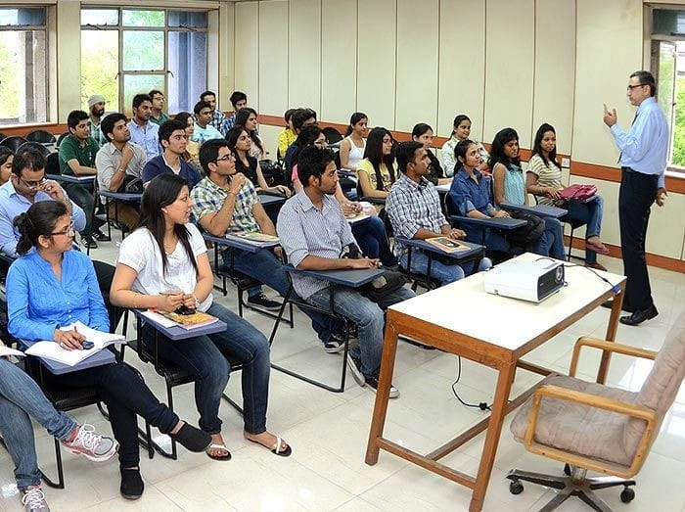

|  |  |  |  |  |
| --- | --- | --- | --- | --- |
| **Sr. No** | **Enrollment no.** | **Name** | **Branch** | **Absent/ Present** |
| 1 | 2122001001 | Sing Shivam Ugrasensing | Automobile | Present |
| 2 | 2122001002 | Thakor Shubh Arvindkumar | Automobile | Present |
| 3 | 2122001003 | Meet Prashant Barot | Automobile | Present |
| 4 | 2122001004 | Patel Ronak Manishkumar | Automobile | Present |
| 5 | 2122001005 | Pathan Arbaz Khan Aabid Khan | Automobile | Present |
| 6 | 2122001006 | Paliwal Pankit Mohanlal | Automobile | Present |
| 7 | 2122001007 | Vaghela Gaurav Jaydipsinh | Automobile | Present |
| 8 | 2122001008 | Vekariya Jainam Vipulbhai | Automobile | Present |
| 9 | 2122001009 | Justin Thomas | Automobile | Present |
| 10 | 2122001010 | Mendapara Yash Bharatbhai | Automobile | Present |
| 11 | 2122002001 | Chauhan Parth Rashminkumar | Civil | Present |
| 12 | 2122002002 | Shah Jaimil Manishkumar | Civil | Present |
| 13 | 2122002003 | Rathore Manthansingh Manishsingh | Civil | Present |
| 14 | 2122002004 | Patel Dev Narendrabhai | Civil | Present |
| 15 | 2122002005 | Patel Arthit Jayeshkumar | Civil | Present |
| 16 | 2122002006 | Patel Safal Jigarbhai | Civil | Present |
| 17 | 2122003001 | Mokariya Vishal Manjibhai | Computer | Present |
| 18 | 2122003002 | Patel Parth Chiragbhai | Computer | Present |
| 19 | 2122003003 | Hadiyel Samir Dilipbhai | Computer | Present |
| 20 | 2122003004 | Shah Maharshi Vipulkumar | Computer | Present |
| 21 | 2122003005 | Soni Het Manishkumar | Computer | Present |
| 22 | 2122003006 | Dave Kush Niravkumar | Computer | Present |
| 23 | 2122003007 | Thakor Kirit Ranjeetji | Computer | Present |
| 24 | 2122003008 | Patel Mayur Rajeshkumar | Computer | Present |
| 25 | 2122003009 | Satwik Ravinder Kumar Chauhan | Computer | Present |
| 26 | 2122003010 | Makwana Devkumar Dipakbhai | Computer | Present |
| 27 | 2122003011 | Sharma Shubham Darpan | Computer | Present |
| 28 | 2122003012 | Chavda Parita Hirenbhai | Computer | Present |
| 29 | 2122003013 | Parmar Mansi Rajnikant | Computer | Present |
| 30 | 2122003014 | Patel Mit Upendrabhai | Computer | Present |
| 31 | 2122003015 | Krunal Laxmikant Chaudhari | Computer | Present |
| 32 | 2122003016 | Patel Nitya Jayendra | Computer | Present |
| 33 | 2122003017 | Patel Krishkumar Anilbhai | Computer | Present |



|  |  |  |  |
| --- | --- | --- | --- |
| **Seminar Assessment Report for The Academic Year 2021-2022** | | | |
| **2021-2022** | **Option** | **Total Answer** | **Average Evaluation (Out of 4)** |
| ***1. Was the Trainer well prepared with their content?*** | Strongly Agree | 30 | **3.91** |
| Agree | 3 |
| Not Agree | 0 |
| Strongly disagree | 0 |
| ***2. Was the trainer professional?*** | Strongly Agree | 24 | **3.67** |
| Agree | 7 |
| Not Agree | 2 |
| Strongly disagree | 0 |
| ***3. Did the training content matched your expectations?*** | Strongly Agree | 26 | **3.76** |
| Agree | 6 |
| Not Agree | 1 |
| Strongly disagree | 0 |
| ***4. Was the trainer punctual?*** | Strongly Agree | 29 | **3.82** |
| Agree | 2 |
| Not Agree | 2 |
| Strongly disagree | 0 |
| ***5. Was The Trainer communicating in English?*** | Strongly Agree | 26 | **3.70** |
| Agree | 4 |
| Not Agree | 3 |
| Strongly disagree | 0 |
| ***6. Was the class engaging?*** | Strongly Agree | 30 | **3.91** |
| Agree | 3 |
| Not Agree | 0 |
| Strongly disagree | 0 |
|  |  |  |  |
|  |  |  |  |
|  | **Average Score (Out of 4)** | **3.79** |  |
|  | **Total Effectiveness** | **94.82%** |  |

**3 Post Assessment Analysis**









































