

**Academic Year**

**2020- 2021**

Date: 03/08/2020

To,

The Provost,

Swarrnim Startup and Innovation University,

Gandhinagar- 322420

Subject: Commencement of Soft Skills and Training Classes

As the Manager of the Training and Placement Department, I am writing to propose an initiative that will significantly enhance our students’ employability and overall professional development. In today’s competitive job market, technical skills alone are not sufficient. Employers increasingly seek candidates with strong skills—such as communication, teamwork, adaptability, and problem-solving abilities. To address this need, I recommend the introduction of Soft skills/ Quant/Verbal-training classes across all departments.

I kindly request your support in implementing this initiative. Let us work together to prepare our

Students’ for success beyond academia.

Thank you for your attention to this matter.

Sincerely,

Mr.Nimesh Dave

Manager,

Training and Placement Department

Swarrnim Startup and Innovation University

|  |  |  |  |  |
| --- | --- | --- | --- | --- |
| **INDEX** | | | |  |
| **SR. No.** |  | **Topic** | **Page No** |  |
| **1** | | **Training Need Analysis** | **1-4** |  | |
| **1.1** | | **Pre-Assessment Analysis** | 1-4 |  | |
| **2** | | **Training Need Initiative** | **5-53** |  | |
| **2.1** | | **Course Plan** | **6-18** |  | |
| 2.1.1 | | Odd Semester Course Plan | 6-12 |  | |
| 2.1.2 | | Even Semester Course Plan | 13-18 |  | |
| **2.2** | | **Time-Table** | **19-24** |  | |
| 2.2.1 | | Odd Semester Time-Table | 19-21 |  | |
| 2.2.2 | | Even Semester Time-Table | 22-24 |  | |
| **2.3** | | **Training Attendance** | **25-31** |  | |
| **2.4** | | **Workshop/Seminar** | **32-53** |  | |
|  | | Workshops Report 1 | 32-35 |  | |
|  | | Workshops Report 2 | 36-39 |  | |
|  | | Workshops Report 3 | 40-43 |  | |
|  | | Workshops Report 4 | 44-48 |  | |
|  | | Workshops Report 5 | 49-53 |  | |
| **3** | | **Post Assessment Analysis** | **54-66** |  | |
| **3.1** | | Slow Learner Chart | 66 |  | |
| **3.2** | | Average Learner Chart | 66 |  | |
| **3.3** | | Fast Learner Chart | 66 |  | |

**1 Training Need Analysis**











**2. Training Need Initiative**

**5.1.3- Following Capacity development and skills enhancement initiatives**

**are taken by the institution:**

**1. Soft skills**

**2. Language and communication skills**

|  |  |  |  |
| --- | --- | --- | --- |
| **Name of Capacity building and skills enhancement** | **Date of Implementation (DD-MM-YYYY)** | **Number of Students Enrolled** | **Name of the agencies/consultants involved with contact details (If Any)** |
| English Language Class | 09-08-2020 | 187 | T&P (Internal Team) |

**2.1 Verbal Ability Course Plan**

**2.1.1 Odd Semester Course Plan Semester -3**

|  |  |  |
| --- | --- | --- |
| **Course Title** | **Course Planner** | **Lectures Hours/Week** |
| Verbal Ability | Mr.Nimish Dave | 1 |

|  |  |  |  |
| --- | --- | --- | --- |
| **Reference Books (RB)** | | | |
| **Sr No** | **Title** | **Author** | **Publisher Name** |
| RB-1 | Cambridge English Empower A2 Elementary Workbook without answers | Peter Anderson | Cambridge University Press |
| RB-2 | Cambridge English Empower B1+ Intermediate Student Book | Adrian Doff, Craig Thaine, Herbert Puchta | Cambridge University Press |
| RB-3 | High School English Grammar and Composition Book (Multicolour Edition) | Wren Martin | S.Chand |
| RB-4 | Commonly Mis-Pronounced Words | Lucy | English with Lucy |
| RB-5 | General English for Competitive Examinations | A.P. Bhardwaj | Dorling Kindersley (India)Pvt.Ltd |

|  |  |  |
| --- | --- | --- |
| **Relevant Websites ( RW )** | | |
| **Sr No** | **(Web address) (only if relevant to the course)** | **Salient Features** |
| RW-1 | <https://www.newtondesk.com/english-syllabus/> | English Grammar |
| RW-2 | <https://leverageedu.com/blog/50-difficult-words-with-meanings/> | Difficult Words- Vocabulary |
| RW-3 | <https://exams.recruitmentindia.in/questions/english/idioms-and-phrases/> | Worksheet -Idioms And Phrases |
| RW-4 | <https://exams.recruitmentindia.in/questions/english/spelling-test/> | Spelling Test |
| RW-5 | <https://www.grammarwiz.com/english-grammar-worksheets.html> | Grammar Worksheets |
| RW-6 | <https://owl.purdue.edu/owl_exercises/grammar_exercises/articles/articles_exercise_2.html> | Grammar Worksheets |
| RW-7 | <https://byjus.com/english/grammar-exercises/> | Grammar Worksheets |
| RW-8 | <https://www.englishgrammar.org/> | Grammar Worksheets |
| RW-9 | <https://www.hitbullseye.com/> | Punctuation, |
| RW-10 | <https://onlymyenglish.com/> | Tenses Exercise |

|  |  |  |
| --- | --- | --- |
| **AUDIO VISUALS (AV)** | | |
| **Sr No** | **(Web address) (only if relevant to the course)** | **Salient Features** |
| AV-1 | <https://www.youtube.com/watch?v=0Vr971stX4Y&list=PLsABmu-DQz-6WxP9pGjR9-SsiFJpwMRpE> | English Through Stories- **Red Roses** |
| AV-2 | <https://www.youtube.com/watch?v=X-BxJWWyO0E> | Parts Of Speech |
| AV-3 | <https://www.youtube.com/watch?v=YZ6Zz7SWr04> | Reading Comprehension |
| AV-4 | <https://www.youtube.com/watch?v=MrfwE2EClxs> | Para Jumbled, Sentence Arrangement |
| AV-5 | <https://www.youtube.com/watch?v=xFGUTzBlAP8> | Spot The Error |
| AV-6 | <https://www.youtube.com/watch?v=P3JYuFEIhuo> | Sentence Completion |
| AV-7 | <https://www.youtube.com/watch?v=kZHEcb_h7js> | Active Passive |
| AV-8 | <https://www.youtube.com/watch?v=AqX2dJ4IH5Q> | Degree Of Comparison |
| AV-9 | <https://www.youtube.com/watch?v=MwQdQI7valM> | Tenses |
| AV-10 | <https://www.youtube.com/watch?v=eplQBhE0-Hg> | Direct- Indirect |
| AV-11 | <https://www.youtube.com/watch?v=htYbnd9Pnos> | Tenses |
| AV-12 | <https://www.youtube.com/watch?v=Zjmgo7rh4pw> | Critical Reasoning |
| AV-13 | <https://www.youtube.com/watch?v=dI-6ppn_udc> | Subject Verb Agreement |
| AV-14 | <https://www.youtube.com/watch?v=4H3-2smRJJY> | Conditional Sentence |
| AV-15 | <https://www.youtube.com/watch?v=Fx43zz0XtUs> | Idioms And Phrases |
| AV-16 | <https://www.youtube.com/watch?v=3YPMi1RbSb> | One Word Substitute |

|  |  |  |  |  |  |  |
| --- | --- | --- | --- | --- | --- | --- |
| **Week Number** | **Lecture Number** | **Broad Topic (Sub Topic)** | **Other Readings, Relevant Websites, Audio Visual Aids** | **Lecture Description** | **Learning Outcomes** | **Pedagogical Tool Demonstration/ Case Study / Images / animation / ppt etc. Planned** |
| Week 1 | Lecture 1 | Parts of speech | RB-1,  RB-2  RB-3, RW-1, RW- 4,  AV-2 | Every word in English can be classified as one of eight parts of speech. The term part of speech refers to the role a word plays in a sentence that are nouns, pronouns, verb, adjective, adverb, preposition, conjunction and interjection | Students would be able to learn about the different parts of speech that the words we use every day fall into, and how we use them together to communicate ideas clearly. | Workbook,  practice sheets |
| Week 2 | Lecture 2 |
| Week 3 | Lecture 3 | Articles and punctuation | RB-1,  RB-2  RB-3  RW-4, RW-5 | Basic Concept and use of articles for formation of sentence. Basic concept and importance of use of punctuation. | Student would be able to understand concept and use of articles and punctuation in their sentence formation. | Workbook,  practice sheets |
| Week 4 | Lecture 4 | Tenses | RB-1,  RB-2  RB-3  RW-1,RW-5,  RW-6, AV- 9, AV-11 | They will learn all types of tenses and its’ formation. They will learn how to use them in their day to day life to make better professional communications. | Students will learn all type tenses and its’ sentence formation. Students will be able to express proper meaning | Workbook,  practice sheets |
| Week 5 | Lecture 5 |
| Week 6 | Lecture 6 |
| Week 7 | Lecture 7 | Active – Passive Voice | RB-1,  RB-2  RB-3  RW-5, RW-6  AV-7 | Students will learn basic concept of Active and Passive in verbal, how to use active and passive in their routine life to have effective communication. | Students would be able to use and identify active and passive in their sentences. | Workbook,  practice sheets |
| Week8 | Lecture 8 |
| Week 9 | Lecture 9 |
| Week 10 | Lecture 10 | Degree of Comparison | RB-1,  RB-2  RB-3  RW-1, RW-5, RW-9, AV- 8 | Students will learn degree of comparison as an important tool for finding the errors, sentence corrections and many other topics covered in different examination. | Students will be able to distinguish types of adjective and type of degrees. | Workbook,  practice sheets |

**ODD Semester- 5**

|  |  |  |
| --- | --- | --- |
| **Course Title** | **Course Planner** | **Lectures Hours/Week** |
| Verbal Ability | Mr.Nimish Dave | 1 |

|  |  |  |  |
| --- | --- | --- | --- |
| **Reference Books ( RB)** | | | |
| **Sr No** | **Title** | **Author** | **Publisher Name** |
| RB-1 | Cambridge English Empower A2 Elementary Workbook without answers | Peter Anderson | Cambridge University press |
| RB-2 | Cambridge English Empower B1+ Intermediate Student Book | Adrian Doff, Craig Thaine, Herbert Puchta | Cambridge University press |
| RB-3 | High School English Grammar and Composition Book (Multicolour Edition) | Wren Martin | S.Chand |
| RB-4 | Commonly Mis-Pronounced Words | Lucy | English with Lucy |
| RB-5 | General English for Competitive Examinations | A.P. Bhardwaj | Dorling Kindersley (india)pvt.Ltd |

|  |  |  |
| --- | --- | --- |
| **Relevant Websites ( RW )** | | |
| **Sr No** | **(Web address) (only if relevant to the course)** | **Salient Features** |
| RW-1 | <https://www.newtondesk.com/english-syllabus/> | English Grammar |
| RW-2 | <https://leverageedu.com/blog/50-difficult-words-with-meanings/> | Difficult words- vocabulary |
| RW-3 | <https://exams.recruitmentindia.in/questions/english/idioms-and-phrases/> | worksheet -idioms and phrases |
| RW-4 | <https://exams.recruitmentindia.in/questions/english/spelling-test/> | spelling test |
| RW-5 | <https://www.grammarwiz.com/english-grammar-worksheets.html> | grammar worksheets |
| RW-6 | <https://owl.purdue.edu/owl_exercises/grammar_exercises/articles/articles_exercise_2.html> | grammar worksheets |
| RW-7 | <https://byjus.com/english/grammar-exercises/> | grammar worksheets |
| RW-8 | <https://www.englishgrammar.org/> | grammar worksheets |
| RW-9 | <https://www.hitbullseye.com/> | EXAM tests |
| RW-10 | <https://onlymyenglish.com/> | tenses exercise |

|  |  |  |
| --- | --- | --- |
| **AUDIO VISUALS (AV)** | | |
| **Sr No** | **(Web address) (only if relevant to the course)** | **Salient Features** |
| AV-1 | <https://www.youtube.com/watch?v=0Vr971stX4Y&list=PLsABmu-DQz-6WxP9pGjR9-SsiFJpwMRpE> | English Through Stories- Red Roses |
| AV-2 | <https://www.youtube.com/watch?v=X-BxJWWyO0E> | Parts Of Speech |
| AV-3 | <https://www.youtube.com/watch?v=YZ6Zz7SWr04> | Reading Comprehension |
| AV-4 | <https://www.youtube.com/watch?v=MrfwE2EClxs> | Para Jumbled, Sentence Arrangement |
| AV-5 | <https://www.youtube.com/watch?v=xFGUTzBlAP8> | Spot The Error |
| AV-6 | <https://www.youtube.com/watch?v=P3JYuFEIhuo> | Sentence Completion |
| AV-7 | <https://www.youtube.com/watch?v=kZHEcb_h7js> | Active Passive |
| AV-8 | <https://www.youtube.com/watch?v=AqX2dJ4IH5Q> | Degree Of Comparision |
| AV-9 | <https://www.youtube.com/watch?v=MwQdQI7valM> | Tenses |
| AV-10 | <https://www.youtube.com/watch?v=eplQBhE0-Hg> | Direct- Indirect |
| AV-11 | <https://www.youtube.com/watch?v=htYbnd9Pnos> | Tenses |
| AV-12 | <https://www.youtube.com/watch?v=Zjmgo7rh4pw> | Critical Reasoning |
| AV-13 | <https://www.youtube.com/watch?v=dI-6ppn_udc> | Subject Verb Agreement |
| AV-14 | <https://www.youtube.com/watch?v=4H3-2smRJJY> | Conditional Sentence |
| AV-15 | <https://www.youtube.com/watch?v=Fx43zz0XtUs> | Idioms And Phrases |
| AV-16 | <https://www.youtube.com/watch?v=3YPMi1RbSb> | One Word Substitute |

|  |  |  |  |  |  |  |  |
| --- | --- | --- | --- | --- | --- | --- | --- |
| **Week Number** | **Lecture Number** | **Broad Topic (Sub Topic)** | **Other Readings, Relevant Websites, Audio Visual Aids** | | **Lecture Description** | **Learning Outcomes** | **Pedagogical Tool Demonstration/ Case Study / Images / animation / ppt etc. Planned** |
| Week 1 | Lecture 1 | Complete the Sentence | RB-3, RB-4, RB-5, RW-1, RW-4, AV-6 |  | Students will learn that is a common test in most competitive exams. They will learn the strategy to solve it. | They will be able to solve complete the sentences segment in all competitive and placement related exams | Work book, Practice sheet |
| Week 2 | Lecture 2 | Sentence arrangement, sentence Correction | RB-3, RB-4, RB-5, RW- 1, RW-4, RW-9, AV-4 | | Students will learn how to solve competitive and placement oriented questions based on sentence arrangement . | Students will be able to identify and solve sentence arrangement and sentence correction segments in all examinations. | Work book, Practice sheet |
| Week 3 | Lecture 3 | Critical Reasoning | RB-3, RB-4, RB-5, RW- 1, RW-4, RW-9, AV-12 | | It intends to assess skills in students -in identifying an argument, evaluating statements, reaching at a conclusion . | Students will be able to identify an argument, evaluating statements, reaching at a conclusion to resolve the problem. | Work book, Practice sheet |
| Week 4 | Lecture 4 |
| Week 5 | Lecture 5 | Written communication- e-mail, business letter, cover letter, CV | RB-3, RB-4, RB-5 | | Students will learn good written communication that will improves teams, inspires high performance and enhances the workplace culture. | Communication is a two-way process, so they will be able to take notice of other people's Verbal Ability and non-Verbal Ability signals as written communication. | Work book, Practice sheet |
| Week 6 | Lecture 6 |
| Week 7 | Lecture 7 |
| Week 8 | Lecture 8 | Reading Comprehension | RB-3, RB-4, RB-5, RW- 1, RW-4,RW-9, | | Reading Comprehension tests a student on a number of skills, including English comprehension and logical ability, language skills such as reading and vocabulary. | Speed reading, high concentration is linked to Reading Comprehension. Students will be able to do them all simultaneously to solve reading comprehension. | Work book, Practice sheet |
| Week 9 | Lecture 9 |
| Week 10 | Lecture 10 | Mock Test | RB-1, RB-2, RB-3, RB-4, RB-5, RW- 1, RW-4, RW-9,  AV-4, AV-6, AV-12 | | Mock tests will help students to be focused about how to solve it. They will to be ‘test –ready’. | Students will be able to overcome their fear of examination by practicing them again and again. |  |

**2.1.2 Even Semester Course Plan**

**Even Semester- 4**

|  |  |  |
| --- | --- | --- |
| **Course Title** | **Course Planner** | **Lectures Hours/Week** |
| Verbal Ability | Mr.Nimish Dave | 1 |

|  |  |  |  |
| --- | --- | --- | --- |
| **Reference Books ( RB)** | | | |
| **Sr No** | **Title** | **Author** | **Publisher Name** |
| RB-1 | Cambridge English Empower A2 Elementary Workbook without answers | Peter Anderson | Cambridge University press |
| RB-2 | Cambridge English Empower B1+ Intermediate Student Book | Adrian Doff, Craig Thaine, Herbert Puchta | Cambridge University press |
| RB-3 | High School English Grammar and Composition Book (Multi colour Edition) | Wren Martin | S.Chand |
| RB-4 | Commonly Mispronounced Words | Lucy | English with Lucy |
| RB-5 | General English for Competitive Examinations | A.P. Bhardwaj | Dorling Kindersley (India)pvt. Ltd |

|  |  |  |
| --- | --- | --- |
| **AUDIO VISUALS (AV)** | | |
| **Sr No** | **(Web address) (only if relevant to the course)** | **Salient Features** |
| AV-1 | <https://www.youtube.com/watch?v=0Vr971stX4Y&list=PLsABmu-DQz-6WxP9pGjR9-SsiFJpwMRpE> | English Through Stories- **Red Roses** |
| AV-2 | <https://www.youtube.com/watch?v=X-BxJWWyO0E> | Parts Of Speech |
| AV-3 | <https://www.youtube.com/watch?v=YZ6Zz7SWr04> | Reading Comprehension |
| AV-4 | <https://www.youtube.com/watch?v=MrfwE2EClxs> | Para Jumbled, Sentence Arrangement |
| AV-5 | <https://www.youtube.com/watch?v=xFGUTzBlAP8> | Spot The Error |
| AV-6 | <https://www.youtube.com/watch?v=P3JYuFEIhuo> | Sentence Completion |
| AV-7 | <https://www.youtube.com/watch?v=kZHEcb_h7js> | Active Passive |
| AV-8 | <https://www.youtube.com/watch?v=AqX2dJ4IH5Q> | Degree Of Comparision |
| AV-9 | <https://www.youtube.com/watch?v=MwQdQI7valM> | Tenses |
| AV-10 | <https://www.youtube.com/watch?v=eplQBhE0-Hg> | Direct- Indirect |
| AV-11 | <https://www.youtube.com/watch?v=htYbnd9Pnos> | Tenses |
| AV-12 | <https://www.youtube.com/watch?v=Zjmgo7rh4pw> | Critical Reasoning |
| AV-13 | <https://www.youtube.com/watch?v=dI-6ppn_udc> | Subject Verb Agreement |
| AV-14 | <https://www.youtube.com/watch?v=4H3-2smRJJY> | Conditional Sentence |
| AV-15 | <https://www.youtube.com/watch?v=Fx43zz0XtUs> | Idioms And Phrases |
| AV-16 | <https://www.youtube.com/watch?v=3YPMi1RbSb> | One Word Substitute |

|  |  |  |
| --- | --- | --- |
| **Relevant Websites ( RW )** | | |
| **Sr No** | **(Web address) (only if relevant to the course)** | **Salient Features** |
| RW-1 | <https://www.newtondesk.com/english-syllabus/> | English Grammar |
| RW-2 | <https://leverageedu.com/blog/50-difficult-words-with-meanings/> | Difficult Words- Vocabulary |
| RW-3 | <https://exams.recruitmentindia.in/questions/english/idioms-and-phrases/> | Worksheet -Idioms and Phrases |
| RW-4 | <https://exams.recruitmentindia.in/questions/english/spelling-test/> | Spelling Test |
| RW-5 | <https://www.grammarwiz.com/english-grammar-worksheets.html> | Grammar Worksheets |
| RW-6 | <https://owl.purdue.edu/owl_exercises/grammar_exercises/articles/articles_exercise_2.html> | Grammar Worksheets |
| RW-7 | <https://byjus.com/english/grammar-exercises/> | Grammar Worksheets |
| RW-8 | <https://www.englishgrammar.org/> | Grammar Worksheets |
| RW-9 | <https://www.hitbullseye.com/> | Punctuation |
| RW-10 | <https://onlymyenglish.com/> | Tenses Exercise |

|  |  |  |  |  |  |  |
| --- | --- | --- | --- | --- | --- | --- |
| **Week No.** | **Lecture Number** | **Broad Topic (Sub Topic)** | **Other Readings, Relevant Websites, Audio Visual Aids** | **Lecture Description** | **Learning Outcomes** | **Pedagogical Tool Demonstration/ Case Study / Images / animation / ppt etc. Planned** |
| Week 1 | Lecture 1 | Direct- Indirect Speech | RB-1,  RB-2,  RB-3,  RW-1,  RW-5, RW-6,  RW-8,  AV-10 | Students will learn to understand the basic concept of direct and indirect speech. Student will know how to use direct - indirect speech. | Students will learn how to read conversations and hoe to interpret indirect speeches. | Practice sheet, workbook |
| Week 2 | Lecture 2 |
| Week 3 | Lecture 3 |
| Week 4 | Lecture 4 | Vocabulary- synonym- antonym, homophones, homonyms, words often confuse etc. | RB-1,  RB-2,  RB-4,  RW-2 | Students will learn how to improve vocabulary in English by getting acquainted to various different words. They will learn how to put them into sentences. | Students will be able to use different new words. They will also be able to solve vocabulary based questions more conveniently. | Practice sheet, workbook |
| Week 5 | Lecture 5 |
| Week 6 | Lecture 6 |
| Week 7 | Lecture 7 | Subject verb agreement  Conditional sentence | RB-1,  RB-2,  RB-3,  RW-1,  RW-5, RW-6,  RW-8,  AV- 13,  AV-14 | Student will understand how to use subject- verb in grammar. They will learn how it is useful in company placement rounds and for competitive exams.. | Students will be able to use conditional sentences in their vocabulary and they will also be able to identify error spotting with the help if it. | Practice sheet, workbook |
| Week 8 | Lecture 8 |
| Week 9 | Lecture 9 | Idioms and Phrases,  One Word Substitute | RB-1,  RB-5,  RW-3,  AV15,  AV16 | Students will learn different types of idioms that are used in professional life. They will also learn one word substitute to make their language richer. | The students will be able to use idioms and phrases in their routine and in all types of communications. They will also learn one word substitute as a part of vocabulary learning. | Practice sheet, workbook |
| Week 10 | Lecture 10 |

**EVEN Semester- 6**

|  |  |  |
| --- | --- | --- |
| **Course Title** | **Course Planner** | **Lectures Hours/Week** |
| Verbal Ability | Mr.Nimish Dave | 1 |

|  |  |  |  |
| --- | --- | --- | --- |
| **Reference Books ( RB)** | | | |
| **Sr No** | **Title** | **Author** | **Publisher Name** |
| RB-1 | Cambridge English Empower A2 Elementary Workbook without answers | Peter Anderson | Cambridge University press |
| RB-2 | Cambridge English Empower B1+ Intermediate Student Book | Adrian Doff, Craig Thaine, Herbert Puchta | Cambridge University press |
| RB-3 | High School English Grammar and Composition Book (Multicolour Edition) | Wren Martin | S.Chand |
| RB-4 | Commonly Mis-Pronounced Words | Lucy | English with Lucy |
| RB-5 | General English for Competitive Examinations | A.P. Bhardwaj | Dorling Kindersley (india)pvt.Ltd |

|  |  |  |
| --- | --- | --- |
| Relevant Websites ( RW ) | | |
| **Sr No** | **(Web address) (only if relevant to the course)** | **Salient Features** |
| RW-1 | <https://www.newtondesk.com/english-syllabus/> | English Grammar |
| RW-2 | <https://leverageedu.com/blog/50-difficult-words-with-meanings/> | Difficult words- vocabulary, Cloze Test,  Parajumble, sentence arrangement |
| RW-3 | <https://exams.recruitmentindia.in/questions/english/idioms-and-phrases/> | worksheet -idioms and phrases, one word substitute |
| RW-4 | <https://exams.recruitmentindia.in/questions/english/spelling-test/> | spelling test, |
| RW-5 | <https://www.grammarwiz.com/english-grammar-worksheets.html> | grammar worksheets |
| RW-6 | <https://owl.purdue.edu/owl_exercises/grammar_exercises/articles/articles_exercise_2.html> | grammar worksheets |
| RW-7 | <https://byjus.com/english/grammar-exercises/> | grammar worksheets |
| RW-8 | <https://www.englishgrammar.org/> | grammar worksheets |
| RW-9 | <https://www.hitbullseye.com/> | Punctuation |
| RW-10 | <https://onlymyenglish.com/> | tenses exercise |

|  |  |  |
| --- | --- | --- |
| **AUDIO VISUALS (AV)** | | |
| **Sr No** | **(Web address) (only if relevant to the course)** | **Salient Features** |
| AV-1 | <https://www.youtube.com/watch?v=0Vr971stX4Y&list=PLsABmu-DQz-6WxP9pGjR9-SsiFJpwMRpE> | English through stories- red roses |
| AV-2 | <https://www.youtube.com/watch?v=X-BxJWWyO0E> | parts of speech |
| AV-3 | <https://www.youtube.com/watch?v=YZ6Zz7SWr04> | reading comprehension |
| AV-4 | <https://www.youtube.com/watch?v=MrfwE2EClxs> | para jumbled, sentence arrangement |
| AV-5 | <https://www.youtube.com/watch?v=xFGUTzBlAP8> | spot the error |
| AV-6 | <https://www.youtube.com/watch?v=P3JYuFEIhuo> | sentence completion |
| AV-7 | <https://www.youtube.com/watch?v=kZHEcb_h7js> | active passive |
| AV-8 | <https://www.youtube.com/watch?v=AqX2dJ4IH5Q> | degree of comparison |
| AV-9 | <https://www.youtube.com/watch?v=MwQdQI7valM> | tenses |
| AV-10 | <https://www.youtube.com/watch?v=eplQBhE0-Hg> | direct- indirect |
| AV-11 | <https://www.youtube.com/watch?v=htYbnd9Pnos> | tenses |
| AV-12 | <https://www.youtube.com/watch?v=Zjmgo7rh4pw> | critical reasoning |
| AV-13 | <https://www.youtube.com/watch?v=dI-6ppn_udc> | Subject verb agreement |
| AV-14 | <https://www.youtube.com/watch?v=4H3-2smRJJY> | conditional sentence |
| AV-15 | <https://www.youtube.com/watch?v=Fx43zz0XtUs> | idioms and phrases |
| AV-16 | <https://www.youtube.com/watch?v=3YPMi1RbSb> | one word substitute |

|  |  |  |  |  |  |  |
| --- | --- | --- | --- | --- | --- | --- |
| **Week Number** | **Lecture Number** | **Broad Topic (Sub Topic)** | **Other Readings, Relevant Websites, Audio Visual Aids** | **Lecture Description** | **Learning Outcomes** | **Pedagogical Tool Demonstration/ Case Study / Images / animation / ppt etc. Planned** |
| Week 1 | Lecture 1 | English Pronunciation- Transcription | RB-4,AV-1 | It will help students to understand actual way to read new words and it’s pronunciation. | They will learn how to pronounce correctly new words. | Exercise sheets, workbook |
| Week 2 | Lecture 2 | Para-Jumble | RB-5,AV-4, RW-2 | Students will learn different approaches to analyze paragraph and will learn how to identify transition words. | Students will be able to identify how to read and how to complete the para-jumbles correctly | Exercise sheets, workbook |
| Week 3 | Lecture 3 |
| Week 4 | Lecture 4 | Find The Error | RB-5  AV-5  RW-2 | Students will learn the importance of error spotting in exams and they will learn tricks to solve it easily. | Students will be able to apply tricks to spot the error/ find the error part for all types of competitive exams | Exercise sheets, workbook |
| Week5 | Lecture 5 |
| Week6 | Lecture 6 | Cloze Test | RB-5, RW-3 | Students will learn how to solve cloze test in no time. They will learn the tricks to solve two major formats of cloze test: fill in the blanks and replacing the word more swiftly and correctly. | They will be able to solve cloze tests more swiftly, they will be able identify both formats to perform the test. | Exercise sheets, workbook |
| Week7 | Lecture 7 |
| Week 8 | Lecture 8 | Mock Test ** | RB-5,RB-4,AV-1  AV-4,AV-5, RW-2, RW-3 | Students will learn how to be placement ready with all the parameters keeping in mind. They will put all the Verbal Ability knowledge into practice by appearing for mock tests. | They will be more confident and prepared for the tests prior to actual company drives. | Exercise sheets, workbook |
| Week 9 | Lecture 9 |
| Week-10 | Lecture 10 |

**Practice Sheet- 1.** [**https://Odd Semester 3**](https://drive.google.com/file/d/1o3HWixXBsMk4Oo0xJOVAk2rew0NG3U5_/view?usp=drive_link)

**2.** [**https://Even Semester4**](https://drive.google.com/file/d/1WFgVB71Oq_CqE9Xwx_zjvM0D4S83MvQo/view?usp=drive_link)

**3. https://ODD Semester5**

**4.** [**https://Even Semester 6**](https://drive.google.com/file/d/1DUcekPphUI571QiKUMknJ3AWoQGc_XiV/view?usp=drive_link)

**2.2 Time-Table**

**2.2.1 Odd Semester Time-Table**

|  |  |  |  |  |  |  |
| --- | --- | --- | --- | --- | --- | --- |
| **Course: BBA/BCOM/BCA/BSC IT** | | | **Semester : 5** | | **Year : 2020-2021** | |
| **Day/Time** | **Monday** | **Tuesday** | **Wednesday** | **Thursday** | **Friday** | **Saturday** |
| **9:15 - 10:15** |  |  |  |  |  | **Verbal Ability** |
| **10:15 - 11:15** |  |  |  |  |  |  |
| **11:15 - 12:15** |  |  |  |  |  |  |
| **RECESS-12:15 - 1:00** | | | | | | |
| **13:00 - 14:00** |  |  |  |  |  |  |
| **14:00 - 15:00** |  |  |  |  |  |  |
| **15:00 - 16:00** |  |  |  |  |  |  |

|  |  |  |  |  |  |  |
| --- | --- | --- | --- | --- | --- | --- |
| **Course: BBA/BCOM/BCA/BSC IT** | | | **Semester : 3** | | **Year : 2020-2021** | |
| **Day/Time** | **Monday** | **Tuesday** | **Wednesday** | **Thursday** | **Friday** | **Saturday** |
| **9:15 - 10:15** |  |  |  |  |  |  |
| **10:15 - 11:15** |  |  |  |  |  |  |
| **11:15 - 12:15** |  |  |  |  |  | **Verbal Ability** |
| **RECESS-12:15 - 1:00** | | | | | | |
| **13:00 - 14:00** |  |  |  |  |  |  |
| **14:00 - 15:00** |  |  |  |  |  |  |
| **15:00 - 16:00** |  |  |  |  |  |  |

|  |  |  |  |  |  |  |
| --- | --- | --- | --- | --- | --- | --- |
| **Course: Diploma** | | | **Semester : 5** | | **Year : 2020-2021** | |
| **Day/Time** | **Monday** | **Tuesday** | **Wednesday** | **Thursday** | **Friday** | **Saturday** |
| **9:15 - 10:15** |  | **Verbal Ability** |  |  |  |  |
| **10:15 - 11:15** |  |  |  |  |  |  |
| **11:15 - 12:15** |  |  |  |  |  |  |
| **RECESS-12:15 - 1:00** | | | | | | |
| **13:00 - 14:00** |  |  |  |  |  |  |
| **14:00 - 15:00** |  |  |  |  |  |  |
| **15:00 - 16:00** |  |  |  |  |  |  |

|  |  |  |  |  |  |  |
| --- | --- | --- | --- | --- | --- | --- |
| **Course: Diploma** | | | **Semester : 3** | | **Year : 2020-2021** | |
| **Day/Time** | **Monday** | **Tuesday** | **Wednesday** | **Thursday** | **Friday** | **Saturday** |
| **9:15 - 10:15** |  |  |  |  |  |  |
| **10:15 - 11:15** |  |  |  |  |  |  |
| **11:15 - 12:15** |  |  |  |  |  |  |
| **RECESS-12:15 - 1:00** | | | | | | |
| **13:00 - 14:00** |  |  |  |  |  |  |
| **14:00 - 15:00** |  |  |  |  |  |  |
| **15:00 - 16:00** |  | **Verbal Ability** |  |  |  |  |

|  |  |  |  |  |  |  |  |
| --- | --- | --- | --- | --- | --- | --- | --- |
| **Course: MBA/MCA** | | | **Semester : 1** | | | **Year : 2020-2021** | |
| **Day/Time** | **Monday** | **Tuesday** | **Wednesday** | **Thursday** | **Friday** | | **Saturday** |
| **9:15 - 10:15** |  |  |  |  |  | |  |
| **10:15 - 11:15** |  |  |  |  |  | |  |
| **11:15 - 12:15** |  |  |  |  |  | |  |
| **RECESS-12:15 - 1:00** | | | | | | | |
| **13:00 - 14:00** |  |  |  |  |  | |  |
| **14:00 - 15:00** |  |  |  |  |  | | **Verbal Ability** |
| **15:00 - 16:00** |  |  |  |  |  | |  |

|  |  |  |  |  |  |  |  |
| --- | --- | --- | --- | --- | --- | --- | --- |
| **Course: MBA/MCA** | | | **Semester : 3** | | | **Year : 2020-2021** | |
| **Day/Time** | **Monday** | **Tuesday** | **Wednesday** | **Thursday** | **Friday** | | **Saturday** |
| **9:15 - 10:15** |  |  |  |  |  | |  |
| **10:15 - 11:15** |  |  |  |  |  | |  |
| **11:15 - 12:15** |  |  |  |  |  | |  |
| **RECESS-12:15 - 1:00** | | | | | | | |
| **13:00 - 14:00** |  |  |  |  |  | | **Verbal Ability** |
| **14:00 - 15:00** |  |  |  |  |  | |  |
| **15:00 - 16:00** |  |  |  |  |  | |  |

|  |  |  |  |  |  |  |  |
| --- | --- | --- | --- | --- | --- | --- | --- |
| **Course: SIT** | | | **Semester : 3** | | | **Year : 2020-2021** | |
| **Day/Time** | **Monday** | **Tuesday** | **Wednesday** | **Thursday** | **Friday** | | **Saturday** |
| **9:15 - 10:15** |  |  |  |  |  | |  |
| **10:15 - 11:15** |  |  |  |  |  | |  |
| **11:15 - 12:15** |  |  |  |  |  | |  |
| **RECESS-12:15 - 1:00** | | | | | | | |
| **13:00 - 14:00** |  |  |  |  |  | |  |
| **14:00 - 15:00** |  |  |  |  |  | |  |
| **15:00 - 16:00** |  |  |  |  |  | |  |
| **16:00 - 17:00** |  | **Verbal Ability** |  |  |  | |  |

|  |  |  |  |  |  |  |  |
| --- | --- | --- | --- | --- | --- | --- | --- |
| **Course: SIT** | | | **Semester : 5** | | | **Year : 2020-2021** | |
| **Day/Time** | **Monday** | **Tuesday** | **Wednesday** | **Thursday** | **Friday** | | **Saturday** |
| **9:15 - 10:15** |  |  |  |  |  | |  |
| **10:15 - 11:15** |  |  |  |  |  | |  |
| **11:15 - 12:15** |  |  |  |  |  | |  |
| **RECESS-12:15 - 1:00** | | | | | | | |
| **13:00 - 14:00** |  |  |  |  |  | |  |
| **14:00 - 15:00** |  |  |  |  |  | |  |
| **15:00 - 16:00** |  |  |  |  |  | |  |
| **16:00 - 17:00** | **Verbal Ability** |  |  |  |  | |  |

**Department wise Time Table -Even Semester**

|  |  |  |  |  |  |  |
| --- | --- | --- | --- | --- | --- | --- |
| **Course: BBA/BCOM/BCA/BSC IT** | | | **Semester : 4** | | **Year : 2020-2021** | |
| **Day/Time** | **Monday** | **Tuesday** | **Wednesday** | **Thursday** | **Friday** | **Saturday** |
| **9:15 - 10:15** |  |  |  |  |  |  |
| **10:15 - 11:15** |  |  |  |  |  | **Verbal Ability** |
| **11:15 - 12:15** |  |  |  |  |  |  |
| **RECESS-12:15 - 1:00** | | | | | | |
| **13:00 - 14:00** |  |  |  |  |  |  |
| **14:00 - 15:00** |  |  |  |  |  |  |
| **15:00 - 16:00** |  |  |  |  |  |  |

|  |  |  |  |  |  |  |
| --- | --- | --- | --- | --- | --- | --- |
| **Course: BBA/BCOM/BCA/BSC IT** | | | **Semester : 6** | | **Year : 2020-2021** | |
| **Day/Time** | **Monday** | **Tuesday** | **Wednesday** | **Thursday** | **Friday** | **Saturday** |
| **9:15 - 10:15** |  |  |  |  |  | **Verbal Ability** |
| **10:15 - 11:15** |  |  |  |  |  |  |
| **11:15 - 12:15** |  |  |  |  |  |  |
| **RECESS-12:15 - 1:00** | | | | | | |
| **13:00 - 14:00** |  |  |  |  |  |  |
| **14:00 - 15:00** |  |  |  |  |  |  |
| **15:00 - 16:00** |  |  |  |  |  |  |

|  |  |  |  |  |  |  |  |
| --- | --- | --- | --- | --- | --- | --- | --- |
| **Course: SIT** | | | **Semester : 4** | | | **Year : 2020-2021** | |
| **Day/Time** | **Monday** | **Tuesday** | **Wednesday** | **Thursday** | **Friday** | | **Saturday** |
| **9:15 - 10:15** |  |  |  |  |  | |  |
| **10:15 - 11:15** |  |  |  |  |  | |  |
| **11:15 - 12:15** |  |  |  |  |  | |  |
| **RECESS-12:15 - 1:00** | | | | | | | |
| **13:00 - 14:00** |  |  |  |  |  | |  |
| **14:00 - 15:00** |  |  |  |  |  | |  |
| **15:00 - 16:00** |  |  |  |  |  | |  |
| **16:00 - 17:00** |  | **Verbal Ability** |  |  |  | |  |

|  |  |  |  |  |  |  |  |
| --- | --- | --- | --- | --- | --- | --- | --- |
| **Course: SIT** | | | **Semester : 6** | | | **Year : 2020-2021** | |
| **Day/Time** | **Monday** | **Tuesday** | **Wednesday** | **Thursday** | **Friday** | | **Saturday** |
| **9:15 - 10:15** |  |  |  |  |  | |  |
| **10:15 - 11:15** |  |  |  |  |  | |  |
| **11:15 - 12:15** |  |  |  |  |  | |  |
| **RECESS-12:15 - 1:00** | | | | | | | |
| **13:00 - 14:00** |  |  |  |  |  | |  |
| **14:00 - 15:00** |  |  |  |  |  | |  |
| **15:00 - 16:00** |  |  |  |  |  | |  |
| **16:00 - 17:00** | **Verbal Ability** |  |  |  |  | |  |

|  |  |  |  |  |  |  |
| --- | --- | --- | --- | --- | --- | --- |
| **Course: Diploma** | | | **Semester : 4** | | **Year : 2020-2021** | |
| **Day/Time** | **Monday** | **Tuesday** | **Wednesday** | **Thursday** | **Friday** | **Saturday** |
| **9:15 - 10:15** |  |  |  |  |  |  |
| **10:15 - 11:15** |  |  |  |  |  |  |
| **11:15 - 12:15** |  |  |  |  |  |  |
| **RECESS-12:15 - 1:00** | | | | | | |
| **13:00 - 14:00** |  |  |  |  |  |  |
| **14:00 - 15:00** |  |  |  |  |  |  |
| **15:00 - 16:00** |  |  |  |  |  |  |
| **16:00 - 17:00** |  |  |  |  | **Verbal Ability** |  |

|  |  |  |  |  |  |  |
| --- | --- | --- | --- | --- | --- | --- |
| **Course: Diploma** | | | **Semester : 6** | | **Year : 2020-2021** | |
| **Day/Time** | **Monday** | **Tuesday** | **Wednesday** | **Thursday** | **Friday** | **Saturday** |
| **9:15 - 10:15** |  |  |  |  |  |  |
| **10:15 - 11:15** |  |  |  |  |  |  |
| **11:15 - 12:15** |  |  |  |  |  |  |
| **RECESS-12:15 - 1:00** | | | | | | |
| **13:00 - 14:00** |  |  |  |  |  |  |
| **14:00 - 15:00** |  |  |  |  |  |  |
| **15:00 - 16:00** |  |  |  |  |  |  |
| **16:00 - 17:00** |  |  |  | **Verbal Ability** |  |  |

|  |  |  |  |  |  |  |  |
| --- | --- | --- | --- | --- | --- | --- | --- |
| **Course: MBA/MCA** | | | **Semester :2** | | | **Year : 2020-2021** | |
| **Day/Time** | **Monday** | **Tuesday** | **Wednesday** | **Thursday** | **Friday** | | **Saturday** |
| **9:15 - 10:15** |  |  |  |  |  | |  |
| **10:15 - 11:15** |  |  |  |  |  | | **Verbal Ability** |
| **11:15 - 12:15** |  |  |  |  |  | |  |
| **RECESS-12:15 - 1:00** | | | | | | | |
| **13:00 - 14:00** |  |  |  |  |  | |  |
| **14:00 - 15:00** |  |  |  |  |  | |  |

|  |  |  |  |  |  |  |  |
| --- | --- | --- | --- | --- | --- | --- | --- |
| **Course: MBA/MCA** | | | **Semester :4** | | | **Year : 2020-2021** | |
| **Day/Time** | **Monday** | **Tuesday** | **Wednesday** | **Thursday** | **Friday** | | **Saturday** |
| **9:15 - 10:15** |  |  |  |  |  | | **Verbal Ability** |
| **10:15 - 11:15** |  |  |  |  |  | |  |
| **11:15 - 12:15** |  |  |  |  |  | |  |
| **RECESS-12:15 - 1:00** | | | | | | | |
| **13:00 - 14:00** |  |  |  |  |  | |  |
| **14:00 - 15:00** |  |  |  |  |  | |  |
| **15:00 - 16:00** |  |  |  |  |  | |  |

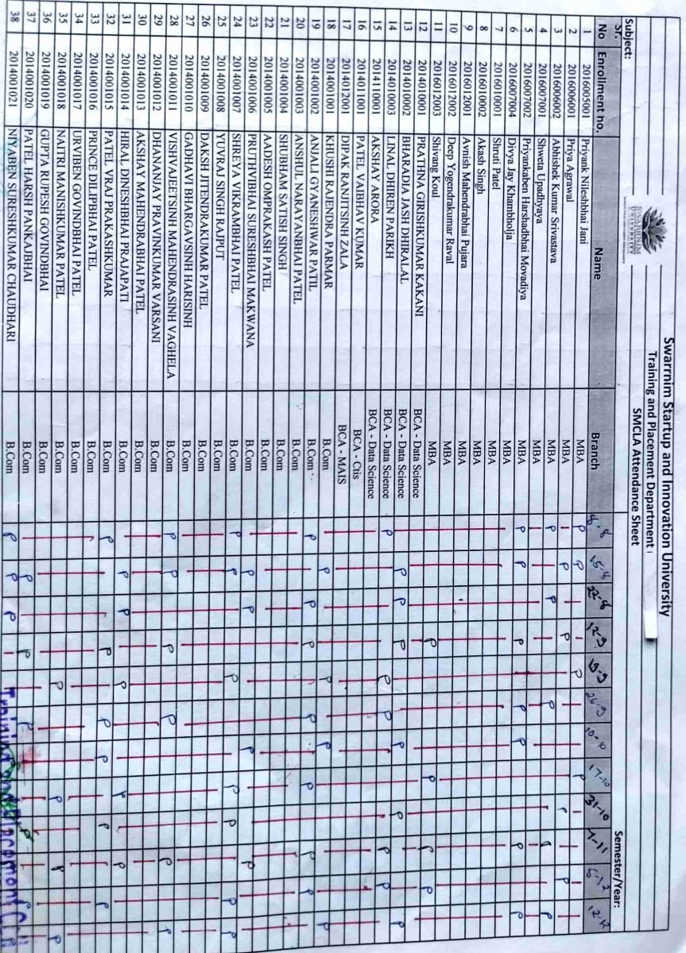

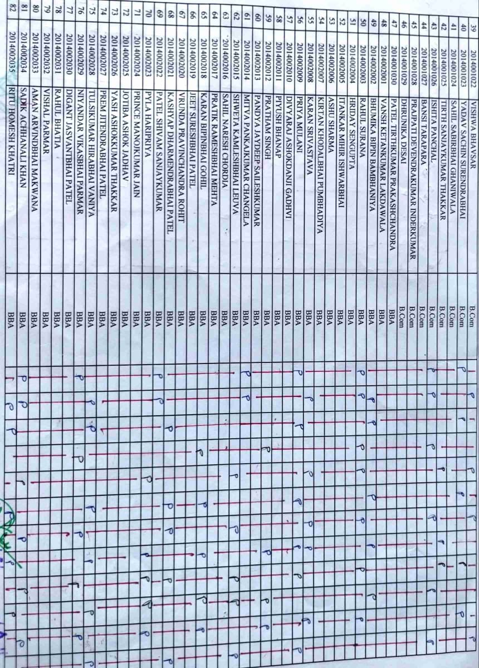

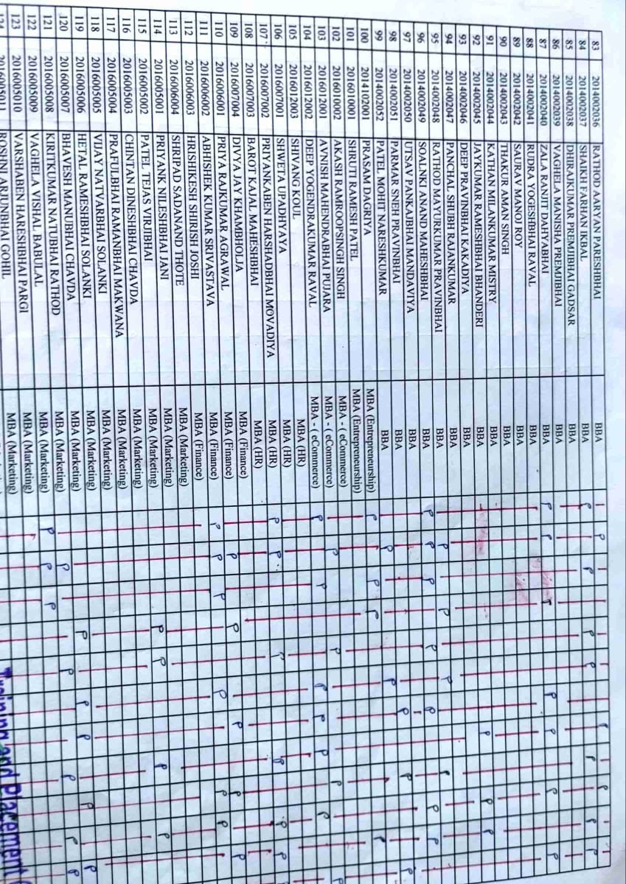

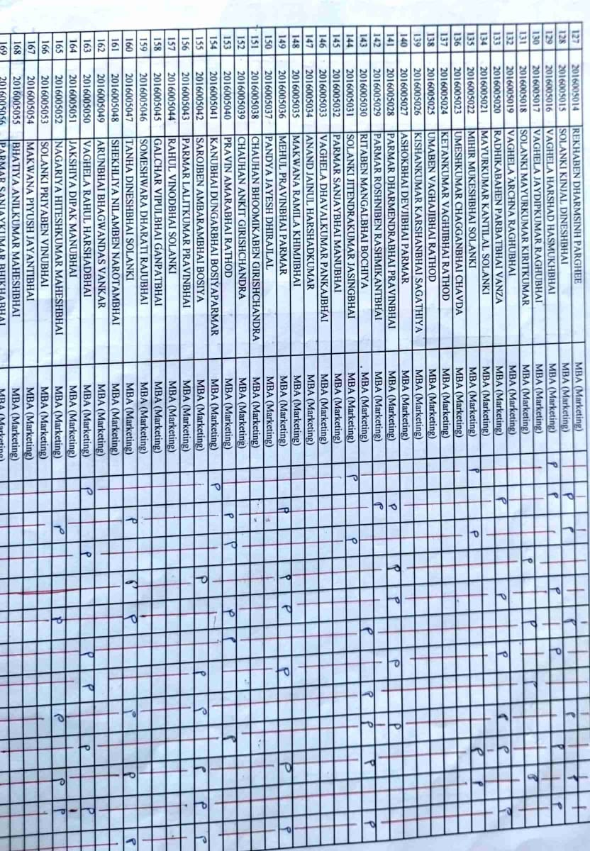

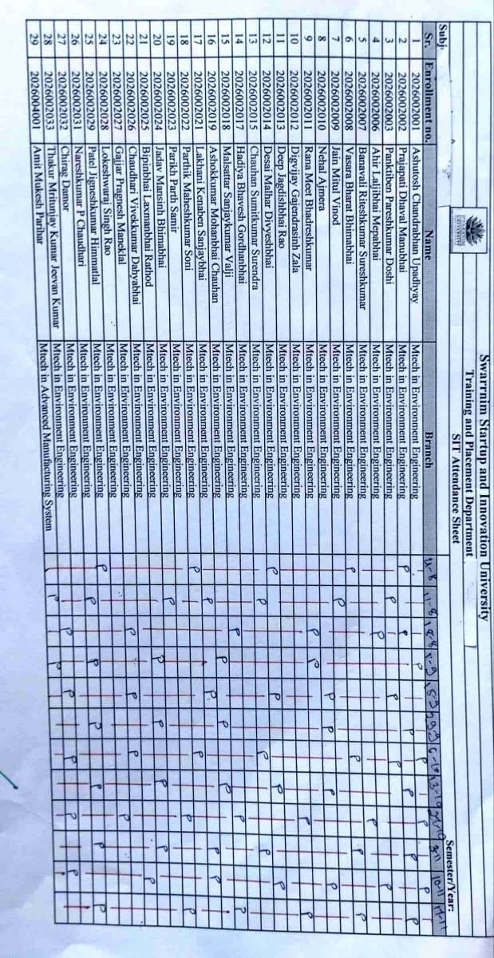

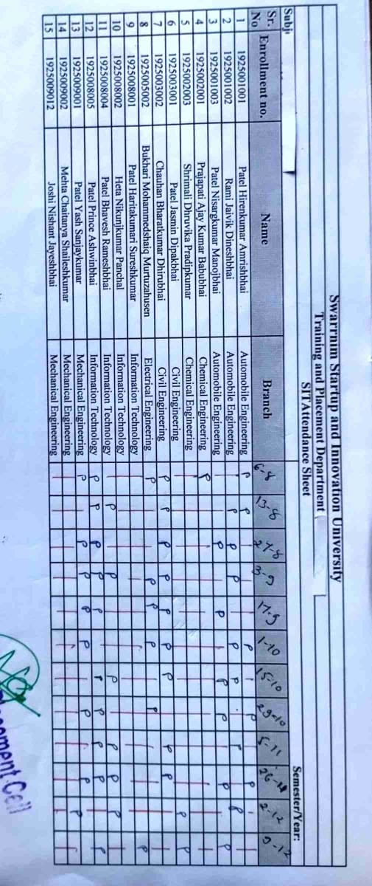

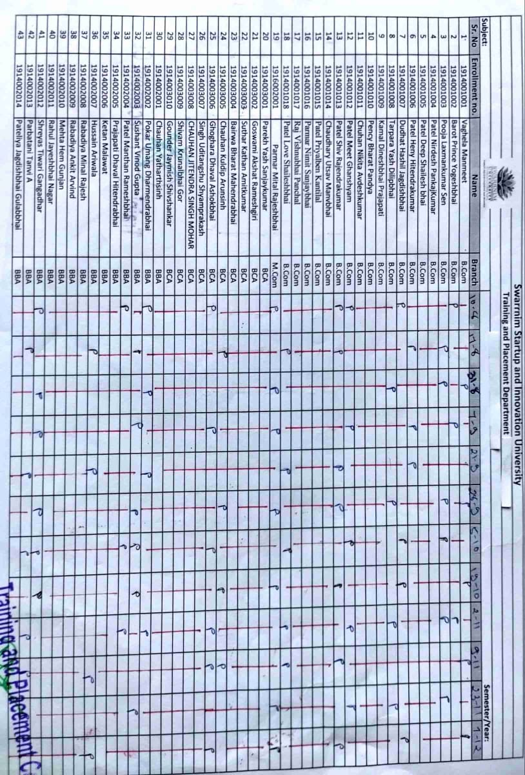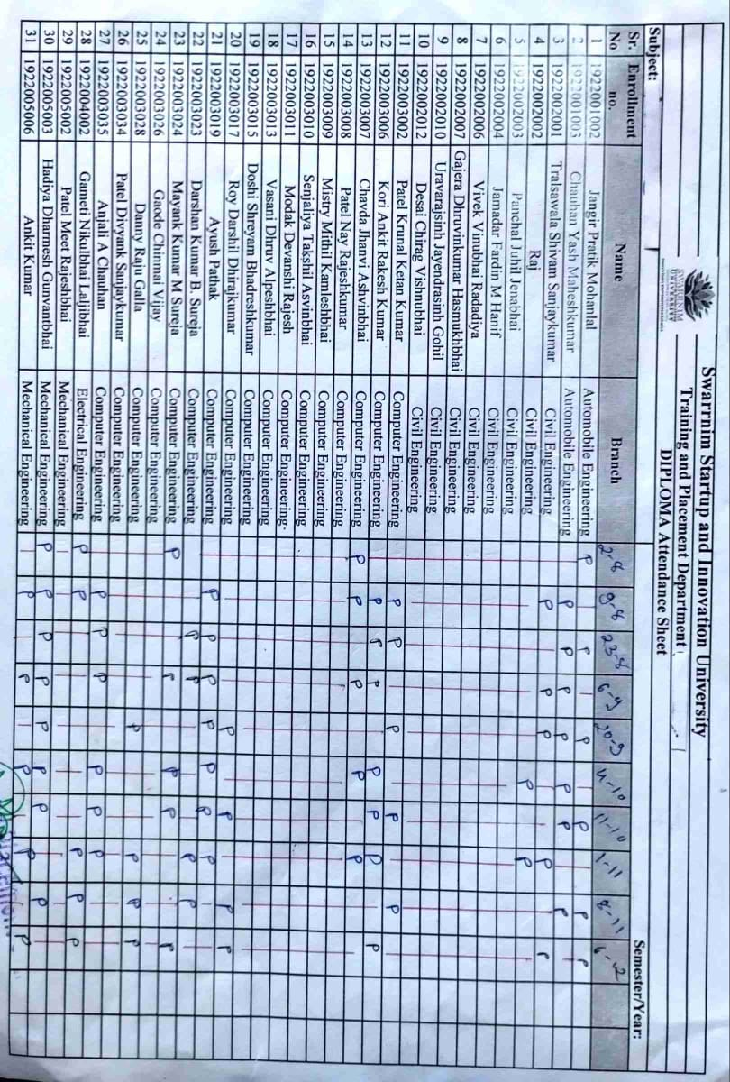

**2.4 Workshop/Seminar/Webinar**

1. **Name of Event: webinar report on “Adventures in Grammar: The Power of Stories” for management students.**

**Date of Event: 07/08/2020**

**Organized by: Training and Placement cell, Swarrnim Startup and Innovation University**

**Event Coordinator: Mr.Nimish Dave**

**Topic Overview:** In this webinar, we explore the dynamic relationship between grammar instruction and storytelling. By integrating narratives into language teaching, educators can enhance students’ understanding and retention of grammatical concepts.

**Key Points:**

1. **Contextual Learning:** Stories provide context for grammar rules. When students encounter grammar within a narrative, they grasp its practical application more effectively.
2. **Memorable Examples:** Engaging stories create memorable examples of grammar in action. Participants learn through relatable scenarios rather than abstract rules.
3. **Motivation and Engagement:** Storytelling captures learners’ interest. Grammar becomes an adventure, encouraging active participation and curiosity.
4. **Creative Exercises:** Use stories to design grammar exercises. For instance, analyze character dialogues, identify verb tenses, or rewrite sentences inspired by plot twists.
5. **Cultural Insights:** Stories offer cultural insights, exposing learners to diverse language patterns. Explore idiomatic expressions, regional variations, and historical context.

**Outcome:** “Adventures in Grammar” invites students to harness the power of stories, making grammar an exciting journey rather than a dry set of rules.

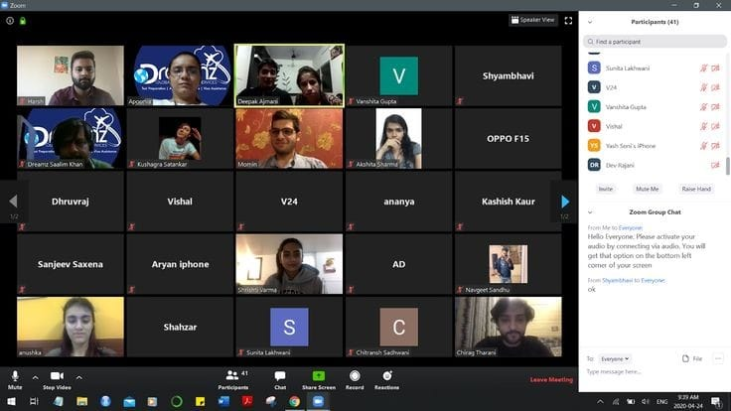

Attendance: 41

|  |  |  |  |  |
| --- | --- | --- | --- | --- |
| **Sr. No** | **Enrollment no.** | **Name** | **Branch** | **Present/Absent** |
| 1 | 2016005001 | Priyank Nileshbhai Jani | MBA | Present |
| 2 | 2016006001 | Priya Agrawal | MBA | Present |
| 3 | 2016006002 | Abhishek Kumar Srivastava | MBA | Present |
| 4 | 2016007001 | Shweta Upadhyaya | MBA | Present |
| 5 | 2016007002 | Priyankaben Harshadbhai Movadiya | MBA | Present |
| 6 | 2016007004 | Divya Jay Khambholja | MBA | Present |
| 7 | 2016010001 | Shruti Patel | MBA | Present |
| 8 | 2016010002 | Akash Singh | MBA | Present |
| 9 | 2016012001 | Avnish Mahendrabhai Pujara | MBA | Present |
| 10 | 2016012002 | Deep Yogendrakumar Raval | MBA | Present |
| 11 | 2016012003 | Shivang Koul | MBA | Present |
| 12 | 2014010001 | Prathna Girishkumar Kakani | BCA - Data Science | Present |
| 13 | 2014010002 | Bharadia Jash Dhiralal | BCA - Data Science | Present |
| 14 | 2014010003 | Linal Dhiren Parikh | BCA - Data Science | Present |
| 15 | 2014110001 | Akshay Arora | BCA - Data Science | Present |
| 16 | 2014011001 | Patel Vaibhav Kumar | BCA - Ctis | Present |
| 17 | 2014012001 | Dipak Ranjitsinh Zala | BCA - MAIS | Present |
| 18 | 2014001001 | Khushi Rajendra Parmar | B.Com | Present |
| 19 | 2014001002 | Anjali Gyaneshwar Patil | B.Com | Present |
| 20 | 2014001003 | Anshul Narayanbhai Patel | B.Com | Present |
| 21 | 2014001004 | Shubham Satish Singh | B.Com | Present |
| 22 | 2014001005 | Aadesh Omprakash Patel | B.Com | Present |
| 23 | 2014001006 | Pruthvibhai Sureshbhai Makwana | B.Com | Present |
| 24 | 2014001007 | Shreya Vikrambhai Patel | B.Com | Present |
| 25 | 2014001008 | Yuvraj Singh Rajput | B.Com | Present |
| 26 | 2014001009 | Daksh Jitendrakumar Patel | B.Com | Present |
| 27 | 2014001010 | Gadhavi Bhargavsinh Harisinh | B.Com | Present |
| 28 | 2014001011 | Vishvajeetsinh Mahendrasinh Vaghela | B.Com | Present |
| 29 | 2014001012 | Dhananjay Pravinkumar Varsani | B.Com | Present |
| 30 | 2014001013 | Akshay Mahendrabhai Patel | B.Com | Present |
| 31 | 2014001014 | Hiral Dineshbhai Prajapati | B.Com | Present |
| 32 | 2014001015 | Patel Vraj Prakashkumar | B.Com | Present |
| 33 | 2014001016 | Prince Dilipbhai Patel | B.Com | Present |
| 34 | 2014001017 | Urviben Govindbhai Patel | B.Com | Present |
| 35 | 2014001018 | Naitri Manishkumar Patel | B.Com | Present |
| 36 | 2014001019 | Gupta Rupesh Govindbhai | B.Com | Present |
| 37 | 2014001020 | Patel Harsh Pankajbhai | B.Com | Present |
| 38 | 2014001021 | Niyaben Sureshkumar Chaudhari | B.Com | Present |
| 39 | 2014001022 | Vishwa Bhavsar | B.Com | Present |
| 40 | 2014001023 | Yadav Sachin Surendrabhai | B.Com | Present |
| 41 | 2014001024 | Sahil Sabirbhai Ghaniwala | B.Com | Present |



|  |  |  |  |
| --- | --- | --- | --- |
| **Seminar Assessment Report for The Academic Year 2020-2021** | | | |
| **2020-2021** | **Option** | **Total Answer** | **Average Evaluation (Out of 4)** |
| ***1. Was the Trainer well prepared with their content?*** | Strongly Agree | 32 | **3.73** |
| Agree | 7 |
| Not Agree | 2 |
| Strongly disagree | 0 |
| ***2. Was the trainer professional?*** | Strongly Agree | 31 | **3.76** |
| Agree | 10 |
| Not Agree | 0 |
| Strongly disagree | 0 |
| ***3. Did the training content matched your expectations?*** | Strongly Agree | 36 | **3.88** |
| Agree | 5 |
| Not Agree | 0 |
| Strongly disagree | 0 |
| ***4. Was the trainer punctual?*** | Strongly Agree | 33 | **3.71** |
| Agree | 4 |
| Not Agree | 4 |
| Strongly disagree | 0 |
| ***5. Was The Trainer communicating in English?*** | Strongly Agree | 34 | **3.71** |
| Agree | 2 |
| Not Agree | 5 |
| Strongly disagree | 0 |
| ***6. Was the class engaging?*** | Strongly Agree | 41 | 4 |
| Agree | 0 |
| Not Agree | 0 |
| Strongly disagree | 0 |
|  |  |  |  |
|  |  |  |  |
|  | **Average Score (Out of 4)** | **3.80** |  |
|  | **Total Effectiveness** | **94.92%** |  |

**2**. **Name of Event: webinar report on “Adventures in Grammar: The Power of Stories” for science students**

**Date of Event: 10/08/2020**

**Organized by: Training and Placement cell, Swarrnim Startup and Innovation University**

**Event Coordinator: Mr.Nimish Dave**

**Topic Overview:** In this webinar, we explore the dynamic relationship between grammar instruction and storytelling. By integrating narratives into language teaching, educators can enhance students’ understanding and retention of grammatical concepts.

**Key Points:**

1. **Contextual Learning:** Stories provide context for grammar rules. When students encounter grammar within a narrative, they grasp its practical application more effectively.
2. **Memorable Examples:** Engaging stories create memorable examples of grammar in action. Participants learn through relatable scenarios rather than abstract rules.
3. **Motivation and Engagement:** Storytelling captures learners’ interest. Grammar becomes an adventure, encouraging active participation and curiosity.
4. **Creative Exercises:** Use stories to design grammar exercises. For instance, analyze character dialogues, identify verb tenses, or rewrite sentences inspired by plot twists.
5. **Cultural Insights:** Stories offer cultural insights, exposing learners to diverse language patterns. Explore idiomatic expressions, regional variations, and historical context.

**Outcome:** “Adventures in Grammar” invites students to harness the power of stories, making grammar an exciting journey rather than a dry set of rules.

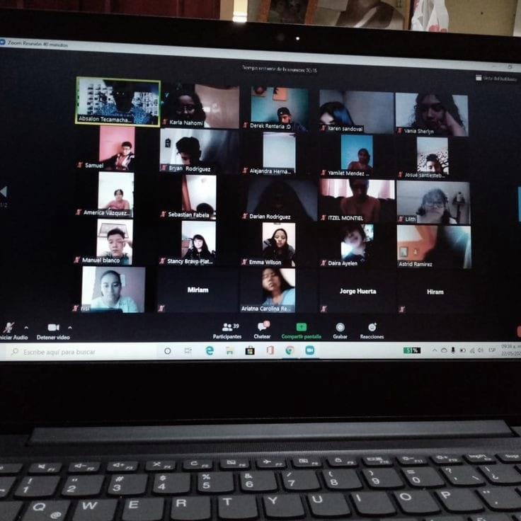

Attendance: 26

|  |  |  |  |  |
| --- | --- | --- | --- | --- |
| **Sr. No** | **Enrollment no.** | **Name** | **Branch** | **Present/Absent** |
| 1 | 2054102002 | Pradip Patel | BSc in Chemistry | Present |
| 2 | 2054102003 | Sadhu Jignesh Harendrakumar | BSc in Chemistry | Present |
| 3 | 2056001002 | Desai Anandkumar Vaghajibhai | MSc in Organic Chemistry | Present |
| 4 | 2056001003 | Panot Chiragkumar Himmatbhai | MSc in Organic Chemistry | Present |
| 5 | 2056001004 | Nayak Mohitkumar Bhikhabhai | MSc in Organic Chemistry | Present |
| 6 | 2056001005 | Patel Kuldeep Navinbhai | MSc in Organic Chemistry | Present |
| 7 | 2056001006 | Jaimin Shailesh Bhai Patel | MSc in Organic Chemistry | Present |
| 8 | 2056001007 | Prajapati Ravi Vishnubhai | MSc in Organic Chemistry | Present |
| 9 | 2056001009 | Mulani Harvi Bharatbhai | MSc in Organic Chemistry | Present |
| 10 | 2056001011 | Santi | MSc in Organic Chemistry | Present |
| 11 | 2056001013 | Patel Mitul Rajendrakumar | MSc in Organic Chemistry | Present |
| 12 | 2056001014 | Dharajiya Kirtan Naranbhai | MSc in Organic Chemistry | Present |
| 13 | 2056001015 | Aghera Mansi Kishorkumar | MSc in Organic Chemistry | Present |
| 14 | 2056001016 | Nayak Juhiben Harshadkumar | MSc in Organic Chemistry | Present |
| 15 | 2056001021 | Patel Helly Maheshkumar | MSc in Organic Chemistry | Present |
| 16 | 2056001022 | Patel Dharmeshkumar Dahyabhai | MSc in Organic Chemistry | Present |
| 17 | 2056001023 | Parimalkumar Chimanbhai Parmar | MSc in Organic Chemistry | Present |
| 18 | 2056001024 | Patel Jay Bhupendrabhai | MSc in Organic Chemistry | Present |
| 19 | 2056001026 | Patel Mayur Arvindbhai | MSc in Organic Chemistry | Present |
| 20 | 2056001027 | Patel Kena Dipeepbhai | MSc in Organic Chemistry | Present |
| 21 | 2056001028 | Nisarg Patel | MSc in Organic Chemistry | Present |
| 22 | 2056001029 | Patel Meet Chandreshbhai | MSc in Organic Chemistry | Present |
| 23 | 2056001030 | Patel Princebhai Vishnubhai | MSc in Organic Chemistry | Present |
| 24 | 2056001031 | Patel Rohankumar Natwarbhai | MSc in Analytical Chemistry | Present |
| 25 | 2056001032 | Patel Rutvik Chandrakant | MSc in Organic Chemistry | Present |
| 26 | 2056001033 | Utsav Tribhovanbhai Patel | MSc in Organic Chemistry | Present |



|  |  |  |  |
| --- | --- | --- | --- |
| **Seminar Assessment Report for The Academic Year 2020-2021** | | | |
| **2020-2021** | **Option** | **Total Answer** | **Average Evaluation (Out of 4)** |
| ***1. Was the Trainer well prepared with their content?*** | Strongly Agree | 20 | **3.73** |
| Agree | 5 |
| Not Agree | 1 |
| Strongly disagree | 0 |
| ***2. Was the trainer professional?*** | Strongly Agree | 18 | **3.69** |
| Agree | 8 |
| Not Agree | 0 |
| Strongly disagree | 0 |
| ***3. Did the training content matched your expectations?*** | Strongly Agree | 22 | **3.85** |
| Agree | 4 |
| Not Agree | 0 |
| Strongly disagree | 0 |
| ***4. Was the trainer punctual?*** | Strongly Agree | 20 | **3.77** |
| Agree | 6 |
| Not Agree | 0 |
| Strongly disagree | 0 |
| ***5. Was The Trainer communicating in English?*** | Strongly Agree | 20 | **3.62** |
| Agree | 2 |
| Not Agree | 4 |
| Strongly disagree | 0 |
| ***6. Was the class engaging?*** | Strongly Agree | 20 | **3.77** |
| Agree | 6 |
| Not Agree | 0 |
| Strongly disagree | 0 |
|  |  |  |  |
|  |  |  |  |
|  | **Average Score (Out of 4)** | **3.74** |  |
|  | **Total Effectiveness** | **93.43%** |  |

**3.** **Webinar report on The Line Between: Questions, Responses, and Critical Reading” for technology learners**.

**Date of Event: 10/08/2020**

**Organized by: Training and Placement cell, Swarrnim Startup and Innovation University**

**Event Coordinator: Mr.Nimish Dave**

**Webinar Overview:** This session delves into the intricate relationship between question formation, responses, and critical reading within the context of grammar comprehension.

**Key Points:**

1. **Question Structures:**
   * Participants explore various question types (declarative, interrogative, imperative) and their grammatical structures.
   * Emphasis on forming effective questions for communication and comprehension.
2. **Response Strategies:**
   * Analyze how different responses (direct, indirect, evasive) impact conversation flow.
   * Discuss cultural variations in response patterns.
3. **Critical Reading Skills:**
   * Connect grammar understanding to critical reading abilities.
   * Explore how recognizing linguistic cues enhances comprehension.
4. **Grammar as Context:**
   * Grammar isn’t isolated; it informs meaning.
   * Participants learn to decode grammar nuances in texts.
5. **Interactive Exercises:**
   * Engage in practical exercises: dissecting dialogues, identifying implied questions, and analyzing responses.
   * Apply critical reading skills to uncover deeper layers of meaning.

**Takeaway:** “The Line Between” underscores that grammar isn’t just rules—it’s a gateway to effective communication and insightful reading.

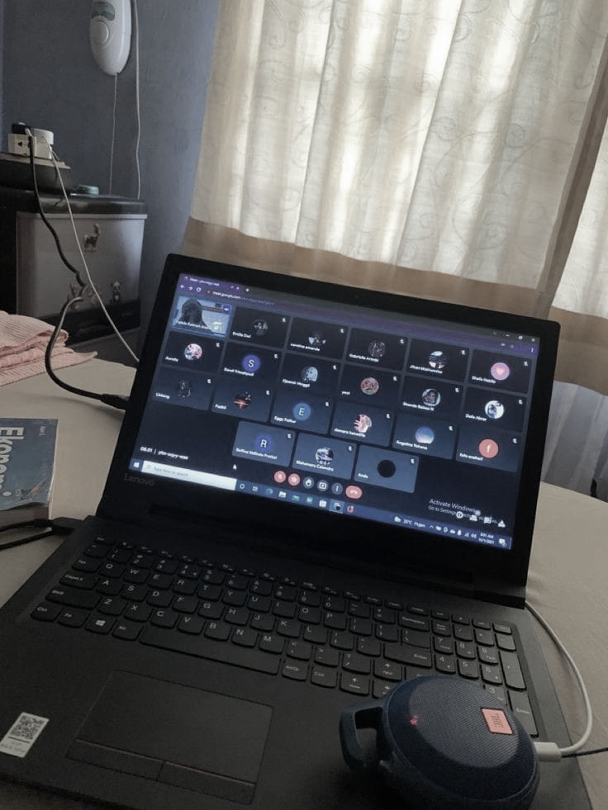

Attendance:21

|  |  |  |  |  |
| --- | --- | --- | --- | --- |
| **Sr. No** | **Enrollment no.** | **Name** | **Branch** | **Present/Absent** |
| 1 | 1922001002 | Jangir Pratik Mohanlal | Automobile Engineering | Present |
| 2 | 1922001003 | Chauhan Yash Maheshkumar | Automobile Engineering | Present |
| 3 | 1922002001 | Tralsawala Shivam Sanjaykumar | Civil Engineering | Present |
| 4 | 1922002002 | Raj | Civil Engineering | Present |
| 5 | 1922002003 | Panchal Juhil Jenabhai | Civil Engineering | Present |
| 6 | 1922002004 | Jamadar Fardin M Hanif | Civil Engineering | Present |
| 7 | 1922002006 | Vivek Vinubhai Radadiya | Civil Engineering | Present |
| 8 | 1922002007 | Gajera Dhruvinkumar Hasmukhbhai | Civil Engineering | Present |
| 9 | 1922002009 | Vasani Dhruv Alpeshbhai | Civil Engineering | Present |
| 10 | 1922002010 | Uravarajsinh Jayendrasinh Gohil | Civil Engineering | Present |
| 11 | 1922002012 | Desai Chirag Vishnubhai | Civil Engineering | Present |
| 12 | 1922003002 | Patel Krunal Ketan Kumar | Computer Engineering | Present |
| 13 | 1922003006 | Kori Ankit Rakesh Kumar | Computer Engineering | Present |
| 14 | 1922003007 | Chavda Jhanvi Ashvinbhai | Computer Engineering | Present |
| 15 | 1922003008 | Patel Nay Rajeshkumar | Computer Engineering | Present |
| 16 | 1922003009 | Mistry Mithil Kamleshbhai | Computer Engineering | Present |
| 17 | 1922003010 | Senjaliya Takshil Asvinbhai | Computer Engineering | Present |
| 18 | 1922003011 | Modak Devanshi Rajesh | Computer Engineering | Present |
| 19 | 1922003013 | Vasani Dhruv Alpeshbhai | Computer Engineering | Present |
| 20 | 1922003015 | Doshi Shreyam Bhadreshkumar | Computer Engineering | Present |
| 21 | 1922003017 | Roy Darshil Dhirajkumar | Computer Engineering | Present |



|  |  |  |  |
| --- | --- | --- | --- |
| **Seminar Assessment Report for The Academic Year 2020-2021** | | | |
| **2020-2021** | **Option** | **Total Answer** | **Average Evaluation (Out of 4)** |
| ***1. Was the Trainer well prepared with their content?*** | Strongly Agree | 17 | **3.73** |
| Agree | 3 |
| Not Agree | 1 |
| Strongly disagree | 0 |
| ***2. Was the trainer professional?*** | Strongly Agree | 13 | **3.69** |
| Agree | 8 |
| Not Agree | 0 |
| Strongly disagree | 0 |
| ***3. Did the training content matched your expectations?*** | Strongly Agree | 16 | **3.85** |
| Agree | 5 |
| Not Agree | 0 |
| Strongly disagree | 0 |
| ***4. Was the trainer punctual?*** | Strongly Agree | 19 | **3.77** |
| Agree | 0 |
| Not Agree | 2 |
| Strongly disagree | 0 |
| ***5. Was The Trainer communicating in English?*** | Strongly Agree | 15 | **3.62** |
| Agree | 0 |
| Not Agree | 6 |
| Strongly disagree | 0 |
| ***6. Was the class engaging?*** | Strongly Agree | 19 | **3.77** |
| Agree | 2 |
| Not Agree | 0 |
| Strongly disagree | 0 |
|  |  |  |  |
|  |  |  |  |
|  | **Average Score (Out of 4)** | **3.71** |  |
|  | **Total Effectiveness** | **92.86%** |  |

**4 webinar report on The Line Between: Questions, Responses, and Critical Reading” for technology learners.**

**Date of Event: 09/11/2020**

**Organized by: Training and Placement cell, Swarrnim Startup and Innovation University**

**Event Coordinator: Mr.Nimish Dave**

**Webinar Overview**

The webinar titled “The Line Between: Questions, Responses, and Critical Reading” was designed specifically for technology learners. It aimed to enhance their critical reading skills, which are essential for comprehending complex technical texts and improving overall academic performance. The key objectives were:

1. Understanding Critical Reading:
   * To explain the importance of critical reading in the context of technology and engineering.
   * To highlight techniques for analyzing and interpreting technical texts.
2. Developing Questioning Skills:
   * To teach participants how to formulate effective questions that lead to deeper understanding.
   * To demonstrate the role of questioning in critical reading and problem-solving.
3. Effective Responses:
   * To provide strategies for crafting thoughtful and analytical responses to technical content.
   * To emphasize the importance of evidence-based responses in academic and professional settings.

Webinar Highlights

1. Introduction to Critical Reading:
   * Participants were introduced to the concept of critical reading and its relevance in the technology field.
   * Techniques for identifying key ideas, arguments, and evidence in technical texts were discussed.
2. Questioning Techniques:
   * The webinar covered various questioning techniques, including open-ended and probing questions.
   * Examples of how to use questions to dissect complex technical documents were provided.
3. Crafting Responses:
   * Strategies for developing well-structured and analytical responses were shared.
   * Participants practiced responding to technical texts, focusing on clarity, coherence, and evidence-based arguments.
4. Interactive Sessions:
   * Interactive sessions allowed participants to apply the concepts learned through group discussions and exercises.
   * Real-world examples from technical fields were used to illustrate the application of critical reading and questioning techniques.

**Conclusion**

The webinar successfully highlighted the importance of critical reading, effective questioning, and analytical responses for technology learners. By mastering these skills, participants can enhance their comprehension of technical texts and improve their academic and professional performance.

**Program Outcome**

1. Enhanced Critical Reading Skills: Participants gained a deeper understanding of critical reading techniques and their application in the technology field.
2. Improved Questioning Abilities: Strategies for formulating effective questions were provided, leading to better comprehension and problem-solving skills.
3. Analytical Response Development: Participants learned to craft thoughtful and evidence-based responses to technical content.

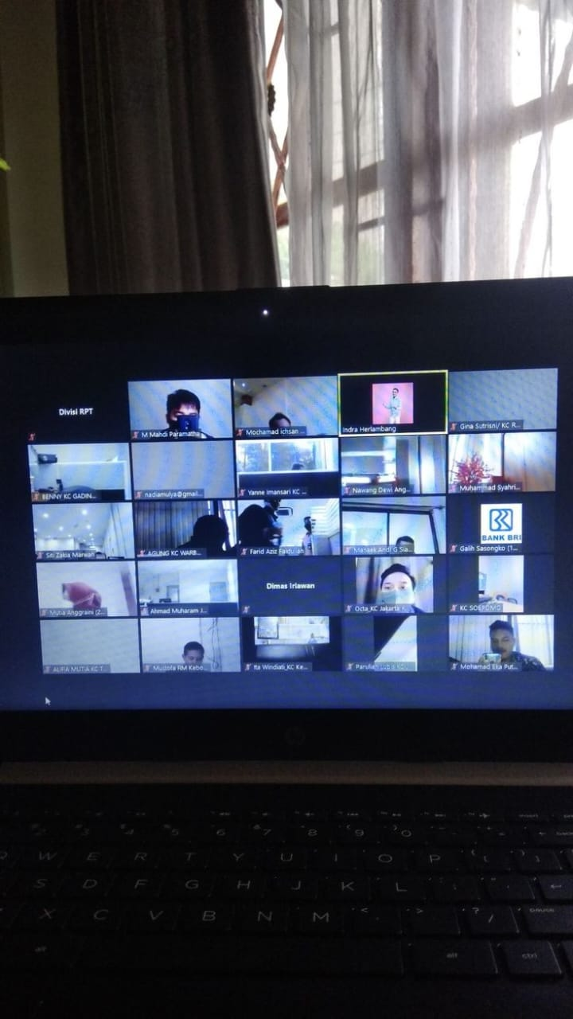

Attendance: 23

|  |  |  |  |  |
| --- | --- | --- | --- | --- |
| **Sr. No** | **Enrollment no.** | **Name** | **Branch** | **Present/ Absent** |
| 1 | 2016005001 | Priyank Nileshbhai Jani | MBA | Present |
| 2 | 2016006001 | Priya Agrawal | MBA | Present |
| 3 | 2016006002 | Abhishek Kumar Srivastava | MBA | Present |
| 4 | 2016007001 | Shweta Upadhyaya | MBA | Present |
| 5 | 2016007002 | Priyankaben Harshadbhai Movadiya | MBA | Present |
| 6 | 2016007004 | Divya Jay Khambholja | MBA | Present |
| 7 | 2016010001 | Shruti Patel | MBA | Present |
| 8 | 2016010002 | Akash Singh | MBA | Present |
| 9 | 2016012001 | Avnish Mahendrabhai Pujara | MBA | Present |
| 10 | 2016012002 | Deep Yogendrakumar Raval | MBA | Present |
| 11 | 2016012003 | Shivang Koul | MBA | Present |
| 12 | 2014010001 | Prathna girishkumar kakani | BCA - Data Science | Present |
| 13 | 2014010002 | Bharadia jash dhiralal | BCA - Data Science | Present |
| 14 | 2014010003 | Linal dhiren parikh | BCA - Data Science | Present |
| 15 | 2014110001 | Akshay arora | BCA - Data Science | Present |
| 16 | 2014011001 | Patel vaibhav kumar | BCA - Ctis | Present |
| 17 | 2014012001 | Dipak ranjitsinh zala | BCA - MAIS | Present |
| 18 | 2014001001 | Khushi rajendra parmar | B.Com | Present |
| 19 | 2014001002 | Anjali gyaneshwar patil | B.Com | Present |
| 20 | 2014001003 | Anshul narayanbhai patel | B.Com | Present |
| 21 | 2014001004 | Shubham satish singh | B.Com | Present |
| 22 | 2014001005 | Aadesh omprakash patel | B.Com | Present |
| 23 | 2014001006 | Pruthvibhai sureshbhai makwana | B.Com | Present |



|  |  |  |  |
| --- | --- | --- | --- |
| **Seminar Assessment Report for The Academic Year 2020-2021** | | | |
| **2020-2021** | **Option** | **Total Answer** | **Average Evaluation (Out of 4)** |
| ***1. Was the Trainer well prepared with their content?*** | Strongly Agree | 18 | **3.78** |
| Agree | 5 |
| Not Agree | 0 |
| Strongly disagree | 0 |
| ***2. Was the trainer professional?*** | Strongly Agree | 11 | **3.48** |
| Agree | 12 |
| Not Agree | 0 |
| Strongly disagree | 0 |
| ***3. Did the training content matched your expectations?*** | Strongly Agree | 19 | **3.96** |
| Agree | 5 |
| Not Agree | 0 |
| Strongly disagree | 0 |
| ***4. Was the trainer punctual?*** | Strongly Agree | 23 | **4.00** |
| Agree | 0 |
| Not Agree | 0 |
| Strongly disagree | 0 |
| ***5. Was The Trainer communicating in English?*** | Strongly Agree | 16 | **3.39** |
| Agree | 0 |
| Not Agree | 7 |
| Strongly disagree | 0 |
| ***6. Was the class engaging?*** | Strongly Agree | 17 | **3.74** |
| Agree | 6 |
| Not Agree | 0 |
| Strongly disagree | 0 |
|  |  |  |  |
|  |  |  |  |
|  | **Average Score (Out of 4)** | **3.72** |  |
|  | **Total Effectiveness** | **93.12%** |  |

**5. Webinar Report: Advanced Grammar for Competitive Exams**

**Date:23/02/2021  
Organized by: Training and Placement Cell, Swarrnim Startup and Innovation University  
Event Coordinator: Mr. Nimish Dave**

**Objective**

The webinar aimed to equip participants with advanced grammar skills essential for excelling in competitive exams. The key objectives were:

1. **Understanding Advanced Grammar:**
   * To explain complex grammar rules and their applications.
   * To highlight the importance of advanced grammar in competitive exams.
2. **Application in Competitive Exams:**
   * To demonstrate how advanced grammar is tested in various competitive exams.
   * To provide strategies for answering grammar-related questions effectively.

**Webinar Highlights**

1. **Complex Sentence Structures:**
   * Participants learned about complex sentence structures, including compound and complex sentences.
   * Examples: “Although he was tired, he finished his homework,” “She studied hard, so she passed the exam.”
2. **Subjunctive Mood:**
   * The use of the subjunctive mood in expressing wishes, demands, and hypothetical situations was discussed.
   * Examples: “If I were you, I would study more,” “It is essential that he be present.”
3. **Advanced Verb Tenses:**
   * Detailed explanations of perfect tenses and their usage in different contexts.
   * Examples: “She has been studying for hours,” “They will have completed the project by next week.”
4. **Common Errors and Tips:**
   * Participants were made aware of common grammar errors and how to avoid them.
   * Tips included practicing with sample questions, understanding the context, and reviewing grammar rules regularly.
5. **Practice Exercises:**
   * Interactive exercises were conducted to identify and correct advanced grammar errors.
   * Sample questions from previous competitive exams were discussed.

**Conclusion**

The webinar emphasized the critical role of advanced grammar in English language proficiency, especially for competitive exams. By mastering advanced grammar, participants can improve their accuracy and performance in the English language section of these exams.

**Program Outcome**

1. **Enhanced Understanding:** Participants gained a clear understanding of complex grammar rules and their applications.
2. **Improved Accuracy:** Strategies and tips provided helped participants reduce errors in grammar-related questions.
3. **Exam Readiness:** Participants felt more confident in tackling advanced grammar questions in competitive exams.

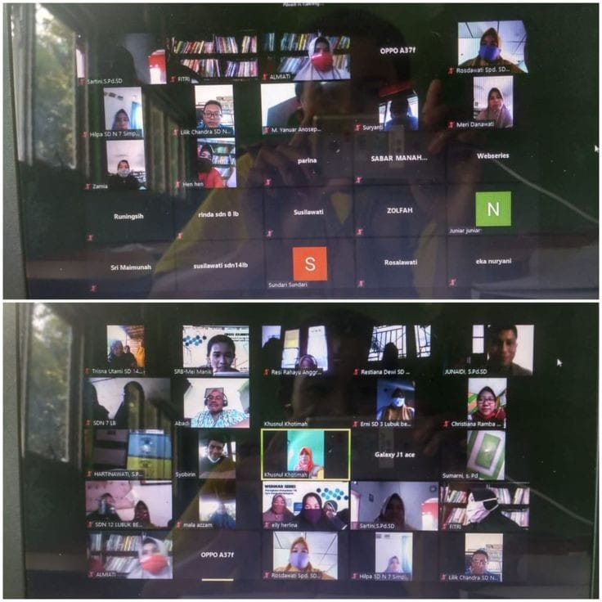

Attendance:27

|  |  |  |  |  |
| --- | --- | --- | --- | --- |
| **Sr. No** | **Enrollment no.** | **Name** | **Branch** | **Present/ Absent** |
| 1 | 2026002001 | Ashutosh Chandrabhan Upadhyay | M.Tech. EE | Present |
| 2 | 2026002002 | Prajapati Dhaval Manubhai | M.Tech. EE | Present |
| 3 | 2026002003 | Panktiben Pareshkumar Doshi | M.Tech. EE | Present |
| 4 | 2026002006 | Ahir Laljibhai Mepabhai | M.Tech. EE | Present |
| 5 | 2026002007 | Banavali Riteshkumar Sureshkumar | M.Tech. EE | Present |
| 6 | 2026002008 | Vasara Bharat Bhimabhai | M.Tech. EE | Present |
| 7 | 2026002009 | Jain Mitul Vinod | M.Tech. EE | Present |
| 8 | 2026002010 | Nehal Ajmera | M.Tech. EE | Present |
| 9 | 2026002011 | Rana Meet Bhadreshkumar | M.Tech. EE | Present |
| 10 | 2026002012 | Digvijay Gajendrasinh Zala | M.Tech. EE | Present |
| 11 | 2026002013 | Deep Jagdishbhai Rao | M.Tech. EE | Present |
| 12 | 2026002014 | Desai Malhar Divyeshbhai | M.Tech. EE | Present |
| 13 | 2026002015 | Chauhan Sumitkumar Surendra | M.Tech. EE | Present |
| 14 | 2026002017 | Hadiya Bhavesh Gordhanbhai | M.Tech. EE | Present |
| 15 | 2026002018 | Malsattar Sanjaykumar Valji | M.Tech. EE | Present |
| 16 | 2026002019 | Ashokkumar Mohanbhai Chauhan | M.Tech. EE | Present |
| 17 | 2026002021 | Lakhani Kenaben Sanjaybhai | M.Tech. EE | Present |
| 18 | 2026002022 | Parthik Maheshkumar Soni | M.Tech. EE | Present |
| 19 | 2026002023 | Parikh Parth Samir | M.Tech. EE | Present |
| 20 | 2026002024 | Jadav Mansinh Bhimabhai | M.Tech. EE | Present |
| 21 | 2026002025 | Bipinbhai Laxmanbhai Rathod | M.Tech. EE | Present |
| 22 | 2026002026 | Chaudhari Vivekkumar Dahyabhai | M.Tech. EE | Present |
| 23 | 2026002027 | Gajjar Pragnesh Maneklal | M.Tech. EE | Present |
| 24 | 2026002028 | Lokeshwaraj Singh Rao | M.Tech. EE | Present |
| 25 | 2026002029 | Patel Jigneshkumar Himmatlal | M.Tech. EE | Present |
| 26 | 2026002031 | Nareshkumar P Chaudhari | M.Tech. EE | Present |
| 27 | 2026002032 | Chirag Damor | M.Tech. EE | Present |



|  |  |  |  |
| --- | --- | --- | --- |
| **Seminar Assessment Report for The Academic Year 2020-2021** | | | |
| **2020-2021** | **Option** | **Total Answer** | **Average Evaluation (Out of 4)** |
| ***1. Was the Trainer well prepared with their content?*** | Strongly Agree | 26 | **3.78** |
| Agree | 1 |
| Not Agree | 0 |
| Strongly disagree | 0 |
| ***2. Was the trainer professional?*** | Strongly Agree | 19 | **3.48** |
| Agree | 8 |
| Not Agree | 0 |
| Strongly disagree | 0 |
| ***3. Did the training content matched your expectations?*** | Strongly Agree | 20 | **3.96** |
| Agree | 7 |
| Not Agree | 0 |
| Strongly disagree | 0 |
| ***4. Was the trainer punctual?*** | Strongly Agree | 24 | **4.00** |
| Agree | 3 |
| Not Agree | 0 |
| Strongly disagree | 0 |
| ***5. Was The Trainer communicating in English?*** | Strongly Agree | 24 | **3.39** |
| Agree | 2 |
| Not Agree | 1 |
| Strongly disagree | 0 |
| ***6. Was the class engaging?*** | Strongly Agree | 21 | **3.74** |
| Agree | 6 |
| Not Agree | 0 |
| Strongly disagree | 0 |
|  |  |  |  |
|  |  |  |  |
|  | **Average Score (Out of 4)** | **3.68** |  |
|  | **Total Effectiveness** | **92.11%** |  |

**3 Post Assessment Analysis**

























