

**Academic Year**

**2018- 2019**

|  |  |  |  |  |
| --- | --- | --- | --- | --- |
| **INDEX** | | | |  |
| **SR. No.** |  | **Topic** | **Page No** |  |
| **1** | | **Training Need Analysis** | **3-5** |  |
| **1.1** | | **Pre-Assessment Analysis** | **3-5** |  |
| **2** | | **Training Need Initiative** | **6-53** |  |
| **2.1** | | **Course Plan** | **8-20** |  |
| 2.1.1 | | Odd Semester Course Plan | 8-14 |  |
| 2.1.2 | | Even Semester Course Plan | 15-20 |  |
| **2.2** | | **Time-Table** | **21-26** |  |
| 2.2.1 | | Odd Semester Time-Table | 21-23 |  |
| 2.2.2 | | Even Semester Time-Table | 24-26 |  |
| **2.3** | | **Training Attendance** | **27-29** |  |
| **2.4** | | **Workshop/Seminar** | **30-53** |  |
|  | | Workshops Report 1 | 30-34 |  |
|  | | Workshops Report 2 | 35-38 |  |
|  | | Workshops Report 3 | 39-43 |  |
|  | | Workshops Report 4 | 44-48 |  |
|  | | Workshops Report 5 | 49-53 |  |
| **3** | | **Post Assessment Analysis** | **54-59** |  |
| **3.1** | | Slow Learner Chart | 59 |  |
| **3.2** | | Average Learner Chart | 59 |  |
| **3.3** | | Fast Learner Chart | 59 |  |

Date: 16/7/2018

To,

The Provost,

Swarrnim Startup and Innovation University,

Gandhinagar- 322420

Subject: Commencement of Soft Skills and Training Classes

As the Manager of the Training and Placement Department, I am writing to propose an initiative that will significantly enhance our students’ employability and overall professional development. In today’s competitive job market, technical skills alone are not sufficient. Employers increasingly seek candidates with strong skills—such as communication, teamwork, adaptability, and problem-solving abilities. To address this need, I recommend the introduction of Soft skills/ Quant/Verbal-training classes across all departments.

I kindly request your support in implementing this initiative. Let us work together to prepare our

students for success beyond academia.

Thank you for your attention to this matter.

Sincerely,

Mr.Nimesh Dave

Manager,

Training and Placement Department

Swarrnim Startup and Innovation University

**1. Training Needs Analysis**

**1.1 Pre-assessment (Progress Reports)**







**2. Training Need Initiative**

**5.1.3- Following Capacity development and skills enhancement initiatives**

**are taken by the institution:**

**1. Soft skills**

**2. Language and communication skills**

|  |  |  |  |
| --- | --- | --- | --- |
| **Name of Capacity building and skills enhancement** | **Date of Implementation (DD-MM-YYYY)** | **Number of Students Enrolled** | **Name of the agencies/consultants involved with contact details (If Any)** |
| English Language Class | 24-07-2018 | 136 | T&P (Internal Team) |

**2.1 Verbal Ability Course Plan**

**2.1.1 Odd Semester Course Plan Semester -3**

|  |  |  |
| --- | --- | --- |
| **Course Title** | **Course Planner** | **Lectures Hours/Week** |
| VERBAL | Mr.Nimish Dave | 1 |

|  |  |  |  |
| --- | --- | --- | --- |
| **Reference Books (RB)** | | | |
| **Sr No** | **Title** | **Author** | **Publisher Name** |
| RB-1 | Cambridge English Empower A2 Elementary Workbook | Peter Anderson | Cambridge University Press |
| RB-2 | Cambridge English Empower B1+ Intermediate | Adrian Doff, Craig | Cambridge University Press |
| RB-3 | High School English Grammar and Composition Book | Wren Martin | S.Chand |
| RB-4 | Commonly Mis-Pronounced Words | Lucy | English with Lucy |
| RB-5 | General English for Competitive Examinations | A.P. Bhardwaj | Dorling Kindersley (India)Pvt.Ltd |

|  |  |  |
| --- | --- | --- |
| **Relevant Websites ( RW )** | | |
| **Sr No** | **(Web address) (only if relevant to the course)** | **Salient Features** |
| RW-1 | <https://www.newtondesk.com/english-syllabus/> | English Grammar |
| RW-2 | <https://leverageedu.com/blog/50-difficult-words-with-meanings/> | Difficult Words- Vocabulary |
| RW-3 | <https://exams.recruitmentindia.in/questions/english/idioms-and-phrases/> | Worksheet -Idioms And Phrases |
| RW-4 | <https://exams.recruitmentindia.in/questions/english/spelling-test/> | Spelling Test |
| RW-5 | <https://www.grammarwiz.com/english-grammar-worksheets.html> | Grammar Worksheets |
| RW-6 | <https://owl.purdue.edu/owl_exercises/grammar_exercises/articles/articles_exercise_2.html> | Grammar Worksheets |
| RW-7 | <https://byjus.com/english/grammar-exercises/> | Grammar Worksheets |
| RW-8 | <https://www.englishgrammar.org/> | Grammar Worksheets |
| RW-9 | <https://www.hitbullseye.com/> | Punctuation, |
| RW-10 | <https://onlymyenglish.com/> | Tenses Exercise |

|  |  |  |
| --- | --- | --- |
| **AUDIO VISUALS (AV)** | | |
| **Sr No** | **(Web address) (only if relevant to the course)** | **Salient Features** |
| AV-1 | <https://www.youtube.com/watch?v=0Vr971stX4Y&list=PLsABmu-DQz-6WxP9pGjR9-SsiFJpwMRpE> | Speaking in English |
| AV-2 | <https://www.youtube.com/watch?v=X-BxJWWyO0E> | Parts Of Speech |
| AV-3 | <https://www.youtube.com/watch?v=YZ6Zz7SWr04> | Reading Comprehension |
| AV-4 | <https://www.youtube.com/watch?v=MrfwE2EClxs> | Sentence Arrangement |
| AV-5 | <https://www.youtube.com/watch?v=xFGUTzBlAP8> | Spot The Error |
| AV-6 | <https://www.youtube.com/watch?v=P3JYuFEIhuo> | Sentence Completion |
| AV-7 | <https://www.youtube.com/watch?v=kZHEcb_h7js> | Active Passive |
| AV-8 | <https://www.youtube.com/watch?v=AqX2dJ4IH5Q> | Degree Of Comparison |
| AV-9 | <https://www.youtube.com/watch?v=MwQdQI7valM> | Tenses |
| AV-10 | <https://www.youtube.com/watch?v=eplQBhE0-Hg> | Direct- Indirect |
| AV-11 | <https://www.youtube.com/watch?v=htYbnd9Pnos> | Tenses |
| AV-12 | <https://www.youtube.com/watch?v=Zjmgo7rh4pw> | Critical Thinking |
| AV-13 | <https://www.youtube.com/watch?v=dI-6ppn_udc> | Subject Verb Agreement |
| AV-14 | <https://www.youtube.com/watch?v=4H3-2smRJJY> | Conditional Sentence |
| AV-15 | <https://www.youtube.com/watch?v=Fx43zz0XtUs> | Idioms And Phrases |
| AV-16 | <https://www.youtube.com/watch?v=3YPMi1RbSb> | One Word Substitute |

|  |  |  |  |  |  |  |
| --- | --- | --- | --- | --- | --- | --- |
| **Week Number** | **Lecture Number** | **Broad Topic (Sub Topic)** | **Other Readings, Relevant Websites, Audio Visual Aids** | **Lecture Description** | **Learning Outcomes** | **Pedagogical Tool Demonstration/ Case Study / Images / animation / ppt etc. Planned** |
| Week 1 | Lecture 1 | Parts of speech | RB-1,  RB-2  RB-3, RW-1, RW- 4,  AV-2 | Every word in English can be classified as one of eight parts of speech. The term part of speech refers to the role a word plays in a sentence that are nouns, pronouns, verb, adjective, adverb, preposition, conjunction and interjection | Students would be able to learn about the different parts of speech that the words we use every day fall into, and how we use them together to communicate ideas clearly. | Workbook,  practice sheets |
| Week 2 | Lecture 2 |
| Week 3 | Lecture 3 | Articles and punctuation | RB-1,  RB-2  RB-3  RW-4, RW-5 | Basic Concept and use of articles for formation of sentence. Basic concept and importance of use of punctuation. | Student would be able to understand concept and use of articles and punctuation in their sentence formation. | Workbook,  practice sheets |
| Week 4 | Lecture 4 | Tenses | RB-1,  RB-2  RB-3  RW-1,RW-5,  RW-6, AV- 9, AV-11 | They will learn all types of tenses and its’ formation. They will learn how to use them in their day to day life to make better professional communications. | Students will learn all type tenses and its’ sentence formation. Students will be able to express proper meaning | Workbook,  practice sheets |
| Week 5 | Lecture 5 |
| Week 6 | Lecture 6 |
| Week 7 | Lecture 7 | Active – Passive Voice | RB-1,  RB-2  RB-3  RW-5, RW-6  AV-7 | Students will learn basic concept of Active and Passive in verbal, how to use active and passive in their routine life to have effective communication. | Students would be able to use and identify active and passive in their sentences. | Workbook,  practice sheets |
| Week8 | Lecture 8 |
| Week 9 | Lecture 9 |
| Week 10 | Lecture 10 | Degree of Comparison | RB-1,  RB-2  RB-3  RW-1, RW-5, RW-9, AV- 8 | Students will learn degree of comparison as an important tool for finding the errors, sentence corrections and many other topics covered in different examination. | Students will be able to distinguish types of adjective and type of degrees. | Workbook,  practice sheets |

**ODD Semester- 5**

|  |  |  |
| --- | --- | --- |
| **Course Title** | **Course Planner** | **Lectures Hours/Week** |
| VERBAL | Mr.Nimish Dave | 1 |

|  |  |  |  |
| --- | --- | --- | --- |
| **Reference Books ( RB)** | | | |
| **Sr No** | **Title** | **Author** | **Publisher Name** |
| RB-1 | Cambridge English Empower A2 Elementary Workbook | Peter Anderson | Cambridge University press |
| RB-2 | Cambridge English Empower B1+ Intermediate | Craig Thaine, Herbert Puchta | Cambridge University press |
| RB-3 | High School English Grammar and Composition | Wren Martin | S.Chand |
| RB-4 | Commonly Mis-Pronounced Words | Lucy | English with Lucy |
| RB-5 | General English for Competitive Examinations | A.P. Bhardwaj | Dorling Kindersley |

|  |  |  |
| --- | --- | --- |
| **Relevant Websites ( RW )** | | |
| **Sr No** | **(Web address) (only if relevant to the course)** | **Salient Features** |
| RW-1 | <https://www.newtondesk.com/english-syllabus/> | English Grammar |
| RW-2 | <https://leverageedu.com/blog/50-difficult-words-with-meanings/> | Difficult Words- Vocabulary |
| RW-3 | <https://exams.recruitmentindia.in/questions/english/idioms-and-phrases/> | Worksheet -Idioms And Phrases |
| RW-4 | <https://exams.recruitmentindia.in/questions/english/spelling-test/> | Spelling Test |
| RW-5 | <https://www.grammarwiz.com/english-grammar-worksheets.html> | Grammar Worksheets |
| RW-6 | <https://owl.purdue.edu/owl_exercises/grammar_exercises/articles/articles_exercise_2.html> | Grammar Worksheets |
| RW-7 | <https://byjus.com/english/grammar-exercises/> | Grammar Worksheets |
| RW-8 | <https://www.englishgrammar.org/> | Grammar Worksheets |
| RW-9 | <https://www.hitbullseye.com/> | Punctuation, |
| RW-10 | <https://onlymyenglish.com/> | Tenses Exercise |

|  |  |  |
| --- | --- | --- |
| **AUDIO VISUALS (AV)** | | |
| **Sr No** | **(Web address) (only if relevant to the course)** | **Salient Features** |
| AV-1 | <https://www.youtube.com/watch?v=0Vr971stX4Y&list=PLsABmu-DQz-6WxP9pGjR9-SsiFJpwMRpE> | Speaking in English |
| AV-2 | <https://www.youtube.com/watch?v=X-BxJWWyO0E> | Parts Of Speech |
| AV-3 | <https://www.youtube.com/watch?v=YZ6Zz7SWr04> | Reading Comprehension |
| AV-4 | <https://www.youtube.com/watch?v=MrfwE2EClxs> | Sentence Arrangement |
| AV-5 | <https://www.youtube.com/watch?v=xFGUTzBlAP8> | Spot The Error |
| AV-6 | <https://www.youtube.com/watch?v=P3JYuFEIhuo> | Sentence Completion |
| AV-7 | <https://www.youtube.com/watch?v=kZHEcb_h7js> | Active Passive |
| AV-8 | <https://www.youtube.com/watch?v=AqX2dJ4IH5Q> | Degree Of Comparison |
| AV-9 | <https://www.youtube.com/watch?v=MwQdQI7valM> | Tenses |
| AV-10 | <https://www.youtube.com/watch?v=eplQBhE0-Hg> | Direct- Indirect |
| AV-11 | <https://www.youtube.com/watch?v=htYbnd9Pnos> | Tenses |
| AV-12 | <https://www.youtube.com/watch?v=Zjmgo7rh4pw> | Critical Thinking |
| AV-13 | <https://www.youtube.com/watch?v=dI-6ppn_udc> | Subject Verb Agreement |
| AV-14 | <https://www.youtube.com/watch?v=4H3-2smRJJY> | Conditional Sentence |
| AV-15 | <https://www.youtube.com/watch?v=Fx43zz0XtUs> | Idioms And Phrases |
| AV-16 | <https://www.youtube.com/watch?v=3YPMi1RbSb> | One Word Substitute |

|  |  |  |  |  |  |  |
| --- | --- | --- | --- | --- | --- | --- |
| **Week Number** | **Lecture Number** | **Broad Topic (Sub Topic)** | **Readings, Relevant Websites, Audio Visual Aids** | **Lecture Description** | **Learning Outcomes** | **Pedagogical Tool Demonstration/ Case Study / Images / animation / ppt etc. Planned** |
| Week 1 | Lecture 1 | Complete the Sentence | RB-3 RB-4 RB-5 AV-6 | Students will learn that is a common test in most competitive exams. They will learn the strategy to solve it. | They will be able to solve complete the sentences segment in all competitive and placement related exams | Work book, Practice sheet |
| Week 2 | Lecture 2 | Sentence arrangement, sentence Correction | RB-3, RB-4, RB-5, RW- 1, RW-4, RW-9, AV-4 | Students will learn how to solve competitive and placement oriented questions based on sentence arrangement . | Students will be able to identify and solve sentence arrangement and sentence correction segments in all examinations. | Work book, Practice sheet |
| Week 3 | Lecture 3 | Critical Reasoning | RB-3, RB-4, RB-5, RW- 1, RW-4, RW-9, AV-12 | It intends to assess skills in students -in identifying an argument, evaluating statements, reaching at a conclusion in course of action. | Students will be able to identify an argument, evaluating statements, reaching at a conclusion to resolve the problem. | Work book, Practice sheet |
| Week 4 | Lecture 4 |
| Week 5 | Lecture 5 | Written communication- e-mail, business letter, cover letter, CV | RB-3, RB-4, RB-5 | Students will learn good written communication that will improves teams, inspires high performance and enhances the workplace culture. | Communication is a two-way process, so they will be able to take notice of other people's verbal and nonverbal signals as communication. | Work book, Practice sheet |
| Week 6 | Lecture 6 |
| Week 7 | Lecture 7 |
| Week 8 | Lecture 8 | Reading Comprehension | RB-3, RB-4, RB-5, RW- 1, RW-4, RW-9, | Reading Comprehension tests a student on a number of skills, including English comprehension and logical ability, language skills such as reading and vocabulary. | Speed reading, high concentration and material retention are all linked to Reading Comprehension. Students will be able to do them all simultaneously to solve RC. | Work book, Practice sheet |
| Week 9 | Lecture 9 |
| Week 10 | Lecture 10 | Mock Test | RB-1, RB-2, RB-3, RB-4, RB-5, RW- 1, RW-4,RW-9, AV-4, AV-6, AV-12 | Mock tests will help students to be more focused. They’ll learn how to be ‘test –ready’. | Students will be able to overcome their fear of examination by practicing them again and again. |  |

**2.1.2 Even Semester Plan- Semester- 4**

|  |  |  |
| --- | --- | --- |
| **Course Title** | **Course Planner** | **Lectures Hours/Week** |
| VERBAL | Mr.Nimish Dave | 1 |

|  |  |  |  |
| --- | --- | --- | --- |
| **Reference Books ( RB)** | | | |
| **Sr No** | **Title** | **Author** | **Publisher Name** |
| RB-1 | Cambridge English Empower A2 Elementary Workbook without answers | Peter Anderson | Cambridge University press |
| RB-2 | Cambridge English Empower B1+ Intermediate Student Book | Adrian Doff, Craig Thaine, Herbert Puchta | Cambridge University press |
| RB-3 | High School English Grammar and Composition Book (Multi colour Edition) | Wren Martin | S.Chand |
| RB-4 | Commonly Mispronounced Words | Lucy | English with Lucy |
| RB-5 | General English for Competitive Examinations | A.P. Bhardwaj | Dorling Kindersley (India)pvt. Ltd |

|  |  |  |
| --- | --- | --- |
| **Relevant Websites ( RW )** | | |
| **Sr No** | **(Web address) (only if relevant to the course)** | **Salient Features** |
| RW-1 | <https://www.newtondesk.com/english-syllabus/> | English Grammar |
| RW-2 | <https://leverageedu.com/blog/50-difficult-words-with-meanings/> | Difficult Words- Vocabulary |
| RW-3 | <https://exams.recruitmentindia.in/questions/english/idioms-and-phrases/> | Worksheet -Idioms And Phrases |
| RW-4 | <https://exams.recruitmentindia.in/questions/english/spelling-test/> | Spelling Test |
| RW-5 | <https://www.grammarwiz.com/english-grammar-worksheets.html> | Grammar Worksheets |
| RW-6 | <https://owl.purdue.edu/owl_exercises/grammar_exercises/articles/articles_exercise_2.html> | Grammar Worksheets |
| RW-7 | <https://byjus.com/english/grammar-exercises/> | Grammar Worksheets |
| RW-8 | <https://www.englishgrammar.org/> | Grammar Worksheets |
| RW-9 | <https://www.hitbullseye.com/> | Punctuation, |
| RW-10 | <https://onlymyenglish.com/> | Tenses Exercise |

|  |  |  |
| --- | --- | --- |
| **AUDIO VISUALS (AV)** | | |
| **Sr No** | **(Web address) (only if relevant to the course)** | **Salient Features** |
| AV-1 | <https://www.youtube.com/watch?v=0Vr971stX4Y&list=PLsABmu-DQz-6WxP9pGjR9-SsiFJpwMRpE> | Speaking in English |
| AV-2 | <https://www.youtube.com/watch?v=X-BxJWWyO0E> | Parts Of Speech |
| AV-3 | <https://www.youtube.com/watch?v=YZ6Zz7SWr04> | Reading Comprehension |
| AV-4 | <https://www.youtube.com/watch?v=MrfwE2EClxs> | Sentence Arrangement |
| AV-5 | <https://www.youtube.com/watch?v=xFGUTzBlAP8> | Spot The Error |
| AV-6 | <https://www.youtube.com/watch?v=P3JYuFEIhuo> | Sentence Completion |
| AV-7 | <https://www.youtube.com/watch?v=kZHEcb_h7js> | Active Passive |
| AV-8 | <https://www.youtube.com/watch?v=AqX2dJ4IH5Q> | Degree Of Comparison |
| AV-9 | <https://www.youtube.com/watch?v=MwQdQI7valM> | Tenses |
| AV-10 | <https://www.youtube.com/watch?v=eplQBhE0-Hg> | Direct- Indirect |
| AV-11 | <https://www.youtube.com/watch?v=htYbnd9Pnos> | Tenses |
| AV-12 | <https://www.youtube.com/watch?v=Zjmgo7rh4pw> | Critical Thinking |
| AV-13 | <https://www.youtube.com/watch?v=dI-6ppn_udc> | Subject Verb Agreement |
| AV-14 | <https://www.youtube.com/watch?v=4H3-2smRJJY> | Conditional Sentence |
| AV-15 | <https://www.youtube.com/watch?v=Fx43zz0XtUs> | Idioms And Phrases |
| AV-16 | <https://www.youtube.com/watch?v=3YPMi1RbSb> | One Word Substitute |

|  |  |  |  |  |  |  |
| --- | --- | --- | --- | --- | --- | --- |
| **Week No.** | **Lecture Number** | **Broad Topic (Sub Topic)** | **Other Readings, Relevant Websites, Audio Visual Aids** | **Lecture Description** | **Learning Outcomes** | **Pedagogical Tool Demonstration/ Case Study / Images / animation / ppt etc. Planned** |
| Week 1 | Lecture 1 | Direct- Indirect Speech | RB-1,  RB-2,  RB-3,  RW-1,  RW-5, RW-6,  RW-8,  AV- 10 | Students will learn to understand the basic concept of direct and indirect speech. Student will know how to use direct - indirect speech. | Students will learn how to read conversations and hoe to interpret indirect speeches. | Practice sheet, workbook |
| Week 2 | Lecture 2 |
| Week 3 | Lecture 3 |
| Week 4 | Lecture 4 | Vocabulary- synonym- antonym, homophones, homonyms, words often confuse etc. | RB-1,  RB-2,  RB-4,  RW-2 | Students will learn how to improve vocabulary in English by getting acquainted to various different words. They will learn how to put them into sentences. | Students will be able to use different new words. They will also be able to solve vocabulary based questions more conveniently. | Practice sheet, workbook |
| Week 5 | Lecture 5 |
| Week 6 | Lecture 6 |
| Week 7 | Lecture 7 | Subject verb agreement  Conditional sentence | RB-1,  RB-2,  RB-3,  RW-1,  RW-5, RW-6,  RW-8,  AV- 13,  AV-14 | Student will understand how to use subject- verb in grammar. They will learn how it is useful in company placement rounds and for competitive exams.. | Students will be able to use conditional sentences in their vocabulary and they will also be able to identify error spotting with the help if it. | Practice sheet, workbook |
| Week 8 | Lecture 8 |
| Week 9 | Lecture 9 | Idioms and Phrases,  One Word Substitute | RB-1,  RB-5,  RW-3,  AV-5, AV-6 | Students will learn different types of idioms that are used in professional life. They will also learn one word substitute to make their language richer. | The students will be able to use idioms and phrases in their routine and in all types of communications. They will also learn one word substitute as a part of vocabulary learning. | Practice sheet, workbook |
| Week 10 | Lecture 10 |

**EVEN Semester- 6**

|  |  |  |
| --- | --- | --- |
| **Course Title** | **Course Planner** | **Lectures Hours/Week** |
| VERBAL | Mr.Nimish Dave | 1 |

|  |  |  |  |
| --- | --- | --- | --- |
| **Reference Books ( RB)** | | | |
| **Sr No** | **Title** | **Author** | **Publisher Name** |
| RB-1 | Cambridge English Empower A2 Elementary Workbook without answers | Peter Anderson | Cambridge University press |
| RB-2 | Cambridge English Empower B1+ Intermediate Student Book | Adrian Doff, Craig Thaine, Herbert Puchta | Cambridge University press |
| RB-3 | High School English Grammar and Composition Book (Multicolour Edition) | Wren Martin | S.Chand |
| RB-4 | Commonly Mis-Pronounced Words | Lucy | English with Lucy |
| RB-5 | General English for Competitive Examinations | A.P. Bhardwaj | Dorling Kindersley (india)pvt.Ltd |

|  |  |  |
| --- | --- | --- |
| **Relevant Websites ( RW )** | | |
| **Sr No** | **(Web address) (only if relevant to the course)** | **Salient Features** |
| RW-1 | <https://www.newtondesk.com/english-syllabus/> | English Grammar |
| RW-2 | <https://leverageedu.com/blog/50-difficult-words-with-meanings/> | Difficult Words- Vocabulary |
| RW-3 | <https://exams.recruitmentindia.in/questions/english/idioms-and-phrases/> | Worksheet -Idioms And Phrases |
| RW-4 | <https://exams.recruitmentindia.in/questions/english/spelling-test/> | Spelling Test |
| RW-5 | <https://www.grammarwiz.com/english-grammar-worksheets.html> | Grammar Worksheets |
| RW-6 | <https://owl.purdue.edu/owl_exercises/grammar_exercises/articles/articles_exercise_2.html> | Grammar Worksheets |
| RW-7 | <https://byjus.com/english/grammar-exercises/> | Grammar Worksheets |
| RW-8 | <https://www.englishgrammar.org/> | Grammar Worksheets |
| RW-9 | <https://www.hitbullseye.com/> | Punctuation, |
| RW-10 | <https://onlymyenglish.com/> | Tenses Exercise |

|  |  |  |
| --- | --- | --- |
| **AUDIO VISUALS (AV)** | | |
| **Sr No** | **(Web address) (only if relevant to the course)** | **Salient Features** |
| AV-1 | <https://www.youtube.com/watch?v=0Vr971stX4Y&list=PLsABmu-DQz-6WxP9pGjR9-SsiFJpwMRpE> | Speaking in English |
| AV-2 | <https://www.youtube.com/watch?v=X-BxJWWyO0E> | Parts Of Speech |
| AV-3 | <https://www.youtube.com/watch?v=YZ6Zz7SWr04> | Reading Comprehension |
| AV-4 | <https://www.youtube.com/watch?v=MrfwE2EClxs> | Sentence Arrangement |
| AV-5 | <https://www.youtube.com/watch?v=xFGUTzBlAP8> | Spot The Error |
| AV-6 | <https://www.youtube.com/watch?v=P3JYuFEIhuo> | Sentence Completion |
| AV-7 | <https://www.youtube.com/watch?v=kZHEcb_h7js> | Active Passive |
| AV-8 | <https://www.youtube.com/watch?v=AqX2dJ4IH5Q> | Degree Of Comparison |
| AV-9 | <https://www.youtube.com/watch?v=MwQdQI7valM> | Tenses |
| AV-10 | <https://www.youtube.com/watch?v=eplQBhE0-Hg> | Direct- Indirect |
| AV-11 | <https://www.youtube.com/watch?v=htYbnd9Pnos> | Tenses |
| AV-12 | <https://www.youtube.com/watch?v=Zjmgo7rh4pw> | Critical Thinking |
| AV-13 | <https://www.youtube.com/watch?v=dI-6ppn_udc> | Subject Verb Agreement |
| AV-14 | <https://www.youtube.com/watch?v=4H3-2smRJJY> | Conditional Sentence |
| AV-15 | <https://www.youtube.com/watch?v=Fx43zz0XtUs> | Idioms And Phrases |
| AV-16 | <https://www.youtube.com/watch?v=3YPMi1RbSb> | One Word Substitute |

|  |  |  |  |  |  |  |
| --- | --- | --- | --- | --- | --- | --- |
| **Week Number** | **Lecture Number** | **Broad Topic (Sub Topic)** | **Other Readings, Relevant Websites, Audio Visual Aids** | **Lecture Description** | **Learning Outcomes** | **Pedagogical Tool Demonstration/ Case Study / Images / animation / ppt etc. Planned** |
| Week 1 | Lecture 1 | English Pronunciation- Transcription | RB-4,AV-1 | It will help students to understand actual way to read new words and it’s pronunciation. | They will learn how to pronounce correctly new words. | Exercise sheets, workbook |
| Week 2 | Lecture 2 | Para-Jumble | RB-5,AV-4, RW-2 | Students will learn different approaches to analyze paragraph and will learn how to identify transition words. | Students will be able to identify how to read and how to complete the para-jumbles correctly | Exercise sheets, workbook |
| Week 3 | Lecture 3 |
| Week 4 | Lecture 4 | Find The Error | RB-5  AV-5  RW-2 | Students will learn the importance of error spotting in exams and they will learn tricks to solve it easily. | Students will be able to apply tricks to spot the error/ find the error part for all types of competitive exams | Exercise sheets, workbook |
| Week5 | Lecture 5 |
| Week6 | Lecture 6 | Cloze Test | RB-5, RW-3 | Students will learn how to solve cloze test in no time. They will learn the tricks to solve two major formats of cloze test: fill in the blanks and replacing the word more swiftly and correctly. | They will be able to solve cloze tests more swiftly, they will be able identify both formats to perform the test. | Exercise sheets, workbook |
| Week7 | Lecture 7 |
| Week 8 | Lecture 8 | Mock Test ** | RB-5,RB-4,AV-1  AV-4,AV-5, RW-2, RW-3 | Students will learn how to be placement ready with all the parameters keeping in mind. They will put all the verbal knowledge into practice. | They will be more confident and prepared for the tests prior to actual company drives. | Exercise sheets, workbook |
| Week 9 | Lecture 9 |
| Week-10 | Lecture 10 |

**Practice Sheet- 1.** [**Semester-3**](https://drive.google.com/file/d/1o3HWixXBsMk4Oo0xJOVAk2rew0NG3U5_/view?usp=drive_link) **2.** [**Semester-4**](https://drive.google.com/file/d/1WFgVB71Oq_CqE9Xwx_zjvM0D4S83MvQo/view?usp=drive_link)

**3.** [**Semester-5**](https://drive.google.com/file/d/1GMU-VDbO1YyZFGrp_eoDupmFjDYwDKuE/view?usp=drive_link) **4.** [**Semester-6**](https://drive.google.com/file/d/1DUcekPphUI571QiKUMknJ3AWoQGc_XiV/view?usp=drive_link)

**2.2 Time-Table**

**2.2.1 Department wise Time Table -ODD Semester**

|  |  |  |  |  |  |  |
| --- | --- | --- | --- | --- | --- | --- |
| **Course: BBA/BCOM/BCA/BSC IT** | | | **Semester : 5** | | **Year : 2018-2019** | |
| **Day/Time** | **Monday** | **Tuesday** | **Wednesday** | **Thursday** | **Friday** | **Saturday** |
| **9:15 - 10:15** |  |  |  |  |  | **Verbal** |
| **10:15 - 11:15** |  |  |  |  |  |  |
| **11:15 - 12:15** |  |  |  |  |  |  |
| **RECESS-12:15 - 1:00** | | | | | | |
| **13:00 - 14:00** |  |  |  |  |  |  |
| **14:00 - 15:00** |  |  |  |  |  |  |
| **15:00 - 16:00** |  |  |  |  |  |  |
| **16:00 - 17:00** |  |  |  |  |  |  |

|  |  |  |  |  |  |  |
| --- | --- | --- | --- | --- | --- | --- |
| **Course: BBA/BCOM/BCA/BSC IT** | | | **Semester : 3** | | **Year : 2018-2019** | |
| **Day/Time** | **Monday** | **Tuesday** | **Wednesday** | **Thursday** | **Friday** | **Saturday** |
| **9:15 - 10:15** |  |  |  |  |  |  |
| **10:15 - 11:15** |  |  |  |  |  | **Verbal** |
| **11:15 - 12:15** |  |  |  |  |  |  |
| **RECESS-12:15 - 1:00** | | | | | | |
| **13:00 - 14:00** |  |  |  |  |  |  |
| **14:00 - 15:00** |  |  |  |  |  |  |
| **15:00 - 16:00** |  |  |  |  |  |  |
| **16:00 - 17:00** |  |  |  |  |  |  |

|  |  |  |  |  |  |  |
| --- | --- | --- | --- | --- | --- | --- |
| **Course: Diploma** | | | **Semester : 5** | | **Year : 2018-2019** | |
| **Day/Time** | **Monday** | **Tuesday** | **Wednesday** | **Thursday** | **Friday** | **Saturday** |
| **9:15 - 10:15** |  |  |  |  |  |  |
| **10:15 - 11:15** |  |  |  |  |  |  |
| **11:15 - 12:15** |  |  |  |  |  |  |
| **RECESS-12:15 - 1:00** | | | | | | |
| **13:00 - 14:00** |  |  |  |  |  |  |
| **14:00 - 15:00** |  |  |  |  |  |  |
| **15:00 - 16:00** |  |  |  |  |  |  |
| **16:00 - 17:00** |  |  |  | **Verbal** |  |  |

|  |  |  |  |  |  |  |
| --- | --- | --- | --- | --- | --- | --- |
| **Course: Diploma** | | | **Semester : 3** | | **Year : 2018-2019** | |
| **Day/Time** | **Monday** | **Tuesday** | **Wednesday** | **Thursday** | **Friday** | **Saturday** |
| **9:15 - 10:15** |  |  |  |  |  |  |
| **10:15 - 11:15** |  |  |  |  |  |  |
| **11:15 - 12:15** |  |  |  |  |  |  |
| **RECESS-12:15 - 1:00** | | | | | | |
| **13:00 - 14:00** |  |  |  |  |  |  |
| **14:00 - 15:00** |  |  |  |  |  |  |
| **15:00 - 16:00** |  |  |  |  |  |  |
| **16:00 - 17:00** |  |  |  |  | **Verbal** |  |

|  |  |  |  |  |  |  |
| --- | --- | --- | --- | --- | --- | --- |
| **Course: Diploma** | | | **Semester : 3** | | **Year : 2018-2019** | |
| **Day/Time** | **Monday** | **Tuesday** | **Wednesday** | **Thursday** | **Friday** | **Saturday** |
| **9:15 - 10:15** |  |  |  |  |  |  |
| **10:15 - 11:15** |  |  |  |  |  |  |
| **11:15 - 12:15** |  |  |  |  |  |  |
| **RECESS-12:15 - 1:00** | | | | | | |
| **13:00 - 14:00** |  |  |  |  |  |  |
| **14:00 - 15:00** |  |  |  |  |  |  |
| **15:00 - 16:00** |  |  |  |  |  |  |
| **16:00 - 17:00** |  |  |  |  | **Verbal** |  |

|  |  |  |  |  |  |  |
| --- | --- | --- | --- | --- | --- | --- |
| **Course: SIT** | | | **Semester : 5** | | **Year : 2018-2019** | |
| **Day/Time** | **Monday** | **Tuesday** | **Wednesday** | **Thursday** | **Friday** | **Saturday** |
| **9:15 - 10:15** |  |  |  |  |  |  |
| **10:15 - 11:15** |  |  |  |  |  |  |
| **11:15 - 12:15** |  |  |  |  |  |  |
| **RECESS-12:15 - 1:00** | | | | | | |
| **13:00 - 14:00** |  |  |  |  |  |  |
| **14:00 - 15:00** |  |  |  |  |  |  |
| **15:00 - 16:00** |  |  |  |  |  |  |
| **16:00 - 17:00** | **Verbal** |  |  |  |  |  |

|  |  |  |  |  |  |  |
| --- | --- | --- | --- | --- | --- | --- |
| **Course: SIT** | | | **Semester : 3** | | **Year : 2018-2019** | |
| **Day/Time** | **Monday** | **Tuesday** | **Wednesday** | **Thursday** | **Friday** | **Saturday** |
| **9:15 - 10:15** |  |  |  |  |  |  |
| **10:15 - 11:15** |  |  |  |  |  |  |
| **11:15 - 12:15** |  |  |  |  |  |  |
| **RECESS-12:15 - 1:00** | | | | | | |
| **13:00 - 14:00** |  |  |  |  |  |  |
| **14:00 - 15:00** |  |  |  |  |  |  |
| **15:00 - 16:00** |  |  |  |  |  |  |
| **16:00 - 17:00** |  | **Verbal** |  |  |  |  |

**2.2.2 Department wise Time Table -Even Semester**

|  |  |  |  |  |  |  |
| --- | --- | --- | --- | --- | --- | --- |
| **Course: BBA/BCOM/BCA/BSC IT** | | | **Semester : 5** | | **Year : 2018-2019** | |
| **Day/Time** | **Monday** | **Tuesday** | **Wednesday** | **Thursday** | **Friday** | **Saturday** |
| **9:15 - 10:15** |  |  |  |  |  | **Verbal** |
| **10:15 - 11:15** |  |  |  |  |  |  |
| **11:15 - 12:15** |  |  |  |  |  |  |
| **RECESS-12:15 - 1:00** | | | | | | |
| **13:00 - 14:00** |  |  |  |  |  |  |
| **14:00 - 15:00** |  |  |  |  |  |  |
| **15:00 - 16:00** |  |  |  |  |  |  |
| **16:00 - 17:00** |  |  |  |  |  |  |

|  |  |  |  |  |  |  |
| --- | --- | --- | --- | --- | --- | --- |
| **Course: BBA/BCOM/BCA/BSC IT** | | | **Semester : 3** | | **Year : 2018-2019** | |
| **Day/Time** | **Monday** | **Tuesday** | **Wednesday** | **Thursday** | **Friday** | **Saturday** |
| **9:15 - 10:15** |  |  |  |  |  | **Verbal** |
| **10:15 - 11:15** |  |  |  |  |  |  |
| **11:15 - 12:15** |  |  |  |  |  |  |
| **RECESS-12:15 - 1:00** | | | | | | |
| **13:00 - 14:00** |  |  |  |  |  |  |
| **14:00 - 15:00** |  |  |  |  |  |  |
| **15:00 - 16:00** |  |  |  |  |  |  |
| **16:00 - 17:00** |  |  |  |  |  |  |

|  |  |  |  |  |  |  |
| --- | --- | --- | --- | --- | --- | --- |
| **Course: Diploma** | | | **Semester : 5** | | **Year : 2018-2019** | |
| **Day/Time** | **Monday** | **Tuesday** | **Wednesday** | **Thursday** | **Friday** | **Saturday** |
| **9:15 - 10:15** |  |  |  |  |  |  |
| **10:15 - 11:15** |  |  |  |  |  |  |
| **11:15 - 12:15** |  |  |  |  |  |  |
| **RECESS-12:15 - 1:00** | | | | | | |
| **13:00 - 14:00** |  |  |  |  |  |  |
| **14:00 - 15:00** |  |  |  |  |  |  |
| **15:00 - 16:00** |  |  |  |  |  |  |
| **16:00 - 17:00** |  |  |  | **Verbal** |  |  |

|  |  |  |  |  |  |  |
| --- | --- | --- | --- | --- | --- | --- |
| **Course: Diploma** | | | **Semester : 3** | | **Year : 2018-2019** | |
| **Day/Time** | **Monday** | **Tuesday** | **Wednesday** | **Thursday** | **Friday** | **Saturday** |
| **9:15 - 10:15** |  |  |  |  |  |  |
| **10:15 - 11:15** |  |  |  |  |  |  |
| **11:15 - 12:15** |  |  |  |  |  |  |
| **RECESS-12:15 - 1:00** | | | | | | |
| **13:00 - 14:00** |  |  |  |  |  |  |
| **14:00 - 15:00** |  |  |  |  |  |  |
| **15:00 - 16:00** |  |  |  |  |  |  |
| **16:00 - 17:00** |  |  |  |  | **Verbal** |  |

|  |  |  |  |  |  |  |
| --- | --- | --- | --- | --- | --- | --- |
| **Course: Diploma** | | | **Semester : 3** | | **Year : 2018-2019** | |
| **Day/Time** | **Monday** | **Tuesday** | **Wednesday** | **Thursday** | **Friday** | **Saturday** |
| **9:15 - 10:15** |  |  |  |  |  |  |
| **10:15 - 11:15** |  |  |  |  |  |  |
| **11:15 - 12:15** |  |  |  |  |  |  |
| **RECESS-12:15 - 1:00** | | | | | | |
| **13:00 - 14:00** |  |  |  |  |  |  |
| **14:00 - 15:00** |  |  |  |  |  |  |
| **15:00 - 16:00** |  |  |  |  |  |  |
| **16:00 - 17:00** |  |  |  |  | **Verbal** |  |

|  |  |  |  |  |  |  |
| --- | --- | --- | --- | --- | --- | --- |
| **Course: SIT** | | | **Semester : 5** | | **Year : 2018-2019** | |
| **Day/Time** | **Monday** | **Tuesday** | **Wednesday** | **Thursday** | **Friday** | **Saturday** |
| **9:15 - 10:15** |  |  |  |  |  |  |
| **10:15 - 11:15** |  |  |  |  |  |  |
| **11:15 - 12:15** |  |  |  |  |  |  |
| **RECESS-12:15 - 1:00** | | | | | | |
| **13:00 - 14:00** |  |  |  |  |  |  |
| **14:00 - 15:00** |  |  |  |  |  |  |
| **15:00 - 16:00** |  |  |  |  |  |  |
| **16:00 - 17:00** | **Verbal** |  |  |  |  |  |

|  |  |  |  |  |  |  |
| --- | --- | --- | --- | --- | --- | --- |
| **Course: SIT** | | | **Semester : 3** | | **Year : 2018-2019** | |
| **Day/Time** | **Monday** | **Tuesday** | **Wednesday** | **Thursday** | **Friday** | **Saturday** |
| **9:15 - 10:15** |  |  |  |  |  |  |
| **10:15 - 11:15** |  |  |  |  |  |  |
| **11:15 - 12:15** |  |  |  |  |  |  |
| **RECESS-12:15 - 1:00** | | | | | | |
| **13:00 - 14:00** |  |  |  |  |  |  |
| **14:00 - 15:00** |  |  |  |  |  |  |
| **15:00 - 16:00** |  |  |  |  |  |  |
| **16:00 - 17:00** |  | **Verbal** |  |  |  |  |

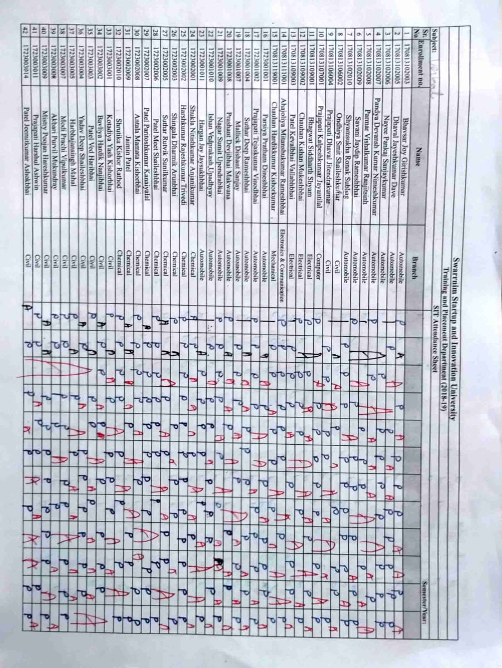**2.3 Attendance**

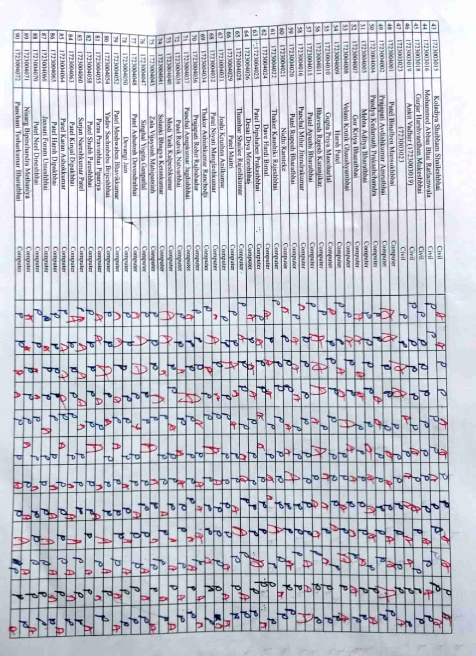

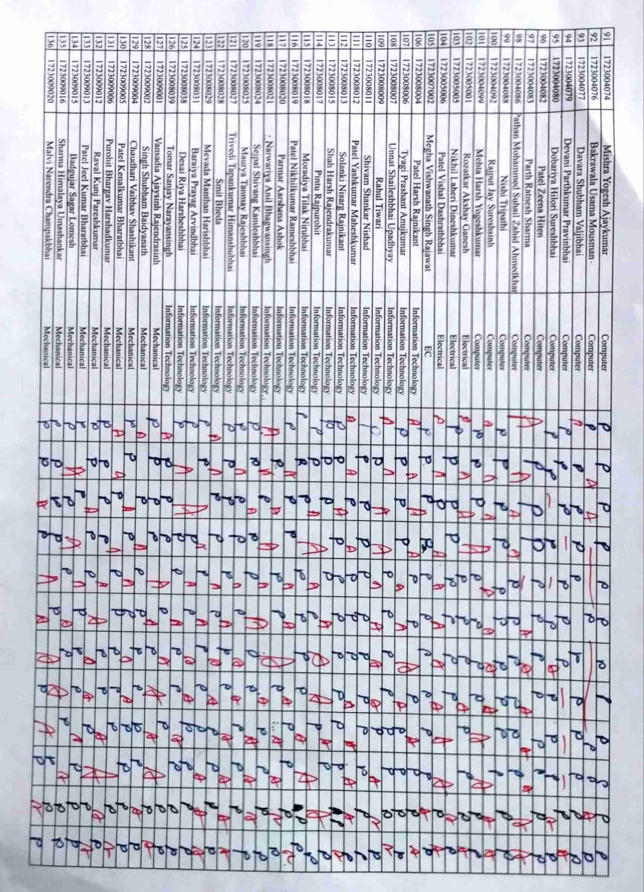

**2.4 Workshop/Seminar**

1. **Name of Event: Workshop Report: Connecting Grammar to Real-World Contexts**

**Date of Event: 07/09/2018**

**Organized by: Training and Placement cell, Swarrnim Startup and Innovation University**

**Event Coordinator: Mr.Nimish Dave**

# Objective:

# **Contextual Learning**:

* + Understand the importance of context in grammar instruction.
  + Explore how real-world scenarios enhance students’ grasp of grammar concepts.

1. **Authentic Materials**:
   * Discuss using authentic texts (news articles, advertisements, social media posts) to teach grammar.
   * Analyze how context-rich materials engage learners and promote deeper understanding.
2. **Task-Based Activities:**
   * Design communicative tasks that integrate grammar.
   * Participants collaborated on creating activities related to travel, shopping, job interviews, and more.

## **Workshop Highlights**

### 1. Contextual Grammar Lessons

* Participants examined grammar rules within specific contexts (e.g., ordering food at a restaurant, writing emails).
* Examples included verb tenses in travel narratives and prepositions in directions.

### 2. Real-Life Scenarios

* Authentic dialogues and role-playing exercises allowed participants to apply grammar rules.
* Participants practiced negotiating prices, making recommendations, and expressing opinions.

### 3. Technology Integration

* Explore digital tools (language apps, podcasts, online news) that provide real-world language input.
* Discuss how learners can engage with these resources to reinforce grammar skills.

### 4. Error Analysis

* Participants analyzed authentic texts for common errors.
* Emphasis on identifying patterns and discussing why certain structures are used.

## **Conclusion**

The workshop highlighted the symbiotic relationship between grammar and context. By connecting grammar to real-world situations, educators empower learners to use language authentically. As we bridge theory and practice, grammar becomes a dynamic and purposeful aspect of language learning.

**Program Outcome:**

1. **Meaningful Learning: Grammar is more than rules; it’s a tool for effective communication.**
2. **Learner Engagement: Real-world contexts motivate learners and make grammar relevant.**
3. 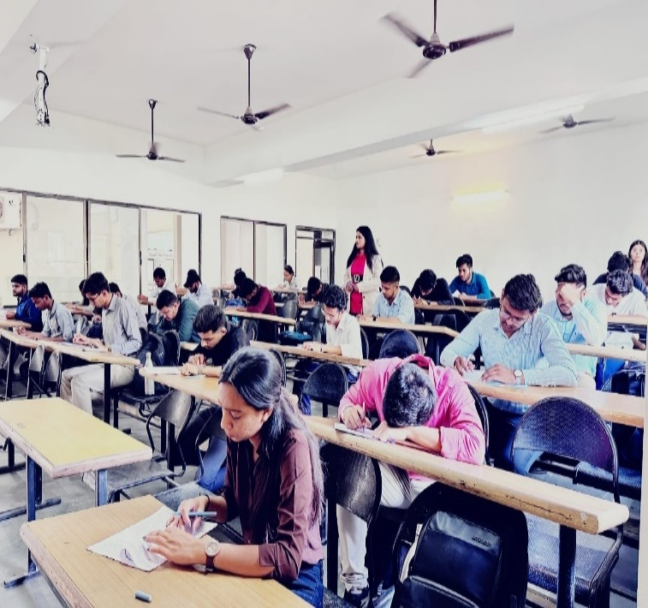**Teacher Adaptability: Educators can tailor activities to suit learners’ interests and needs.**

Attendance: 41

|  |  |  |  |  |
| --- | --- | --- | --- | --- |
| **Sr. No** | **Enrollment no.** | **Name** | **Branch** | **Present/Absent** |
| 1 | 1864001001 | Solanki Ankit V | BBA | Present |
| 2 | 1864001002 | Yadav Aakash R | BBA | Present |
| 3 | 1864001003 | Prajapati Pooja N | BBA | Present |
| 4 | 1864001004 | Gor Adarsh Nitinbhai | BBA | Present |
| 5 | 1864001005 | Rajput Chahalraj Hareshkumar | BBA | Present |
| 6 | 1864001006 | Panchal Mital Atulbhai | BBA | Present |
| 7 | 1864001007 | Yadav Paras | BBA | Present |
| 8 | 1864001008 | Patel Parth Shaileshbhai | BBA | Present |
| 9 | 1864001009 | Shah Jainam Vinodchandra | BBA | Present |
| 10 | 1864001010 | Sonawane Raj P | BBA | Present |
| 11 | 1864001011 | Chauhan Rakesh | BBA | Present |
| 12 | 1864001012 | Dabbiwala Mohammedabrar | BBA | Present |
| 13 | 1864001013 | Vyas Dhrumil Jankbhai | BBA | Present |
| 14 | 1864001014 | Tharwani Roshni | BBA | Present |
| 15 | 1864001015 | Kashyap Yash | BBA | Present |
| 16 | 1864001016 | Kushwaha Rishabh | BBA | Present |
| 17 | 1864001017 | Singh Tarunkumar Pradeepkumar | BBA | Present |
| 18 | 1864001018 | Makwana Mukesh Manubhai | BBA | Present |
| 19 | 1864001019 | Barot Rishi B | BBA | Present |
| 20 | 1864001020 | Sanjana Sadish Nair | BBA | Present |
| 21 | 1864001021 | Chaudhari Kajalben Sumanbhai | BBA | Present |
| 22 | 1864001022 | Patel Piyushkumar Dhirubhai | BBA | Present |
| 23 | 1864001023 | Pathan Zaidkhan Shezadkhan | BBA | Present |
| 24 | 1864001024 | Prajapati Naval Dipakkumar | BBA | Present |
| 25 | 1864001025 | Gamit Pradyumkumar Limjibhai | BBA | Present |
| 26 | 1864001026 | Gamit Sumitkumar Chitubhai | BBA | Present |
| 27 | 1864001027 | Gamit Kautik Babubhai | BBA | Present |
| 28 | 1864001028 | Chauhan Jinal Subhashbhai | BBA | Present |
| 29 | 1814001001 | Bharwad Nikita Mahesh | B.Com | Present |
| 30 | 1814001002 | Patel Shaishavkumar Rohitbhai | B.Com | Present |
| 31 | 1814001003 | Maisuriya Rutvik Shaileshbhai | B.Com | Present |
| 32 | 1814001004 | Vyas Viren Dineshbhai | B.Com | Present |
| 33 | 1814001005 | Mehta Vandan | B.Com | Present |
| 34 | 1814001006 | Ankit Keshavji Hadiya | B.Com | Present |
| 35 | 1814001007 | Patel Parth Ashokbhai | B.Com | Present |
| 36 | 1814001008 | Meenakshi Vikramkumar Rajpurohit | B.Com | Present |
| 37 | 1814001009 | Gamit Pradipkumar Balvantbhai | B.Com | Present |
| 38 | 1814001010 | Patel Rakeshbhai Bharatbhai | B.Com | Present |
| 39 | 1814001011 | Talaviya Ishan Manubhai | B.Com | Present |
| 40 | 1814001012 | Patel Naineshkumar Shankarbhai | B.Com | Present |
| 41 | 1814001013 | Rathod Jigneshbhai Jagdhishbhai | B.Com | Present |



|  |  |  |  |
| --- | --- | --- | --- |
| **Seminar Assessment Report for The Academic Year 2018-2019** | | | |
| **2018-2019** | **Option** | **Total Answer** | **Average Evaluation (Out of 4)** |
| ***1. Was the Trainer well prepared with their content?*** | Strongly Agree | 29 | **3.63** |
| Agree | 9 |
| Not Agree | 3 |
| Strongly disagree | 0 |
| ***2. Was the trainer professional?*** | Strongly Agree | 29 | **3.68** |
| Agree | 11 |
| Not Agree | 1 |
| Strongly disagree | 0 |
| ***3. Did the training content matched your expectations?*** | Strongly Agree | 29 | **3.60** |
| Agree | 8 |
| Not Agree | 4 |
| Strongly disagree | 0 |
| ***4. Was the trainer punctual?*** | Strongly Agree | 32 | **3.65** |
| Agree | 4 |
| Not Agree | 5 |
| Strongly disagree | 0 |
| ***5. Was The Trainer communicating in English?*** | Strongly Agree | 31 | **3.60** |
| Agree | 4 |
| Not Agree | 6 |
| Strongly disagree | 0 |
| ***6. Was the class engaging?*** | Strongly Agree | 25 | **3.60** |
| Agree | 16 |
| Not Agree | 0 |
| Strongly disagree | 0 |
|  |  |  |  |
|  |  |  |  |
|  | **Average Score (Out of 4)** | **3.63** |  |
|  | **Total Effectiveness** | **90.85%** |  |

1. **Name of Event: Workshop “Connecting Grammar to Real-World Contexts”**

**Date of Event: 14/10/2018**

**Organized by: Training and Placement cell, Swarrnim Startup and Innovation University**

**Event Coordinator: Mr. Nimish Dave**

The workshop, organized by the Training and Placement Cell at Swarrnim Startup and Innovation University, focused on the symbiotic relationship between grammar instruction and real-world contexts. Key highlights included:

1. **Contextual Grammar Lessons:**
   * Participants explored grammar rules within specific contexts (e.g., ordering food at a restaurant, writing emails).
   * Examples covered verb tenses in travel narratives and prepositions in directions.
2. **Real-Life Scenarios:**
   * Authentic dialogues and role-playing exercises allowed participants to apply grammar rules.
   * Topics included negotiating prices, making recommendations, and expressing opinions.
3. **Technology Integration:**
   * Participants discussed digital tools (language apps, podcasts, online news) for real-world language input.
   * Emphasis was on reinforcing grammar skills through these resources.
4. **Error Analysis:**
   * Authentic texts were analyzed for common errors, focusing on patterns and usage.

**Outcome**: The program outcomes highlighted meaningful learning, learner engagement, and teacher adaptability. Grammar, beyond rules, became a dynamic tool for effective communication.

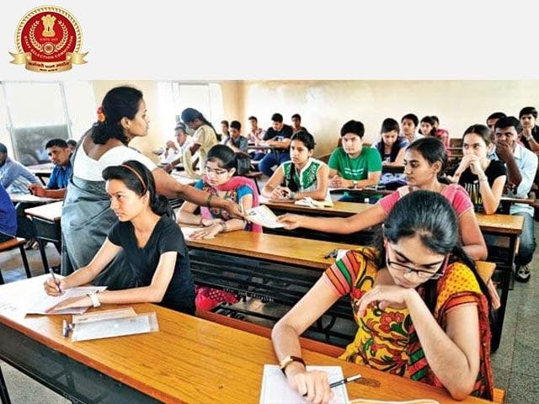

Attendence: 24

|  |  |  |  |  |
| --- | --- | --- | --- | --- |
| **Sr. No** | **Enrollment no.** | **Name** | **Branch** | **Present/Absent** |
| 1 | 1824001002 | Shaury Patel | Automobile Engineering | Present |
| 2 | 1824001003 | Tarun Ramina | Automobile Engineering | Present |
| 3 | 1824001004 | Tadhani Sagar Sureshbhai | Automobile Engineering | Present |
| 4 | 1824001005 | Harsh Ashokbhai Thummar | Automobile Engineering | Present |
| 5 | 1824001006 | Amrit Raj Singh | Automobile Engineering | Present |
| 6 | 1824002001 | Gadhavi Dharmikdan Bhupatsinh | Chemical Engineering | Present |
| 7 | 1824002002 | Gadhiya Jay Dineshbhai | Chemical Engineering | Absent |
| 8 | 1824002003 | Kshatriya Surajsinh Pramodsinh | Chemical Engineering | Present |
| 9 | 1824002005 | Patel Manav Bhaveshkumar | Chemical Engineering | Present |
| 10 | 1824002006 | Patel Uchit Chandrakant | Chemical Engineering | Present |
| 11 | 1824002007 | Solanki Gaurav Kishorbhai | Chemical Engineering | Present |
| 12 | 1824002008 | Khushi Samir Thakkar | Chemical Engineering | Present |
| 13 | 1824003004 | Himal Dhaulakoti | Civil Engineering | Present |
| 14 | 1824003006 | Yashesh Dipeshkumar Joshi | Civil Engineering | Absent |
| 15 | 1824003007 | Makwana Nikunjkumar Dineshbhai | Civil Engineering | Present |
| 16 | 1824003012 | Patel Ruchitkumar Pankajbhai | Civil Engineering | Present |
| 17 | 1824003017 | Kakadiya Jaymeen Trifulbhai | Civil Engineering | Present |
| 18 | 1824003026 | Parmar Nihal Girishbhai | Civil Engineering | Present |
| 19 | 1824004001 | Bhatt Devansh Yogeshkumar | Computer Engineering | Present |
| 20 | 1824004003 | Harmanjyot Kaur Saini | Computer Engineering | Present |
| 21 | 1824004006 | Jani Riddhi Jaydevbhai | Computer Engineering | Absent |
| 22 | 1824004008 | Joshi Maulik Hemantkumar | Computer Engineering | Present |
| 23 | 1824004009 | Kashyap Rahul Dipakbhai | Computer Engineering | Present |
| 24 | 1824004010 | Khatra Drashti Bharatbhai | Computer Engineering | Present |
| 25 | 1824004011 | Rahul Tiwari | Computer Engineering | Present |
| 26 | 1824004016 | Panchotiya Aviraj Sumanbhai | Computer Engineering | Present |
| 27 | 1824004017 | Prajapati Haniben Rameshkumar | Computer Engineering | Present |



|  |  |  |  |
| --- | --- | --- | --- |
| **Seminar Assessment Report for The Academic Year 2018-2019** | | | |
| **2018-2019** | **Option** | **Total Answer** | **Average Evaluation (Out of 4)** |
| ***1. Was the Trainer well prepared with their content?*** | Strongly Agree | 16 | **3.59** |
| Agree | 11 |
| Not Agree | 0 |
| Strongly disagree | 0 |
| ***2. Was the trainer professional?*** | Strongly Agree | 19 | **3.70** |
| Agree | 8 |
| Not Agree | 0 |
| Strongly disagree | 0 |
| ***3. Did the training content matched your expectations?*** | Strongly Agree | 19 | **3.70** |
| Agree | 8 |
| Not Agree | 0 |
| Strongly disagree | 0 |
| ***4. Was the trainer punctual?*** | Strongly Agree | 18 | **3.56** |
| Agree | 6 |
| Not Agree | 3 |
| Strongly disagree | 0 |
| ***5. Was The Trainer communicating in English?*** | Strongly Agree | 15 | **3.33** |
| Agree | 6 |
| Not Agree | 6 |
| Strongly disagree | 0 |
| ***6. Was the class engaging?*** | Strongly Agree | 16 | **3.59** |
| Agree | 11 |
| Not Agree | 0 |
| Strongly disagree | 0 |
|  |  |  |  |
|  |  |  |  |
|  | **Average Score (Out of 4)** | **3.58** |  |
|  | **Total Effectiveness** | **89.51%** |  |

1. **Name of Event: a seminar on “Navigating Voice: A Comparative Study of Active and Passive Voice”**

**Date of Event: 09/11/2018**

**Organized by: Training and Placement cell, Swarrnim Startup and Innovation University**

**Event Coordinator: Mr.Nimish Dave**

## Active Voice

In active voice, the subject of the sentence **performs** the action expressed by the verb. For example:

* **Active Voice:** Jerry knocked over the lamp.

## Passive Voice

In passive voice, the subject **receives** the action. It’s often formed with a linking verb (e.g., “was,” “had been”) followed by the past participle of the verb. For example:

* **Passive Voice:** The lamp was knocked over by Jerry.

### Usefulness of Passive Voice

* **Emphasizing Action:** Passive voice emphasizes the fact that an action has taken place, rather than focusing on who performed it.
* **Unknown Agent:** It’s helpful when the doer of an action (the agent) is unknown.
  + Example: “The kitchen has been cleaned.”
* **News Coverage:** In news headlines, passive voice succinctly conveys known information.
  + Example: “Man Attacked on Elm Street.”

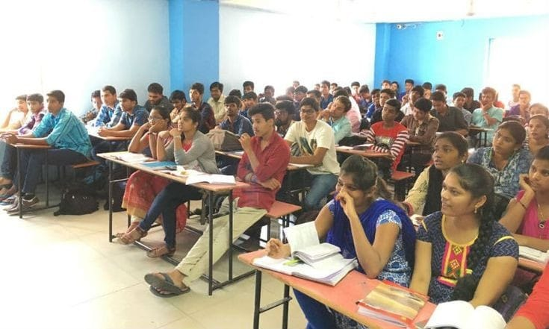

Attendance: 48

|  |  |  |  |  |  |
| --- | --- | --- | --- | --- | --- |
| **Sr. No** | **Enrollment no.** | **Name** | **Branch** | **Present/ Absent** |  |
| 1 | 1824004041 | Solanki Dharm Pravinsinh | Computer Engineering | Present |  |
| 2 | 1824004043 | Sonkavade Siddharth Prabhakarbhai | Computer Engineering | Present |  |
| 3 | 1824004044 | Talpada Kolipatel Radhikaben Rajubhai | Computer Engineering | Present |  |
| 4 | 1824004046 | Ronakkumr Vinodbhai Thakkar | Computer Engineering | Present |  |
| 5 | 1824004047 | Thakkar Sachdev Manthanbhai Yogeshbhai | Computer Engineering | Present |  |
| 6 | 1824004048 | Thakkar Tapasvi Jigarbhai | Computer Engineering | Present |  |
| 7 | 1824004049 | Vaidik Arvind Patel | Computer Engineering | Present |  |
| 8 | 1824004051 | Jay Vyas | Computer Engineering | Present |  |
| 9 | 1824004052 | Patel Rutulkumar Dilipkumar | Computer Engineering | Present |  |
| 10 | 1824004053 | Christian Ronald | Computer Engineering | Present |  |
| 11 | 1824004054 | Deepak Kumar | Computer Engineering | Present |  |
| 12 | 1824004056 | Yadav Anurag | Computer Engineering | Present |  |
| 13 | 1824004062 | Vishwakarma Rohit Rameshwar | Computer Engineering | Present |  |
| 14 | 1824008001 | Brijrajsinh Solanki | IT | Present |  |
| 15 | 1824008004 | Kazi Mohammed Mushaab Mohammed Yakub | IT | Present |  |
| 16 | 1824008006 | Prajapati Viralkumar Maheshbhai | IT | Present |  |
| 17 | 1824008015 | Sarabuwala Sufiyan Maksudbhai | IT | Present |  |
| 18 | 1824008016 | Savaliya Rishika Ashokbhai | IT | Present |  |
| 19 | 1824008017 | Abhishek Shah | IT | Present |  |
| 20 | 1824008018 | Shah Dhruvi Sujalbhai | IT | Present |  |
| 21 | 1824008020 | Sharma Neha Kishanbhai | IT | Present |  |
| 22 | 1824008021 | Varma Kriti Rajeshbhai | IT | Present |  |
| 23 | 1824008022 | Vasoya Tulsi Jivanbhai | IT | Present |  |
| 24 | 1824008025 | Patel Vidhi Nareshbhai | IT | Present |  |
| 25 | 1824009002 | Neelesh Gajjar | Mechanical Engineering | Present |  |
| 26 | 1824009003 | Panchal Meet Nileshbhai | Mechanical Engineering | Present |  |
| 27 | 1824009006 | Rabari Vishal Baldevbhai | Mechanical Engineering | Present |  |
| 28 | 1824009007 | Saiyed Jawadali Israrali | Mechanical Engineering | Present |  |
| 29 | 1824009008 | Shah Megh Rajendra | Mechanical Engineering | Present |  |
| 30 | 1824009012 | Aditya Yadav | Mechanical Engineering | Present |  |
| 31 | 1824009013 | Om Kumar Tiwari | Mechanical Engineering | Present |  |
| 32 | 1824009015 | Sharma Raunak Satyendranath | Mechanical Engineering | Present |  |
| 33 | 1824009019 | Patel Yash Dineshkumar | Mechanical Engineering | Present |  |
| 34 | 1824009020 | Arpit Patel | Mechanical Engineering | Present |  |
| 35 | 1824009021 | Patel Vaibhav Mukeshbhai | Mechanical Engineering | Present |  |
| 36 | 1825002001 | Kothari Nirajkumar Nayanbhai | Chemical Engineering | Present |  |
| 37 | 1825003001 | Jatin Pravinbhai Sindhav | Civil Engineering | Present |  |
| 38 | 1825004002 | Panchal Nirmal D | Computer Engineering | Present |  |
| 39 | 1825005001 | Patel Prince Bhagvanbhai | Electrical Engineering | Present |  |
| 40 | 1825005002 | Mohammad Afazal | Electrical Engineering | Present |  |
| 41 | 1825005003 | Parmar Kaushikkumar Laxmanbhai | Electrical Engineering | Present |  |
| 42 | 1825005004 | Yash Tarunbhai Parmar | Electrical Engineering | Present |  |
| 43 | 1825005005 | Chaudhari Harshbhai Bharatbhai | Electrical Engineering | Present |  |
| 44 | 1825008002 | Tripathi Saurav | IT | Present |  |
| 45 | 1825009003 | Tarangkumar Kaushikbhai Patel | Mechanical Engineering | Present |  |
| 46 | 1825009004 | Lalakiya Deepkumar Kiritbhai | Mechanical Engineering | Present |  |
| 47 | 1825009008 | Nimje Nikhilkumar Maroti | Mechanical Engineering | Present |  |
| 48 | 1825009010 | Prajapati Daxeshkumar Kaushikbhai | Mechanical Engineering | Present |  |



|  |  |  |  |
| --- | --- | --- | --- |
| **Seminar Assessment Report for The Academic Year 2018-2019** | | | |
| **2018-2019** | **Option** | **Total Answer** | **Average Evaluation (Out of 4)** |
| ***1. Was the Trainer well prepared with their content?*** | Strongly Agree | 29 | **3.60** |
| Agree | 19 |
| Not Agree | 0 |
| Strongly disagree | 0 |
| ***2. Was the trainer professional?*** | Strongly Agree | 28 | **3.58** |
| Agree | 20 |
| Not Agree | 0 |
| Strongly disagree | 0 |
| ***3. Did the training content matched your expectations?*** | Strongly Agree | 31 | **3.65** |
| Agree | 17 |
| Not Agree | 0 |
| Strongly disagree | 0 |
| ***4. Was the trainer punctual?*** | Strongly Agree | 29 | **3.56** |
| Agree | 17 |
| Not Agree | 2 |
| Strongly disagree | 0 |
| ***5. Was The Trainer communicating in English?*** | Strongly Agree | 32 | **3.60** |
| Agree | 13 |
| Not Agree | 3 |
| Strongly disagree | 0 |
| ***6. Was the class engaging?*** | Strongly Agree | 32 | **3.67** |
| Agree | 16 |
| Not Agree | 0 |
| Strongly disagree | 0 |
|  |  |  |  |
|  |  |  |  |
|  | **Average Score (Out of 4)** | **3.61** |  |
|  | **Total Effectiveness** | **90.28%** |  |

1. **Seminar Report: Tenses in English Grammar for Competitive Exams**

**Date:**23/02/2019  
**Organized by: Training and Placement cell, Swarrnim Startup and Innovation University**

**Event Coordinator: Mr.Nimish Dave**

**Objective**

The seminar aimed to provide a comprehensive understanding of tenses in English grammar, focusing on their application in competitive exams. The key objectives were:

1. **Understanding Tenses:**
   * To explain the different types of tenses and their usage.
   * To highlight the importance of tenses in competitive exams.
2. **Application in Competitive Exams:**
   * To demonstrate how tenses are tested in various competitive exams.
   * To provide strategies for answering tense-related questions effectively.

**Seminar Highlights**

1. **Types of Tenses:**
   * **Present Tense:** Describes actions happening now or regularly.
     + Examples: “She writes a letter,” “They are playing football.”
   * **Past Tense:** Describes actions that happened in the past.
     + Examples: “He wrote a letter,” “They were playing football.”
   * **Future Tense:** Describes actions that will happen in the future.
     + Examples: “She will write a letter,” “They will be playing football.”
2. **Subcategories of Tenses:**
   * **Simple Tense:** Basic form of the tense.
     + Examples: “I eat,” “She ate,” “They will eat.”
   * **Continuous Tense:** Describes ongoing actions.
     + Examples: “I am eating,” “She was eating,” “They will be eating.”
   * **Perfect Tense:** Describes completed actions.
     + Examples: “I have eaten,” “She had eaten,” “They will have eaten.”
   * **Perfect Continuous Tense:** Describes actions that were ongoing and completed at some point.
     + Examples: “I have been eating,” “She had been eating,” “They will have been eating.”
3. **Common Errors and Tips:**
   * **Common Errors:** Misuse of tenses, incorrect verb forms, and confusion between tenses.
   * **Tips:** Practice with sample questions, understand the context, and review grammar rules regularly.
4. **Practice Exercises:**
   * Participants engaged in exercises to identify and correct tense errors.
   * Sample questions from previous competitive exams were discussed.

**Conclusion**

The seminar emphasized the critical role of tenses in English grammar, especially for competitive exams. By mastering tenses, candidates can improve their accuracy and performance in the English language section of these exams.

**Outcome**

1. **Enhanced Understanding:** Participants gained a clear understanding of different tenses and their usage.
2. **Improved Accuracy:** Strategies and tips provided helped participants reduce errors in tense-related questions.
3. **Exam Readiness:** Participants felt more confident in tackling tense-related questions in competitive exams.

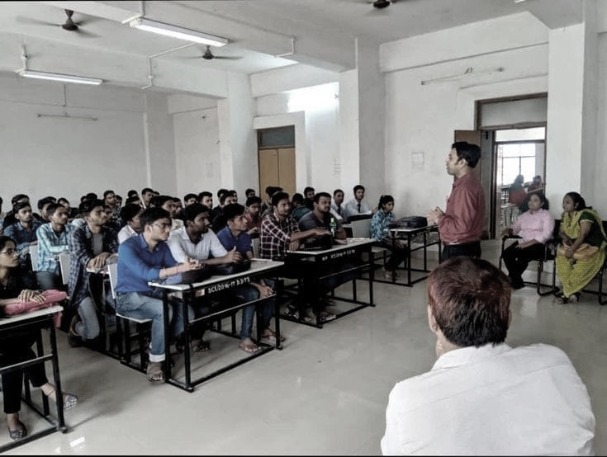Attendance: 39

|  |  |  |  |  |
| --- | --- | --- | --- | --- |
| **Sr. No** | **Enrollment no.** | **Name** | **Branch** | **Present/ Absent** |
| 1 | 1864001001 | Solanki Ankit V | BBA | Present |
| 2 | 1864001002 | Yadav Aakash R | BBA | Present |
| 3 | 1864001003 | Prajapati Pooja N | BBA | Present |
| 4 | 1864001004 | Gor Adarsh Nitinbhai | BBA | Present |
| 5 | 1864001005 | Rajput Chahalraj Hareshkumar | BBA | Present |
| 6 | 1864001006 | Panchal Mital Atulbhai | BBA | Present |
| 7 | 1864001007 | Yadav Paras | BBA | Present |
| 8 | 1864001008 | Patel Parth Shaileshbhai | BBA | Present |
| 9 | 1864001009 | Shah Jainam Vinodchandra | BBA | Present |
| 10 | 1864001010 | Sonawane Raj P | BBA | Present |
| 11 | 1864001011 | Chauhan Rakesh | BBA | Present |
| 12 | 1864001012 | Dabbiwala Mohammedabrar | BBA | Present |
| 13 | 1864001013 | Vyas Dhrumil Jankbhai | BBA | Present |
| 14 | 1864001014 | Tharwani Roshni | BBA | Present |
| 15 | 1864001015 | Kashyap Yash | BBA | Present |
| 16 | 1864001016 | Kushwaha Rishabh | BBA | Present |
| 17 | 1864001017 | Singh Tarunkumar Pradeepkumar | BBA | Present |
| 18 | 1864001018 | Makwana Mukesh Manubhai | BBA | Present |
| 19 | 1864001019 | Barot Rishi B | BBA | Present |
| 20 | 1864001020 | Sanjana Sadish Nair | BBA | Present |
| 21 | 1864001021 | Chaudhari Kajalben Sumanbhai | BBA | Present |
| 22 | 1864001022 | Patel Piyushkumar Dhirubhai | BBA | Present |
| 23 | 1864001023 | Pathan Zaidkhan Shezadkhan | BBA | Present |
| 24 | 1864001024 | Prajapati Naval Dipakkumar | BBA | Present |
| 25 | 1864001025 | Gamit Pradyumkumar Limjibhai | BBA | Present |
| 26 | 1864001026 | Gamit Sumitkumar Chitubhai | BBA | Present |
| 27 | 1864001027 | Gamit Kautik Babubhai | BBA | Present |
| 28 | 1864001028 | Chauhan Jinal Subhashbhai | BBA | Present |
| 29 | 1814001001 | Bharwad Nikita Mahesh | B.Com | Present |
| 30 | 1814001002 | Patel Shaishavkumar Rohitbhai | B.Com | Present |
| 31 | 1814001003 | Maisuriya Rutvik Shaileshbhai | B.Com | Present |
| 32 | 1814001004 | Vyas Viren Dineshbhai | B.Com | Present |
| 33 | 1814001005 | Mehta Vandan | B.Com | Present |
| 34 | 1814001006 | Ankit Keshavji Hadiya | B.Com | Present |
| 35 | 1814001007 | Patel Parth Ashokbhai | B.Com | Present |
| 36 | 1814001008 | Meenakshi Vikramkumar Rajpurohit | B.Com | Present |
| 37 | 1814001009 | Gamit Pradipkumar Balvantbhai | B.Com | Present |
| 38 | 1814001010 | Patel Rakeshbhai Bharatbhai | B.Com | Present |
| 39 | 1814001011 | Talaviya Ishan Manubhai | B.Com | Present |



|  |  |  |  |
| --- | --- | --- | --- |
| **Seminar Assessment Report for The Academic Year 2018-2019** | | | |
| **2018-2019** | **Option** | **Total Answer** | **Average Evaluation (Out of 4)** |
| ***1. Was the Trainer well prepared with their content?*** | Strongly Agree | 33 | **3.85** |
| Agree | 6 |
| Not Agree | 0 |
| Strongly disagree | 0 |
| ***2. Was the trainer professional?*** | Strongly Agree | 25 | **3.64** |
| Agree | 14 |
| Not Agree | 0 |
| Strongly disagree | 0 |
| ***3. Did the training content matched your expectations?*** | Strongly Agree | 28 | **3.72** |
| Agree | 11 |
| Not Agree | 0 |
| Strongly disagree | 0 |
| ***4. Was the trainer punctual?*** | Strongly Agree | 33 | **3.69** |
| Agree | 0 |
| Not Agree | 6 |
| Strongly disagree | 0 |
| ***5. Was The Trainer communicating in English?*** | Strongly Agree | 30 | **3.77** |
| Agree | 9 |
| Not Agree | 0 |
| Strongly disagree | 0 |
| ***6. Was the class engaging?*** | Strongly Agree | 30 | **3.77** |
| Agree | 9 |
| Not Agree | 0 |
| Strongly disagree | 0 |
|  |  |  |  |
|  |  |  |  |
|  | **Average Score (Out of 4)** | **3.74** |  |
|  | **Total Effectiveness** | **93.48%** |  |

**5. Workshop Report: Skimming and Scanning Techniques in Reading and Writing**

**Date:**20/03/2019  
**Organized by: Training and Placement cell, Swarrnim Startup and Innovation University**

**Event Coordinator: Mr.Nimish Dave**

**Introduction**

The workshop on “Skimming and Scanning Techniques in Reading and Writing” was conducted to enhance participants’ reading efficiency and comprehension skills. These techniques are essential for quickly processing large volumes of text, making them invaluable for both academic and professional settings.

**Objectives**

* To understand the concepts of skimming and scanning.
* To learn practical applications of these techniques in reading and writing.
* To improve overall reading speed and comprehension.

**Workshop Overview**

The workshop was divided into several sessions, each focusing on different aspects of skimming and scanning.

**Session 1: Introduction to Skimming and Scanning**

* **Skimming**: Reading quickly to get the gist of the content. Focuses on headings, subheadings, and the first and last sentences of paragraphs.
* **Scanning**: Searching for specific information within a text. Involves looking for keywords, dates, names, or specific phrases.

**Session 2: Techniques and Strategies**

* **Skimming Techniques**:
  + Read the title, introduction, and conclusion.
  + Focus on headings, subheadings, and highlighted text.
  + Read the first sentence of each paragraph to understand the main idea.
* **Scanning Techniques**:
  + Identify keywords related to the information you need.
  + Move your eyes quickly over the text to locate these keywords.
  + Read the surrounding text once the keyword is found to gather the necessary details.

**Session 3: Practical Exercises**

Participants engaged in hands-on activities to practice skimming and scanning. They were given various texts, including articles, reports, and research papers, and asked to apply the techniques learned.

**Session 4: Applications in Writing**

* **Using Skimming and Scanning for Research**: How to efficiently gather information from multiple sources.
* **Improving Writing Skills**: Using skimming to outline and organize content, and scanning to ensure accuracy and completeness.

**Key Takeaways**

* **Efficiency**: Skimming and scanning significantly reduce the time required to process large amounts of text.
* **Comprehension**: These techniques help in retaining key information and understanding the main ideas without reading every word.
* **Application**: Useful in various contexts, from academic research to professional document review.

**Feedback and Conclusion**

Participants found the workshop highly beneficial, noting improvements in their reading speed and comprehension. The practical exercises were particularly appreciated for providing hands-on experience.

The workshop concluded with a Q&A session, where participants could clarify doubts and discuss further applications of skimming and scanning techniques.

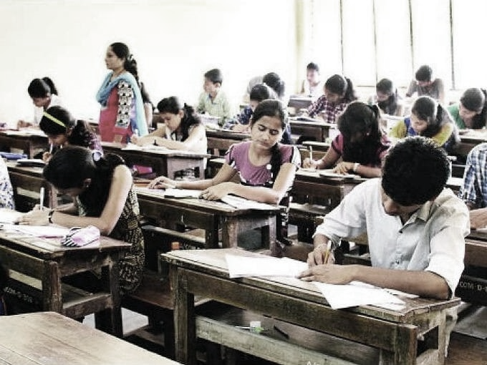

Attendance: 28

|  |  |  |  |  |
| --- | --- | --- | --- | --- |
| **Sr. No** | **Enrollment no.** | **Name** | **Branch** | **Present/ Absent** |
| 1 | 170813102003 | Bhavsar Joy Girishkumar | Automobile | Present |
| 2 | 170813102005 | Dhaval Jayeshkumar Dave | Automobile | Present |
| 3 | 170813102006 | Nayee Pankaj Sanjaykumar | Automobile | Present |
| 4 | 170813102007 | Pandya Devansh Kumar Nimeshkumar | Automobile | Present |
| 5 | 170813102008 | Parmar Vishalkumar Ranjitsinh | Automobile | Present |
| 6 | 170813102009 | Savani Jaydip Rameshbhai | Automobile | Present |
| 7 | 170813102010 | Shyamsukha Ronak Subhag | Automobile | Present |
| 8 | 170813106002 | Ondhiya Smit Shaileshkumar | Civil | Present |
| 9 | 170813106004 | Prajapati Dhaval Jitendrakumar | Civil | Present |
| 10 | 170813107001 | Prajapati Kalpeshkumar Jayantilal | Computer | Present |
| 11 | 170813109001 | Bhagwat Siddharth Shyam | Electrical | Present |
| 12 | 170813109002 | Chauhan Kishan Mukeshbhai | Electrical | Present |
| 13 | 170813109003 | Patel Kevalbhai Vallabhbhai | Electrical | Present |
| 14 | 170813111001 | Ahajoliya Mitanshukumar Rameshbhai | EC | Present |
| 15 | 170813119001 | Chauhan Hardikkumar Kishorkumar | Mechanical | Present |
| 16 | 1723001001 | Parsiya Pratham Dineshbhai | Automobile | Present |
| 17 | 1723001002 | Prajapati Tejaskumar Vinodbhai | Automobile | Present |
| 18 | 1723001004 | Suthar Deep Rameshbhai | Automobile | Present |
| 19 | 1723001007 | Mallick Dishant Sanjay | Automobile | Present |
| 20 | 1723001008 | Prashant Devjibhai Makwana | Automobile | Present |
| 21 | 1723001009 | Nagar Sumit Upendrabhai | Automobile | Present |
| 22 | 1723001010 | Ishan Vedprakash Upadhyay | Automobile | Present |
| 23 | 1723001011 | Hargan Jay Jaysukhbhai | Automobile | Present |
| 24 | 1723002001 | Shukla Nitishkumar Anjanikumar | Chemical | Present |
| 25 | 1723002002 | Harshkumar Rajeshkumar Trivedi | Chemical | Present |
| 26 | 1723002003 | Shingala Dharmik Arunbhai | Chemical | Present |
| 27 | 1723002005 | Suthar Rutvik Sunilkumar | Chemical | Present |
| 28 | 1723002006 | Patel Meet Shaileshbhai | Chemical | Present |



|  |  |  |  |
| --- | --- | --- | --- |
| **Seminar Assessment Report for The Academic Year 2018-2019** | | | |
| **2018-2019** | **Option** | **Total Answer** | **Average Evaluation (Out of 4)** |
| ***1. Was the Trainer well prepared with their content?*** | Strongly Agree | 24 | **3.86** |
| Agree | 4 |
| Not Agree | 0 |
| Strongly disagree | 0 |
| ***2. Was the trainer professional?*** | Strongly Agree | 16 | **3.57** |
| Agree | 12 |
| Not Agree | 0 |
| Strongly disagree | 0 |
| ***3. Did the training content matched your expectations?*** | Strongly Agree | 20 | **3.57** |
| Agree | 8 |
| Not Agree | 0 |
| Strongly disagree | 0 |
| ***4. Was the trainer punctual?*** | Strongly Agree | 24 | **3.71** |
| Agree | 0 |
| Not Agree | 4 |
| Strongly disagree | 0 |
| ***5. Was The Trainer communicating in English?*** | Strongly Agree | 18 | **3.29** |
| Agree | 0 |
| Not Agree | 10 |
| Strongly disagree | 0 |
| ***6. Was the class engaging?*** | Strongly Agree | 20 | **3.43** |
| Agree | 0 |
| Not Agree | 8 |
| Strongly disagree | 0 |
|  |  |  |  |
|  |  |  |  |
|  | **Average Score (Out of 4)** | **3.60** |  |
|  | **Total Effectiveness** | **89.88%** |  |

**3 Post Assessment Analysis**











