**LMS**

**Module list:**

1. Assignment Module
2. Digital Repository Module
3. Online Classroom
4. Quiz
5. Mentoring

**Please go to your ERP:** <https://ssiulms.qualcampus.com/>

Please enter your credentials to Log in:

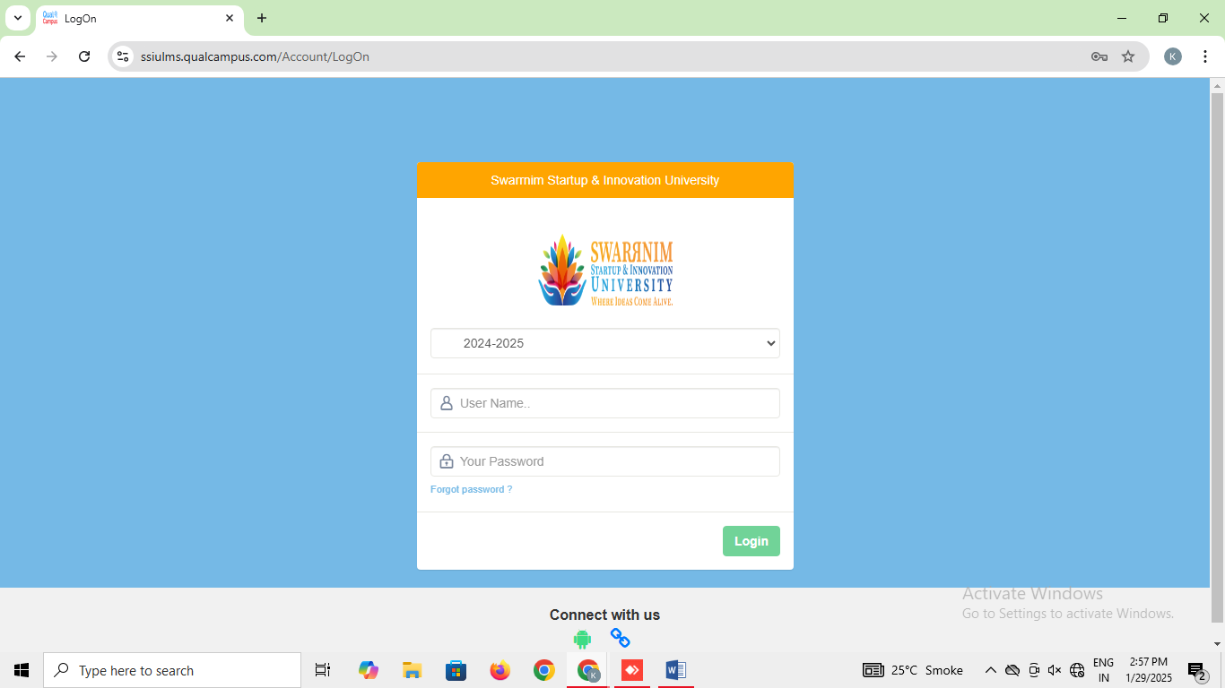

1. **Assignment Module: -** [**https://ssiulms.qualcampus.com/Dashboard_Assignment_Admin**](https://ssiulms.qualcampus.com/Dashboard_Assignment_Admin)

**Dashboard**: To view the all the assignment of the faculty member

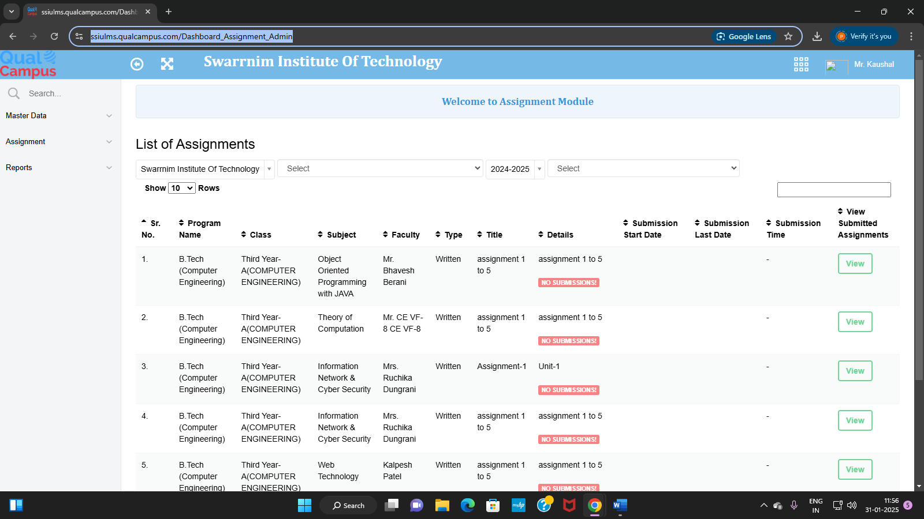

<https://ssiulms.qualcampus.com/Assignment/Index/>

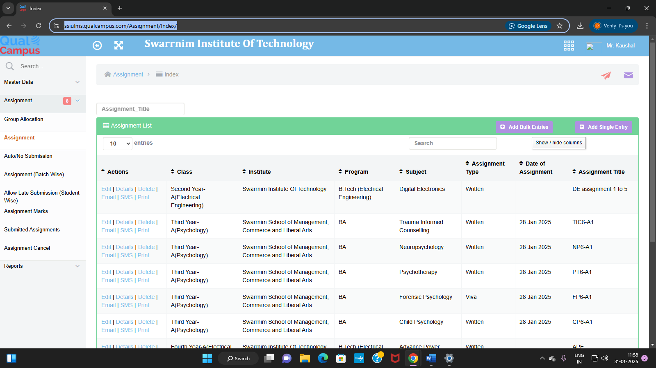

**Marks Summary:** [**https://ssiulms.qualcampus.com/RPT_Assignment_Mark_Summary/Index/#**](https://ssiulms.qualcampus.com/RPT_Assignment_Mark_Summary/Index/)

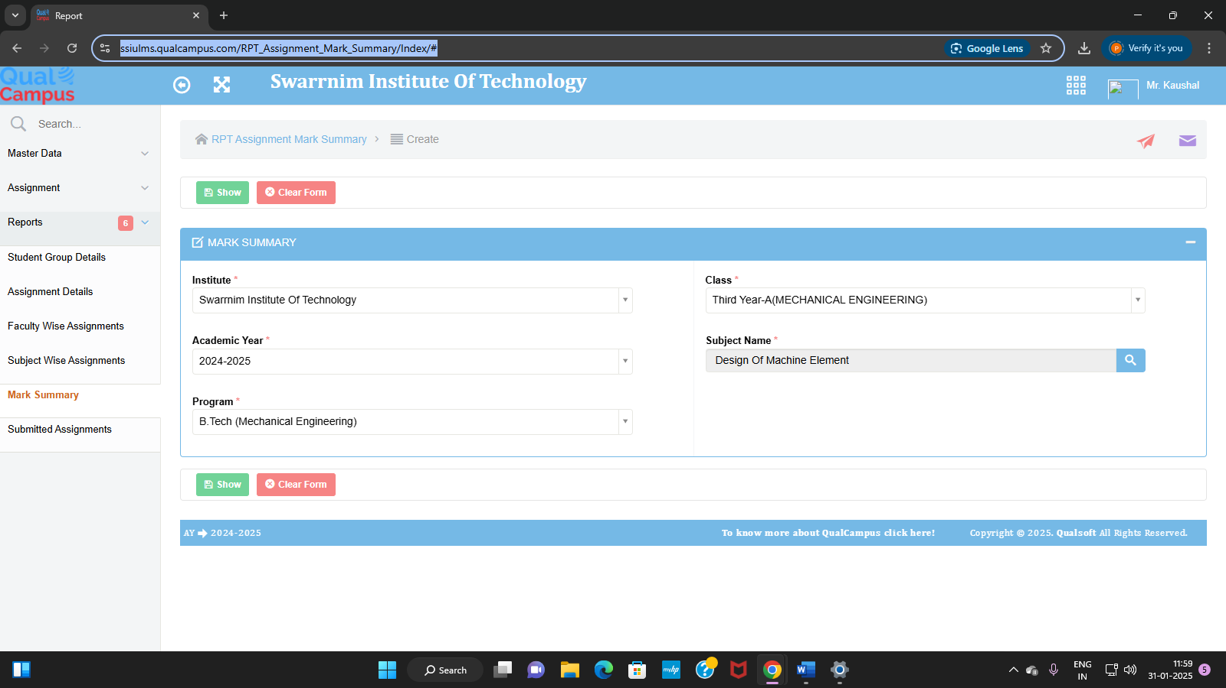

<https://ssiulms.qualcampus.com/Report_Viewer.aspx>

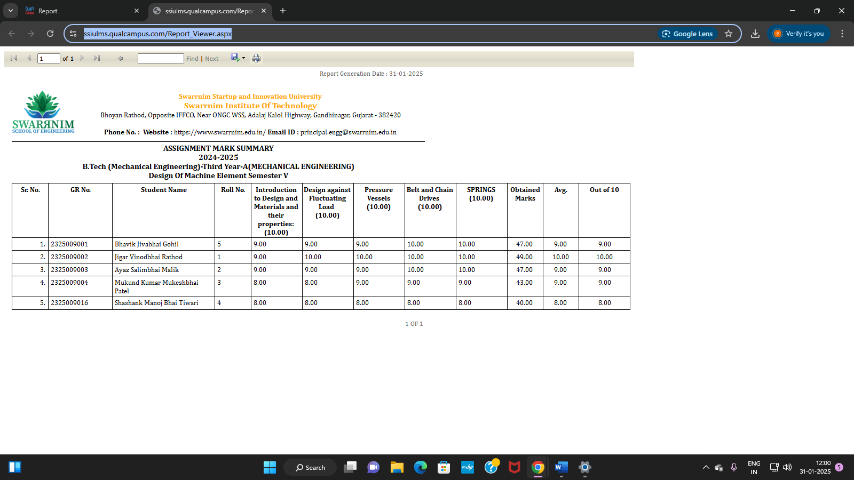

1. **Digital Repository Module:-** [**https://ssiulms.qualcampus.com/Digital_Book_Detail/Create**](https://ssiulms.qualcampus.com/Digital_Book_Detail/Create)

Upload different documents of the department.

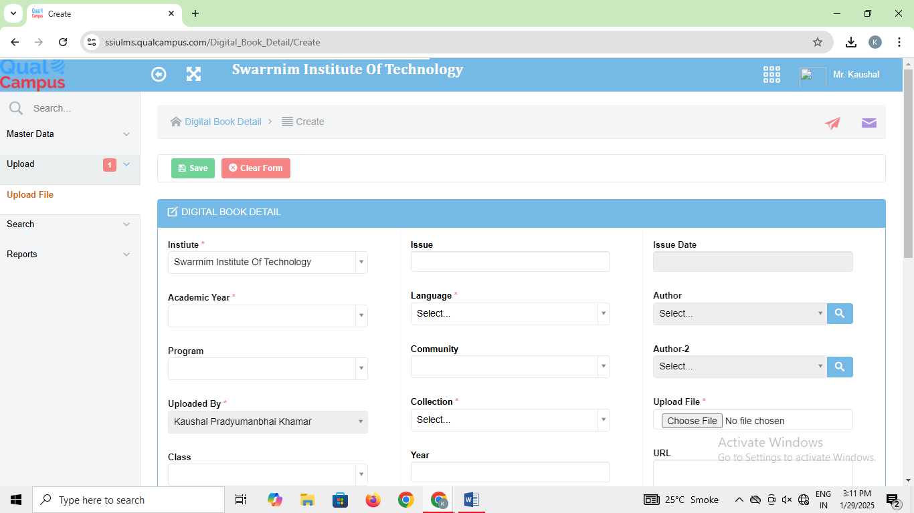

<https://ssiulms.qualcampus.com/Digital_Book_Detail/Index/>

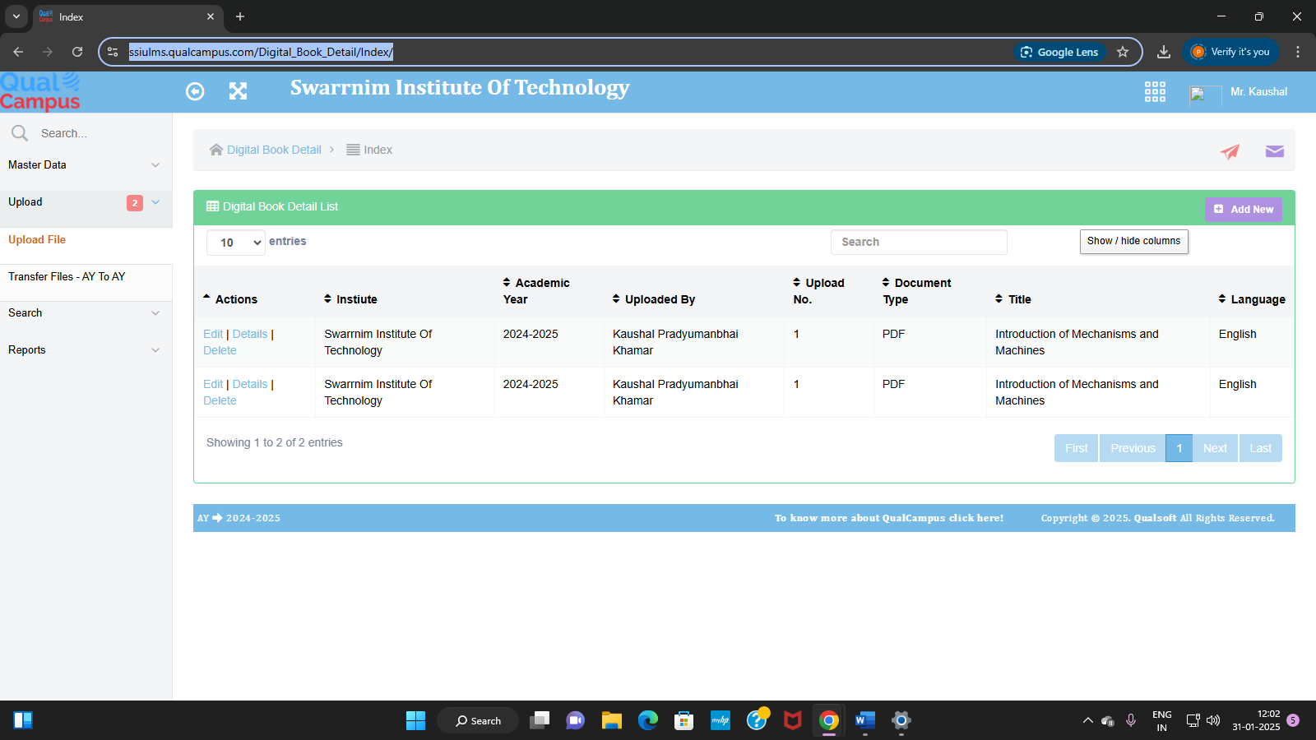

<https://ssiulms.qualcampus.com/Digital_Search/Index/>

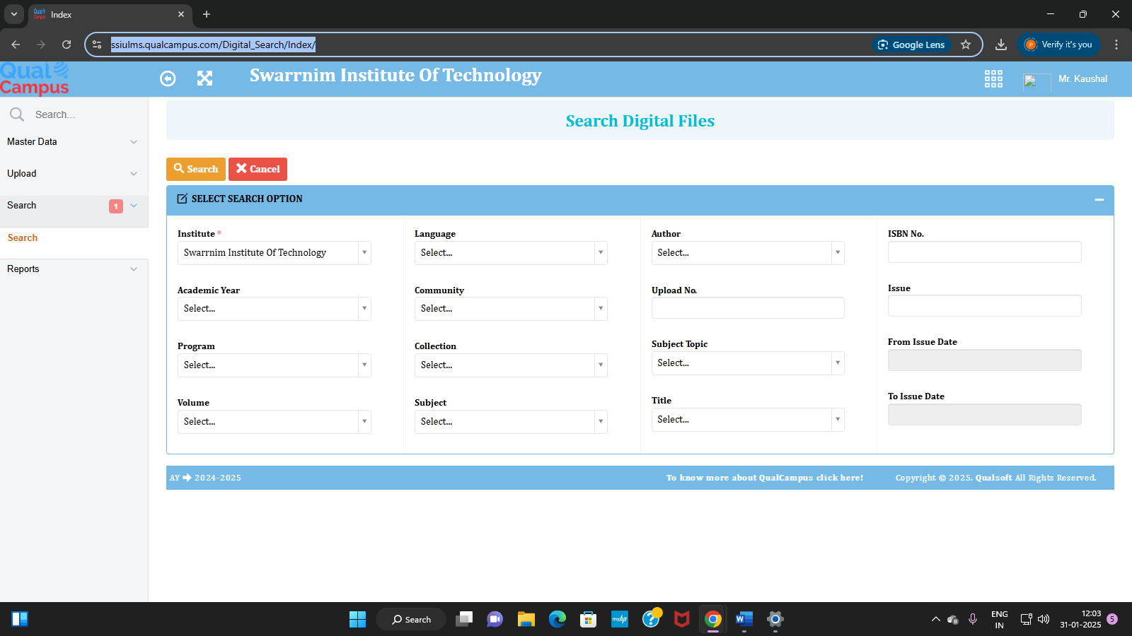

<https://ssiulms.qualcampus.com/Digital_Search/SearchList?Inst_ID=60272&AY_ID=17&Program_ID=91&Digital_Document_Type_ID=undefined&Library_Volume_ID=&Language_Master_ID=&Digital_Community_ID=&Digital_Collection_ID=&Book_Subject_ID=&Digital_Subject_Topic_ID=&Digital_Title_ID=&Author_Master_ID=&Book_No=&Issue=&ISBN_No=&From_Issue_Date=&To_Issue_Datev>=

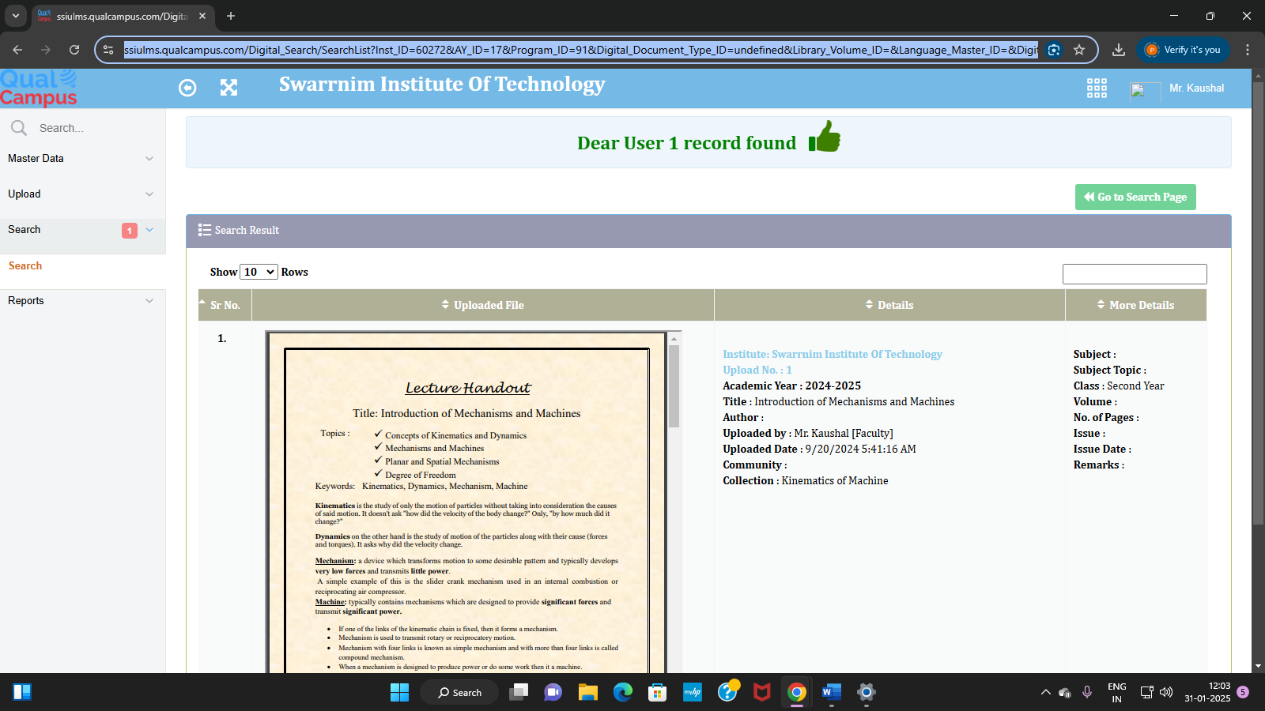

**3. Online Classroom Module:**

[**https://ssiulms.qualcampus.com/Online_Class_Room_Lecture/Create**](https://ssiulms.qualcampus.com/Online_Class_Room_Lecture/Create)

**Upload Lecture:** Faculty Member can upload video of their assigned subjects

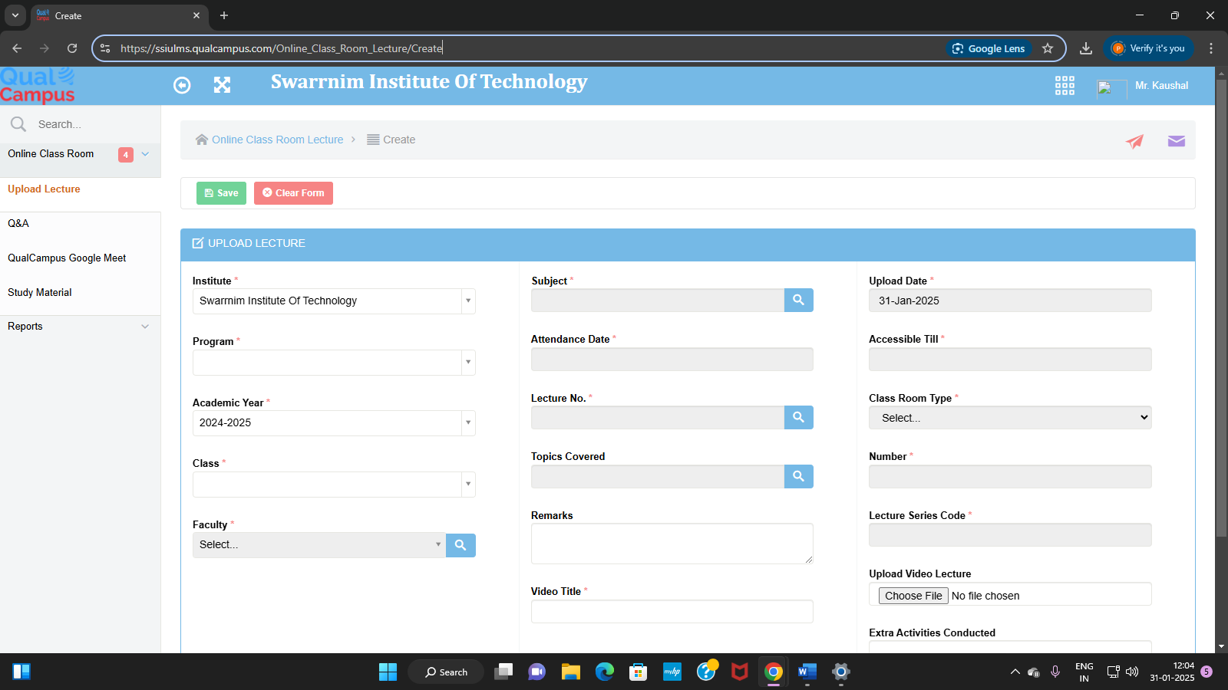

<https://ssiulms.qualcampus.com/Online_Class_Room_Lecture/Details/62>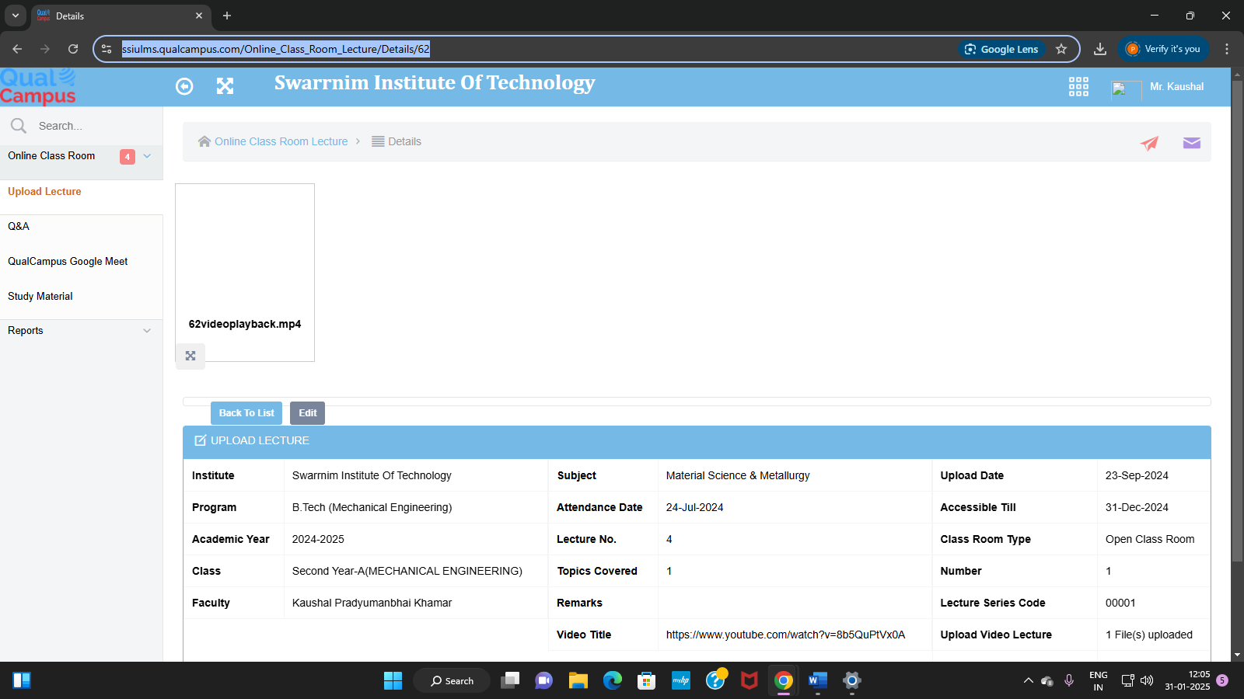

<https://ssiulms.qualcampus.com/Online_Class_Room_Lecture/ViewFile?OC_Room_Lecture_ID=62&OC_Lecture_File_ID=16>

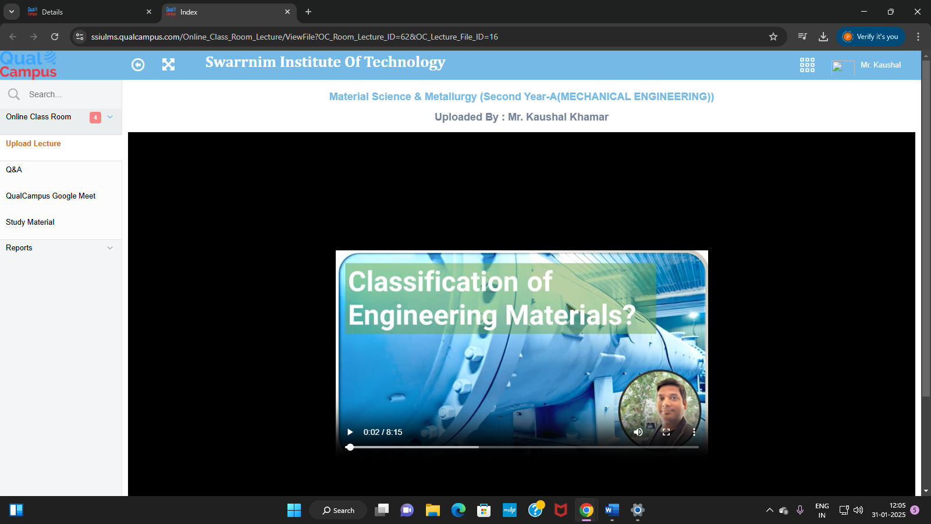

**Study Material:** <https://ssiulms.qualcampus.com/Online_Class_Study_Material/Index/>

Subject Faculty Members can upload subject related study material.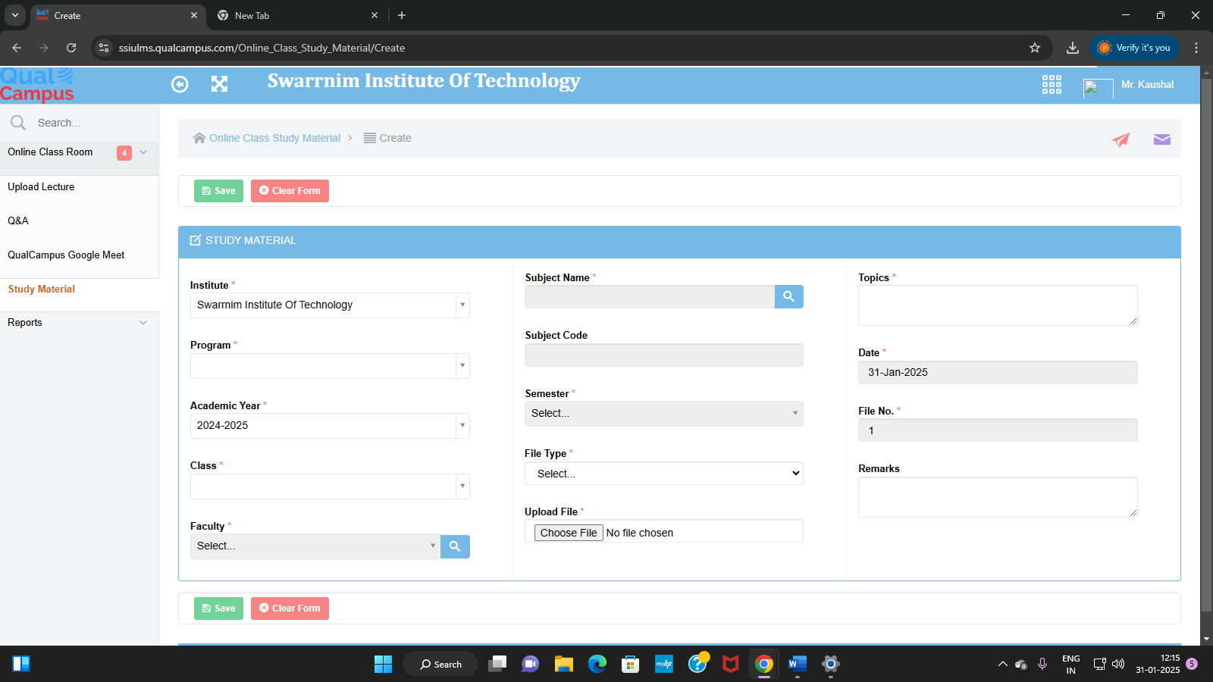

<https://ssiulms.qualcampus.com/Online_Class_Study_Material/Details/44298>

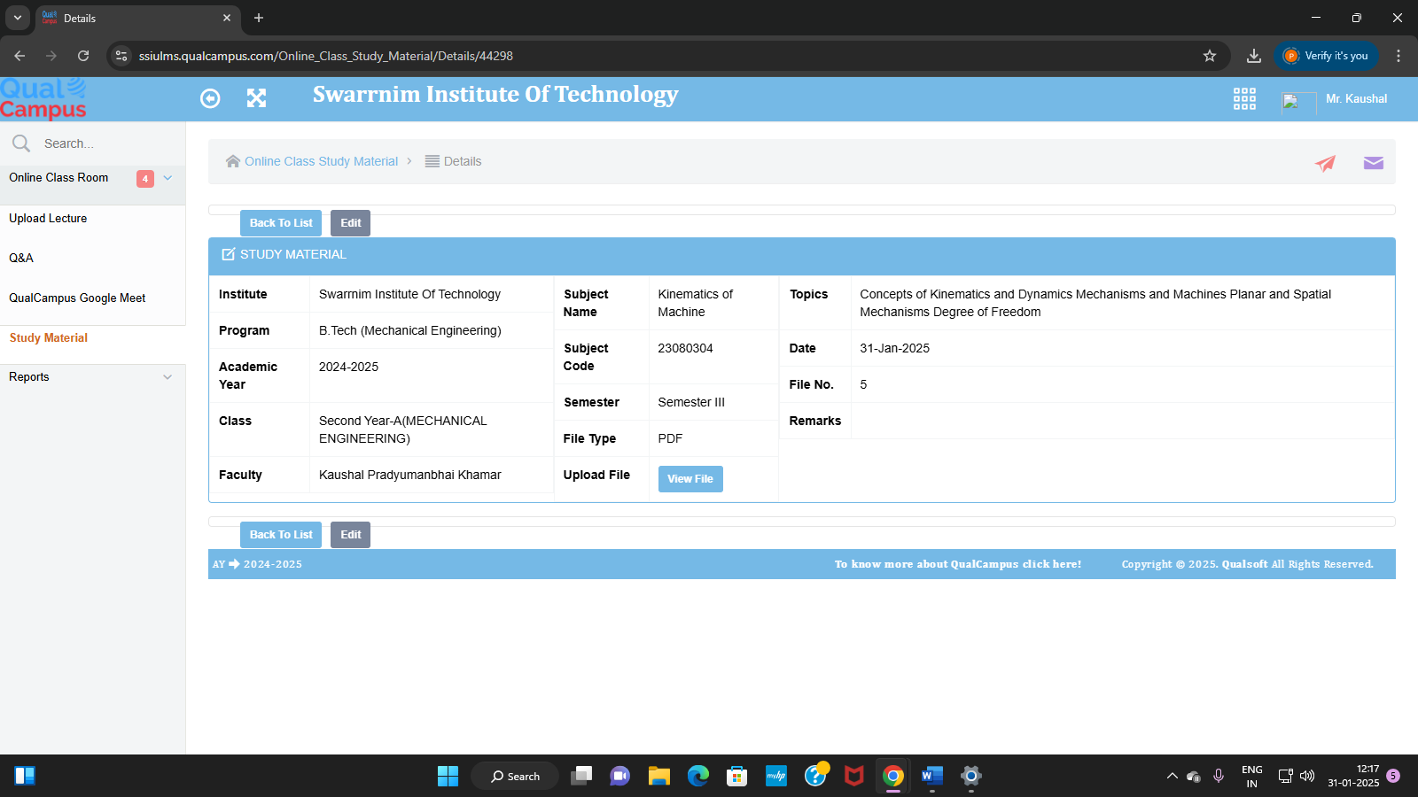

[**https://ssiulms.qualcampus.com/Online_Class_Study_Material/Details/44298**](https://ssiulms.qualcampus.com/Online_Class_Study_Material/Details/44298)

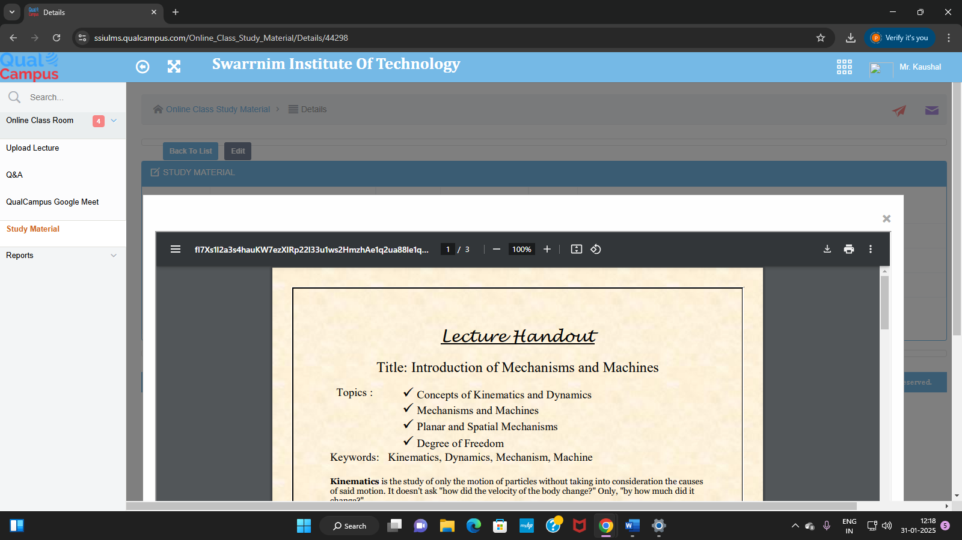

**4. Quiz Module**

[**https://ssiulms.qualcampus.com/Quiz/Create**](https://ssiulms.qualcampus.com/Quiz/Create)

To create the quiz of the subject.

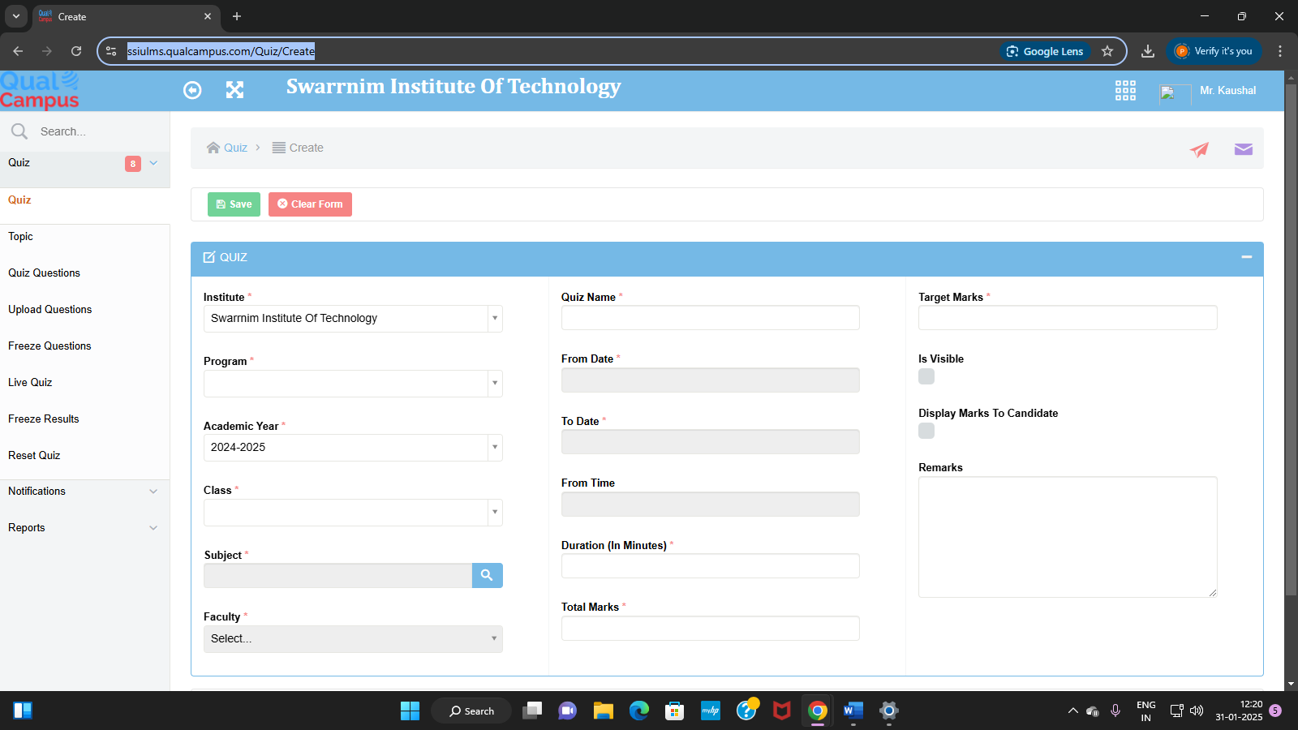

<https://ssiulms.qualcampus.com/Quiz/Details/4ZMDooS2HjRakTyhPcUcWAe1q2ua88le1q2ua88l>

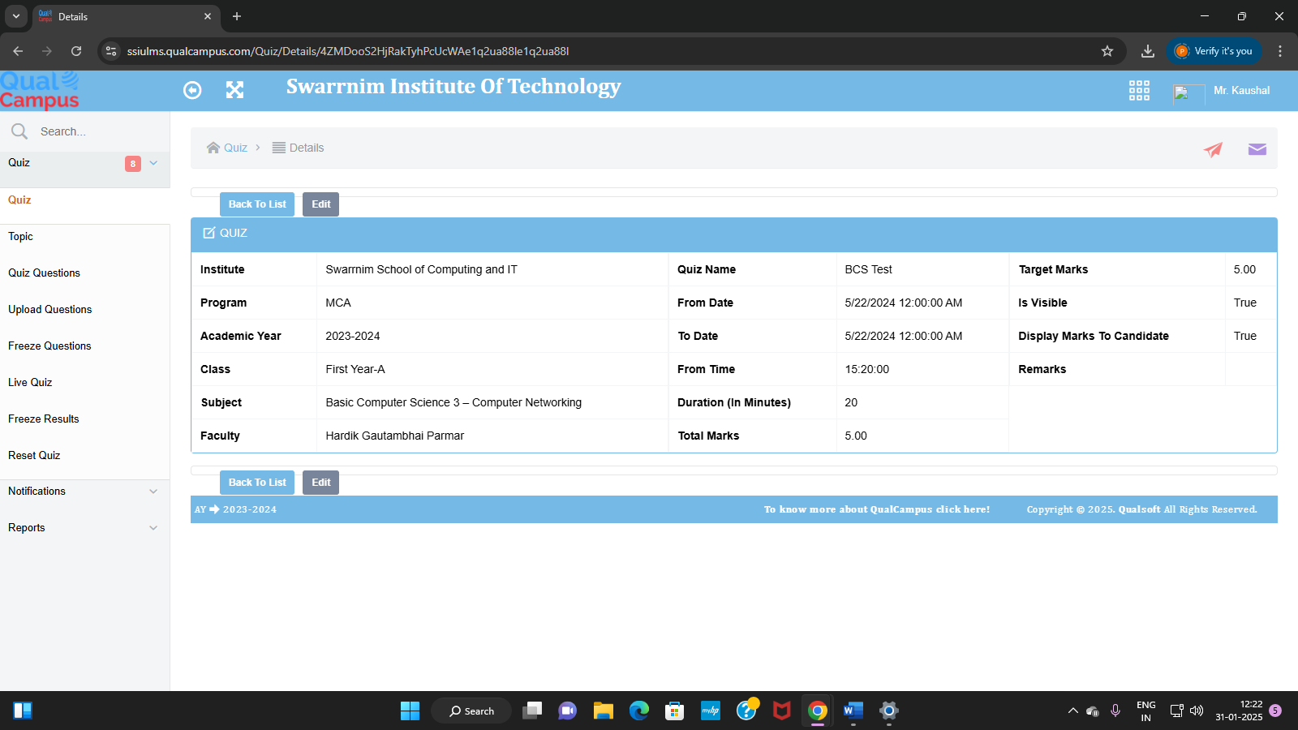

**Quiz Questions**: <https://ssiulms.qualcampus.com/Quiz_Questions/Index/>

To add the questions in the created quiz

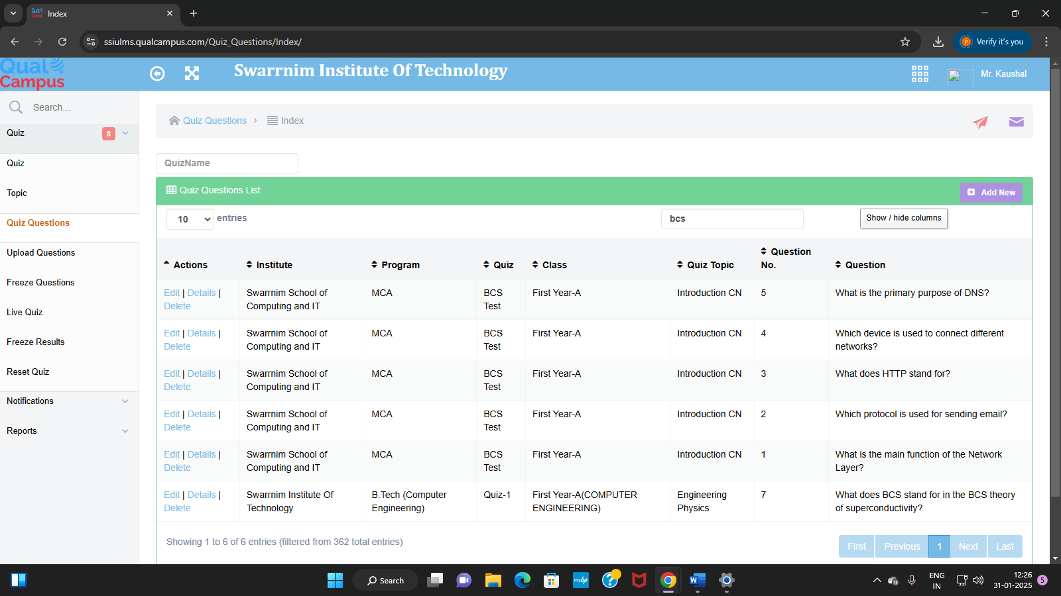

**Student Marks Summary:**

[**https://ssiulms.qualcampus.com/RPT_Quiz_Summary/Index/**](https://ssiulms.qualcampus.com/RPT_Quiz_Summary/Index/)

To view obtained marks by the students in quiz

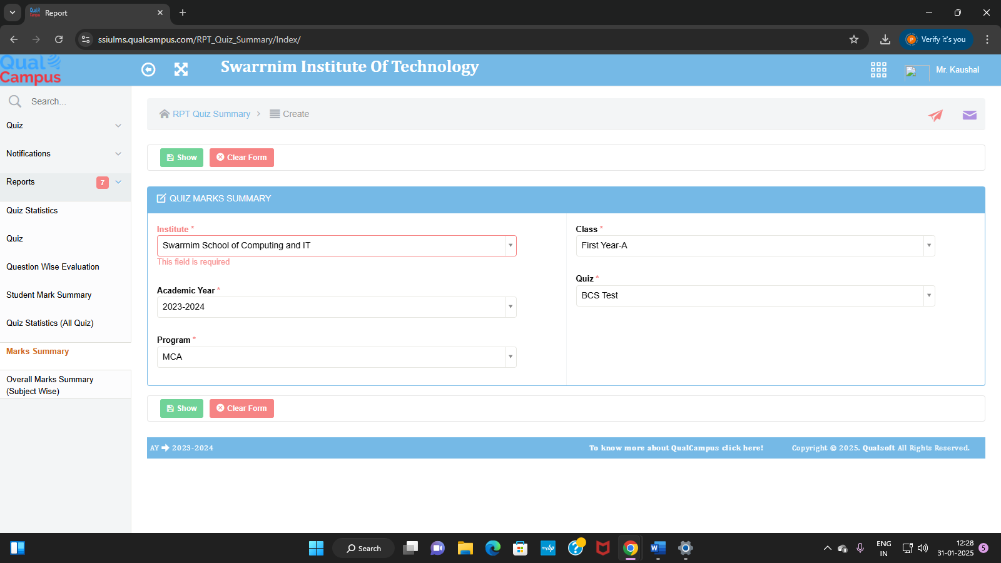

<https://ssiulms.qualcampus.com/Report_Viewer.aspx>

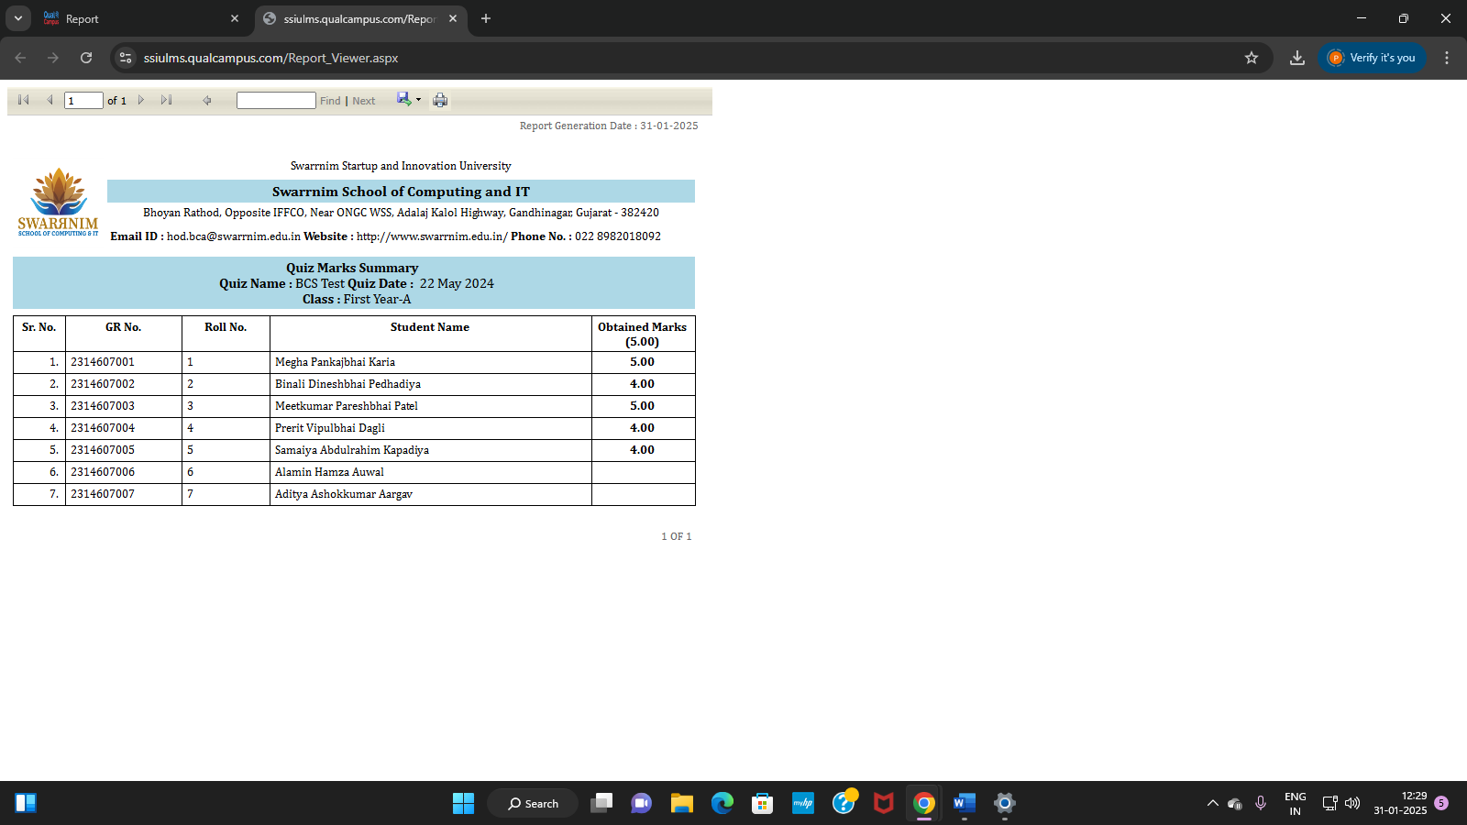

**5. Mentoring Module**

[**https://ssiulms.qualcampus.com/Mentor_Mentee_Bulk**](https://ssiulms.qualcampus.com/Mentor_Mentee_Bulk)

To view the student allocated list to the mentor

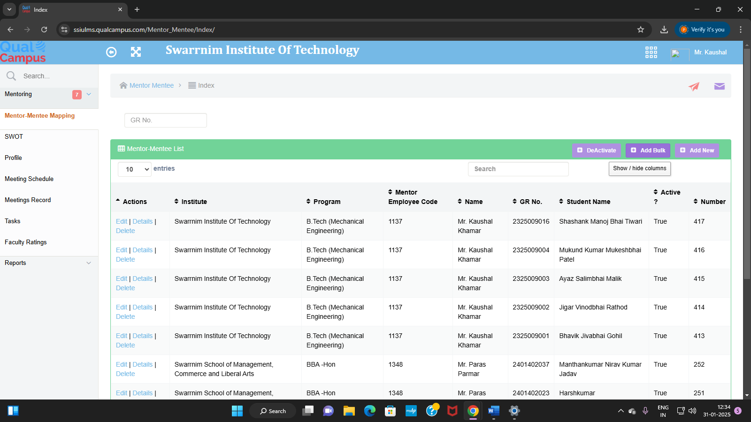

<https://ssiulms.qualcampus.com/Mentor_Mentee/Index/>

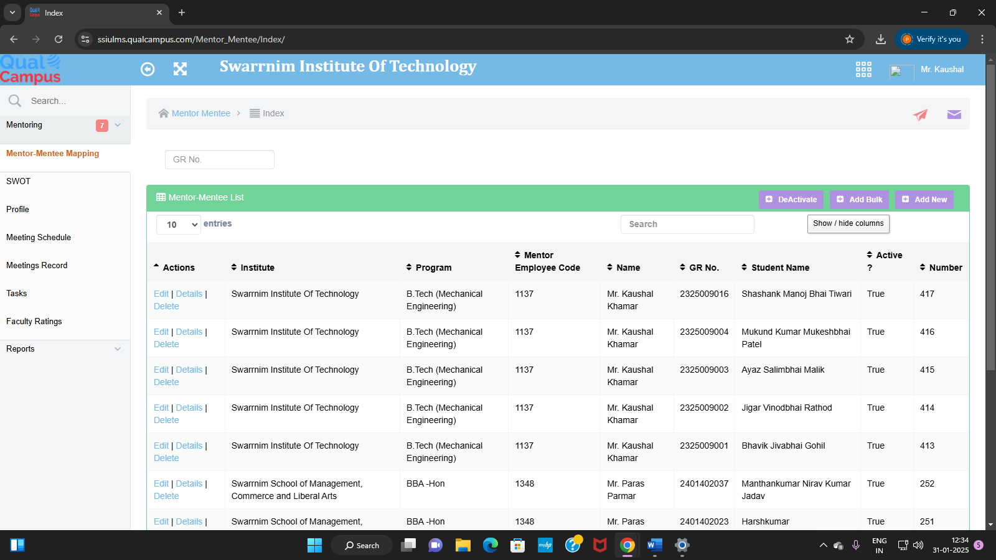

**Meeting Schedule**: <https://ssiulms.qualcampus.com/Mentor_Meeting_Schedule/Create>

To schedule the meeting with the students

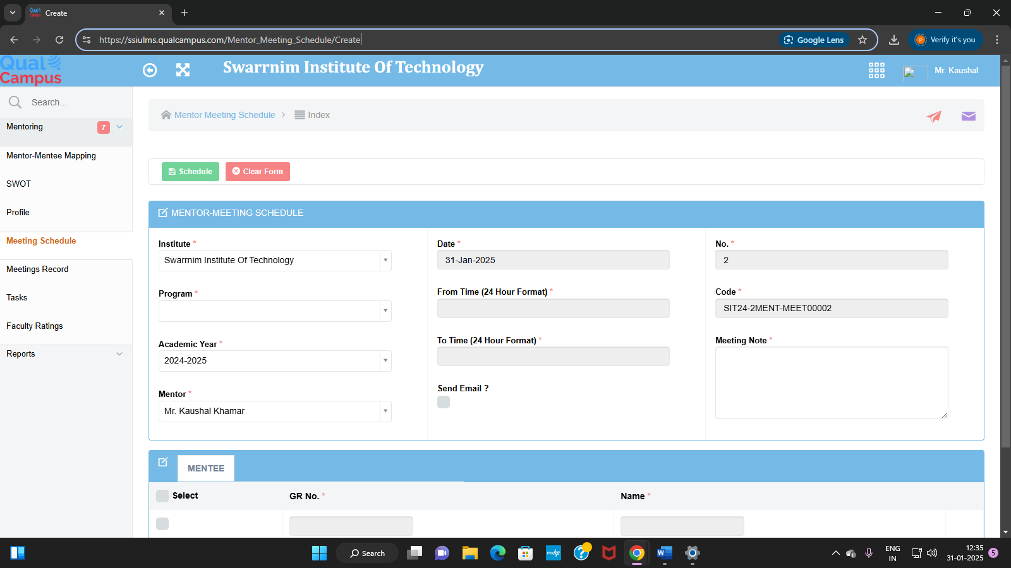

[**https://ssiulms.qualcampus.com/Mentor_Meeting_Schedule/Details/49**](https://ssiulms.qualcampus.com/Mentor_Meeting_Schedule/Details/49)

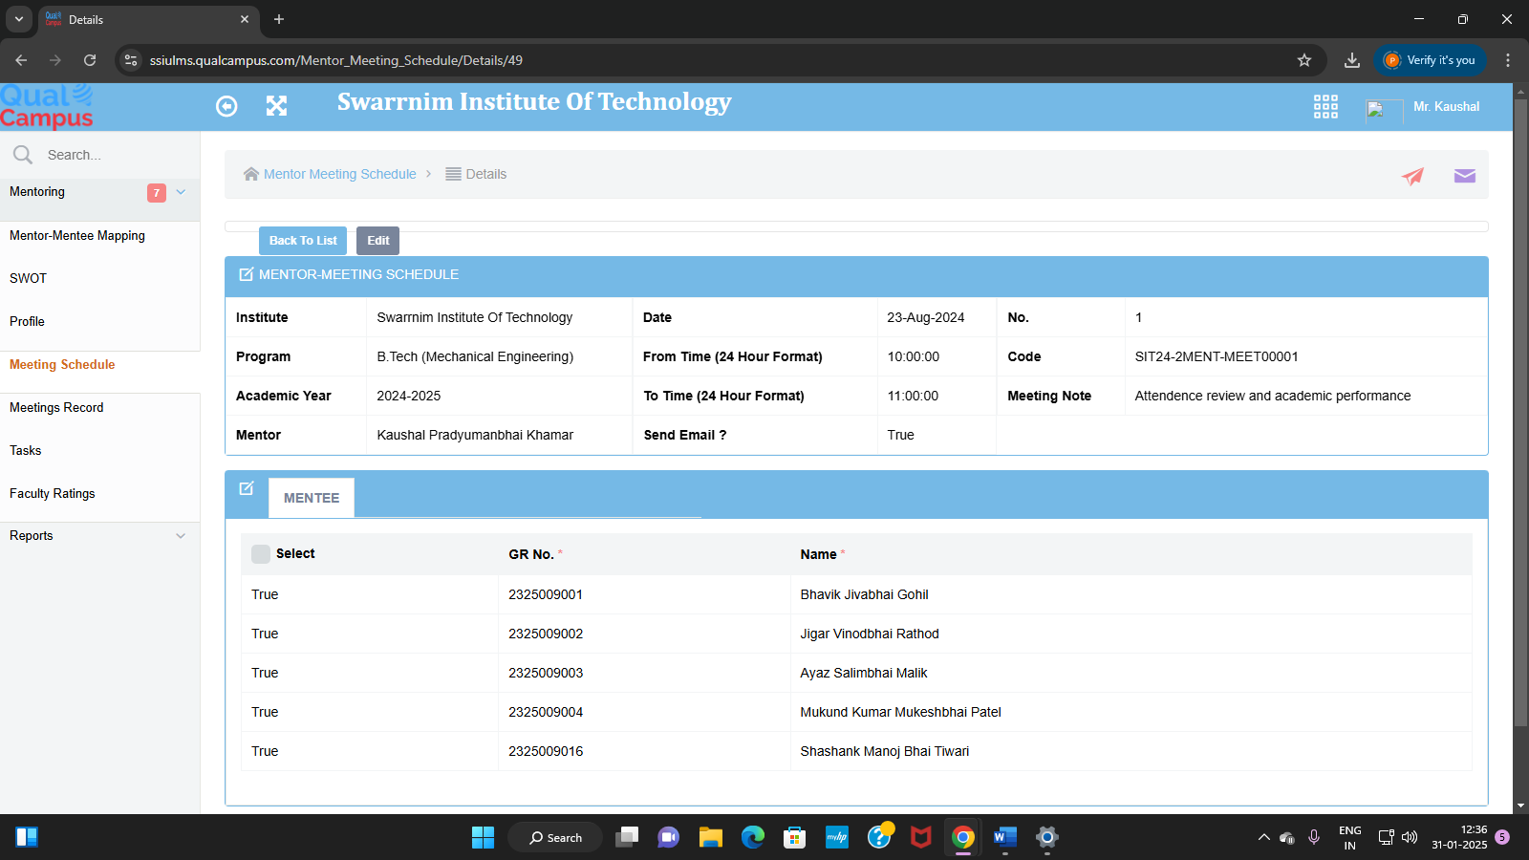

**Meeting Record:** <https://ssiulms.qualcampus.com/Mentor_Meetings/Index/>

To view the detail report of conducted meeting with students

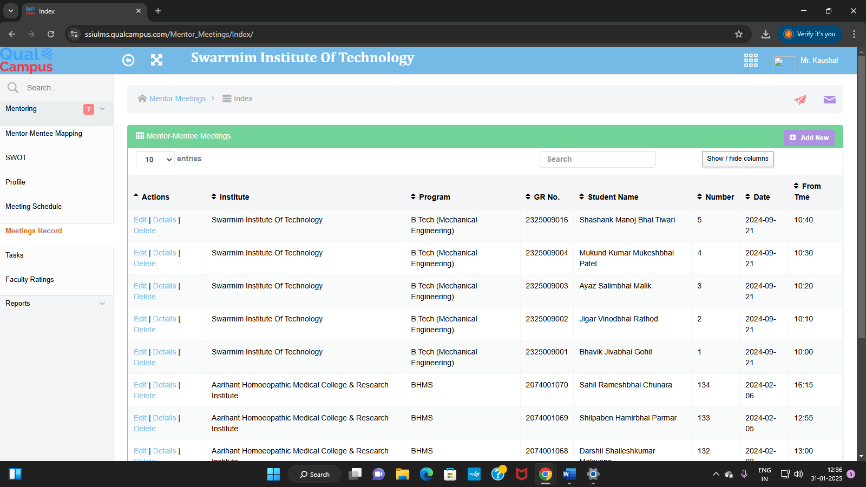

MENTOR-MENTEE DETAILS :

<https://ssiulms.qualcampus.com/RPT_Mentor_Mentee/Index/>

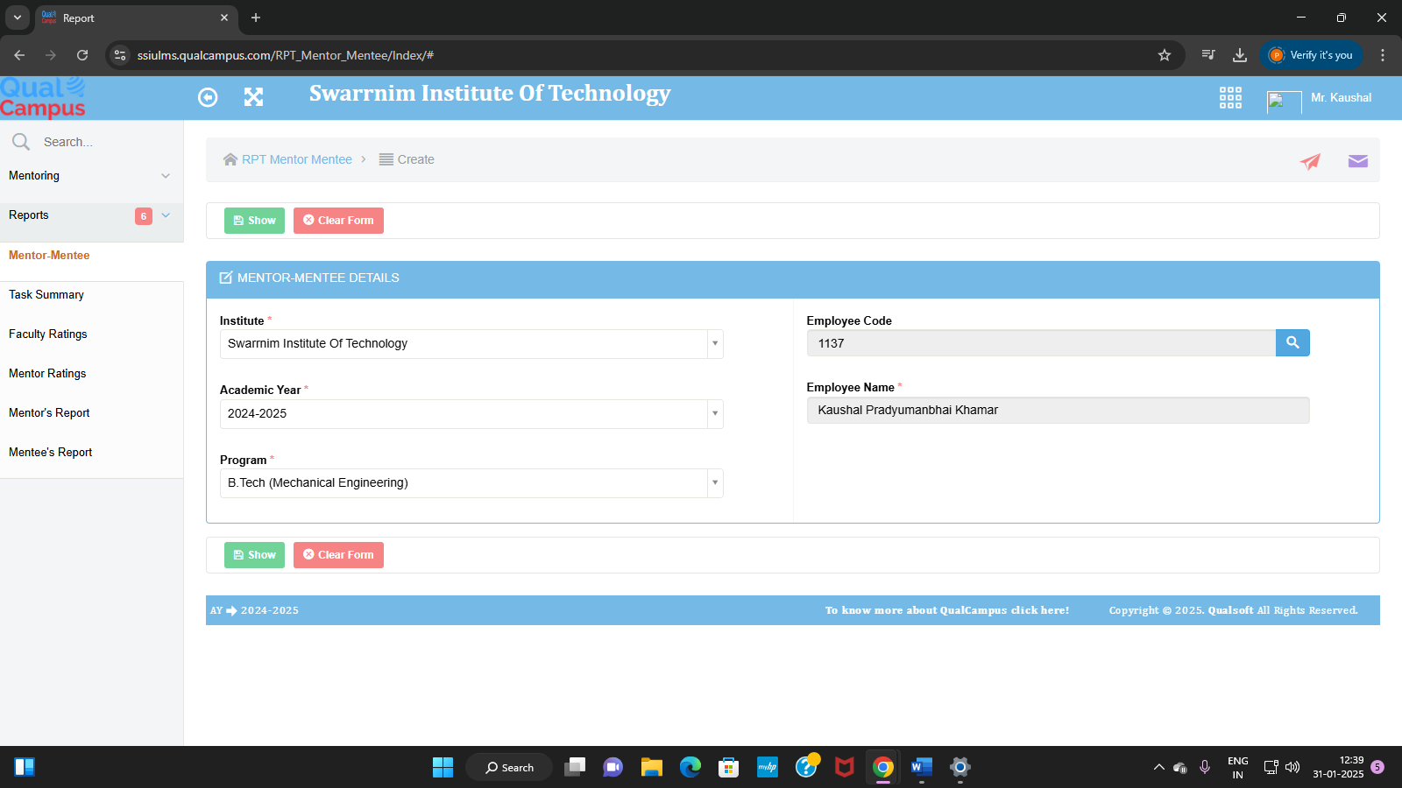

<https://ssiulms.qualcampus.com/Report_Viewer.aspx>

