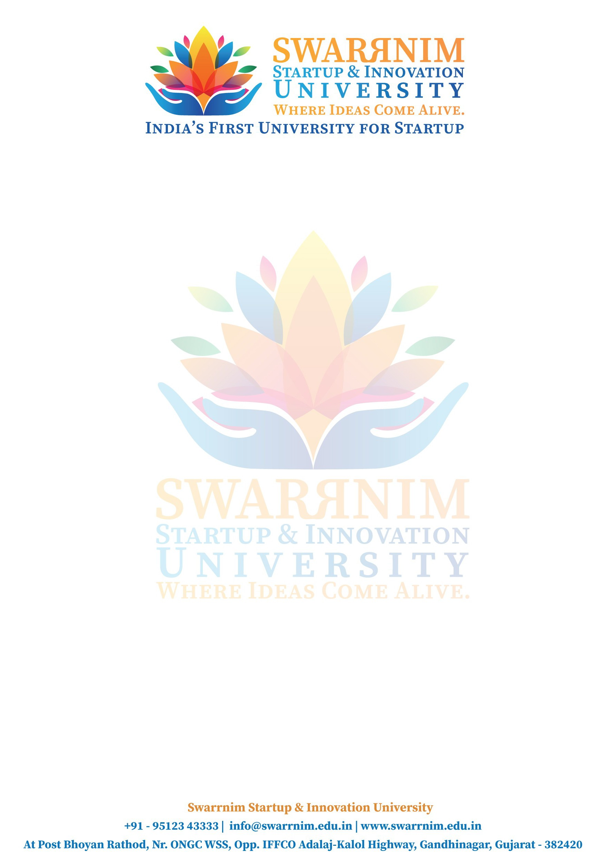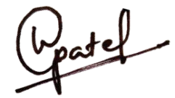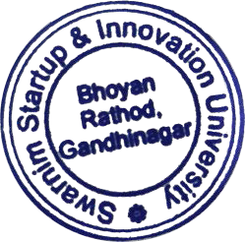

To, Date: 05/03/2023

The Registrar,

Swarrnim Startup and Innovation University, Gandhinagar.

Subject: Request for financial support to attend national seminar.

Dear Sir,

This is to communicate you that following faculty members are attending the national seminar on Modern Management in Amrit Kaal which is scheduled to be held between 16th March 2023 to 17th March 2023 at International School of Business and Media, Bangaluru.

|  |  |  |
| --- | --- | --- |
| Sr. No. | Faculty Name | Amount (Rs.) |
| 01 | Dr. Saurabhi Chatuvedi | 5000 |
| 03 | Hardik Nayee | 5000 |
| 04 | Paras Parmar | 5000 |
| 05 | Dr. Shashikant Bhagat | 8000 |
| 06 | Dr. Arti Khandhar | 5000 |
| 07 | Dr. Anil Borkar | 5000 |
| 08 | Honey Nayankumar Vyas | 5677 |
| 09 | Dr. Varsha Patel | 5238 |
|  | Total Amount | 43,915/- |

Head