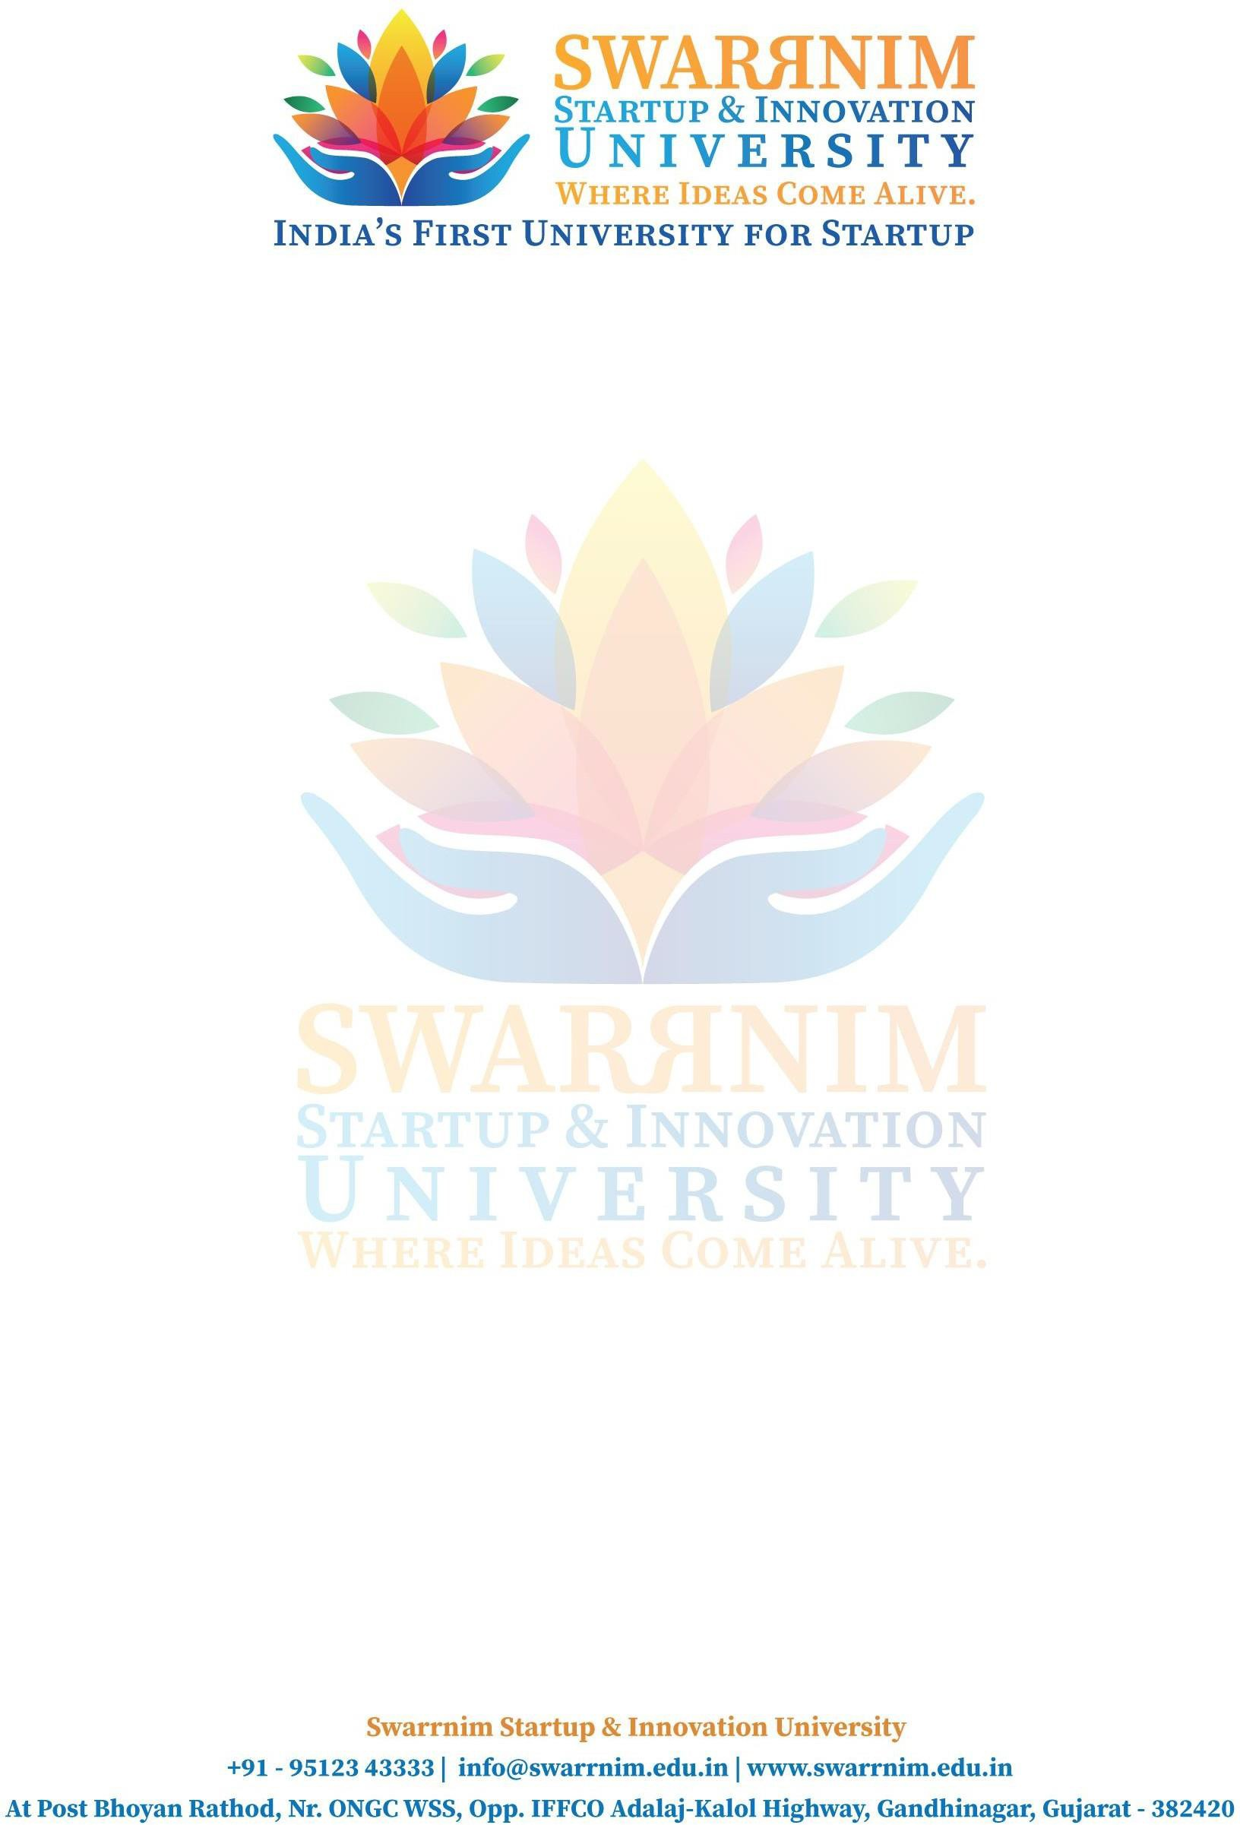

Date: 22/10/2022

To, Registrar,

Swarrnim Start Up & Innovation University, Gandhinagar

Subject: To provide financial support to faculties for conference

As per our policy to support faculty to attend conferences & Workshops, the following faculty member have sought approval to attend Conference on “Attended workshop on “International conference on Innovation solution to technical, engineering and technology problem “ on 28,29/10/2022 .You are requested to kindly approve the financial support.

**Requested expences :** Registration Fee/ Travel & Other Expense I hope you would find everything in order.

This are the list of faculties and their expences :

|  |  |  |
| --- | --- | --- |
| 1 | Dr Savan Tank | 5000 |
| 2 | Dr Sayantani Basu | 5000 |
| 3 | Prof. Brinda Gowani | 5000 |

Thank you for considering my request. I am happy to provide any additional information or documentation required to support my application. I look forward to your positive response.