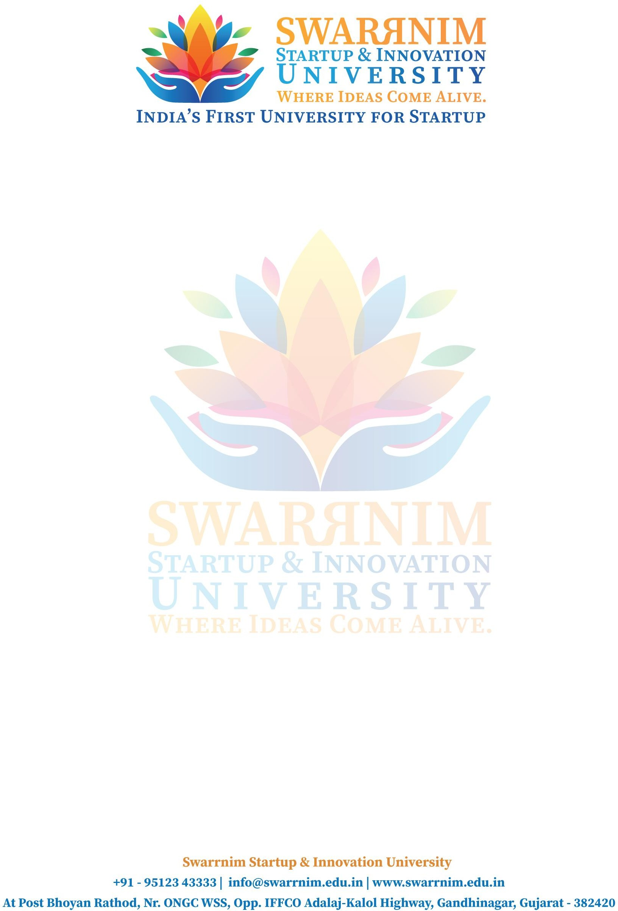

Date: 19/10/2020

To, Registrar,

Swarrnim Start Up & Innovation University, Gandhinagar

Subject: To provide financial support to faculties for seminar

As per our policy to support faculty to attend conferences & Workshops, the following faculty member have sought approval to attend Conference/Seminar in the month of October. You are requested to kindly approve the financial support.

Purpose: Registration Fee/ Travel & Other Expense I hope you would find everything in order.

This are the list of faculties and their expences :

|  |  |  |
| --- | --- | --- |
| Sr. No | Name of Faculty | Amount |
| 1 | Prem Prajapati | 5786 |

Thank you for considering my request. I am happy to provide any additional information or documentation required to support my application. I look forward to your positive response.