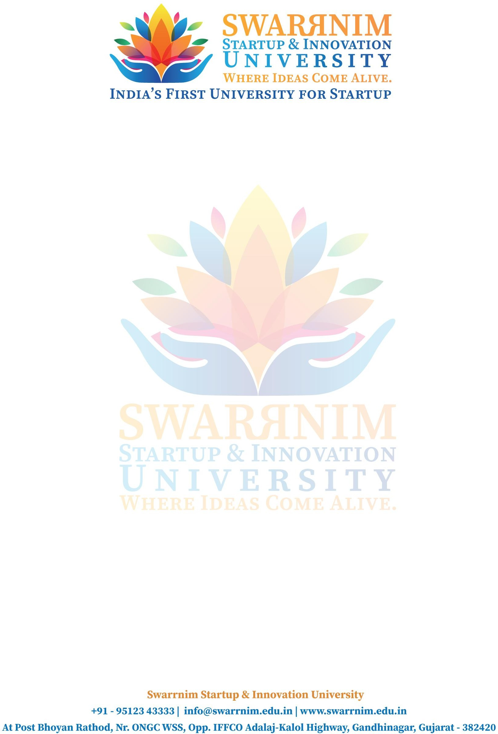

Date: 02/06/2020

To, Registrar,

Swarrnim Start Up & Innovation University, Gandhinagar

Subject: To provide financial support to faculties for seminar

As per our policy to support faculty to attend conferences & Workshops, the following faculty member have sought approval to attend Conference/Seminar in the month of May. You are requested to kindly approve the financial support.

Purpose: Registration Fee/ Travel & Other Expense I hope you would find everything in order.

This are the list of faculties and their expenses :

|  |  |  |  |
| --- | --- | --- | --- |
| Sr. No | Name of Faculty | Event Name | Amount |
| 1 | Dr.Archana Pandey | Webinar on Citizen Science : Social Distancing and Social Media | 5000 |
| 2 | Ankita Kaneriya | "Microbiology: Prospects & Future" | 5000 |
| 3 | Mittal Makwana | "Microbiology: Prospects & Future" | 5000 |
| 4 | Anjali Prajapati | "Microbiology: Prospects & Future" | 5000 |
| 5 | Hemali Kachhadiya | "Microbiology: Prospects & Future" | 5000 |
| 6 | Prem Prajapati | "Recent perspective of science in life of Covid-19 pandemic" | 5000 |
| 7 | Hemali Kachhadiya | Developement of viral vaccine & other preventive measures in pandemic | 5000 |
| 8 | Hemali Kachhadiya | Molecular diagnostics in modern medicines | 5000 |
| 9 | Hemali Kachhadiya | “LIFE SCIENCES RESEARCH: POST COIVD 19” | 5000 |
| 10 | Hemali Kachhadiya | Bioinformatics:Applications & Aspects | 5000 |
| 11 | Prem Prajapati | A travel for scientific indian minds | 5000 |
| 12 | Prem Prajapati | "Approaching goverment competitive examination in the present crisis of Covid-19" | 5000 |
| 13 | Prem Prajapati | "Getting started in sky watching" : A two day webinar crash course on Amuteur Astronomy | 5000 |

Thank you for considering my request. I am happy to provide any additional information or documentation required to support my application. I look forward to your positive response.