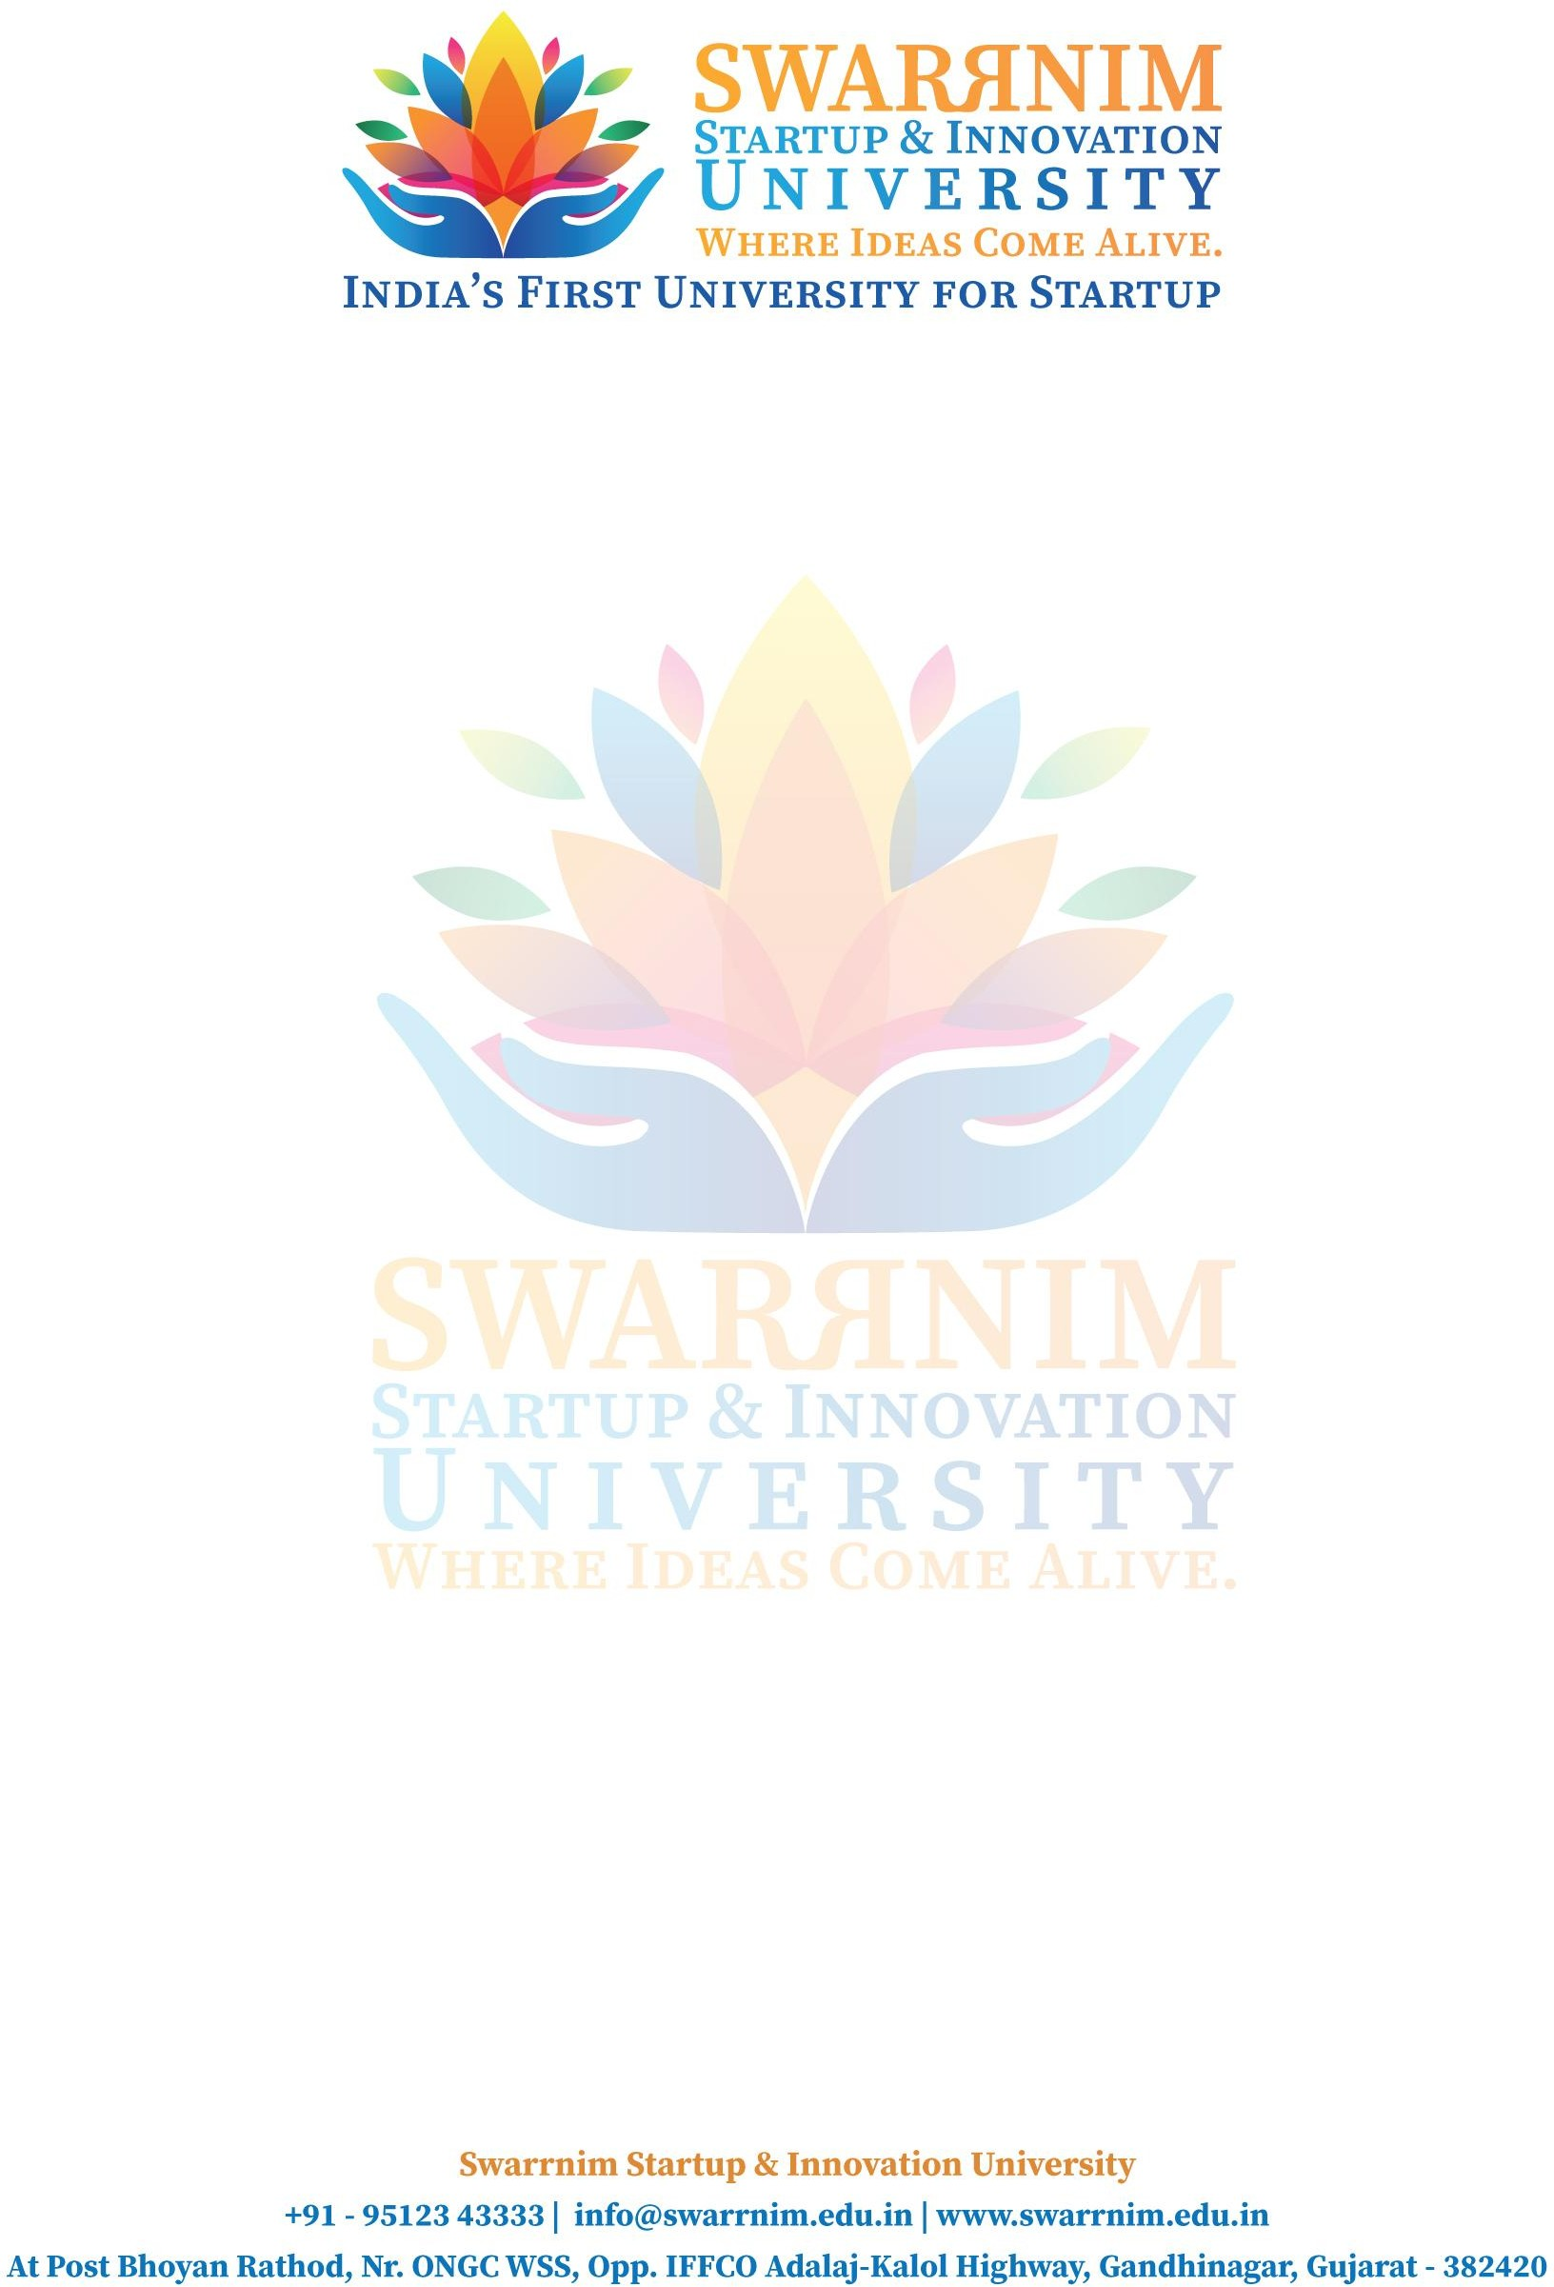

Date: 30/04/2020

To, Registrar,

Swarrnim Start Up & Innovation University, Gandhinagar

Subject: To provide financial support to faculties for seminar

As per our policy to support faculty to attend conferences & Workshops, the following faculty member have sought approval to attend Conference/Seminar in the month of April. You are requested to kindly approve the financial support.

Purpose: Registration Fee/ Travel & Other Expense I hope you would find everything in order.

This are the list of faculties and their expenses :

|  |  |  |  |
| --- | --- | --- | --- |
| **Sr. No** | **Name of Faculty** | **Event name** | **Amount** |
| 1 | Anjali Prajapati | Competency-Based Learning: Introduction | 6036 |
| 2 | Dhara Soni | 5950 |
| 3 | Dr.Hemant Chaube | 6810 |
| 4 | Nitin Parmar | 7680 |
| 5 | Prabhuta Patel | 8000 |
| 6 | Saloni Joshi | 5880 |
| 7 | Supriya Tiwari | 5000 |
| 8 | Vipul Sadava | 5000 |
| 9 | Prem Prajapati | Physics Webinar: - "Stay Home, Enjoy Physics" | 5000 |
| 10 | Prem Prajapati | "Stories on Black Hole and Cosmos, Basic Astronomy and Nano Technology" | 5000 |
| 11 | Prem Prajapati | "Essential Concept in Chemical Science" | 5000 |
| 12 | Dr.Archana Pandey | Webinar on Citizen science : COVID-19 Pandemic : Learning for Science and Society | 5000 |
| 13 | Dr.Archana Pandey | Webinar on Citizen Science : Exploring the Virus World | 5000 |
| 14 | Dr.Archana Pandey | Webinar on Citizen Science : Learning from Home - Digital way | 5000 |
| 15 | Dr.Archana Pandey | Webinar on Citizen Science : Disease Defense | 7416 |
| 16 | Prem Prajapati | "Striking a Balance Between Physics Learning and Approaching Competitive Exams" | 5575 |

Thank you for considering my request. I am happy to provide any additional information or documentation required to support my application. I look forward to your positive response.