To, Registrar,
Swarrnim Startup and Innovation University Subject: Financial support to attend workshop Respected sir,

Date: 03/11/2023

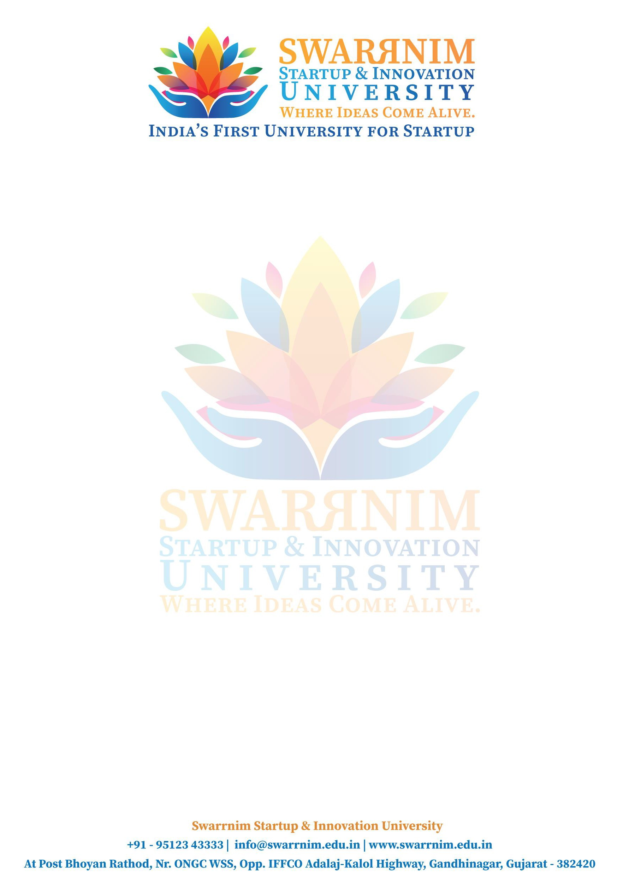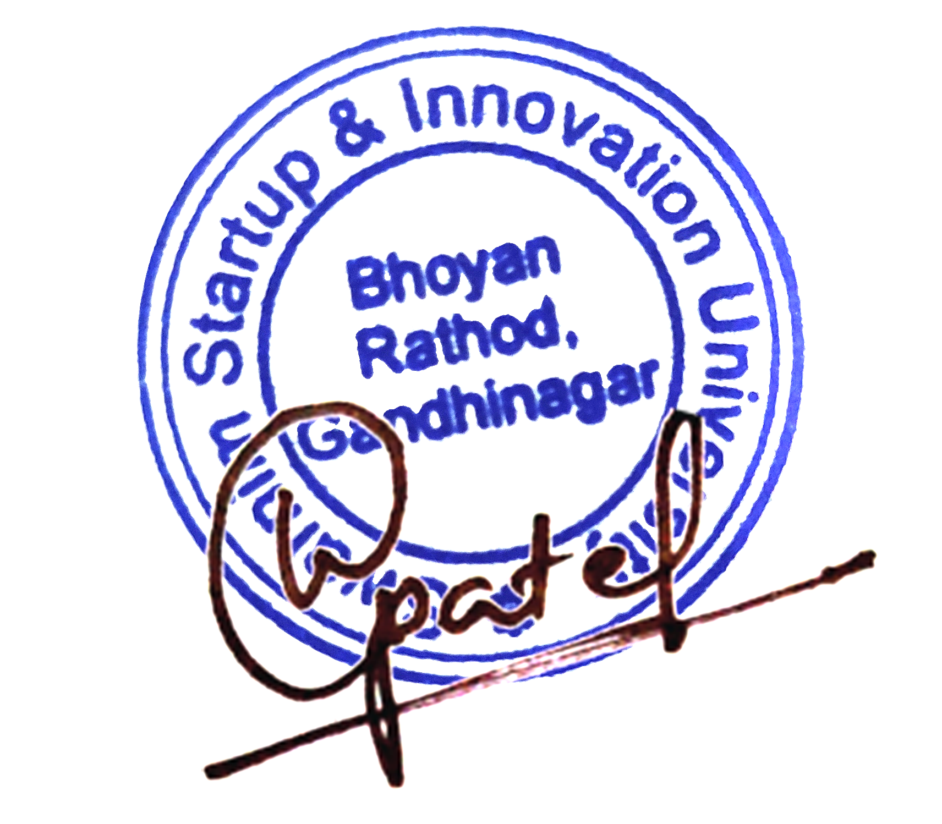As our policy to support faculties to attend workshop/seminar & conferences the below mentioned faculties have sought approval to attend academic workshop on pharmacy at “Dr. Willmar Schwabe India Pyt. Ltd.” on 31/10/2023. You are requested to kindly approve the financial support.

Sr.No. | Name of faculties | Amount
1 | DR. NIRAV BHATT | 5000
2 | DR. S K JHA | 5000
3 | DR. KAVISH PANDEY | 5000

Registrar SSIU

To, Registrar,
Swarrnim Startup and Innovation University

Date: 13/06/2023

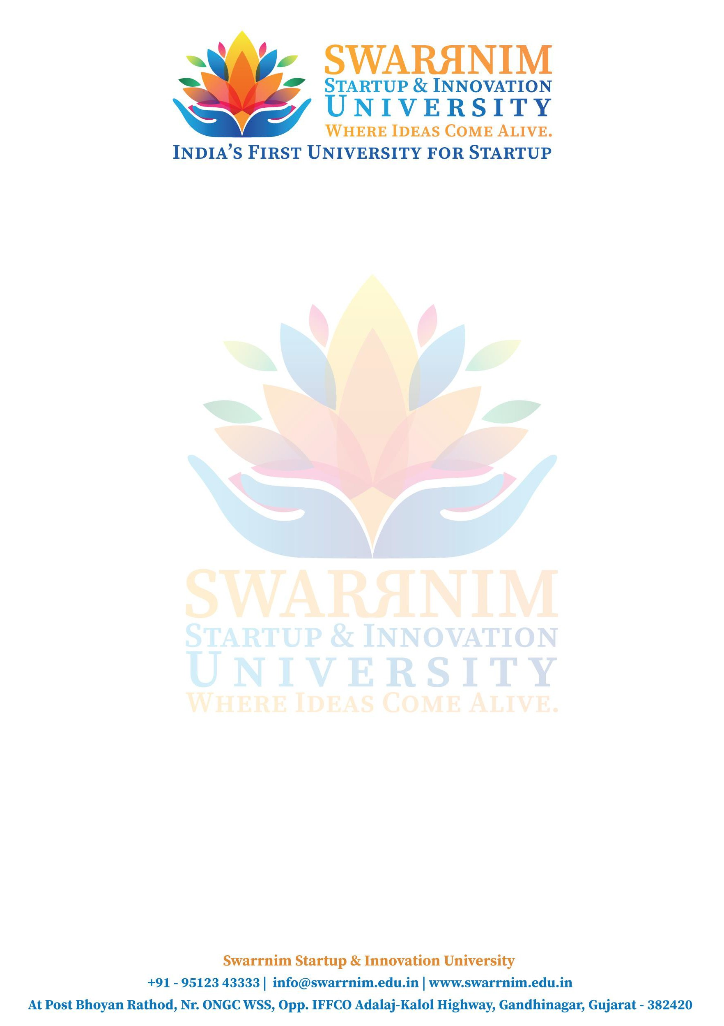
Subject: Financial support to attend workshop/Conference

Respected sir,

As our policy to support faculties to attend workshop/seminar & conferences the below mentioned faculties have sought approval to attend Academic workshop of Community medicine on “Mundra Port Visit” on 06/06/2023. You are requested to kindly approve the financial support.

Purpose: Registration fees and others Name of Faculty: Dr. Chintan Pandya Amount: 7000
Name of Faculty: Dr. Jaya Srivastava

Amount: 7000

Registrar SSIU

To, Registrar,
Swarrnim Startup and Innovation University

Date: 16/04/2024

Subject: Financial support to attend workshop/Conference

Respected sir,

As our policy to support faculties to attend workshop/seminar & conferences the below mentioned faculties have sought approval to attend Academic workshop on “Scientific Convention on World Homoeopathic day” on 10/04/2024 & 11/04/2024. You are requested to kindly approve the financial support.

Purpose: Registration fees and others Name of Faculty: Dr. Chintan Pandya Amount: 7000
Name of Faculty: Dr. Nirav Bhatt

Amount: 7000

Registrar SSIU

To, Registrar,
Swarrnim Startup and Innovation University Subject: Financial support to attend workshop Respected sir,

Date: 31/07/2023

As our policy to support faculties to attend workshop/seminar & conferences the below mentioned faculties have sought approval to attend academic workshop on FMT at: “Sundarvan Mini Zoo” on 25/07/2023. You are requested to kindly approve the financial support.

Sr. No. | Name of faculties | Amount
1 | DR. NIDHI BHAVSAR | 5173
2 | DR. KHUSHBOO PRAJAPATI | 5600
3 | DR. NISHA MANANI | 5520

Registrar SSIU

To, Registrar,
Swarrnim Startup and Innovation University Subject: Financial support to attend workshop Respected sir,

Date: 05/09/2023

As our policy to support faculties to attend workshop/seminar & conferences the below mentioned faculties have sought approval to attend academic workshop on FMT at “National Forensic Science University.” on 31/08/2023. You are requested to kindly approve the financial support.

Sr.No. | Name of faculties | Amount
1 | DR. DHANANJAY DUBEY | 6000
2 | DR. MAHESH GITE | 5000
3 | DR. RAJIV PERES | 6250
4 | DR. RAMKRISHNA MISHRA | 5000
5 | DR. MITALI LATHIGRA | 5899
6 | DR. PALAK RAJWAT | 5853

Registrar SSIU

To, Registrar,
Swarrnim Startup and Innovation University Subject: Financial support to attend workshop Respected sir,

Date: 07/08/2023

As our policy to support faculties to attend workshop/seminar & conferences the below mentioned faculties have sought approval to attend academic workshop on FMT at “Taluka Police Station.” on 31/07/2023. You are requested to kindly approve the financial support.

Sr.No. | Name of faculties | Amount
1 | DR. SYEDA MASSARAT | 5000
2 | DR. RAJIV PERES | 5000
3 | DR. PRIYANKA CHAUHAN | 5000
4 | DR. DISHA SHOTRIYA | 5000

Registrar SSIU

To, Registrar,
Swarrnim Startup and Innovation University Subject: Financial support to attend workshop Respected sir,

Date: 28/12/2023

As our policy to support faculties to attend workshop/seminar & conferences the below mentioned faculties have sought approval to attend academic workshop on FMT at “District Court Visit” on 18/12/2023 to 20/12/2023. You are requested to kindly approve the financial support.

Sr.No. | Name of faculties | Amount
1 | DR. RIDDHI MAKWANA | 5000
2 | DR. RAKESH SHARMA | 5000
3 | DR. KRISHNA BISWAL | 5290

Registrar SSIU

To, Registrar,
Swarrnim Startup and Innovation University

Date: 27/02/2024

Subject: Financial support to attend workshop/Conference

Respected sir,

As our policy to support faculties to attend workshop/seminar & conferences the below mentioned faculties have sought approval to attend Academic workshop on “Clinical Approach to various cases with similimum selection” on 23/02/2024. You are requested to kindly approve the financial support.

Purpose: Registration fees and others Name of Faculty: Dr. Kinjal Patel Amount: 6836

Registrar SSIU

To, Registrar,
Swarrnim Startup and Innovation University

Date: 31/01/2024

Subject: Financial support to attend workshop/Conference

Respected sir,

As our policy to support faculties to attend workshop/seminar & conferences the below mentioned faculties have sought approval to attend the national level competition on 25/01/2024. You are requested to kindly approve the financial support.

Purpose: Registration fees and others Name of Faculty: Dr. Kinjal Patel Amount: 6836

Registrar SSIU

