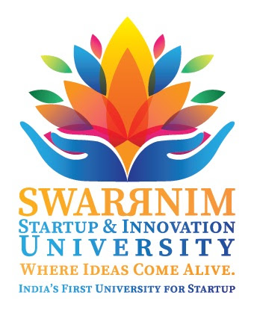

**Ref: Swarrnim/RO/2018/12 Date: 19/11/2018**

**CIRCULAR- IDENTIFY SLOW AND ADVANCE LEARNERS**

Swarrnim Start Up & Innovation University is always committed to the ethical pursuit of knowledge and assuring our all stakeholders that we are taking all necessary actions and interventions to support and encourage both slow learners and advance learners. For this purpose, policy guidelines on slow and advance learners are framed. You are required to identify slow and advance learners from your respective program year/semester wise and ensure the timely conduct of necessary actions and activities as per the policy guidelines.

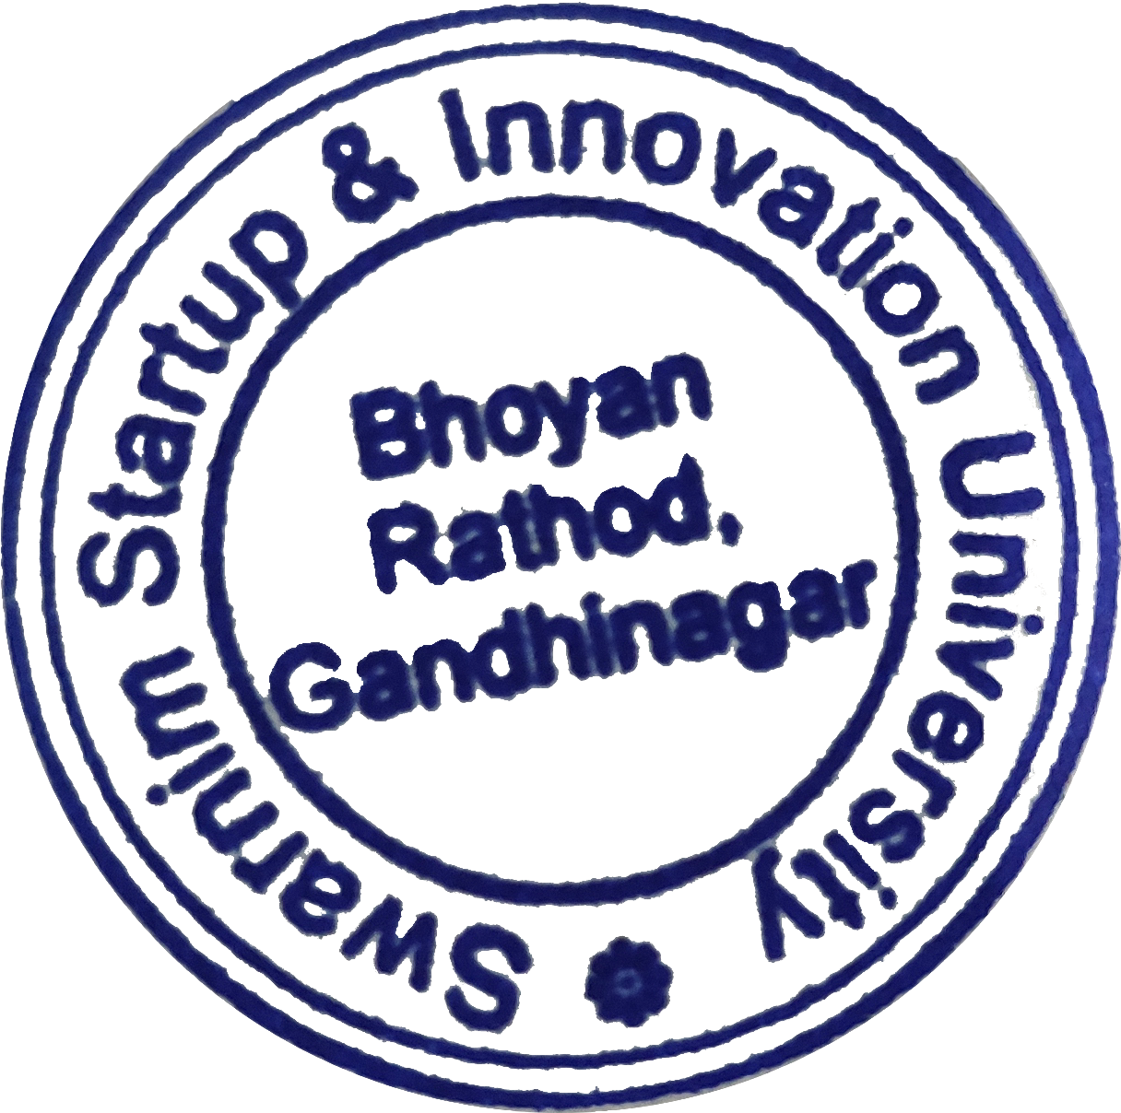



**Dr. S. S. THAKUR**

**Registrar**

**POLICY ON SLOW LEARNERS AND ADVANCED LEARNERS**

Swarrnim Start Up & Innovation University being India’s first start-up & Innovation University, stands on principles of Innovation & Entrepreneurship, aims to impart education to all the students as per their level of grasp to create budding entrepreneurs who can be globally competent.

Every student at Swarrnim Start Up & Innovation University (henceforth mentioned as The University) is treated with respect and their unique skills are recognized. For newly admitted students, the institution takes necessary steps with an emphasis on developing their talent and orienting them towards the fundamental academic characteristics of the curriculum. The purpose of this policy is to define the procedure and lay down the provisions for establishing a support mechanism for catering to the students as per their learning abilities.

**Mechanism adapted to identify slow learners and advanced learners:**

**For 1st Year/Semester**

* Performance in 1ST internal/ mid-semester examinations
* Active Participation in round the semester /year activities

**From 2nd Year/Semester Onwards**

* Based on results of the previous year/semester's university exam
* Active Participation in round-the-year activities

For 1st year/semester internal exam is a convenient way for faculty members to evaluate students performing capabilities since the examinations provide them with a sense of how capable the students are to acquiring new subjects. Students who have failed in two or more two subjects in the first internal/mid-semester exams will be identified as slow learners for that year/ semester. Regular academic and personal counseling by mentors to students is provided, significantly improving the student’s academic performance for the next exams.

From 2nd year/semester onwards students who have failed in two or more than two subjects in the final exams of the University will be identified as slow learners.

10% of the total strength of the class will be considered as slow learners and 10% of the total strength of the class will be identified as advanced learners.

Once the students are identified as slow/advanced learners, The University has established an intensive system to cater to the students as per their requirements.

**The following activities are conducted for slow learners**

1. Remedial classes
2. Clinical/laboratory learning for the students
3. Individual counseling to the slow learner

The University adopts measurable criteria to identify low performers. Every department of the University organizes special lectures called as remedial classes for low performers and to solve their difficulties in the subject they have failed and to improve their knowledge and skills in those subjects. So that they can successfully pass the remedial examination. Based on remedial class and their performance in subsequent remedial exams results, their progress is evaluated.

**Following activities are conducted for advanced learners**

1. Encouragement to participate in conferences and seminars and present the papers
2. Arranging expert sessions to Incorporate projects in curriculum
3. Encouraging students to take part in competitive examination
4. Organizing classes for competitive examinations
5. Summer Research Programme
6. Providing Scope for add-on courses
7. Conducting seminars and workshops on advance topic/technology
8. Felicitation of achievers on convocation day
9. Career planning guidance by training and placement officer

Each department of the University provides opportunities for advanced learners to showcase their talents through participation in seminars, Quiz competitions, and workshops for skill development, giving opportunities to students as per their skills in events, seminars, and conferences. Additionally, students have the opportunity to demonstrate their grasp of a subject's components at the weekly seminar presentation which is organized by several departments. The University also provides value-added courses and career-focused skill courses for the benefit of the students. The University has designed a multi-level system to deliver education to the students to make them reach the highest caliber.





**Dr. S. S. THAKUR**

**Registrar**