

Academic Year 2020-2021

Date: 03/08/2020
To,
The Provost,
Swarrnim Startup and Innovation University, Gandhinagar- 322420

Subject: Commencement of Soft Skills and Training Classes

As the Manager of the Training and Placement Department, I am writing to propose an initiative that will significantly enhance our student’s employability and overall professional development.
In today’s competitive job market, technical skills alone are not sufficient. Employers increasingly seek candidates with strong skills—such as communication, teamwork, adaptability, and problem-solving abilities. To address this need, I recommend the introduction of Soft Skills training classes across all departments.

I kindly request your support in implementing this initiative. Let us work together to prepare our students for success beyond academia.

Thank you for your attention to this matter.

Sincerely,

Mr. Vijayant Kumar Director,
Training and Placement Department Swarrnim Startup and Innovation University

5.1.3 - Following Capacity development and skills enhancement initiatives are taken by the institution:

1. Soft Skills

Name of Capacity building and skills enhancement | Date of Implementation (DD-MM-YYYY) | Number of Students Enrolled | Name of the agencies/consultants involved with contact details (If Any)
Soft Skill | 03/08/2020 | 223 | T&P (Internal Team)

INDEX
Sr. No. | Topic | Page No
1. Training Need Analysis |  | 5-16
1.1 Pre Assessment Analysis |  | 5
2.1 Course Plan |  | 17-85
2.1.1 Odd Semester Course Plan |  | 17-49
2.2.2 Even Semester Course Plan |  | 50-85
2.2 Time-Table |  | 86-98
2.2.1 Odd Semester Time-Table |  | 86-92
2.2.2 Even Semester Time-Table |  | 92-98
2.3 Training Attendance |  | 99-112
2.4 Workshop/Seminar |  | 113-138
Workshops Report 1 |  | 113
Workshops Report 2 |  | 118
Workshops Report 3 |  | 123
Workshops Report 4 |  | 128
Workshops Report 5 |  | 133
3. Post Assessment Analysis |  | 139-179
3.1 Slow Learner Chart |  | 179
3.2 Average Learner Chart |  | 179
3.3 Fast Learner Chart |  | 179


Training Need Analysis - Pre Assessment Analysis SIT Pre Assessment Analysis :
Progress Report (2020-2021)
Btech Semester 1 - Pre Assessment
Sno | Enrollment Number | Student Name | Branch | Appear ance (10) | Body Languag e (10) | Communic ation Skills (10) | Confidence (10) | Did the student carry CV (YES/NO) | Overall Rating (40)
1 | 1925001001 | Patel Hirenkumar Amrishbhai | Technology in Automobile Engineering | 0 | 2 | 1 | 1 | No | 4
2 | 1925001002 | Rami Jaivik Dineshbhai | Technology in Automobile Engineering | 1 | 1 | 1 | 1 | No | 4
3 | 1925001003 | Patel Nisargkumar Manojbhai | Technology in Automobile Engineering | 1 | 0 | 1 | 0 | No | 2
4 | 1925002001 | Prajapati Ajay Kumar Babubhai | Technology in Chemical Engineering | 1 | 3 | 1 | 0 | No | 5
5 | 1925002003 | Shrimali Dhruvika Pradipkumar | Technology in Chemical Engineering | 2 | 1 | 1 | 1 | No | 5
6 | 1925003001 | Patel Jasmin Dipakbhai | Technology in Civil Engineering | 1 | 0 | 2 | 1 | No | 4
7 | 1925003002 | Chauhan Bharatkumar Dhirubhai | Technology in Civil Engineering | 1 | 1 | 1 | 1 | No | 4
8 | 1925005002 | Bukhari Mohammeds haiq Murtuzahuse n | Technology in Electrical Engineering | 1 | 0 | 1 | 0 | No | 2
9 | 1925008001 | Patel Haritakumar i Sureshkumar | Technology in Information Technology | 0 | 1 | 2 | 0 | No | 3
10 | 1925008002 | Heta Nikunjkuma r Panchal | Technology in Information Technology | 1 | 0 | 2 | 1 | No | 4

11 | 1925008004 | Patel Bhavesh Rameshbhai | Technology in Information Technology | 1 | 1 | 2 | 1 | No | 5
12 | 1925008005 | Patel Prince Ashwinbhai | Technology in Information Technology | 0 | 2 | 1 | 1 | No | 4
13 | 1925009001 | Patel Yash Sanjaykumar | Technology in Mechanical Engineering | 1 | 1 | 1 | 1 | No | 4
14 | 1925009002 | Mehta Chaitanya Shaileshkum ar | Technology in Mechanical Engineering | 1 | 0 | 1 | 0 | No | 2
15 | 1925009012 | Joshi Nishant Jayeshbhai | Technology in Mechanical Engineering | 0 | 1 | 2 | 0 | No | 3

Progress Report (2020-2021)
Diploma Semester 1 - Pre Assessment
Sno | Enrollment Number | Student Name | Branch | Appear ance (10) | Body Language (10) | Communic ation Skills (10) | Confidence (10) | Did the student carry CV (YES/NO) | Overall Rating (40)
1 | 1922001002 | Jangir Pratik Mohanlal | Automobile Engineering | 1 | 0 | 2 | 1 | No | 4
2 | 1922001003 | Chauhan Yash Maheshkuma r | Automobile Engineering | 1 | 1 | 2 | 1 | No | 5
3 | 1922002001 | Tralsawala Shivam Sanjaykumar | Civil Engineering | 0 | 2 | 1 | 1 | No | 4
4 | 1922002002 | Raj | Civil Engineering | 1 | 1 | 1 | 1 | No | 4
5 | 1922002003 | Panchal Juhil Jenabhai | Civil Engineering | 1 | 0 | 1 | 0 | No | 2
6 | 1922002004 | Jamadar Fardin M Hanif | Civil Engineering | 1 | 3 | 1 | 0 | No | 5
7 | 1922002006 | Vivek Vinubhai Radadiya | Civil Engineering | 2 | 1 | 1 | 1 | No | 5
8 | 1922002007 | Gajera Dhruvinkuma r Hasmukhbhai | Civil Engineering | 1 | 0 | 2 | 1 | No | 4

9 | 1922002010 | Uravarajsinh Jayendrasinh Gohil | Civil Engineering | 1 | 1 | 1 | 1 | No | 4
10 | 1922002012 | Desai Chirag Vishnubhai | Civil Engineering | 1 | 0 | 1 | 0 | No | 2
11 | 1922003002 | Patel Krunal Ketan Kumar | Computer Engineering | 0 | 1 | 2 | 0 | No | 3
12 | 1922003006 | Kori Ankit Rakesh Kumar | Computer Engineering | 1 | 0 | 2 | 1 | No | 4
13 | 1922003007 | Chavda Jhanvi Ashvinbhai | Computer Engineering | 1 | 1 | 2 | 1 | No | 5
14 | 1922003008 | Patel Nay Rajeshkumar | Computer Engineering | 0 | 2 | 1 | 1 | No | 4
15 | 1922003009 | Mistry Mithil Kamleshbhai | Computer Engineering | 1 | 1 | 1 | 1 | No | 4
16 | 1922003010 | Senjaliya Takshil Asvinbhai | Computer Engineering | 1 | 0 | 1 | 0 | No | 2
17 | 1922003011 | Modak Devanshi Rajesh | Computer Engineering | 0 | 1 | 2 | 0 | No | 3
18 | 1922003013 | Vasani Dhruv Alpeshbhai | Computer Engineering | 1 | 0 | 2 | 1 | No | 4
19 | 1922003015 | Doshi Shreyam Bhadreshkum ar | Computer Engineering | 1 | 1 | 2 | 1 | No | 5
20 | 1922003017 | Roy Darshil Dhirajkumar | Computer Engineering | 0 | 2 | 1 | 1 | No | 4
21 | 1922003019 | Ayush Pathak | Computer Engineering | 1 | 1 | 1 | 1 | No | 4
22 | 1922003023 | Darshan Kumar B. Sureja | Computer Engineering | 1 | 0 | 1 | 0 | No | 2
23 | 1922003024 | Mayank Kumar M Sureja | Computer Engineering | 1 | 3 | 1 | 0 | No | 5
24 | 1922003026 | Gaode Chinmai Vijay | Computer Engineering | 2 | 1 | 1 | 1 | No | 5
25 | 1922003028 | Danny Raju Galla | Computer Engineering | 1 | 0 | 2 | 1 | No | 4
26 | 1922003034 | Patel Divyank Sanjaykumar | Computer Engineering | 1 | 1 | 1 | 1 | No | 4
27 | 1922003035 | Anjali A | Computer | 1 | 0 | 1 | 0 | No | 2

 |  | Chauhan | Engineering
28 | 1922004002 | Gameti Nikulbhai Laljibhai | Electrical Engineering | 0 | 1 | 2 | 0 | No | 3
29 | 1922005002 | Patel Meet Rajeshbhai | Mechanical Engineering | 1 | 0 | 2 | 1 | No | 4
30 | 1922005003 | Hadiya Dharmesh Gunvantbhai | Mechanical Engineering | 1 | 1 | 2 | 1 | No | 5
31 | 1922005006 | Ankit Kumar | Mechanical Engineering | 0 | 2 | 1 | 1 | No | 4
32 | 2222003009 | Panchal Jainilkumar Dharmendraku mar | Computer Engineering | 1 | 1 | 1 | 1 | No | 4
33 | 2222003010 | Desai Jay Kalpeshkumar | Computer Engineering | 1 | 0 | 1 | 0 | No | 2
34 | 2222003011 | Parmar Jatin Kantibhai | Computer Engineering | 0 | 1 | 2 | 0 | No | 3
35 | 2222003012 | Bavluwala Hammad Mohammad Husen | Computer Engineering | 1 | 0 | 2 | 1 | No | 4
36 | 2222003013 | Sorthiya Krisha Arvindkumar | Computer Engineering | 1 | 1 | 2 | 1 | No | 5
37 | 2222003014 | Patel Sujal Amitkumar | Computer Engineering | 0 | 2 | 1 | 1 | No | 4
38 | 2222003015 | Gautam Raj Gupta | Computer Engineering | 1 | 1 | 1 | 1 | No | 4
39 | 2222003016 | Joshi Krupali Himanshubhai | Computer Engineering | 1 | 0 | 1 | 0 | No | 2
40 | 2222003017 | Barot Rudra Shivlal | Computer Engineering | 1 | 3 | 1 | 0 | No | 5
41 | 2222003018 | Sureja Gourav Kalpitbhai | Computer Engineering | 2 | 1 | 1 | 1 | No | 5
42 | 2222003019 | Solanki Kinnari Kalidas | Computer Engineering | 1 | 0 | 2 | 1 | No | 4
43 | 2222003020 | Gohil Pruthvi Kalpesh | Computer Engineering | 1 | 1 | 1 | 1 | No | 4
44 | 2222003021 | Gajjar Tanvi Ranjitkumar | Computer Engineering | 1 | 0 | 1 | 0 | No | 2
45 | 2222003022 | Khandakar Jaydeep Jayeshbhai | Computer Engineering | 0 | 1 | 2 | 0 | No | 3
46 | 2222003023 | Shah Hetu Jasmin | Computer Engineering | 1 | 0 | 2 | 1 | No | 4
47 | 2222003024 | Vaghela Janvi Vijaykumar | Computer Engineering | 1 | 1 | 2 | 1 | No | 5
48 | 2222003025 | Raval Raj | Computer | 0 | 2 | 1 | 1 | No | 4

 |  | Manishbhai | Engineering
49 | 2222003026 | Rawat Jubin Bhagatsingh | Computer Engineering | 1 | 1 | 1 | 1 | No | 4
50 | 2222003027 | Chauhan Sneha Dalpatbhai | Computer Engineering | 1 | 0 | 1 | 0 | No | 2
51 | 2222003028 | Sojalliya Harsh Hiteshkumar | Computer Engineering | 0 | 1 | 2 | 0 | No | 3
52 | 2222003029 | Princekumar Prithviraj Chaudhari | Computer Engineering | 0 | 2 | 1 | 1 | No | 4
53 | 2222003030 | Patel Jeel Vinodbhai | Computer Engineering | 1 | 1 | 1 | 1 | No | 4
54 | 2222003031 | Makwana Yashasvi Anilkumar | Computer Engineering | 1 | 0 | 1 | 0 | No | 2
55 | 2222003032 | Raju Mandal | Computer Engineering | 0 | 1 | 2 | 0 | No | 3
56 | 2222003033 | Thakkar Neel Rasikbhai | Computer Engineering | 1 | 0 | 2 | 1 | No | 4
57 | 2222003034 | Ayush Barnwal | Computer Engineering | 1 | 1 | 2 | 1 | No | 5
58 | 2222003035 | Sanjiv Kumar Saday | Computer Engineering | 0 | 2 | 1 | 1 | No | 4
59 | 2222003036 | Tripathi Rudresh Hariprasad | Computer Engineering | 1 | 1 | 1 | 1 | No | 4
60 | 2222003037 | Patel Manthan Sandipbhai | Computer Engineering | 1 | 0 | 1 | 0 | No | 2
61 | 2222003038 | Patel Janay Amitbhai | Computer Engineering | 0 | 1 | 2 | 0 | No | 3
62 | 2222003039 | Dhyan Nimbark | Computer Engineering | 1 | 0 | 2 | 1 | No | 4
63 | 2222003040 | Patel Meet Harshadbhai | Computer Engineering | 1 | 1 | 2 | 1 | No | 5
64 | 2222003081 | Darji Abhi Pareshkumar | Computer Engineering | 0 | 2 | 1 | 1 | No | 4
65 | 2222003082 | Patel Shrutkumar Ravindrabhai | Computer Engineering | 1 | 1 | 1 | 1 | No | 4
66 | 2222003083 | Patel Smit Maheshbhai | Computer Engineering | 1 | 0 | 1 | 0 | No | 2
67 | 2222003084 | Patel Param Kiritkumar | Computer Engineering | 1 | 1 | 1 | 1 | No | 4
68 | 2222004001 | Mohite Rishit Yashvant | Electrical Engineering | 1 | 0 | 1 | 0 | No | 2
69 | 2222004002 | Malawat Shourya Pratap Singh | Electrical Engineering | 0 | 2 | 1 | 1 | No | 4
70 | 2222005001 | Parase Amol Shrirang | Mechanical Engineering | 1 | 1 | 1 | 1 | No | 4
71 | 2222005002 | Patel Keyur | Mechanical | 1 | 0 | 1 | 0 | No | 2

 |  | Vishnulal | Engineering
72 | 2222005003 | Patel Meet Atulbhai | Mechanical Engineering | 0 | 1 | 2 | 0 | No | 3
73 | 2222005004 | Patel Dhyey Rakeshkumar | Mechanical Engineering | 1 | 0 | 2 | 1 | No | 4
74 | 2222005009 | Pathan Armankhan Salimkhan | Mechanical Engineering | 1 | 1 | 2 | 1 | No | 5

SMCLA Pre Assessment Analysis :

Progress Report (2020-2021)
BCA/BBA/BCom/BA / Semester 1 - Pre Assessment
Sno | Enrollment Number | Student Name | Branch | Appeara nce (10) | Body Language (10) | Communic ation Skills (10) | Confidence (10) | Did the student carry CV (YES/NO) | Overall Rating (40)
1 | 1914001001 | Vaghela Manmeet | B com | 1 | 0 | 2 | 1 | No | 4
2 | 1914001002 | Barot Prince Yogeshbhai | B com | 1 | 1 | 2 | 1 | No | 5
3 | 1914001003 | Pooja Laxmankumar Sen | B com | 0 | 2 | 1 | 1 | No | 4
4 | 1914001004 | Patel Nirdesh PankajKumar | B com | 1 | 1 | 1 | 1 | No | 4
5 | 1914001005 | Patel Deep Shailesh bhai | B com | 1 | 0 | 1 | 0 | No | 2
6 | 1914001006 | Patel Heny Hitendrakumar | B com | 1 | 3 | 1 | 0 | No | 5
7 | 1914001007 | Dudhat Hashil Jagdishbhai | B com | 2 | 1 | 1 | 1 | No | 5
8 | 1914001008 | Tarpara Yash Dilipbhai | B com | 1 | 0 | 2 | 1 | No | 4
9 | 1914001009 | Kamal Dineshbhai Prajapati | B com | 1 | 1 | 1 | 1 | No | 4
10 | 1914001010 | Pency Bharat Pandya | B com | 1 | 0 | 1 | 0 | No | 2
11 | 1914001011 | Chuhan Nikita Avdeshkumar | B com | 0 | 1 | 2 | 0 | No | 3
12 | 1914001012 | Patel Meet Ghanshyam | B com | 1 | 0 | 2 | 1 | No | 4
13 | 1914001013 | Patel Shiv Rajendrakumar | B com | 1 | 1 | 2 | 1 | No | 5
14 | 1914001014 | Chaudhary Utsav Manvbhai | B com | 0 | 2 | 1 | 1 | No | 4
15 | 1914001015 | Patel Priyalben Kantilal | B com | 1 | 1 | 1 | 1 | No | 4

16 | 1914001016 | Parmar Nimit Sanjaybhai | B com | 1 | 0 | 1 | 0 | No | 2
17 | 1914001017 | Raj Vishnubhai Panchal | B com | 0 | 1 | 2 | 0 | No | 3
18 | 1914001018 | Patel Love Shaileshbhai | B com | 1 | 0 | 2 | 1 | No | 4
19 | 1916002001 | Parmar Mital Rajeshbhai | M.Com (Economi cs) | 1 | 1 | 2 | 1 | No | 5
20 | 1914003001 | Parekh Yash Sanjaykumar | BCA | 0 | 2 | 1 | 1 | No | 4
21 | 1914003002 | Goswami Akshat Rameshgiri | BCA | 1 | 1 | 1 | 1 | No | 4
22 | 1914003003 | Suthar Kathan Amitkumar | BCA | 1 | 0 | 1 | 0 | No | 2
23 | 1914003004 | Bairwa Bharat Mahendrabhai | BCA | 0 | 1 | 2 | 0 | No | 3
24 | 1914003005 | Chauhan Kuldip Arunsinh | BCA | 1 | 0 | 2 | 1 | No | 4
25 | 1914003006 | Ghoghara Dhaval Ashokbhai | BCA | 1 | 1 | 2 | 1 | No | 5
26 | 1914003007 | Singh Uditangshu Shyamprakash | BCA | 1 | 1 | 1 | 1 | No | 4
27 | 1914003008 | CHAUHAN JITENDRA SINGH MOHAR SINGH | BCA | 1 | 0 | 1 | 0 | No | 2
28 | 1914003009 | Shivam Krunalbhai Gor | BCA | 0 | 1 | 2 | 0 | No | 3
29 | 1914003010 | Gounder Jaymish Shivshankar | BCA | 1 | 0 | 2 | 1 | No | 4
30 | 1914002001 | Chauhan Yatharthsinh Dharmendrasinh | BBA | 1 | 1 | 2 | 1 | No | 5
31 | 1914002002 | Pokar Umang Dharmendrabhai | BBA | 0 | 2 | 1 | 1 | No | 4
32 | 1914002003 | Sushant Vinod Gupta | BBA | 1 | 1 | 1 | 1 | No | 4
33 | 1914002004 | Patel Manthan Rameshbhai | BBA | 1 | 0 | 1 | 0 | No | 2
34 | 1914002005 | Prajapati Dhaval Hitendrabhai | BBA | 1 | 3 | 1 | 0 | No | 5
35 | 1914002006 | Ketan Malawat | BBA | 2 | 1 | 1 | 1 | No | 5
36 | 1914002007 | Hussain Ariwala | BBA | 1 | 0 | 2 | 1 | No | 4
37 | 1914002008 | Rabadiya Minal Rajesh | BBA | 1 | 1 | 1 | 1 | No | 4

38 | 1914002009 | Rabadiya Ankit Arvind | BBA | 1 | 0 | 1 | 0 | No | 2
39 | 1914002010 | Mehta Hem Gunjan | BBA | 0 | 1 | 2 | 0 | No | 3
40 | 1914002011 | Rahul Jayeshbhai Nagar | BBA | 1 | 0 | 2 | 1 | No | 4
41 | 1914002012 | Shreyas Tiwari Gangadhar | BBA | 1 | 1 | 2 | 1 | No | 5
42 | 1914002013 | Parbatani Tanvi A | BBA | 1 | 0 | 1 | 0 | No | 2
43 | 1914002014 | Pateliya Jagdishbhai Gulabbhai | BBA | 0 | 1 | 2 | 0 | No | 3
44 | 1914002015 | Patel Rutvikkumar Bharatbhai | BBA | 1 | 0 | 2 | 1 | No | 4
45 | 1914002016 | Patel Himesh Mineshkumar | BBA | 1 | 1 | 2 | 1 | No | 5
46 | 1914002017 | Yash Jignesh Shah | BBA | 0 | 2 | 1 | 1 | No | 4
47 | 1914002018 | Chaudhary Tisha Manojbhai | BBA | 1 | 1 | 1 | 1 | No | 4
48 | 1914002019 | Hansika Kushwah | BBA | 1 | 0 | 1 | 0 | No | 2
49 | 1914002020 | Asari Tarunkumar Rajeshbhai | BBA | 1 | 3 | 1 | 0 | No | 5
50 | 1914002021 | Patel Sharad Kalpeshkumar | BBA | 2 | 1 | 1 | 1 | No | 5
51 | 1914002022 | Verma Chirag Jitendra | BBA | 1 | 0 | 2 | 1 | No | 4
52 | 1914002023 | Kashish Anand | BBA | 1 | 1 | 1 | 1 | No | 4
53 | 1914002024 | Rajput Kirankumar | BBA | 1 | 0 | 1 | 0 | No | 2
54 | 1916005001 | Soni Parthiv Girishbhai | MBA | 0 | 1 | 2 | 0 | No | 3
55 | 1916005002 | Varan Bhagirathbhai Ambarambhai | MBA | 1 | 0 | 2 | 1 | No | 4
56 | 1916005003 | Satyajitsinh Bhupendrasinh Chavda | MBA | 1 | 1 | 2 | 1 | No | 5

BSC Adalaj Pre Assessment Analysis :

Progress Report (2020-2021)
BSC Adalaj / Semester 1 - Pre-Assessment
Sno | Enrollment Number | Student Name | Appear ance (10) | Body Language (10) | Communic ation Skills (10) | Confidence (10) | Did the student carry CV (YES/NO) | Overall Rating (40)
1 | 1954001001 | Ansari Shabnam Moh Hussain | 0 | 2 | 1 | 1 | No | 4
2 | 1954001003 | Jadeja Jayrajsinh Natvarsinh | 1 | 1 | 1 | 1 | No | 4
3 | 1954001004 | Joshi Dhruvi Sudhirbhai | 1 | 0 | 2 | 1 | No | 4
4 | 1954001005 | Mishra Sapna Sunilkumar | 1 | 1 | 2 | 1 | No | 5
5 | 1954001006 | Pandey Rajeshwari Prabhakar | 0 | 2 | 1 | 1 | No | 4
6 | 1954001009 | Patel Kalyan V. | 1 | 1 | 1 | 1 | No | 4
7 | 1954001011 | Shrushti Kalpeshkumar Patel | 1 | 0 | 1 | 0 | No | 2
8 | 1954001012 | Pujan Rajeshkumar Patel | 1 | 3 | 1 | 0 | No | 5
9 | 1954001013 | Radhika Raikwar | 2 | 1 | 1 | 1 | No | 5
10 | 1954001014 | Sandeli Singh Chauhan | 1 | 0 | 2 | 1 | No | 4
11 | 1954001015 | Baria Ajamelkumar Narvatbhai | 1 | 1 | 1 | 1 | No | 4
12 | 1954001016 | Patel Dhanrajsinh Bharatsinh | 1 | 0 | 1 | 0 | No | 2
13 | 1954001019 | Raj Sanghvi | 0 | 1 | 2 | 0 | No | 3
14 | 1954001021 | Chhabhaiya Darshan Arvindbhai | 1 | 0 | 2 | 1 | No | 4
15 | 1954002001 | Naimish | 1 | 1 | 2 | 1 | No | 5
16 | 1954002002 | Barot Rudra Sachinkumar | 0 | 2 | 1 | 1 | No | 4
17 | 1954002003 | Bihola Dharmendrasinh Abhesinh | 1 | 1 | 1 | 1 | No | 4
18 | 1954002005 | Gohil Rushang Rajendrabhai | 1 | 0 | 1 | 0 | No | 2
19 | 1954002006 | Deep Patel | 0 | 1 | 2 | 0 | No | 3
20 | 1954002007 | Patel Deep | 0 | 2 | 1 | 1 | No | 4

 |  | Manojbhai
21 | 1954002008 | Patel Harshil Pravinbhai | 1 | 1 | 1 | 1 | No | 4
22 | 1954002010 | Patel Raj Satishkumar | 1 | 0 | 1 | 0 | No | 2
23 | 1954002011 | Patel Ronak Ramesh Kumar | 1 | 0 | 2 | 1 | No | 4
24 | 1954002014 | Solanki Dhatri Pareshbhai | 1 | 1 | 2 | 1 | No | 5
25 | 1954002015 | Chauhan Jaypalsinh Mahipatsinh | 1 | 0 | 1 | 0 | No | 2
26 | 1954002018 | Patel Mihir Rajnikantbhai | 0 | 1 | 2 | 0 | No | 3
27 | 1954002019 | Kamlesh Prajapati Jaykaran | 1 | 0 | 2 | 1 | No | 4
28 | 1954002021 | Patel Jaykumar Prakashbhai | 1 | 1 | 2 | 1 | No | 5
29 | 1954002022 | Rajvanshi Jaymeen Baldevbhai | 0 | 2 | 1 | 1 | No | 4
30 | 1954002023 | Patel Tirth Jayeshbhai | 1 | 1 | 1 | 1 | No | 4
31 | 1954002024 | Patel Dhruv Sureshbhai | 1 | 0 | 1 | 0 | No | 2
32 | 1954002025 | Dhorajiya Raj Manishbhai | 1 | 3 | 1 | 0 | No | 5
33 | 1954002027 | Parth Patel | 2 | 1 | 1 | 1 | No | 5
34 | 1954003002 | Jignesh Thakur | 0 | 2 | 1 | 1 | No | 4
35 | 1954004001 | Jigar Amaliyar | 1 | 1 | 1 | 1 | No | 4
36 | 1954004002 | Asari Kinjal Bansilal | 1 | 0 | 2 | 1 | No | 4
37 | 1954004003 | Babariya Shreya Ashokkumar | 1 | 1 | 2 | 1 | No | 5
38 | 1954004004 | Barot Khanak Nachiketabhai | 0 | 2 | 1 | 1 | No | 4
39 | 1954004006 | Bhatt Aesha Dipakkumar | 1 | 1 | 1 | 1 | No | 4
40 | 1954004008 | Daisy Raju Galla | 1 | 0 | 1 | 0 | No | 2
41 | 1954004009 | Damor Jaykumar Bharatbhai | 1 | 3 | 1 | 0 | No | 5
42 | 1954004011 | Kalmi Kaveri Chhatrasingh | 2 | 1 | 1 | 1 | No | 5
43 | 1954004013 | Magnesh Panchal | 1 | 0 | 2 | 1 | No | 4
44 | 1954004014 | Modi Harsh Mukeshbhai | 1 | 1 | 1 | 1 | No | 4

45 | 1954004016 | Nupur Shilpankumar Patel | 1 | 0 | 1 | 0 | No | 2
46 | 1954004018 | Patel Dhruviben Ajitkumar | 0 | 1 | 2 | 0 | No | 3
47 | 1954004021 | Patel Jeeya Harshvardhan | 1 | 0 | 2 | 1 | No | 4
48 | 1954004022 | Patel Jinalben Pankajkumar | 1 | 1 | 2 | 1 | No | 5
49 | 1954004023 | Patel Niti Arvindbhai | 0 | 2 | 1 | 1 | No | 4
50 | 1954004024 | Patel Prapti Rameshbhai | 1 | 1 | 1 | 1 | No | 4
51 | 1954004026 | Patel Riya Maheshbhai | 1 | 0 | 1 | 0 | No | 2
52 | 1954004027 | Rajput Pooja Pramodsingh | 0 | 1 | 2 | 0 | No | 3
53 | 1954004028 | Prajapati Janvi Hasmukhbhai | 0 | 2 | 1 | 1 | No | 4
54 | 1954004029 | Prajapati Rutvikkumar Kanubhai | 1 | 1 | 1 | 1 | No | 4
55 | 1954004031 | Patel Princy Pankajkumar | 1 | 0 | 1 | 0 | No | 2
56 | 1954004032 | Priyal Panchal Bharatbhai | 1 | 0 | 2 | 1 | No | 4
57 | 1954004033 | Samika Ashok Pandwala | 1 | 1 | 2 | 1 | No | 5
58 | 1954004034 | Shah Vismay Anilbhai | 1 | 0 | 1 | 0 | No | 2
59 | 1954004035 | Shaikh Nazli Mahmad Hasnain | 0 | 1 | 2 | 0 | No | 3
60 | 1954004037 | Thakar Haril Manojbhai | 1 | 0 | 2 | 1 | No | 4
61 | 1954004038 | Trivedi Dhvani Rameshbhai | 1 | 1 | 2 | 1 | No | 5
62 | 1954004039 | Vyas Aayushi Rushiraj | 0 | 2 | 1 | 1 | No | 4
63 | 1954004040 | Jaikishan Ramesh Agrawal | 1 | 1 | 1 | 1 | No | 4
64 | 1954004042 | Janvi Chetan Patel | 1 | 0 | 1 | 0 | No | 2
65 | 1954004044 | Hely Vinodkumar Patel | 1 | 3 | 1 | 0 | No | 5
66 | 1954004045 | Sangada Hardik Bharatbhai | 2 | 1 | 1 | 1 | No | 5
67 | 1954004047 | Bhatt Rutvi Jigarbhai | 0 | 2 | 1 | 1 | No | 4

68 | 1954004048 | Himanshi Harish Katariya | 1 | 1 | 1 | 1 | No | 4
69 | 1954004049 | Kanabar Jash Vipulkumar | 1 | 0 | 2 | 1 | No | 4
70 | 1954004050 | Panchal Shreyanshi Girishkumar | 1 | 1 | 2 | 1 | No | 5
71 | 1954004051 | Patel Janki Pankaj Kumar | 0 | 2 | 1 | 1 | No | 4
72 | 1954004052 | Patel Heniben Jigneshkumar | 1 | 1 | 1 | 1 | No | 4
73 | 1954004056 | Ghadiya Rutu Ashwinbhai | 1 | 0 | 1 | 0 | No | 2
74 | 1954005001 | Rajput Sonu Upendrasingh | 1 | 3 | 1 | 0 | No | 5
75 | 1956002018 | Richa Khilwani | 2 | 1 | 1 | 1 | No | 5
76 | 1956002020 | Patel Yashkumar Bharatbhai | 1 | 0 | 2 | 1 | No | 4
77 | 1956003001 | Ashwinkumar Bhanaji Suthar | 1 | 1 | 1 | 1 | No | 4
78 | 1956003003 | Joshi Bhanuprasad Jayrambhai | 1 | 0 | 1 | 0 | No | 2

Odd Course Plan - Semester 1

Course Title | Course Planner | Lectures Hours/Week
Soft Skills | Nimish Dave | 2

Reference Books ( RB)
Sr No | Title | Author | Publisher Name
RB-1 | The Effective Executive | Peter F. Drucker | Harper Business
RB-2 | The Power of Habit | Charles Duhigg | Random House
RB-3 | Thinking, Fast and Slow | Daniel Kahneman | Farrar, Straus and Giroux
RB-1 | Soft Skills For Dummies | Cindi Reiman | John Wiley & Sons, Inc.

Relevant Websites ( RW )
Sr No | (Web address) (only if relevant to the course) | Unit Name
RW-1 | Speak the right way! | People Skills
RW-2 | How to be successful? | People Skills
RW-3 | First and last impressions | First Impressions
RW-4 | Walk the talk! | People Skills
RW - 5 | Be professional | Professional Ethics
RW - 6 | Concept Of Happiness & Appreciation | Professional Ethics
RW - 7 | Professional Interaction | Professional Ethics
RW - 8 | Ethics of life | Professional Ethics
RW - 9 | Swoting Technique | SWOT Analysis

Audio Visual Aids (AV)
Sr No | (AV aids) | Salient Features | Key Points

AV-1 | How to communicate professionally? | Basic Understanding Of Communication Skills | Effective Communication:  Story Concept: A group of strangers gets stuck in an elevator during a power outage. As they try to find a way out, they must navigate their differences, communicate effectively, and work together to solve the problem.
AV-2 | Dream team! | "The Power of Teamwork" by Simon Sinek | Teamwork and Collaboration:  Story Concept: A group of individuals from different backgrounds comes together to plan and execute a community project. They face challenges, conflicting ideas, and personal biases, but through teamwork and collaboration, they overcome obstacles and achieve their goal.
AV-3 | Case study on SWOT | SWOT Analysis | SWOT  SWOT analysis is a valuable tool that provides a structured framework for assessing and evaluating a situation, whether it's related to a business, project, personal decision, or any other scenario.
AV-4 | Self assessment analysis | SWOT (Personal) | A personal SWOT analysis is a self-assessment tool that helps you gain a better understanding of yourself and your current situation. It serves as a foundation for setting personal goals, making decisions, and creating strategies to maximize your strengths, address your weaknesses, leverage opportunities, and overcome threats.
AV-5 | Four A’s of Clothing | Four A’s Of Dressing | The 4 A's of dressing are important for students as they provide avenues for self-expression, boost self-confidence, and prepare them for professional settings. It also helps in building personal branding, facilitating social integration, managing resources, fostering self-awareness, and contributing to overall well-being.
AV - 6 | How to master self-presentation? | Self Presentation | Self-presentation plays a crucial role in forming positive first impressions. People often judge others based on initial encounters, and a strong self-presentation can create a favorable impression that can open doors to opportunities.  Effective self-presentation skills are essential for professional success. Whether it's job interviews, internships, or networking events, presenting oneself confidently and professionally can significantly impact career prospects.
AV - 7 | Positive and negative attitude | The Art Of Attitude | Maintaining a positive attitude can enhance your ability to overcome challenges, adapt to new situations, and seize opportunities. It is crucial to cultivate a growth mindset, where you view failures as learning experiences and embrace a can-do attitude. By fostering a positive attitude, you can inspire and influence others, build stronger relationships, and create a supportive and collaborative environment.

Relevant Websites ( RW )
Week Number | Lecture Number | Broad Topic (Sub Topic) | Other Readings, Audio Visual Aids | Lecture Description | Learning Outcomes | Pedagogical Tool Demonstration/ Case Study / Images / animation / ppt etc. Planned | Live Examples
Week 1 | Lecture 1 | Daily life skill | RB-2, RW-2, AV-1 | This lecture aims to equip participants with essential soft skills that are crucial for achieving success in various aspects of life.  The session will explore a range of key skills, including communication, teamwork, adaptability, problem-solving, and leadership. Through interactive discussions, case studies, and engaging activities, participants will gain a deeper understanding of these skills and learn practical strategies for applying them in their personal and professional lives. By the end of the session, participants will have a solid foundation in the essential skills needed to thrive in today's dynamic and  interconnected world. | - Understand the importance of essential skills for personal and  professional success.  - Identify and develop key essential skills necessary for  success.  - Apply essential skills in various  real-life scenarios. | - Introduction (15 minutes)  - Exploring Essential Skills (30 minutes)  - Key Essential Skills (60 minutes)  - Skill Development Strategies (45 minutes)  - Application of Essential Skills (45  minutes)  - Reflection and Conclusion (15  minutes) | Ratan Tata, Virat Kohli, Satya Nadella, Priyanka Chopra Jonas, Sudha Murty
Week 2 | Lecture 2 | Self assessment analysis | AV-3, AV-4, RW - 9 | This topic is to provide you with a comprehensive understanding of SWOT (Strengths, Weaknesses, Opportunities, and Threats) analysis. SWOT analysis is a strategic planning tool that helps individuals and organizations assess internal and external factors affecting their performance and make informed decisions.  Through this lecture, students will learn how to conduct a SWOT analysis effectively and apply it in various professional contexts. | - Define SWOT analysis and its  relevance to personal and professional development.  - Identify and evaluate their own strengths and weaknesses.  - Identify and evaluate potential opportunities and  threats in their environment.  - Apply the findings of a  SWOT analysis to set personal and professional goals. | - Introduction (15 minutes)  - Understanding SWOT Analysis (30  minutes)  - Strengths Exploration (45  minutes)  - Weaknesses Reflection (45 minutes)  - Identifying Opportunities (45  minutes)  - Assessing Threats (45 minutes)  - Application and Action Planning (30  minutes) | Narendra Modi
 |  |  |  |  | 5. Utilize the insights gained

Relevant Websites ( RW )
Week Number | Lecture Number | Broad Topic (Sub Topic) | Other Readings, Audio Visual Aids | Lecture Description | Learning Outcomes | Pedagogical Tool Demonstration/ Case Study / Images / animation / ppt etc. Planned | Live Examples
 |  |  |  |  | from SWOT | VIII. Conclusion (15
 |  |  |  |  | analysis to | minutes)
 |  |  |  |  | develop strategies
 |  |  |  |  | for
 |  |  |  |  | self-improvement
 |  |  |  |  | .
Week 3 | Lecture 3 | Basics of effective communication | AV-1,RW-2,AV  -2, RW-4 | This lecture aims to equip participants with the essential skills and knowledge required to communicate effectively in various personal and professional contexts.  Through interactive activities and practical examples, participants will explore key concepts such as active listening, non-verbal communication, and clear messaging. This  three-hour session will provide a solid foundation for improving communication skills and establishing positive connections with others. | - Understand the importance of  effective communication in personal and professional settings.  - Identify and practice active  listening techniques to enhance understanding.  - Demonstrate the use of appropriate  non-verbal cues to reinforce messages. | - Introduction (15 minutes)  - Importance of Effective  Communication (20 minutes)  - Application of effective  communication (40 minutes)  - Non-Verbal Communication (40  minutes)  - Practice and Rephrase Unclear  Statements (40 minutes) | Satya Nadella, Priyanka Chopra Jonas, Sudha Murty
 |  |  |  |  | 4. Develop clear and concise  messaging skills for improved communication. | VI. Applying Communication (40  minutes)
5. Apply effective
communication strategies in real-life scenarios.
Week - 4 | Lecture 4 | Positive first impressions | AV-6, RW-3 | This interactive session focuses on the importance of self-presentation in creating positive initial impressions. Participants will explore key strategies and techniques to enhance their personal brand and project a confident and professional image in | - Understand the significance of self-presentation in creating initial  impressions.  - Identify the elements that contribute to a | Section 1: Introduction  (Duration: 20 minutes)  - Opening Activity:  Icebreaker (5 minutes)  - Lecture: Importance of  Self-Presentation (15 minutes) | Amitabh Bachchan, Kiran Bedi, Deepika Padukone, Sachin Tendulkar, AR Rahman

Relevant Websites ( RW )
Week Number | Lecture Number | Broad Topic (Sub Topic) | Other Readings, Audio Visual Aids | Lecture Description | Learning Outcomes | Pedagogical Tool Demonstration/ Case Study / Images / animation / ppt etc. Planned | Live Examples
 |  |  |  | various social and professional settings. | positive  self-presentation.  3. Apply effective  strategies to enhance personal branding. | Section 2: Elements of Effective  Self-Presentation (Duration: 60 minutes)  2.1 Presentation: Appearance and  Dressing (20 minutes)
 |  |  |  |  | 4. Demonstrate confidence and professionalism  in social and professional interactions. | 2.2 Presentation: Body Language and  Nonverbal Communication (20 minutes)  2.3 Activity: Role Play (20 minutes)
 |  |  |  |  |  | Section 3: Enhancing Personal Branding (Duration: 60 minutes)
3.1 Presentation:
Communication Skills (20 minutes)
3.2 Activity: Elevator
Pitch (20 minutes)
3.3 Presentation: Online Presence and
Social Media (20 minutes)
 |  |  |  |  |  | Section 4: Confidence and Professionalism (Duration: 40 minutes)
 |  |  |  |  |  | 4.1 Presentation: Confidence-Building Strategies (20 minutes)
4.2 Activity: Group
Discussion (20 minutes)
 |  |  |  |  |  | Section 5: Conclusion and Recap (Duration: 20 minutes)
5.1 Recap and Key Takeaways (10
minutes)

Relevant Websites ( RW )
Week Number | Lecture Number | Broad Topic (Sub Topic) | Other Readings, Audio Visual Aids | Lecture Description | Learning Outcomes | Pedagogical Tool Demonstration/ Case Study / Images / animation / ppt etc. Planned | Live Examples
 |  |  |  |  |  | 5.2 Q&A Session (10 minutes)
Week 5 | Lecture 5 | 4 A'S Of  Dressing | AV-5, RB-1 | Trainer will discuss the 4 A's of appearance which are: Appropriate Dressing, Authentic Dressing, Approachable Dressing and Affordable Dressing. | - Understand the significance of  dressing appropriately in different environments.  - Embrace authenticity in their personal  style while adhering to professional norms. | - Introduction (10 minutes)  - Appropriateness (30 minutes)  - Authenticity (30 minutes)  - Appearance (40 minutes)  - Adherence to Norms (40 minutes) | Deepika Padukone, Narendra Modi
 |  |  |  |  | 3. Recognize the impact of  appearance on self-confidence and others' perceptions. | VI. Practical Tips and Wrap-up (20 minutes)
4. Apply practical tips and
guidelines to enhance their dressing style for different occasions.
Week 6 | Lecture 6 | The Art of Attitude | AV-7 | In this interactive session, students will explore the importance of attitude in personal and professional development. Attitude plays a significant role in shaping our behaviors, relationships, and overall success in life. Through real-life examples and practical exercises, participants will learn how to cultivate a positive and growth-oriented attitude, enhance their interpersonal skills, and | - Understand the impact of attitude on personal and  professional success.  - Develop a positive and  growth-oriented attitude.  - Enhance interpersonal  skills for effective communication | - Introduction (15 minutes)  - Understanding Attitude (30 minutes)  - Cultivating a Positive Attitude (45  minutes)  - Enhancing Interpersonal Skills (45  minutes)  - Resilience and Overcoming | Sachin Tendulkar,  A.P.J. Abdul Kalam

Relevant Websites ( RW )
Week Number | Lecture Number | Broad Topic (Sub Topic) | Other Readings, Audio Visual Aids | Lecture Description | Learning Outcomes | Pedagogical Tool Demonstration/ Case Study / Images / animation / ppt etc. Planned | Live Examples
 |  |  |  | effectively manage challenges and setbacks. | and collaboration. | Challenges (45 minutes)
 |  |  |  |  | 4. Apply strategies to  manage challenges and setbacks with a resilient attitude. | VI. The Art of Attitude in Relationships (30  minutes)  VII. Conclusion and Reflection (15 minutes)
5. Recognize and appreciate the
power of attitude in building strong relationships.
Week 7 | Lecture 7 | Polite Protocol | RW - 5 | This interactive session will explore the importance of maintaining decorum, fostering positive relationships, and enhancing overall effectiveness through polite protocol. | - Understand the significance of polite protocol in  personal and professional interactions.  - Identify key elements of polite communication, including active  listening, empathy, and respect. | - Introduction (15 minutes)  - The Importance of Polite Protocol (20  minutes)  - Key Elements of Polite Communication  (30 minutes)  - Enhancing Interpersonal  Relationships (30 minutes) | Ratan Tata, Shashi Tharoor, N.R. Narayan Murthy
 |  |  |  |  | 3. Apply strategies to  enhance interpersonal relationships and foster a positive environment. | V. Polite Protocol in Professional Settings  (40 minutes)  VI. Polite Protocol in Social Settings (30  minutes)
 |  |  |  |  | 4. Demonstrate effective  techniques for addressing conflicts and resolving disagreements politely. | VII. Conclusion and Summary (15 minutes)
5. Recognize cultural nuances
and adapt
communication

Relevant Websites ( RW )
Week Number | Lecture Number | Broad Topic (Sub Topic) | Other Readings, Audio Visual Aids | Lecture Description | Learning Outcomes | Pedagogical Tool Demonstration/ Case Study / Images / animation / ppt etc. Planned | Live Examples
 |  |  |  |  | styles accordingly in an Indian context.
Week 8 | Lecture 8 | How to practice gratitude? | RW - 6 | In this lecture, students will explore the concept of happiness and appreciation, focusing on their significance in personal and professional life. We will delve into the factors that contribute to happiness and learn strategies for cultivating an appreciative mindset.  Through interactive discussions and real-life examples, participants will gain a deeper understanding of how happiness and appreciation can positively impact their overall well-being and relationships. | - Define the concept of  happiness and appreciation.  - Identify the factors that contribute to happiness.  - Understand the importance of appreciation in personal and professional  contexts.  - Apply strategies to  cultivate happiness and appreciation in daily life. | - Introduction (15 minutes)  - Understanding Happiness (45 minutes)  - Cultivating Happiness (60 minutes)  - The Power of Appreciation (45  minutes)  - Practicing Appreciation (45  minutes)  - Integrating Happiness and Appreciation (30  minutes) | Laxmi Agarwal
 |  |  |  |  | 5. Recognize the benefits of practicing gratitude and appreciation.
6. Demonstrate an understanding
of cultural examples of happiness and appreciation in India.
Week 9 | Lecture 9 | Professional do’s and dont’s | RW - 7 | Here the trainer will discuss the concept of professional interaction and its impact on career growth. Provide examples of both positive and negative professional interactions.  Emphasize the value of active listening and | - Understand the significance of professional interaction and  ethics.  - Identify key principles of  ethical behavior | - Introduction (5 minutes)  - Understanding Professional Interaction  (30 minutes)  - Principles of Professional Ethics (45  minutes)  - Effective Communication in | Sundar Pichai

Relevant Websites ( RW )
Week Number | Lecture Number | Broad Topic (Sub Topic) | Other Readings, Audio Visual Aids | Lecture Description | Learning Outcomes | Pedagogical Tool Demonstration/ Case Study / Images / animation / ppt etc. Planned | Live Examples
 |  |  |  | empathy in communication. | in a professional setting.  - Identify and understand key principles of  professional ethics.  - Analyze and address ethical dilemmas in a professional  context.  - Encourage continued learning and application of professional interaction and  ethics. | Professional Settings (60 minutes)  V. Resolving Ethical Dilemmas (45 minutes)  VI. Wrap-up and Closing Remarks (10  minutes)
Week 10 | Lecture 10 | Ethical culture | RW - 8 | Students with an understanding of different professional ethics that are crucial for their future careers. The lecture will cover various ethical principles and values that should guide students' behavior and  decision-making in professional settings. | - Define professional ethics and its significance in the workplace.  - Identify and differentiate  between different professional ethics.  - Understand the potential  consequences of unethical behavior in a professional context.  - Apply ethical principles and  values to real-life scenarios encountered in the workplace. | - Introduction (15 minutes)  - Overview of Professional Ethics (30  minutes)  - Different Professional Ethics (60  minutes)  - Ethical Communication  - Integrity and Honesty  - Respect and Cultural Sensitivity  - Accountability and Responsibility  - Consequences of Unethical Behavior (30  minutes)  - Applying Ethical Principles (45 minutes)  - Maintaining a Positive Professional  Reputation (15 minutes)  - Conclusion and Recap (15 minutes) | Satya Nadella

Soft Skills Course Plan - Semester 3

Course Title | Course Planner | Lectures Hours/Week
Soft Skills | Nimish Dave | 1

Reference Books (RB)
Sr No | Title | Author | Publisher Name
RB-1 | The Art of People | Dave Kerpen | Crown Business
RB-2 | The 7 Habits of Highly Effective People | Stephen R. Covey | Free Press
RB-3 | Communications Skills WorkBook | ©AICTE Approved | NA
RB-4 | The Definitive Book of Body Language | Barbara Pease | Orion (21 October 2004)

Relevant Websites (RW)
Sr No | (Web address) (only if relevant to the course) | Unit Name
RW-1 | How to build teams? | Team Building
RW-2 | Team management | Team Building Process
RW-3 | Conflict Management | Dealing With Conflicts
RW-4 | Conflict To Collaboration | Conflict To Collaboration
RW - 5 | Lead with example | Empower Through Leadership
RW - 6 | Lead Through A Vision | Lead Through A Vision
RW - 7 | Powerpoint Presentations | Powerpoint Presentations
RW - 8 | Effective time management | Time Management
RW - 9 | Effective Use Of Time | Effective Use Of Time

Audio Visual Aids ( AV )
Sr No | (AV aids) | Salient Features | Key Points
AV-1 | What is Team Building? | Team Building | Team building is a vital skill for college students as it fosters collaboration, communication, and synergy within a group. By working together effectively, students can achieve greater outcomes, solve complex problems, and generate innovative ideas.
AV-2 | Manage conflicts effectively | Dealing With Conflicts | First, encourage open communication and active listening to foster understanding between conflicting parties. Encourage students to express their concerns respectfully and listen to others' perspectives without judgment. Second, stress the importance of empathy and considering different viewpoints to find common ground. Encourage students to put themselves in others' shoes to better understand their feelings and motivations.
AV-3 | Conflict to Collaboration | Conflict To Collaboration | Encourage college students to approach conflicts with an open mind and willingness to listen to different perspectives. Emphasize the importance of effective communication, active listening, and empathy in resolving conflicts. Encourage them to focus on interests rather than positions, seeking common ground and win-win solutions.
AV-4 | Leadership skills | Empower Through Leadership | First, emphasize the importance of self-awareness and personal growth, encouraging students to understand their strengths, weaknesses, and values. Next, stress the significance of effective communication and active listening, as these skills foster collaboration and create a supportive environment.
AV-5 | Balanced time management | Introduction And Importance Of Time Management | Time management is a crucial skill for college students as it helps them effectively prioritize tasks, reduce stress, and achieve academic success. By managing time efficiently, students can allocate dedicated periods for studying, attending classes, completing assignments, and participating in extracurricular activities. This allows them to maintain a balanced lifestyle and avoid last-minute cramming, ensuring a deeper understanding of the subjects.

Relevant Websites ( RW )
Week Number | Lecture Number | Broad Topic (Sub Topic) | Other Readings, Relevant Websites, Audio Visual Aids | Lecture Description | Learning Outcomes | Pedagogical Tool Demonstratio n/ Case Study  / Images / animation / ppt etc.  Planned | Live Examples
Week 1 | Lecture 1 | Introduction To Team Building | RW-1, AV-1 | This lecture aims to introduce students to the concept of team building and its significance in the professional world. | - Understand the importance of team building in professional settings.  - Identify key principles and strategies for successful team  building. | - Introduction (5 minutes)  - Importance of Team Building (10 minutes)  - Principles of Team Building (20 minutes)  - Benefits and Challenges of Working in Teams (15 minutes)  - ​  Communication and Collaboration Skills (25 minutes)  - ​  Problem-Solving and  Decision-Making in Teams (25 minutes)  - Cultural and Diversity Considerations (15 minutes)  - Real-Life Examples from India (30 minutes)  - Recap and  Conclusion (10 minutes) | Ratan Tata, Virat Kohli, Satya Nadella, Priyanka Chopra Jonas, Sudha Murty
3. Recognize the benefits and challenges of working in
teams.
4. Develop effective
communication and collaboration skills within a team.
5. Apply problem-solving
and decision-making techniques in a
team context.
6. Appreciate the cultural and diversity aspects
of team building.
7. Analyze real-life
examples of successful team
building in the

Relevant Websites ( RW )
Week Number | Lecture Number | Broad Topic (Sub Topic) | Other Readings, Relevant Websites, Audio Visual Aids | Lecture Description | Learning Outcomes | Pedagogical Tool Demonstratio n/ Case Study  / Images / animation / ppt etc.  Planned | Live Examples
 |  |  |  |  | Indian context.
Week 2 | Lecture 2 | How to have teams and build them effectively? | RW-2 | Here the students will explore the importance of effective teamwork and learn practical techniques to enhance their  team-building skills. | - Understand the significance of teamwork in various contexts.  - Identify the stages of the team building  process. | - Introduction (15 minutes)  - Understanding Teamwork (30  minutes)  - Stages of Team Building  Process (45 minutes)  - Strategies for Building  Effective Teams (60 minutes)  - Conflict Resolution in  Teams (30 minutes)  - Implementing Team Building Techniques (30  minutes)  - Conclusion and Wrap-up (15  minutes) | Narendra Modi
 |  |  |  |  | 3. Apply key strategies to enhance team cohesion and collaboration.
4. Recognize the role of effective communication
and conflict resolution in team dynamics.
5. Analyze Indian examples
of successful team building initiatives.
6. Develop an action plan for implementing team building techniques in
their own college experiences.
Week 3 | Lecture 3 | Dealing With Conflicts | AV-2, RW-3 | The session will cover various aspects of conflict  resolution, | 1. Understand the nature of conflicts and  their impact on | 1.Introduction (10 minutes) | Satya Nadella, Priyanka Chopra Jonas, Sudha

Relevant Websites ( RW )
Week Number | Lecture Number | Broad Topic (Sub Topic) | Other Readings, Relevant Websites, Audio Visual Aids | Lecture Description | Learning Outcomes | Pedagogical Tool Demonstratio n/ Case Study  / Images / animation / ppt etc.  Planned | Live Examples
 |  |  |  | including understanding the nature of conflicts, identifying common conflict triggers, and developing effective communication and negotiation skills. | personal and professional relationships.  - Identify common triggers and underlying  causes of conflicts.  - Develop effective  communication skills to express their perspectives and needs assertively. | - Understanding  Conflicts (30 minutes)  - Triggers and Causes of Conflicts (30 minutes)  - Effective Communication in Conflicts (45 minutes)  - Negotiation and  Problem-Solving (45 minutes) | Murty
 |  |  |  |  | 4. Apply negotiation techniques to  resolve conflicts and reach mutually beneficial agreements. | 6. Emotional Intelligence and Self-Management (30 minutes)  7. Conflict Resolution Strategies (45 minutes)
 |  |  |  |  | 5. Demonstrate empathy and active listening  skills to understand the perspectives of others. | 8. Conclusion and  Reflection (15 minutes)
6. Apply problem-solving
strategies to address conflicts in a constructive manner.
 |  |  |  |  | 7. Develop self-awareness and emotional

Relevant Websites ( RW )
Week Number | Lecture Number | Broad Topic (Sub Topic) | Other Readings, Relevant Websites, Audio Visual Aids | Lecture Description | Learning Outcomes | Pedagogical Tool Demonstratio n/ Case Study  / Images / animation / ppt etc.  Planned | Live Examples
intelligence to manage conflicts effectively.
8. Recognize the importance of compromise and collaboration in
conflict resolution.
Week - 4 | Lecture 4 | Collaboration skills | AV-3, RW-4 | The session aims to provide students with the necessary knowledge and techniques to transform conflicts into collaborative opportunities. | - Understand the nature and types of conflicts that commonly arise in various contexts.  - Identify their personal conflict  management styles and their strengths and limitations.  - Apply effective  communication techniques to address conflicts and facilitate collaboration.  - Recognize the importance of empathy and active listening  in resolving conflicts.  - Utilize negotiation and problem-solving  strategies to | - Introduction (10 minutes)  - Understanding Conflict (30  minutes)  - Conflict Management  Styles (20 minutes)  - Effective Communication  (40 minutes)  - Collaboration Strategies (40  minutes)  - Applying Conflict  Resolution Skills (40 minutes)  - Wrap-up and Conclusion (10  minutes) | MS Dhoni

Relevant Websites ( RW )
Week Number | Lecture Number | Broad Topic (Sub Topic) | Other Readings, Relevant Websites, Audio Visual Aids | Lecture Description | Learning Outcomes | Pedagogical Tool Demonstratio n/ Case Study  / Images / animation / ppt etc.  Planned | Live Examples
achieve win-win outcomes.
6. Analyze real-life Indian examples of conflicts and collaborations to
gain practical insights.
Week 5 | Lecture 5 | Empowerment through leadership | AV-4, RW-5 | This interactive session provides students a comprehensive understanding of leadership skills and strategies. | - Understand the fundamental concepts and theories of leadership.  - Identify and develop their own leadership  style.  - Recognize the importance of  ethical leadership.  - Apply effective  communication skills to lead and inspire others.  - Foster teamwork and collaboration.  - Develop strategies for  resolving conflicts and managing challenges.  - Apply leadership skills | - Introduction to  Leadership (30 minutes)  - Leadership Theories and  Styles (30 minutes)  - Ethical  Leadership (30 minutes)  - ​  Communication and Influence (30 minutes)  - Building Effective Teams  (30 minutes)  - Conflict Resolution and Challenges (30  minutes)  - Leadership in an Indian Context  (30 minutes)  - Conclusion and  Reflection (30 minutes)

Relevant Websites ( RW )
Week Number | Lecture Number | Broad Topic (Sub Topic) | Other Readings, Relevant Websites, Audio Visual Aids | Lecture Description | Learning Outcomes | Pedagogical Tool Demonstratio n/ Case Study  / Images / animation / ppt etc.  Planned | Live Examples
 |  |  |  |  | in real-life situations, specifically within an Indian context.
Week 6 | Lecture 6 | Significance of leading | RW-6 | This lecture aims to empower college students with the essential leadership skill of leading through a vision.  Students will explore the importance of having a clear vision, learn how to articulate their vision effectively, and understand how to inspire and motivate others to work towards a common goal. | - Understand the significance of leading through a vision in personal and professional life.  - Articulate their vision clearly and concisely.  - Identify strategies to inspire and  motivate others to work towards a shared vision.  - Analyze and evaluate real-life  examples of visionary leaders in India.  - Apply the principles of  leading through a vision to their own leadership journeys. | - Introduction (15 minutes)  - Understanding Leadership and  Vision (30 minutes)  - Creating a Compelling Vision (45  minutes)  - ​  Communicating the Vision (30 minutes)  - Overcoming Challenges in  Leading Through a Vision (30 minutes)  - Case Studies and Role Plays (60 minutes)  - Developing an Action Plan (30 minutes)  - Q&A and Closing (15  minutes) | Sachin Tendulkar, A.P.J. Abdul Kalam
Week 7 | Lecture 7 | PPT Making | RW - 7 | Trainer will introduce and  explain the concept | 1.Understand the importance  of PowerPoint | 1. Introduction  (15 minutes) | Ratan Tata, Shashi Tharoor,  N.R. Narayan

Relevant Websites ( RW )
Week Number | Lecture Number | Broad Topic (Sub Topic) | Other Readings, Relevant Websites, Audio Visual Aids | Lecture Description | Learning Outcomes | Pedagogical Tool Demonstratio n/ Case Study  / Images / animation / ppt etc.  Planned | Live Examples
 |  |  |  | of powerpoint presentations. | presentations as a communication tool.  - Apply design principles to create visually appealing and professional-loo  king slides.  - Use PowerPoint features and  tools effectively to enhance presentations.  - Develop effective delivery  techniques to engage and connect with the audience.  - Identify common mistakes to  avoid in PowerPoint presentations.  - Adapt presentation techniques for  different audience types and settings.  - Apply critical thinking skills to  organize and | - Understanding  the Basics (30 minutes)  - Visual Design and Slide  Creation (60 minutes)  - PowerPoint Features and  Tools (45 minutes)  - Delivery  Techniques (45 minutes)  - Common Mistakes to Avoid  (30 minutes)  - Adapting to Audience and Settings (30  minutes)  - Storytelling  Techniques (30 minutes)  - Conclusion and  Q&A (15  minutes) | Murthy

Relevant Websites ( RW )
Week Number | Lecture Number | Broad Topic (Sub Topic) | Other Readings, Relevant Websites, Audio Visual Aids | Lecture Description | Learning Outcomes | Pedagogical Tool Demonstratio n/ Case Study  / Images / animation / ppt etc.  Planned | Live Examples
structure content effectively.
- Utilize storytelling techniques to
make presentations more impactful.
- Incorporate Indian cultural examples to
make presentations relatable and engaging.
Week 8 | Lecture 8 | Group Presentations |  | Here the trainer will review the group presentations being conducted by the students.
Week 9 | Lecture 9 | Introduction And Importance Of Time Management | RW - 8, AV-5 | Trainer will explain the importance of Time management and how to manage it well? | - Understand the concept of time management and its relevance in college life.  - Recognize the benefits of  effective time management for academic success.  - Identify common  time-wasting activities and develop strategies to overcome them. | - Introduction  (15 minutes)  - Understanding Time  Management (30 minutes)  - Identifying Time-Wasting Activities (20  minutes)  - Prioritization and Goal Setting  (30 minutes)  - Organizing Schedules and  Managing | Sundar Pichai

Relevant Websites ( RW )
Week Number | Lecture Number | Broad Topic (Sub Topic) | Other Readings, Relevant Websites, Audio Visual Aids | Lecture Description | Learning Outcomes | Pedagogical Tool Demonstratio n/ Case Study  / Images / animation / ppt etc.  Planned | Live Examples
 |  |  |  |  | - Apply practical  techniques for prioritizing tasks and setting realistic goals.  - Demonstrate effective  strategies for organizing schedules and managing deadlines.  - Implement time  management techniques to reduce stress and improve work-life balance.  - Cultivate habits that promote  self-discipline and focus. | Deadlines (40 minutes)  - Stress Reduction and  Work-Life Balance (35 minutes)  - Cultivating Habits for  Effective Time Management (30 minutes)  - Recap and  Conclusion (10 minutes)
Week 10 | Lecture 10 | Effective Use Of Time | RW - 9 | Trainer will explain the effectiveness of time management and how this can help the students to improve in their professional lives. | - Understand the significance of effective time management in academic and personal life.  - Identify common  time-wasting activities and their impact on productivity.  - Apply practical | - Introduction  (10 minutes)  - Understanding Time-Wasting Activities (20  minutes)  - Time Management Techniques (40  minutes)  - Tools and Apps for Time | Satya Nadella

Relevant Websites ( RW )
Week Number | Lecture Number | Broad Topic (Sub Topic) | Other Readings, Relevant Websites, Audio Visual Aids | Lecture Description | Learning Outcomes | Pedagogical Tool Demonstratio n/ Case Study  / Images / animation / ppt etc.  Planned | Live Examples
 |  |  |  |  | strategies to improve time management skills.  4. Relate the concepts of time management to  real-life examples in an Indian context. | Management (20 minutes)  - Creating a Personalized  Time Management Plan (30 minutes)  - Q&A Session and Discussion (15 minutes)  - Conclusion and  Recap (10 minutes)

Soft Skills Course Plan - Semester 5

Course Title | Course Planner | Lectures Hours/Week
Soft Skills | Nimish Dave | 1

Reference Books (RB)
Sr No | Title | Author | Publisher Name
RB-1 | Soft Skills For Dummies | Cindi Reiman | John Wiley & Sons, Inc.
RB-2 | The Johari Window Model | Dinesh Soni | NA
RB-3 | Emotional Intelligence: Why It Can Matter More Than IQ | Daniel Goleman | Bantam
RB-4 | Quick Emotional Intelligence | Adele B. Lynn | Adele Lynn.

Relevant Websites (RW)
Sr No | (Web address) (only if relevant to the course) | Unit Name
RW-1 | Different styles of communication | Communication Styles
RW-2 | Say NO professionally | How To Say No?
RW-3 | How To Be Interview Ready? | Interview Skills
RW-4 | Social media management | Profile Building
RW - 5 | Self Introduction | Self Introduction
RW - 6 | Call Etiquettes | Telephone Etiquettes

RW - 7 | Create the right CV's | CV Making

Audio Visual Aids ( AV )
Sr No | (AV aids) | Salient Features | Key Points
AV-1 | 4 styles of communication | Communication Styles | To foster healthy communication, strive to be assertive, balancing respect for others while expressing yourself clearly and honestly. Avoid aggressive and passive-aggressive behaviors, as they can lead to misunderstandings and strain relationships. Encourage open dialogue, active listening, and empathy to promote effective communication with others.
AV-2 | What to say when you want to say NO? | How To Say No? | Learning to say no is an essential skill that empowers us to set boundaries and prioritize our well-being. The key points to remember when addressing "How to Say No" are: First, be assertive but polite, clearly stating your decision without apologizing excessively.  Second, consider the request and your existing commitments, ensuring you don't overcommit yourself. Third, offer alternatives or suggest someone else who might be able to help.
AV-3 | Interview preparation | How To Be Interview Ready? | To be interview-ready, focus on three key points: preparation, presentation, and confidence. First, research the company and the role extensively, understanding their values, products, and industry trends. Practice common interview questions and be ready to showcase your skills and experiences with specific examples. Second, present yourself professionally by dressing appropriately, maintaining good body language, and showing enthusiasm for the opportunity.

Relevant Websites ( RW )
Week Number | Lecture Number | Broad Topic (Sub Topic) | Other Readings, Relevant Websites, Audio Visual Aids | Lecture Description | Learning Outcomes | Pedagogical Tool Demonstration/ Case Study / Images / animation / ppt etc. Planned | Live Examples
Week 1 | Lecture 1 | Communication Styles | RW-1, AV-1 | Introduce the concept of communication styles and their | a. Identify and  differentiate between | 1.Assertive Communication (Duration: 45 minutes)

Relevant Websites ( RW )
Week Number | Lecture Number | Broad Topic (Sub Topic) | Other Readings, Relevant Websites, Audio Visual Aids | Lecture Description | Learning Outcomes | Pedagogical Tool Demonstration/ Case Study / Images / animation / ppt etc. Planned | Live Examples
 |  |  |  | importance in various contexts, including personal and professional settings.  Define and explain the four main communication styles: Assertive, Aggressive, Passive-Aggressive  , and Passive. | assertive, aggressive, passive-aggre ssive, and passive communicati on styles.  - Recognize the impact of  each communicati on style on interpersonal relationships and team dynamics.  - Evaluate and adapt their own  communicati on style to become more effective communicato rs.  - Apply the principles of  assertive communicati on to resolve conflicts and express their needs confidently. | - Aggressive Communication (Duration: 30 minutes)  - Passive-Aggressiv e Communication (Duration: 30 minutes)  - Role-Play and Feedback (Duration: 30 minutes)  - Conclusion (Duration: 10 minutes)
Week 2 | Lecture 2 | How To Say No? | RW-2, AV - 2 | This lecture aims to equip students with the essential soft skill of saying "No" effectively and assertively. It focuses on understanding the | Understand the significance of setting boundaries and its impact on personal well-being | - Introduction (Duration: 15 minutes)  - Understanding Boundaries (Duration: 30 minutes)

Relevant Websites ( RW )
Week Number | Lecture Number | Broad Topic (Sub Topic) | Other Readings, Relevant Websites, Audio Visual Aids | Lecture Description | Learning Outcomes | Pedagogical Tool Demonstration/ Case Study / Images / animation / ppt etc. Planned | Live Examples
 |  |  |  | importance of setting boundaries, managing time and commitments, and developing communication strategies to decline requests or invitations while maintaining positive relationships. | and academic performance.  Identify common scenarios where saying "No" is appropriate and necessary as a student.  Develop effective communicati on techniques to decline requests or invitations politely and assertively.  Manage time and commitments efficiently to avoid overextendin g oneself.  Apply learned skills to maintain positive relationships while asserting personal boundaries.  Recognize the cultural nuances and social norms of saying "No" in an | 3. Identifying Scenarios (Duration:  30 minutes)  - Effective Communication  Techniques (Duration: 60 minutes)  - Time Management and  Prioritization (Duration: 45 minutes)  - Nurturing Positive Relationships (Duration: 30 minutes)  - Conclusion and Recap (Duration: 10 minutes)  - Wrap-up  (Duration: 5 minutes)

Relevant Websites ( RW )
Week Number | Lecture Number | Broad Topic (Sub Topic) | Other Readings, Relevant Websites, Audio Visual Aids | Lecture Description | Learning Outcomes | Pedagogical Tool Demonstration/ Case Study / Images / animation / ppt etc. Planned | Live Examples
 |  |  |  |  | Indian context.
Week 3 | Lecture 3 | Be Interview Ready | AV-3, RW-3 | Here are the interview preparation techniques to confidently face job interviews.  This interactive session focuses on practical tips, strategies, and real-world examples to enhance their employability and increase their  chances of securing their desired job roles. | Understand the importance of soft skills in the job interview process.  Identify common interview formats and types.  Master effective verbal and non-verbal communicati on during interviews.  Develop strategies for answering common interview questions confidently.  Demonstrate professionalis m and positive body language during interviews.  Handle challenging interview situations | Introduction and Importance of Soft Skills - 20 minutes  Types of Job Interviews - 20 minutes  Verbal and Non-Verbal  Communication - 30 minutes  Mastering Interview Questions - 40 minutes  Professionalism and Positive Body Language - 25 minutes  Handling Challenging Interview Situations  - 30 minutes  Researching the Company and the Role - 20 minutes  Showcasing Skills and Experiences - 25 minutes  Real-life Indian Interview Examples  - 30 minutes  Q&A Session - 20 minutes

Relevant Websites ( RW )
Week Number | Lecture Number | Broad Topic (Sub Topic) | Other Readings, Relevant Websites, Audio Visual Aids | Lecture Description | Learning Outcomes | Pedagogical Tool Demonstration/ Case Study / Images / animation / ppt etc. Planned | Live Examples
with composure.
Apply techniques to research the company and the role they are applying for.
Effectively present their skills and experiences to showcase their suitability for the position.
Week - 4 | Lecture 4 | Social media management | RW-4 | Participants will gain insights into optimizing their profiles, leveraging social media for career development, and understanding the dos and don'ts of online networking.  Through a mix of practical examples and hands-on exercises, students will be guided on crafting impactful profiles that stand out to potential employers and industry peers. | Understand the importance of maintaining a professional social media presence.  Create and optimize an impressive LinkedIn profile tailored for their career goals.  Compose engaging tweets and understand Twitter etiquette for professional networking. | - Introduction to Social Media Profile Building (Duration: 20 minutes)  - Building an Effective LinkedIn Profile (Duration: 50  minutes)  - Networking on LinkedIn (Duration:  40 minutes)  - Twitter for Professional Development (Duration: 30  minutes)  - Twitter Etiquette and Building a  Brand (Duration: 30 minutes)  - Leveraging Social Media for Job

Relevant Websites ( RW )
Week Number | Lecture Number | Broad Topic (Sub Topic) | Other Readings, Relevant Websites, Audio Visual Aids | Lecture Description | Learning Outcomes | Pedagogical Tool Demonstration/ Case Study / Images / animation / ppt etc. Planned | Live Examples
 |  |  |  |  | Utilize LinkedIn and Twitter as powerful tools for job hunting and industry research.  Apply the concepts of personal branding to enhance their online reputation. | Search (Duration: 40 minutes)  7. Wrap-up and  Q&A (Duration: 10 minutes)
Week 5 | Lecture 5 | Self presentation and introduction | RW-5 | The "Self Introduction" session is designed to help college students develop essential soft skills, specifically focusing on the art of introducing themselves confidently and effectively in various settings.  The session will cover the importance of self-introduction,  key components to include, tips for engaging delivery, and provide live Indian examples to illustrate the concepts. | Understand the significance of a  well-crafted self-introducti on in different contexts.  Identify the key components to include in a self-introducti on.  Exhibit improved communicati on skills and self-confiden ce while introducing themselves.  Apply the learning to real-life situations, especially in | - Introduction (15 mins)  - Key Components of a Self  Introduction (30 mins)  - LIVE Indian  Example 1: Cultural  Relevance (15 mins)  - Engaging Delivery Techniques  (45 mins)  - LIVE Indian  Example 2: College Interview Scenario (20 mins)  - Overcoming Nervousness and  Building Confidence (20 mins)  - LIVE Indian  Example 3: Social

Relevant Websites ( RW )
Week Number | Lecture Number | Broad Topic (Sub Topic) | Other Readings, Relevant Websites, Audio Visual Aids | Lecture Description | Learning Outcomes | Pedagogical Tool Demonstration/ Case Study / Images / animation / ppt etc. Planned | Live Examples
 |  |  |  |  | Indian cultural settings. | Networking Event (20 mins)  - Interactive Role-Play Activity  (30 mins)  - Dos and Don'ts (15 mins)  - Conclusion (10 mins)
Week 6 | Lecture 6 | Personal Interviews |  | The session will cover essential aspects of interview preparation, including understanding the interview process, developing effective communication skills, mastering body language, and handling common interview questions. | Understand the key components of a personal interview and its importance in the  college-to-car eer transition.  Develop effective communicati on skills to confidently express their thoughts and experiences.  Master positive body language to create a lasting impression during interviews.  Identify common interview questions and practice techniques to | - Introductio n to Personal Interviews (Duration: 30 mins)  - Effective  Communic ation Skills (Duration: 1 hour)  - Mastering Body Language (Duration: 45 mins)  - Handling  Common Interview Questions (Duration: 45 mins)  - Q&A and Mock Interview Practice (Duration: 30 mins)

Relevant Websites ( RW )
Week Number | Lecture Number | Broad Topic (Sub Topic) | Other Readings, Relevant Websites, Audio Visual Aids | Lecture Description | Learning Outcomes | Pedagogical Tool Demonstration/ Case Study / Images / animation / ppt etc. Planned | Live Examples
answer them confidently.
Apply learnings from real-life Indian examples to contextualize interview scenarios.
Week 7 | Lecture 7 | Call Etiquettes | RW - 6 | With essential telephone etiquettes, enabling students to communicate confidently and professionally in various phone conversations. The lecture will cover the fundamentals of effective communication, phone etiquette best practices, and live Indian examples to emphasize the relevance of these skills in real-life scenarios. | Understand the importance of telephone etiquettes in professional and personal communicati on.  Demonstrate active listening skills to engage in meaningful conversations  .  Apply effective communicati on techniques to convey their thoughts clearly and confidently.  Use proper phone etiquette to create a positive impression on | - Introductio n (Duration: 15 minutes)  - Fundament als of Effective Communic ation (Duration: 30 minutes)  - Active Listening Skills (Duration: 45 minutes)  - Phone Etiquette Best Practices (Duration: 45 minutes)  - Handling  Difficult Phone Conversatio ns (Duration: 45 minutes)  - Language  and Tone on the Phone

Relevant Websites ( RW )
Week Number | Lecture Number | Broad Topic (Sub Topic) | Other Readings, Relevant Websites, Audio Visual Aids | Lecture Description | Learning Outcomes | Pedagogical Tool Demonstration/ Case Study / Images / animation / ppt etc. Planned | Live Examples
 |  |  |  |  | callers or recipients.  Handle difficult or challenging phone conversations with tact and diplomacy.  Utilize appropriate language and tone while communicati ng on the phone.  Apply the knowledge gained in different academic and professional settings. | (Duration: 30 minutes)  - Q&A and Recap (Duration: 15 minutes)  - Conclusion (Duration: 15 minutes)
Week 8 | Lecture 8 | How to make CVs? | RW-7 | This three-hour interactive session aims to equip college students with the necessary skills to create compelling CVs that effectively showcase their strengths and experiences. The workshop will cover essential components, formatting tips, and dos and don'ts of crafting a winning CV. | Understand the purpose and importance of a well-crafted CV.  Identify the essential components of a CV and how to structure them effectively.  Learn formatting tips and design | - Introduction (15 minutes)  - Understanding the Elements of a CV (45 minutes)  - Crafting an  Impressive CV (60 minutes)  - Formatting and  Design (30 minutes)  - Tailoring CVs for Job Applications (45 minutes)  - Avoiding Common CV

Relevant Websites ( RW )
Week Number | Lecture Number | Broad Topic (Sub Topic) | Other Readings, Relevant Websites, Audio Visual Aids | Lecture Description | Learning Outcomes | Pedagogical Tool Demonstration/ Case Study / Images / animation / ppt etc. Planned | Live Examples
 |  |  |  |  | principles to make their CV visually appealing.  Demonstrate the ability to tailor their CVs for specific job applications.  Avoid common CV mistakes and present themselves professionally to potential employers. | Mistakes (15 minutes)  - Q&A and  Feedback (15 minutes)  - Conclusion (15 minutes)
Week 9 | Lecture 9 | CV Presentations |  | Impactful CV presentations help students to focus on enhancing their abilities to present their qualifications, experiences, and skills effectively, enabling them to stand out in the competitive job market. Through practical exercises, live examples, and peer feedback, students will gain confidence and valuable insights into crafting compelling CV presentations. | Understand the importance of CV  presentations in the job application process.  Identify key elements to include in a well-structure d CV presentation.  Demonstrate effective verbal and non-verbal communicati on skills during the presentation. | - Introductio n (Duration: 15 minutes)  - Understand ing CV Presentatio ns (Duration: 30 minutes)  - Effective  Communic ation (Duration: 60 minutes)  - Engaging  Visual Aids (Duration: 45 minutes)  - Peer Practice Sessions (Duration: 60 minutes)

Relevant Websites ( RW )
Week Number | Lecture Number | Broad Topic (Sub Topic) | Other Readings, Relevant Websites, Audio Visual Aids | Lecture Description | Learning Outcomes | Pedagogical Tool Demonstration/ Case Study / Images / animation / ppt etc. Planned | Live Examples
 |  |  |  |  | Incorporate visual aids to enhance the visual appeal and impact of their CV presentations.  Receive constructive feedback and use it to improve their CV  presentations. | - Feedback and Reflection (Duration: 30 minutes)  - Conclusion (Duration: 15 minutes)
Week 10 | Lecture 10 | Mock Drive

Even Course Plan - Semester 2

Course Title | Course Planner | Lectures Hours/Week
Soft Skills | Nimish Dave | 2

Reference Books (RB)
Sr No | Title | Author | Publisher Name
RB-1 | The Effective Executive | Peter F. Drucker | Harper Business
RB-2 | Effective Communication And Soft Skills | Nitin Bhattnagar, Mamta Bhatnagar | Pearson Pub.
RB-3 | Difficult Conversations | Douglas Stone, Bruce Patton, Sheila Heen | Penguin Books
RB-4 | The Definitive Book of Body Language | Barbara Pease | Orion (21 October 2004)

Relevant Websites (RW)
Sr No | (Web address) (only if relevant to the course) | Unit Name
RW-1 | The power of body language | ARTICULATIVE SKILLS
RW-2 | Communication skills | ARTICULATIVE SKILLS
RW-3 | How to nail the small talk? | ARTICULATIVE SKILLS
RW-4 | How to develop a positive self image? | Self Image

Relevant Websites (RW)
Sr No | (Web address) (only if relevant to the course) | Unit Name
RW - 5 | Adapt to Improve | Self Analysis
RW - 6 | Non verbal cues | Non Verbal Communication
RW - 7 | Fundamentals Of Listening | Professional Ethics
RW - 8 | Listen effectively | Professional Ethics
RW - 9 | Planning and management of goals | Goal Setting
RW - 10 | Set higher goals | Goal Setting
RW - 11 | Goal setting techniques | Goal Setting

Audio Visual Aids ( AV )
Sr No | (AV aids) | Salient Features | Key Points
AV-1 | 7-38-55 rule | Communication Rule | A group of strangers gets stuck in an elevator during a power outage. As they try to find a way out, they must navigate their differences, communicate effectively, and work together to solve the problem.
AV-2 | Different types of communication | Types Of Communication | By incorporating these 7 C's into your communication, you can enhance the clarity, effectiveness, and impact of your message.  Remember, effective communication is a skill that can be improved with practice, feedback, and a willingness to continuously learn and adapt.
AV-3 | Small Talk and Conversational Skills | How to initiate small talks | Remember to encourage participants to be themselves, be genuine, and have fun in their conversations. Small talk can open doors to new connections, opportunities, and deeper relationships if approached with a positive attitude and a willingness to engage with others.

Audio Visual Aids ( AV )
Sr No | (AV aids) | Salient Features | Key Points
AV-4 | Positive self image | Self Image | The role of self-image in relationships and success.Emphasize that a positive self-image contributes to healthy boundaries, effective communication, and assertiveness. Additionally, highlight how self-image can influence academic and career success by impacting confidence, motivation, decision-making, and the ability to seize opportunities.
AV-5 | Adaptability & Flexibility | eLearning Course | Adapt To Improve | Adaptability refers to the ability to adjust, change, and thrive in new or changing circumstances. It involves being open to change, embracing challenges, and effectively responding to unexpected situations.  Remember, adaptability is a skill that can be developed and strengthened over time through practice, experience, and a willingness to embrace change.
AV - 6 | Different types of body language | Body Language | Body language plays a crucial role in communication, as it can convey emotions, attitudes, and intentions without the need for verbal expression.  Understanding and interpreting body language can enhance interpersonal interactions, improve communication effectiveness, and build rapport.
AV - 7 | Active Listening | Fundamentals Of Listening | Active listening is a communication skill that involves fully focusing on, understanding, and responding to the speaker in a conversation. It requires giving one's undivided attention, avoiding distractions, and showing genuine interest in what the speaker is saying.
AV - 8 | Types of Listening Skills | Appreciative Listening | Appreciative listening is a valuable soft skill that involves actively and empathetic listening to others to understand, acknowledge, and appreciate their thoughts, feelings, and experiences.
AV - 9 | Listening abilities | Listening vs Hearing | Listening is a skill that can be developed and honed through practice. Techniques such as being fully present, maintaining eye contact, using open-ended questions, and summarizing key points can enhance listening abilities.
AV - 10 | I WAS WRONG - How I Set Goals | Set and Achieve Goals | Explain the significance of setting goals in personal and professional life. Goals provide direction, motivation, and a sense of purpose. They help individuals prioritize their efforts, make progress, and achieve success.

Relevant Websites ( RW )
Week Number | Lecture Number | Broad Topic (Sub Topic) | Other Readings, Relevant Websites, Audio Visual Aids | Lecture Description | Learning Outcomes | Pedagogical Tool Demonstratio n/ Case Study  / Images / animation / ppt etc.  Planned | Live Examples
Week 1 | Lecture 1 | Interpersonal relationships | RW-1, AV-1 | Understanding the nuances of effective communication can enhance interpersonal relationships, improve teamwork, and boost career prospects. This lecture will provide students with an overview of the key components of communication and how Mehrabian's Rule can be applied to improve their communication skills. | - Define communication and its importance in various contexts.  - Identify the key components  of communication.  - Understand Albert  Mehrabian's Rule and its relevance to non-verbal communication.  - Apply Mehrabian's  Rule to interpret and improve their own  non-verbal communication.  - Recognize the impact of  non-verbal cues on interpersonal relationships. | - I. Introduction to  Communication (20 minutes)  - Key Components of Communication  (30 minutes)  - Albert Mehrabian's Rule  (40 minutes)  - Applying Mehrabian's Rule  (50 minutes)  - Impact of Non-Verbal  Communication (30 minutes)  - Effective Communication Skills: Indian Examples (50  minutes)  - Recap and Q&A (20  minutes) | Ratan Tata, Virat Kohli, Satya Nadella, Priyanka Chopra Jonas, Sudha Murty
6. Demonstrate effective
communication skills using Indian examples.
Week 2 | Lecture 2 | Fundamentals of | AV-2, RW-2 | 7 C's of | 1.Understand | I. Introduction | Narendra Modi
 |  | communication |  | Communication, | the importance | (Duration: 15
 |  |  |  | which are | of effective | minutes)
 |  |  |  | fundamental | communication
 |  |  |  | principles for
 |  |  |  | effective

Relevant Websites ( RW )
Week Number | Lecture Number | Broad Topic (Sub Topic) | Other Readings, Relevant Websites, Audio Visual Aids | Lecture Description | Learning Outcomes | Pedagogical Tool Demonstratio n/ Case Study  / Images / animation / ppt etc.  Planned | Live Examples
 |  |  |  | communication. The tool includes an overview of each C, followed by real-life Indian examples to illustrate their practical application. By the end of this interactive session, students will have a solid foundation in applying the 7 C's to enhance their communication skills. | in various contexts.  - Identify and explain the 7 C's  of Communication.  - Recognize and apply the 7  C's through real-life Indian examples.  - Develop skills to improve personal  communication strategies. | - Clarity (Duration: 30  minutes)  - Completeness (Duration: 30  minutes)  - Conciseness (Duration: 30  minutes)  - Correctness (Duration: 45  minutes)  - Courtesy (Duration: 45  minutes)
 |  |  |  |  | 5. Apply the 7 C's to enhance  their communication effectiveness in academic and professional settings. | VII. Coherent (Duration: 30  minutes)  VIII. Conclusion and Wrap-up (Duration: 15  minutes)
Week 3 | Lecture 3 | Small Talk and Conversational Skills | AV-3, RW-3 | Trainer will encourage the students on how to initiate small talks and the importance of it.  - How to find common interests? | Students will learn how to make small talks and initiate small professional conversations. | - Introduction (5 minutes)  - Icebreaker Activity: "Two Truths and a Lie" (10 minutes)  - Lecture: Understanding Small Talk (30 minutes) | Satya Nadella, Priyanka Chopra Jonas, Sudha Murty
 |  |  |  |  |  | IV. Activity: Role Play (40 minutes)

Relevant Websites ( RW )
Week Number | Lecture Number | Broad Topic (Sub Topic) | Other Readings, Relevant Websites, Audio Visual Aids | Lecture Description | Learning Outcomes | Pedagogical Tool Demonstratio n/ Case Study  / Images / animation / ppt etc.  Planned | Live Examples
- Lecture: Enhancing Conversational Skills (30 minutes)
- Activity: Group Discussion (45 minutes)
- Summary and Conclusion (10 minutes)
- Evaluation (10 minutes)
Week - 4 | Lecture 4 | How to work on Self Image? | AV-4, RW-4 | This session aims to help college students understand and develop a positive self-image. | - Define and understand the concept of self-image  - Identify factors that influence self-image  - Recognize and address  negative self-image issues  - Apply strategies to develop and maintain a  positive self-image  - Analyze Indian examples and case studies | - Introduction to  Self-Image (10 minutes)  - Factors Influencing  Self-Image (20 minutes)  - Recognizing Self-Image Issues  (30 minutes)  - Building a Positive  Self-Image (50 minutes)  - Overcoming Self-Image  Challenges (30 minutes)  - Indian Examples and | Amitabh Bachchan, Kiran Bedi, Deepika Padukone, Sachin Tendulkar, AR Rahman

Relevant Websites ( RW )
Week Number | Lecture Number | Broad Topic (Sub Topic) | Other Readings, Relevant Websites, Audio Visual Aids | Lecture Description | Learning Outcomes | Pedagogical Tool Demonstratio n/ Case Study  / Images / animation / ppt etc.  Planned | Live Examples
 |  |  |  |  | related to self-image challenges  6. Demonstrate enhanced  self-confidence and resilience | Case Studies (20 minutes)  - Strategies for Maintaining a  Positive Self-Image (20  minutes)  - Interactive  Activities (30 minutes)  - Q&A and  Conclusion (10 minutes)
Week 5 | Lecture 5 | Adaptability skills | AV-5, RW-5 | This lecture aims to help students understand the importance of adaptability in personal and professional growth. | - Understand the concept of adaptability and its relevance in  personal and professional contexts.  - Recognize the benefits of being  adaptable in college life and beyond.  - Identify personal  strengths and areas for improvement related to adaptability.  - Apply practical  strategies to enhance adaptability skills. | - Introduction  (15 minutes)  - Understanding  Adaptability (30 minutes)  - Benefits of  Adaptability (20 minutes)  - Assessing Personal  Adaptability (25 minutes)  - Strategies to Enhance  Adaptability (45 minutes)  - Adapting to  Change (30 minutes)  - Thriving in Diverse  Environments (30 minutes)

Relevant Websites ( RW )
Week Number | Lecture Number | Broad Topic (Sub Topic) | Other Readings, Relevant Websites, Audio Visual Aids | Lecture Description | Learning Outcomes | Pedagogical Tool Demonstratio n/ Case Study  / Images / animation / ppt etc.  Planned | Live Examples
 |  |  |  |  | - Demonstrate an  understanding of how adaptability can lead to personal growth and success.  - Analyze and discuss real-life Indian examples of individuals  who have effectively adapted to improve their lives. | - Q&A and Group Discussion  (30 minutes)  - Conclusion and  Summary (15 minutes)
Week 6 | Lecture 6 | Non verbal communication | AV-6, RW-6 | In this lecture on body language, students will gain a comprehensive understanding of the importance of non-verbal communication and its impact on personal and professional interactions. The lecture will cover various aspects of body language, including gestures, facial expressions, posture, and eye contact. | - Understand the significance of body language in communication.  - Identify different types of non-verbal cues and their  meanings.  - Recognize the impact of body  language on personal and professional relationships.  - Demonstrate effective use of gestures, facial expressions, and  posture to enhance communication. | - Introduction (Duration: 15 minutes)  - Understanding Nonverbal Cues (Duration: 45  minutes)  - Interpreting Body Language (Duration: 45  minutes)  - Improving Body Language (Duration: 60  minutes)  - Indian Examples of  Body Language (Duration: 30 minutes)  - Conclusion and Q&A Session | Sachin Tendulkar,  A.P.J. Abdul Kalam

Relevant Websites ( RW )
Week Number | Lecture Number | Broad Topic (Sub Topic) | Other Readings, Relevant Websites, Audio Visual Aids | Lecture Description | Learning Outcomes | Pedagogical Tool Demonstratio n/ Case Study  / Images / animation / ppt etc.  Planned | Live Examples
 |  |  |  |  | - Establish eye contact and understand its importance in  different contexts.  - Interpret and respond  appropriately to different body language signals.  - Apply body language  techniques to project confidence and credibility.  - Adapt body language to  different cultural and social settings.  - Evaluate their own body  language and make necessary improvements.  - Develop awareness of the impact of body  language in interviews, presentations, and group discussions. | (Duration: 15 minutes)

Relevant Websites ( RW )
Week Number | Lecture Number | Broad Topic (Sub Topic) | Other Readings, Relevant Websites, Audio Visual Aids | Lecture Description | Learning Outcomes | Pedagogical Tool Demonstratio n/ Case Study  / Images / animation / ppt etc.  Planned | Live Examples
Week 7 | Lecture 7 | Fundamentals Of Listening | RW - 7, AV-7 | In this interactive session on the fundamentals of listening, we will explore the importance of effective listening skills in various aspects of life. We will delve into different listening techniques, barriers to effective listening, and strategies to overcome them. | - Understand the significance of effective listening skills in personal, academic, and professional settings.  - Identify different types of listening and  their applications.  - Recognize common barriers  to effective listening.  - Apply strategies to overcome barriers and  enhance listening skills.  - Demonstrate active listening  techniques through real-life Indian examples. | - Introduction  (10 minutes)  - Types of  Listening (20 minutes)  - Barriers to Effective  Listening (15 minutes)  - Strategies for Overcoming Barriers (20  minutes)  - Active Listening  Techniques (30 minutes)  - Reflection and  Practice (30 minutes)  - Overcoming Cultural and  Language Barriers (20 minutes)  - Wrap-up and Key Takeaways  (15 minutes) | Ratan Tata, Shashi Tharoor,  N.R. Narayan Murthy
Week 8 | Lecture 8 | Appreciative Listening | RW -8, AV-8 | This interactive lecture aims to introduce college students to the concept of appreciative listening and its importance in personal and professional settings. | - Understand the concept of appreciative listening and its significance in interpersonal communication.  - Identify the key elements of  effective | 1: Introduction to Appreciative Listening (Duration: 45 minutes)  2: Developing Appreciative Listening Skills (Duration: 1 hour  15 minutes) | Laxmi Agarwal

Relevant Websites ( RW )
Week Number | Lecture Number | Broad Topic (Sub Topic) | Other Readings, Relevant Websites, Audio Visual Aids | Lecture Description | Learning Outcomes | Pedagogical Tool Demonstratio n/ Case Study  / Images / animation / ppt etc.  Planned | Live Examples
 |  |  |  |  | appreciative listening.  - Apply active listening  techniques to enhance their listening skills.  - Demonstrate empathy and  understanding in their interactions with others.  - Recognize and overcome  barriers to appreciative listening.  - Apply appreciative listening skills  in various personal and professional contexts.  - Appreciate the cultural nuances and importance of listening in an Indian context. | 3: Overcoming Barriers and Applying Appreciative Listening (Duration: 1 hour)
Week 9 | Lecture 9 | Set and Achieve Goals | RW - 9, AV-9 | This lecture aims to guide students in setting and achieving their goals effectively. | - Understand the importance of goal setting in personal and academic growth.  - Identify specific,  measurable, | - Introduction  (Duration: 15 minutes)  - Understanding Goal Setting (Duration: 30  minutes) | Sundar Pichai

Relevant Websites ( RW )
Week Number | Lecture Number | Broad Topic (Sub Topic) | Other Readings, Relevant Websites, Audio Visual Aids | Lecture Description | Learning Outcomes | Pedagogical Tool Demonstratio n/ Case Study  / Images / animation / ppt etc.  Planned | Live Examples
 |  |  |  |  | achievable, relevant, and time-bound (SMART) goals.  - Develop strategies to overcome obstacles and stay motivated.  - Apply goal-setting techniques to  real-life situations through Indian examples. | - Setting SMART Goals (Duration: 45  minutes)  - Strategies for Goal  Achievement (Duration: 60 minutes)  - Indian Examples of Goal  Achievement (Duration: 45 minutes)  - Review and Conclusion (Duration: 15  minutes)
Week 10 | Lecture 10 | Goal Management | RW - 10, AV-10 | This interactive lecture aims to introduce students to the concept of goal management and provide them with practical strategies to effectively set and achieve their goals. | - Understand the importance of goal management for college students  - Differentiate between  short-term and long-term goals  - Set meaningful goals aligned with personal  values and interests  - Prioritize goals effectively  - Create action plans to achieve  goals | - Introduction (10 minutes)  - Understanding Goals (20 minutes)  - Setting Meaningful Goals  (30 minutes)  - Prioritizing Goals (20 minutes)  - Action Planning (40  minutes)  - Overcoming Obstacles (30  minutes)  - Monitoring and Adjusting | Satya Nadella

Relevant Websites ( RW )
Week Number | Lecture Number | Broad Topic (Sub Topic) | Other Readings, Relevant Websites, Audio Visual Aids | Lecture Description | Learning Outcomes | Pedagogical Tool Demonstratio n/ Case Study  / Images / animation / ppt etc.  Planned | Live Examples
 |  |  |  |  | - Overcome obstacles in  pursuit of goals  - Monitor and adjust goals as  needed  - Celebrate achievements and reflect on  progress  - Apply goal management strategies to  real-life scenarios | Goals (30 minutes)  VIII. Celebration and Reflection (20 minutes)  IX. Conclusion and Recap (10  minutes)
Week 11 | Lecture 11 | Setting SMART Goals | RW-11, AV-11 | The trainer will introduce the concept of smart goals to the students and explain all the segments of SMART goals: Specific, Measureable, Achievable, Relevant and Time bound. | - Define SMART goals and understand their significance in personal and academic contexts.  - Identify the five components of SMART  goals.  - Apply the SMART  framework to set specific, measurable, attainable, relevant, and time-bound goals.  - Develop an action plan to | - Introduction (15 minutes)  - Understanding SMART Goals (30 minutes)  - Setting SMART Goals (45 minutes)  - Developing an Action Plan (30  minutes)  - Reviewing and Adjusting Goals  (20 minutes)  - Conclusion and Reflection (20 minutes)

Relevant Websites ( RW )
Week Number | Lecture Number | Broad Topic (Sub Topic) | Other Readings, Relevant Websites, Audio Visual Aids | Lecture Description | Learning Outcomes | Pedagogical Tool Demonstratio n/ Case Study  / Images / animation / ppt etc.  Planned | Live Examples
achieve their goals.
- Understand the importance of reviewing and adjusting goals as needed.
- Recognize real-life examples of successful goal setting.

Soft Skills Course Plan - Semester 4

Course Title | Course Planner | Lectures Hours/Week
Soft Skills | Nimish Dave | 1

Reference Books (RB)
Sr No | Title | Author | Publisher Name
RB-1 | Influence: The Psychology of Persuasion | Robert B. Cialdini | Harper Business
RB-2 | Getting to Yes | Roger Fisher, William Ury, Bruce Patton | Penguin Books
RB-3 | Emotional Intelligence: Why It Can Matter More Than IQ | Daniel Goleman | Bantam
RB-4 | Drive: The Surprising Truth About What Motivates Us | Daniel H. Pink | Riverhead Books

Relevant Websites (RW)
Sr No | (Web address) (only if relevant to the course) | Unit Name
RW-1 | How to handle stress like a pro? | Stress Management
RW-2 | Anger control | Anger Management
RW-3 | Self presentation management | Self Management

RW-4 | Johari Window | Johari Window
RW - 5 | The art of emotional intelligence | Introduction To Emotional Intelligence
RW - 6 | Empathy management | Understand With Empathy

Audio Visual Aids ( AV )
Sr No | (AV aids) | Salient Features | Key Points
AV-1 | How to destress the stress? | Stress Management | Stress management to college students involves emphasizing key points to help them effectively cope with the pressures and demands of academic life. First, it's crucial to prioritize self-care by practicing healthy habits such as regular exercise, adequate sleep, and balanced nutrition. Encourage students to identify and utilize stress reduction techniques that work for them, such as deep breathing exercises and mindfulness.
AV-2 | Anger Management | Anger Management | Acknowledging that anger is a normal emotion that everyone experiences, but it's how we express and manage it that matters. Encourage students to identify their triggers and recognize the physical and emotional signs of anger. Teach them effective communication skills to express their feelings calmly and assertively.
AV-3 | Self Management | Self Management | When addressing self-management to college students, it is essential to emphasize the following key points. Firstly, prioritize time effectively by creating a schedule or to-do list, allowing for balanced attention to academics, extracurricular activities, and personal life. Secondly, practice self-discipline by setting realistic goals and staying focused on them, avoiding procrastination, and maintaining a healthy work-life balance.
AV-4 | Johari Window | Johari Window | The Johari Window is a valuable tool for college students to enhance self-awareness and improve interpersonal communication. Its key points can be summarized as follows: The Johari Window is a model that helps individuals understand themselves and their relationships with others.
AV-5 | Self regulation management | Introduction To Emotional Intelligence | By developing emotional intelligence, students can enhance their self-awareness, self-regulation, motivation, empathy, and social skills. This not only contributes to personal well-being and mental health but also fosters better relationships, effective communication, and leadership abilities. Encouraging students to cultivate emotional intelligence equips them with valuable tools to succeed academically, professionally, and personally, enabling them to navigate challenges, make sound decisions, and build meaningful connections in a rapidly changing world.

Audio Visual Aids ( AV )
Sr No | (AV aids) | Salient Features | Key Points
AV - 6 | Understand With Empathy | Understand With Empathy | Understanding with empathy is a crucial skill that college students can cultivate to enhance their relationships, communication, and personal growth. It involves putting oneself in someone else's shoes, acknowledging their emotions, and showing compassion. By practicing empathy, students can foster deeper connections with their peers, professors, and the wider community. Key points to address include actively listening to others without judgment, seeking to understand different perspectives, and validating the feelings and experiences of others.
AV - 7 | Public speaking - The easy way | One Minute JAM Sessions | This session will help to highlight the importance of effective communication skills, including public speaking, interpersonal skills, and active listening.
AV - 8 | Introduction to GD | Introduction to GD | Group Discussion, or GD, is an essential skill that college students need to master. It involves a structured conversation among a group of individuals on a specific topic. The primary objective of GD is to exchange ideas, analyze different perspectives, and develop critical thinking skills.

Relevant Websites ( RW )
Week Number | Lecture Number | Broad Topic (Sub Topic) | Other Readings, Relevant Websites, Audio Visual Aids | Lecture Description | Learning Outcomes | Pedagogical Tool Demonstration/ Case Study / Images / animation / ppt etc. Planned | Live Examples
Week 1 | Lecture 1 | Stress Management | RW-1, AV-1 | The lecture will cover various aspects of stress, its impact on academic and personal life, and practical strategies to manage and reduce stress levels. | - Understand the concept of stress and its impact on academic performance and personal well-being.  - Identify common stressors faced by college students in  India. | - Introduction and Understanding Stress (30 minutes)  - Common Stressors for  College Students in India (20 minutes)  - Signs and Symptoms of Stress  (15 minutes)  - Stress Management Techniques (60  minutes) | Ratan Tata, Virat Kohli, Satya Nadella, Priyanka Chopra Jonas, Sudha Murty
 |  |  |  |  | 3. Recognize signs and  symptoms of | 5. Self-Care and Work-Life Balance

Relevant Websites ( RW )
Week Number | Lecture Number | Broad Topic (Sub Topic) | Other Readings, Relevant Websites, Audio Visual Aids | Lecture Description | Learning Outcomes | Pedagogical Tool Demonstration/ Case Study / Images / animation / ppt etc. Planned | Live Examples
 |  |  |  |  | stress in oneself and others.  4. Apply effective  stress management techniques to reduce and cope with stress. | (30 minutes)  6. Case Studies and Real-Life Examples  (45 minutes)  7. Recap and Q&A Session (20 minutes)
5. Develop strategies for maintaining a
healthy work-life balance.
6. Cultivate resilience and
enhance personal well-being.
Week 2 | Lecture 2 | Manage your anger effectively | RW-2, AV - 2 | This lecture is designed to help students understand and manage their anger effectively.  The lecture will provide insights into the causes and consequences of anger and equip students with practical strategies to control and channelize their anger in a constructive manner. | - Identify the triggers and underlying causes of anger.  - Understand the  consequences of uncontrolled anger on personal and academic life.  - Develop strategies to manage anger effectively. | - Introduction to Anger (5 minutes)  - Causes of Anger (15 minutes)  - Consequences of Uncontrolled Anger  (15 minutes)  - Anger Awareness  Exercise (15 minutes)  - Anger Styles and Expression (10  minutes)  - Anger Management | Chetan Bhagat, Mary Kom
 |  |  |  |  | 4. Apply anger

Relevant Websites ( RW )
Week Number | Lecture Number | Broad Topic (Sub Topic) | Other Readings, Relevant Websites, Audio Visual Aids | Lecture Description | Learning Outcomes | Pedagogical Tool Demonstration/ Case Study / Images / animation / ppt etc. Planned | Live Examples
 |  |  |  |  | management techniques to resolve conflicts and maintain healthy relationships.  5. Cultivate emotional  intelligence to regulate and express anger appropriately.  6.  Demonstrate empathy and understanding towards others' anger. | Techniques (30 minutes)  - Healthy Conflict  Resolution (30 minutes)  - Emotional Intelligence and  Anger (15 minutes)  - Anger Management Plan  (15 minutes)  - Role-playing  and Scenarios (30 minutes)  - Review and  Reflection (10 minutes)  - Transferability  of Skills (10 minutes)  - Action Plan and Conclusion (10  minutes)
Week 3 | Lecture 3 | Essential Self Management | AV-3, RW-3 | This lecture aims to help students develop essential self-management skills that are crucial for their personal and academic success. | - Understand the importance of self-managem ent skills in college life and beyond.  - Identify personal challenges that hinder effective  self-managem ent. | - Introductio  n (15  minutes)  - Understand ing  Self-Manag ement (30 minutes)  - Identifying Personal Challenges (30  minutes)  - Strategies for Enhancing Self-Discip | Satya Nadella, Priyanka Chopra Jonas, Sudha Murty

Relevant Websites ( RW )
Week Number | Lecture Number | Broad Topic (Sub Topic) | Other Readings, Relevant Websites, Audio Visual Aids | Lecture Description | Learning Outcomes | Pedagogical Tool Demonstration/ Case Study / Images / animation / ppt etc. Planned | Live Examples
 |  |  |  |  | - Develop practical  strategies for enhancing self-discipline and time management.  - Set clear goals and create an  action plan to achieve them.  - Apply self-managem ent techniques  to improve academic performance and personal well-being.  - Recognize the  importance of discipline in achieving long-term success. | line (45 minutes)  - Goal Setting and Action Planning (45  minutes)  - Applying  Self-Manag ement Techniques (45  minutes)  - Discipline  for  Long-Term Success (30  minutes)  - Conclusion and Q&A (15  minutes)
Week - 4 | Lecture 4 | Johari Window | AV-4, RW-4 | This lecture is designed to introduce college students to the Johari Window, a powerful model for understanding  self-awareness and interpersonal relationships.  Through interactive discussions,  self-reflection exercises, and real-life Indian  examples, students | - Understand the concept of the Johari Window and its four quadrants.  - Identify their own strengths, weaknesses, blind spots, and hidden  potential. | - Introduction and  Overview (15 minutes)  - Exploring the  Quadrants (45 minutes)  - Self-reflection  Activity (15 minutes)  - Real-life Indian  Examples (60 minutes)

Relevant Websites ( RW )
Week Number | Lecture Number | Broad Topic (Sub Topic) | Other Readings, Relevant Websites, Audio Visual Aids | Lecture Description | Learning Outcomes | Pedagogical Tool Demonstration/ Case Study / Images / animation / ppt etc. Planned | Live Examples
 |  |  |  | will gain insights into their own personalities, improve their communication skills, and develop stronger relationships with others. | - Enhance self-awarenes  s and recognize the importance of personal development.  - Apply the Johari Window model to improve  communicatio n and build trust in relationships.  - ​  Demonstrate empathy and respect for diverse perspectives. | 5. Application and Group Discussion  (45 minutes)
Week 5 | Lecture 5 | Emotional Intelligence Management | AV-5, RW-5 | This pedagogical tool aims to introduce college students to the concept of emotional intelligence (EI) and its importance in personal and professional life.  The session will provide a comprehensive overview of EI, covering its definition, components, and practical applications. | Define emotional intelligence and its key components.  Understand the importance of emotional intelligence in personal and professional contexts.  Recognize the impact of emotional intelligence on relationships and | Introduction and Icebreaker Activity (15 minutes)  Definition and Components of Emotional Intelligence (30 minutes)  Importance of Emotional Intelligence (20 minutes)  Indian Examples of Emotional Intelligence (30 minutes)  Impact of Emotional Intelligence on

Relevant Websites ( RW )
Week Number | Lecture Number | Broad Topic (Sub Topic) | Other Readings, Relevant Websites, Audio Visual Aids | Lecture Description | Learning Outcomes | Pedagogical Tool Demonstration/ Case Study / Images / animation / ppt etc. Planned | Live Examples
 |  |  |  |  | decision-maki ng.  Identify strategies to enhance and develop their own emotional intelligence.  Apply emotional intelligence principles to real-life situations through Indian examples. | Relationships (45 minutes)  Enhancing and Developing Emotional Intelligence (45 minutes)  Applying Emotional Intelligence in Decision-Making (30 minutes)  Conclusion and Wrap-up (15 minutes)
Week 6 | Lecture 6 | Understanding with empathy | RW-6, AV - 6 | In this lecture, we will explore the concept of understanding with empathy and its significance in developing effective communication and interpersonal skills.  We will delve into the importance of empathy in various contexts and provide practical examples to help college students understand and apply empathy in their personal and professional lives. | Define empathy and understand its role in effective communicatio n.  Recognize the benefits of practicing empathy in personal and professional relationships.  Apply empathetic listening skills to improve interpersonal communicatio n. | - Introductio  n and Icebreaker Activity (15  minutes)  - Understand  ing Empathy (30  minutes)  - Benefits of  Empathy (20  minutes)  - Empathetic  Listening Skills (40 minutes)  - Empathy in  Cross-Cult ural Settings | Sachin Tendulkar,  A.P.J. Abdul Kalam

Relevant Websites ( RW )
Week Number | Lecture Number | Broad Topic (Sub Topic) | Other Readings, Relevant Websites, Audio Visual Aids | Lecture Description | Learning Outcomes | Pedagogical Tool Demonstration/ Case Study / Images / animation / ppt etc. Planned | Live Examples
 |  |  |  |  | Demonstrate empathy in cross-cultural and diverse settings.  Identify and manage personal biases to enhance empathic understanding  .  Utilize empathy as a tool for conflict resolution and problem-solvi ng.  Understand the significance of  self-empathy and its impact on personal well-being. | (30  minutes)  - Managing  Biases for Empathy (25  minutes)  - Empathy for Conflict Resolution  (35  minutes)  - Self-Empat  hy and Personal Well-being (25  minutes)  - Wrap-up  and Reflection (15  minutes)
Week 7 | Lecture 7 | One Minute JAM Sessions | AV - 7 | The One Minute JAM (Just A Minute) Sessions are an interactive and engaging pedagogical tool designed to enhance students' communication skills, critical thinking abilities, and confidence. | Understand the concept and purpose of One Minute JAM Sessions.  Utilize effective strategies to prepare for and participate in JAM sessions. | - Introductio  n (15  minutes)  - Understand  ing JAM Sessions (30  minutes)  - Strategies  for Effective JAM  Sessions (45  minutes)

Relevant Websites ( RW )
Week Number | Lecture Number | Broad Topic (Sub Topic) | Other Readings, Relevant Websites, Audio Visual Aids | Lecture Description | Learning Outcomes | Pedagogical Tool Demonstration/ Case Study / Images / animation / ppt etc. Planned | Live Examples
 |  |  |  |  | Enhance their ability to think quickly and articulate their thoughts concisely.  Build confidence in public speaking and overcome stage fright.  Analyze and evaluate the use of examples in JAM sessions through live Indian case studies.  Apply their newly acquired skills in real-life situations, both academically and professionally. | - Live Indian  Examples (60  minutes)  - Practice Sessions  (45  minutes)  - Reflection  and Wrap-Up (15  minutes)
Week 8 | Lecture 8 | Introduction to GD |  | This lecture is designed to introduce students to the concept of Group Discussion (GD) as an essential soft skill.  The lecture provides a comprehensive understanding of GD, its purpose, | Understand the purpose and significance of Group Discussion (GD).  Identify the key elements of an effective GD. | - Introductio  n to GD (15  minutes)  - Key Elements  of an Effective GD (20  minutes)  - Active Listening

Relevant Websites ( RW )
Week Number | Lecture Number | Broad Topic (Sub Topic) | Other Readings, Relevant Websites, Audio Visual Aids | Lecture Description | Learning Outcomes | Pedagogical Tool Demonstration/ Case Study / Images / animation / ppt etc. Planned | Live Examples
 |  |  |  | and its significance in various aspects of personal and professional life. | Demonstrate active listening and effective communicatio n skills during GDs.  Analyze and critically evaluate arguments presented during a GD.  Apply strategies to contribute constructively and enhance their participation in GDs.  Gain confidence in expressing ideas and opinions in a group setting.  Develop teamwork and collaboration skills through GDs.  Recognize cultural sensitivities and respect diverse viewpoints in GDs. | and Effective Communic ation Skills (30  minutes)  - Analyzing  and Evaluating Arguments (25  minutes)  - Strategies  for Constructiv e Participatio n (30  minutes)  - Confidence  Building and Expressing Ideas (25 minutes)  - Teamwork  and Collaborati on in GD (20  minutes)  - Cultural Sensitivitie  s and Diverse Viewpoints (15  minutes)  - Live Indian  Examples (30  minutes)  - Summary and Recap

Relevant Websites ( RW )
Week Number | Lecture Number | Broad Topic (Sub Topic) | Other Readings, Relevant Websites, Audio Visual Aids | Lecture Description | Learning Outcomes | Pedagogical Tool Demonstration/ Case Study / Images / animation / ppt etc. Planned | Live Examples
(10
minutes)
Week 9 | Lecture 9 | Case Studies |  | This lecture aims to enhance students' soft skills through the use of case studies. Students will explore  real-life scenarios and analyze them from different perspectives, enabling them to develop critical thinking, problem-solving, and  decision-making abilities. | Understand the concept and purpose of case studies.  Analyze and interpret case studies effectively.  Apply theoretical knowledge to practical scenarios.  Develop critical thinking and problem-solvi ng skills.  Enhance decision-maki ng abilities.  Collaborate effectively in group discussions.  Draw conclusions and make recommendati ons based on case study analysis.  Recognize the relevance of soft skills in | - Introductio n to Case Studies - 15 minutes  - Understand ing Case Study Analysis - 30 minutes  - Group Discussion: Analyzing a Case Study - 40 minutes  - Indian Example: Case Study on Entreprene urship - 30 minutes  - Break: Refreshme nts - 15 minutes  - Applying  Theoretical Knowledge to Case Studies - 30 minutes  - Group Exercise: Decision Making in a Case Study - 40 minutes  - Indian Example: Case Study  on | Sundar Pichai

Relevant Websites ( RW )
Week Number | Lecture Number | Broad Topic (Sub Topic) | Other Readings, Relevant Websites, Audio Visual Aids | Lecture Description | Learning Outcomes | Pedagogical Tool Demonstration/ Case Study / Images / animation / ppt etc. Planned | Live Examples
 |  |  |  |  | professional settings.  Appreciate the value of real-life examples in learning. | Teamwork  - 30  minutes  9. Conclusion and Takeaways  - 10  minutes
Week 10 | Lecture 10 | Mock Practice |  | This lecture is designed to provide college students with a hands-on experience of participating in a Group Discussion (GD). | Understand the purpose and structure of a Group Discussion.  Apply effective communicatio n strategies during a GD.  Demonstrate active listening skills and respect for others' opinions.  Develop critical thinking abilities to analyze and contribute to the discussion.  Enhance persuasive speaking skills to express ideas convincingly. | Introduction (5 minutes)  Overview of GD Structure (10 minutes)  Guidelines for Effective GD Participation (25 minutes)  Mock GD Practice (90 minutes)  Reflection and Discussion (20 minutes)  Conclusion and Wrap-up (5 minutes)

Relevant Websites ( RW )
Week Number | Lecture Number | Broad Topic (Sub Topic) | Other Readings, Relevant Websites, Audio Visual Aids | Lecture Description | Learning Outcomes | Pedagogical Tool Demonstration/ Case Study / Images / animation / ppt etc. Planned | Live Examples
 |  |  |  |  | .

Soft Skills Course Plan - Semester 6

Course Title | Course Planner | Lectures Hours/Week
Soft Skills | Nimish Dave | 1

Reference Books (RB)
Sr No | Title | Author | Publisher Name
RB-1 | Soft Skills For Dummies | Cindi Reiman | John Wiley & Sons, Inc.
RB-2 | The Johari Window Model | Dinesh Soni | NA
RB-3 | The Five Dysfunctions of a Team | Patrick Lencioni | Jossey-Bass
RB-4 | Quick Emotional Intelligence | Adele B. Lynn | Adele Lynn.

Relevant Websites (RW)
Sr No | (Web address) (only if relevant to the course) | Unit Name
RW-1 | Employability Skills | Employability Skills
RW-2 | Public Speaking | Public Speaking

RW-3 | Power Of Choice Making | Power Of Choice Making
RW-4 | Decide With Confidence | Decide With Confidence

Audio Visual Aids ( AV )
Sr No | (AV aids) | Salient Features | Key Points
AV-1 | Employability Skills | Employability Skills | Students should develop critical thinking and problem-solving skills to tackle real-world challenges. A proactive approach to learning and adaptability will help them stay updated with evolving industry trends. Teamwork and leadership skills are essential for collaborative projects and career advancement. Being tech-savvy and possessing digital literacy are vital in today's  tech-driven world.
AV-2 | Public Speaking | Public Speaking | Public speaking for college students can be a daunting task, but mastering this skill is essential for academic and personal success. To excel in public speaking, focus on a few key points. First, thoroughly prepare your content to build confidence and ensure a smooth delivery. Organize your speech with a clear introduction, body, and conclusion. Engage the audience by incorporating relatable examples, stories, or visuals.

Relevant Websites ( RW )
Week Number | Lecture Number | Broad Topic (Sub Topic) | Other Readings, Relevant Websites, Audio Visual Aids | Lecture Description | Learning Outcomes | Pedagogical Tool Demonstration/ Case Study / Images / animation / ppt etc. Planned | Live Examples
Week 1 | Lecture 1 | Practical Of GD And Panel Discussion |  | The lecture will focus on practical techniques, tips, | Understand the purpose and | Introduction to GD and Panel Discussions (15

Relevant Websites ( RW )
Week Number | Lecture Number | Broad Topic (Sub Topic) | Other Readings, Relevant Websites, Audio Visual Aids | Lecture Description | Learning Outcomes | Pedagogical Tool Demonstration/ Case Study / Images / animation / ppt etc. Planned | Live Examples
 |  |  |  | and strategies to excel in these communication formats commonly used in various academic and professional settings. Through engaging discussions and live Indian examples, participants will develop confidence, effective communication, critical thinking, and teamwork skills. | importance of GD and Panel Discussions in academic and professional environments.  Identify and apply key techniques for effective communicati on during GDs and Panel Discussions.  Demonstrate critical thinking and problem-solvi ng abilities while presenting their viewpoints.  Develop active listening skills to comprehend and respond to others' opinions.  Collaborate efficiently as a team member during group discussions.  Manage nerves and anxiety | minutes)  Key Skills for Successful GDs (45 minutes)  Live Indian Example: A Successful College GD (15 minutes)  Preparing for Panel Discussions (45 minutes)  Live Indian Example: An Impactful Panel Discussion (15 minutes)  Building Teamwork and Collaboration Skills (30 minutes)  Dealing with Nerves and Anxiety (15 minutes)  Q&A and Interactive Session (15 minutes)  Wrap-up and Conclusion (15 minutes)

Relevant Websites ( RW )
Week Number | Lecture Number | Broad Topic (Sub Topic) | Other Readings, Relevant Websites, Audio Visual Aids | Lecture Description | Learning Outcomes | Pedagogical Tool Demonstration/ Case Study / Images / animation / ppt etc. Planned | Live Examples
during GDs and Panel Discussions.
Analyze and learn from real-life Indian examples of successful GDs and Panel Discussions.
Week 2 | Lecture 2 | Employability Skills | RW-1, AV - 1 | The session will cover a range of soft skills that employers highly value in potential candidates.  Through practical examples and discussions, students will learn how to enhance their employability and stand out in the competitive job market. | Understand the concept of employability skills and their significance in the job market.  Identify key employability skills required by employers in different industries.  Demonstrate improved communicati on skills, both verbal and written.  Develop effective teamwork and collaboration abilities.  Cultivate problem-solvi ng and critical | - Introductio  n to Employabil ity Skills (Duration: 20 minutes)  - Communic ation Skills (Duration: 30 minutes)  - Teamwork  and Collaborati on (Duration: 30 minutes)  - Problem-so  lving and Critical Thinking (Duration: 40 minutes)  - Adaptabilit  y and Flexibility (Duration: 20 minutes)  - Time Manageme  nt and Organizatio  n

Relevant Websites ( RW )
Week Number | Lecture Number | Broad Topic (Sub Topic) | Other Readings, Relevant Websites, Audio Visual Aids | Lecture Description | Learning Outcomes | Pedagogical Tool Demonstration/ Case Study / Images / animation / ppt etc. Planned | Live Examples
 |  |  |  |  | thinking skills.  Exhibit adaptability and flexibility in a professional context.  Demonstrate time management and organizational skills.  Enhance their self-confiden ce and emotional intelligence.  Create a personalized action plan to continuously improve their employability skills. | (Duration: 30 minutes)  - Self-confid  ence and Emotional Intelligence (Duration: 40 minutes)  - Creating an Action Plan (Duration: 30 minutes)  - Conclusion  and Q&A (Duration: 20 minutes)
Week 3 | Lecture 3 | Public Speaking | AV-2, RW-2 | This interactive and engaging workshop on Public Speaking is designed to equip college students with the essential skills and techniques needed to become confident and effective public speakers. Through a combination of theory, practical exercises, and live  Indian examples, | Understand the importance of public speaking in various aspects of life, both personally and professionally  .  Identify and overcome common fears | - Introductio n to Public Speaking (Duration: 15 minutes)  - Overcomin g Public Speaking Anxiety (Duration: 30 minutes)  - Structure and Organizatio n

Relevant Websites ( RW )
Week Number | Lecture Number | Broad Topic (Sub Topic) | Other Readings, Relevant Websites, Audio Visual Aids | Lecture Description | Learning Outcomes | Pedagogical Tool Demonstration/ Case Study / Images / animation / ppt etc. Planned | Live Examples
 |  |  |  | participants will learn how to overcome fear, structure compelling speeches, use body language effectively, and engage their audience with impactful presentations. | and anxieties related to public speaking.  Organize and structure their speeches to make them clear, coherent, and persuasive.  Utilize body language, gestures, and vocal variety to enhance their delivery and connect with the audience.  Employ effective storytelling techniques to make their presentations more engaging.  Handle impromptu speaking situations with confidence and clarity.  Analyze and provide constructive feedback on their own and | (Duration: 45 minutes)  - Non-Verbal Communic ation (Duration: 45 minutes)  - Engaging the Audience (Duration: 30 minutes)  - Impromptu Speaking (Duration: 30 minutes)  - Speech Evaluation and Feedback (Duration: 15 minutes)  - Conclusion and Takeaways (Duration: 15 minutes)

Relevant Websites ( RW )
Week Number | Lecture Number | Broad Topic (Sub Topic) | Other Readings, Relevant Websites, Audio Visual Aids | Lecture Description | Learning Outcomes | Pedagogical Tool Demonstration/ Case Study / Images / animation / ppt etc. Planned | Live Examples
others' speeches.
Draw inspiration from live Indian examples of influential public speakers.
Week - 4 | Lecture 4 | Power Of Choice Making | RW-3 | Students will explore the significance of choice making, understand the factors influencing decision-making, and learn practical strategies to enhance their decision-making abilities. Through engaging activities and real-life Indian examples, students will gain confidence in navigating the complexities of choices they encounter during their college years and beyond. | Understand the importance of effective decision-maki ng in personal and academic life.  Identify key factors influencing decision-maki ng processes.  Evaluate the consequences of their choices and decisions.  Apply critical thinking and problem-solvi ng skills to make informed choices.  Utilize practical strategies for enhancing | Introduction and Icebreaker (15 mins)  The Power of Choice Making (30 mins)  Factors Influencing Decision Making (45 mins)  Consequences of Choices (30 mins)  Critical Thinking and  Problem-Solving (45 mins)  Strategies for Effective Decision Making (45 mins)  Building  Self-Confidence in Choices (15 mins)  Conclusion and Q&A (15 mins)  Wrap-up and Reflection (15 mins)  Closing Remarks (5 mins)

Relevant Websites ( RW )
Week Number | Lecture Number | Broad Topic (Sub Topic) | Other Readings, Relevant Websites, Audio Visual Aids | Lecture Description | Learning Outcomes | Pedagogical Tool Demonstration/ Case Study / Images / animation / ppt etc. Planned | Live Examples
decision-maki ng abilities.
Demonstrate increased self-confiden
ce in handling decision-maki ng situations.
Week 5 | Lecture 5 | Decide With Confidence | RW-4 | The session will focus on understanding decision-making processes, overcoming decision-making challenges, and applying practical strategies to enhance  decision-making abilities. The content is designed to engage students through interactive discussions,  real-life Indian examples, and activities that foster critical thinking and self-awareness. | Understand the importance of confident decision-maki ng in various life situations.  Identify common obstacles to decision-maki ng and learn strategies to overcome them.  Apply decision-maki ng models and frameworks for effective choices.  Cultivate  self-awarenes s and confidence in decision-maki ng abilities.  Analyze real-life Indian examples of confident | - Introduction (Duration: 15 mins)  - Understanding Decision Making (Duration: 30 mins)  - Challenges in Decision Making (Duration: 45 mins)  - Decision-Making Models (Duration:  45 mins)  - Building Self-Awareness  (Duration: 30 mins)  - Practical Decision-Making  Strategies (Duration: 45 mins)  - Conclusion and Reflection  (Duration: 15 mins)

Relevant Websites ( RW )
Week Number | Lecture Number | Broad Topic (Sub Topic) | Other Readings, Relevant Websites, Audio Visual Aids | Lecture Description | Learning Outcomes | Pedagogical Tool Demonstration/ Case Study / Images / animation / ppt etc. Planned | Live Examples
 |  |  |  |  | decision-maki ng to draw insights and inspiration.
Week 6 | Lecture 6 | Mock Drive |  | The Mock Drive is a comprehensive 3-hour soft skills training session  designed for college students to enhance their public speaking abilities,  decision-making skills, and interview readiness. This interactive workshop will include mock scenarios, real-life examples, and practical exercises to help students gain confidence and excel in various professional and academic situations. | Deliver persuasive and effective public speeches with confidence and clarity.  Make well-informe d decisions  under pressure and uncertain circumstances  .  Prepare for college interviews and present themselves professionally  .  Develop essential soft skills, including communicati on, critical thinking, and problem-solvi ng.

Odd Semester Time Tables - Department Wise

Swarrnim Startup and Innovation University
Course: Ayurveda |  |  | Year : 1 |  | Year : 2020 - 21
Day/Time | Monday | Tuesday | Wednesday | Thursday | Friday | Saturday
9:15 - 10:15
10:15 - 11:15 | Soft Skills
11:15 - 12:15
RECESS-12:15 - 1:00
13:00 - 14:00
14:00 - 15:00
15:00 - 16:00
 |  | Subject
 |  | Soft Skills

Swarrnim Startup and Innovation University
Course: B.Tech |  |  | Semester : 1 |  | Year : 2020 - 21
Day/Time | Monday | Tuesday | Wednesday | Thursday | Friday | Saturday
9:15 - 10:15
10:15 - 11:15
11:15 - 12:15
RECESS-12:15 - 1:00
13:00 - 14:00
14:00 - 15:00
15:00 - 16:00
16:00 –17:00 |  |  | Soft Skills
 |  | Subject
 |  | Soft Skills

Course: Diploma |  |  | Semester : 3 |  | Year : 2020 - 21
Day/Time | Monday | Tuesday | Wednesday | Thursday | Friday | Saturday
9:15 - 10:15
10:15 - 11:15
11:15 - 12:15
RECESS-12:15 - 1:00
13:00 - 14:00
14:00 - 15:00
15:00 - 16:00
16:00 –17:00 |  |  |  |  | Soft Skills
 |  | Subject
 |  | Soft Skills

Swarrnim Startup and Innovation University
Course: MBA/MCA |  |  | Year : 2 |  |  | Year : 2020 - 21
Day/Time | Monday | Tuesday | Wednesday | Thursday | Friday |  | Saturday
9:15 - 10:15 |  |  |  |  |  |  | Soft Skills
10:15 - 11:15
11:15 - 12:15
RECESS-12:15 - 1:00
13:00 - 14:00
14:00 - 15:00
15:00 - 16:00
 |  | Subject
 |  | Soft Skills

Swarrnim Startup and Innovation University
Course: BCA/BSC IT/ BBA/ AG/ B.Com |  |  | Semester : 3 |  |  | Year : 2020 - 21
Day/Time | Monday | Tuesday | Wednesday | Thursday | Friday |  | Saturday
9:15 - 10:15
10:15 - 11:15
11:15 - 12:15 |  |  |  |  |  |  | Soft Skills
RECESS-12:15 - 1:00
13:00 - 14:00
14:00 - 15:00
15:00 - 16:00
 |  | Subject
 |  | Soft Skills

Swarrnim Startup and Innovation University
Course: B.Tech | Semester : 3 | Year : 2020 - 21

Day/Time | Monday | Tuesday | Wednesday | Thursday | Friday | Saturday
9:15 - 10:15
10:15 - 11:15
11:15 - 12:15
RECESS-12:15 - 1:00
13:00 - 14:00
14:00 - 15:00
15:00 - 16:00
16:00 – 17:00 |  | Soft Skills
 |  | Subject
 |  | Soft Skills

Swarrnim Startup and Innovation University
Course: BCA/BSC IT/BBA/AG/B.com |  |  | Semester : 1 |  |  | Year : 2020 - 21
Day/Time | Monday | Tuesday | Wednesday | Thursday | Friday |  | Saturday
9:15 - 10:15 |  |  |  |  |  |  | Soft Skills
10:15 - 11:15
11:15 - 12:15
RECESS-12:15 - 1:00
13:00 - 14:00
14:00 - 15:00
15:00 - 16:00
 |  | Subject
 |  | Soft Skills

Swarrnim Startup and Innovation University
Course: Ayurveda |  |  | Year : 2 |  | Year : 2020 - 21
Day/Time | Monday | Tuesday | Wednesday | Thursday | Friday | Saturday
9:15 - 10:15
10:15 - 11:15
11:15 - 12:15
RECESS-12:15 - 1:00
13:00 - 14:00
14:00 - 15:00
15:00 - 16:00 |  |  |  |  |  | Soft Skills
 |  | Subject
 |  | Soft Skills

Swarrnim Startup and Innovation University
Course: Diploma |  |  | Semester : 1 |  | Year : 2020 - 21
Day/Time | Monday | Tuesday | Wednesday | Thursday | Friday | Saturday

9:15 - 10:15
10:15 - 11:15
11:15 - 12:15
RECESS-12:15 - 1:00
13:00 - 14:00
14:00 - 15:00
15:00 - 16:00
16:00 –17:00 |  |  |  |  |  | Soft Skills
 |  | Subject
 |  | Soft Skills

Swarrnim Startup and Innovation University
Course: Physiotherapy |  |  | Year : 2 |  |  | Year : 2020 - 21
Day/Time | Monday | Tuesday | Wednesday | Thursday | Friday |  | Saturday
9:15 - 10:15
10:15 - 11:15
11:15 - 12:15
RECESS-12:15 - 1:00
13:00 - 14:00
14:00 - 15:00
15:00 - 16:00 |  |  |  |  |  |  | Soft Skills
 |  | Subject
 |  | Soft Skills

Swarrnim Startup and Innovation University
Course: Physiotherapy |  |  | Year : 3 |  |  | Year : 2020 - 21
Day/Time | Monday | Tuesday | Wednesday | Thursday | Friday |  | Saturday
9:15 - 10:15
10:15 - 11:15
11:15 - 12:15 |  |  |  |  |  |  | Soft Skills
RECESS-12:15 - 1:00
13:00 - 14:00
14:00 - 15:00
15:00 - 16:00
 |  | Subject
 |  | Soft Skills

Swarrnim Startup and Innovation University
Course: MBA/MCA |  |  | Year : 1 |  |  | Year : 2020 - 21
Day/Time | Monday | Tuesday | Wednesday | Thursday | Friday |  | Saturday
9:15 - 10:15

10:15 - 11:15 |  |  |  |  |  | Soft Skills
11:15 - 12:15
RECESS-12:15 - 1:00
13:00 - 14:00
14:00 - 15:00
15:00 - 16:00
 |  | Subject
 |  | Soft Skills

Swarrnim Startup and Innovation University
Course: B.Tech |  |  | Semester : 5 |  |  | Year : 2020 - 21
Day/Time | Monday | Tuesday | Wednesday | Thursday | Friday |  | Saturday
9:15 - 10:15
10:15 - 11:15
11:15 - 12:15
RECESS-12:15 - 1:00
13:00 - 14:00
14:00 - 15:00
15:00 - 16:00
16:00 – 17:00 |  | Soft Skills
 |  | Subject
 |  | Soft Skills

Swarrnim Startup and Innovation University
Course: BBA/Bsc.AG/B.com |  |  | Semester : 5 |  |  | Year : 2020 - 21
Day/Time | Monday | Tuesday | Wednesday | Thursday | Friday |  | Saturday
9:15 - 10:15 |  |  |  |  |  |  | Soft Skills
10:15 - 11:15
11:15 - 12:15
RECESS-12:15 - 1:00
13:00 - 14:00
14:00 - 15:00
15:00 - 16:00
 |  | Subject
 |  | Soft Skills

Swarrnim Startup and Innovation University
Course: Diploma |  |  | Semester : 3 |  |  | Year : 2020 - 21
Day/Time | Monday | Tuesday | Wednesday | Thursday | Friday |  | Saturday
9:15 - 10:15
10:15 - 11:15

11:15 - 12:15
RECESS-12:15 - 1:00
13:00 - 14:00
14:00 - 15:00
15:00 - 16:00
16:00 – 17:00 |  |  |  |  | Soft Skills
 |  | Subject
 |  | Soft Skills

Swarrnim Startup and Innovation University
Course: Diploma |  |  | Semester : 5 |  |  | Year : 2020 - 21
Day/Time | Monday | Tuesday | Wednesday | Thursday | Friday |  | Saturday
9:15 - 10:15
10:15 - 11:15
11:15 - 12:15
RECESS-12:15 - 1:00
13:00 - 14:00
14:00 - 15:00
15:00 - 16:00
16:00 – 17:00 |  |  |  |  |  |  | Soft Skills
 |  | Subject
 |  | Soft Skills

Swarrnim Startup and Innovation University
Course: BSC |  |  | Semester : 1 |  |  | Year : 2020 - 21
Day/Time | Monday | Tuesday | Wednesday | Thursday | Friday |  | Saturday
9:15 - 10:15 |  |  |  |  | Soft Skills
10:15 - 11:15
11:15 - 12:15
RECESS-12:15 - 1:00
13:00 - 14:00
14:00 - 15:00
15:00 - 16:00
 |  | Subject
 |  | Soft Skills

Swarrnim Startup and Innovation University
Course: BSC |  |  | Semester : 5 |  |  | Year : 2020 - 21
Day/Time | Monday | Tuesday | Wednesday | Thursday | Friday |  | Saturday

9:15 - 10:15
10:15 - 11:15 |  |  |  |  | Soft Skills
11:15 - 12:15
RECESS-12:15 - 1:00
13:00 - 14:00
14:00 - 15:00
15:00 - 16:00
 |  | Subject
 |  | Soft Skills

Swarrnim Startup and Innovation University
Course: BSC |  |  | Semester : 3 |  |  | Year : 2020 - 21
Day/Time | Monday | Tuesday | Wednesday | Thursday | Friday |  | Saturday
9:15 - 10:15
10:15 - 11:15
11:15 - 12:15 |  |  |  |  | Soft Skills
RECESS-12:15 - 1:00
13:00 - 14:00
14:00 - 15:00
15:00 - 16:00
 |  | Subject
 |  | Soft Skills

Even Semester Time Tables - Department Wise

Course: Ayurveda |  |  | Year : 1 |  | Year : 2020 - 21
Day/Time | Monday | Tuesday | Wednesday | Thursday | Friday | Saturday
9:15 - 10:15
10:15 - 11:15 | Soft Skills
11:15 - 12:15
RECESS-12:15 - 1:00
13:00 - 14:00
14:00 - 15:00
15:00 - 16:00
 |  | Subject
 |  | Soft Skills

Course: B.Tech |  |  | Semester : 1 |  | Year : 2020 - 21
Day/Time | Monday | Tuesday | Wednesday | Thursday | Friday | Saturday
9:15 - 10:15
10:15 - 11:15
11:15 - 12:15

RECESS-12:15 - 1:00
13:00 - 14:00
14:00 - 15:00
15:00 - 16:00
16:00 –17:00 |  |  | Soft Skills
 |  | Subject
 |  | Soft Skills

Swarrnim Startup and Innovation University
Course: Diploma |  |  | Semester : 3 |  | Year : 2020 - 21
Day/Time | Monday | Tuesday | Wednesday | Thursday | Friday | Saturday
9:15 - 10:15
10:15 - 11:15
11:15 - 12:15
RECESS-12:15 - 1:00
13:00 - 14:00
14:00 - 15:00
15:00 - 16:00
16:00 –17:00 |  |  |  |  | Soft Skills
 |  | Subject
 |  | Soft Skills

Swarrnim Startup and Innovation University
Course: MBA/MCA |  |  | Year : 2 |  |  | Year : 2020 - 21
Day/Time | Monday | Tuesday | Wednesday | Thursday | Friday |  | Saturday
9:15 - 10:15 |  |  |  |  |  |  | Soft Skills
10:15 - 11:15
11:15 - 12:15
RECESS-12:15 - 1:00
13:00 - 14:00
14:00 - 15:00
15:00 - 16:00
 |  | Subject
 |  | Soft Skills

Swarrnim Startup and Innovation University
Course: BCA/BSC IT/ BBA/ AG/ B.Com |  |  | Semester : 3 |  |  | Year : 2020 - 21
Day/Time | Monday | Tuesday | Wednesday | Thursday | Friday |  | Saturday
9:15 - 10:15
10:15 - 11:15
11:15 - 12:15 |  |  |  |  |  |  | Soft Skills

RECESS-12:15 - 1:00
13:00 - 14:00
14:00 - 15:00
15:00 - 16:00
Subject
Soft Skills

Swarrnim Startup and Innovation University
Course: B.Tech |  |  | Semester : 3 |  |  | Year : 2020 - 21
Day/Time | Monday | Tuesday | Wednesday | Thursday | Friday |  | Saturday
9:15 - 10:15
10:15 - 11:15
11:15 - 12:15
RECESS-12:15 - 1:00
13:00 - 14:00
14:00 - 15:00
15:00 - 16:00
16:00 – 17:00 |  | Soft Skills
 |  | Subject
 |  | Soft Skills

Swarrnim Startup and Innovation University
Course: BCA/BSC IT/BBA/AG/B.com |  |  | Semester : 1 |  |  | Year : 2020 - 21
Day/Time | Monday | Tuesday | Wednesday | Thursday | Friday |  | Saturday
9:15 - 10:15 |  |  |  |  |  |  | Soft Skills
10:15 - 11:15
11:15 - 12:15
RECESS-12:15 - 1:00
13:00 - 14:00
14:00 - 15:00
15:00 - 16:00
 |  | Subject
 |  | Soft Skills

Swarrnim Startup and Innovation University
Course: Ayurveda |  |  | Year : 2 |  | Year : 2020 - 21
Day/Time | Monday | Tuesday | Wednesday | Thursday | Friday | Saturday
9:15 - 10:15
10:15 - 11:15

11:15 - 12:15
RECESS-12:15 - 1:00
13:00 - 14:00
14:00 - 15:00
15:00 - 16:00 |  |  |  |  |  | Soft Skills
 |  | Subject
 |  | Soft Skills

Swarrnim Startup and Innovation University
Course: Diploma |  |  | Semester : 1 |  | Year : 2020 - 21
Day/Time | Monday | Tuesday | Wednesday | Thursday | Friday | Saturday
9:15 - 10:15
10:15 - 11:15
11:15 - 12:15
RECESS-12:15 - 1:00
13:00 - 14:00
14:00 - 15:00
15:00 - 16:00
16:00 –17:00 |  |  |  |  |  | Soft Skills
 |  | Subject
 |  | Soft Skills

Swarrnim Startup and Innovation University
Course: Physiotherapy |  |  | Year : 2 |  |  | Year : 2020 - 21
Day/Time | Monday | Tuesday | Wednesday | Thursday | Friday |  | Saturday
9:15 - 10:15
10:15 - 11:15
11:15 - 12:15
RECESS-12:15 - 1:00
13:00 - 14:00
14:00 - 15:00
15:00 - 16:00 |  |  |  |  |  |  | Soft Skills
 |  | Subject
 |  | Soft Skills

Swarrnim Startup and Innovation University
Course: Physiotherapy |  |  | Year : 3 |  |  | Year : 2020 - 21
Day/Time | Monday | Tuesday | Wednesday | Thursday | Friday |  | Saturday
9:15 - 10:15
10:15 - 11:15
11:15 - 12:15 |  |  |  |  |  |  | Soft Skills

RECESS-12:15 - 1:00
13:00 - 14:00
14:00 - 15:00
15:00 - 16:00
Subject
Soft Skills

Swarrnim Startup and Innovation University
Course: MBA/MCA |  |  | Year : 1 |  |  | Year : 2020 - 21
Day/Time | Monday | Tuesday | Wednesday | Thursday | Friday |  | Saturday
9:15 - 10:15
10:15 - 11:15 |  |  |  |  |  |  | Soft Skills
11:15 - 12:15
RECESS-12:15 - 1:00
13:00 - 14:00
14:00 - 15:00
15:00 - 16:00
 |  | Subject
 |  | Soft Skills

Swarrnim Startup and Innovation University
Course: B.Tech |  |  | Semester : 5 |  |  | Year : 2020 - 21
Day/Time | Monday | Tuesday | Wednesday | Thursday | Friday |  | Saturday
9:15 - 10:15
10:15 - 11:15
11:15 - 12:15
RECESS-12:15 - 1:00
13:00 - 14:00
14:00 - 15:00
15:00 - 16:00
16:00 – 17:00 |  | Soft Skills
 |  | Subject
 |  | Soft Skills

Swarrnim Startup and Innovation University
Course: BBA/Bsc.AG/B.com |  |  | Semester : 5 |  |  | Year : 2020 - 21
Day/Time | Monday | Tuesday | Wednesday | Thursday | Friday |  | Saturday
9:15 - 10:15 |  |  |  |  |  |  | Soft Skills
10:15 - 11:15
11:15 - 12:15
RECESS-12:15 - 1:00

13:00 - 14:00
14:00 - 15:00
15:00 - 16:00
Subject
Soft Skills

Swarrnim Startup and Innovation University
Course: Diploma |  |  | Semester : 3 |  |  | Year : 2020 - 21
Day/Time | Monday | Year : 2020 - 21 | Wednesday | Thursday | Friday |  | Saturday
9:15 - 10:15
10:15 - 11:15
11:15 - 12:15
RECESS-12:15 - 1:00
13:00 - 14:00
14:00 - 15:00
15:00 - 16:00
16:00 – 17:00 |  |  |  |  | Soft Skills
 |  | Subject
 |  | Soft Skills

Swarrnim Startup and Innovation University
Course: Diploma |  |  | Semester : 5 |  |  | Year : 2020 - 21
Day/Time | Monday | Tuesday | Wednesday | Thursday | Friday |  | Saturday
9:15 - 10:15
10:15 - 11:15
11:15 - 12:15
RECESS-12:15 - 1:00
13:00 - 14:00
14:00 - 15:00
15:00 - 16:00
16:00 – 17:00 |  |  |  |  |  |  | Soft Skills
 |  | Subject
 |  | Soft Skills

Swarrnim Startup and Innovation University
Course: BSC |  |  | Semester : 1 |  |  | Year : 2020 - 21
Day/Time | Monday | Tuesday | Wednesday | Thursday | Friday |  | Saturday
9:15 - 10:15 |  |  |  |  | Soft Skills
10:15 - 11:15
11:15 - 12:15
RECESS-12:15 - 1:00

13:00 - 14:00
14:00 - 15:00
15:00 - 16:00
Subject
Soft Skills

Swarrnim Startup and Innovation University
Course: BSC |  |  | Semester : 5 |  |  | Year : 2020 - 21
Day/Time | Monday | Tuesday | Wednesday | Thursday | Friday |  | Saturday
9:15 - 10:15
10:15 - 11:15 |  |  |  |  | Soft Skills
11:15 - 12:15
RECESS-12:15 - 1:00
13:00 - 14:00
14:00 - 15:00
15:00 - 16:00
 |  | Subject
 |  | Soft Skills

Swarrnim Startup and Innovation University
Course: BSC |  |  | Semester : 3 |  |  | Year : 2020 - 21
Day/Time | Monday | Tuesday | Wednesday | Thursday | Friday |  | Saturday
9:15 - 10:15
10:15 - 11:15
11:15 - 12:15 |  |  |  |  | Soft Skills
RECESS-12:15 - 1:00
13:00 - 14:00
14:00 - 15:00
15:00 - 16:00
 |  | Subject
 |  | Soft Skills

2.3 Training Attendance
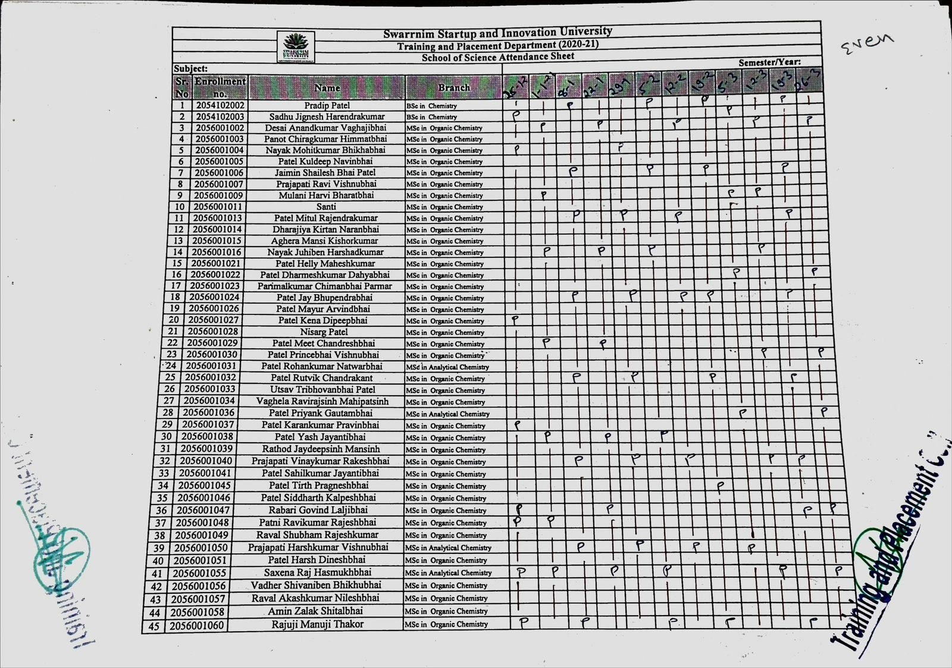
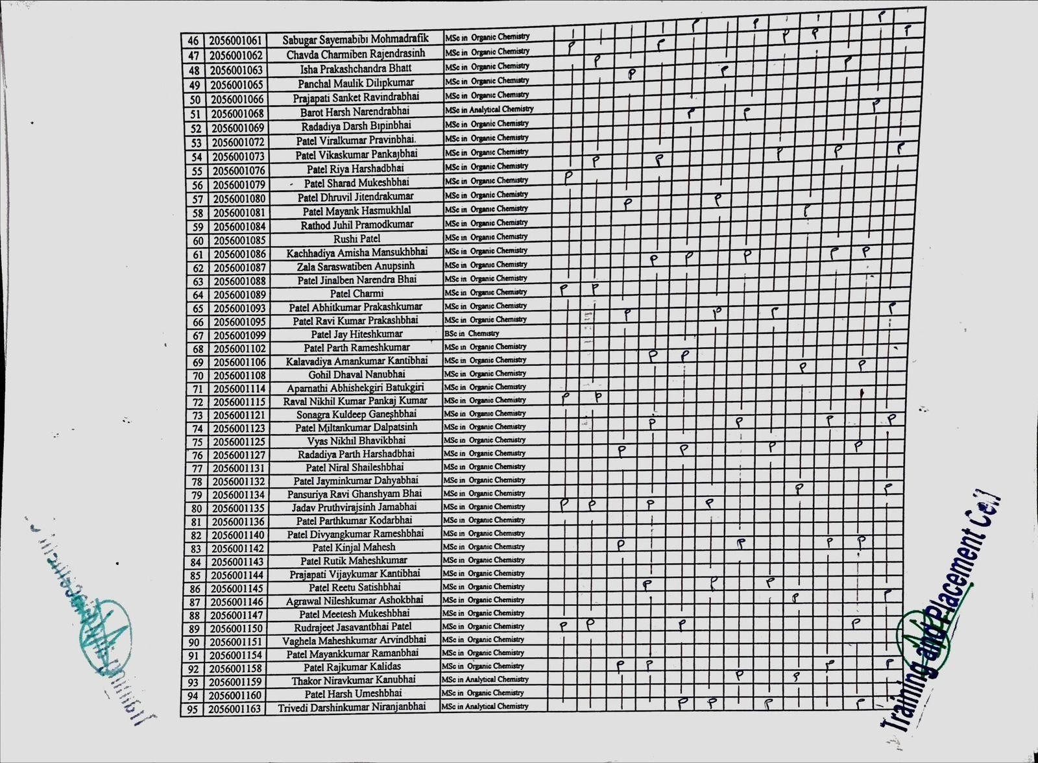

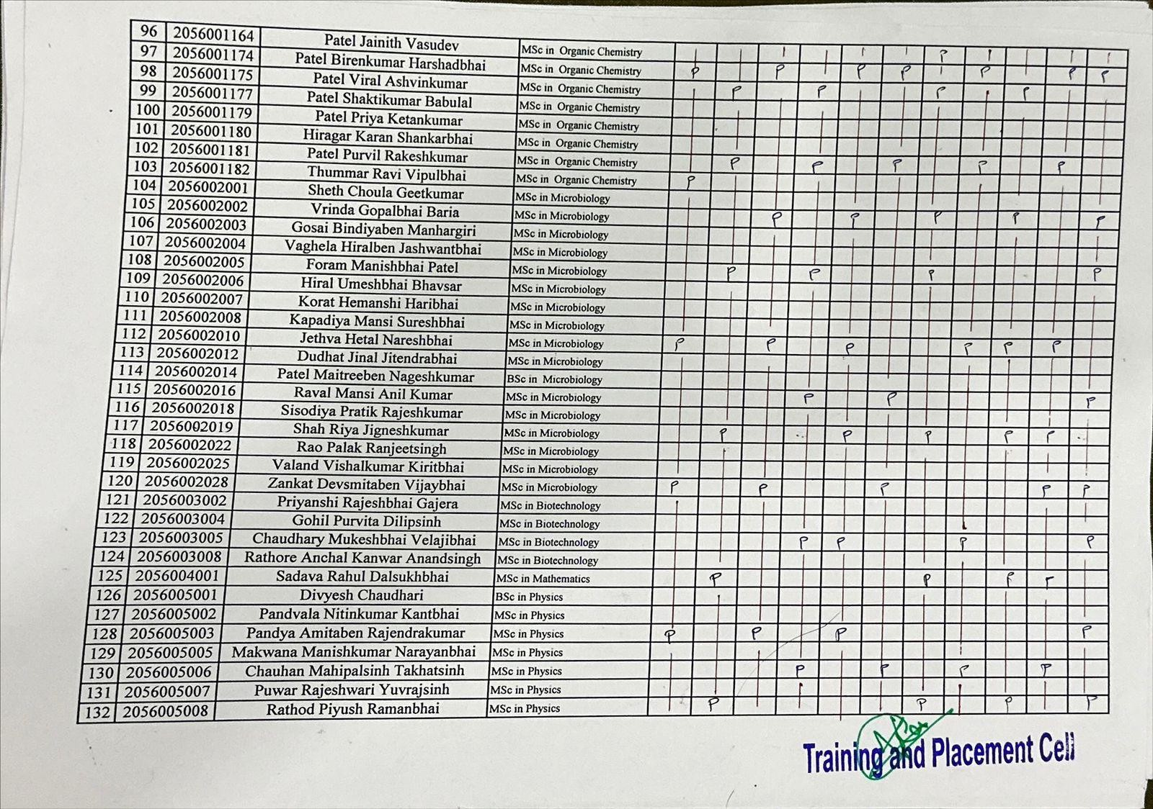

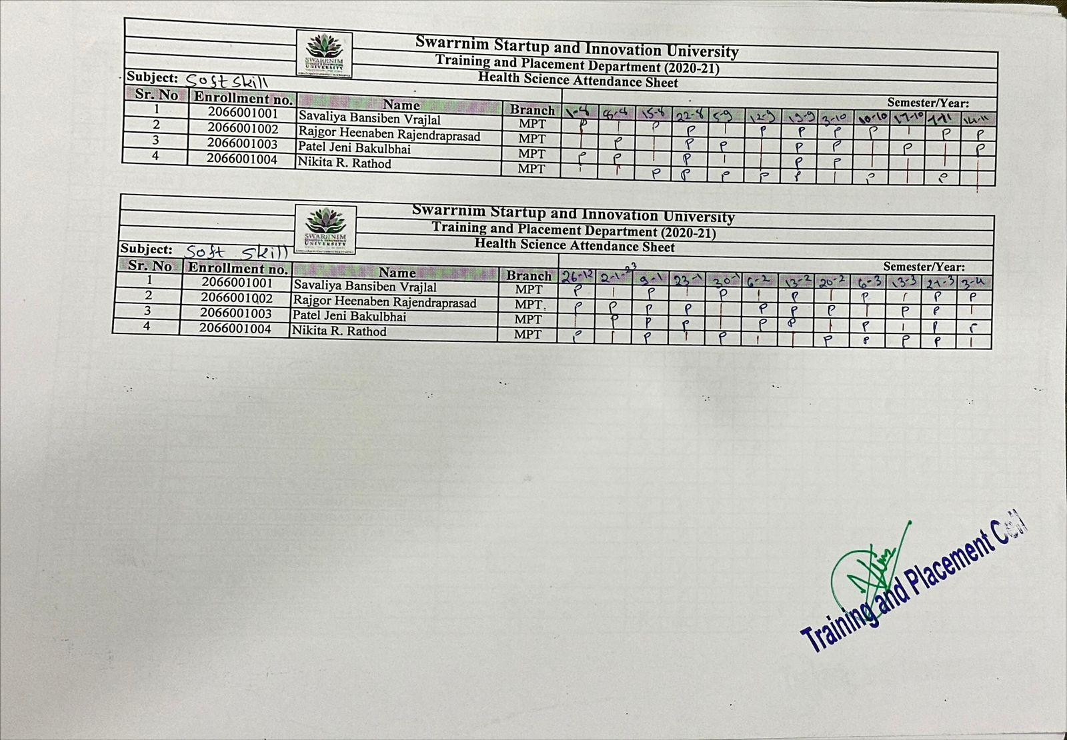

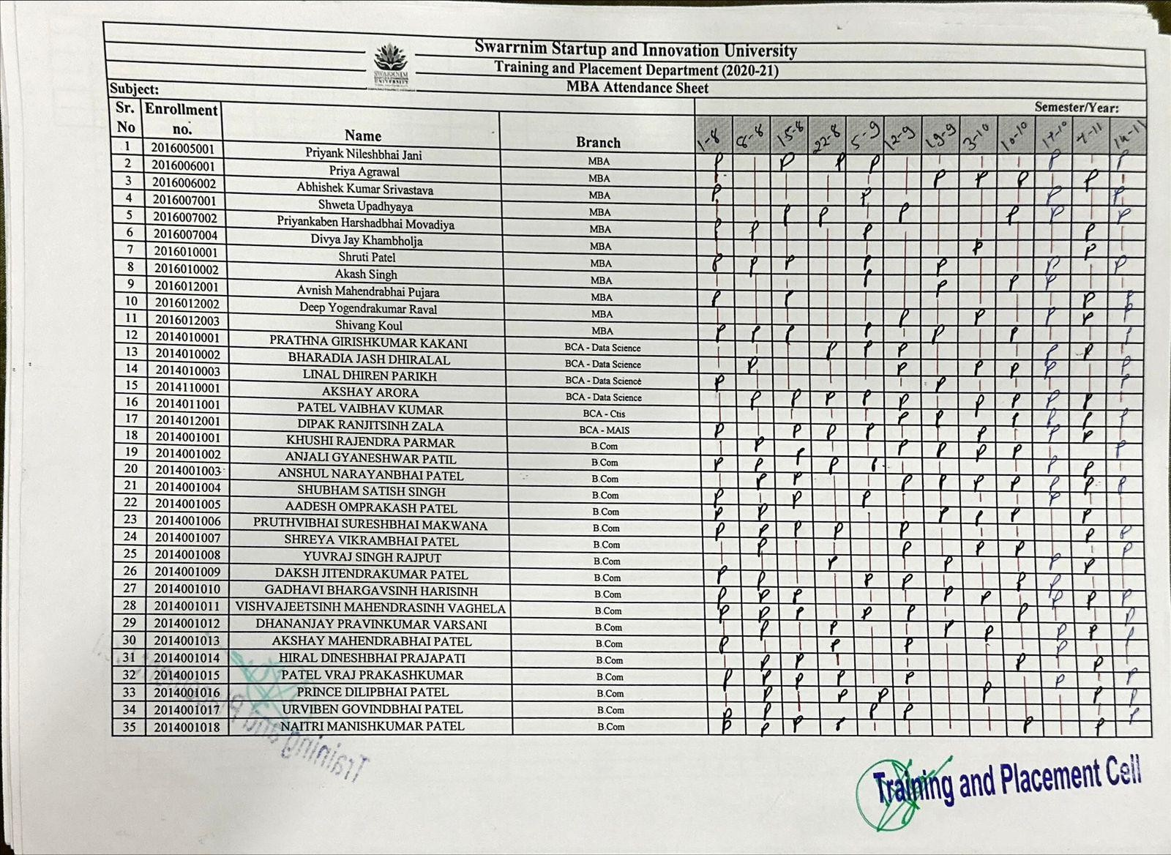

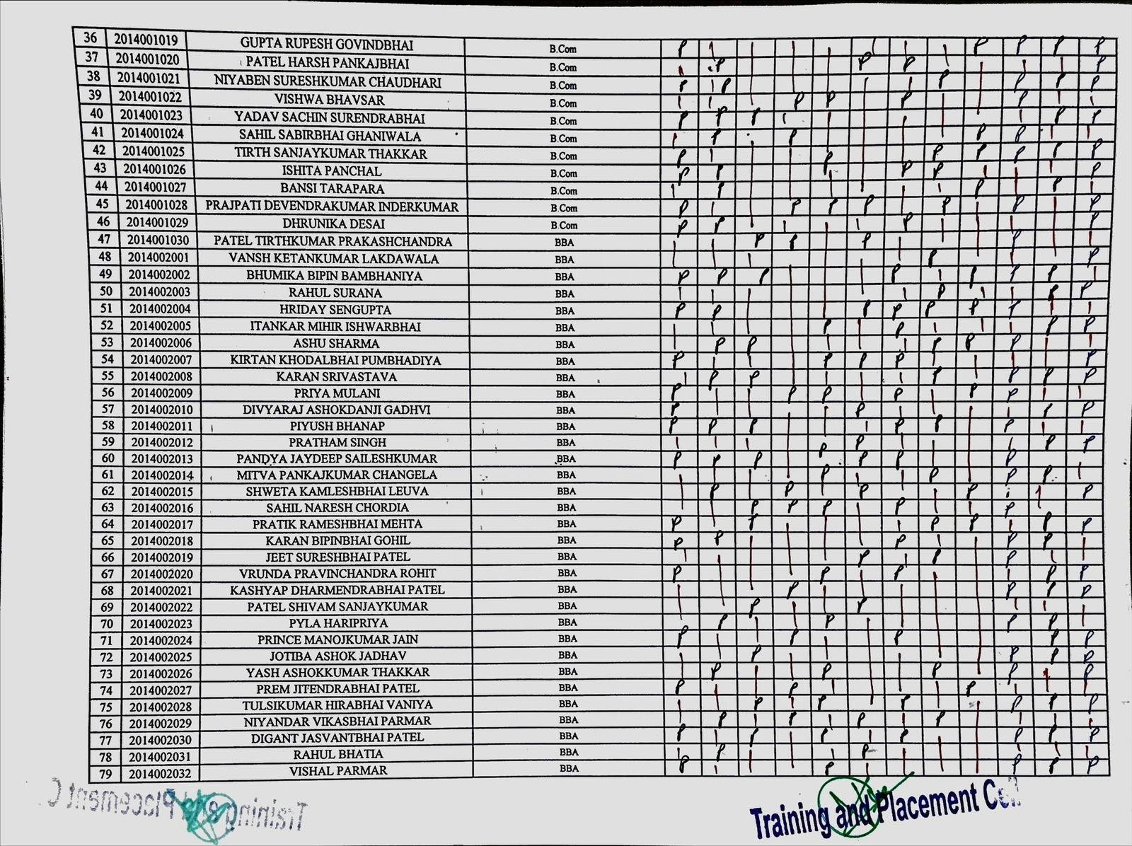

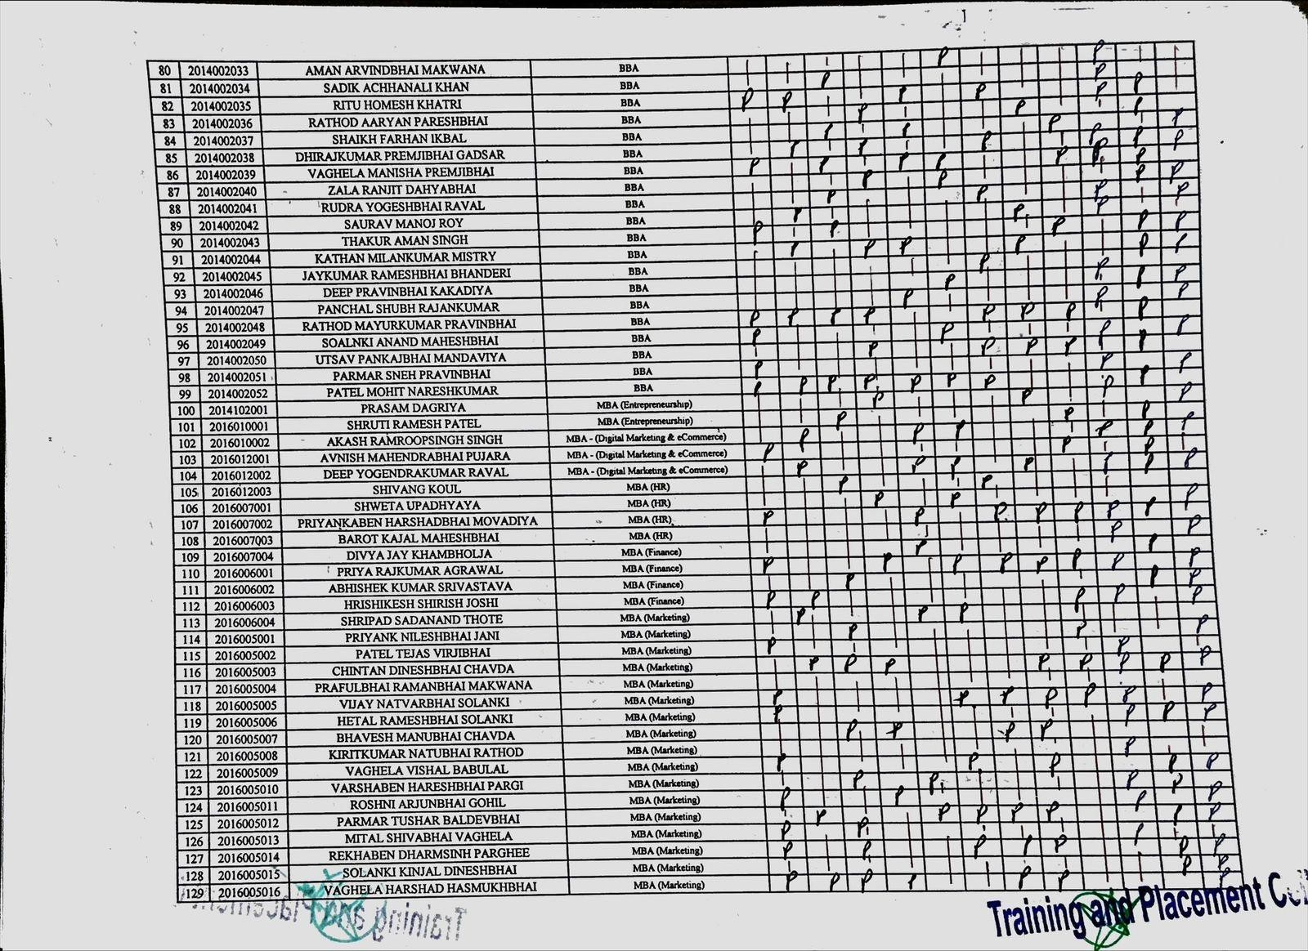

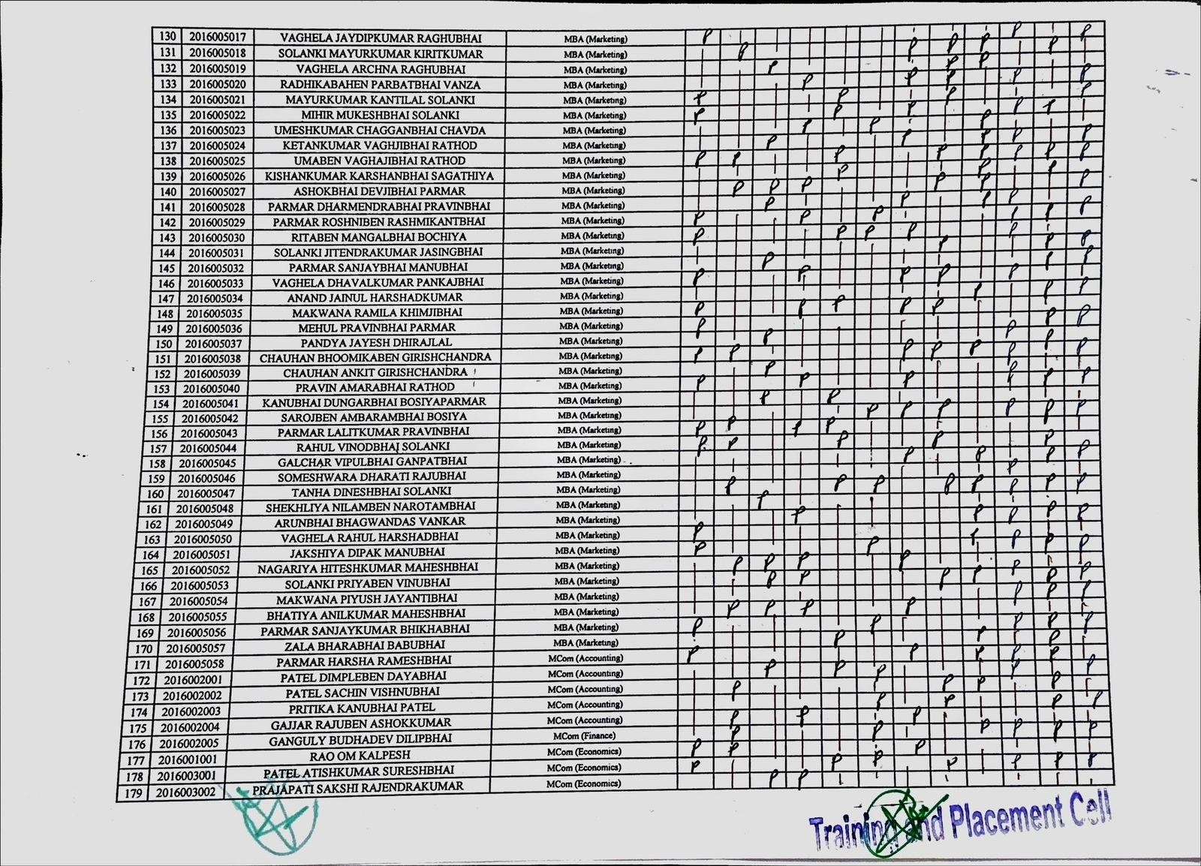

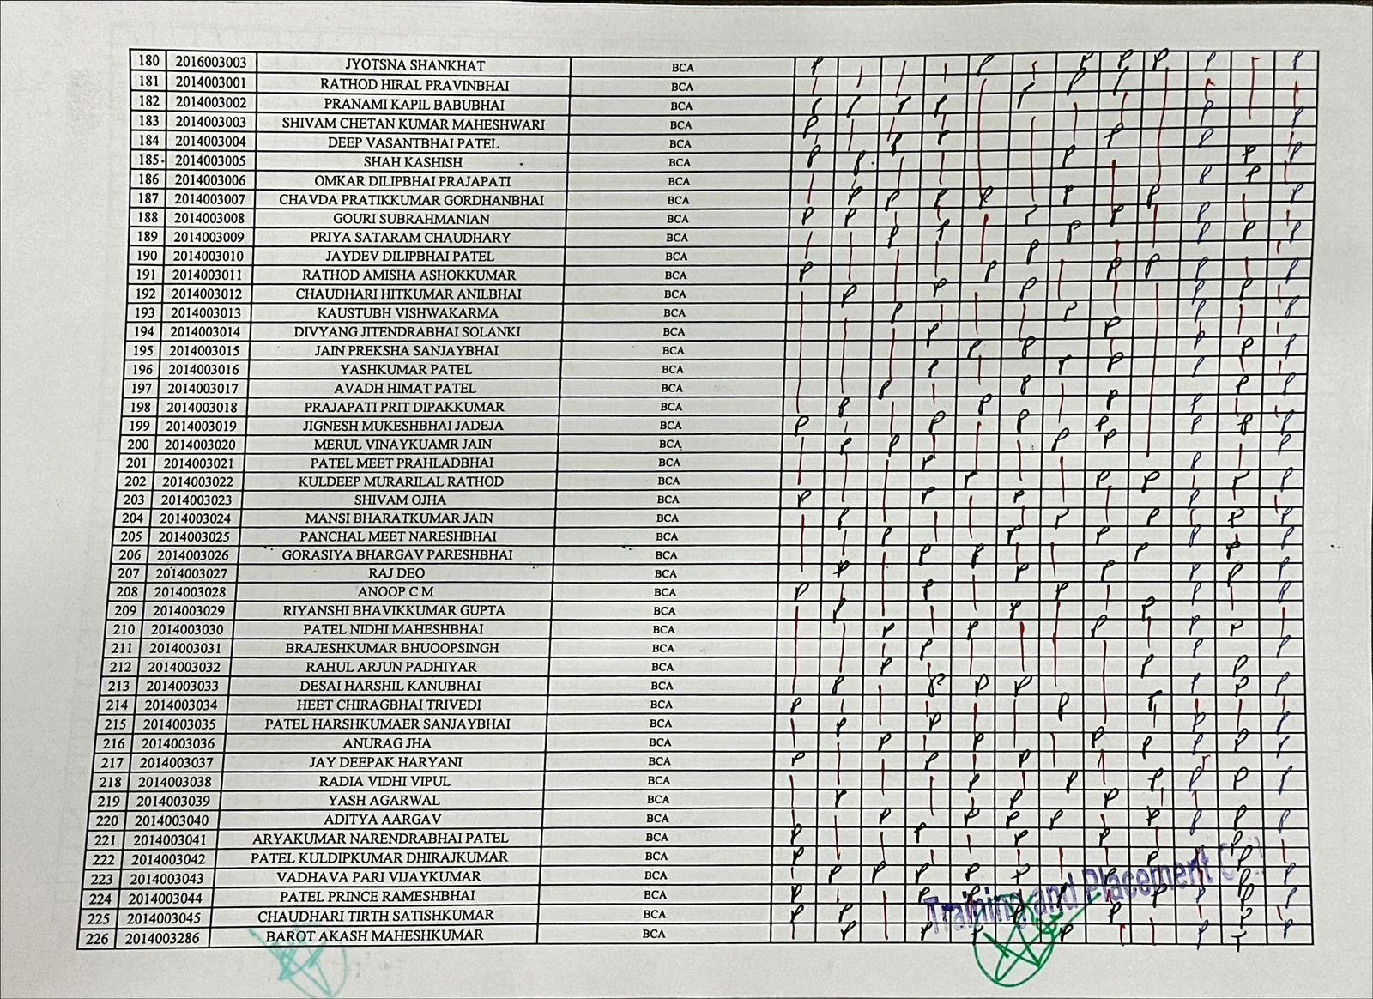

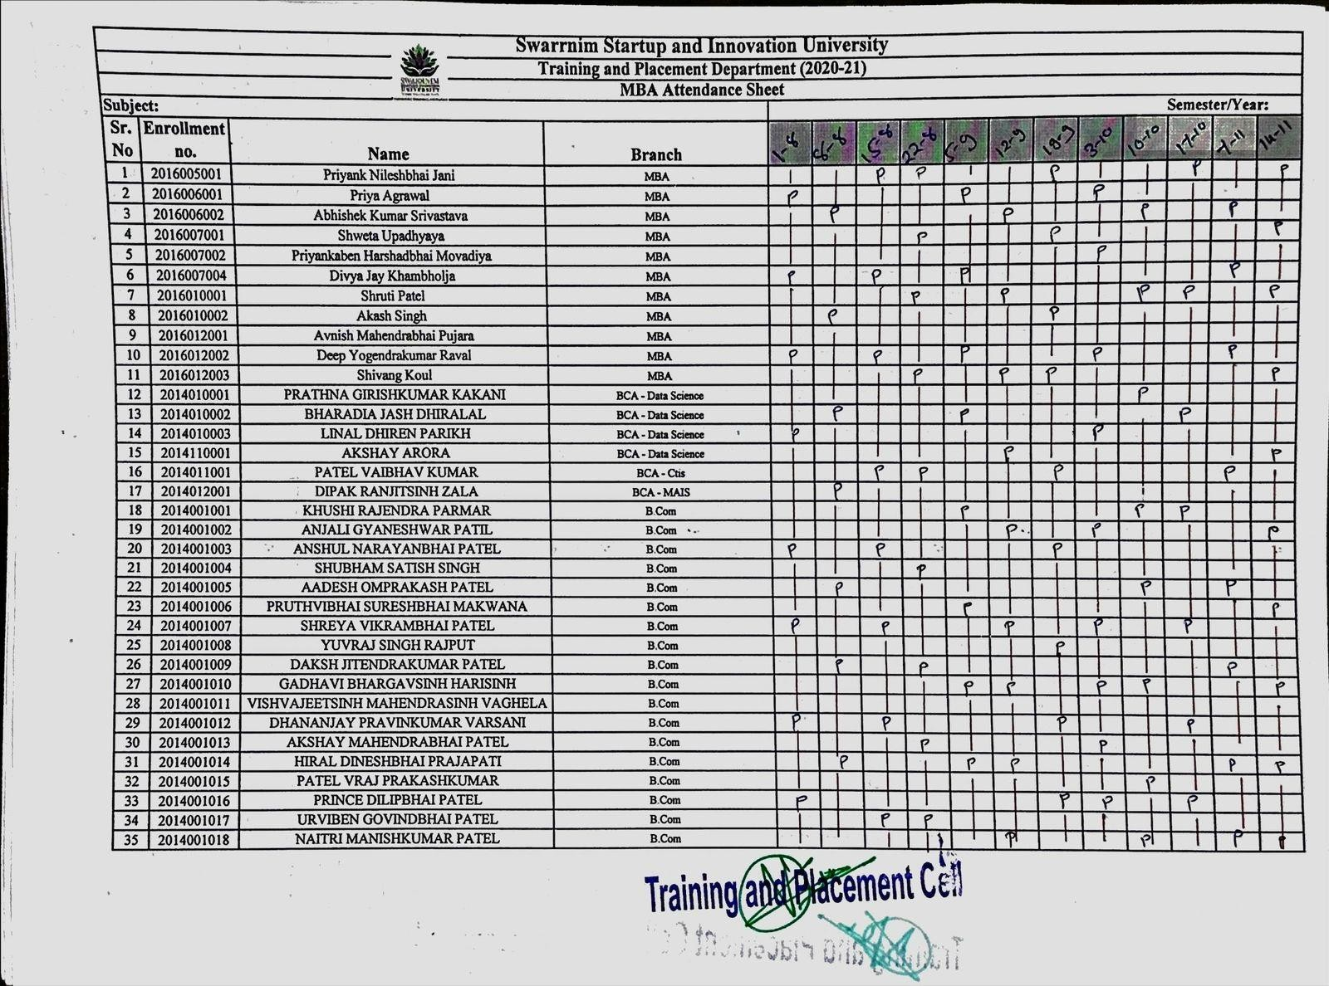

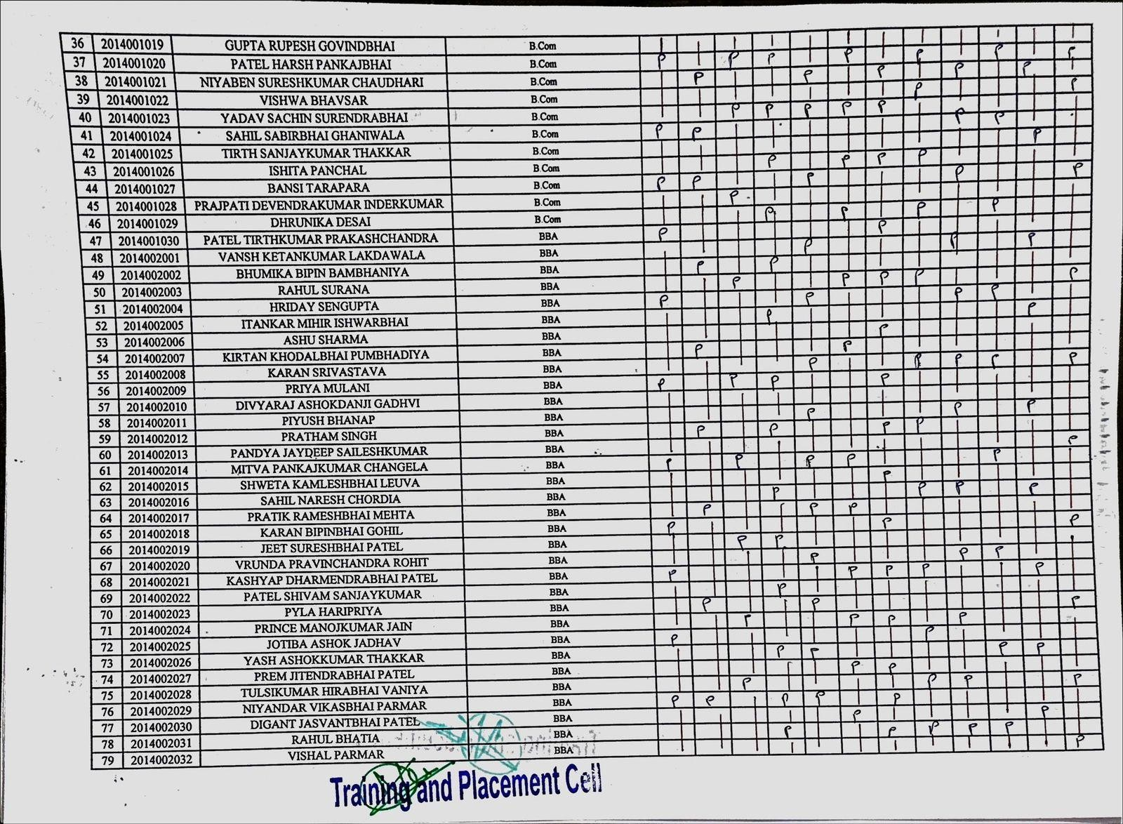

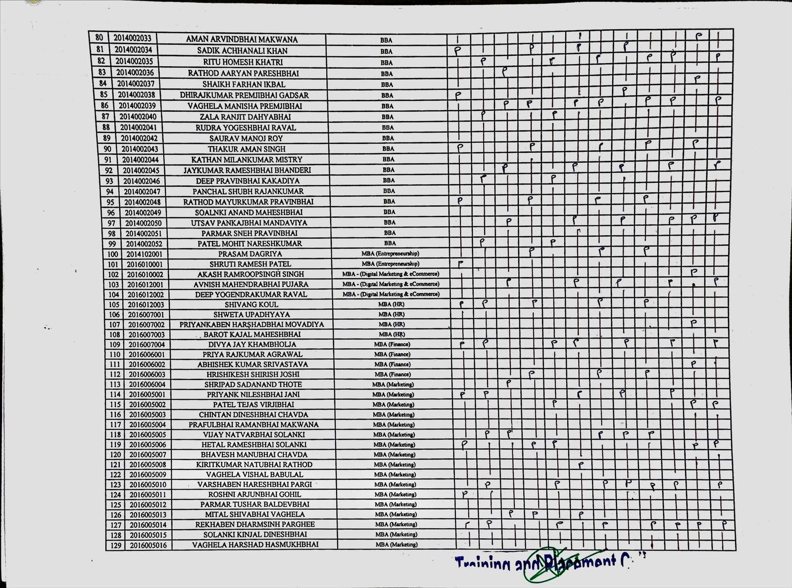

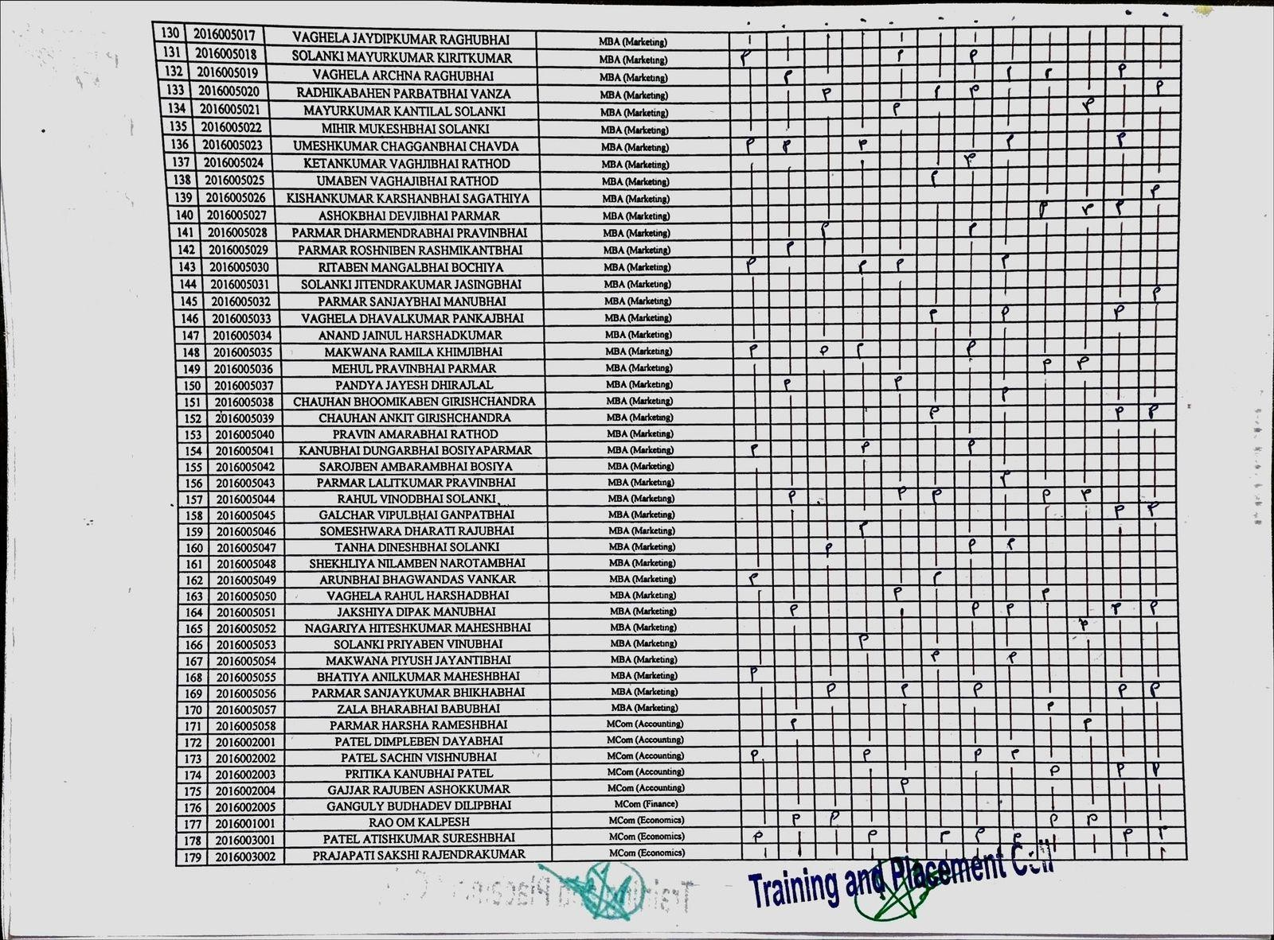

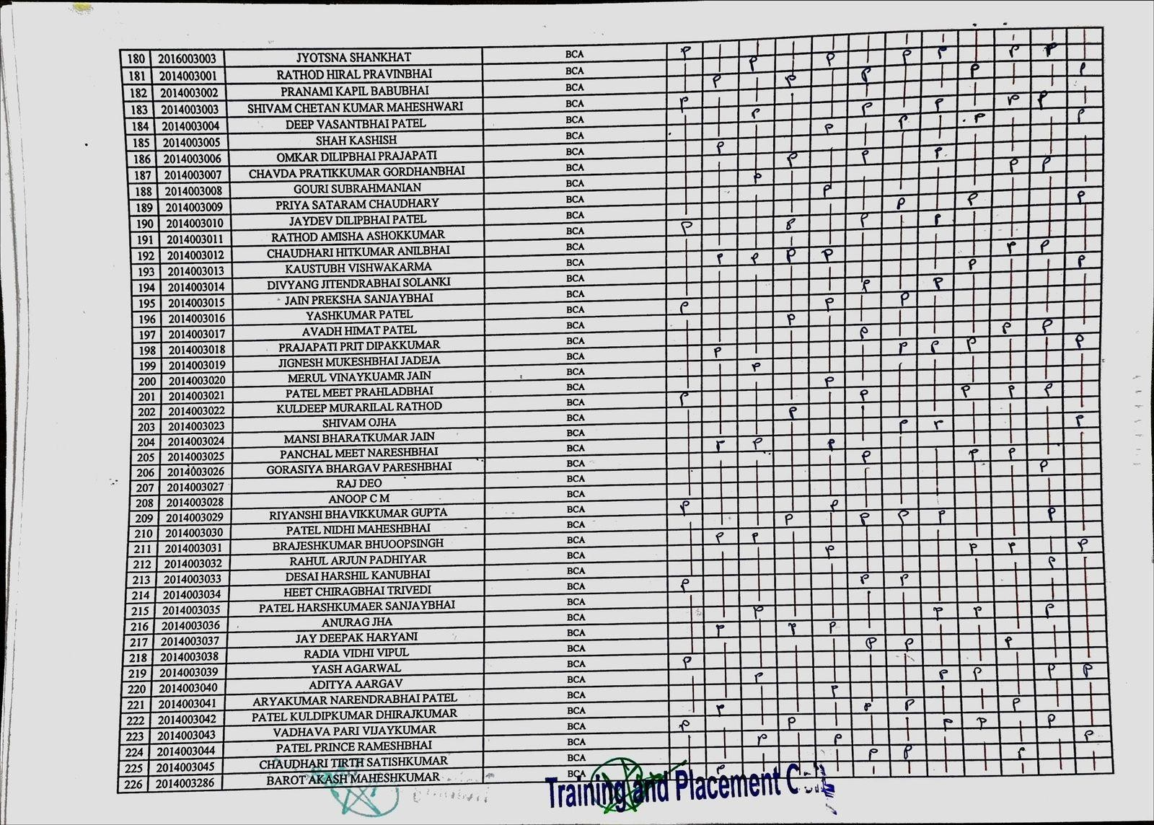

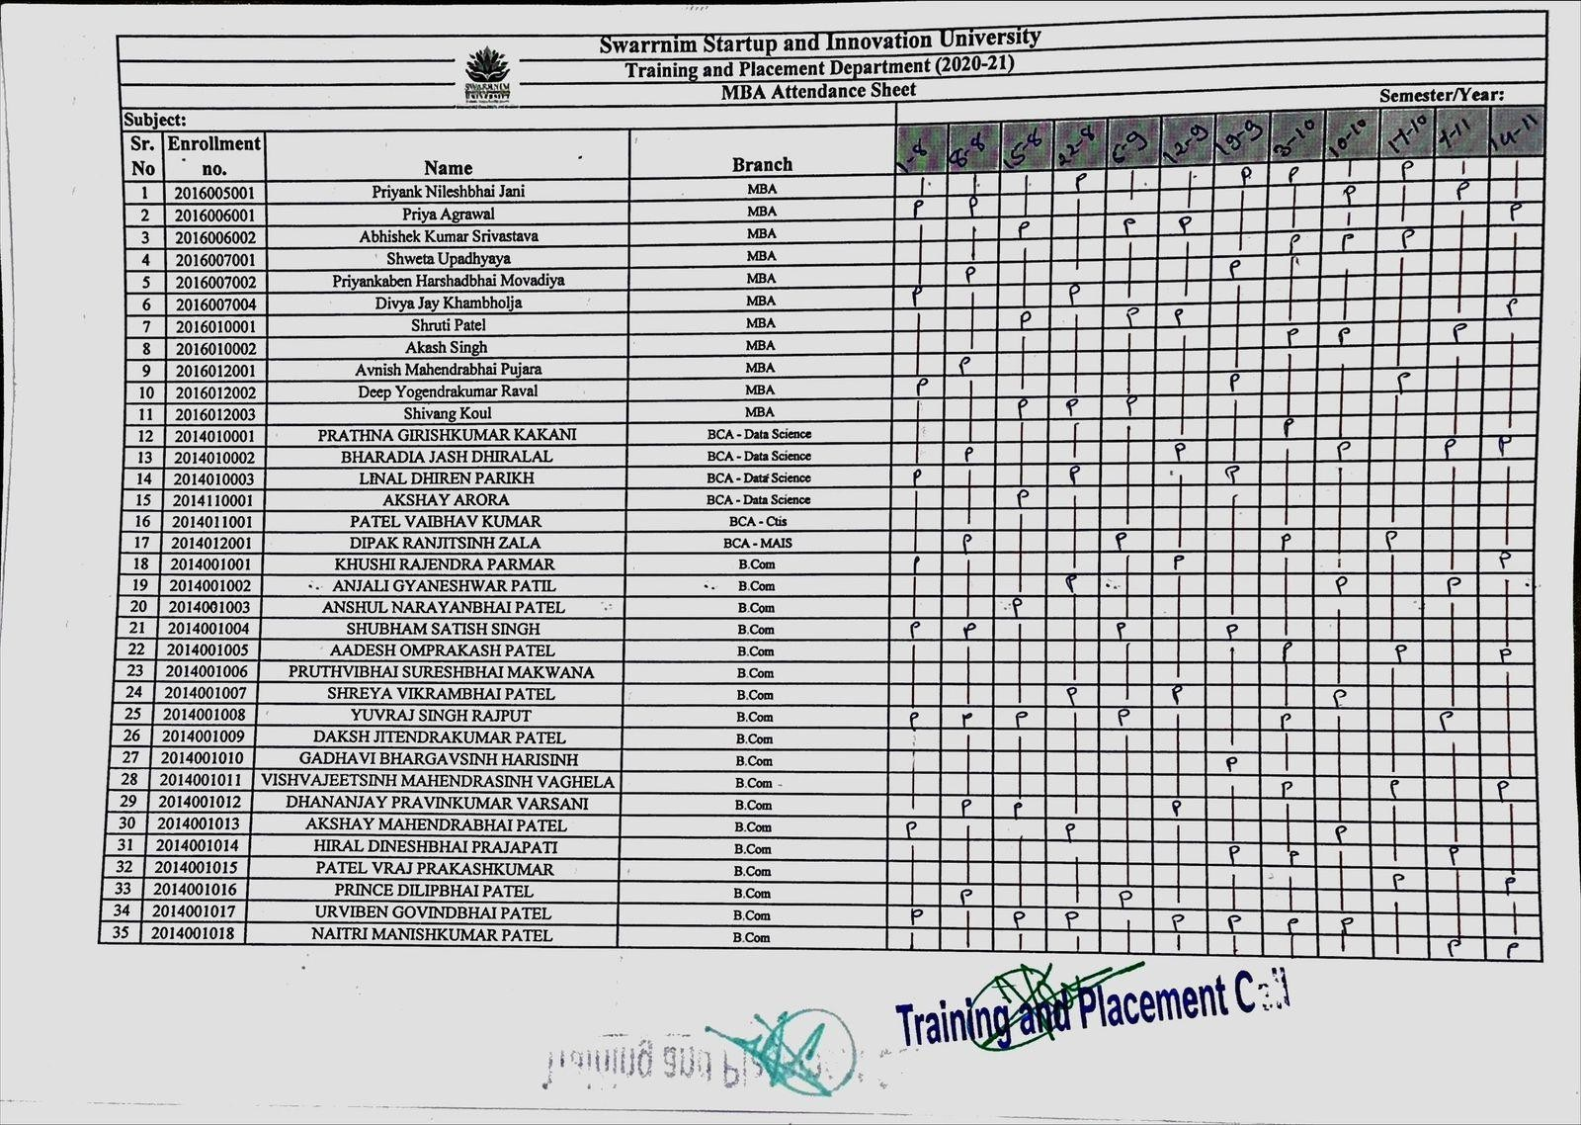

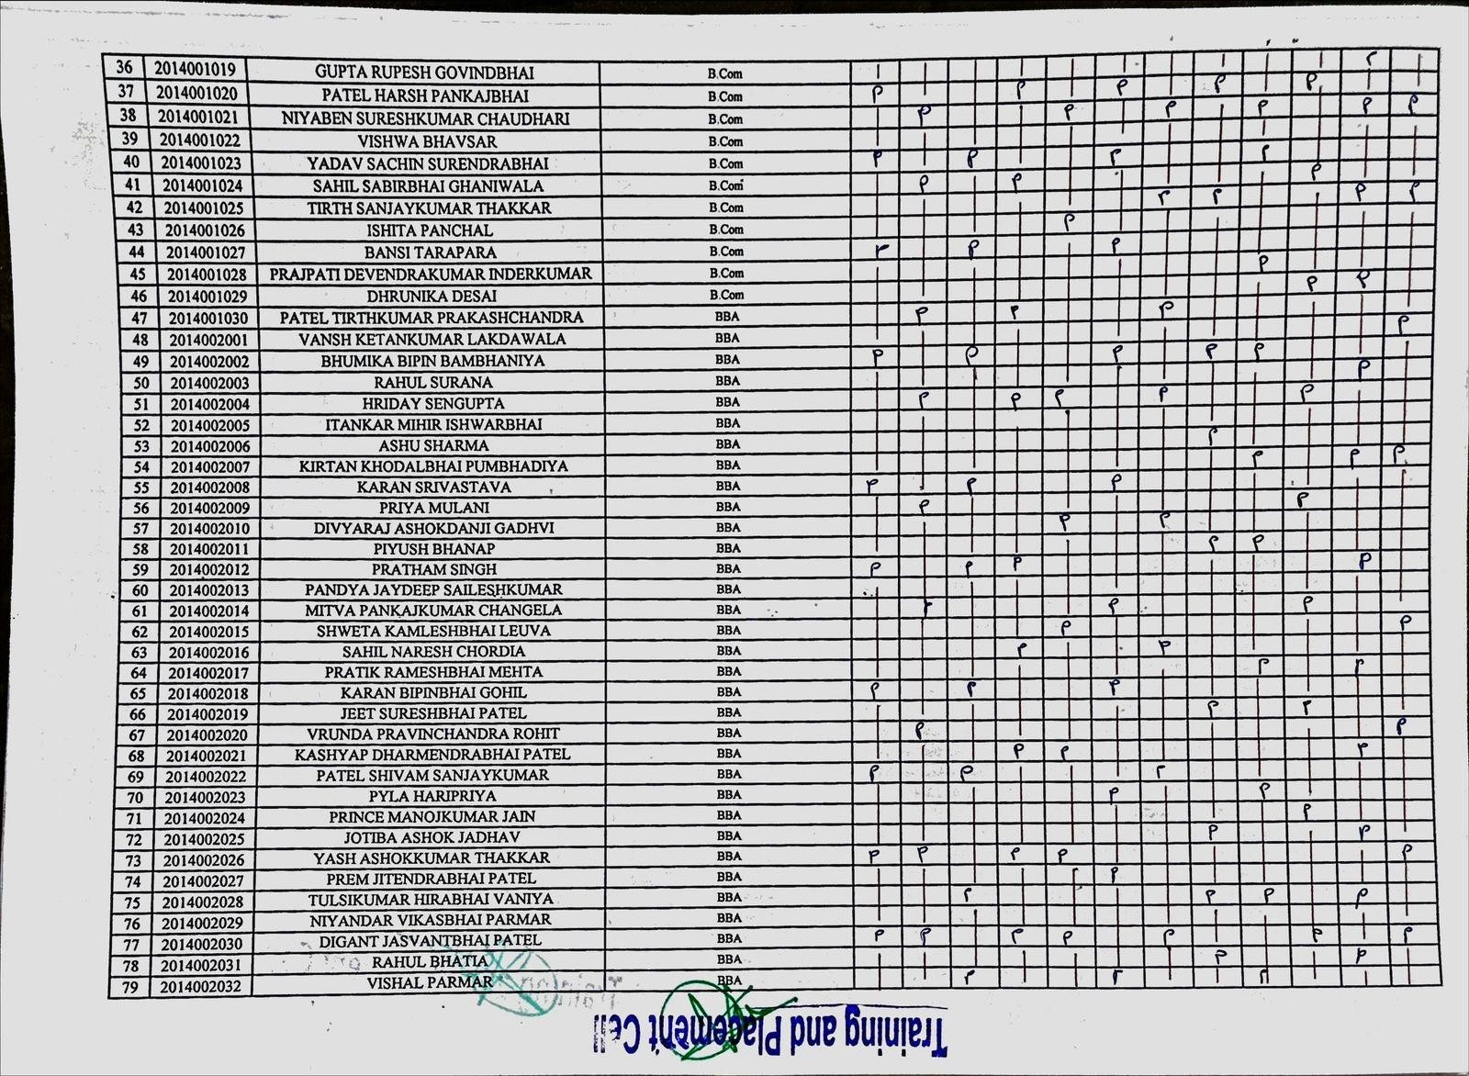

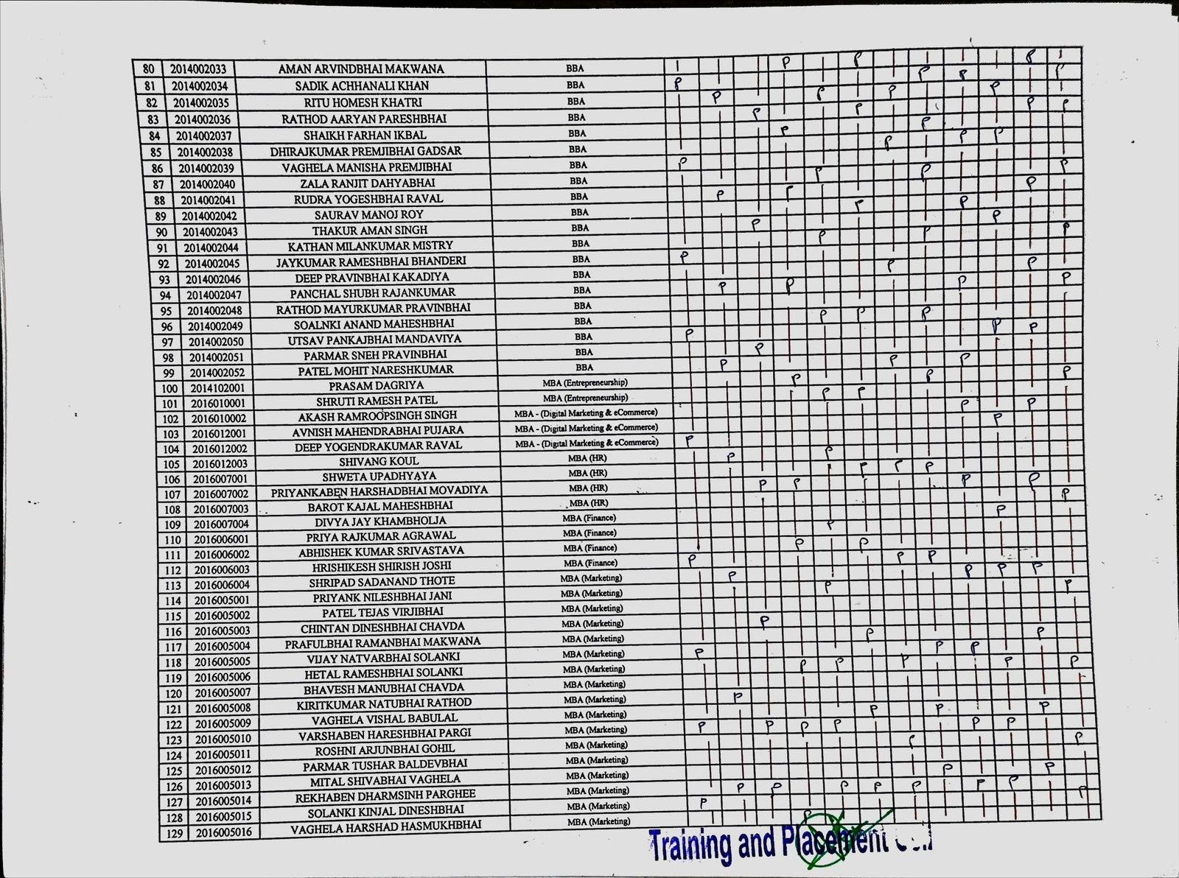

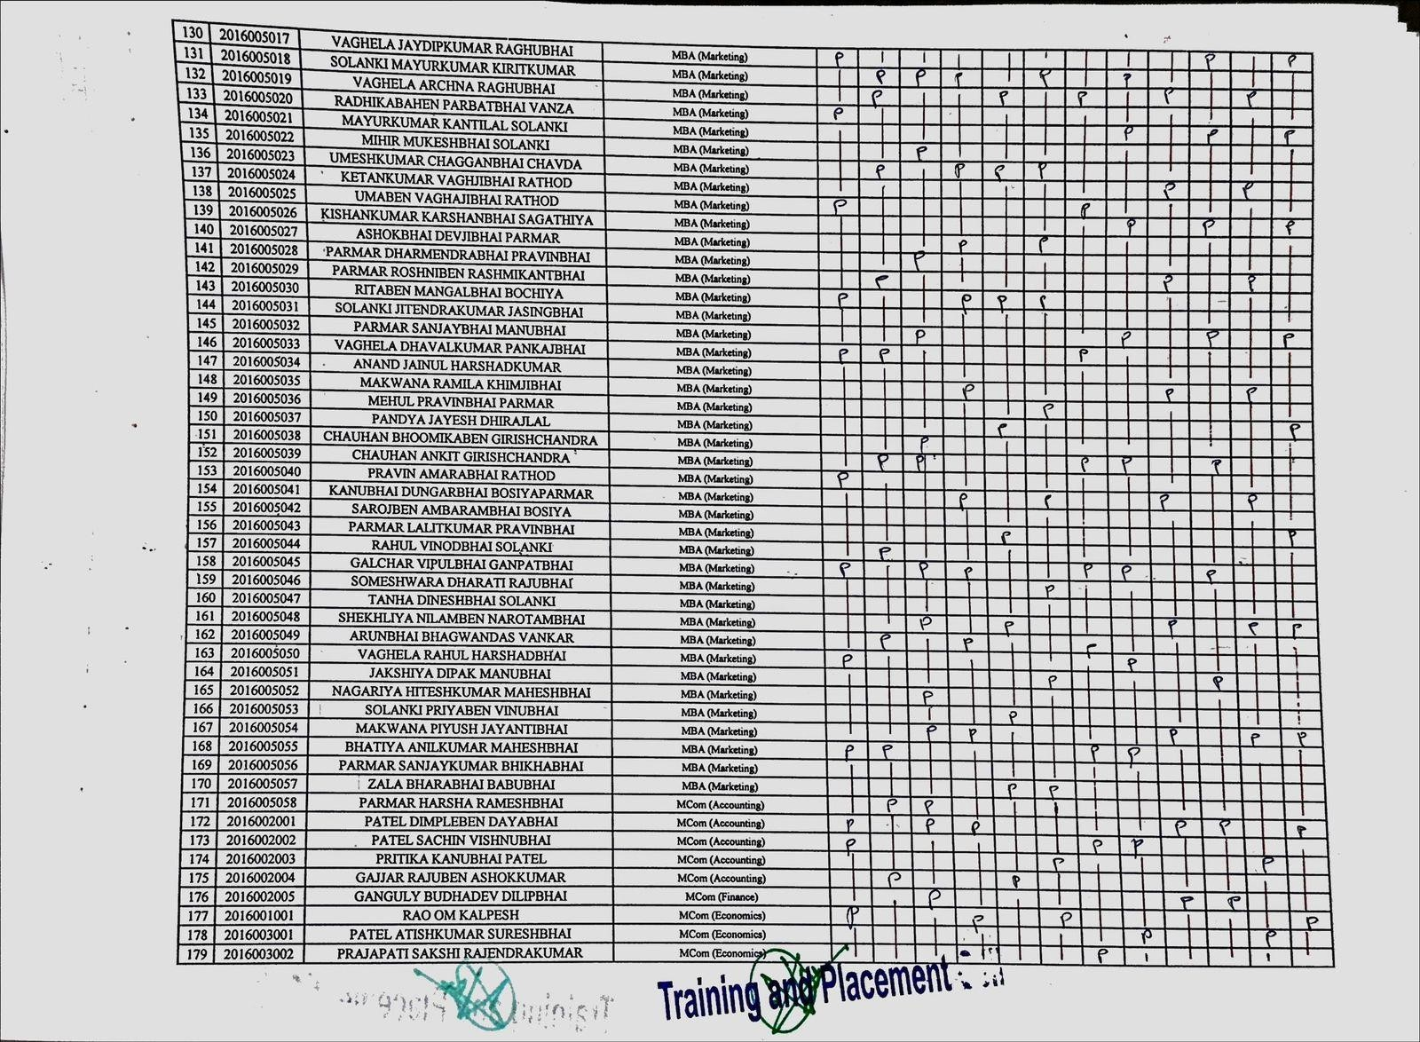

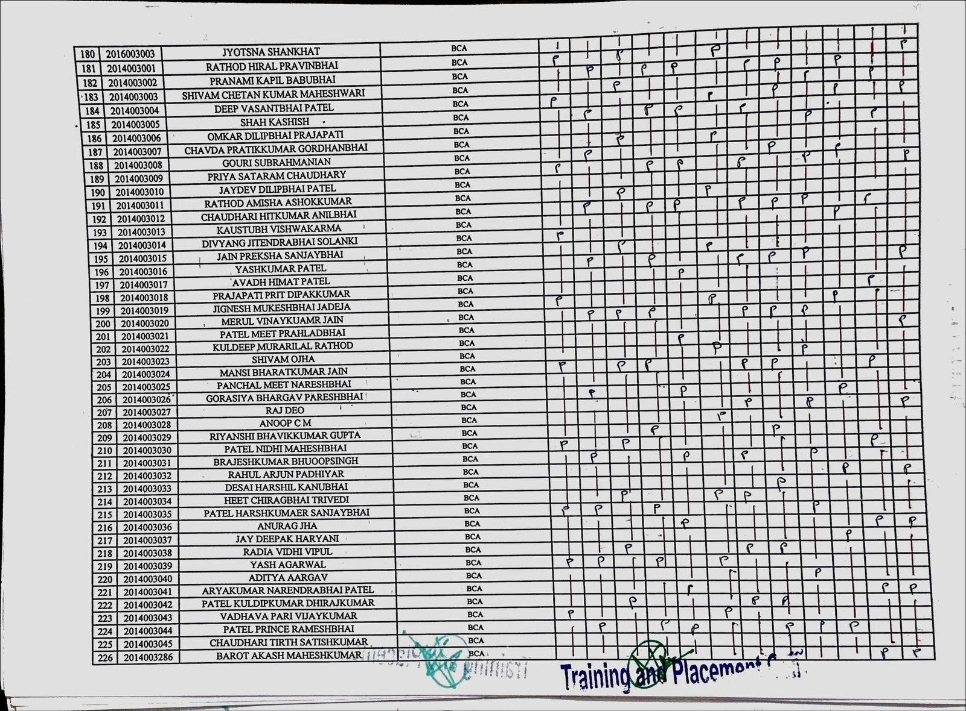

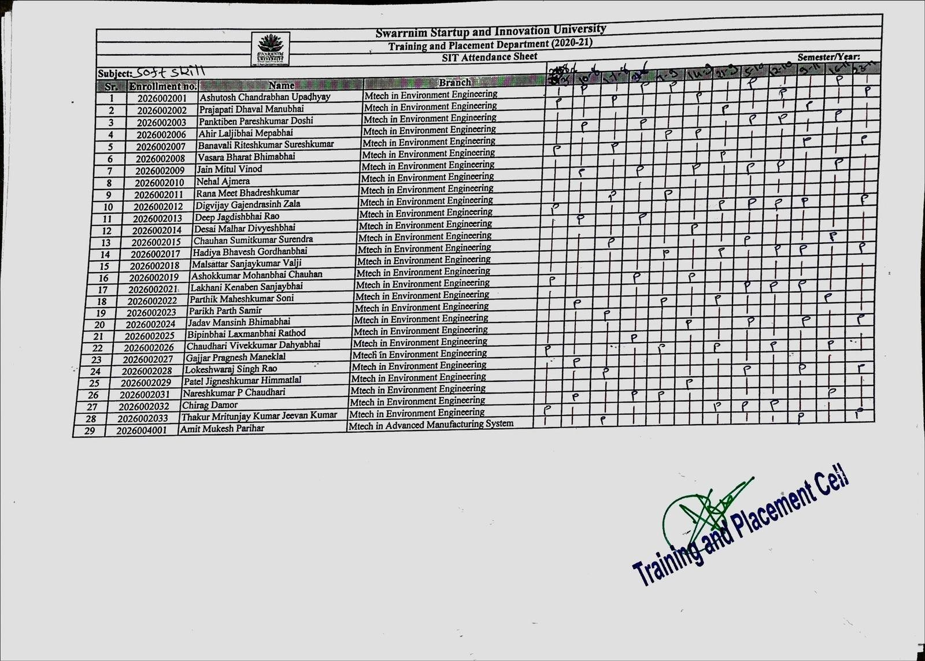

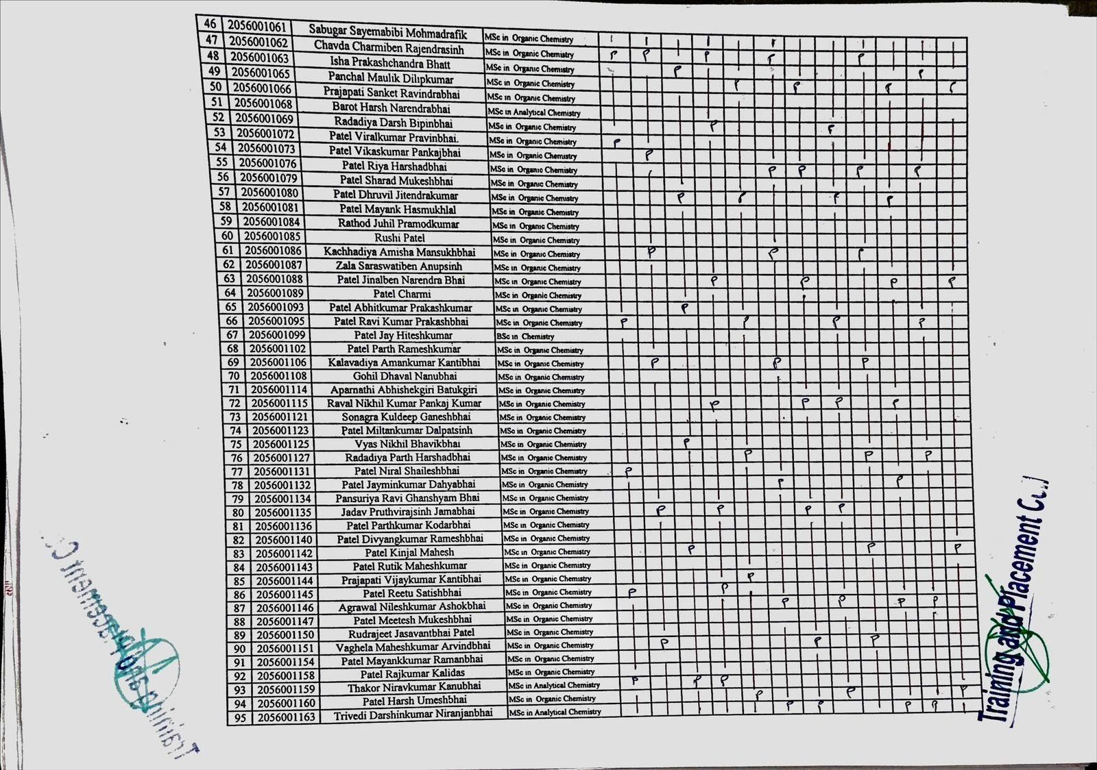

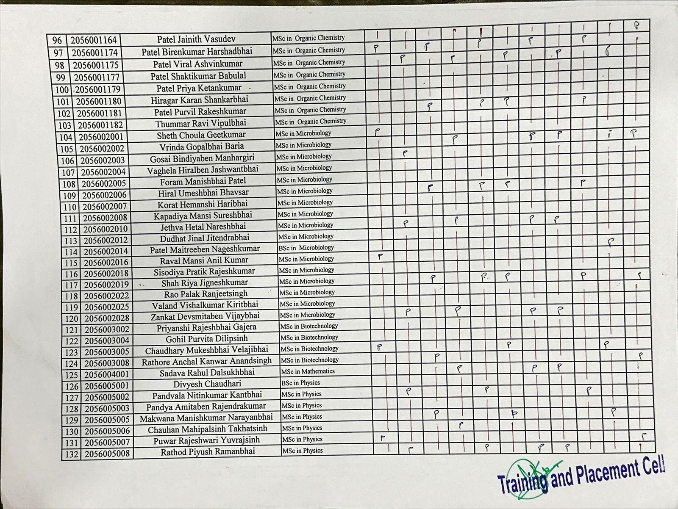

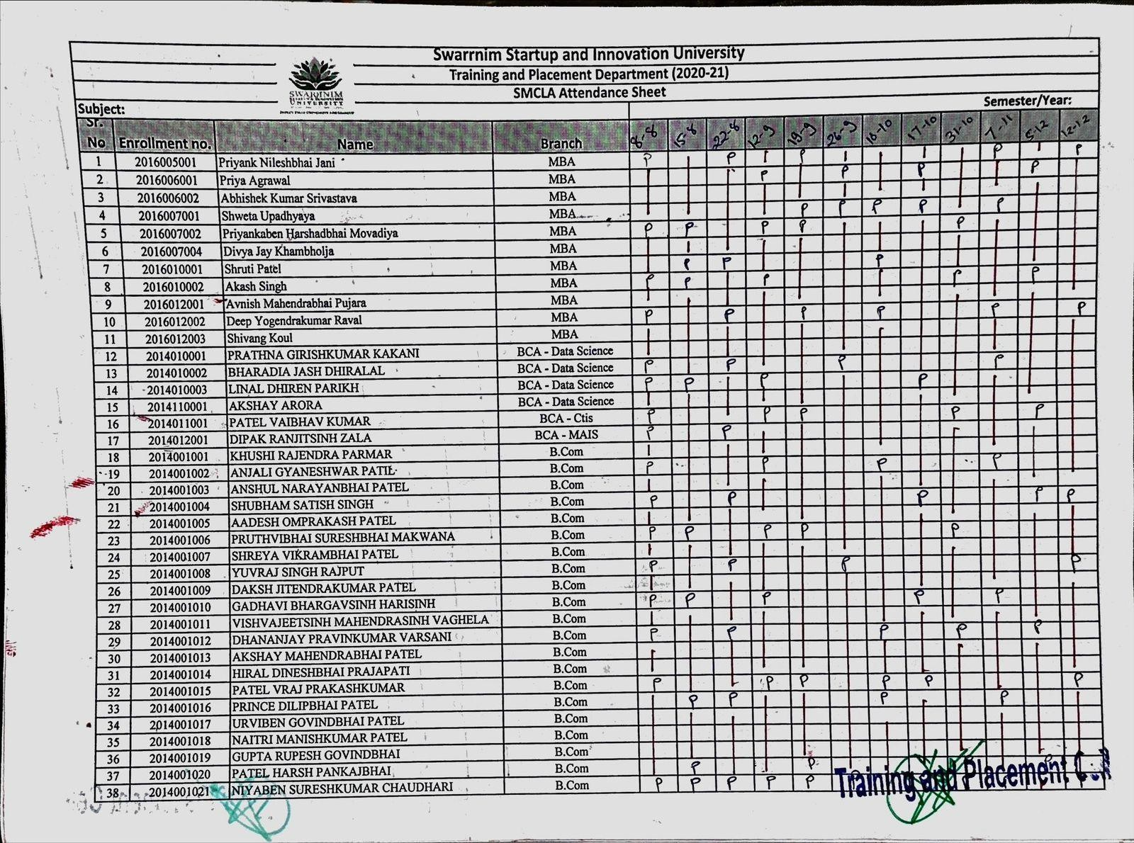

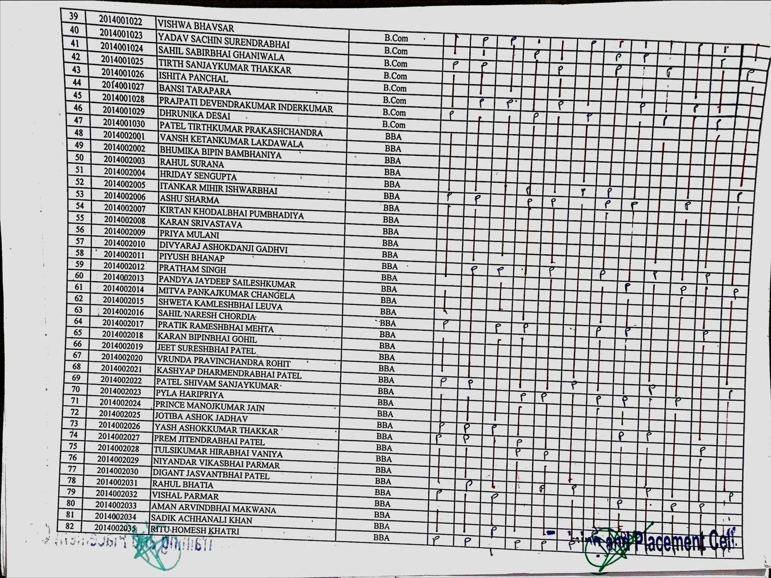

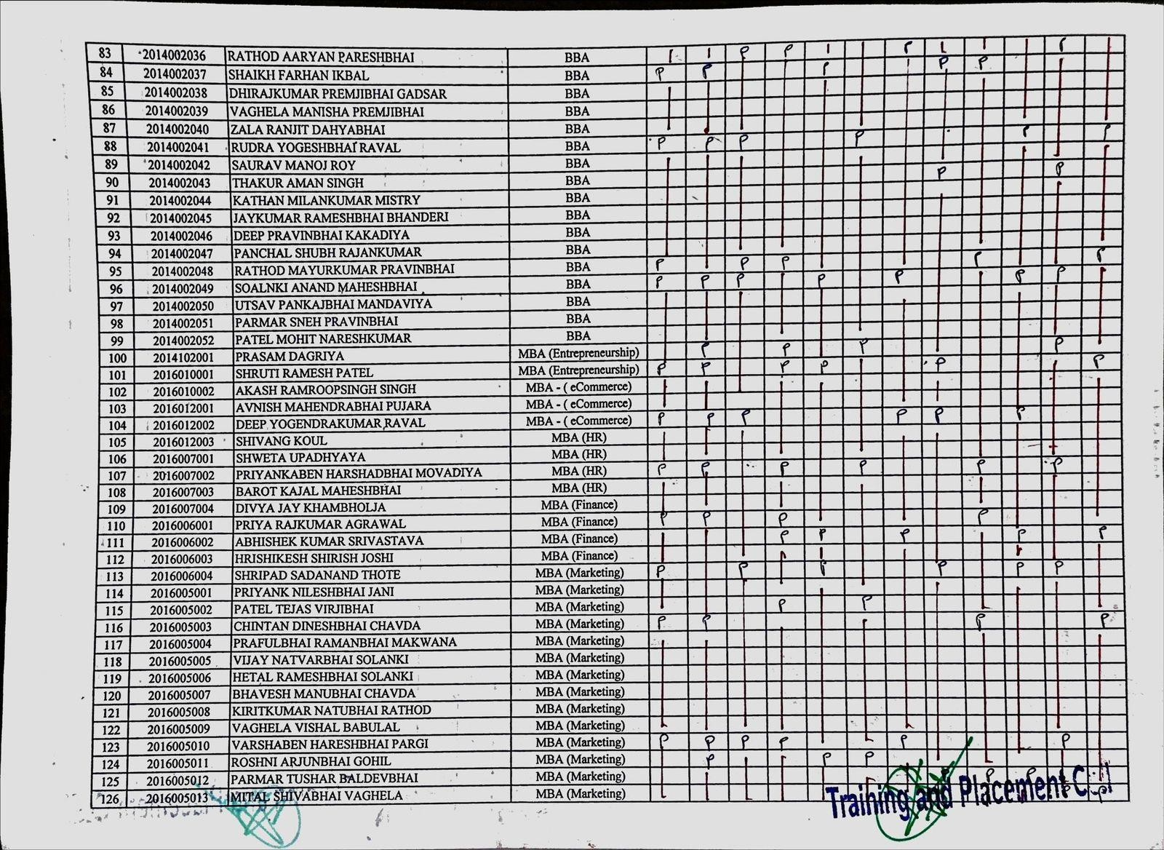

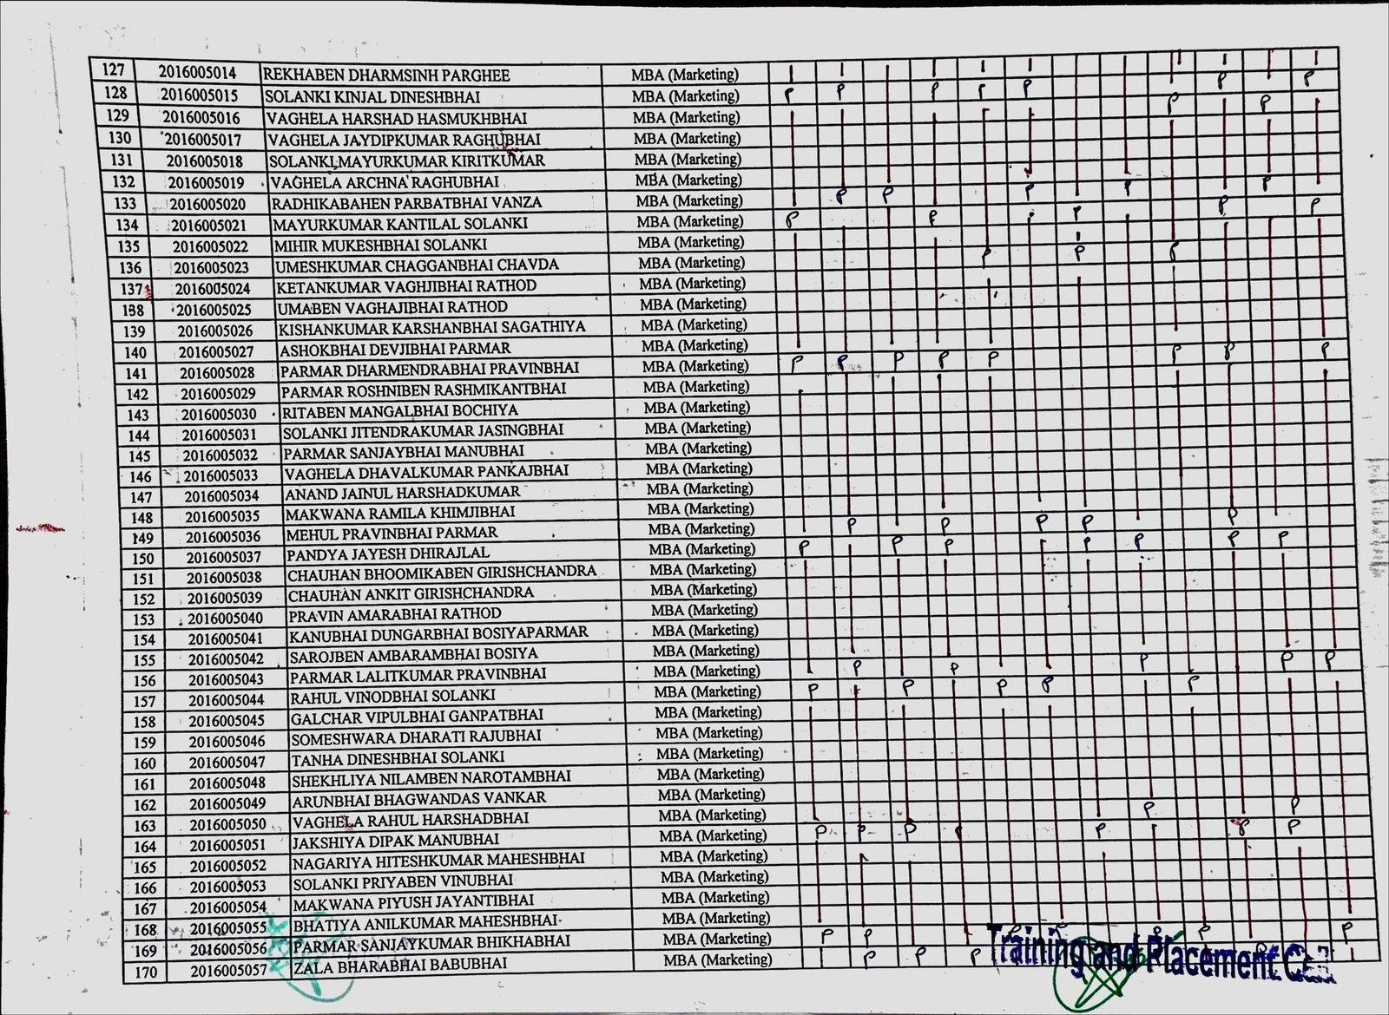

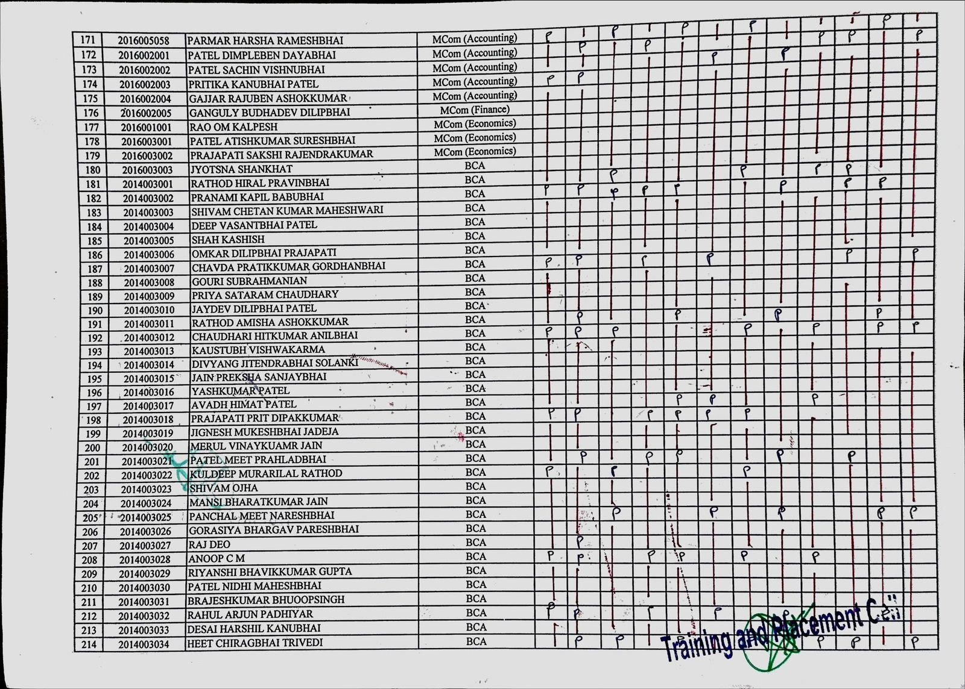

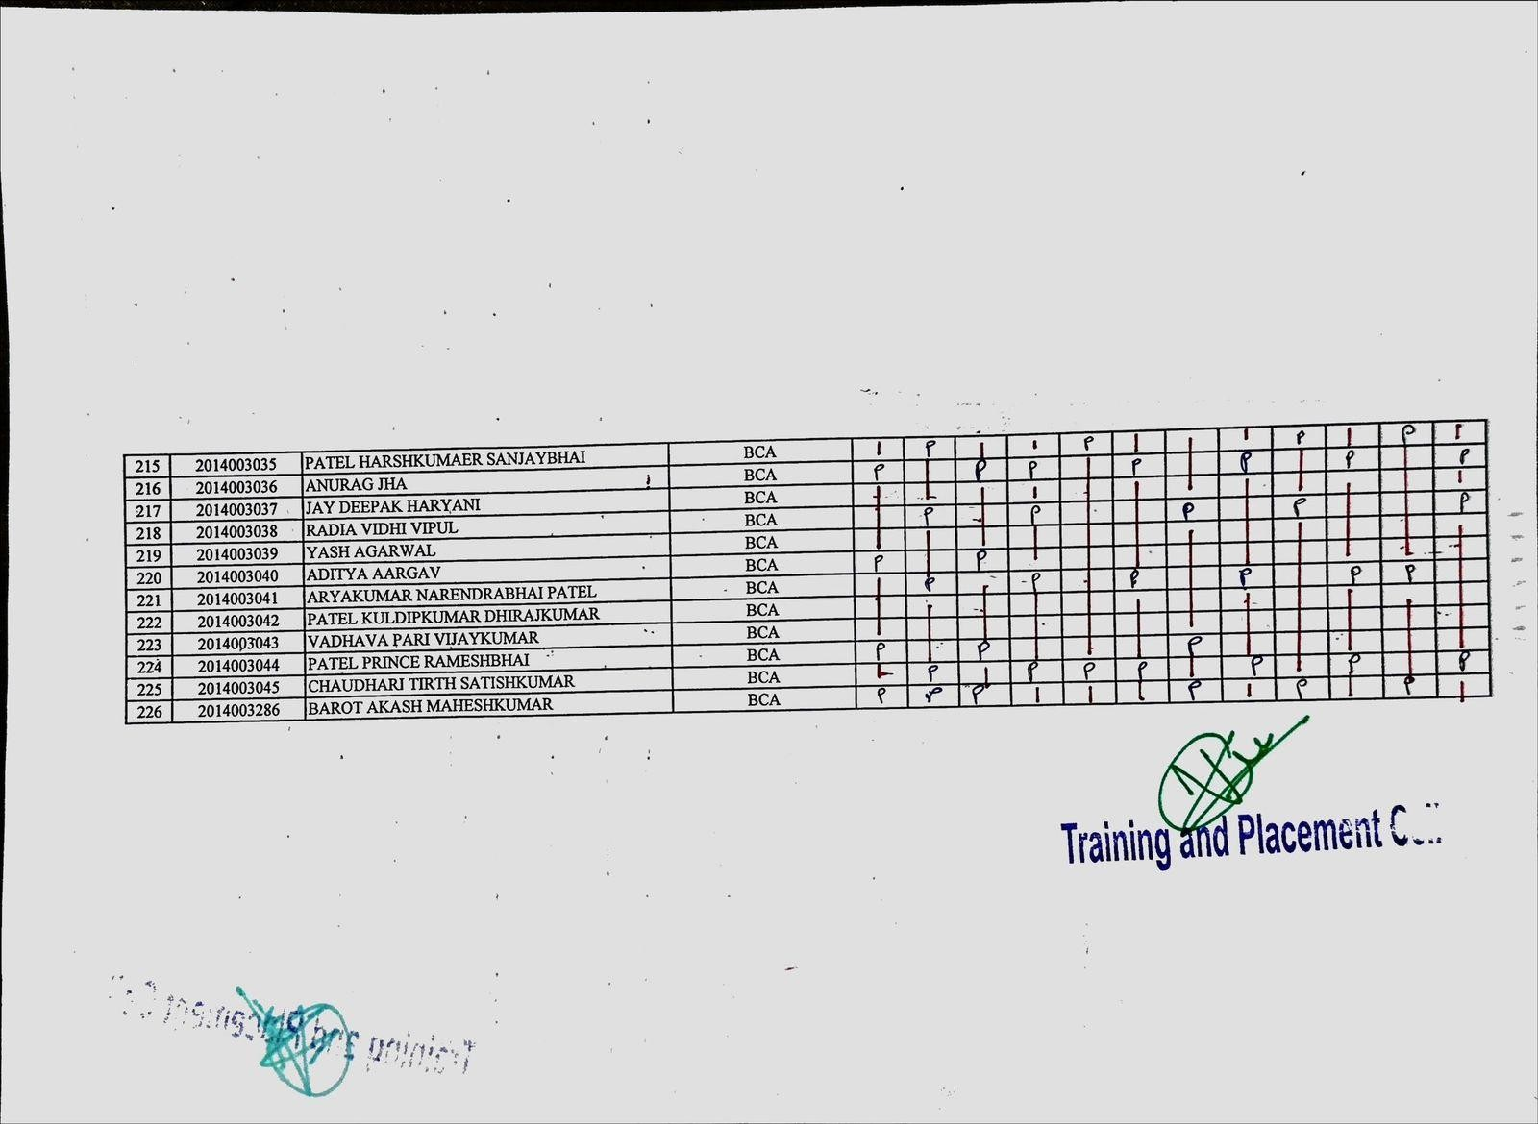

SOFT SKILLS REPORTS YEAR 2020-21

Name of Workshop: Boost Emotional Intelligence Date of Workshop: October 7, 2020
Organized by: Training And Placement Department, SSIU
Objective: To enhance student’s understanding and management of emotions, as well as their ability to empathize with others.
Report: The emotional intelligence program included interactive sessions on recognizing and regulating emotions, both their own and others'. Activities such as journaling and group discussions helped students explore their emotional responses and develop strategies for managing them. The program fostered a supportive environment, encouraging students to share and learn from each other's experiences.
Program Outcome: Students attended sessions on understanding and managing emotions, empathy, and social skills. They engaged in self-reflection exercises and group discussions, becoming more self-aware, empathetic, and capable of maintaining positive interpersonal relationships.

Snippets From The Workshop:
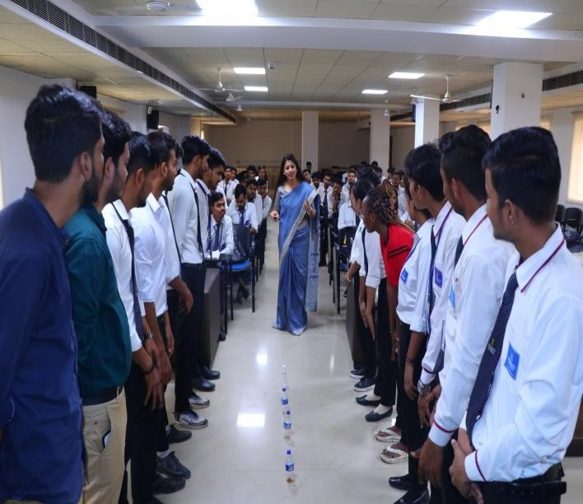

Attendance:

Swarrnim Startup and Innovation University
Training and Placement Department (2020-21)
Sr. No | Enrollment  no. | Name | Branch
1 | 2016005001 | Priyank Nileshbhai Jani | MBA
2 | 2016006001 | Priya Agrawal | MBA
3 | 2016006002 | Abhishek Kumar Srivastava | MBA
4 | 2016007001 | Shweta Upadhyaya | MBA
5 | 2016007002 | Priyankaben Harshadbhai Movadiya | MBA
6 | 2016007004 | Divya Jay Khambholja | MBA
7 | 2016010001 | Shruti Patel | MBA

Swarrnim Startup and Innovation University
Training and Placement Department (2020-21)
Sr. No | Enrollment  no. | Name | Branch
8 | 2016010002 | Akash Singh | MBA
9 | 2016012001 | Avnish Mahendrabhai Pujara | MBA
10 | 2016012002 | Deep Yogendrakumar Raval | MBA
11 | 2016012003 | Shivang Koul | MBA
12 | 2014010001 | PRATHNA GIRISHKUMAR KAKANI | BCA - Data Science
13 | 2014010002 | BHARADIA JASH DHIRAJLAL | BCA - Data Science
14 | 2014010003 | LINAL DHIREN PARIKH | BCA - Data Science
15 | 2014110001 | AKSHAY ARORA | BCA - Data Science
16 | 2014011001 | PATEL VAIBHAV KUMAR | BCA - Ctis
17 | 2014012001 | DIPAK RANJITSINH ZALA | BCA - MAIS
18 | 2014001001 | KHUSHI RAJENDRA PARMAR | B.Com
19 | 2014001002 | ANJALI GYANESHWAR PATIL | B.Com
20 | 2014001003 | ANSHUL NARAYANBHAI PATEL | B.Com
21 | 2014001004 | SHUBHAM SATISH SINGH | B.Com
22 | 2014001005 | AADESH OMPRAKASH PATEL | B.Com
23 | 2014001006 | PRUTHVI BHAI SURESHBHAI MAKWANA | B.Com
24 | 2014001007 | SHREYA VIKRAMBHAI PATEL | B.Com
25 | 2014001008 | YUVRAJ SINGH RAJPUT | B.Com
26 | 2014001009 | DAKSH JITENDRAKUMAR PATEL | B.Com
27 | 2014001010 | GADHAVI BHARGAVSINH HARISINH | B.Com
28 | 2014001011 | VISHVAJEETSINH MAHENDRASINH VAGHELA | B.Com
29 | 2014001012 | DHANANJAY PRAVINKUMAR VARSANI | B.Com
30 | 2014001013 | AKSHAY MAHENDRABHAI PATEL | B.Com
31 | 2014001014 | HIRAL DINESHBHAI PRAJAPATI | B.Com
32 | 2014001015 | PATEL VRAJ PRAKASH KUMAR | B.Com
33 | 2014001016 | PRINCE DILIPBHAI PATEL | B.Com
34 | 2014001017 | URVIBEN GOVINDBHAI PATEL | B.Com
35 | 2014001018 | NAITRI MANISHKUMAR PATEL | B.Com
36 | 2014001019 | GUPTA RUPESH GOVINDBHAI | B.Com
37 | 2014001020 | PATEL HARSH PANKAJBHAI | B.Com
38 | 2014001021 | NIYABEN SURESHKUMAR CHAUDHARI | B.Com
39 | 2014001022 | VISHWA BHAVSAR | B.Com
40 | 2014001023 | YADAV SACHIN SURENDRABHAI | B.Com
41 | 2014001024 | SAHIL SABIRBHAI GHANIWALA | B.Com
Feedback Form
Academic Year (2020 -2021)
Training Type: Soft Skills
Sno | Enrollment Number | Student Name | 1. Was the Trainer well prepared with their  content? | 2. Was the  trainer professi  onal? | 3. Did the training  content match your  expectations? | 4. Was the  trainer punctual  ? | 5. Was The Trainer  communicati ng in English? | 6. Was the class engaging?
1 | 2016005001 | Priyank Nileshbhai | Strongly | Strongly | Agreed | Strongly | Strongly | Strongly

 |  | Jani | Agreed | Agreed |  | Agreed | Agreed | Agreed
2 | 2016006001 | Priya Agrawal | Strongly  Agreed | Agreed | Agreed | Strongly  Agreed | Not agree | Strongly  Agreed
3 | 2016006002 | Abhishek Kumar Srivastava | Agreed | Agreed | Agreed | Strongly Agreed | Strongly Agreed | Strongly Agreed
4 | 2016007001 | Shweta Upadhyaya | Strongly Agreed | Strongly Agreed | Agreed | Strongly Agreed | Strongly Agreed | Strongly Agreed
5 | 2016007002 | Priyankaben Harshadbhai Movadiya | Strongly Agreed | Strongly Agreed | Agreed | Strongly Agreed | Agreed | Agreed
6 | 2016007004 | Divya Jay  Khambholja | Strongly  Agreed | Agreed | Agreed | Not  agree | Strongly  Agreed | Agreed
7 | 2016010001 | Shruti Patel | Strongly Agreed | Strongly Agreed | Agreed | Strongly Agreed | Agreed | Agreed
8 | 2016010002 | Akash Singh | Strongly  Agreed | Strongly  Agreed | Strongly  Agreed | Strongly  Agreed | Agreed | Agreed
9 | 2016012001 | Avnish Mahendrabhai Pujara | Strongly Agreed | Strongly Agreed | Strongly Agreed | Agreed | Agreed | Agreed
10 | 2016012002 | Deep Yogendrakumar  Raval | Agreed | Strongly Agreed | Strongly Agreed | Strongly Agreed | Agreed | Agreed
11 | 2016012003 | Shivang Koul | Not agree | Strongly Agreed | Strongly Agreed | Agreed | Agreed | Agreed
12 | 2014010001 | PRATHNA GIRISHKUMAR  KAKANI | Strongly Agreed | Strongly Agreed | Agreed | Agreed | Agreed | Agreed
13 | 2014010002 | BHARADIA JASH DHIRAJLAL | Agreed | Strongly Agreed | Strongly Agreed | Agreed | Agreed | Strongly Agreed
14 | 2014010003 | LINAL DHIREN  PARIKH | Strongly  Agreed | Strongly  Agreed | Strongly  Agreed | Agreed | Agreed | Strongly  Agreed
15 | 2014110001 | AKSHAY ARORA | Strongly Agreed | Strongly Agreed | Agreed | Agreed | Strongly Agreed | Strongly Agreed
16 | 2014011001 | PATEL VAIBHAV KUMAR | Strongly Agreed | Agreed | Not agree | Agreed | Strongly Agreed | Strongly Agreed
17 | 2014012001 | DIPAK RANJITSINH ZALA | Strongly Agreed | Strongly Agreed | Strongly Agreed | Agreed | Strongly Agreed | Agreed
18 | 2014001001 | KHUSHI RAJENDRA  PARMAR | Strongly  Agreed | Not  agree | Strongly  Agreed | Agreed | Agreed | Strongly  Agreed
19 | 2014001002 | ANJALI GYANESHWAR PATIL | Strongly Agreed | Strongly Agreed | Agreed | Agreed | Strongly Agreed | Agreed
20 | 2014001003 | ANSHUL NARAYANBHAI  PATEL | Strongly Agreed | Agreed | Strongly Agreed | Agreed | Not agree | Strongly Agreed
21 | 2014001004 | SHUBHAM SATISH SINGH | Agreed | Agreed | Strongly Agreed | Strongly Agreed | Strongly Agreed | Strongly Agreed
22 | 2014001005 | AADESH OMPRAKASH  PATEL | Strongly Agreed | Strongly Agreed | Strongly Agreed | Strongly Agreed | Strongly Agreed | Strongly Agreed
23 | 2014001006 | PRUTHVI BHAI SURESHBHAI MAKWANA | Strongly Agreed | Strongly Agreed | Strongly Agreed | Strongly Agreed | Agreed | Strongly Agreed
24 | 2014001007 | SHREYA | Strongly | Agreed | Strongly | Not | Strongly | Strongly

 |  | VIKRAMBHAI PATEL | Agreed |  | Agreed | agree | Agreed | Agreed
25 | 2014001008 | YUVRAJ SINGH RAJPUT | Strongly Agreed | Strongly Agreed | Strongly Agreed | Not agree | Strongly Agreed | Strongly Agreed
26 | 2014001009 | DAKSH JITENDRAKUMAR PATEL | Strongly Agreed | Strongly Agreed | Strongly Agreed | Not agree | Not agree | Agreed
27 | 2014001010 | GADHAVI BHARGAVSINH  HARISINH | Strongly Agreed | Strongly Agreed | Strongly Agreed | Agreed | Not agree | Agreed
28 | 2014001011 | VISHVAJEETSINH MAHENDRASINH VAGHELA | Agreed | Strongly Agreed | Strongly Agreed | Not agree | Not agree | Agreed
29 | 2014001012 | DHANANJAY PRAVINKUMAR  VARSANI | Not agree | Strongly Agreed | Strongly Agreed | Not agree | Not agree | Agreed
30 | 2014001013 | AKSHAY MAHENDRABHAI PATEL | Strongly Agreed | Strongly Agreed | Agreed | Not agree | Not agree | Agreed
31 | 2014001014 | HIRAL DINESHBHAI  PRAJAPATI | Agreed | Strongly  Agreed | Strongly  Agreed | Not  agree | Not agree | Agreed
32 | 2014001015 | PATEL VRAJ PRAKASH KUMAR | Strongly Agreed | Strongly Agreed | Strongly Agreed | Agreed | Strongly Agreed | Agreed
33 | 2014001016 | PRINCE DILIPBHAI  PATEL | Strongly  Agreed | Strongly  Agreed | Agreed | Strongly  Agreed | Strongly  Agreed | Agreed
34 | 2014001017 | URVIBEN GOVINDBHAI PATEL | Strongly Agreed | Agreed | Not agree | Strongly Agreed | Strongly Agreed | Agreed
35 | 2014001018 | NAITRI MANISHKUMAR  PATEL | Strongly Agreed | Strongly Agreed | Strongly Agreed | Strongly Agreed | Strongly Agreed | Agreed
36 | 2014001019 | GUPTA RUPESH GOVINDBHAI | Strongly Agreed | Not agree | Strongly Agreed | Strongly Agreed | Agreed | Strongly Agreed
37 | 2014001020 | PATEL HARSH  PANKAJBHAI | Strongly  Agreed | Strongly  Agreed | Strongly  Agreed | Agreed | Strongly  Agreed | Strongly  Agreed
38 | 2014001021 | NIYABEN SURESHKUMAR CHAUDHARI | Strongly Agreed | Strongly Agreed | Agreed | Strongly Agreed | Strongly Agreed | Strongly Agreed
39 | 2014001022 | VISHWA BHAVSAR | Strongly  Agreed | Agreed | Not agree | Strongly  Agreed | Strongly  Agreed | Strongly  Agreed
40 | 2014001023 | YADAV SACHIN SURENDRABHAI | Strongly Agreed | Strongly Agreed | Strongly Agreed | Strongly Agreed | Strongly Agreed | Agreed
41 | 2014001024 | SAHIL SABIRBHAI GHANIWALA | Strongly Agreed | Not agree | Strongly Agreed | Strongly Agreed | Agreed | Agreed

Swarrnim Startup & Innovation University,Gujarat
Academic Year 2020-21
2020-21 | Option | Total Answer | Average Evaluation (Out  of 4)
1. Was the Trainer well prepared with their content? | Strongly Agree | 33 | 3.75
 | Agree | 6
 | Not Agree | 2
 | Strongly disagree | 0
2. Was the trainer  professional? | Strongly Agree | 29 | 3.63
 | Agree | 9
 | Not Agree | 3
 | Strongly disagree | 0
3. Did the training content matched your expectations? | Strongly Agree | 25 | 3.53
 | Agree | 13
 | Not Agree | 3
 | Strongly disagree | 0
4. Was the trainer  punctual? | Strongly Agree | 19 | 3.26
 | Agree | 14
 | Not Agree | 8
 | Strongly disagree | 0
5. Was The Trainer  communicating in English? | Strongly Agree | 20 | 3.29
 | Agree | 13
 | Not Agree | 8
 | Strongly disagree | 0
6. Was the class engaging? | Strongly Agree | 19 | 3.46
 | Agree | 22
 | Not Agree | 0
 | Strongly disagree | 0

Average Score (Out of 4) | 3.48
Total Effectiveness | 87%

Name of Workshop: Improve Problem-Solving Skills Date of Workshop: October 21, 2020
Organized by: Training And Placement Department, SSIU
Objective: To equip students with techniques for identifying and solving problems effectively.
Report: Students participated in case studies and brainstorming sessions where they identified problems and proposed solutions. They learned various problem-solving techniques, such as root cause analysis and creative thinking, which enhanced their ability to tackle challenges efficiently.
Program Outcome: This program involved interactive case studies and problem-solving exercises. Students worked in groups to analyze real-life scenarios, identify key issues, and brainstorm potential solutions. Facilitators guided them through techniques like mind mapping and SWOT analysis. By the end of the program, students felt more confident in their ability to address and solve complex problems.
Snippets From The Workshop:
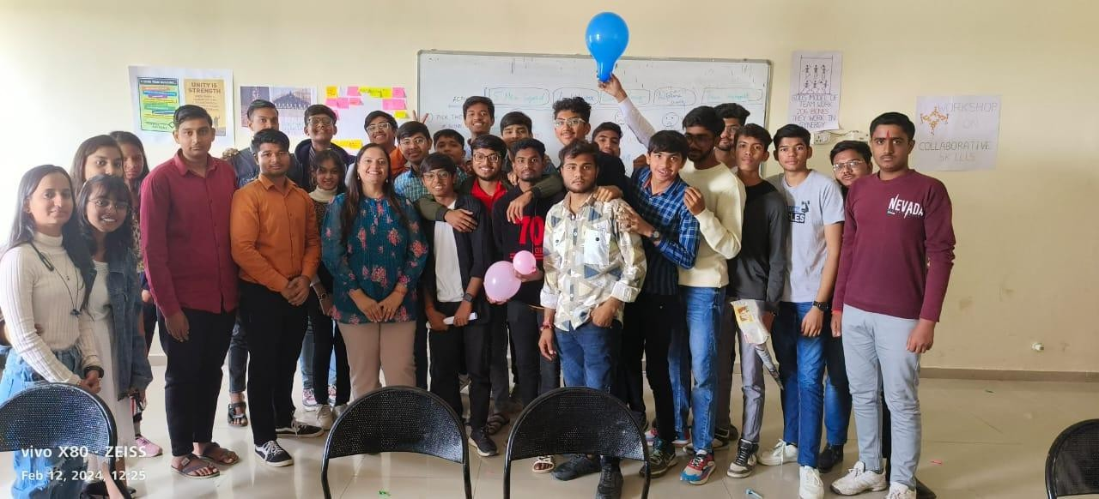

Attendance:

Swarrnim Startup and Innovation University
Training and Placement Department (2020-21)
Sr. No | Enrollment no. | Name | Branch
1 | 2014001025 | TIRTH SANJAYKUMAR THAKKAR | B.Com
2 | 2014001026 | ISHITA PANCHAL | B.Com
3 | 2014001027 | BANSI TARAPARA | B.Com
4 | 2014001028 | PRAJPATI DEVENDRA KUMAR INDER  KUMAR | B.Com
5 | 2014001029 | DHRUNIKA DESAI | B.Com
6 | 2014001030 | PATEL PARTHKUMAR PRAKASHCHANDRA | BBA
7 | 2014002001 | VANSH KETANKUMAR LAKDAWALA | BBA
8 | 2014002002 | BHUMIKA BIPIN BAMBHANIYA | BBA
9 | 2014002003 | RAHUL SURANA | BBA
10 | 2014002004 | HRIDAY SENGUPTA | BBA
11 | 2014002005 | ITANKAR MIHIR ISHWARBHAI | BBA
12 | 2014002006 | ASHU SHARMA | BBA

Swarrnim Startup and Innovation University
Training and Placement Department (2020-21)
Sr. No | Enrollment no. | Name | Branch
13 | 2014002007 | KIRTAN KHODALBHAI PUMBHADIYA | BBA
14 | 2014002008 | KARAN SRIVASTAVA | BBA
15 | 2014002009 | PRIYA MULANI | BBA
16 | 2014002010 | DIVYARAJ ASHOKDANJI GADHVI | BBA
17 | 2014002011 | PIYUSH BHANAP | BBA
18 | 2014002012 | PRATHAM SINGH | BBA
19 | 2014002013 | PANDYA JAYDEEP SAILESHKUMAR | BBA
20 | 2014002014 | MITVA PANKAJKUMAR CHANGELA | BBA
21 | 2014002015 | SHWETA KAMLESHBHAI LEUVA | BBA
22 | 2014002016 | SAHIL NARESH CHORDIA | BBA
23 | 2014002017 | PRATIK RAMESHBHAI MEHTA | BBA
24 | 2014002018 | KARAN BIPINBHAI GOHIL | BBA
25 | 2014002019 | JEET SURESHBHAI PATEL | BBA
26 | 2014002020 | VRUNDA PRAVINCHANDRA ROHIT | BBA
27 | 2014002021 | KASHYAP DHARMENDRABHAI PATEL | BBA
28 | 2014002022 | PATEL SHIVAM SANJAYKUMAR | BBA
29 | 2014002023 | PYLA HARIPRIYA | BBA
30 | 2014002024 | PRINCE MANOJKUMAR JAIN | BBA
31 | 2014002025 | JOTIBA ASHOK JADHAV | BBA
32 | 2014002026 | YASH ASHOKKUMAR THAKKAR | BBA
33 | 2014002027 | PREM JITENDRABHAI PATEL | BBA
34 | 2014002028 | TULSI KUMAR HIRABHAI VANIYA | BBA
35 | 2014002029 | NIYANDER VIKASBHAI PARMAR | BBA
36 | 2014002030 | DIGANT JASVANTBHAI PATEL | BBA
37 | 2014002031 | RAHUL BHATIA | BBA
38 | 2014002032 | VISHAL PARMAR | BBA
39 | 2014002033 | AMAN ARVINDBHAI MAKWANA | BBA
40 | 2014002034 | SADIK ACHHANALI KHAN | BBA
41 | 2014002035 | RITU HOMESH KHATRI | BBA
42 | 2014002036 | RATHOD AARYAN PARESHBHAI | BBA
43 | 2014002037 | SHAIKH FARHAN IKBAL | BBA
44 | 2014002038 | DHIRAJKUMAR PREMJIBHAI GADSAR | BBA
45 | 2014002039 | VAGHELA MANISHA PREMJIBHAI | BBA
46 | 2014002040 | ZALA RANJIT DAHYABHAI | BBA
47 | 2014002041 | RUDRA YOGESHBHAI RAVAL | BBA
Feedback Form
Academic Year (2020 -2021)
Training Type: Soft Skills
Sno | Enrollment Number | Student Name | 1. Was the Trainer well prepared with their content? | 2. Was the trainer  professiona l? | 3. Did the training content  match your expectations? | 4. Was the  trainer punctual? | 5. Was The Trainer  communica ting in English? | 6. Was the class  engaging?
1 | 2014001025 | TIRTH | Strongly | Strongly | Strongly | Agreed | Strongly | Agreed

 |  | SANJAYKUMAR THAKKAR | Agreed | Agreed | Agreed |  | Agreed
2 | 2014001026 | ISHITA PANCHAL | Agreed | Agreed | Strongly Agreed | Strongly Agreed | Strongly Agreed | Agreed
3 | 2014001027 | BANSI TARAPARA | Strongly Agreed | Agreed | Agreed | Strongly Agreed | Not agree | Agreed
4 | 2014001028 | PRAJPATI DEVENDRA KUMAR INDER  KUMAR | Agreed | Agreed | Strongly Agreed | Strongly Agreed | Strongly Agreed | Agreed
5 | 2014001029 | DHRUNIKA DESAI | Strongly Agreed | Agreed | Strongly Agreed | Agreed | Strongly Agreed | Agreed
6 | 2014001030 | PATEL PARTHKUMAR PRAKASHCHANDR A | Agreed | Agreed | Agreed | Strongly Agreed | Agreed | Agreed
7 | 2014002001 | VANSH KETANKUMAR LAKDAWALA | Agreed | Agreed | Not agree | Strongly Agreed | Strongly Agreed | Strongly Agreed
8 | 2014002002 | BHUMIKA BIPIN  BAMBHANIYA | Agreed | Strongly  Agreed | Strongly  Agreed | Strongly  Agreed | Strongly  Agreed | Agreed
9 | 2014002003 | RAHUL SURANA | Agreed | Not agree | Strongly Agreed | Agreed | Agreed | Strongly Agreed
10 | 2014002004 | HRIDAY SENGUPTA | Agreed | Strongly  Agreed | Strongly  Agreed | Agreed | Agreed | Strongly  Agreed
11 | 2014002005 | ITANKAR MIHIR ISHWARBHAI | Agreed | Strongly Agreed | Agreed | Agreed | Agreed | Strongly Agreed
12 | 2014002006 | ASHU SHARMA | Agreed | Strongly Agreed | Agreed | Agreed | Agreed | Strongly Agreed
13 | 2014002007 | KIRTAN KHODALBHAI PUMBHADIYA | Strongly Agreed | Agreed | Strongly Agreed | Agreed | Not agree | Not agree
14 | 2014002008 | KARAN  SRIVASTAVA | Agreed | Agreed | Strongly  Agreed | Agreed | Agreed | Strongly  Agreed
15 | 2014002009 | PRIYA MULANI | Strongly Agreed | Strongly Agreed | Strongly Agreed | Agreed | Agreed | Strongly Agreed
16 | 2014002010 | DIVYARAJ ASHOKDANJI  GADHVI | Strongly Agreed | Strongly Agreed | Strongly Agreed | Agreed | Agreed | Strongly Agreed
17 | 2014002011 | PIYUSH BHANAP | Strongly Agreed | Agreed | Agreed | Not agree | Agreed | Strongly Agreed
18 | 2014002012 | PRATHAM SINGH | Strongly  Agreed | Strongly  Agreed | Strongly  Agreed | Strongly  Agreed | Agreed | Strongly  Agreed
19 | 2014002013 | PANDYA JAYDEEP SAILESHKUMAR | Strongly Agreed | Strongly Agreed | Strongly Agreed | Strongly Agreed | Agreed | Strongly Agreed
20 | 2014002014 | MITVA PANKAJKUMAR CHANGELA | Strongly Agreed | Strongly Agreed | Strongly Agreed | Agreed | Agreed | Strongly Agreed
21 | 2014002015 | SHWETA KAMLESHBHAI LEUVA | Agreed | Strongly Agreed | Strongly Agreed | Strongly Agreed | Strongly Agreed | Strongly Agreed
22 | 2014002016 | SAHIL NARESH  CHORDIA | Not agree | Agreed | Strongly  Agreed | Strongly  Agreed | Strongly  Agreed | Strongly  Agreed
23 | 2014002017 | PRATIK | Strongly | Strongly | Strongly | Agreed | Agreed | Not agree

 |  | RAMESHBHAI MEHTA | Agreed | Agreed | Agreed
24 | 2014002018 | KARAN BIPINBHAI GOHIL | Strongly Agreed | Strongly Agreed | Agreed | Strongly Agreed | Strongly Agreed | Strongly Agreed
25 | 2014002019 | JEET SURESHBHAI PATEL | Strongly Agreed | Agreed | Not agree | Strongly Agreed | Strongly Agreed | Strongly Agreed
26 | 2014002020 | VRUNDA PRAVINCHANDRA  ROHIT | Strongly Agreed | Not agree | Strongly Agreed | Strongly Agreed | Not agree | Agreed
27 | 2014002021 | KASHYAP DHARMENDRABH AI PATEL | Strongly Agreed | Not agree | Not agree | Strongly Agreed | Agreed | Not agree
28 | 2014002022 | PATEL SHIVAM  SANJAYKUMAR | Strongly  Agreed | Strongly  Agreed | Strongly  Agreed | Strongly  Agreed | Strongly  Agreed | Strongly  Agreed
29 | 2014002023 | PYLA HARIPRIYA | Strongly Agreed | Strongly Agreed | Agreed | Strongly Agreed | Strongly Agreed | Strongly Agreed
30 | 2014002024 | PRINCE MANOJKUMAR  JAIN | Strongly Agreed | Strongly Agreed | Strongly Agreed | Strongly Agreed | Strongly Agreed | Strongly Agreed
31 | 2014002025 | JOTIBA ASHOK JADHAV | Strongly Agreed | Strongly Agreed | Strongly Agreed | Strongly Agreed | Not agree | Strongly Agreed
32 | 2014002026 | YASH ASHOKKUMAR  THAKKAR | Agreed | Strongly Agreed | Strongly Agreed | Agreed | Not agree | Strongly Agreed
33 | 2014002027 | PREM JITENDRABHAI PATEL | Agreed | Strongly Agreed | Strongly Agreed | Strongly Agreed | Not agree | Strongly Agreed
34 | 2014002028 | TULSI KUMAR  HIRABHAI VANIYA | Agreed | Strongly  Agreed | Strongly  Agreed | Agreed | Not agree | Strongly  Agreed
35 | 2014002029 | NIYANDER VIKASBHAI PARMAR | Agreed | Strongly Agreed | Agreed | Strongly Agreed | Not agree | Strongly Agreed
36 | 2014002030 | DIGANT JASVANTBHAI  PATEL | Agreed | Agreed | Not agree | Strongly Agreed | Not agree | Strongly Agreed
37 | 2014002031 | RAHUL BHATIA | Agreed | Strongly Agreed | Strongly Agreed | Strongly Agreed | Agreed | Agreed
38 | 2014002032 | VISHAL PARMAR | Agreed | Not agree | Strongly Agreed | Strongly Agreed | Agreed | Strongly Agreed
39 | 2014002033 | AMAN ARVINDBHAI MAKWANA | Agreed | Strongly Agreed | Strongly Agreed | Agreed | Agreed | Strongly Agreed
40 | 2014002034 | SADIK ACHHANALI  KHAN | Agreed | Strongly  Agreed | Agreed | Strongly  Agreed | Agreed | Strongly  Agreed
41 | 2014002035 | RITU HOMESH KHATRI | Strongly Agreed | Strongly Agreed | Strongly Agreed | Strongly Agreed | Agreed | Strongly Agreed
42 | 2014002036 | RATHOD AARYAN  PARESHBHAI | Strongly  Agreed | Strongly  Agreed | Strongly  Agreed | Strongly  Agreed | Agreed | Agreed
43 | 2014002037 | SHAIKH FARHAN IKBAL | Agreed | Strongly Agreed | Strongly Agreed | Agreed | Strongly Agreed | Agreed
44 | 2014002038 | DHIRAJKUMAR PREMJIBHAI GADSAR | Agreed | Strongly Agreed | Agreed | Strongly Agreed | Strongly Agreed | Agreed
45 | 2014002039 | VAGHELA | Agreed | Strongly | Agreed | Strongly | Strongly | Agreed

 |  | MANISHA PREMJIBHAI |  | Agreed |  | Agreed | Agreed
46 | 2014002040 | ZALA RANJIT DAHYABHAI | Agreed | Strongly Agreed | Agreed | Strongly Agreed | Strongly Agreed | Agreed
47 | 2014002041 | RUDRA YOGESHBHAI RAVAL | Strongly Agreed | Strongly Agreed | Strongly Agreed | Agreed | Strongly Agreed | Agreed

Swarrnim Startup & Innovation University,Gujarat
Academic Year 2020-21
2020-21 | Option | Total Answer | Average Evaluation (Out of 4)
1. Was the Trainer well prepared with their content? | Strongly Agree | 22 | 3.44
 | Agree | 24
 | Not Agree | 1
 | Strongly disagree | 0
2. Was the trainer  professional? | Strongly Agree | 31 | 3.57
 | Agree | 12
 | Not Agree | 4
 | Strongly disagree | 0
3. Did the training content matched your expectations? | Strongly Agree | 31 | 3.57
 | Agree | 12
 | Not Agree | 4
 | Strongly disagree | 0
4. Was the trainer  punctual? | Strongly Agree | 29 | 3.59
 | Agree | 17
 | Not Agree | 1
 | Strongly disagree | 0
5. Was The Trainer  communicating in English? | Strongly Agree | 18 | 3.19
 | Agree | 20
 | Not Agree | 9
 | Strongly disagree | 0
6. Was the class engaging? | Strongly Agree | 29 | 3.55
 | Agree | 15
 | Not Agree | 3
 | Strongly disagree | 0

Average Score (Out of 4) | 3.485
Total Effectiveness | 87%

Name of Workshop: Enhance Critical Thinking Date of Seminar: February 24, 2021
Organized by: Training And Placement Department, SSIU

Objective: To develop a student's ability to analyze information and make reasoned decisions.
Report: Students engaged in critical thinking exercises such as analyzing news articles, participating in debates, and solving logic puzzles. The program emphasized the importance of questioning assumptions and evaluating evidence. By honing their critical thinking skills, students became better equipped to make informed decisions and develop well-reasoned arguments.
Program Outcome: The program included activities like debates, logic puzzles, and scenario analysis. Students learned to evaluate arguments, identify biases, and think logically, which strengthened their decision-making and analytical skills.
Snippets From The Workshop:

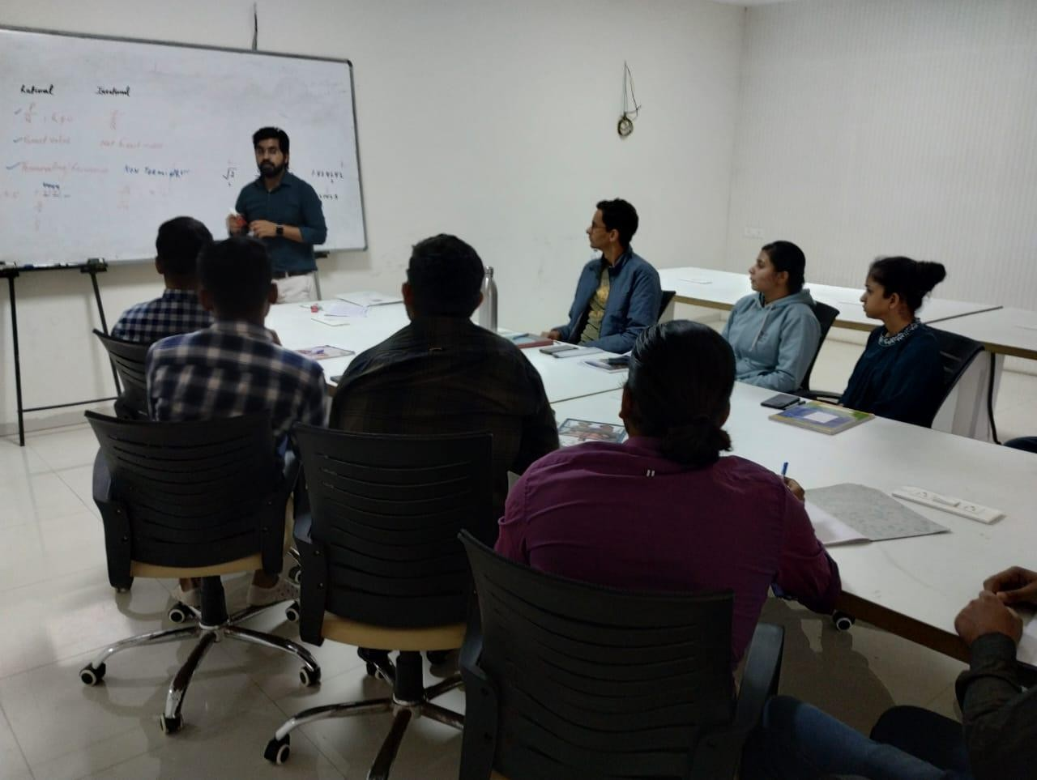

Attendance:

Swarrnim Startup and Innovation University
Training and Placement Department (2020-21)
Sr. No | Enrollment no. | Name | Branch
1 | 2014002042 | SAURAV MANOJ ROY | BBA
2 | 2014002043 | THAKUR AMAN SINGH | BBA
3 | 2014002044 | KATHAN MILANKUMAR MISTRY | BBA
4 | 2014002045 | JAYKUMAR RAMESHBHAI BHANDERI | BBA
5 | 2014002046 | DEEP PRAVINBHAI KAKADIYA | BBA
6 | 2014002047 | PANCHAL SHUBH RAJANKUMAR | BBA
7 | 2014002048 | RATHOD MAYURKUMAR PRAVINBHAI | BBA
8 | 2014002049 | SOALNKI ANAND MAHESHBHAI | BBA
9 | 2014002050 | UTSAV PANKAJBHAI MANDAVIYA | BBA
10 | 2014002051 | PARMAR SNEH PRAVINBHAI | BBA

Swarrnim Startup and Innovation University
Training and Placement Department (2020-21)
Sr. No | Enrollment no. | Name | Branch
11 | 2014002052 | PATEL MOHIT NARESHKUMAR | BBA
12 | 2014102001 | PRASAM DAGARIYA | MBA (Entrepreneurship)
13 | 2016010001 | SHRUTI RAMESH PATEL | MBA (Entrepreneurship)
14 | 2016010002 | AKASH RAMROOPSINGH SINGH | MBA - (Digital Marketing & eCommerce)
15 | 2016012001 | AVNISH MAHENDRABHAI PUJARA | MBA - (Digital Marketing & eCommerce)
16 | 2016012002 | DEEP YOGENDRAKUMAR RAVAL | MBA - (Digital Marketing & eCommerce)
17 | 2016012003 | SHIVANG KOUL | MBA (HR)
18 | 2016007001 | SHWETA UPADHYAYA | MBA (HR)
19 | 2016007002 | PRIYANKABEN HARSHADBHAI MOVADIYA | MBA (HR)
20 | 2016007003 | BAROT KAJAL MAHESHBHAI | MBA (HR)
21 | 2016007004 | DIVYA JAY KHAMBHOLJA | MBA (Finance)
22 | 2016006001 | PRIYA RAJKUMAR AGRAWAL | MBA (Finance)
23 | 2016006002 | ABHISHEK KUMAR SRIVASTAVA | MBA (Finance)
24 | 2016006003 | HRISHIKESH SHIRISH JOSHI | MBA (Finance)
25 | 2016006004 | SHRIPAD SADANAND THOTE | MBA (Marketing)
26 | 2016005001 | PRIYANK NILESHBHAI JANI | MBA (Marketing)
27 | 2016005002 | PATEL TEJAS VIRJIBHAI | MBA (Marketing)
28 | 2016005003 | CHINTAN DINESHBHAI CHAVDA | MBA (Marketing)
29 | 2016005004 | PRAFULBHAI RAMANBHAI MAKWANA | MBA (Marketing)
30 | 2016005005 | VIJAY NATVARBHAI SOLANKI | MBA (Marketing)
31 | 2016005006 | HETAL RAMESHBHAI SOLANKI | MBA (Marketing)
32 | 2016005007 | BHAVESH MANUBHAI CHAVDA | MBA (Marketing)
33 | 2016005008 | KIRITKUMAR NATUBHAI RATHOD | MBA (Marketing)
34 | 2016005009 | VAGHELA VISHAL BABULAL | MBA (Marketing)
35 | 2016005051 | JAKSHIYA DIPAK MANUBHAI | MBA (Marketing)
36 | 2016005052 | NAGARIYA HITESHKUMAR MAHESHBHAI | MBA (Marketing)
37 | 2016005053 | SOLANKI PRIYABEN VINUBHAI | MBA (Marketing)
38 | 2016005054 | MAKWANA PIYUSH JAYANTIBHAI | MBA (Marketing)
39 | 2016005055 | BHATIYA ANIL KUMAR MAHESHBHAI | MBA (Marketing)
40 | 2016005056 | PARMAR SANJAYKUMAR BHIKHABHAI | MBA (Marketing)
41 | 2016005057 | ZALA BHARABHAI BABUBHAI | MBA (Marketing)
42 | 2016005058 | PARMAR HARSH RAMESHBHAI | MCom (Accounting)
43 | 2016002001 | PATEL DIMPLEBEN DAYABHAI | MCom (Accounting)
44 | 2016002002 | PATEL SACHIN VISHNUBHAI | MCom (Accounting)
Feedback Form
Academic Year (2020 -2021)
Training Type: Soft Skills
Sno | Enrollment Number | Student Name | 1. Was the Trainer well prepared with their content? | 2. Was the trainer  professiona l? | 3. Did the training content  match your expectation s? | 4. Was the trainer  punctual? | 5. Was The Trainer  communicati ng in English? | 6. Was the class  engaging?
1 | 2014002042 | SAURAV MANOJ | Strongly | Strongly | Strongly | Strongly | Strongly | Strongly

 |  | ROY | Agreed | Agreed | Agreed | Agreed | Agreed | Agreed
2 | 2014002043 | THAKUR AMAN  SINGH | Strongly  Agreed | Strongly  Agreed | Strongly  Agreed | Strongly  Agreed | Strongly  Agreed | Agreed
3 | 2014002044 | KATHAN MILANKUMAR MISTRY | Strongly Agreed | Strongly Agreed | Strongly Agreed | Agreed | Strongly Agreed | Strongly Agreed
4 | 2014002045 | JAYKUMAR RAMESHBHAI  BHANDERI | Strongly Agreed | Strongly Agreed | Agreed | Strongly Agreed | Strongly Agreed | Strongly Agreed
5 | 2014002046 | DEEP PRAVINBHAI KAKADIYA | Strongly Agreed | Agreed | Agreed | Agreed | Strongly Agreed | Agreed
6 | 2014002047 | PANCHAL SHUBH  RAJANKUMAR | Strongly Agreed | Strongly Agreed | Agreed | Agreed | Strongly Agreed | Agreed
7 | 2014002048 | RATHOD MAYURKUMAR PRAVINBHAI | Strongly Agreed | Strongly Agreed | Agreed | Agreed | Strongly Agreed | Agreed
8 | 2014002049 | SOALNKI ANAND  MAHESHBHAI | Strongly  Agreed | Strongly  Agreed | Agreed | Agreed | Strongly  Agreed | Agreed
9 | 2014002050 | UTSAV PANKAJBHAI MANDAVIYA | Strongly Agreed | Agreed | Agreed | Agreed | Not agree | Agreed
10 | 2014002051 | PARMAR SNEH  PRAVINBHAI | Agreed | Agreed | Agreed | Agreed | Strongly  Agreed | Agreed
11 | 2014002052 | PATEL MOHIT NARESHKUMAR | Strongly Agreed | Strongly Agreed | Agreed | Agreed | Strongly Agreed | Agreed
12 | 2014102001 | PRASAM DAGARIYA | Strongly Agreed | Strongly Agreed | Agreed | Agreed | Agreed | Agreed
13 | 2016010001 | SHRUTI RAMESH PATEL | Strongly Agreed | Strongly Agreed | Strongly Agreed | Agreed | Strongly Agreed | Agreed
14 | 2016010002 | AKASH RAMROOPSING  H SINGH | Strongly Agreed | Agreed | Agreed | Agreed | Agreed | Agreed
15 | 2016012001 | AVNISH MAHENDRABHA I PUJARA | Strongly Agreed | Strongly Agreed | Agreed | Agreed | Strongly Agreed | Strongly Agreed
16 | 2016012002 | DEEP YOGENDRAKUM  AR RAVAL | Strongly Agreed | Agreed | Strongly Agreed | Agreed | Not agree | Strongly Agreed
17 | 2016012003 | SHIVANG KOUL | Agreed | Agreed | Strongly Agreed | Agreed | Strongly Agreed | Strongly Agreed
18 | 2016007001 | SHWETA UPADHYAYA | Strongly Agreed | Strongly Agreed | Agreed | Agreed | Strongly Agreed | Not agree
19 | 2016007002 | PRIYANKABEN HARSHADBHAI MOVADIYA | Strongly Agreed | Strongly Agreed | Strongly Agreed | Agreed | Agreed | Strongly Agreed
20 | 2016007003 | BAROT KAJAL  MAHESHBHAI | Strongly  Agreed | Agreed | Strongly  Agreed | Agreed | Strongly  Agreed | Strongly  Agreed
21 | 2016007004 | DIVYA JAY KHAMBHOLJA | Strongly Agreed | Strongly Agreed | Strongly Agreed | Strongly Agreed | Strongly Agreed | Strongly Agreed
22 | 2016006001 | PRIYA RAJKUMAR  AGRAWAL | Strongly Agreed | Strongly Agreed | Strongly Agreed | Agreed | Agreed | Strongly Agreed

23 | 2016006002 | ABHISHEK KUMAR SRIVASTAVA | Agreed | Strongly Agreed | Agreed | Strongly Agreed | Strongly Agreed | Strongly Agreed
24 | 2016006003 | HRISHIKESH  SHIRISH JOSHI | Not agree | Strongly  Agreed | Strongly  Agreed | Strongly  Agreed | Strongly  Agreed | Agreed
25 | 2016006004 | SHRIPAD SADANAND THOTE | Strongly Agreed | Strongly Agreed | Agreed | Strongly Agreed | Strongly Agreed | Agreed
26 | 2016005001 | PRIYANK NILESHBHAI  JANI | Agreed | Agreed | Strongly Agreed | Strongly Agreed | Agreed | Agreed
27 | 2016005002 | PATEL TEJAS VIRJIBHAI | Strongly Agreed | Agreed | Agreed | Agreed | Strongly Agreed | Agreed
28 | 2016005003 | CHINTAN DINESHBHAI  CHAVDA | Strongly Agreed | Agreed | Agreed | Strongly Agreed | Agreed | Strongly Agreed
29 | 2016005004 | PRAFULBHAI RAMANBHAI MAKWANA | Agreed | Agreed | Agreed | Agreed | Strongly Agreed | Strongly Agreed
30 | 2016005005 | VIJAY NATVARBHAI  SOLANKI | Strongly Agreed | Agreed | Agreed | Agreed | Strongly Agreed | Strongly Agreed
31 | 2016005006 | HETAL RAMESHBHAI SOLANKI | Strongly Agreed | Agreed | Agreed | Agreed | Strongly Agreed | Strongly Agreed
32 | 2016005007 | BHAVESH MANUBHAI  CHAVDA | Agreed | Agreed | Agreed | Strongly Agreed | Agreed | Not agree
33 | 2016005008 | KIRITKUMAR NATUBHAI RATHOD | Not agree | Not agree | Agreed | Strongly Agreed | Agreed | Not agree
34 | 2016005009 | VAGHELA VISHAL  BABULAL | Strongly Agreed | Not agree | Agreed | Strongly Agreed | Agreed | Not agree
35 | 2016005051 | JAKSHIYA DIPAK MANUBHAI | Agreed | Not agree | Strongly Agreed | Agreed | Agreed | Not agree
36 | 2016005052 | NAGARIYA HITESHKUMAR MAHESHBHAI | Strongly Agreed | Not agree | Agreed | Agreed | Agreed | Not agree
37 | 2016005053 | SOLANKI PRIYABEN VINUBHAI | Strongly Agreed | Not agree | Agreed | Agreed | Agreed | Agreed
38 | 2016005054 | MAKWANA PIYUSH  JAYANTIBHAI | Strongly Agreed | Agreed | Strongly Agreed | Agreed | Agreed | Agreed
39 | 2016005055 | BHATIYA ANIL KUMAR MAHESHBHAI | Strongly Agreed | Strongly Agreed | Agreed | Agreed | Strongly Agreed | Agreed
40 | 2016005056 | PARMAR SANJAYKUMAR  BHIKHABHAI | Not agree | Strongly Agreed | Strongly Agreed | Agreed | Strongly Agreed | Agreed
41 | 2016005057 | ZALA BHARABHAI BABUBHAI | Strongly Agreed | Not agree | Agreed | Agreed | Strongly Agreed | Agreed

42 | 2016005058 | PARMAR HARSH RAMESHBHAI | Agreed | Strongly Agreed | Agreed | Agreed | Strongly Agreed | Strongly Agreed
43 | 2016002001 | PATEL DIMPLEBEN DAYABHAI | Strongly Agreed | Agreed | Strongly Agreed | Agreed | Agreed | Strongly Agreed
44 | 2016002002 | PATEL SACHIN VISHNUBHAI | Strongly Agreed | Agreed | Agreed | Strongly Agreed | Strongly Agreed | Agreed

Swarrnim Startup & Innovation University,Gujarat
Academic Year 2020-21
2020-21 | Option | Total Answer | Average Evaluation  (Out of 4)
1. Was the Trainer well prepared with  their content? | Strongly Agree | 33 | 3.68
 | Agree | 8
 | Not Agree | 3
 | Strongly disagree | 0
2. Was the trainer professional? | Strongly Agree | 23 | 3.38
 | Agree | 15
 | Not Agree | 6
 | Strongly disagree | 0
3. Did the training content matched  your expectations? | Strongly Agree | 16 | 3.36
 | Agree | 28
 | Not Agree | 0
 | Strongly disagree | 0
4. Was the trainer punctual? | Strongly Agree | 13 | 3.29
 | Agree | 31
 | Not Agree | 0
 | Strongly disagree | 0
5. Was The Trainer communicating in  English? | Strongly Agree | 28 | 3.59
 | Agree | 14
 | Not Agree | 2
 | Strongly disagree | 0
6. Was the class engaging? | Strongly Agree | 17 | 3.25
 | Agree | 21
 | Not Agree | 6
 | Strongly disagree | 0

Average Score (Out of 4) | 3.425
Total Effectiveness | 85.60%

Name of Seminar: Improve Conflict Resolution Skills Date of Seminar: January 20, 2021
Organized by: Training And Placement Department, SSIU
Objective: To teach students strategies for resolving conflicts amicably and constructively.
Report: The conflict resolution program involved role-playing exercises where students practiced resolving hypothetical disputes. Workshops focused on communication techniques, such as active listening and assertiveness. Students also learned about mediation and negotiation strategies, which enabled them to handle conflicts more effectively and maintain positive relationships.
Program Outcome: Students engaged in role-playing scenarios and conflict resolution workshops. They learned about active listening, negotiation, and finding common ground, which helped them manage and resolve conflicts in a positive manner.
Snippet:
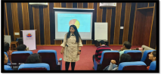

Attendance:

Swarrnim Startup and Innovation University
Training and Placement Department (2020-21)
Sr. No | Enrollment no. | Name | Branch
1 | 2116005001 | Trilokani Ashwin Hareshbhai | MBA- MARKETING
2 | 2116005002 | Devda Vipul Prakash Sundar | MBA- MARKETING
3 | 2116005003 | Kushwaha Rishabh Hemant | MBA- MARKETING
4 | 2116005004 | Prajapati Pooja Nathuram | MBA- MARKETING
5 | 2116005005 | Tripathi Krishna Shivprakash | MBA- MARKETING
6 | 2116005006 | Bhatt Abhishek Yogeshchandra | MBA- MARKETING
7 | 2116005007 | Bhanderi Abhaykumar Hiteshbhai | MBA- MARKETING
8 | 2116005008 | Barot Shivamkumar Manojbhai | MBA- MARKETING
9 | 2116005009 | Sheladiya Darshilkumar Himmatbhai | MBA- MARKETING
10 | 2116005010 | Jani Yash Vipulbhai | MBA- MARKETING
11 | 2116005011 | Patel Nishantkumar Narendrabhai | MBA- MARKETING
12 | 2116005012 | Khambhaliya Darshan Jagdishbhai | MBA- MARKETING
13 | 2116006001 | Gondalia Parth Kaushikbhai | MBA- FINANCE
14 | 2116006002 | Vipin Singh | MBA- FINANCE
15 | 2116006003 | Patel Keyurkumar Maheshbhai | MBA- FINANCE
16 | 2116006004 | Patel Dhruvkumar Dipakbhai | MBA- FINANCE
17 | 2116006005 | Soni Zeal Vijay | MBA- FINANCE

Swarrnim Startup and Innovation University
Training and Placement Department (2020-21)
Sr. No | Enrollment no. | Name | Branch
18 | 2116006006 | Palve Sagar Bhai Amrutbhai | MBA- FINANCE
19 | 2116006007 | Thakor Mahimaben Dipakkumar | MBA- FINANCE
20 | 2116006008 | Sahani Sahil Sohanlal | MBA- FINANCE
21 | 2116006009 | Chauhan Yash Nileshbhai | MBA- FINANCE
22 | 2116006010 | Amin Ekta Narayanbhai | MBA- FINANCE
23 | 2116006011 | Mali Arti Rakeshbhai | MBA- FINANCE
24 | 2116006012 | Solanki Hiral Pravinkumar | MBA- FINANCE
25 | 2116007001 | Purohit Diya Nareshkumar | MBA- HR
26 | 2116007002 | Trivedi Siddharth Pravinchandra | MBA- HR
27 | 2116007003 | Nikam Pranjali Pravin | MBA- HR
28 | 2116007004 | Raval Kamya Ajaykumar | MBA- HR
29 | 2116007005 | Chauhan Rakesh Gulabbhai | MBA- HR
30 | 2116007006 | Agarwal Rupal Nankchand | MBA- HR
31 | 2116007007 | Rajput Himadri Harivanshsingh | MBA- HR
32 | 2116007008 | Hingu Hemali Dineshkumar | MBA- HR
33 | 2116007009 | Pandya Maitri Sunilbhai | MBA- HR
34 | 2116007010 | Parmar Aartiben Deepakbhai | MBA- HR
35 | 2116007011 | Patel Brijesh Mukeshkumar | MBA- HR
36 | 2116007012 | Dabbi Wala Mohd Abrar Mohd Allarakha | MBA- HR
37 | 2116007013 | Prajapati Jahnavi Kirit | MBA- HR
38 | 2116007014 | Dave Harsh Jayeshkumar | MBA- HR
39 | 2116007015 | Rajyaguru Satyam Bhadreshbhai | MBA- HR
40 | 2116007016 | Patel Vishvaben Jayantibhai | MBA- HR
41 | 2116007017 | Makwana Sonu Gautambhai | MBA- HR
42 | 2116007018 | Sadhu Priteshkumar Girishbhai | MBA- HR
43 | 2116007019 | Shrimali Vishakha Pravinkumar | MBA- HR
44 | 2116010001 | Brahmbhatt Yash Bhalchandra | MBA - ENTREPRENEURSHIP
45 | 2116015001 | Raval Jaydi Itendrakumar | MBA- FINANCE
46 | 2116015002 | Patel Shivani Narendrabhai | MBA- FINANCE
47 | 2116015003 | Jha Khushbu Sanjivkumar | MBA- FINANCE
48 | 2116015004 | Delvadiya Jenil Ashvinbhai | MBA- FINANCE
49 | 2116015005 | Bhabhera Hardik Babubhai | MBA- FINANCE
50 | 2116015006 | Rathod Vikas Ramnikbhai | MBA- FINANCE
51 | 2114010001 | TOPIYA HETKUMAR MAHESHBHAI | BCA (DS)
52 | 2114010002 | RAJPARA DHRUVIKA DHARMESH | BCA (DS)
53 | 2114010003 | BHAGAT SRUSTIBEN RAJESHBHAI | BCA (DS)
54 | 2114010004 | BHUMI MANSUKHBHAI  BHANUSHALI | BCA (DS)
55 | 2114011001 | PATEL ARYA NARENDRABHAI | BCA-CTIS

Feedback Form
Academic Year (2020 -2021)
Training Type: Soft Skills
Sno | Enrollment Number | Student Name | 1. Was the Trainer well prepared with their content? | 2. Was the  trainer professi onal? | 3. Did the training content  match your expectation s? | 4. Was the trainer  punctual? | 5. Was The Trainer  communica ting in English? | 6. Was the class  engaging?
1 | 2116005001 | Trilokani Ashwin  Hareshbhai | Strongly  Agreed | Strongly  Agreed | Strongly  Agreed | Strongly  Agreed | Strongly  Agreed | Strongly  Agreed
2 | 2116005002 | Devda Vipul  Prakash Sundar | Strongly  Agreed | Strongly  Agreed | Agreed | Strongly  Agreed | Strongly  Agreed | Not agree
3 | 2116005003 | Kushwaha Rishabh Hemant | Strongly Agreed | Agreed | Strongly Agreed | Strongly Agreed | Not agree | Strongly Agreed
4 | 2116005004 | Prajapati Pooja Nathuram | Agreed | Agreed | Strongly Agreed | Strongly Agreed | Strongly Agreed | Strongly Agreed
5 | 2116005005 | Tripathi Krishna Shivprakash | Agreed | Strongly Agreed | Strongly Agreed | Strongly Agreed | Strongly Agreed | Not agree
6 | 2116005006 | Bhatt Abhishek  Yogeshchandra | Agreed | Strongly  Agreed | Strongly  Agreed | Strongly  Agreed | Agreed | Not agree
7 | 2116005007 | Bhanderi Abhaykumar Hiteshbhai | Agreed | Agreed | Agreed | Not agree | Strongly Agreed | Not agree
8 | 2116005008 | Barot Shivamkumar  Manojbhai | Agreed | Strongly Agreed | Strongly Agreed | Strongly Agreed | Strongly Agreed | Not agree
9 | 2116005009 | Sheladiya Darshilkumar Himmatbhai | Agreed | Strongly Agreed | Strongly Agreed | Strongly Agreed | Strongly Agreed | Not agree
10 | 2116005010 | Jani Yash Vipulbhai | Agreed | Strongly  Agreed | Strongly  Agreed | Agreed | Strongly  Agreed | Not agree
11 | 2116005011 | Patel Nishantkumar Narendrabhai | Agreed | Strongly Agreed | Strongly Agreed | Strongly Agreed | Strongly Agreed | Not agree
12 | 2116005012 | Khambhaliya Darshan  Jagdishbhai | Agreed | Agreed | Strongly Agreed | Strongly Agreed | Not agree | Not agree
13 | 2116006001 | Gondalia Parth Kaushikbhai | Agreed | Agreed | Strongly Agreed | Strongly Agreed | Strongly Agreed | Not agree
14 | 2116006002 | Vipin Singh | Agreed | Strongly Agreed | Agreed | Strongly Agreed | Strongly Agreed | Not agree
15 | 2116006003 | Patel Keyurkumar Maheshbhai | Agreed | Strongly Agreed | Agreed | Strongly Agreed | Agreed | Strongly Agreed
16 | 2116006004 | Patel Dhruvkumar  Dipakbhai | Agreed | Agreed | Agreed | Not agree | Strongly  Agreed | Agreed
17 | 2116006005 | Soni Zeal Vijay | Agreed | Strongly Agreed | Agreed | Strongly Agreed | Strongly Agreed | Not agree
18 | 2116006006 | Palve Sagar Bhai Amrutbhai | Strongly Agreed | Strongly Agreed | Agreed | Strongly Agreed | Strongly Agreed | Agreed
19 | 2116006007 | Thakor Mahimaben Dipakkumar | Strongly Agreed | Strongly Agreed | Agreed | Agreed | Strongly Agreed | Agreed

20 | 2116006008 | Sahani Sahil Sohanlal | Strongly Agreed | Strongly Agreed | Agreed | Strongly Agreed | Strongly Agreed | Agreed
21 | 2116006009 | Chauhan Yash Nileshbhai | Agreed | Agreed | Agreed | Strongly Agreed | Not agree | Strongly Agreed
22 | 2116006010 | Amin Ekta Narayanbhai | Agreed | Agreed | Strongly Agreed | Strongly Agreed | Strongly Agreed | Strongly Agreed
23 | 2116006011 | Mali Arti  Rakeshbhai | Strongly  Agreed | Strongly  Agreed | Agreed | Strongly  Agreed | Strongly  Agreed | Strongly  Agreed
24 | 2116006012 | Solanki Hiral Pravinkumar | Agreed | Strongly Agreed | Strongly Agreed | Strongly Agreed | Agreed | Strongly Agreed
25 | 2116007001 | Purohit Diya Nareshkumar | Agreed | Agreed | Strongly Agreed | Not agree | Strongly Agreed | Not agree
26 | 2116007002 | Trivedi Siddharth Pravinchandra | Agreed | Strongly Agreed | Not agree | Strongly Agreed | Strongly Agreed | Strongly Agreed
27 | 2116007003 | Nikam Pranjali  Pravin | Agreed | Strongly  Agreed | Not agree | Strongly  Agreed | Strongly  Agreed | Strongly  Agreed
28 | 2116007004 | Raval Kamya Ajaykumar | Agreed | Strongly Agreed | Not agree | Agreed | Agreed | Agreed
29 | 2116007005 | Chauhan Rakesh Gulabbhai | Agreed | Strongly Agreed | Not agree | Strongly Agreed | Agreed | Agreed
30 | 2116007006 | Agarwal Rupal Nankchand | Agreed | Agreed | Agreed | Not agree | Agreed | Agreed
31 | 2116007007 | Rajput Himadri  Harivanshsingh | Strongly  Agreed | Strongly  Agreed | Agreed | Strongly  Agreed | Not agree | Agreed
32 | 2116007008 | Hingu Hemali Dineshkumar | Strongly Agreed | Strongly Agreed | Agreed | Strongly Agreed | Agreed | Agreed
33 | 2116007009 | Pandya Maitri Sunilbhai | Not agree | Strongly Agreed | Not agree | Agreed | Agreed | Agreed
34 | 2116007010 | Parmar Aartiben Deepakbhai | Strongly Agreed | Not agree | Agreed | Strongly Agreed | Agreed | Strongly Agreed
35 | 2116007011 | Patel Brijesh  Mukeshkumar | Strongly  Agreed | Strongly  Agreed | Agreed | Strongly  Agreed | Strongly  Agreed | Strongly  Agreed
36 | 2116007012 | Dabbi Wala Mohd Abrar Mohd Allarakha | Strongly Agreed | Strongly Agreed | Not agree | Strongly Agreed | Strongly Agreed | Agreed
37 | 2116007013 | Prajapati Jahnavi  Kirit | Strongly  Agreed | Agreed | Agreed | Strongly  Agreed | Not agree | Agreed
38 | 2116007014 | Dave Harsh Jayeshkumar | Agreed | Agreed | Strongly Agreed | Strongly Agreed | Strongly Agreed | Strongly Agreed
39 | 2116007015 | Rajyaguru Satyam Bhadreshbhai | Strongly Agreed | Strongly Agreed | Agreed | Not agree | Strongly Agreed | Agreed
40 | 2116007016 | Patel Vishvaben Jayantibhai | Strongly Agreed | Strongly Agreed | Agreed | Strongly Agreed | Agreed | Agreed
41 | 2116007017 | Makwana Sonu  Gautambhai | Agreed | Agreed | Strongly  Agreed | Not agree | Strongly  Agreed | Agreed
42 | 2116007018 | Sadhu Priteshkumar Girishbhai | Agreed | Strongly Agreed | Strongly Agreed | Strongly Agreed | Strongly Agreed | Agreed
43 | 2116007019 | Shrimali Vishakha  Pravinkumar | Agreed | Strongly  Agreed | Strongly  Agreed | Strongly  Agreed | Strongly  Agreed | Agreed
44 | 2116010001 | Brahmbhatt Yash Bhalchandra | Agreed | Strongly Agreed | Strongly Agreed | Agreed | Strongly Agreed | Agreed
45 | 2116015001 | Raval Jaydi Itendrakumar | Agreed | Strongly Agreed | Strongly Agreed | Strongly Agreed | Strongly Agreed | Agreed

46 | 2116015002 | Patel Shivani Narendrabhai | Agreed | Agreed | Agreed | Not agree | Strongly Agreed | Agreed
47 | 2116015003 | Jha Khushbu Sanjivkumar | Agreed | Strongly Agreed | Agreed | Strongly Agreed | Strongly Agreed | Agreed
48 | 2116015004 | Delvadiya Jenil Ashvinbhai | Strongly Agreed | Not agree | Agreed | Strongly Agreed | Agreed | Agreed
49 | 2116015005 | Bhabhera Hardik  Babubhai | Strongly  Agreed | Not  agree | Agreed | Agreed | Agreed | Strongly  Agreed
50 | 2116015006 | Rathod Vikas Ramnikbhai | Agreed | Not agree | Agreed | Strongly Agreed | Agreed | Strongly Agreed
51 | 2114010001 | TOPIYA HETKUMAR MAHESHBHAI | Strongly Agreed | Strongly Agreed | Strongly Agreed | Strongly Agreed | Agreed | Strongly Agreed
52 | 2114010002 | RAJPARA DHRUVIKA DHARMESH | Not agree | Agreed | Strongly Agreed | Not agree | Agreed | Strongly Agreed
53 | 2114010003 | BHAGAT SRUSTIBEN  RAJESHBHAI | Not agree | Strongly Agreed | Not agree | Strongly Agreed | Agreed | Agreed
54 | 2114010004 | BHUMI MANSUKHBHAI BHANUSHALI | Not agree | Strongly Agreed | Strongly Agreed | Strongly Agreed | Agreed | Agreed
55 | 2114011001 | PATEL ARYA  NARENDRABHAI | Strongly  Agreed | Strongly  Agreed | Strongly  Agreed | Agreed | Agreed | Agreed

Swarrnim Startup & Innovation University,Gujarat
Academic Year 2020-21
2020-21 | Option | Total Answer | Average Evaluation (Out  of 4)
1. Was the Trainer well prepared with  their content? | Strongly Agree | 19 | 3.27
 | Agree | 32
 | Not Agree | 4
 | Strongly disagree | 0
2. Was the trainer professional? | Strongly Agree | 36 | 3.58
 | Agree | 15
 | Not Agree | 4
 | Strongly disagree | 0
3. Did the training content match your  expectations? | Strongly Agree | 24 | 3.3
 | Agree | 24
 | Not Agree | 7
 | Strongly disagree | 0
4. Was the trainer punctual? | Strongly Agree | 40 | 3.58
 | Agree | 7
 | Not Agree | 8
 | Strongly disagree | 0

5. Was The Trainer communicating in  English? | Strongly Agree | 32 | 3.49
 | Agree | 18
 | Not Agree | 5
 | Strongly disagree | 0
6. Was the class engaging? | Strongly Agree | 17 | 3.07
 | Agree | 25
 | Not Agree | 13
 | Strongly disagree | 0

Average Score (Out of 4) | 3.38
Total Effectiveness | 85%

Name of Workshop: Develop Presentation Skills Date of Workshop: February 10, 2021
Organized by: Training And Placement Department, SSIU
Objective: To improve student’s ability to design and deliver effective presentations.
Report: The presentation skills program included sessions on crafting compelling narratives, designing engaging slides, and mastering public speaking techniques. Students gave multiple presentations and received constructive feedback from peers and instructors. The hands-on experience helped them overcome stage fright and deliver more impactful presentations.
Program Outcome: Students participated in workshops on public speaking, slide design, and storytelling. They practiced delivering presentations in front of peers, receiving feedback to refine their skills. This led to increased confidence and proficiency in presenting information.
Snippet:
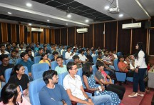

Attendance:

Swarrnim Startup and Innovation University
Training and Placement Department (2020-21)
Sr. No | Enrollment no. | Name | Branch
1 | 2114011002 | SNEH GUPTA | BCA-CTIS
2 | 2114011003 | DUSARA JENIS BHARATBHAI | BCA-CTIS
3 | 2114011004 | PATEL YASHVI NALINBHAI | BCA-CTIS
4 | 2114011005 | SENGHAL UJAS JITENDRBHAI | BCA-CTIS
5 | 2114011006 | GOSWAMI TANVI SURESHGIRI | BCA-CTIS
6 | 2114011007 | LADUMOR KAUSHIK GANPATBHAI | BCA-CTIS
7 | 2116015001 | RAVAL JAYDI ITENDRAKUMAR | MBA- FINANCE
8 | 2116015002 | PATEL SHIVANI NARENDRABHAI | MBA- FINANCE
9 | 2116015003 | JHA KHUSHBU SANJIVKUMAR | MBA- FINANCE
10 | 2116015004 | DELVADIYA JENIL ASHVINBHAI | MBA- FINANCE
11 | 2116015005 | BHABHERA HARDIK BABUBHAI | MBA- FINANCE
12 | 2116015006 | RATHOD VIKAS RAMNIKBHAI | MBA- FINANCE
13 | 2114006001 | AYUSH KUMAR | BBA - IB
14 | 2114006002 | BHATT SANJAY JAYKUMAR | BBA - IB
15 | 2114006003 | KARAN BHARATBHAI LUTYA | BBA - IB
16 | 2114006004 | SHAH JENIM DRIGESH | BBA - IB
17 | 2114006005 | CHEVEN NORALY OFINAR NHANTUMBO | BBA - IB
18 | 2114006006 | SHAIJAL RATHOD | BBA - IB
19 | 2114006007 | JANAK PRAJAPATI | BBA - IB
20 | 2114006008 | M.D. SARFRAZ | BBA - IB
21 | 2114007001 | AKRUTI ARPAN PATEL | BBA - FINANCIAL SERVICES
22 | 2114007002 | PATEL YASHASHVI PRAVINBHAI | BBA - FINANCIAL SERVICES
23 | 2114101001 | ANSHU KACHHELA | COMMERCE
24 | 2114003001 | ADITYA PRATAP SINGH BHAGAT SINGH | BCA
25 | 2114003002 | TANWANI PIYUSH DHARMENDRA | BCA
26 | 2114003003 | KAMLIYA NAVNEET BHUKHUBHAI | BCA
27 | 2114003004 | BASANTANI VINIT MAHESHKUMAR | BCA
28 | 2114003005 | PIRZADA AMIR HAMZA ZAKIRHUSAIN | BCA
29 | 2114003006 | PATEL NEELKUMAR RASIKBHAI | BCA
30 | 2114003007 | RAJPUT PREMSINGH KANAIYALAL | BCA
31 | 2114003008 | PRAJAPATI MITEN VIJAYBHAI | BCA
32 | 2114003009 | JAIN HARSH RAJIV KUMAR | BCA
33 | 2114003010 | DESAI JAYDEEP MOHANBHAI | BCA
34 | 2114003011 | HARSH KUMAR MANOJKUMAR BAROT | BCA
35 | 2114003012 | RAJPUROHIT KARINA GANGESHKUMAR | BCA
36 | 2114003013 | THAKUR NIKITA BHISHAMPALSINGH | BCA
37 | 2114003014 | BAROT ROHIT KUMAR SANJAYKUMAR | BCA
38 | 2114003015 | BRAHMBHATT DHRUV YOGESHKUMAR | BCA
39 | 2114003016 | VIRADIYA HARSH RAJUBHAI | BCA
40 | 2114003017 | SHAIKH MAAZ AZAZ HUSAIN | BCA
41 | 2114003018 | PATEL KEYUR KUMAR | BCA

Swarrnim Startup and Innovation University
Training and Placement Department (2020-21)
Sr. No | Enrollment no. | Name | Branch
42 | 2114003019 | AKASH CHATTAR | BCA
43 | 2114003020 | BALAI PRIYANSU PAWANKUMAR | BCA
44 | 2114003021 | NAVRANG LAL SAINI | BCA
45 | 2114003022 | DEV RAKESHBHAI NAYEE | BCA
46 | 2114003023 | KALASH KUMAR ALWANI | BCA
47 | 2114003024 | SONI NISHI DEEPAKBHAI | BCA
48 | 2114003025 | PATEL NISHABAHEN MUKESHBHAI | BCA
49 | 2114003026 | RAJPUT NIKHILSINGH NAREDRASINGH | BCA
50 | 2114003027 | GAYAKWAD SACHIN MADANBHAI | BCA

Feedback Form
Academic Year (2020 -2021)
Training Type: Soft Skills
Sno | Enrollment Number | Student Name | 1. Was the Trainer well prepared with their content? | 2. Was the  trainer professio nal? | 3. Did the training content  match your expectatio  ns? | 4. Was the  trainer punctual  ? | 5. Was The Trainer  communica ting in English? | 6. Was the class  engaging?
1 | 2114011002 | SNEH GUPTA | Strongly Agreed | Agreed | Strongly Agreed | Strongly Agreed | Strongly Agreed | Agreed
2 | 2114011003 | DUSARA JENIS BHARATBHAI | Strongly Agreed | Agreed | Strongly Agreed | Agreed | Strongly Agreed | Agreed
3 | 2114011004 | PATEL YASHVI NALINBHAI | Strongly Agreed | Agreed | Strongly Agreed | Agreed | Not agree | Agreed
4 | 2114011005 | SENGHAL UJAS  JITENDRBHAI | Agreed | Agreed | Agreed | Agreed | Strongly  Agreed | Agreed
5 | 2114011006 | GOSWAMI TANVI SURESHGIRI | Agreed | Agreed | Strongly Agreed | Agreed | Strongly Agreed | Agreed
6 | 2114011007 | LADUMOR KAUSHIK  GANPATBHAI | Agreed | Strongly Agreed | Agreed | Strongly Agreed | Strongly Agreed | Strongly Agreed
7 | 2116015001 | RAVAL JAYDI ITENDRAKUMAR | Agreed | Agreed | Strongly Agreed | Strongly Agreed | Not agree | Strongly Agreed
8 | 2116015002 | PATEL SHIVANI  NARENDRABHAI | Agreed | Strongly  Agreed | Strongly  Agreed | Strongly  Agreed | Strongly  Agreed | Agreed
9 | 2116015003 | JHA KHUSHBU SANJIVKUMAR | Agreed | Not agree | Strongly Agreed | Strongly Agreed | Agreed | Strongly Agreed
10 | 2116015004 | DELVADIYA JENIL ASHVINBHAI | Agreed | Strongly Agreed | Strongly Agreed | Strongly Agreed | Strongly Agreed | Strongly Agreed
11 | 2116015005 | BHABHERA HARDIK BABUBHAI | Strongly Agreed | Strongly Agreed | Agreed | Strongly Agreed | Strongly Agreed | Strongly Agreed
12 | 2116015006 | RATHOD VIKAS | Agreed | Strongly | Strongly | Agreed | Strongly | Strongly

 |  | RAMNIKBHAI |  | Agreed | Agreed |  | Agreed | Agreed
13 | 2114006001 | AYUSH KUMAR | Strongly  Agreed | Agreed | Strongly  Agreed | Agreed | Not agree | Strongly  Agreed
14 | 2114006002 | BHATT SANJAY JAYKUMAR | Agreed | Agreed | Strongly Agreed | Agreed | Strongly Agreed | Strongly Agreed
15 | 2114006003 | KARAN BHARATBHAI LUTYA | Strongly Agreed | Strongly Agreed | Strongly Agreed | Agreed | Strongly Agreed | Agreed
16 | 2114006004 | SHAH JENIM DRIGESH | Agreed | Strongly Agreed | Agreed | Agreed | Agreed | Agreed
17 | 2114006005 | CHEVEN NORALY OFINAR  NHANTUMBO | Agreed | Agreed | Agreed | Agreed | Strongly Agreed | Agreed
18 | 2114006006 | SHAIJAL RATHOD | Agreed | Strongly Agreed | Agreed | Not agree | Strongly Agreed | Agreed
19 | 2114006007 | JANAK PRAJAPATI | Strongly Agreed | Strongly Agreed | Strongly Agreed | Agreed | Strongly Agreed | Strongly Agreed
20 | 2114006008 | M.D. SARFRAZ | Strongly Agreed | Strongly Agreed | Agreed | Strongly Agreed | Strongly Agreed | Strongly Agreed
21 | 2114007001 | AKRUTI ARPAN  PATEL | Strongly  Agreed | Agreed | Strongly  Agreed | Strongly  Agreed | Agreed | Strongly  Agreed
22 | 2114007002 | PATEL YASHASHVI PRAVINBHAI | Strongly Agreed | Strongly Agreed | Strongly Agreed | Strongly Agreed | Strongly Agreed | Agreed
23 | 2114101001 | ANSHU  KACHHELA | Agreed | Agreed | Strongly  Agreed | Agreed | Strongly  Agreed | Agreed
24 | 2114003001 | ADITYA PRATAP SINGH BHAGAT SINGH | Agreed | Agreed | Strongly Agreed | Agreed | Not agree | Agreed
25 | 2114003002 | TANWANI PIYUSH  DHARMENDRA | Agreed | Agreed | Agreed | Agreed | Strongly Agreed | Agreed
26 | 2114003003 | KAMLIYA NAVNEET BHUKHUBHAI | Agreed | Agreed | Strongly Agreed | Agreed | Strongly Agreed | Agreed
27 | 2114003004 | BASANTANI VINIT  MAHESHKUMAR | Agreed | Strongly Agreed | Agreed | Strongly Agreed | Strongly Agreed | Strongly Agreed
28 | 2114003005 | PIRZADA AMIR HAMZA ZAKIRHUSAIN | Agreed | Agreed | Strongly Agreed | Strongly Agreed | Not agree | Strongly Agreed
29 | 2114003006 | PATEL NEELKUMAR  RASIKBHAI | Agreed | Strongly Agreed | Strongly Agreed | Strongly Agreed | Strongly Agreed | Agreed
30 | 2114003007 | RAJPUT PREMSINGH KANAIYALAL | Agreed | Not agree | Strongly Agreed | Strongly Agreed | Agreed | Strongly Agreed
31 | 2114003008 | PRAJAPATI MITEN  VIJAYBHAI | Agreed | Strongly Agreed | Strongly Agreed | Strongly Agreed | Strongly Agreed | Strongly Agreed
32 | 2114003009 | JAIN HARSH RAJIV KUMAR | Agreed | Strongly Agreed | Agreed | Strongly Agreed | Strongly Agreed | Strongly Agreed
33 | 2114003010 | DESAI JAYDEEP MOHANBHAI | Agreed | Strongly Agreed | Strongly Agreed | Agreed | Strongly Agreed | Strongly Agreed

34 | 2114003011 | HARSH KUMAR MANOJKUMAR BAROT | Agreed | Agreed | Strongly Agreed | Agreed | Not agree | Strongly Agreed
35 | 2114003012 | RAJPUROHIT KARINA GANGESHKUMA  R | Agreed | Agreed | Strongly Agreed | Agreed | Strongly Agreed | Strongly Agreed
36 | 2114003013 | THAKUR NIKITA BHISHAMPALSIN GH | Agreed | Strongly Agreed | Strongly Agreed | Agreed | Strongly Agreed | Agreed
37 | 2114003014 | BAROT ROHIT KUMAR  SANJAYKUMAR | Strongly Agreed | Strongly Agreed | Agreed | Agreed | Agreed | Agreed
38 | 2114003015 | BRAHMBHATT DHRUV YOGESHKUMAR | Agreed | Agreed | Strongly Agreed | Agreed | Strongly Agreed | Agreed
39 | 2114003016 | VIRADIYA HARSH  RAJUBHAI | Strongly Agreed | Strongly Agreed | Strongly Agreed | Not agree | Agreed | Agreed
40 | 2114003017 | SHAIKH MAAZ AZAZ HUSAIN | Agreed | Strongly Agreed | Strongly Agreed | Agreed | Strongly Agreed | Strongly Agreed
41 | 2114003018 | PATEL KEYUR KUMAR | Strongly Agreed | Strongly Agreed | Agreed | Strongly Agreed | Strongly Agreed | Strongly Agreed
42 | 2114003019 | AKASH CHATTAR | Strongly Agreed | Agreed | Strongly Agreed | Strongly Agreed | Agreed | Strongly Agreed
43 | 2114003020 | BALAI PRIYANSU  PAWANKUMAR | Strongly  Agreed | Strongly  Agreed | Strongly  Agreed | Strongly  Agreed | Strongly  Agreed | Agreed
44 | 2114003021 | NAVRANG LAL SAINI | Agreed | Agreed | Strongly Agreed | Agreed | Strongly Agreed | Strongly Agreed
45 | 2114003022 | DEV RAKESHBHAI NAYEE | Agreed | Agreed | Strongly Agreed | Agreed | Strongly Agreed | Agreed
46 | 2114003023 | KALASH KUMAR ALWANI | Strongly Agreed | Strongly Agreed | Agreed | Agreed | Agreed | Agreed
47 | 2114003024 | SONI NISHI  DEEPAKBHAI | Strongly  Agreed | Agreed | Strongly  Agreed | Agreed | Strongly  Agreed | Agreed
48 | 2114003025 | PATEL NISHABAHEN MUKESHBHAI | Strongly Agreed | Strongly Agreed | Strongly Agreed | Not agree | Strongly Agreed | Agreed
49 | 2114003026 | RAJPUT NIKHILSINGH  NAREDRASINGH | Agreed | Strongly Agreed | Strongly Agreed | Agreed | Strongly Agreed | Strongly Agreed
50 | 2114003027 | GAYAKWAD SACHIN MADANBHAI | Strongly Agreed | Strongly Agreed | Agreed | Strongly Agreed | Strongly Agreed | Strongly Agreed

Swarrnim Startup & Innovation University,Gujarat
Academic Year 2020-21
2020-21 | Option | Total Answer | Average Evaluation (Out of 4)
1. Was the Trainer well prepared with  their content? | Strongly Agree | 19 | 3.38
 | Agree | 31
 | Not Agree | 0
 | Strongly disagree | 0
2. Was the trainer professional? | Strongly Agree | 26 | 3.48
 | Agree | 22
 | Not Agree | 2
 | Strongly disagree | 0
3. Did the training content match your  expectations? | Strongly Agree | 36 | 3.72
 | Agree | 14
 | Not Agree | 0
 | Strongly disagree | 0
4. Was the trainer punctual? | Strongly Agree | 20 | 3.34
 | Agree | 27
 | Not Agree | 3
 | Strongly disagree | 0
5. Was The Trainer communicating in  English? | Strongly Agree | 36 | 3.6
 | Agree | 8
 | Not Agree | 6
 | Strongly disagree | 0
6. Was the class engaging? | Strongly Agree | 25 | 3.5
 | Agree | 25
 | Not Agree | 0
 | Strongly disagree | 0

Average Score (Out of 4) | 3.5
Total Effectiveness | 87.50%

Post Assessment Analysis
SIT Post Assessment Analysis:

Progress Report (2020-2021)
Btech Semester 1 - Post Assessment
Sno | Enrollment Number | Student Name | Branch | Appear ance (10) | Body Language (10) | Communic ation Skills (10) | Confidence (10) | Did the student carry CV (YES/NO) | Overall Rating (40)
1 | 1925001001 | Patel Hirenkumar Amrishbhai | Technology in Automobile Engineering | 2 | 2 | 3 | 3 | NA | 10
2 | 1925001002 | Rami Jaivik Dineshbhai | Technology in Automobile Engineering | 2 | 3 | 2 | 3 | NA | 10
3 | 1925001003 | Patel Nisargkumar Manojbhai | Technology in Automobile Engineering | 4 | 2 | 2 | 3 | NA | 11
4 | 1925002001 | Prajapati Ajay Kumar Babubhai | Technology in Chemical Engineering | 3 | 3 | 2 | 3 | NA | 11
5 | 1925002003 | Shrimali Dhruvika Pradipkumar | Technology in Chemical Engineering | 3 | 3 | 2 | 3 | NA | 11
6 | 1925003001 | Patel Jasmin Dipakbhai | Technology in Civil Engineering | 3 | 3 | 2 | 3 | NA | 11
7 | 1925003002 | Chauhan Bharatkumar Dhirubhai | Technology in Civil Engineering | 2 | 3 | 1 | 2 | NA | 8
8 | 1925005002 | Bukhari Mohammedshai q Murtuzahusen | Technology in Electrical Engineering | 2 | 3 | 2 | 1 | NA | 8
9 | 1925008001 | Patel Haritakumari Sureshkumar | Technology in Information Technology | 2 | 3 | 3 | 2 | NA | 10
10 | 1925008002 | Heta Nikunjkumar Panchal | Technology in Information Technology | 3 | 2 | 2 | 1 | NA | 8
11 | 1925008004 | Patel Bhavesh Rameshbhai | Technology in Information | 2 | 3 | 3 | 2 | NA | 10

 |  |  | Technology
12 | 1925008005 | Patel Prince Ashwinbhai | Technology in Information Technology | 2 | 2 | 3 | 2 | NA | 9
13 | 1925009001 | Patel Yash Sanjaykumar | Technology in Mechanical Engineering | 3 | 3 | 2 | 2 | NA | 10
14 | 1925009002 | Mehta Chaitanya Shaileshkumar | Technology in Mechanical Engineering | 2 | 3 | 2 | 3 | NA | 10
15 | 1925009012 | Joshi Nishant Jayeshbhai | Technology in Mechanical Engineering | 2 | 2 | 3 | 3 | NA | 10

Progress Report (2020-2021)
Btech Semester 2 - Post Assessment
Sno | Enrollment Number | Student Name | Branch | Appeara nce (10) | Body Languag e (10) | Communic ation Skills (10) | Confidence (10) | Did the student carry CV (YES/NO) | Overall Rating (40)
1 | 1925001001 | Patel Hirenkumar Amrishbhai | Technology in Automobile Engineering | 3 | 3 | 2 | 4 | No | 12
2 | 1925001002 | Rami Jaivik Dineshbhai | Technology in Automobile Engineering | 4 | 3 | 5 | 5 | No | 17
3 | 1925001003 | Patel Nisargkumar Manojbhai | Technology in Automobile Engineering | 5 | 5 | 3 | 5 | No | 18
4 | 1925002001 | Prajapati Ajay Kumar Babubhai | Technology in Chemical Engineering | 5 | 3 | 5 | 5 | No | 18
5 | 1925002003 | Shrimali Dhruvika Pradipkumar | Technology in Chemical Engineering | 4 | 5 | 4 | 5 | No | 18
6 | 1925003001 | Patel Jasmin Dipakbhai | Technology in Civil Engineering | 3 | 4 | 5 | 5 | No | 17
7 | 1925003002 | Chauhan Bharatkumar Dhirubhai | Technology in Civil Engineering | 4 | 3 | 5 | 5 | No | 17
8 | 1925005002 | Bukhari Mohammedshaiq | Technology in Electrical | 5 | 5 | 3 | 5 | No | 18

 |  | Murtuzahusen | Engineering
9 | 1925008001 | Patel Haritakumari Sureshkumar | Technology in Information Technology | 5 | 3 | 5 | 5 | No | 18
10 | 1925008002 | Heta Nikunjkumar Panchal | Technology in Information Technology | 4 | 5 | 4 | 5 | No | 18
11 | 1925008004 | Patel Bhavesh Rameshbhai | Technology in Information Technology | 3 | 4 | 5 | 5 | No | 17
12 | 1925008005 | Patel Prince Ashwinbhai | Technology in Information Technology | 3 | 5 | 4 | 5 | No | 17
13 | 1925009001 | Patel Yash Sanjaykumar | Technology in Mechanical Engineering | 5 | 3 | 3 | 4 | No | 15
14 | 1925009002 | Mehta Chaitanya Shaileshkumar | Technology in Mechanical Engineering | 3 | 3 | 2 | 4 | No | 12
15 | 1925009012 | Joshi Nishant Jayeshbhai | Technology in Mechanical Engineering | 4 | 3 | 2 | 5 | No | 14

Progress Report (2020-2021)
Btech Semester 3 - Post Assessment
Sno | Enrollment Number | Student Name | Branch | Appearan ce (10) | Body Language (10) | Communic ation Skills (10) | Confidence (10) | Did the student carry CV (YES/NO) | Overall Rating (40)
1 | 1824001002 | Shaury Patel | Automobile Engineering | 6 | 5 | 3 | 5 | No | 19
2 | 1824001003 | Tarun Ramina | Automobile Engineering | 5 | 4 | 4 | 5 | No | 18
3 | 1824001004 | Tadhani Sagar Sureshbhai | Automobile Engineering | 4 | 4 | 4 | 6 | No | 18
4 | 1824001005 | Harsh Ashokbhai Thummar | Automobile Engineering | 6 | 5 | 5 | 5 | No | 21
5 | 1824001006 | Amrit Raj Singh | Automobile Engineering | 5 | 6 | 4 | 4 | No | 19
6 | 1824002001 | Gadhavi Dharmikdan Bhupatsinh | Chemical Engineering | 3 | 4 | 6 | 7 | No | 20
7 | 1824002002 | Gadhiya Jay | Chemical | 4 | 5 | 4 | 5 | No | 18

 |  | Dineshbhai | Engineering
8 | 1824002003 | Kshatriya Surajsinh Pramodsinh | Chemical Engineering | 5 | 4 | 7 | 6 | No | 22
9 | 1824002005 | Patel Manav Bhaveshkumar | Chemical Engineering | 4 | 5 | 3 | 6 | No | 18
10 | 1824002006 | Patel Uchit Chandrakant | Chemical Engineering | 6 | 6 | 4 | 5 | No | 21
11 | 1824002007 | Solanki Gaurav Kishorbhai | Chemical Engineering | 5 | 6 | 4 | 5 | No | 20
12 | 1824002008 | Khushi Samir Thakkar | Chemical Engineering | 4 | 5 | 3 | 7 | No | 19
13 | 1825002001 | Kothari Nirajkumar Nayanbhai | Chemical Engineering | 7 | 6 | 3 | 5 | No | 21
14 | 1824003004 | Himal Dhaulakoti | Civil Engineering | 4 | 4 | 4 | 6 | No | 18
15 | 1824003006 | Yashesh Dipeshkumar Joshi | Civil Engineering | 6 | 5 | 5 | 5 | No | 21
16 | 1824003007 | Makwana Nikunjkumar Dineshbhai | Civil Engineering | 5 | 4 | 7 | 6 | No | 22
17 | 1824003012 | Patel Ruchitkumar Pankajbhai | Civil Engineering | 6 | 5 | 5 | 5 | No | 21
18 | 1824003017 | Kakadiya Jaymeen Trifulbhai | Civil Engineering | 3 | 4 | 6 | 7 | No | 20
19 | 1824003026 | Parmar Nihal Girishbhai | Civil Engineering | 4 | 5 | 4 | 5 | No | 18
20 | 1825003001 | Jatin Pravinbhai Sindhav | Civil Engineering | 5 | 4 | 7 | 6 | No | 22
21 | 1824004001 | Bhatt Devansh Yogeshkumar | Computer Engineering | 6 | 5 | 3 | 5 | No | 19
22 | 1824004003 | Harmanjyot Kaur Saini | Computer Engineering | 5 | 4 | 4 | 5 | No | 18
23 | 1824004006 | Jani Riddhi Jaydevbhai | Computer Engineering | 4 | 4 | 4 | 6 | No | 18
24 | 1824004008 | Joshi Maulik Hemantkumar | Computer Engineering | 6 | 5 | 5 | 5 | No | 21
25 | 1824004009 | Kashyap Rahul Dipakbhai | Computer Engineering | 5 | 6 | 4 | 4 | No | 19
26 | 1824004010 | Khatra Drashti Bharatbhai | Computer Engineering | 3 | 4 | 6 | 7 | No | 20
27 | 1824004011 | Rahul Tiwari | Computer | 4 | 5 | 4 | 5 | No | 18

 |  |  | Engineering
28 | 1824004016 | Panchotiya Aviraj Sumanbhai | Computer Engineering | 5 | 4 | 7 | 6 | No | 22
29 | 1824004017 | Prajapati Haniben Rameshkumar | Computer Engineering | 4 | 5 | 3 | 6 | No | 18
30 | 1824004018 | Patel Adarsh | Computer Engineering | 6 | 6 | 4 | 5 | No | 21
31 | 1824004020 | Patel Deep Sureshkumar | Computer Engineering | 5 | 6 | 4 | 5 | No | 20
32 | 1824004022 | Patel Divyakumar Nitinbhai | Computer Engineering | 4 | 5 | 3 | 7 | No | 19
33 | 1824004033 | Pothiwal Harmitkaur Charansingh | Computer Engineering | 7 | 6 | 3 | 5 | No | 21
34 | 1824004036 | Abhishek Ketanbhai Sankdecha | Computer Engineering | 4 | 4 | 4 | 6 | No | 18
35 | 1824004037 | Shah Dhruv Sujalbhai | Computer Engineering | 6 | 5 | 5 | 5 | No | 21
36 | 1824004039 | Shah Karm Bhadreshbhai | Computer Engineering | 5 | 4 | 7 | 6 | No | 22
37 | 1824004041 | Solanki Dharm Pravinsinh | Computer Engineering | 6 | 5 | 5 | 5 | No | 21
38 | 1824004043 | Sonkavade Siddharth Prabhakarbhai | Computer Engineering | 3 | 4 | 6 | 7 | No | 20
39 | 1824004044 | Talpada Kolipatel Radhikaben Rajubhai | Computer Engineering | 4 | 5 | 4 | 5 | No | 18
40 | 1824004046 | Ronakkumr Vinodbhai Thakkar | Computer Engineering | 5 | 4 | 7 | 6 | No | 22
41 | 1824004047 | Thakkar Sachdev Manthanbhai Yogeshbhai | Computer Engineering | 6 | 5 | 5 | 5 | No | 21
42 | 1824004048 | Thakkar Tapasvi Jigarbhai | Computer Engineering | 5 | 6 | 4 | 4 | No | 19
43 | 1824004049 | Vaidik Arvind Patel | Computer Engineering | 6 | 5 | 3 | 5 | No | 19
44 | 1824004051 | Jay Vyas | Computer Engineering | 6 | 6 | 5 | 5 | No | 22
45 | 1824004052 | Patel | Computer | 5 | 6 | 4 | 5 | No | 20

 |  | Rutulkumar Dilipkumar | Engineering
46 | 1824004053 | Christian Ronald | Computer Engineering | 4 | 5 | 3 | 7 | No | 19
47 | 1824004054 | Deepak Kumar | Computer Engineering | 7 | 6 | 3 | 5 | No | 21
48 | 1824004056 | Yadav Anurag | Computer Engineering | 4 | 4 | 4 | 6 | No | 18
49 | 1824004062 | Vishwakarma Rohit Rameshwar | Computer Engineering | 6 | 5 | 5 | 5 | No | 21
50 | 1825004002 | Panchal Nirmal D | Computer Engineering | 5 | 6 | 4 | 4 | No | 19
51 | 1825005001 | Patel Prince Bhagvanbhai | Electrical Engineering | 6 | 5 | 3 | 5 | No | 19
52 | 1825005002 | Mohammad Afazal | Electrical Engineering | 6 | 6 | 5 | 5 | No | 22
53 | 1825005003 | Parmar Kaushikkumar Laxmanbhai | Electrical Engineering | 6 | 5 | 5 | 5 | No | 21
54 | 1825005004 | Yash Tarunbhai Parmar | Electrical Engineering | 5 | 6 | 4 | 4 | No | 19
55 | 1825005005 | Chaudhari Harshbhai Bharatbhai | Electrical Engineering | 6 | 5 | 3 | 5 | No | 19
56 | 1824008001 | Brijrajsinh Solanki | Information Technology | 6 | 6 | 5 | 5 | No | 22
57 | 1824008004 | Kazi Mohammed Mushaab Mohammed Yakub | Information Technology | 5 | 6 | 4 | 5 | No | 20
58 | 1824008006 | Prajapati Viralkumar Maheshbhai | Information Technology | 4 | 5 | 3 | 7 | No | 19
59 | 1824008015 | Sarabuwala Sufiyan Maksudbhai | Information Technology | 7 | 6 | 3 | 5 | No | 21
60 | 1824008016 | Savaliya Rishika Ashokbhai | Information Technology | 4 | 4 | 4 | 6 | No | 18
61 | 1824008017 | Abhishek Shah | Information Technology | 6 | 5 | 5 | 5 | No | 21
62 | 1824008018 | Shah Dhruvi Sujalbhai | Information Technology | 5 | 6 | 4 | 4 | No | 19
63 | 1824008020 | Sharma Neha Kishanbhai | Information Technology | 6 | 5 | 3 | 5 | No | 19

64 | 1824008021 | Varma Kriti Rajeshbhai | Information Technology | 6 | 6 | 5 | 5 | No | 22
65 | 1824008022 | Vasoya Tulsi Jivanbhai | Information Technology | 5 | 4 | 7 | 6 | No | 22
66 | 1824008025 | Patel Vidhi Nareshbhai | Information Technology | 4 | 5 | 3 | 6 | No | 18
67 | 1825008002 | Tripathi Saurav | Information Technology | 4 | 4 | 4 | 6 | No | 18
68 | 1824009002 | Neelesh Gajjar | Mechanical Engineering | 6 | 5 | 5 | 5 | No | 21
69 | 1824009003 | Panchal Meet Nileshbhai | Mechanical Engineering | 5 | 6 | 4 | 4 | No | 19
70 | 1824009006 | Rabari Vishal Baldevbhai | Mechanical Engineering | 6 | 5 | 3 | 5 | No | 19
71 | 1824009007 | Saiyed Jawadali Israrali | Mechanical Engineering | 5 | 4 | 4 | 5 | No | 18
72 | 1824009008 | Shah Megh Rajendra | Mechanical Engineering | 4 | 4 | 4 | 6 | No | 18
73 | 1824009012 | Aditya Yadav | Mechanical Engineering | 6 | 5 | 5 | 5 | No | 21
74 | 1824009013 | Om Kumar Tiwari | Mechanical Engineering | 5 | 6 | 4 | 4 | No | 19
75 | 1824009015 | Sharma Raunak Satyendranath | Mechanical Engineering | 6 | 5 | 3 | 5 | No | 19
76 | 1824009019 | Patel Yash Dineshkumar | Mechanical Engineering | 6 | 6 | 5 | 5 | No | 22
77 | 1824009020 | Arpit Patel | Mechanical Engineering | 5 | 4 | 5 | 4 | No | 18
78 | 1824009021 | Patel Vaibhav Mukeshbhai | Mechanical Engineering | 6 | 5 | 5 | 4 | No | 20
79 | 1825009003 | Tarangkumar Kaushikbhai Patel | Mechanical Engineering | 5 | 7 | 4 | 6 | Yes | 22
80 | 1825009004 | Lalakiya Deepkumar Kiritbhai | Mechanical Engineering | 5 | 6 | 4 | 5 | No | 20
81 | 1825009008 | Nimje Nikhilkumar Maroti | Mechanical Engineering | 5 | 4 | 5 | 4 | No | 18
82 | 1825009010 | Prajapati Daxeshkumar Kaushikbhai | Mechanical Engineering | 6 | 5 | 5 | 4 | No | 20

Progress Report (2020-2021)
Btech Semester 4 - Post Assessment
Sno | Enrollment Number | Student Name | Branch | Appear ance (10) | Body Language (10) | Communic ation Skills (10) | Confidence (10) | Did the student carry CV (YES/NO) | Overall Rating (40)
1 | 1824001002 | Shaury Patel | Automobile Engineering | 5 | 6 | 6 | 6 | No | 23
2 | 1824001003 | Tarun Ramina | Automobile Engineering | 7 | 6 | 5 | 7 | No | 25
3 | 1824001004 | Tadhani Sagar Sureshbhai | Automobile Engineering | 7 | 5 | 5 | 7 | No | 24
4 | 1824001005 | Harsh Ashokbhai Thummar | Automobile Engineering | 7 | 7 | 6 | 7 | No | 27
5 | 1824001006 | Amrit Raj Singh | Automobile Engineering | 6 | 7 | 6 | 7 | No | 26
6 | 1824002001 | Gadhavi Dharmikdan Bhupatsinh | Chemical Engineering | 5 | 6 | 7 | 7 | No | 25
7 | 1824002002 | Gadhiya Jay Dineshbhai | Chemical Engineering | 7 | 5 | 5 | 6 | No | 23
8 | 1824002003 | Kshatriya Surajsinh Pramodsinh | Chemical Engineering | 5 | 6 | 6 | 6 | No | 23
9 | 1824002005 | Patel Manav Bhaveshkuma r | Chemical Engineering | 7 | 6 | 5 | 7 | No | 25
10 | 1824002006 | Patel Uchit Chandrakant | Chemical Engineering | 7 | 5 | 5 | 7 | No | 24
11 | 1824002007 | Solanki Gaurav Kishorbhai | Chemical Engineering | 6 | 6 | 5 | 6 | No | 23
12 | 1824002008 | Khushi Samir Thakkar | Chemical Engineering | 5 | 6 | 5 | 7 | No | 23
13 | 1825002001 | Kothari Nirajkumar Nayanbhai | Chemical Engineering | 5 | 7 | 6 | 6 | No | 24
14 | 1824003004 | Himal Dhaulakoti | Civil Engineering | 7 | 7 | 6 | 7 | No | 27
15 | 1824003006 | Yashesh Dipeshkumar Joshi | Civil Engineering | 6 | 7 | 6 | 7 | No | 26
16 | 1824003007 | Makwana Nikunjkumar Dineshbhai | Civil Engineering | 5 | 6 | 7 | 7 | No | 25
17 | 1824003012 | Patel | Civil | 6 | 7 | 5 | 7 | No | 25

 |  | Ruchitkumar Pankajbhai | Engineering
18 | 1824003017 | Kakadiya Jaymeen Trifulbhai | Civil Engineering | 7 | 6 | 4 | 6 | No | 23
19 | 1824003026 | Parmar Nihal Girishbhai | Civil Engineering | 5 | 6 | 5 | 7 | No | 23
20 | 1825003001 | Jatin Pravinbhai Sindhav | Civil Engineering | 5 | 7 | 6 | 6 | No | 24
21 | 1824004001 | Bhatt Devansh Yogeshkumar | Computer Engineering | 7 | 7 | 6 | 7 | No | 27
22 | 1824004003 | Harmanjyot Kaur Saini | Computer Engineering | 6 | 7 | 6 | 7 | No | 26
23 | 1824004006 | Jani Riddhi Jaydevbhai | Computer Engineering | 5 | 6 | 7 | 7 | No | 25
24 | 1824004008 | Joshi Maulik Hemantkumar | Computer Engineering | 6 | 7 | 5 | 7 | No | 25
25 | 1824004009 | Kashyap Rahul Dipakbhai | Computer Engineering | 7 | 6 | 4 | 6 | No | 23
26 | 1824004010 | Khatra Drashti Bharatbhai | Computer Engineering | 5 | 7 | 6 | 6 | No | 24
27 | 1824004011 | Rahul Tiwari | Computer Engineering | 5 | 5 | 5 | 7 | No | 22
28 | 1824004016 | Panchotiya Aviraj Sumanbhai | Computer Engineering | 6 | 7 | 5 | 6 | No | 24
29 | 1824004017 | Prajapati Haniben Rameshkumar | Computer Engineering | 7 | 5 | 5 | 6 | No | 23
30 | 1824004018 | Patel Adarsh | Computer Engineering | 5 | 6 | 6 | 6 | No | 23
31 | 1824004020 | Patel Deep Sureshkumar | Computer Engineering | 7 | 6 | 5 | 7 | No | 25
32 | 1824004022 | Patel Divyakumar Nitinbhai | Computer Engineering | 7 | 5 | 5 | 7 | No | 24
33 | 1824004033 | Pothiwal Harmitkaur Charansingh | Computer Engineering | 7 | 7 | 6 | 7 | No | 27
34 | 1824004036 | Abhishek Ketanbhai Sankdecha | Computer Engineering | 6 | 7 | 6 | 7 | No | 26
35 | 1824004037 | Shah Dhruv Sujalbhai | Computer Engineering | 5 | 6 | 7 | 7 | No | 25
36 | 1824004039 | Shah Karm | Computer | 7 | 5 | 5 | 6 | No | 23

 |  | Bhadreshbhai | Engineering
37 | 1824004041 | Solanki Dharm Pravinsinh | Computer Engineering | 5 | 6 | 6 | 6 | No | 23
38 | 1824004043 | Sonkavade Siddharth Prabhakarbhai | Computer Engineering | 7 | 6 | 5 | 7 | No | 25
39 | 1824004044 | Talpada Kolipatel Radhikaben Rajubhai | Computer Engineering | 7 | 5 | 5 | 7 | No | 24
40 | 1824004046 | Ronakkumr Vinodbhai Thakkar | Computer Engineering | 6 | 6 | 5 | 6 | No | 23
41 | 1824004047 | Thakkar Sachdev Manthanbhai Yogeshbhai | Computer Engineering | 5 | 6 | 5 | 7 | No | 23
42 | 1824004048 | Thakkar Tapasvi Jigarbhai | Computer Engineering | 5 | 7 | 6 | 6 | No | 24
43 | 1824004049 | Vaidik Arvind Patel | Computer Engineering | 7 | 7 | 6 | 7 | No | 27
44 | 1824004051 | Jay Vyas | Computer Engineering | 6 | 7 | 6 | 7 | No | 26
45 | 1824004052 | Patel Rutulkumar Dilipkumar | Computer Engineering | 5 | 6 | 7 | 7 | No | 25
46 | 1824004053 | Christian Ronald | Computer Engineering | 6 | 7 | 5 | 7 | No | 25
47 | 1824004054 | Deepak Kumar | Computer Engineering | 7 | 6 | 4 | 6 | No | 23
48 | 1824004056 | Yadav Anurag | Computer Engineering | 5 | 6 | 5 | 7 | No | 23
49 | 1824004062 | Vishwakarma Rohit Rameshwar | Computer Engineering | 5 | 7 | 6 | 6 | No | 24
50 | 1825004002 | Panchal Nirmal D | Computer Engineering | 7 | 7 | 6 | 7 | No | 27
51 | 1825005001 | Patel Prince Bhagvanbhai | Electrical Engineering | 6 | 7 | 6 | 7 | No | 26
52 | 1825005002 | Mohammad Afazal | Electrical Engineering | 5 | 6 | 7 | 7 | No | 25
53 | 1825005003 | Parmar Kaushikkumar Laxmanbhai | Electrical Engineering | 6 | 7 | 5 | 7 | No | 25
54 | 1825005004 | Yash Tarunbhai | Electrical Engineering | 7 | 6 | 4 | 6 | No | 23

 |  | Parmar
55 | 1825005005 | Chaudhari Harshbhai Bharatbhai | Electrical Engineering | 5 | 7 | 6 | 6 | No | 24
56 | 1824008001 | Brijrajsinh Solanki | Information Technology | 5 | 5 | 5 | 7 | No | 22
57 | 1824008004 | Kazi Mohammed Mushaab Mohammed Yakub | Information Technology | 6 | 7 | 5 | 6 | No | 24
58 | 1824008006 | Prajapati Viralkumar Maheshbhai | Information Technology | 7 | 5 | 5 | 6 | No | 23
59 | 1824008015 | Sarabuwala Sufiyan Maksudbhai | Information Technology | 5 | 6 | 6 | 6 | No | 23
60 | 1824008016 | Savaliya Rishika Ashokbhai | Information Technology | 7 | 6 | 5 | 7 | No | 25
61 | 1824008017 | Abhishek Shah | Information Technology | 7 | 5 | 5 | 7 | No | 24
62 | 1824008018 | Shah Dhruvi Sujalbhai | Information Technology | 7 | 7 | 6 | 7 | No | 27
63 | 1824008020 | Sharma Neha Kishanbhai | Information Technology | 6 | 7 | 6 | 7 | No | 26
64 | 1824008021 | Varma Kriti Rajeshbhai | Information Technology | 5 | 6 | 7 | 7 | No | 25
65 | 1824008022 | Vasoya Tulsi Jivanbhai | Information Technology | 7 | 5 | 5 | 6 | No | 23
66 | 1824008025 | Patel Vidhi Nareshbhai | Information Technology | 5 | 6 | 6 | 6 | No | 23
67 | 1825008002 | Tripathi Saurav | Information Technology | 7 | 6 | 5 | 7 | No | 25
68 | 1824009002 | Neelesh Gajjar | Mechanical Engineering | 7 | 5 | 5 | 7 | No | 24
69 | 1824009003 | Panchal Meet Nileshbhai | Mechanical Engineering | 6 | 6 | 5 | 6 | No | 23
70 | 1824009006 | Rabari Vishal Baldevbhai | Mechanical Engineering | 5 | 6 | 5 | 7 | No | 23
71 | 1824009007 | Saiyed Jawadali Israrali | Mechanical Engineering | 5 | 7 | 6 | 6 | No | 24
72 | 1824009008 | Shah Megh Rajendra | Mechanical Engineering | 7 | 7 | 6 | 7 | No | 27
73 | 1824009012 | Aditya Yadav | Mechanical Engineering | 6 | 7 | 6 | 7 | No | 26

74 | 1824009013 | Om Kumar Tiwari | Mechanical Engineering | 5 | 6 | 7 | 7 | No | 25
75 | 1824009015 | Sharma Raunak Satyendranath | Mechanical Engineering | 6 | 7 | 5 | 7 | No | 25
76 | 1824009019 | Patel Yash Dineshkumar | Mechanical Engineering | 7 | 6 | 4 | 6 | No | 23
77 | 1824009020 | Arpit Patel | Mechanical Engineering | 5 | 6 | 5 | 7 | No | 23
78 | 1824009021 | Patel Vaibhav Mukeshbhai | Mechanical Engineering | 5 | 7 | 6 | 6 | No | 24
79 | 1825009003 | Tarangkumar Kaushikbhai Patel | Mechanical Engineering | 7 | 7 | 6 | 7 | No | 27
80 | 1825009004 | Lalakiya Deepkumar Kiritbhai | Mechanical Engineering | 6 | 7 | 6 | 7 | No | 26
81 | 1825009008 | Nimje Nikhilkumar Maroti | Mechanical Engineering | 5 | 6 | 7 | 7 | No | 25
82 | 1825009010 | Prajapati Daxeshkumar Kaushikbhai | Mechanical Engineering | 6 | 7 | 5 | 7 | No | 25

Progress Report (2020-2021)
Diploma Semester 1 - Post Assessment
Sno | Enrollment Number | Student Name | Branch | Appeara nce (10) | Body Language (10) | Communic ation Skills (10) | Confidence (10) | Did the student carry CV (YES/NO) | Overall Rating (40)
1 | 1922001002 | Jangir Pratik Mohanlal | Automobile Engineering | 2 | 3 | 3 | 2 | NA | 10
2 | 1922001003 | Chauhan Yash Maheshkumar | Automobile Engineering | 2 | 2 | 3 | 2 | NA | 9
3 | 1922002001 | Tralsawala Shivam Sanjaykumar | Civil Engineering | 3 | 3 | 2 | 2 | NA | 10
4 | 1922002002 | Raj | Civil Engineering | 2 | 3 | 2 | 3 | NA | 10
5 | 1922002003 | Panchal Juhil Jenabhai | Civil Engineering | 2 | 2 | 3 | 3 | NA | 10
6 | 1922002004 | Jamadar Fardin M Hanif | Civil Engineering | 2 | 3 | 2 | 3 | NA | 10
7 | 1922002006 | Vivek Vinubhai | Civil Engineering | 4 | 2 | 2 | 3 | NA | 11

 |  | Radadiya
8 | 1922002007 | Gajera Dhruvinkumar Hasmukhbhai | Civil Engineering | 2 | 2 | 2 | 2 | NA | 8
9 | 1922002010 | Uravarajsinh Jayendrasinh Gohil | Civil Engineering | 2 | 3 | 2 | 2 | NA | 9
10 | 1922002012 | Desai Chirag Vishnubhai | Civil Engineering | 2 | 1 | 2 | 1 | NA | 6
11 | 1922003002 | Patel Krunal Ketan Kumar | Computer Engineering | 3 | 3 | 2 | 2 | NA | 10
12 | 1922003006 | Kori Ankit Rakesh Kumar | Computer Engineering | 2 | 3 | 2 | 1 | NA | 8
13 | 1922003007 | Chavda Jhanvi Ashvinbhai | Computer Engineering | 2 | 3 | 3 | 2 | NA | 10
14 | 1922003008 | Patel Nay Rajeshkumar | Computer Engineering | 3 | 2 | 2 | 1 | NA | 8
15 | 1922003009 | Mistry Mithil Kamleshbhai | Computer Engineering | 2 | 3 | 3 | 2 | NA | 10
16 | 1922003010 | Senjaliya Takshil Asvinbhai | Computer Engineering | 2 | 2 | 3 | 2 | NA | 9
17 | 1922003011 | Modak Devanshi Rajesh | Computer Engineering | 3 | 3 | 2 | 2 | NA | 10
18 | 1922003013 | Vasani Dhruv Alpeshbhai | Computer Engineering | 2 | 3 | 2 | 3 | NA | 10
19 | 1922003015 | Doshi Shreyam Bhadreshkum ar | Computer Engineering | 2 | 2 | 3 | 3 | NA | 10
20 | 1922003017 | Roy Darshil Dhirajkumar | Computer Engineering | 2 | 2 | 2 | 2 | NA | 8
21 | 1922003019 | Ayush Pathak | Computer Engineering | 2 | 3 | 2 | 2 | NA | 9
22 | 1922003023 | Darshan Kumar B. Sureja | Computer Engineering | 2 | 1 | 2 | 1 | NA | 6
23 | 1922003024 | Mayank Kumar M Sureja | Computer Engineering | 3 | 3 | 2 | 2 | NA | 10
24 | 1922003026 | Gaode Chinmai Vijay | Computer Engineering | 3 | 3 | 2 | 3 | NA | 11
25 | 1922003028 | Danny Raju Galla | Computer Engineering | 2 | 3 | 3 | 2 | NA | 10
26 | 1922003034 | Patel Divyank | Computer | 2 | 2 | 3 | 2 | NA | 9

 |  | Sanjaykumar | Engineering
27 | 1922003035 | Anjali A Chauhan | Computer Engineering | 3 | 3 | 2 | 2 | NA | 10
28 | 1922004002 | Gameti Nikulbhai Laljibhai | Electrical Engineering | 2 | 3 | 2 | 3 | NA | 10
29 | 1922005002 | Patel Meet Rajeshbhai | Mechanical Engineering | 2 | 2 | 3 | 3 | NA | 10
30 | 1922005003 | Hadiya Dharmesh Gunvantbhai | Mechanical Engineering | 2 | 3 | 2 | 3 | NA | 10
31 | 1922005006 | Ankit Kumar | Mechanical Engineering | 4 | 2 | 2 | 3 | NA | 11
32 | 2222003009 | Panchal Jainilkumar Dharmendraku mar | Computer Engineering | 3 | 3 | 2 | 3 | NA | 11
33 | 2222003010 | Desai Jay Kalpeshkumar | Computer Engineering | 2 | 2 | 2 | 2 | NA | 8
34 | 2222003011 | Parmar Jatin Kantibhai | Computer Engineering | 2 | 3 | 2 | 2 | NA | 9
35 | 2222003012 | Bavluwala Hammad Mohammad Husen | Computer Engineering | 2 | 1 | 2 | 1 | NA | 6
36 | 2222003013 | Sorthiya Krisha Arvindkumar | Computer Engineering | 3 | 3 | 2 | 2 | NA | 10
37 | 2222003014 | Patel Sujal Amitkumar | Computer Engineering | 2 | 3 | 3 | 2 | NA | 10
38 | 2222003015 | Gautam Raj Gupta | Computer Engineering | 3 | 2 | 2 | 1 | NA | 8
39 | 2222003016 | Joshi Krupali Himanshubhai | Computer Engineering | 2 | 3 | 3 | 2 | NA | 10
40 | 2222003017 | Barot Rudra Shivlal | Computer Engineering | 2 | 2 | 3 | 2 | NA | 9
41 | 2222003018 | Sureja Gourav Kalpitbhai | Computer Engineering | 3 | 3 | 2 | 2 | NA | 10
42 | 2222003019 | Solanki Kinnari Kalidas | Computer Engineering | 2 | 3 | 2 | 3 | NA | 10
43 | 2222003020 | Gohil Pruthvi Kalpesh | Computer Engineering | 2 | 2 | 3 | 3 | NA | 10
44 | 2222003021 | Gajjar Tanvi Ranjitkumar | Computer Engineering | 2 | 2 | 2 | 2 | NA | 8
45 | 2222003022 | Khandakar Jaydeep Jayeshbhai | Computer Engineering | 2 | 3 | 2 | 2 | NA | 9
46 | 2222003023 | Shah Hetu Jasmin | Computer Engineering | 2 | 1 | 2 | 1 | NA | 6
47 | 2222003024 | Vaghela Janvi Vijaykumar | Computer Engineering | 3 | 3 | 2 | 2 | NA | 10

48 | 2222003025 | Raval Raj Manishbhai | Computer Engineering | 3 | 3 | 2 | 3 | NA | 11
49 | 2222003026 | Rawat Jubin Bhagatsingh | Computer Engineering | 2 | 3 | 3 | 2 | NA | 10
50 | 2222003027 | Chauhan Sneha Dalpatbhai | Computer Engineering | 2 | 2 | 3 | 2 | NA | 9
51 | 2222003028 | Sojalliya Harsh Hiteshkumar | Computer Engineering | 3 | 3 | 2 | 2 | NA | 10
52 | 2222003029 | Princekumar Prithviraj Chaudhari | Computer Engineering | 2 | 3 | 2 | 3 | NA | 10
53 | 2222003030 | Patel Jeel Vinodbhai | Computer Engineering | 2 | 2 | 3 | 3 | NA | 10
54 | 2222003031 | Makwana Yashasvi Anilkumar | Computer Engineering | 2 | 3 | 2 | 3 | NA | 10
55 | 2222003032 | Raju Mandal | Computer Engineering | 4 | 2 | 2 | 3 | NA | 11
56 | 2222003033 | Thakkar Neel Rasikbhai | Computer Engineering | 2 | 2 | 2 | 2 | NA | 8
57 | 2222003034 | Ayush Barnwal | Computer Engineering | 2 | 3 | 2 | 2 | NA | 9
58 | 2222003035 | Sanjiv Kumar Saday | Computer Engineering | 2 | 1 | 2 | 1 | NA | 6
59 | 2222003036 | Tripathi Rudresh Hariprasad | Computer Engineering | 3 | 3 | 2 | 2 | NA | 10
60 | 2222003037 | Patel Manthan Sandipbhai | Computer Engineering | 2 | 3 | 2 | 1 | NA | 8
61 | 2222003038 | Patel Janay Amitbhai | Computer Engineering | 2 | 3 | 3 | 2 | NA | 10
62 | 2222003039 | Dhyan Nimbark | Computer Engineering | 3 | 2 | 2 | 1 | NA | 8
63 | 2222003040 | Patel Meet Harshadbhai | Computer Engineering | 2 | 3 | 3 | 2 | NA | 10
64 | 2222003081 | Darji Abhi Pareshkumar | Computer Engineering | 2 | 2 | 3 | 2 | NA | 9
65 | 2222003082 | Patel Shrutkumar Ravindrabhai | Computer Engineering | 3 | 3 | 2 | 2 | NA | 10
66 | 2222003083 | Patel Smit Maheshbhai | Computer Engineering | 2 | 3 | 2 | 3 | NA | 10
67 | 2222003084 | Patel Param Kiritkumar | Computer Engineering | 2 | 2 | 3 | 3 | NA | 10
68 | 2222004001 | Mohite Rishit Yashvant | Electrical Engineering | 2 | 3 | 2 | 3 | NA | 10
69 | 2222004002 | Malawat Shourya Pratap Singh | Electrical Engineering | 4 | 2 | 2 | 3 | NA | 11
70 | 2222005001 | Parase Amol Shrirang | Mechanical Engineering | 3 | 2 | 2 | 3 | NA | 10
71 | 2222005002 | Patel Keyur | Mechanical | 2 | 2 | 2 | 2 | NA | 8

 |  | Vishnulal | Engineering
72 | 2222005003 | Patel Meet Atulbhai | Mechanical Engineering | 2 | 3 | 2 | 2 | NA | 9
73 | 2222005004 | Patel Dhyey Rakeshkumar | Mechanical Engineering | 2 | 1 | 2 | 1 | NA | 6
74 | 2222005009 | Pathan Armankhan Salimkhan | Mechanical Engineering | 3 | 3 | 2 | 2 | NA | 10

Progress Report (2020-2021)
Diploma Semester 2 - Post Assessment
Sno | Enrollment Number | Student Name | Branch | Appear ance (10) | Body Language (10) | Communic ation Skills (10) | Confidence (10) | Did the student carry CV (YES/NO) | Overall Rating (40)
1 | 1922001002 | Jangir Pratik Mohanlal | Automobile Engineering | 2 | 3 | 3 | 4 | NA | 12
2 | 1922001003 | Chauhan Yash Maheshkumar | Automobile Engineering | 2 | 4 | 3 | 4 | NA | 13
3 | 1922002001 | Tralsawala Shivam Sanjaykumar | Civil Engineering | 3 | 3 | 2 | 4 | NA | 12
4 | 1922002002 | Raj | Civil Engineering | 4 | 3 | 5 | 5 | NA | 17
5 | 1922002003 | Panchal Juhil Jenabhai | Civil Engineering | 5 | 5 | 3 | 5 | NA | 18
6 | 1922002004 | Jamadar Fardin M Hanif | Civil Engineering | 5 | 3 | 5 | 5 | NA | 18
7 | 1922002006 | Vivek Vinubhai Radadiya | Civil Engineering | 4 | 5 | 4 | 5 | NA | 18
8 | 1922002007 | Gajera Dhruvinkumar Hasmukhbhai | Civil Engineering | 3 | 4 | 5 | 5 | NA | 17
9 | 1922002010 | Uravarajsinh Jayendrasinh Gohil | Civil Engineering | 3 | 5 | 4 | 5 | NA | 17
10 | 1922002012 | Desai Chirag Vishnubhai | Civil Engineering | 5 | 3 | 3 | 4 | NA | 15
11 | 1922003002 | Patel Krunal Ketan Kumar | Computer Engineering | 3 | 3 | 2 | 4 | NA | 12
12 | 1922003006 | Kori Ankit Rakesh Kumar | Computer Engineering | 4 | 3 | 2 | 5 | NA | 14
13 | 1922003007 | Chavda Jhanvi Ashvinbhai | Computer Engineering | 2 | 2 | 3 | 5 | NA | 12

14 | 1922003008 | Patel Nay Rajeshkumar | Computer Engineering | 3 | 4 | 2 | 4 | NA | 13
15 | 1922003009 | Mistry Mithil Kamleshbhai | Computer Engineering | 2 | 3 | 3 | 4 | NA | 12
16 | 1922003010 | Senjaliya Takshil Asvinbhai | Computer Engineering | 2 | 4 | 3 | 4 | NA | 13
17 | 1922003011 | Modak Devanshi Rajesh | Computer Engineering | 3 | 3 | 2 | 4 | NA | 12
18 | 1922003013 | Vasani Dhruv Alpeshbhai | Computer Engineering | 4 | 3 | 5 | 5 | NA | 17
19 | 1922003015 | Doshi Shreyam Bhadreshkum ar | Computer Engineering | 5 | 5 | 3 | 5 | NA | 18
20 | 1922003017 | Roy Darshil Dhirajkumar | Computer Engineering | 2 | 3 | 3 | 4 | NA | 12
21 | 1922003019 | Ayush Pathak | Computer Engineering | 2 | 4 | 3 | 4 | NA | 13
22 | 1922003023 | Darshan Kumar B. Sureja | Computer Engineering | 3 | 3 | 2 | 4 | NA | 12
23 | 1922003024 | Mayank Kumar M Sureja | Computer Engineering | 4 | 3 | 5 | 5 | NA | 17
24 | 1922003026 | Gaode Chinmai Vijay | Computer Engineering | 5 | 5 | 3 | 5 | NA | 18
25 | 1922003028 | Danny Raju Galla | Computer Engineering | 5 | 3 | 5 | 5 | NA | 18
26 | 1922003034 | Patel Divyank Sanjaykumar | Computer Engineering | 4 | 5 | 4 | 5 | NA | 18
27 | 1922003035 | Anjali A Chauhan | Computer Engineering | 3 | 4 | 5 | 5 | NA | 17
28 | 1922004002 | Gameti Nikulbhai Laljibhai | Electrical Engineering | 3 | 5 | 4 | 5 | NA | 17
29 | 1922005002 | Patel Meet Rajeshbhai | Mechanical Engineering | 5 | 3 | 3 | 4 | NA | 15
30 | 1922005003 | Hadiya Dharmesh Gunvantbhai | Mechanical Engineering | 3 | 3 | 2 | 4 | NA | 12
31 | 1922005006 | Ankit Kumar | Mechanical Engineering | 4 | 3 | 2 | 5 | NA | 14
32 | 2222003009 | Panchal Jainilkumar Dharmendraku mar | Computer Engineering | 2 | 2 | 3 | 5 | NA | 12

33 | 2222003010 | Desai Jay Kalpeshkumar | Computer Engineering | 3 | 4 | 2 | 4 | NA | 13
34 | 2222003011 | Parmar Jatin Kantibhai | Computer Engineering | 2 | 3 | 3 | 4 | NA | 12
35 | 2222003012 | Bavluwala Hammad Mohammad Husen | Computer Engineering | 2 | 4 | 3 | 4 | NA | 13
36 | 2222003013 | Sorthiya Krisha Arvindkumar | Computer Engineering | 3 | 3 | 2 | 4 | NA | 12
37 | 2222003014 | Patel Sujal Amitkumar | Computer Engineering | 4 | 3 | 5 | 5 | NA | 17
38 | 2222003015 | Gautam Raj Gupta | Computer Engineering | 5 | 5 | 3 | 5 | NA | 18
39 | 2222003016 | Joshi Krupali Himanshubhai | Computer Engineering | 2 | 3 | 3 | 4 | NA | 12
40 | 2222003017 | Barot Rudra Shivlal | Computer Engineering | 2 | 4 | 3 | 4 | NA | 13
41 | 2222003018 | Sureja Gourav Kalpitbhai | Computer Engineering | 3 | 3 | 2 | 4 | NA | 12
42 | 2222003019 | Solanki Kinnari Kalidas | Computer Engineering | 4 | 3 | 5 | 5 | NA | 17
43 | 2222003020 | Gohil Pruthvi Kalpesh | Computer Engineering | 5 | 5 | 3 | 5 | NA | 18
44 | 2222003021 | Gajjar Tanvi Ranjitkumar | Computer Engineering | 5 | 3 | 5 | 5 | NA | 18
45 | 2222003022 | Khandakar Jaydeep Jayeshbhai | Computer Engineering | 4 | 5 | 4 | 5 | NA | 18
46 | 2222003023 | Shah Hetu Jasmin | Computer Engineering | 3 | 4 | 5 | 5 | NA | 17
47 | 2222003024 | Vaghela Janvi Vijaykumar | Computer Engineering | 3 | 5 | 4 | 5 | NA | 17
48 | 2222003025 | Raval Raj Manishbhai | Computer Engineering | 5 | 3 | 3 | 4 | NA | 15
49 | 2222003026 | Rawat Jubin Bhagatsingh | Computer Engineering | 3 | 3 | 2 | 4 | NA | 12
50 | 2222003027 | Chauhan Sneha Dalpatbhai | Computer Engineering | 4 | 3 | 2 | 5 | NA | 14
51 | 2222003028 | Sojalliya Harsh Hiteshkumar | Computer Engineering | 2 | 2 | 3 | 5 | NA | 12
52 | 2222003029 | Princekumar Prithviraj Chaudhari | Computer Engineering | 3 | 4 | 2 | 4 | NA | 13
53 | 2222003030 | Patel Jeel Vinodbhai | Computer Engineering | 2 | 3 | 3 | 4 | NA | 12
54 | 2222003031 | Makwana Yashasvi Anilkumar | Computer Engineering | 2 | 4 | 3 | 4 | NA | 13
55 | 2222003032 | Raju Mandal | Computer Engineering | 3 | 3 | 2 | 4 | NA | 12
56 | 2222003033 | Thakkar Neel | Computer | 4 | 3 | 5 | 5 | NA | 17

 |  | Rasikbhai | Engineering
57 | 2222003034 | Ayush Barnwal | Computer Engineering | 5 | 5 | 3 | 5 | NA | 18
58 | 2222003035 | Sanjiv Kumar Saday | Computer Engineering | 2 | 3 | 3 | 4 | NA | 12
59 | 2222003036 | Tripathi Rudresh Hariprasad | Computer Engineering | 2 | 4 | 3 | 4 | NA | 13
60 | 2222003037 | Patel Manthan Sandipbhai | Computer Engineering | 3 | 3 | 2 | 4 | NA | 12
61 | 2222003038 | Patel Janay Amitbhai | Computer Engineering | 4 | 3 | 5 | 5 | NA | 17
62 | 2222003039 | Dhyan Nimbark | Computer Engineering | 5 | 5 | 3 | 5 | NA | 18
63 | 2222003040 | Patel Meet Harshadbhai | Computer Engineering | 5 | 3 | 5 | 5 | NA | 18
64 | 2222003081 | Darji Abhi Pareshkumar | Computer Engineering | 4 | 5 | 4 | 5 | NA | 18
65 | 2222003082 | Patel Shrutkumar Ravindrabhai | Computer Engineering | 3 | 4 | 5 | 5 | NA | 17
66 | 2222003083 | Patel Smit Maheshbhai | Computer Engineering | 3 | 5 | 4 | 5 | NA | 17
67 | 2222003084 | Patel Param Kiritkumar | Computer Engineering | 5 | 3 | 3 | 4 | NA | 15
68 | 2222004001 | Mohite Rishit Yashvant | Electrical Engineering | 3 | 3 | 2 | 4 | NA | 12
69 | 2222004002 | Malawat Shourya Pratap Singh | Electrical Engineering | 4 | 3 | 2 | 5 | NA | 14
70 | 2222005001 | Parase Amol Shrirang | Mechanical Engineering | 2 | 2 | 3 | 5 | NA | 12
71 | 2222005002 | Patel Keyur Vishnulal | Mechanical Engineering | 3 | 4 | 2 | 4 | NA | 13
72 | 2222005003 | Patel Meet Atulbhai | Mechanical Engineering | 2 | 3 | 3 | 4 | NA | 12
73 | 2222005004 | Patel Dhyey Rakeshkumar | Mechanical Engineering | 2 | 4 | 3 | 4 | NA | 13
74 | 2222005009 | Pathan Armankhan Salimkhan | Mechanical Engineering | 3 | 3 | 2 | 4 | NA | 12

Progress Report (2020-2021)
Diploma Semester 3 - Post Assessment
Sno | Enrollment Number | Student Name | Branch | Appearance (10) | Body Langua ge (10) | Communic ation Skills (10) | Confide nce (10) | Did the student carry CV (YES/NO) | Overall Rating (40)
1 | 1822002001 | Acharya Kunj Upeshkumar | Civil Engineering | 5 | 4 | 7 | 6 | No | 22
02 | 1822002005 | Dhruv Gediya | Civil Engineering | 4 | 5 | 3 | 6 | No | 18
03 | 1822002007 | ( Joshi Maher Sanjaykumar ) | Civil Engineering | 6 | 6 | 4 | 5 | No | 21
04 | 1822003019 | Kikani Mohit Jigneshbhai | Computer Engineering | 5 | 6 | 4 | 5 | No | 20
05 | 1822003025 | Mistry Diya Snehal | Computer Engineering | 4 | 5 | 3 | 7 | No | 19
06 | 1822003027 | Dhrumil Dharmeshbhai Mody | Computer Engineering | 7 | 6 | 3 | 5 | No | 21
07 | 1822003030 | Hiren Dipakbhai Nayak | Computer Engineering | 4 | 4 | 4 | 6 | No | 18
08 | 1822003031 | Panchal Vrushabh Nareshkumar | Computer Engineering | 6 | 5 | 5 | 5 | No | 21
09 | 1822003036 | Patel Aayush Hirenkumar | Computer Engineering | 5 | 6 | 4 | 4 | No | 19
10 | 1822003040 | Darshan Patel | Computer Engineering | 6 | 5 | 3 | 5 | No | 19
11 | 1822003042 | Patel Dev Pankajbhai | Computer Engineering | 6 | 6 | 5 | 5 | No | 22
12 | 1822003043 | Dhaval Nileshkumar Patel | Computer Engineering | 5 | 4 | 5 | 4 | No | 18
13 | 1822003045 | Patel Kartikkumar Bhanubhai | Computer Engineering | 6 | 5 | 5 | 4 | No | 20
14 | 1822003048 | Kishan Hirabhai Patel | Computer Engineering | 4 | 6 | 4 | 6 | No | 20
15 | 1822003050 | Patel Milap Jagdishbhai | Computer Engineering | 5 | 6 | 4 | 4 | No | 19
16 | 1822003051 | Patel Pranali Naginbhai | Computer Engineering | 4 | 6 | 4 | 7 | No | 21
17 | 1822003052 | Patel Sahil Dashrathbhai | Computer Engineering | 5 | 4 | 6 | 6 | No | 21
18 | 1822003065 | Shah Deep Dhaval | Computer | 4 | 5 | 3 | 7 | No | 19

 |  |  | Engineering
19 | 1822003067 | Shah Kathan Pankajkumar | Computer Engineering | 7 | 6 | 3 | 5 | No | 21
20 | 1822003070 | Pratham Sharma | Computer Engineering | 4 | 4 | 4 | 6 | No | 18
21 | 1822003072 | Shrimali Smit Pareshbhai | Computer Engineering | 6 | 5 | 5 | 5 | No | 21
22 | 1822003077 | Vaghela Rachinkumar Shaileshbhai | Computer Engineering | 5 | 6 | 4 | 4 | No | 19
23 | 1822003080 | Varun Natvarlal Lakhwara | Computer Engineering | 6 | 5 | 3 | 5 | No | 19
24 | 1822003081 | Vasim K. Malek | Computer Engineering | 6 | 6 | 4 | 5 | No | 21
25 | 1822003083 | Rami Vedant | Computer Engineering | 5 | 6 | 4 | 5 | No | 20
26 | 1822004003 | Kumavat Nilesh Naranbhai | Electrical Engineering | 4 | 5 | 3 | 7 | No | 19
27 | 1822004005 | Shah Ronakkumar Dineshbhai | Electrical Engineering | 7 | 6 | 3 | 5 | No | 21
28 | 1822005007 | Gaurang Patel | Mechanical Engineering | 4 | 4 | 4 | 6 | No | 18

Progress Report (2020-2021)
Diploma Semester 4 - Post Assessment
Sno | Enrollmen t Number | Student Name | Branch | Appeara nce (10) | Body Langua ge (10) | Communic ation Skills (10) | Confidence (10) | Did the student carry CV (YES/NO) | Overall Rating (40)
1 | 1822002001 | Acharya Kunj Upeshkumar | Civil Engineering | 5 | 7 | 6 | 6 | No | 24
02 | 1822002005 | Dhruv Gediya | Civil Engineering | 5 | 5 | 5 | 7 | No | 22
03 | 1822002007 | ( Joshi Maher Sanjaykumar ) | Civil Engineering | 6 | 7 | 5 | 6 | No | 24
04 | 1822003019 | Kikani Mohit Jigneshbhai | Computer Engineering | 7 | 5 | 5 | 6 | No | 23
05 | 1822003025 | Mistry Diya Snehal | Computer Engineering | 5 | 6 | 6 | 6 | No | 23
06 | 1822003027 | Dhrumil Dharmeshbhai | Computer Engineering | 7 | 6 | 5 | 7 | No | 25

 |  | Mody
07 | 1822003030 | Hiren Dipakbhai Nayak | Computer Engineering | 7 | 5 | 5 | 7 | No | 24
08 | 1822003031 | Panchal Vrushabh Nareshkumar | Computer Engineering | 6 | 6 | 5 | 6 | No | 23
09 | 1822003036 | Patel Aayush Hirenkumar | Computer Engineering | 5 | 6 | 5 | 7 | No | 23
10 | 1822003040 | Darshan Patel | Computer Engineering | 5 | 7 | 6 | 6 | No | 24
11 | 1822003042 | Patel Dev Pankajbhai | Computer Engineering | 7 | 7 | 6 | 7 | No | 27
12 | 1822003043 | Dhaval Nileshkumar Patel | Computer Engineering | 6 | 7 | 6 | 7 | No | 26
13 | 1822003045 | Patel Kartikkumar Bhanubhai | Computer Engineering | 5 | 6 | 7 | 7 | No | 25
14 | 1822003048 | Kishan Hirabhai Patel | Computer Engineering | 7 | 5 | 5 | 6 | No | 23
15 | 1822003050 | Patel Milap Jagdishbhai | Computer Engineering | 5 | 6 | 6 | 6 | No | 23
16 | 1822003051 | Patel Pranali Naginbhai | Computer Engineering | 7 | 6 | 5 | 7 | No | 25
17 | 1822003052 | Patel Sahil Dashrathbhai | Computer Engineering | 7 | 5 | 5 | 7 | No | 24
18 | 1822003065 | Shah Deep Dhaval | Computer Engineering | 6 | 6 | 5 | 6 | No | 23
19 | 1822003067 | Shah Kathan Pankajkumar | Computer Engineering | 5 | 6 | 5 | 7 | No | 23
20 | 1822003070 | Pratham Sharma | Computer Engineering | 5 | 7 | 6 | 6 | No | 24
21 | 1822003072 | Shrimali Smit Pareshbhai | Computer Engineering | 7 | 7 | 6 | 7 | No | 27
22 | 1822003077 | Vaghela Rachinkumar Shaileshbhai | Computer Engineering | 5 | 7 | 6 | 6 | No | 24
23 | 1822003080 | Varun Natvarlal Lakhwara | Computer Engineering | 5 | 5 | 5 | 7 | No | 22
24 | 1822003081 | Vasim K. Malek | Computer Engineering | 6 | 7 | 5 | 6 | No | 24
25 | 1822003083 | Rami Vedant | Computer Engineering | 7 | 5 | 5 | 6 | No | 23
26 | 1822004003 | Kumavat Nilesh Naranbhai | Electrical Engineering | 5 | 6 | 6 | 6 | No | 23

27 | 1822004005 | Shah Ronakkumar Dineshbhai | Electrical Engineering | 7 | 6 | 5 | 7 | No | 25
28 | 1822005007 | Gaurang Patel | Mechanical Engineering | 7 | 5 | 5 | 7 | No | 24

SMCLA Post Assessment Analysis:

Progress Report (2020-2021)
BCA/BBA/BCom/BA / Semester 1 - Post Assessment
Sno | Enrollment Number | Student Name | Branch | Appeara nce (10) | Body Langua ge (10) | Communic ation Skills (10) | Confidence (10) | Did the student carry CV (YES/NO) | Overall Rating (40)
1 | 1914001001 | Vaghela Manmeet | B com | 2 | 3 | 2 | 1 | NA | 8
2 | 1914001002 | Barot Prince Yogeshbhai | B com | 2 | 3 | 3 | 2 | NA | 10
3 | 1914001003 | Pooja Laxmankumar Sen | B com | 3 | 2 | 2 | 1 | NA | 8
4 | 1914001004 | Patel Nirdesh PankajKumar | B com | 2 | 3 | 3 | 2 | NA | 10
5 | 1914001005 | Patel Deep Shailesh bhai | B com | 2 | 2 | 3 | 2 | NA | 9
6 | 1914001006 | Patel Heny Hitendrakumar | B com | 3 | 3 | 2 | 2 | NA | 10
7 | 1914001007 | Dudhat Hashil Jagdishbhai | B com | 2 | 3 | 2 | 3 | NA | 10
8 | 1914001008 | Tarpara Yash Dilipbhai | B com | 2 | 2 | 3 | 3 | NA | 10
9 | 1914001009 | Kamal Dineshbhai Prajapati | B com | 2 | 3 | 2 | 3 | NA | 10
10 | 1914001010 | Pency Bharat Pandya | B com | 4 | 2 | 2 | 3 | NA | 11
11 | 1914001011 | Chuhan Nikita Avdeshkumar | B com | 3 | 2 | 2 | 3 | NA | 10
12 | 1914001012 | Patel Meet Ghanshyam | B com | 3 | 3 | 2 | 3 | NA | 11
13 | 1914001013 | Patel Shiv Rajendrakumar | B com | 3 | 3 | 2 | 3 | NA | 11
14 | 1914001014 | Chaudhary Utsav Manvbhai | B com | 3 | 3 | 2 | 3 | NA | 11
15 | 1914001015 | Patel Priyalben Kantilal | B com | 1 | 3 | 2 | 2 | NA | 8
16 | 1914001016 | Parmar Nimit Sanjaybhai | B com | 1 | 3 | 2 | 2 | NA | 8
17 | 1914001017 | Raj Vishnubhai Panchal | B com | 2 | 3 | 3 | 2 | NA | 10
18 | 1914001018 | Patel Love | B com | 3 | 1 | 1 | 2 | NA | 7

 |  | Shaileshbhai
19 | 1916002001 | Parmar Mital Rajeshbhai | M.Com (Econo mics) | 2 | 3 | 3 | 2 | NA | 10
20 | 1914003001 | Parekh Yash Sanjaykumar | BCA | 2 | 3 | 3 | 2 | NA | 10
21 | 1914003002 | Goswami Akshat Rameshgiri | BCA | 3 | 3 | 2 | 2 | NA | 10
22 | 1914003003 | Suthar Kathan Amitkumar | BCA | 2 | 3 | 2 | 3 | NA | 10
23 | 1914003004 | Bairwa Bharat Mahendrabhai | BCA | 2 | 2 | 2 | 2 | NA | 8
24 | 1914003005 | Chauhan Kuldip Arunsinh | BCA | 2 | 3 | 2 | 2 | NA | 9
25 | 1914003006 | Ghoghara Dhaval Ashokbhai | BCA | 2 | 1 | 2 | 1 | NA | 6
26 | 1914003007 | Singh Uditangshu Shyamprakash | BCA | 3 | 3 | 2 | 2 | NA | 10
27 | 1914003008 | CHAUHAN JITENDRA SINGH MOHAR SINGH | BCA | 2 | 2 | 2 | 2 | NA | 8
28 | 1914003009 | Shivam Krunalbhai Gor | BCA | 3 | 2 | 2 | 2 | NA | 9
29 | 1914003010 | Gounder Jaymish Shivshankar | BCA | 2 | 3 | 2 | 2 | NA | 9
30 | 1914002001 | Chauhan Yatharthsinh Dharmendrasinh | BBA | 2 | 1 | 2 | 1 | NA | 6
31 | 1914002002 | Pokar Umang Dharmendrabhai | BBA | 3 | 3 | 2 | 2 | NA | 10
32 | 1914002003 | Sushant Vinod Gupta | BBA | 2 | 3 | 2 | 1 | NA | 8
33 | 1914002004 | Patel Manthan Rameshbhai | BBA | 2 | 3 | 3 | 2 | NA | 10
34 | 1914002005 | Prajapati Dhaval Hitendrabhai | BBA | 3 | 2 | 2 | 1 | NA | 8
35 | 1914002006 | Ketan Malawat | BBA | 2 | 3 | 3 | 2 | NA | 10
36 | 1914002007 | Hussain Ariwala | BBA | 2 | 2 | 3 | 2 | NA | 9
37 | 1914002008 | Rabadiya Minal Rajesh | BBA | 3 | 3 | 2 | 2 | NA | 10
38 | 1914002009 | Rabadiya Ankit Arvind | BBA | 2 | 3 | 2 | 3 | NA | 10
39 | 1914002010 | Mehta Hem Gunjan | BBA | 2 | 2 | 3 | 3 | NA | 10
40 | 1914002011 | Rahul Jayeshbhai Nagar | BBA | 2 | 3 | 2 | 3 | NA | 10
41 | 1914002012 | Shreyas Tiwari Gangadhar | BBA | 4 | 2 | 2 | 3 | NA | 11
42 | 1914002013 | Parbatani Tanvi A | BBA | 3 | 2 | 2 | 3 | NA | 10
43 | 1914002014 | Pateliya Jagdishbhai | BBA | 3 | 3 | 2 | 3 | NA | 11

 |  | Gulabbhai
44 | 1914002015 | Patel Rutvikkumar Bharatbhai | BBA | 3 | 3 | 2 | 3 | NA | 11
45 | 1914002016 | Patel Himesh Mineshkumar | BBA | 3 | 3 | 2 | 3 | NA | 11
46 | 1914002017 | Yash Jignesh Shah | BBA | 1 | 3 | 2 | 2 | NA | 8
47 | 1914002018 | Chaudhary Tisha Manojbhai | BBA | 1 | 3 | 2 | 2 | NA | 8
48 | 1914002019 | Hansika Kushwah | BBA | 2 | 3 | 3 | 2 | NA | 10
49 | 1914002020 | Asari Tarunkumar Rajeshbhai | BBA | 3 | 1 | 1 | 2 | NA | 7
50 | 1914002021 | Patel Sharad Kalpeshkumar | BBA | 2 | 3 | 3 | 2 | NA | 10
51 | 1914002022 | Verma Chirag Jitendra | BBA | 2 | 3 | 3 | 2 | NA | 10
52 | 1914002023 | Kashish Anand | BBA | 3 | 3 | 2 | 2 | NA | 10
53 | 1914002024 | Rajput Kirankumar | BBA | 2 | 3 | 2 | 3 | NA | 10
54 | 1916005001 | Soni Parthiv Girishbhai | MBA | 2 | 2 | 2 | 2 | NA | 8
55 | 1916005002 | Varan Bhagirathbhai Ambarambhai | MBA | 2 | 3 | 2 | 2 | NA | 9
56 | 1916005003 | Satyajitsinh Bhupendrasinh Chavda | MBA | 2 | 1 | 2 | 1 | NA | 6

Progress Report (2020-2021)
BCA/BBA/BCom/BA / Semester 2 - Post Assessment
Sno | Enrollment Number | Student Name | Branch | Appear ance (10) | Body Language (10) | Communic ation Skills (10) | Confidence (10) | Did the student carry CV (YES/NO) | Overall Rating (40)
1 | 1914001001 | Vaghela Manmeet | B com | 2 | 4 | 3 | 4 | No | 13
2 | 1914001002 | Barot Prince Yogeshbhai | B com | 3 | 3 | 2 | 4 | No | 12
3 | 1914001003 | Pooja Laxmankumar Sen | B com | 4 | 3 | 5 | 5 | No | 17
4 | 1914001004 | Patel Nirdesh PankajKumar | B com | 5 | 5 | 3 | 5 | No | 18
5 | 1914001005 | Patel Deep Shailesh bhai | B com | 5 | 3 | 5 | 5 | No | 18
6 | 1914001006 | Patel Heny Hitendrakumar | B com | 4 | 5 | 4 | 5 | No | 18
7 | 1914001007 | Dudhat Hashil Jagdishbhai | B com | 3 | 4 | 5 | 5 | No | 17
8 | 1914001008 | Tarpara Yash | B com | 4 | 3 | 5 | 5 | No | 17

 |  | Dilipbhai
9 | 1914001009 | Kamal Dineshbhai Prajapati | B com | 5 | 5 | 3 | 5 | No | 18
10 | 1914001010 | Pency Bharat Pandya | B com | 5 | 3 | 5 | 5 | No | 18
11 | 1914001011 | Chuhan Nikita Avdeshkumar | B com | 4 | 5 | 4 | 5 | No | 18
12 | 1914001012 | Patel Meet Ghanshyam | B com | 3 | 4 | 5 | 5 | No | 17
13 | 1914001013 | Patel Shiv Rajendrakumar | B com | 3 | 5 | 4 | 5 | No | 17
14 | 1914001014 | Chaudhary Utsav Manvbhai | B com | 5 | 3 | 3 | 4 | No | 15
15 | 1914001015 | Patel Priyalben Kantilal | B com | 3 | 3 | 2 | 4 | No | 12
16 | 1914001016 | Parmar Nimit Sanjaybhai | B com | 4 | 3 | 2 | 5 | No | 14
17 | 1914001017 | Raj Vishnubhai Panchal | B com | 2 | 2 | 3 | 5 | No | 12
18 | 1914001018 | Patel Love Shaileshbhai | B com | 3 | 4 | 2 | 4 | No | 13
19 | 1916002001 | Parmar Mital Rajeshbhai | M.Com (Economics  ) | 4 | 3 | 5 | 5 | No | 17
20 | 1914003001 | Parekh Yash Sanjaykumar | BCA | 5 | 3 | 5 | 4 | No | 17
21 | 1914003002 | Goswami Akshat Rameshgiri | BCA | 5 | 3 | 5 | 4 | No | 17
22 | 1914003003 | Suthar Kathan Amitkumar | BCA | 5 | 3 | 3 | 4 | No | 15
23 | 1914003004 | Bairwa Bharat Mahendrabhai | BCA | 3 | 5 | 5 | 4 | No | 17
24 | 1914003005 | Chauhan Kuldip Arunsinh | BCA | 5 | 3 | 3 | 4 | No | 15
25 | 1914003006 | Ghoghara Dhaval Ashokbhai | BCA | 5 | 3 | 3 | 4 | No | 15
26 | 1914003007 | Singh Uditangshu Shyamprakash | BCA | 3 | 3 | 2 | 4 | No | 12
27 | 1914003008 | CHAUHAN JITENDRA SINGH | BCA | 4 | 3 | 2 | 5 | No | 14

 |  | MOHAR SINGH
28 | 1914003009 | Shivam Krunalbhai Gor | BCA | 2 | 2 | 3 | 5 | No | 12
29 | 1914003010 | Gounder Jaymish Shivshankar | BCA | 2 | 4 | 3 | 4 | No | 13
30 | 1914002001 | Chauhan Yatharthsinh Dharmendrasin h | BBA | 3 | 3 | 2 | 4 | No | 12
31 | 1914002002 | Pokar Umang Dharmendrabh ai | BBA | 4 | 3 | 5 | 5 | No | 17
32 | 1914002003 | Sushant Vinod Gupta | BBA | 5 | 5 | 3 | 5 | No | 18
33 | 1914002004 | Patel Manthan Rameshbhai | BBA | 5 | 3 | 5 | 5 | No | 18
34 | 1914002005 | Prajapati Dhaval Hitendrabhai | BBA | 4 | 5 | 4 | 5 | No | 18
35 | 1914002006 | Ketan Malawat | BBA | 3 | 4 | 5 | 5 | No | 17
36 | 1914002007 | Hussain Ariwala | BBA | 4 | 3 | 5 | 5 | No | 17
37 | 1914002008 | Rabadiya Minal Rajesh | BBA | 5 | 5 | 3 | 5 | No | 18
38 | 1914002009 | Rabadiya Ankit Arvind | BBA | 5 | 3 | 5 | 5 | No | 18
39 | 1914002010 | Mehta Hem Gunjan | BBA | 4 | 5 | 4 | 5 | No | 18
40 | 1914002011 | Rahul Jayeshbhai Nagar | BBA | 3 | 4 | 5 | 5 | No | 17
41 | 1914002012 | Shreyas Tiwari Gangadhar | BBA | 3 | 5 | 4 | 5 | No | 17
42 | 1914002013 | Parbatani Tanvi A | BBA | 5 | 3 | 3 | 4 | No | 15
43 | 1914002014 | Pateliya Jagdishbhai Gulabbhai | BBA | 3 | 3 | 2 | 4 | No | 12
44 | 1914002015 | Patel Rutvikkumar Bharatbhai | BBA | 4 | 3 | 2 | 5 | No | 14
45 | 1914002016 | Patel Himesh Mineshkumar | BBA | 2 | 2 | 3 | 5 | No | 12
46 | 1914002017 | Yash Jignesh | BBA | 3 | 4 | 2 | 4 | No | 13

 |  | Shah
47 | 1914002018 | Chaudhary Tisha Manojbhai | BBA | 4 | 3 | 5 | 5 | No | 17
48 | 1914002019 | Hansika Kushwah | BBA | 5 | 3 | 5 | 4 | No | 17
49 | 1914002020 | Asari Tarunkumar Rajeshbhai | BBA | 5 | 3 | 5 | 4 | No | 17
50 | 1914002021 | Patel Sharad Kalpeshkumar | BBA | 5 | 3 | 3 | 4 | No | 15
51 | 1914002022 | Verma Chirag Jitendra | BBA | 3 | 5 | 5 | 4 | No | 17
52 | 1914002023 | Kashish Anand | BBA | 5 | 3 | 3 | 4 | No | 15
53 | 1914002024 | Rajput Kirankumar | BBA | 5 | 3 | 3 | 4 | No | 15
54 | 1916005001 | Soni Parthiv Girishbhai | MBA | 3 | 3 | 2 | 4 | No | 12
55 | 1916005002 | Varan Bhagirathbhai Ambarambhai | MBA | 4 | 3 | 2 | 5 | No | 14
56 | 1916005003 | Satyajitsinh Bhupendrasinh Chavda | MBA | 2 | 2 | 3 | 5 | No | 12

Progress Report (2020-2021)
BCA/BBA/BCom/BA / Semester 3 - Post Assessment
Sno | Enrollment Number | Student Name | Branch | Appeara nce (10) | Body Language (10) | Communic ation Skills (10) | Confidence (10) | Did the student carry CV (YES/NO) | Overall Rating (40)
1 | 1864001001 | Solanki Ankit V | BBA | 6 | 5 | 3 | 5 | No | 19
2 | 1864001002 | Yadav Aakash R | BBA | 5 | 4 | 4 | 5 | No | 18
3 | 1864001003 | Prajapati Pooja N | BBA | 4 | 4 | 4 | 6 | No | 18
4 | 1864001004 | Gor Adarsh Nitinbhai | BBA | 6 | 5 | 5 | 5 | No | 21
5 | 1864001005 | Rajput Chahalraj Hareshkumar | BBA | 5 | 6 | 4 | 4 | No | 19
6 | 1864001006 | Panchal Mital Atulbhai | BBA | 3 | 4 | 6 | 7 | No | 20
7 | 1864001007 | Yadav Paras | BBA | 4 | 5 | 4 | 5 | No | 18
8 | 1864001008 | Patel Parth Shaileshbhai | BBA | 5 | 4 | 7 | 6 | No | 22
9 | 1864001009 | Shah Jainam Vinodchandra | BBA | 4 | 5 | 3 | 6 | No | 18

10 | 1864001010 | Sonawane Raj P | BBA | 6 | 6 | 4 | 5 | No | 21
11 | 1864001011 | Chauhan Rakesh | BBA | 5 | 6 | 4 | 5 | No | 20
12 | 1864001012 | Dabbiwala Mohammedabrar | BBA | 4 | 5 | 3 | 7 | No | 19
13 | 1864001013 | Vyas Dhrumil Jankbhai | BBA | 7 | 6 | 3 | 5 | No | 21
14 | 1864001014 | Tharwani Roshni | BBA | 4 | 4 | 4 | 6 | No | 18
15 | 1864001015 | Kashyap Yash | BBA | 6 | 5 | 5 | 5 | No | 21
16 | 1864001016 | Kushwaha Rishabh | BBA | 5 | 4 | 7 | 6 | No | 22
17 | 1864001017 | Singh Tarunkumar Pradeepkumar | BBA | 6 | 5 | 5 | 5 | No | 21
18 | 1864001018 | Makwana Mukesh Manubhai | BBA | 3 | 4 | 6 | 7 | No | 20
19 | 1864001019 | Barot Rishi B | BBA | 4 | 5 | 4 | 5 | No | 18
20 | 1864001020 | Sanjana Sadish Nair | BBA | 5 | 4 | 7 | 6 | No | 22
21 | 1864001021 | Chaudhari Kajalben Sumanbhai | BBA | 4 | 5 | 3 | 6 | No | 18
22 | 1864001022 | Patel Piyushkumar Dhirubhai | BBA | 6 | 6 | 4 | 5 | No | 21
23 | 1864001023 | Pathan Zaidkhan Shezadkhan | BBA | 5 | 6 | 4 | 5 | No | 20
24 | 1864001024 | Prajapati Naval Dipakkumar | BBA | 4 | 5 | 3 | 7 | No | 19
25 | 1864001025 | Gamit Pradyumkumar Limjibhai | BBA | 7 | 6 | 3 | 5 | No | 21
26 | 1864001026 | Gamit Sumitkumar Chitubhai | BBA | 4 | 4 | 4 | 6 | No | 18
27 | 1864001027 | Gamit Kautik Babubhai | BBA | 6 | 5 | 5 | 5 | No | 21
28 | 1864001028 | Chauhan Jinal Subhashbhai | BBA | 5 | 6 | 4 | 4 | No | 19
29 | 1814001001 | Bharwad Nikita Mahesh | B.Com | 6 | 5 | 3 | 5 | No | 19
30 | 1814001002 | Patel Shaishavkumar Rohitbhai | B.Com | 6 | 6 | 5 | 5 | No | 22
31 | 1814001003 | Maisuriya Rutvik Shaileshbhai | B.Com | 5 | 6 | 4 | 5 | No | 20
32 | 1814001004 | Vyas Viren Dineshbhai | B.Com | 4 | 5 | 3 | 7 | No | 19
33 | 1814001005 | Mehta Vandan | B.Com | 7 | 6 | 3 | 5 | No | 21
34 | 1814001006 | Ankit Keshavji | B.Com | 4 | 4 | 4 | 6 | No | 18

 |  | Hadiya
35 | 1814001007 | Patel Parth Ashokbhai | B.Com | 6 | 5 | 5 | 5 | No | 21
36 | 1814001008 | Meenakshi Vikramkumar Rajpurohit | B.Com | 5 | 6 | 4 | 4 | No | 19
37 | 1814001009 | Gamit Pradipkumar Balvantbhai | B.Com | 6 | 5 | 3 | 5 | No | 19
38 | 1814001010 | Patel Rakeshbhai Bharatbhai | B.Com | 6 | 6 | 5 | 5 | No | 22
39 | 1814001011 | Talaviya Ishan Manubhai | B.Com | 3 | 4 | 6 | 7 | No | 20
40 | 1814001012 | Patel Naineshkumar Shankarbhai | B.Com | 4 | 5 | 4 | 5 | No | 18
41 | 1814001013 | Rathod Jigneshbhai Jagdhishbhai | B.Com | 5 | 4 | 7 | 6 | No | 22

Progress Report (2020-2021)
BCA/BBA/BCom/BA / Semester 4 - Post Assessment
Sno | Enrollment Number | Student Name | Branch | Appearan ce (10) | Body Languag e (10) | Communic ation Skills (10) | Confidence (10) | Did the student carry CV (YES/NO) | Overall Rating (40)
1 | 1864001001 | Solanki Ankit V | BBA | 7 | 6 | 5 | 7 | No | 25
2 | 1864001002 | Yadav Aakash R | BBA | 7 | 5 | 5 | 7 | No | 24
3 | 1864001003 | Prajapati Pooja N | BBA | 7 | 7 | 6 | 7 | No | 27
4 | 1864001004 | Gor Adarsh Nitinbhai | BBA | 6 | 7 | 6 | 7 | No | 26
5 | 1864001005 | Rajput Chahalraj Hareshkumar | BBA | 5 | 6 | 7 | 7 | No | 25
6 | 1864001006 | Panchal Mital Atulbhai | BBA | 7 | 5 | 5 | 6 | No | 23
7 | 1864001007 | Yadav Paras | BBA | 5 | 6 | 6 | 6 | No | 23
8 | 1864001008 | Patel Parth Shaileshbhai | BBA | 7 | 6 | 5 | 7 | No | 25
9 | 1864001009 | Shah Jainam Vinodchandra | BBA | 7 | 5 | 5 | 7 | No | 24
10 | 1864001010 | Sonawane Raj P | BBA | 6 | 6 | 5 | 6 | No | 23
11 | 1864001011 | Chauhan Rakesh | BBA | 5 | 6 | 5 | 7 | No | 23
12 | 1864001012 | Dabbiwala Mohammedabra r | BBA | 5 | 7 | 6 | 6 | No | 24
13 | 1864001013 | Vyas Dhrumil | BBA | 7 | 7 | 6 | 7 | No | 27

 |  | Jankbhai
14 | 1864001014 | Tharwani Roshni | BBA | 6 | 7 | 6 | 7 | No | 26
15 | 1864001015 | Kashyap Yash | BBA | 5 | 6 | 7 | 7 | No | 25
16 | 1864001016 | Kushwaha Rishabh | BBA | 6 | 7 | 5 | 7 | No | 25
17 | 1864001017 | Singh Tarunkumar Pradeepkumar | BBA | 7 | 6 | 4 | 6 | No | 23
18 | 1864001018 | Makwana Mukesh Manubhai | BBA | 5 | 6 | 5 | 7 | No | 23
19 | 1864001019 | Barot Rishi B | BBA | 5 | 7 | 6 | 6 | No | 24
20 | 1864001020 | Sanjana Sadish Nair | BBA | 7 | 7 | 6 | 7 | No | 27
21 | 1864001021 | Chaudhari Kajalben Sumanbhai | BBA | 6 | 7 | 6 | 7 | No | 26
22 | 1864001022 | Patel Piyushkumar Dhirubhai | BBA | 5 | 6 | 7 | 7 | No | 25
23 | 1864001023 | Pathan Zaidkhan Shezadkhan | BBA | 6 | 7 | 5 | 7 | No | 25
24 | 1864001024 | Prajapati Naval Dipakkumar | BBA | 7 | 6 | 4 | 6 | No | 23
25 | 1864001025 | Gamit Pradyumkumar Limjibhai | BBA | 5 | 7 | 6 | 6 | No | 24
26 | 1864001026 | Gamit Sumitkumar Chitubhai | BBA | 5 | 5 | 5 | 7 | No | 22
27 | 1864001027 | Gamit Kautik Babubhai | BBA | 6 | 7 | 5 | 6 | No | 24
28 | 1864001028 | Chauhan Jinal Subhashbhai | BBA | 7 | 5 | 5 | 6 | No | 23
29 | 1814001001 | Bharwad Nikita Mahesh | B.Com | 5 | 6 | 6 | 6 | No | 23
30 | 1814001002 | Patel Shaishavkumar Rohitbhai | B.Com | 7 | 6 | 5 | 7 | No | 25
31 | 1814001003 | Maisuriya Rutvik Shaileshbhai | B.Com | 7 | 5 | 5 | 7 | No | 24
32 | 1814001004 | Vyas Viren Dineshbhai | B.Com | 7 | 7 | 6 | 7 | No | 27
33 | 1814001005 | Mehta Vandan | B.Com | 6 | 7 | 6 | 7 | No | 26
34 | 1814001006 | Ankit Keshavji Hadiya | B.Com | 5 | 6 | 7 | 7 | No | 25
35 | 1814001007 | Patel Parth Ashokbhai | B.Com | 7 | 5 | 5 | 6 | No | 23
36 | 1814001008 | Meenakshi | B.Com | 5 | 6 | 6 | 6 | No | 23

 |  | Vikramkumar Rajpurohit
37 | 1814001009 | Gamit Pradipkumar Balvantbhai | B.Com | 7 | 6 | 5 | 7 | No | 25
38 | 1814001010 | Patel Rakeshbhai Bharatbhai | B.Com | 7 | 5 | 5 | 7 | No | 24
39 | 1814001011 | Talaviya Ishan Manubhai | B.Com | 6 | 6 | 5 | 6 | No | 23
40 | 1814001012 | Patel Naineshkumar Shankarbhai | B.Com | 5 | 6 | 5 | 7 | No | 23
41 | 1814001013 | Rathod Jigneshbhai Jagdhishbhai | B.Com | 5 | 7 | 6 | 6 | No | 24

BSC Adalaj Post Assessment Analysis:

Progress Report (2020-2021)
BSC Adalaj / Semester 1 - Post-Assessment
Sno | Enrollment Number | Student Name | Appeara nce (10) | Body Language (10) | Communica tion Skills (10) | Confidence (10) | Did the student carry CV (YES/NO) | Overall Rating (40)
1 | 1954001001 | Ansari Shabnam Moh Hussain | 2 | 3 | 3 | 2 | No | 10
2 | 1954001003 | Jadeja Jayrajsinh Natvarsinh | 3 | 2 | 2 | 1 | No | 8
3 | 1954001004 | Joshi Dhruvi Sudhirbhai | 2 | 3 | 3 | 2 | No | 10
4 | 1954001005 | Mishra Sapna Sunilkumar | 2 | 2 | 3 | 2 | No | 9
5 | 1954001006 | Pandey Rajeshwari Prabhakar | 3 | 3 | 2 | 2 | No | 10
6 | 1954001009 | Patel Kalyan V. | 2 | 3 | 2 | 3 | No | 10
7 | 1954001011 | Shrushti Kalpeshkumar Patel | 2 | 2 | 3 | 3 | No | 10
8 | 1954001012 | Pujan Rajeshkumar Patel | 2 | 3 | 2 | 3 | No | 10
9 | 1954001013 | Radhika Raikwar | 4 | 2 | 2 | 3 | No | 11
10 | 1954001014 | Sandeli Singh Chauhan | 3 | 2 | 2 | 3 | No | 10
11 | 1954001015 | Baria Ajamelkumar Narvatbhai | 3 | 3 | 2 | 3 | No | 11
12 | 1954001016 | Patel Dhanrajsinh | 3 | 3 | 2 | 3 | No | 11

 |  | Bharatsinh
13 | 1954001019 | Raj Sanghvi | 3 | 3 | 2 | 3 | No | 11
14 | 1954001021 | Chhabhaiya Darshan Arvindbhai | 1 | 3 | 2 | 2 | No | 8
15 | 1954002001 | Naimish | 1 | 3 | 2 | 2 | No | 8
16 | 1954002002 | Barot Rudra Sachinkumar | 2 | 3 | 3 | 2 | No | 10
17 | 1954002003 | Bihola Dharmendrasinh Abhesinh | 3 | 1 | 1 | 2 | No | 7
18 | 1954002005 | Gohil Rushang Rajendrabhai | 2 | 3 | 3 | 2 | No | 10
19 | 1954002006 | Deep Patel | 2 | 3 | 3 | 2 | No | 10
20 | 1954002007 | Patel Deep Manojbhai | 3 | 3 | 2 | 2 | No | 10
21 | 1954002008 | Patel Harshil Pravinbhai | 2 | 3 | 2 | 3 | No | 10
22 | 1954002010 | Patel Raj Satishkumar | 2 | 2 | 2 | 2 | No | 8
23 | 1954002011 | Patel Ronak Ramesh Kumar | 2 | 3 | 2 | 2 | No | 9
24 | 1954002014 | Solanki Dhatri Pareshbhai | 2 | 1 | 2 | 1 | No | 6
25 | 1954002015 | Chauhan Jaypalsinh Mahipatsinh | 3 | 3 | 2 | 2 | No | 10
26 | 1954002018 | Patel Mihir Rajnikantbhai | 2 | 2 | 2 | 2 | No | 8
27 | 1954002019 | Kamlesh Prajapati Jaykaran | 3 | 2 | 2 | 2 | No | 9
28 | 1954002021 | Patel Jaykumar Prakashbhai | 2 | 3 | 2 | 2 | No | 9
29 | 1954002022 | Rajvanshi Jaymeen Baldevbhai | 2 | 1 | 2 | 1 | No | 6
30 | 1954002023 | Patel Tirth Jayeshbhai | 3 | 3 | 2 | 2 | No | 10
31 | 1954002024 | Patel Dhruv Sureshbhai | 2 | 3 | 3 | 2 | No | 10
32 | 1954002025 | Dhorajiya Raj Manishbhai | 3 | 2 | 2 | 1 | No | 8
33 | 1954002027 | Parth Patel | 2 | 3 | 3 | 2 | No | 10
34 | 1954003002 | Jignesh Thakur | 2 | 2 | 3 | 2 | No | 9
35 | 1954004001 | Jigar Amaliyar | 3 | 3 | 2 | 2 | No | 10
36 | 1954004002 | Asari Kinjal | 2 | 3 | 2 | 3 | No | 10

 |  | Bansilal
37 | 1954004003 | Babariya Shreya Ashokkumar | 2 | 2 | 3 | 3 | No | 10
38 | 1954004004 | Barot Khanak Nachiketabhai | 2 | 3 | 2 | 3 | No | 10
39 | 1954004006 | Bhatt Aesha Dipakkumar | 4 | 2 | 2 | 3 | No | 11
40 | 1954004008 | Daisy Raju Galla | 3 | 2 | 2 | 3 | No | 10
41 | 1954004009 | Damor Jaykumar Bharatbhai | 3 | 3 | 2 | 3 | No | 11
42 | 1954004011 | Kalmi Kaveri Chhatrasingh | 3 | 3 | 2 | 3 | No | 11
43 | 1954004013 | Magnesh Panchal | 3 | 3 | 2 | 3 | No | 11
44 | 1954004014 | Modi Harsh Mukeshbhai | 1 | 3 | 2 | 2 | No | 8
45 | 1954004016 | Nupur Shilpankumar Patel | 1 | 3 | 2 | 2 | No | 8
46 | 1954004018 | Patel Dhruviben Ajitkumar | 2 | 3 | 3 | 2 | No | 10
47 | 1954004021 | Patel Jeeya Harshvardhan | 3 | 1 | 1 | 2 | No | 7
48 | 1954004022 | Patel Jinalben Pankajkumar | 2 | 3 | 3 | 2 | No | 10
49 | 1954004023 | Patel Niti Arvindbhai | 2 | 3 | 3 | 2 | No | 10
50 | 1954004024 | Patel Prapti Rameshbhai | 3 | 3 | 2 | 2 | No | 10
51 | 1954004026 | Patel Riya Maheshbhai | 2 | 3 | 2 | 3 | No | 10
52 | 1954004027 | Rajput Pooja Pramodsingh | 2 | 2 | 2 | 2 | No | 8
53 | 1954004028 | Prajapati Janvi Hasmukhbhai | 2 | 3 | 2 | 2 | No | 9
54 | 1954004029 | Prajapati Rutvikkumar Kanubhai | 2 | 1 | 2 | 1 | No | 6
55 | 1954004031 | Patel Princy Pankajkumar | 3 | 3 | 2 | 2 | No | 10
56 | 1954004032 | Priyal Panchal Bharatbhai | 2 | 2 | 2 | 2 | No | 8
57 | 1954004033 | Samika Ashok Pandwala | 3 | 2 | 2 | 2 | No | 9
58 | 1954004034 | Shah Vismay Anilbhai | 2 | 3 | 2 | 2 | No | 9
59 | 1954004035 | Shaikh Nazli Mahmad Hasnain | 2 | 1 | 2 | 1 | No | 6

60 | 1954004037 | Thakar Haril Manojbhai | 3 | 3 | 2 | 2 | No | 10
61 | 1954004038 | Trivedi Dhvani Rameshbhai | 2 | 3 | 3 | 2 | No | 10
62 | 1954004039 | Vyas Aayushi Rushiraj | 3 | 2 | 2 | 1 | No | 8
63 | 1954004040 | Jaikishan Ramesh Agrawal | 2 | 3 | 3 | 2 | No | 10
64 | 1954004042 | Janvi Chetan Patel | 2 | 2 | 3 | 2 | No | 9
65 | 1954004044 | Hely Vinodkumar Patel | 3 | 3 | 2 | 2 | No | 10
66 | 1954004045 | Sangada Hardik Bharatbhai | 2 | 3 | 2 | 3 | No | 10
67 | 1954004047 | Bhatt Rutvi Jigarbhai | 2 | 2 | 3 | 3 | No | 10
68 | 1954004048 | Himanshi Harish Katariya | 2 | 3 | 2 | 3 | No | 10
69 | 1954004049 | Kanabar Jash Vipulkumar | 4 | 2 | 2 | 3 | No | 11
70 | 1954004050 | Panchal Shreyanshi Girishkumar | 3 | 2 | 2 | 3 | No | 10
71 | 1954004051 | Patel Janki Pankaj Kumar | 3 | 3 | 2 | 3 | No | 11
72 | 1954004052 | Patel Heniben Jigneshkumar | 3 | 3 | 2 | 3 | No | 11
73 | 1954004056 | Ghadiya Rutu Ashwinbhai | 3 | 3 | 2 | 3 | No | 11
74 | 1954005001 | Rajput Sonu Upendrasingh | 1 | 3 | 2 | 2 | No | 8
75 | 1956002018 | Richa Khilwani | 1 | 3 | 2 | 2 | No | 8
76 | 1956002020 | Patel Yashkumar Bharatbhai | 2 | 3 | 3 | 2 | No | 10
77 | 1956003001 | Ashwinkumar Bhanaji Suthar | 3 | 1 | 1 | 2 | No | 7
78 | 1956003003 | Joshi Bhanuprasad Jayrambhai | 2 | 3 | 3 | 2 | No | 10

Progress Report (2020-2021)
BSC Adalaj / Semester 2 - Post-Assessment
Sno | Enrollment Number | Student Name | Appearance (10) | Body Language (10) | Communica tion Skills (10) | Confidence (10) | Did the student carry CV (YES/NO) | Overall Rating (40)
1 | 1954001001 | Ansari Shabnam Moh Hussain | 2 | 2 | 3 | 5 | No | 12

2 | 1954001003 | Jadeja Jayrajsinh Natvarsinh | 3 | 4 | 2 | 4 | No | 13
3 | 1954001004 | Joshi Dhruvi Sudhirbhai | 2 | 3 | 3 | 4 | No | 12
4 | 1954001005 | Mishra Sapna Sunilkumar | 2 | 4 | 3 | 4 | No | 13
5 | 1954001006 | Pandey Rajeshwari Prabhakar | 3 | 3 | 2 | 4 | No | 12
6 | 1954001009 | Patel Kalyan V. | 4 | 3 | 5 | 5 | No | 17
7 | 1954001011 | Shrushti Kalpeshkumar Patel | 5 | 5 | 3 | 5 | No | 18
8 | 1954001012 | Pujan Rajeshkumar Patel | 5 | 3 | 5 | 5 | No | 18
9 | 1954001013 | Radhika Raikwar | 4 | 5 | 4 | 5 | No | 18
10 | 1954001014 | Sandeli Singh Chauhan | 3 | 4 | 5 | 5 | No | 17
11 | 1954001015 | Baria Ajamelkumar Narvatbhai | 3 | 5 | 4 | 5 | No | 17
12 | 1954001016 | Patel Dhanrajsinh Bharatsinh | 3 | 5 | 5 | 5 | No | 18
13 | 1954001019 | Raj Sanghvi | 5 | 5 | 3 | 4 | No | 17
14 | 1954001021 | Chhabhaiya Darshan Arvindbhai | 3 | 5 | 5 | 5 | No | 18
15 | 1954002001 | Naimish | 3 | 4 | 5 | 5 | No | 17
16 | 1954002002 | Barot Rudra Sachinkumar | 4 | 4 | 5 | 5 | No | 18
17 | 1954002003 | Bihola Dharmendrasinh Abhesinh | 4 | 3 | 5 | 5 | No | 17
18 | 1954002005 | Gohil Rushang Rajendrabhai | 5 | 3 | 5 | 4 | No | 17
19 | 1954002006 | Deep Patel | 5 | 3 | 5 | 4 | No | 17
20 | 1954002007 | Patel Deep Manojbhai | 5 | 3 | 3 | 4 | No | 15
21 | 1954002008 | Patel Harshil Pravinbhai | 2 | 2 | 3 | 5 | No | 12
22 | 1954002010 | Patel Raj Satishkumar | 3 | 4 | 2 | 4 | No | 13
23 | 1954002011 | Patel Ronak Ramesh Kumar | 2 | 3 | 3 | 4 | No | 12
24 | 1954002014 | Solanki Dhatri Pareshbhai | 2 | 4 | 3 | 4 | No | 13

25 | 1954002015 | Chauhan Jaypalsinh Mahipatsinh | 3 | 3 | 2 | 4 | No | 12
26 | 1954002018 | Patel Mihir Rajnikantbhai | 4 | 3 | 5 | 5 | No | 17
27 | 1954002019 | Kamlesh Prajapati Jaykaran | 5 | 5 | 3 | 5 | No | 18
28 | 1954002021 | Patel Jaykumar Prakashbhai | 5 | 3 | 5 | 5 | No | 18
29 | 1954002022 | Rajvanshi Jaymeen Baldevbhai | 4 | 5 | 4 | 5 | No | 18
30 | 1954002023 | Patel Tirth Jayeshbhai | 3 | 4 | 5 | 5 | No | 17
31 | 1954002024 | Patel Dhruv Sureshbhai | 3 | 5 | 4 | 5 | No | 17
32 | 1954002025 | Dhorajiya Raj Manishbhai | 3 | 5 | 5 | 5 | No | 18
33 | 1954002027 | Parth Patel | 5 | 5 | 3 | 4 | No | 17
34 | 1954003002 | Jignesh Thakur | 3 | 5 | 5 | 5 | No | 18
35 | 1954004001 | Jigar Amaliyar | 3 | 4 | 5 | 5 | No | 17
36 | 1954004002 | Asari Kinjal Bansilal | 4 | 4 | 5 | 5 | No | 18
37 | 1954004003 | Babariya Shreya Ashokkumar | 4 | 3 | 5 | 5 | No | 17
38 | 1954004004 | Barot Khanak Nachiketabhai | 5 | 3 | 5 | 4 | No | 17
39 | 1954004006 | Bhatt Aesha Dipakkumar | 5 | 3 | 5 | 4 | No | 17
40 | 1954004008 | Daisy Raju Galla | 5 | 3 | 3 | 4 | No | 15
41 | 1954004009 | Damor Jaykumar Bharatbhai | 2 | 2 | 3 | 5 | No | 12
42 | 1954004011 | Kalmi Kaveri Chhatrasingh | 3 | 4 | 2 | 4 | No | 13
43 | 1954004013 | Magnesh Panchal | 2 | 3 | 3 | 4 | No | 12
44 | 1954004014 | Modi Harsh Mukeshbhai | 2 | 4 | 3 | 4 | No | 13
45 | 1954004016 | Nupur Shilpankumar Patel | 3 | 3 | 2 | 4 | No | 12
46 | 1954004018 | Patel Dhruviben Ajitkumar | 4 | 3 | 5 | 5 | No | 17
47 | 1954004021 | Patel Jeeya Harshvardhan | 5 | 5 | 3 | 5 | No | 18
48 | 1954004022 | Patel Jinalben Pankajkumar | 5 | 3 | 5 | 5 | No | 18

49 | 1954004023 | Patel Niti Arvindbhai | 4 | 5 | 4 | 5 | No | 18
50 | 1954004024 | Patel Prapti Rameshbhai | 3 | 4 | 5 | 5 | No | 17
51 | 1954004026 | Patel Riya Maheshbhai | 3 | 5 | 4 | 5 | No | 17
52 | 1954004027 | Rajput Pooja Pramodsingh | 3 | 5 | 5 | 5 | No | 18
53 | 1954004028 | Prajapati Janvi Hasmukhbhai | 5 | 5 | 3 | 4 | No | 17
54 | 1954004029 | Prajapati Rutvikkumar Kanubhai | 3 | 5 | 5 | 5 | No | 18
55 | 1954004031 | Patel Princy Pankajkumar | 3 | 4 | 5 | 5 | No | 17
56 | 1954004032 | Priyal Panchal Bharatbhai | 4 | 4 | 5 | 5 | No | 18
57 | 1954004033 | Samika Ashok Pandwala | 4 | 3 | 5 | 5 | No | 17
58 | 1954004034 | Shah Vismay Anilbhai | 5 | 3 | 5 | 4 | No | 17
59 | 1954004035 | Shaikh Nazli Mahmad Hasnain | 5 | 3 | 5 | 4 | No | 17
60 | 1954004037 | Thakar Haril Manojbhai | 5 | 3 | 3 | 4 | No | 15
61 | 1954004038 | Trivedi Dhvani Rameshbhai | 2 | 2 | 3 | 5 | No | 12
62 | 1954004039 | Vyas Aayushi Rushiraj | 3 | 4 | 2 | 4 | No | 13
63 | 1954004040 | Jaikishan Ramesh Agrawal | 2 | 3 | 3 | 4 | No | 12
64 | 1954004042 | Janvi Chetan Patel | 2 | 4 | 3 | 4 | No | 13
65 | 1954004044 | Hely Vinodkumar Patel | 3 | 3 | 2 | 4 | No | 12
66 | 1954004045 | Sangada Hardik Bharatbhai | 4 | 3 | 5 | 5 | No | 17
67 | 1954004047 | Bhatt Rutvi Jigarbhai | 5 | 5 | 3 | 5 | No | 18
68 | 1954004048 | Himanshi Harish Katariya | 5 | 3 | 5 | 5 | No | 18
69 | 1954004049 | Kanabar Jash Vipulkumar | 4 | 5 | 4 | 5 | No | 18
70 | 1954004050 | Panchal Shreyanshi Girishkumar | 3 | 4 | 5 | 5 | No | 17
71 | 1954004051 | Patel Janki Pankaj | 3 | 5 | 4 | 5 | No | 17

 |  | Kumar
72 | 1954004052 | Patel Heniben Jigneshkumar | 3 | 5 | 5 | 5 | No | 18
73 | 1954004056 | Ghadiya Rutu Ashwinbhai | 5 | 5 | 3 | 4 | No | 17
74 | 1954005001 | Rajput Sonu Upendrasingh | 3 | 5 | 5 | 5 | No | 18
75 | 1956002018 | Richa Khilwani | 3 | 4 | 5 | 5 | No | 17
76 | 1956002020 | Patel Yashkumar Bharatbhai | 4 | 4 | 5 | 5 | No | 18
77 | 1956003001 | Ashwinkumar Bhanaji Suthar | 4 | 3 | 5 | 5 | No | 17
78 | 1956003003 | Joshi Bhanuprasad Jayrambhai | 5 | 3 | 5 | 4 | No | 17

Progress Report (2020-2021)
BSC Adalaj / Semester 3 - Post-Assessment
Sno | Enrollment Number | Student Name | Appearanc e (10) | Body Language (10) | Communica tion Skills (10) | Confidence (10) | Did the student carry CV (YES/NO) | Overall Rating (40)
1 | 1854004004 | Chaudhari Ashish Babubhai | 5 | 4 | 7 | 6 | No | 22
2 | 1854004031 | Patel Umang Jitendrabhai | 4 | 5 | 3 | 6 | No | 18
3 | 1894001001 | Prajapati Tejaskumar Nareshbhai | 6 | 6 | 4 | 5 | No | 21
4 | 1894001005 | Hardik Patel. | 5 | 6 | 4 | 5 | No | 20
5 | 1894001006 | Chaudhary Chetankumar Muljibhai | 4 | 5 | 3 | 7 | No | 19
6 | 1894001007 | Parmar Roshan Bharatkumar | 7 | 6 | 3 | 5 | No | 21
7 | 1894001008 | Patel Harsh Yogeshkumar | 4 | 4 | 4 | 6 | No | 18
8 | 1894001012 | Panchal Parthibhai Chetanbhai | 6 | 5 | 5 | 5 | No | 21
9 | 1894001014 | Rathva Bhavik Kumar Keshari Singh | 5 | 6 | 4 | 4 | No | 19
10 | 1894001017 | Parmar Binalben | 6 | 5 | 3 | 5 | No | 19

 |  | Satishkumar
11 | 1894001018 | Patel Dhruv Pankajkumar | 6 | 6 | 5 | 5 | No | 22
12 | 1894001019 | Chaudhary Nitesh Bhai Jetaji | 5 | 6 | 4 | 5 | No | 20

Progress Report (2020-2021)
BSC Adalaj / Semester 4 - Post-Assessment
Sno | Enrollment Number | Student Name | Appeara nce (10) | Body Language (10) | Communic ation Skills (10) | Confidence (10) | Did the student carry CV (YES/NO) | Overall Rating (40)
1 | 1854004004 | Chaudhari Ashish Babubhai | 5 | 7 | 6 | 6 | No | 24
2 | 1854004031 | Patel Umang Jitendrabhai | 7 | 7 | 6 | 7 | No | 27
3 | 1894001001 | Prajapati Tejaskumar Nareshbhai | 6 | 7 | 6 | 7 | No | 26
4 | 1894001005 | Hardik Patel. | 5 | 6 | 7 | 7 | No | 25
5 | 1894001006 | Chaudhary Chetankumar Muljibhai | 6 | 7 | 5 | 7 | No | 25
6 | 1894001007 | Parmar Roshan Bharatkumar | 7 | 6 | 4 | 6 | No | 23
7 | 1894001008 | Patel Harsh Yogeshkumar | 5 | 6 | 5 | 7 | No | 23
8 | 1894001012 | Panchal Parthibhai Chetanbhai | 5 | 7 | 6 | 6 | No | 24
9 | 1894001014 | Rathva Bhavik Kumar Keshari Singh | 7 | 7 | 6 | 7 | No | 27
10 | 1894001017 | Parmar Binalben Satishkumar | 6 | 7 | 6 | 7 | No | 26
11 | 1894001018 | Patel Dhruv Pankajkumar | 5 | 6 | 7 | 7 | No | 25
12 | 1894001019 | Chaudhary Nitesh Bhai Jetaji | 6 | 7 | 5 | 7 | No | 25

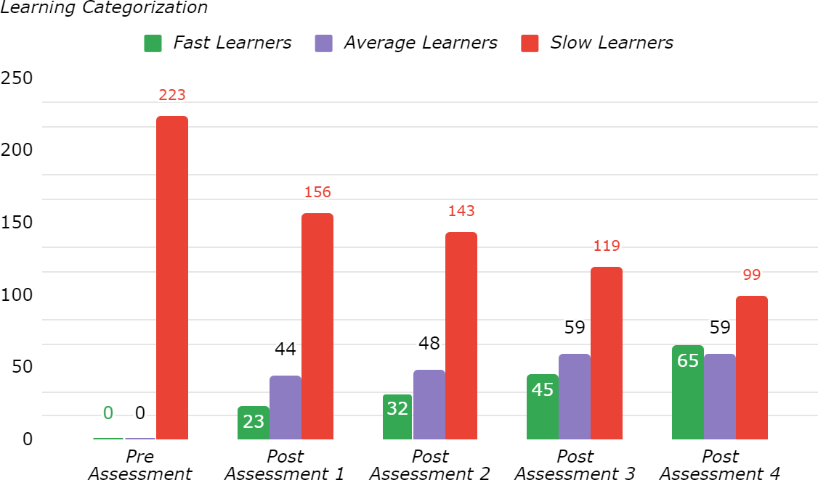

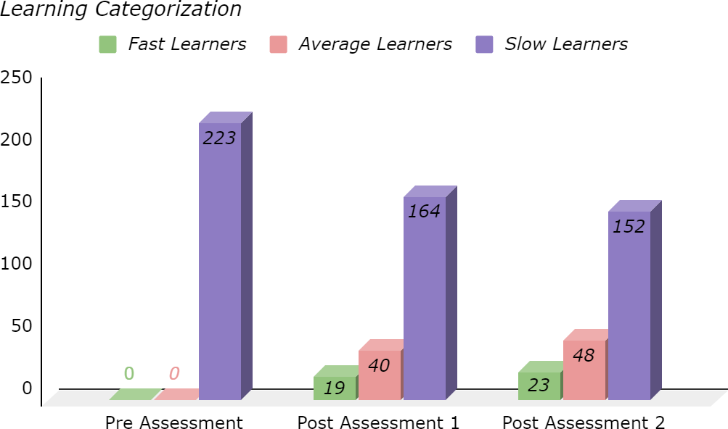
Learning Categorisation Chart:
