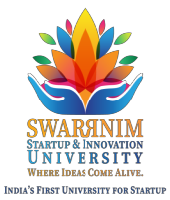

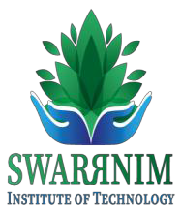

**Swarnim Institute of Technology**

**Department Of Computer Engineering**

**Department of Information Technology**

Gandhinagar , 17/01/2024 — Swarrnim Institute of Technology recently organized a

highly successful workshop on Artificial Intelligence (AI), Data Science, and Data Analysis in collaboration with Pioneer Tech. The event took place on the 17th of January 2024 and saw active participation from students pursuing B. Tech, Diploma, and Computing programs.

The workshop provided an invaluable platform for students and faculty to delve into the latest advancements in AI and data-related technologies. Through collaboration with Pioneer Tech, a leading tech organization, participants gained practical insights into the applications and significance of these cutting-edge fields.

Both students and faculty members exhibited enthusiastic engagement throughout the workshop, showcasing the institute's commitment to fostering a dynamic learning environment. The event aimed to equip participants with essential skills and knowledge in AI, Data Science, and Data Analysis, aligning with the ever-evolving demands of the tech industry.

Swarrnim Institute of Technology continues to play a pivotal role in preparing students for the challenges of the modern workforce. The success of this workshop underscores the institute's dedication to providing quality education and staying at the forefront of technological advancements.

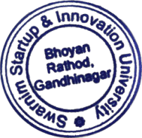 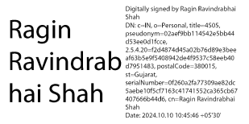

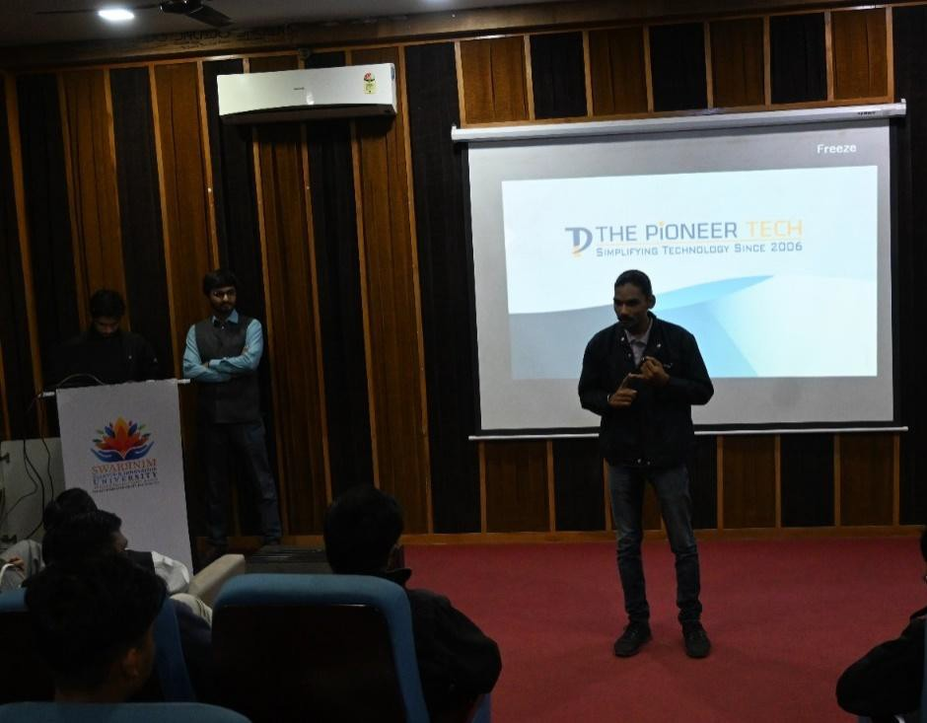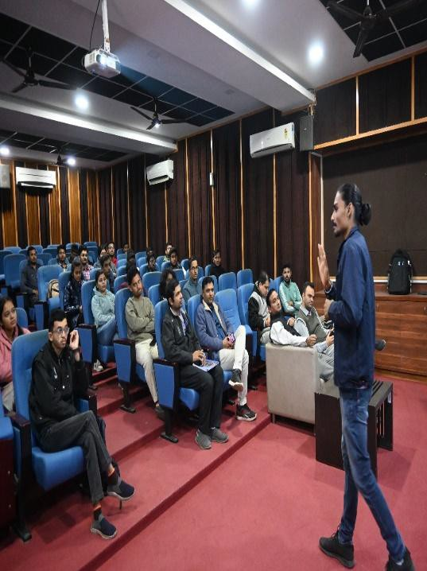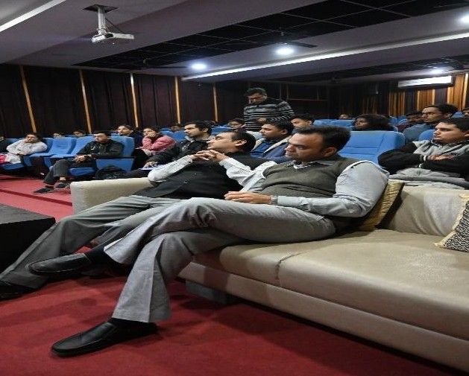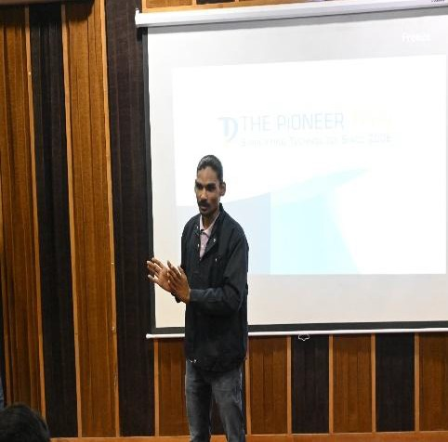

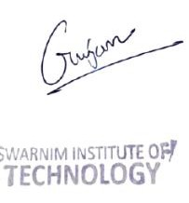

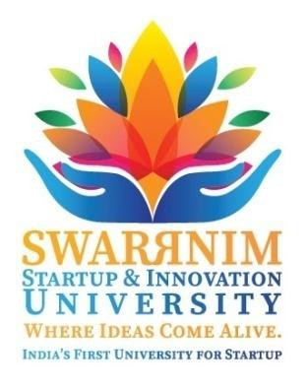

# Swarrnim Startup & Innovation University Activity Report 2024

|  |  |
| --- | --- |
| **Institute/Department** | **SWARRNIM INSTITUTE OF TECHNOGY** |
| **Activity/Event Name** | Workshop |
| **Date of the event** | 19/01/2024 |
| **Duration** | 2Hrs(10:00amto12:00PM) |
| **Participant’s Branch/Institutes** | **SWARRNIM INSTITUTE OF TECHNOLOGY** |
| **Total Number of Participants** | 60 |
| **Name of Mentor/Principal** | DR.JayanShekar |
| **Name of Speaker/Guest** | Mr.Chintan Dave |
| **Faculty Coordinator Details**  **(Name,Designation,Contact Details)** | Prof.Kalpesh Patel Assistant professor  Computer Engineering Department |
| **Student Coordinator Details**  **(Ifany)** | NA |

**Objective of the event:**

The primary objective of the AI Certification Workshop is to equip participants with a comprehensive understanding of Artificial Intelligence, spanning from fundamental concepts to advanced applications. The workshop aims to bridge the gap between theory and practical implementation, empowering attendees to apply AI principles in real-world scenarios.

# Flow of Event:

The workshop will unfold in a structured manner, covering key aspects of AI through

Engaging presentations, interactive discussions, and hands-on exercises. Mr.Chintan Dave, a seasoned expert in the field, will guide participants through the following agenda:

1. Introduction to AI & Ai Cert: Overview of AI concepts & Its certification, its evolution, and its impact on various industries.
2. Fundamental Principles: A deep dive in to the fundamental principles of AI, including machine learning neural networks, and natural language processing.
3. Real-world Applications: Exploration of AI applications across diverse sectors, show casing its transformative potential.
4. Hands- on Exercises: Practical sessions allowing participants to apply their knowledge and skills in real-world scenarios, facilitated by Mr.Chintan Dave.

# Significance/Outcome:

The AI Certification Workshop holds immense significance for participants, the institute, and the broader community:

1. Skill Enhancement: Participants will gain practical insights and skills essential for navigating the AI landscape, enhancing their professional capabilities
2. Networking Opportunities: The event provides a platform for participants to connect with peers, industry professionals, and the esteemed facilitator, fostering valuable networks within the AI community.
3. Industry-Relevant Certification: The certification awarded by Swarrim Institute

of Technology holds weight in the industry, signifying a commitment to excellence in the field of Artificial Intelligence.

1. Empowering Innovation: As AI continues to drive innovation across industries,

This workshop empowers individuals to contribute to and lead the charge in shaping the future.

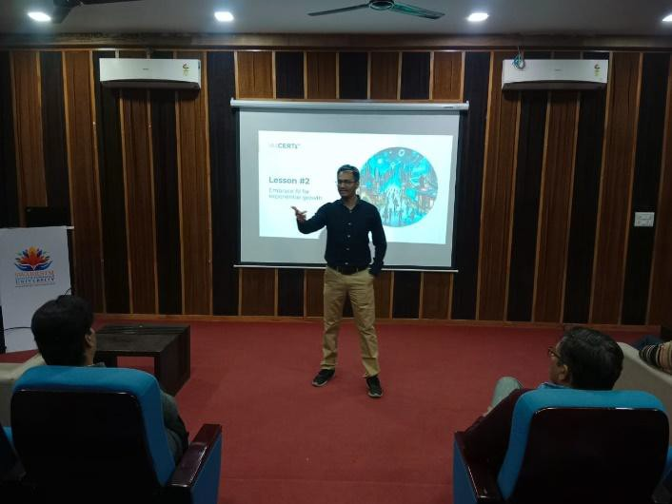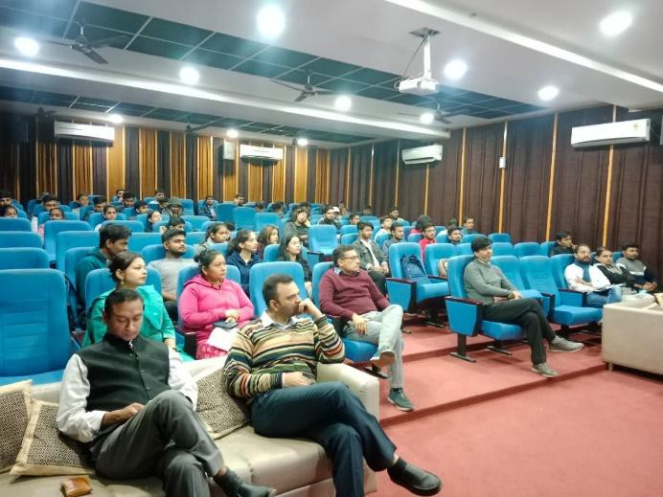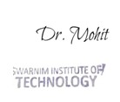

# Conclusion:

As a special feature, Mr.Chintan Dave will be available for consultation sessions, offering participants the rare opportunity to seek personalized guidance on their AI-related queries and projects.

# Photographs:

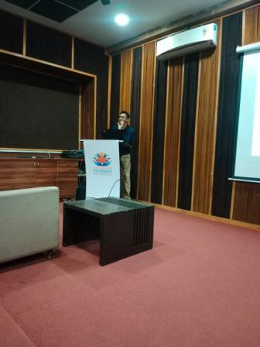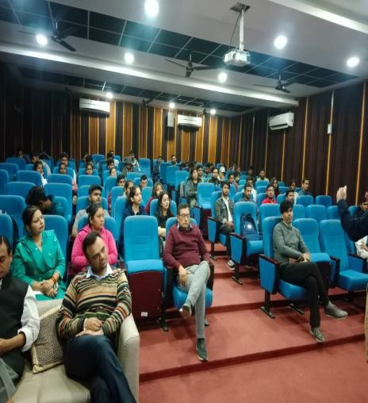

|  |  |
| --- | --- |
|  |  |
|  |  |
|  |  |

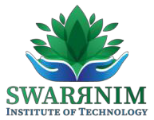

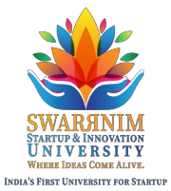

**Swarnim Institute of Technology**

**Department of Computer Engineering**

**Department of Information Technology**

**One day Workshop on Ethical Hacking and Cyber Security**

**Date:** **February 1st, 2024**

**Time:** **10:30 AM-12:30PM**

**Venue:** **Apple Lab**

**Introduction:** On February 1st, 2024, a workshop focusing on Ethical Hacking and Cyber Security was conducted in collaboration with Cyber Octet Private Limited. The workshop aimed to provide participants with comprehensive insights in to the principles, techniques, and importance of ethical hacking and cyber security into day's digital landscape.

**Agenda:**

1. Introduction to Ethical Hacking
2. Understanding Cyber Security Fundamentals
3. Exploring Common Cyber Threats
4. Ethical Hacking Techniques and Best Practices
5. Practical Demonstrations and Hands-on Exercises
6. Q & A Session

**Workshop Overview:**

The workshop began with an introductory session, setting the stage for the exploration of ethical hacking and cyber security concepts. Participants were introduced to the ethical considerations and legal aspects associated with hacking practices.

Following the introduction, experts from Cyber Octet Private Limited delivered engaging presentations on the fundamentals of cyber security, emphasizing the need for proactive measures to protect sensitive data and infrastructure from cyber threats.

A detailed discussion on common cyber threats provided participants within sights into the evolving tactics used by malicious actors to compromise systems and networks. Various attack vectors, including phishing, malware, and social engineering, were explored, highlighting the importance of awareness and vigilance.

Ethical hacking techniques and best practices were elucidated through practical demonstrations and case studies. Participants had the opportunity to observe simulated cyber-attacks and learn how ethical hackers identify vulnerabilities and mitigate risks through penetration testing and vulnerability assessments.

The workshop concluded with a dynamic Q&A session, allowing participants to seek clarification on specific topics and engage in insightful discussions with the speakers and fellow attendees.



**Key Takeaways:**

1. Understanding the ethical considerations and legal framework surrounding

Hacking practices.

2. Recognizing the significance of cyber security measures in safeguarding digital assets and privacy.

3. Identifying common cyber threats and adopting proactive strategies to mitigate risks.

4. Gaining insights into ethical hacking techniques and best practices for securing systems and networks.

5. Acquiring practical skills through hands-on exercises and demonstrations.

**Conclusion:**

The workshop on Ethical Hacking and Cyber Security, organized in collaboration with Cyber Octet Private Limited, provided participants with a comprehensive understanding of the principles and practices essential for safe guarding against cyber threats. The interactive sessions, practical demonstrations, and engaging discussions facilitated knowledge sharing and skill development, empowering attendees to adopt proactive measures in securing their digital environments.

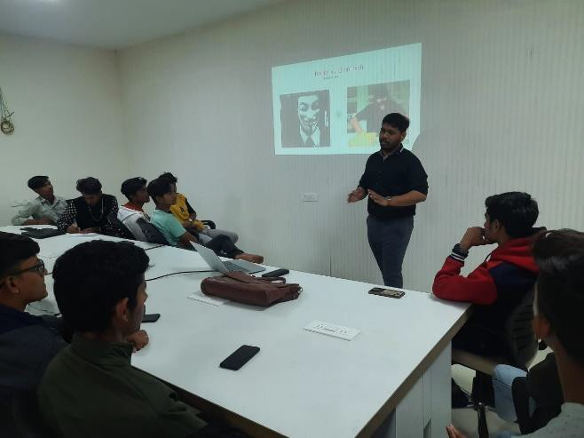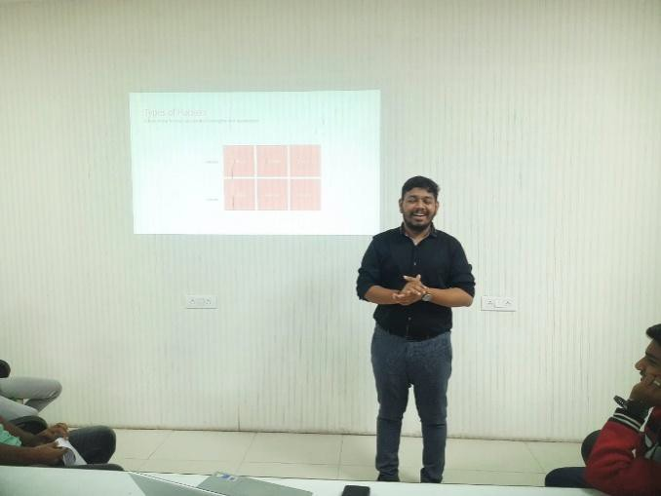

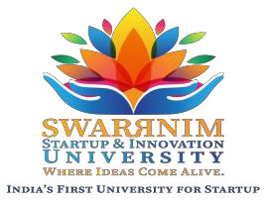 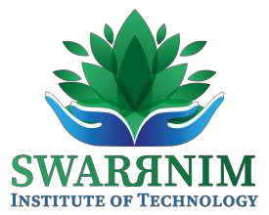

**Swarnim Institute of Technology**

**Department of Computer Engineering**

**Department of Information Technology**

**One day Workshop Introduction to GitHub with GitHub.dev**

**Date**: January29, 2024

**Time**: 10:30AMto12:00PM

**Location**: Apple Lab, Swarrnim University

**Overview:** On January 29, 2024, developers and coding enthusiasts gathered at Swarrnim University's Apple Lab for an enlightening session on "Introduction to GitHub with GitHub.dev," featuring the esteemed expertise of Aryan Gajja (Student) from the Department of Computer Engineering.

**Event Highlights:**

* **Expert Insights:** Aryan Gajjar, a seasoned expert in the field of Computer Engineering, led participants on an immersive journey through the intricacies of Git Hub and its revolutionary extension, GitHub.dev.
* **Hands-On Learning:** Attendees had the unique opportunity to delve into practical demonstrations, gaining in valuable hands- on experience in navigating GitHub's interface and leveraging GitHub.dev's cutting- edge features.
* **Interactive Discussion:** The session fostered an environment of collaborative learning, with attendees actively engaging in discussions, sharing insights, and exploring innovative ways to optimize their coding workflows.
* **Networking Opportunities:** Participants seized the chance to connect with like- minded individuals, forging new professional connections and expanding their network within the developer community.

**Key Take away:**

* **Enhanced Understanding:** Attendees gained a comprehensive understanding of GitHub's functionality and the seamless integration of GitHub.dev into their coding tool kit.
* **Empowerment:** Armed with new found knowledge and skills, participants left feeling empowered to elevate their coding journey and tackle projects with confidence.
* **Community Engagement:** The event served as a catalyst for fostering a vibrant developer community, wherein dividuals come together to learn, collaborate, and innovate.

**Closing Thoughts:** The "Introduction to GitHub with GitHub.dev" session, spear headed by Aryan Gajjar, proved to be are sounding success leaving attendees inspired and equipped to embark on their coding endeavors with renew edvigor. As the world of technology continues to evolve, such educational initiatives play a pivotal role in equipping as paring developers with the tools and insights needed to thrive in an ever-changing landscape.

 

**Glims of event**

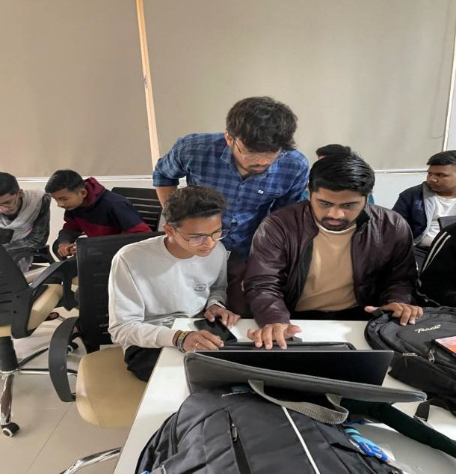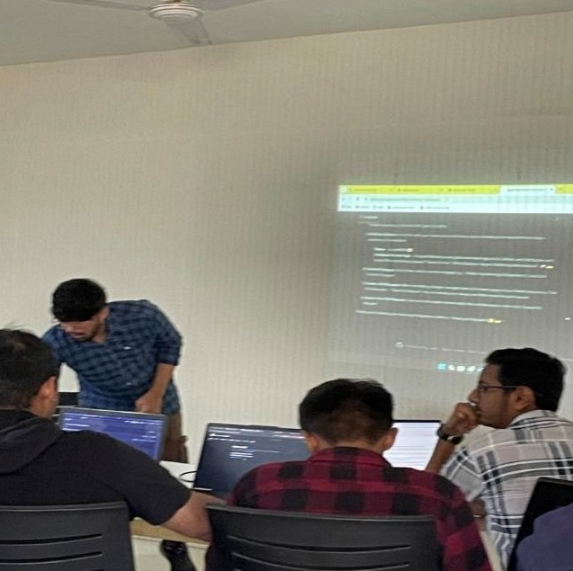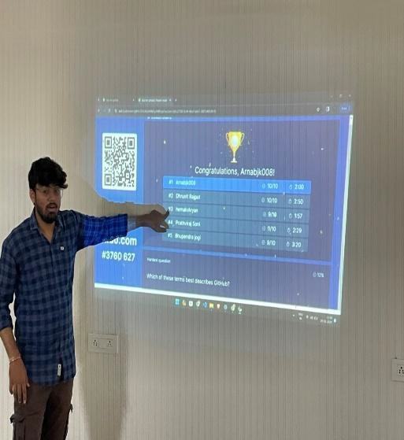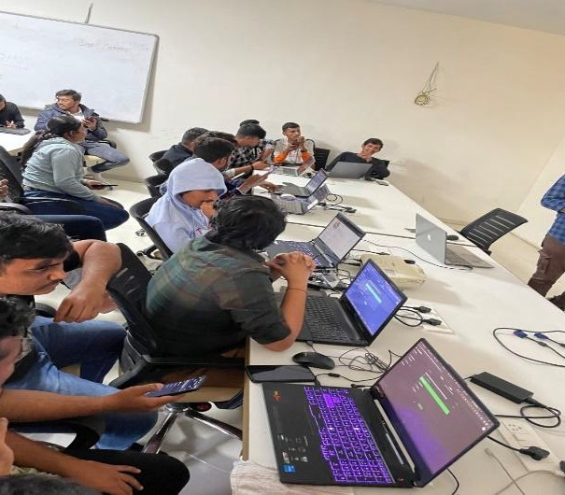





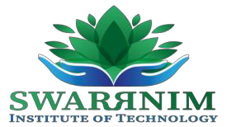

Swarrnim Institute of Technology

**Department Of Computer Engineering**

**Department of Information Technology**

**One day Workshop Introduction to GitHub with GitHub.dev**

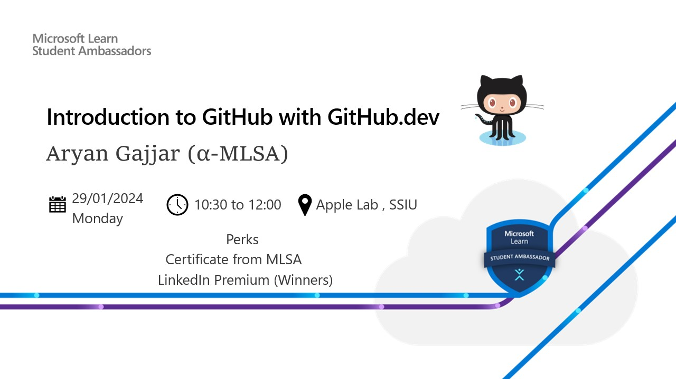

**Date:** **January 29, 2024**

**Time: 10:30 AM to 12:00 PM**

**Location:** **Apple Lab, Swarrnim University**

**Overview:** On January 29, 2024, developers and coding enthusiasts gathered at Swarrnim University's Apple Lab for an enlightening session on "Introduction to GitHub with GitHub.dev," featuring the esteemed expertise of Aryan Gajja (Student) from the Department of Computer Engineering.

**Event Highlights:**

**Expert Insights:** Aryan Gajjar, a seasoned expert in the field of Computer Engineering, led participants on an immersive journey through the intricacies of GitHub and its revolutionary extension, GitHub.dev.

**Hands-On Learning:** Attendees had the unique opportunity to delve into practical demonstrations, gaining invaluable hands-on experience in navigating GitHub's interface and leveraging GitHub.dev's cutting-edge features.

**Interactive Discussion:** The session fostered an environment of collaborative learning, with attendees actively engaging in discussions, sharing insights, and exploring innovative ways to optimize their coding workflows.

**Networking Opportunities:** Participants seized the chance to connect with like-minded individuals, forging new professional connections and expanding their network within the developer community.

**Key Takeaways:**

* **Enhanced Understanding:** Attendees gained a comprehensive understanding of GitHub's functionality and the seamless integration of GitHub.dev into their coding toolkit.
* **Empowerment:** Armed with newfound knowledge and skills, participants left feeling empowered to elevate their coding journey and tackle projects with confidence.
* **Community Engagement:** The event served as a catalyst for fostering a vibrant developer community, where individuals come together to learn, collaborate, and innovate.

**Closing Thoughts:** The "Introduction to GitHub with GitHub.dev" session, spearheaded by Aryan Gajjar, proved to be a resounding success, leaving attendees inspired and equipped to embark on their coding endeavours with renewed vigour. As the world of technology continues to evolve, such educational initiatives play a pivotal role in equipping aspiring developers with the tools and insights needed to thrive in an ever-changing landscape.





**Glims of event**

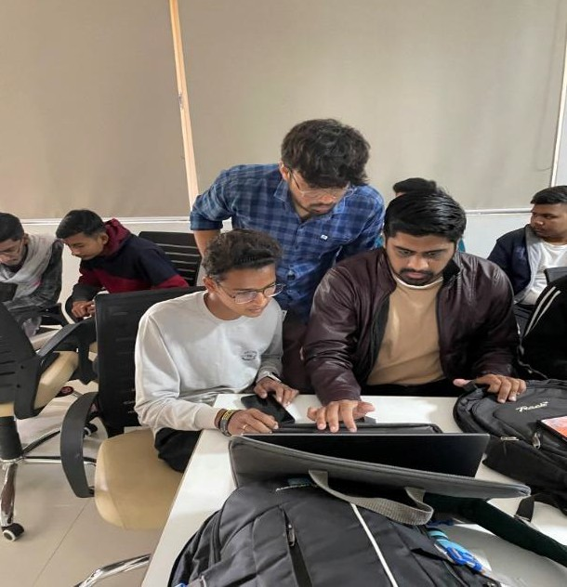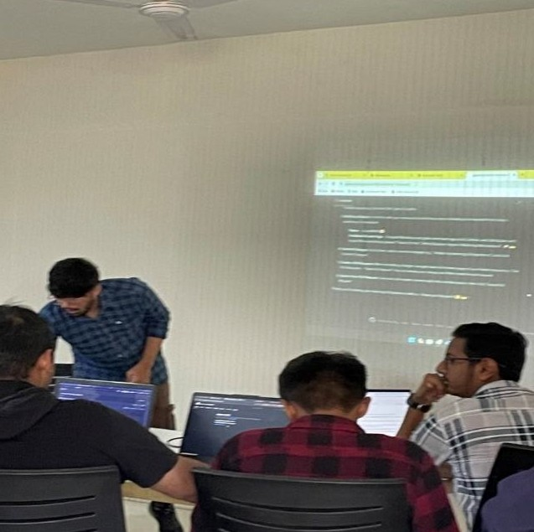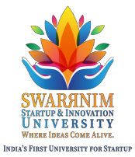



 



**Swarnim Institute of Technology**

**Department of Information Technology**

**Department of Computer Engineering**

**Workshop API 101 using Postman**

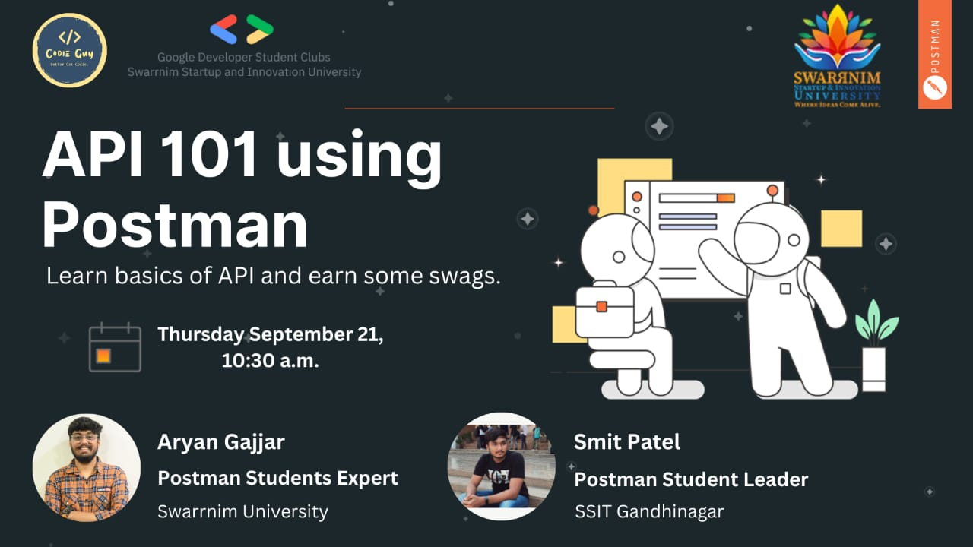

**Topic:** **API 101 using Postman**

**Expert:** **Arayn Gajjar**

**Date:** **September 21, 2023**

**Time:** **10:30 AM onwards**

**Place:** **Apple Lab, Swarrnim University**

**Introduction:** The session titled "API 101 using Postman" was conducted by Arayn Gajjar, an expert in the field, on September 21, 2023, at the Apple Lab in Swarrnim University. The session aimed to provide participants with fundamental knowledge and practical insights into working with APIs using the Postman tool.

**Key Points Covered:**

1. **Understanding APIs:**

* Arayn Gajjar provided a comprehensive overview of Application Programming Interfaces (APIs), explaining their significance in modern software development.
* Participants gained insights into the role of APIs in facilitating communication between different software systems.

1. **Introduction to Postman:**
   * The session delved into the features and functionalities of Postman, a popular API development tool.
   * Arayn Gajjar demonstrated how Postman simplifies the process of testing, documenting, and debugging APIs.
2. **Practical Demonstration:**

* Participants had the opportunity to observe practical demonstrations of API requests and responses using Postman.
* Arayn Gajjar walked through various scenarios, showcasing how to create requests, handle authentication, and interpret responses.

1. **Best Practices and Tips:**

* The expert shared best practices for designing and consuming APIs, emphasizing clarity, consistency, and security.
* Participants received valuable tips for optimizing their API development workflows using Postman.

**Interactive Session:** The session fostered active participation, with attendees engaging in discussions, asking questions, and sharing their experiences related to API development and Postman usage. Arayn Gajjar encouraged a collaborative learning environment, addressing queries and providing additional insights based on real-world scenarios.

**Conclusion**: The session "API 101 using Postman" proved to be informative and beneficial for participants, equipping them with foundational knowledge and practical skills essential for working with APIs. Arayn Gajjar's expertise and interactive teaching style contributed to the success of the session, leaving attendees with a deeper understanding of API concepts and the proficiency to leverage Postman effectively in their projects.

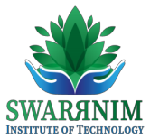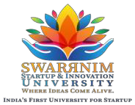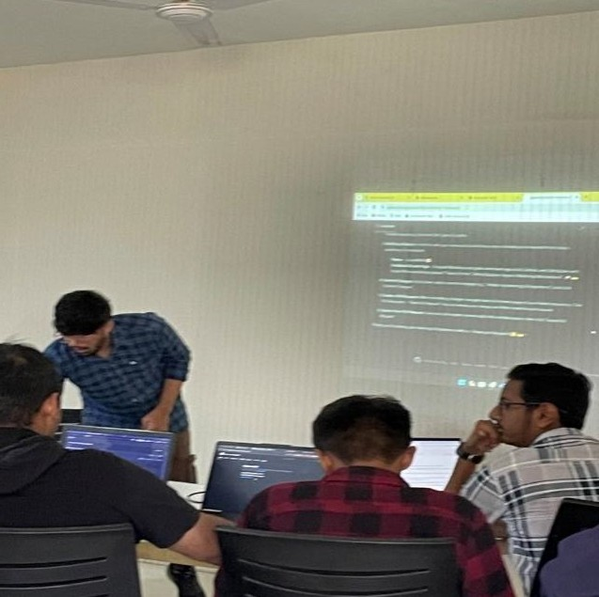

|  |  |
| --- | --- |
|  |  |
|  |  |

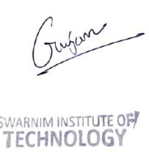

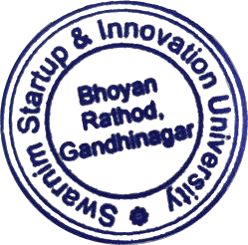

 

**Workshop on Vector Design Tool-Figma**

**Introduction:** **In today's digital era, understanding various technologies and their applications is crucial for individuals and businesses alike. This report provides an overview of essential technologies, human interface guidelines, designing fundamentals, vector design tool Figma, video editing using iMovie, and fundamentals of iOS development.**

1. **Technologies Overview:** Technologies encompass a broad spectrum of tools and systems utilized to accomplish various tasks. These can range from hardware like computers and smartphones to software applications and programming languages. Understanding technologies helps individuals leverage them effectively for personal or professional purposes.
2. **Human Interface Guidelines & Designing Fundamentals:** Human Interface Guidelines (HIG) are a set of principles and recommendations provided by platform developers (such as Apple or Google) to ensure consistency and usability in software interfaces. Designing fundamentals involve understanding principles of visual design, user experience (UX), and user interface (UI) design. This includes aspects such as typography, color theory, layout, and usability.
3. **Vector Design Tool - Figma:** Figma is a cloud-based design tool used for creating user interfaces, websites, and other digital designs collaboratively. It allows real-time collaboration, prototyping, and sharing of designs. Figma's intuitive interface, robust features, and collaborative capabilities make it a popular choice among designers and design teams.
4. **Video Editing with iMovie:** iMovie is a video editing software application developed by Apple Inc. It offers a user-friendly interface and a wide range of tools for editing videos, adding effects, transitions, and audio. iMovie is suitable for beginners and intermediate users looking to create professional-looking videos for various purposes, including personal projects, social media content, and presentations.
5. **iOS Fundamentals & Mobile Application Development:** iOS is Apple's mobile operating system powering devices such as iPhones and iPads. Understanding iOS fundamentals is essential for developing mobile applications for these devices. This involves learning programming languages like Swift, understanding the iOS SDK (Software Development Kit), UI/UX design principles specific to iOS, and adhering to Apple's App Store guidelines for app submission.

**Conclusion:** In conclusion, familiarity with various technologies, human interface guidelines, designing fundamentals, tools like Figma and iMovie, as well as iOS fundamentals, is crucial in today's digital landscape. Whether you're a designer, developer, or content creator, mastering these concepts and tools can significantly enhance your skills and productivity in the digital realm. Continuously staying updated with advancements in technology and design trends is also essential for staying competitive in the industry.

**Here is the schedule of the Faculty Development Program to be held from 1st May to 3rd May 2023.**

|  |  |  |
| --- | --- | --- |
| **Swarrnim Startup & Innovation University (FDP Schedule)** | | |
| **Date** | **Topic of the Session** | **Timings** |
| **1st May 2023** | **Introduction to Technologies** | **12 PM - 3 PM** |
| **Human Interface Guidelines & Designing Fundamentals** | **3 PM - 5 PM** |
| **2nd May 2023** | **Vector Design tool- Figma** | **9 AM - 1 PM** |
| **Video Editing with iMovies** | **2 PM - 5 PM** |
| **3rd May 2023** | **iOS Fundamentals & Mobile Application Development** | **9 AM - 3 PM** |

 