**SWARRNIM**

**STARTUP & INNOVATION UNIVERSITY**

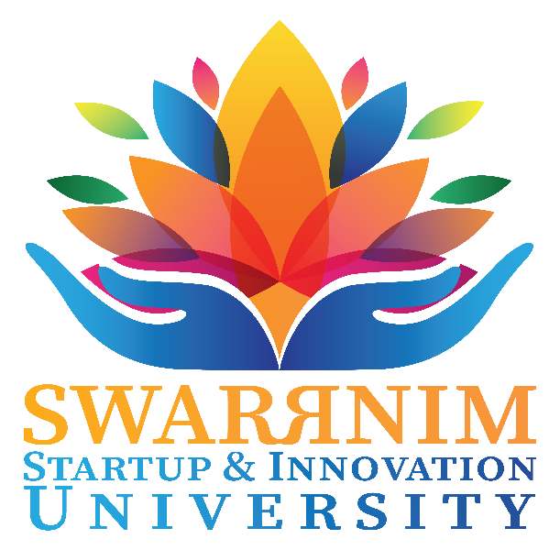

**7.3 Distinctiveness Report of**

**Training & Placement Cell**

**Training & Placement- Comprehensive Summary Report**

1. **Objectives:**

The Training and Placement Cell of Swarrnim Startup & Innovation University is committed to delivering comprehensive campus-to-corporate training across three pivotal verticals: soft skills, aptitude, and verbal ability. Leveraging an industry-aligned curriculum, the weekly training classes impart essential competencies through key concepts, case studies, and real-world simulations. Each student benefits from meticulous, centred, and personalized counselling designed to raise career prospects by honing individual strengths and aligning educational objectives with market demands. Students are also provided tailored guidance targeting goal-setting, strategic planning, and the cultivation of professional comportment, ensuring that every aspirant attains the confidence and readiness required to engage effectively with prospective employers.

To monitor development and reinforce learning outcomes, the Cell administers regular assessments—including mock placement drives and periodic diagnostic tests—to evaluate performance and pinpoint areas for improvement. Specially focused troubleshooting sessions address identified weaknesses through expert-led workshops and one-on-one coaching, ensuring precise skill refinement. In addition, the Cell coordinates a diverse array of events, seminars, and hands-on activities that empower students to apply their knowledge in real-time scenarios. These initiatives foster experiential learning, encourage productive involvement, and cultivate a culture of continuous improvement, ultimately strengthening overall employability and positioning graduates for sustained success in their chosen careers.

1. **Departmental Initiatives :**

**2.1 Deferred Placement Policy:**

Under the Deferred Placement Policy, the Training and Placement Cell provides passed-out students the opportunity to access placement drives, career counselling, and industry engagement for a period of three years from the date of their graduation, postgraduate completion, or degree conferral. The policy’s scope encompasses graduates across all disciplines and ensures equity through eligibility criteria. Opportunities are systematically curated and extended in accordance with each alumnus’s demonstrable skill set and academic discipline, ensuring precise alignment with organizational requirements. Interested candidates are required to complete and submit a duly signed assent form, following which the Placement Department verifies and processes their credentials and profiles. Upon successful processing, students are entered into a dynamic talent pool for consideration in prospective recruitment cycles conducted by corporate partners. The department monitors evolving industry trends, and communicates updated placement schedules to deferred candidates at regular intervals. This policy reflects the institution’s enduring commitment to lifelong career support, enabling alumni to benefit from sustained professional opportunities and industry integration throughout the prescribed three-year tenure.

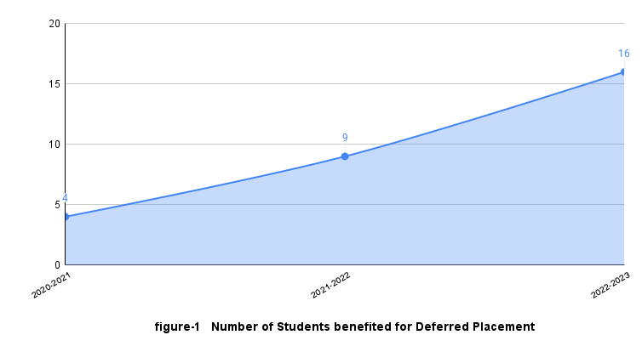

**Please click the link for detailed Benefited Students report:**

<https://drive.google.com/drive/folders/1NX-2j0jn-glwLbZYJbJnZkLUNpk4x1kJ?usp=sharing>

**2.2 Employment Ready Enhancement Program:**

The Placement Readiness Enhancement Program by the Training & Placement Cell is an initiative designed to equip students with the requisite skills, knowledge, exposure necessary for seamless transition into work environments. To validate its progressive impact, the institute presents the program’s course files from the past five years, showcasing a constructively evolving syllabus aligned with student requirements and current market demands. Employing a blend of innovative pedagogy and methodology, the program instils essential competencies, technical proficiencies, and insights into contemporary work cultures. Furthermore, mentoring sessions are seamlessly integrated into the regular curriculum to address queries, foster critical thinking, and broaden students’ perspectives on global industry landscapes.



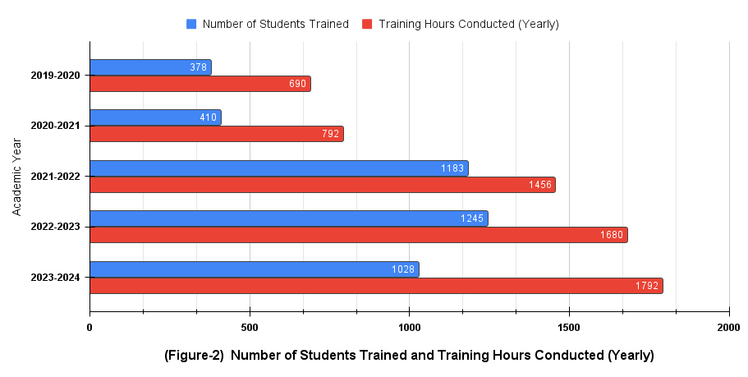

**Please click the link for detailed Course Curriculum report:**

[**https://drive.google.com/drive/folders/1N1uG8PEtMJXjAVjXfD7zAoRhyKGoJcyN?usp=sharing**](https://drive.google.com/drive/folders/1N1uG8PEtMJXjAVjXfD7zAoRhyKGoJcyN?usp=sharing)

**2.3 Career Counselling Cell:**

The Career Counselling Initiative offers one-to-one sessions conducted by expert trainers throughout the academic semesters, meticulously tailored to each student’s objectives—whether higher education, competitive examinations, or entrepreneurial ventures. Every student undergoes comprehensive assessment across three core verticals—soft skills, aptitude, and verbal ability—to identify individual strengths and areas for development. Based on this analysis, students receive guidance on suitable industry sectors aligned with their potential and inclinations, as well as recommendations for optimal role profiles reflecting their current competencies. The initiative further provides corrective strategies and actionable recommendations, thereby illuminating a clear, focused pathway for targeted improvement and sustained career advancement.

**Please click the link for detailed Student Wise report:**

[**https://drive.google.com/drive/folders/1TyLA9WIQABdpmbzuG87NXUdgtAQ5AtSZ?usp=sharing**](https://drive.google.com/drive/folders/1TyLA9WIQABdpmbzuG87NXUdgtAQ5AtSZ?usp=sharing)

**2.4 Industry Integration:**

Under the Industry Integration rubric, Swarrnim Startup & Innovation University has systematically expanded its collaborative footprint. According to the MOU register, 8 MOUs were executed in 2019-20, rising to a peak of 29 in 2020-21, before a brief consolidation to 3 in 2021-22; engagement rebounded to 19 in 2022-23 and 26 in 2023-24. These agreements span domestic leaders in healthcare, engineering, diagnostics, and technology, covering academic exchange, research collaboration, clinical training, skill development, IP support and startup ecosystem building. Notably, clinical partnerships grew from 6 in 2020-21 to over 15 by 2023-24, while skill-development and IP sensitization MOUs emerged in 2022-23 onward. Looking ahead, the University will deepen sector-specific integrations—particularly in AI, renewable energy, and advanced manufacturing—by targeting high-impact R&D collaborations, expanding startup-industry consortia and formalizing credit-bearing internships. This strategic vision ensures holistic alignment with national innovation priorities and continuous enhancement of student employability.

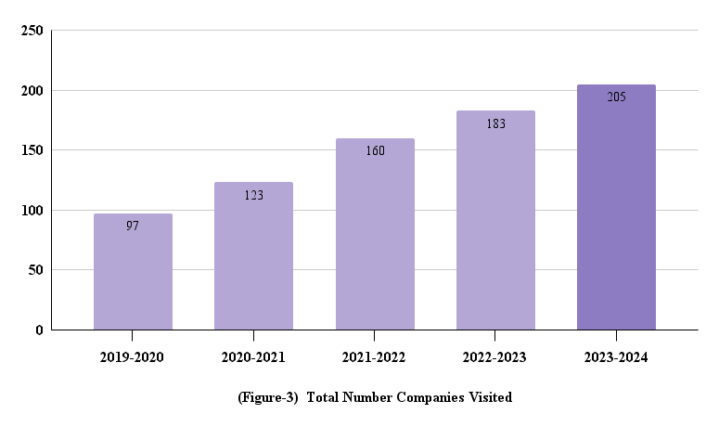

**Please click the link for detailed MoU’s report:**

<https://drive.google.com/drive/folders/1WVJe9_pSRmrBPl8GnXzLJtCU2hKaQMYQ?usp=sharing>

1. **Outcomes:**

The Training & Placement Cell’s targeted Training Needs Analysis (TNA) and Training Needs Identification (TNI) have yielded measurable outcomes: over the past five years, the average placement package has increased by a significant percentage, reflecting sustained industry alignment and curriculum enhancement. Annexure 1 (chart attached) illustrates a consistent rise in the proportion of fast learners—outperforming slower cohorts. Furthermore, department-wise performance in mock assessments has improved annually over the last three years. The metrics underscore the Cell’s efficacy in cultivating professional competencies, facilitating skill advancement, and reinforcing academic excellence. With these key strengths, the T&P Cell remains committed to progressive innovation and elevating student employability and overall readiness.

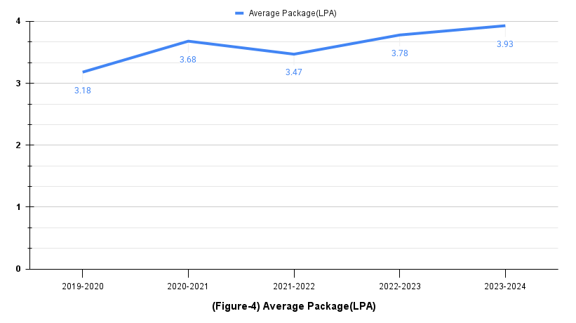

**Please click the link for detailed Student wise as well as department wise TNI/TNA report:**

<https://drive.google.com/drive/folders/1aFrUizcP6DJZyPVogRhi3W_S9bknq2_X?usp=sharing>